8.Write a C program for monoalphabetic cipher is that both sender and receiver must commit the
permuted cipher sequence to memory. A common technique for avoiding this is to use a keyword from
which the cipher sequence can be generated.
For example, using the keyword CIPHER, write out the keyword followed by unused letters in normal
order and match this against the plaintext letters:
plain: a b c d e f g h i j k l m n o p q r s t u v w x y z
cipher: C I P H E R A B D F G J K L M N O Q S T U V W X Y Z give python code

Program:-

import string
# Keyword
keyword = "CIPHER"
# Generate cipher alphabet using keyword
cipher = ""
for ch in keyword + string.ascii_uppercase:
if ch not in cipher:
cipher += ch
# Plaintext alphabet
plain = string.ascii_uppercase
print("Plain alphabet :", plain)
print("Cipher alphabet:", cipher)
# Encryption
message = input("Enter plaintext: ").upper()
encrypted = ""
for ch in message:
if ch in plain:
encrypted += cipher[plain.index(ch)]
else:
encrypted += ch
print("Encrypted text:", encrypted)
# Decryption
decrypted = ""
for ch in encrypted:
if ch in cipher:
decrypted += plain[cipher.index(ch)]
else:
decrypted += ch
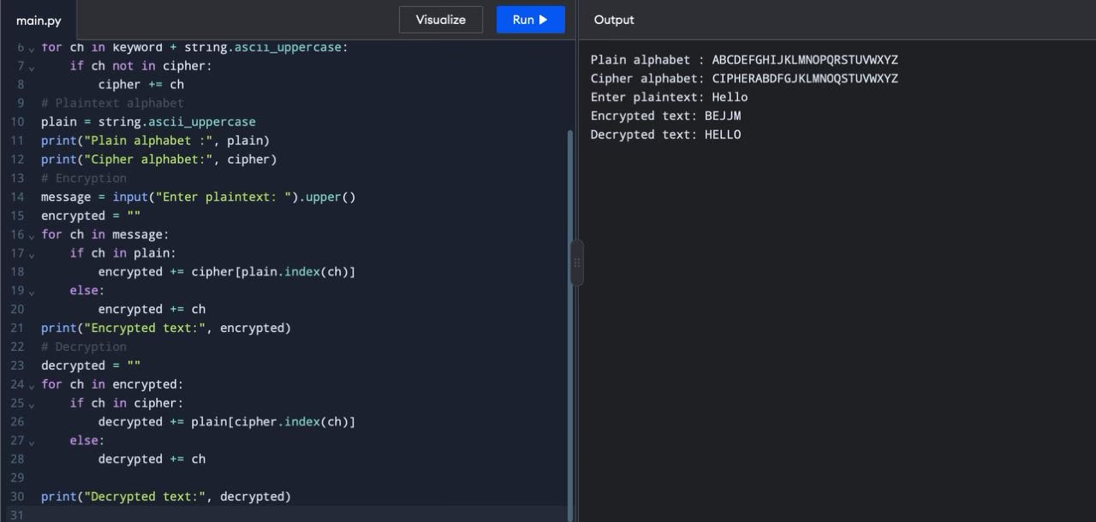
print("Decrypted text:", decrypted)

