Ancient Methods of Calculating Square Roots

Physical evidence exists that the Babylonians had a method of calculating the square root of some numbers as early as 2000 years before the birth of Christ. In the Yale collection there exist an artifact that shows the calculation of the square root of two to five decimal places accurately. Some images of the item, called YBC7289 can be found here. What may surprise many students is that the ancient Babylonian method seems to be the same as the method frequently taught in school text books. The method is frequently attributed to Heron (or Hero) because it appears in his <I>Metrica</i>, and is also called Newton’s method, and the divide-and-average method. The method is an iterative method which involves the following steps: (I will illustrate the method with an example of the square root of 250).
1) Guess a number for the square root I’ll guess badly, and start with 10
2) Divide the number by the guess 250 / 10 = 25
3) Average the original guess and the new guess (25+10)/2 = 17.5
4) make this average value your new “guess” and new guess = 17.5
go back to step 2…..
As you continue through the steps you get the following

Guess | Quotient | Average | Next guess
10 | 250/10 = 25 | (25+10)/2=17.5 | 17.5
17.5 | 250/17.5 = 14.285 | (17.5+14.285)/2=15.89 | 15.89
15.89 | 250/15.89 = 15.73 | (15.89+15.73)/2=15.81 | 15.81
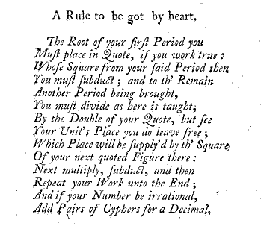
The process may be continued to whatever level of accuracy is desired. Notice that after three divide and averages we have 15.81, which is accurate to the hundredth place. 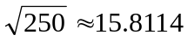.
----------------------------------------------------------------------------------------------
A Chinese method appeared sometime shortly after 200 BC that became very common in American textbooks. The first occurrence of this method that I know of was in the fourth chapter of The Jiuzhang suanshu or Nine Chapters on the Mathematical Art . The book is a practical handbook of mathematics consisting of 246 problems which provide methods of solving common problems of engineering, and trade. The book holds a position in Chinese mathematical development similar to Euclids “Elements” in western mathematics. An explanation of the Chinese method with illustrations can be found here.
The method somehow became the common approach to solving for square roots in textbooks. The image at right shows a poem to be memorized by students to remember the steps which appeared in the 1772 textbook, Arithmetick, both in the theory and practice : made plain and easy in all the common and useful rules , by John Hill. The same algorithm existed into textbooks of the 1960’s and really only disappeared with the emerging ubiquity of the hand held calculator. Here is another look at the same algorithm with directions that may seem clearer, and an example taken from the Wikipedia online dictionary:
Write the number in decimal and divide it into pairs of digits starting from the decimal point. The numbers are laid out similar to the long division algorithm and the final square root will appear above the original number.
For each iteration:
- Bring down the most significant pair of digits not yet used and append them to any remainder. This is the current value referred to in steps 2 and 3.
- If r denotes the part of the result found so far, determine the greatest digit x that does not make y = x(20r + x) exceed the current value. Place the new digit x on the quotient line.
- Subtract y from the current value to form a new remainder.
- If the remainder is zero and there are no more digits to bring down the algorithm has terminated. Otherwise continue with step 1.
Example: What is the square root of 152.2756?
____1__2._3__4_
| 01 52.27 56 1
x 01 1*1=1 1
____ __
00 52 22
2x 00 44 22*2=44 2
_______ ___
08 27 243
24x 07 29 243*3=729 3
_______ ____
98 56 2464
246x 98 56 2464*4=9856 4
_______
00 00 Algorithm terminates: answer is 12.34

I think I probably was taught, and tested, on the use of this algorithm each year from grade 5 or 6 onward, but do not remember ever having seen an explanation for why it worked. Below is my attempt to explain why it works geometrically, using the example of 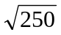 so we can compare with the example above.
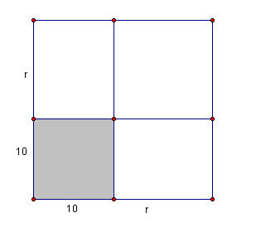
Geometrically, the square root of a number asks for the side of a square whose area is the given number. In this problem we want to find the side of a square whose area is 250 square units. The directions say to mark off the places in two from the decimal place. So we will write it as 2 50 . 00 00 The two represents an area of 200, so we are first looking for the tens digit of the root, that is, we want the largest square with sides of a multiple of ten that will fit inside the square of area 250. This is ten, so our first approximation is ten. The figure at the right shows the square with an area of 250 and part of it covered by our first, and not very good, guess of 10 for the square root. The remaining area to be covered is 150 square units. The same idea appears in the first line of the algorithm
1 __ . __ __ The one in the tens place represents ten 2 50 . 00 00
1 and this one under the 2 hundred represents 10 squared or 100
1 50 and the 150 is the remaining amount to be covered. Up to here it seems quite straightforward, but at this point the double and guess stuff seems weird at first. Look again at the table and notice that we have broken the sides of the square into 10 + some remaining amount labeled r. The remaining 150 is made up of three parts, the top-left rectangle with an area of 10 r, the bottom-right rectangle with an area of 10 r, and the top-right square with area of r².
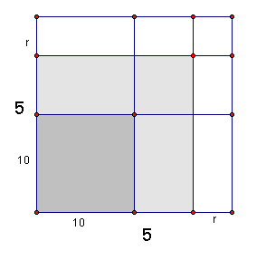
This makes the 150 = 10r + 10 r + r² or, collecting the like terms 20 r + r². If we factor this we get r(20+r). It is these two congruent rectangles that account for the doubling that appears in the next line of the algorithm. Since we are looking for the units digit, 20 + r is a two digit numeral with 2 in the tens place, and r in the units place, like 2r; and we want to select r so that when we multiply the number 2r by r we get a number close to 150. We guess at 6 and try 26 * 6 which is 156… too big, so we try 25*5 and settle for 125
1 5 . ___ ____
2 50 . 00 00
1______________
1 50
25 1 25
25 00

At this point we have enlarged our square to a 15 x 15 square taking up 225 of the 250 square units, and we now have another remainder such that (15+r)² = 250. Our unfilled 15 square units is again composed of two rectangles and a square, with areas of 15 r, 15 r, and r². Since we have the units digit, the next digit will be in the tenths place, and so (30+r ) r must be < 25. Since r is in the tenths place, we can think of 30+r as a decimal number like 30.r and r as .r; (although the algorithm lines up the decimals to avoid having to worry about decimal places. We just think 30_ times _ < 2500 where the same digit must be in both blanks. Using an 8 gives 308 x 8 for 2464
1 5 . _8_ ____
2 50 . 00 00
1______________
1 50
25 1 25
25 00
308 24 64
36 00 The remainder of 36 represents 36 one hundredths error in our approximation. Notice that 15.8² = 249.64. The method can be continued as far as needed for the accuracy required..

A third approach that dates back to antiquity was discovered in the Bakhshali manuscript, an early mathematical manuscript which was only discovered in 1881, but is believed to be a copy of an original that dates back to about 400 AD. The square root algorithm in this birch bark manuscript is given in three steps, and once more I will illustrate the method by finding, yet again, the square root of 250.
The method uses four values, the number (250), the nearest smaller perfect square (225) and its root (15) and the remainder (25) when the nearest square is subtracted from the number.
1) Find the root of the largest square smaller (15)
2) add the root (15) to the fraction formed by dividing the remainder by twice the root (25/30)
3) From this value subtract one half the quotient found by dividing the square of this fraction (25/30) by the sum of the root and the fraction (15 + 25/30).
The value given is 15 + 25/30 - (1/2)(25/30)²/(15+25/30). In decimal form we get 15 + .8333333 - .5(.69444)/(15.83333) which becomes 15 + .83333 - .0219298 which is approximately 15.811403; a very close approximation to the true 15.811388.
This method is derived from the same square image as above, but assumes that r is very small, making r² even smaller. From the image it is clear that if r² is small enough to be dismissed, then the area of the big square, 250, is almost equal to the area of the smaller square inside it, 225, plus twice the area of a rectangle of area 15 x r . In algebra we can write 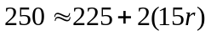. Then if we solve for r we get 5 = 5/6, so the side of the 225 area square, 15, plus the length r, 5/6, give us a good estimate of the root of the 250 area square.
How good? Well 15 5/6 = 95/6, and if we square that we get 250 25/36. Now if we know we are too large, we can find another, better estimate by using the same idea and trying to reduce the square by taking a small rectangle off two adjacent sides of width r₂ (ignoring again a very smaller r₂^2) so the two rectangles removed will be of length 15 + 5/6 times r₂ and we get a new equation 2 (95/6) r₂ = 25/36, and we solve and get 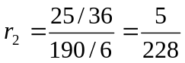. To adjust for being too large, we reduce the 15 5/6 by 5/228 to get our estimate of 15 + 185/228, which is the 15.811388 from the original exercise.
Of course if we were unsatisfied with an approximation that gives a square of 250.0004809, we could repeat the last operation and shave a little more off of the sides by solving 2 (15 + 185/228) r₃= (.0004809)^2 and reduce the previous approximation by r₃.
-------------------------------------------------------------------------------------------------------------
A fourth method of finding square roots was employed by Nicolas Chuquet who wrote Triparty en la science des nombres in 1484, although it was not published until almost 1900. He used a method called the <b>mediant</b>. The mediant of two fractions a/b and c/d is the fraction (a+c)/(b+d). This is the nightmare of elementary math teachers everywhere, the addition of fractions by “adding the tops and adding the bottoms.” Chuquet knew that the resulting value always lay between the two original numbers. From this he could find a new approximation to a square root by finding a number that was too small, and another that was too large, and finding their mediant. Let’s find the square root of 10 (Ok, I’m tired of doing 250)… Since 3² = 9, 3 is too small; and 4²=16 means 4 is too large, so we find the mediant of 3/1 and 4/1 to get 7/2 or 3.5 for our first estimate.
Now we need to know if it is too big or too small, so we square it and the value 12.25 is larger than ten so we want a number between 3 and 7/2. The mediant of 3/1 and 7/2 is 10/3 so we adopt this new approximation of 10/3.
We can continue this process to any degree of accuracy desired by replacing one of our two end values with the new estimate, replacing the larger value if the new estimate is too large, and the smaller iif it falls short of the desired value.

