Healthcare Monitoring System using IoT, Cloud Storage, Big Data Analytics with Apache Spark, and Adaptive Machine Learning Techinques

line 1: 4th Given Name Surname  
line 2: *dept. name of organization*  
*(of Affiliation)*  
line 3: *name of organization   
(of Affiliation)*line 4: City, Country  
line 5: email address or ORCIDline 1: 2nd Given Name Surname  
line 2: *dept. name of organization   
(of Affiliation)*  
line 3: *name of organization   
(of Affiliation)*line 4: City, Country  
line 5: email address or ORCID

*Abstract*—Healthcare monitoring systems are crucial for real-time patient tracking and early disease detection. This paper presents an integrated approach utilizing the Internet of Things (IoT), cloud storage, Big Data analytics with Apache Spark, and adaptive machine learning techniques to enhance remote patient monitoring. IoT sensors collect patient data, which is securely stored in the cloud, enabling real-time access and analysis. Big Data processing through Apache Spark ensures efficient handling of large-scale healthcare data, reducing latency and improving decision-making. Adaptive machine learning models are employed to predict health risks and personalize treatments. The proposed system aims to improve accuracy, reduce latency, and ensure scalable healthcare solutions.

Keywords—IoT, Cloud Computing, Machine Learning, Big Data Analytics, Apache Spark, Healthcare Monitoring, Remote Patient Monitoring

1 Introduction

The increasing prevalence of chronic diseases and the demand for real-time patient monitoring have led to the development of IoT-based healthcare solutions. Traditional healthcare systems face challenges such as delayed diagnosis, lack of real-time monitoring, and data management issues. This paper proposes a system integrating IoT sensors, cloud storage, Big Data analytics with Apache Spark, and adaptive machine learning models to enhance patient care.

## **Internet of Things (IoT)**

IoT plays a vital role in modern healthcare by enabling continuous health monitoring through wearable sensors and smart devices. These devices collect real-time physiological data such as heart rate, oxygen levels, and body temperature, which are then transmitted to cloud storage for further analysis.

***1.2 Real-Time Data Processing***

Real-time data processing is essential for quick decision-making in healthcare. IoT devices generate large amounts of streaming data, which need to be processed instantly to detect abnormalities and alert healthcare providers. Efficient data transmission and processing reduce delays in diagnosis and improve patient outcomes.

## **1.3 Big Data and Apache Spark**

With the massive influx of patient data from IoT devices, traditional data processing methods are insufficient. Big Data technologies such as Apache Spark provide scalable and real-time data processing capabilities. Spark’s in-memory computation and distributed architecture make it suitable for handling large-scale healthcare data efficiently.

## **1.4 Machine Learning in Healthcare**

Machine learning enhances healthcare monitoring by analyzing patient data patterns and making predictive diagnoses. Adaptive ML models continuously learn from incoming data, improving accuracy and personalization . Techinques such as deep learning, decision trees, and support vector machines are widely used to detect anomalies and predict health risks.

The integration of IoT, real-time data processing, Big Data analytics with Apache Spark, and machine learning creates a powerful framework for healthcare monitoring. IoT enables continuous health tracking, real-time data processing ensures quick response to emergencies, Apache Spark facilitates large-scale data handling, and machine learning enhances predictive diagnostics. Together, these technologies improve patient care, reduce latency, and enable personalized treatments. The following sections will explore existing research, the proposed system architecture, experimental results, and the impact of this approach on modern healthcare.

**2 Related Work**

The integration of the Internet of Things (IoT) in healthcare has led to significant advancements in patient monitoring, diagnosis, and personalized healthcare management. Various studies have explored the application of IoT in healthcare, highlighting its benefits, challenges, and

potential solutions.

Several works have focused on the deployment of IoT devices for real-time patient monitoring. IoT-based smart healthcare systems utilize wearable health sensors and smart medical devices to continuously collect and transmit patient data for analysis. These systems provide a seamless way to monitor vital signs and daily activities, reducing the dependency on hospital visits and enabling early diagnosis and intervention. The integration of machine learning (ML) in IoT healthcare has further improved the accuracy and efficiency of monitoring systems. ML models analyse real-time data, detect anomalies, and predict potential health issues, thereby facilitating proactive healthcare management.

However, the diversity in IoT device architectures, network policies, and data structures presents challenges in implementing centralized learning algorithms. To address these issues, distributed learning approaches have been proposed, leveraging big data analytics and cloud computing. Frameworks such as Apache Spark and Hadoop have been employed for efficient data processing and real-time health analysis. The combination of distributed ML models and real-time data ingestion systems, such as Kafka, enables scalable and efficient health monitoring systems, particularly for chronic disease prediction, including diabetes and heart disease.

Security and privacy concerns remain a critical issue in IoT-driven healthcare. With the growing threat landscape, IoT healthcare devices are vulnerable to cybersecurity risks, including unauthorized access and data breaches. Researchers have explored robust authentication mechanisms using ML and deep learning techniques to secure healthcare IoT ecosystems. Monitoring different IoT layers—such as perception, network, cloud, and application—has been emphasized to detect and mitigate cyber threats. Technologies such as Wi-Fi 6, NB-IoT, Bluetooth, ZigBee, LoRa, and 5G NR are being utilized to enhance secure data communication in healthcare networks.

Moreover, studies have proposed hybrid architectures combining cloud-based and edge computing to optimize power consumption and improve the efficiency of IoT-based hospital monitoring systems. The ZigBee mesh protocol, for instance, has been implemented to reduce energy consumption and prolong device lifespan while ensuring continuous patient monitoring.

The integration of IoT in healthcare has revolutionized patient care, but it also brings challenges related to data heterogeneity, real-time processing, and security risks. The existing body of research demonstrates promising solutions through distributed ML approaches, cybersecurity mechanisms, and hybrid computing architectures, paving the way for an advanced and secure IoT-driven healthcare ecosystem.

**3 Proposed System**

The increasing demand for real-time healthcare monitoring necessitates the use of advanced AI-driven systems that can continuously adapt to new data and improve predictive accuracy. Traditional healthcare monitoring systems often suffer from delayed diagnosis, data silos, and limited adaptability.

To overcome these challenges, our proposed system leverages Adaptive Machine Learning, Big Data Processing (Apache Spark), Cloud Storage, and IoT Integration to create an intelligent, scalable, and real-time healthcare monitoring platform.

This system continuously collects patient health data through IoT sensors, processes large datasets efficiently using Apache Spark, and dynamically updates machine learning models in the cloud to enhance predictive accuracy and detect anomalies in real time.

***3.1 System Architecture***

The proposed system follows a three-layer architecture, integrating IoT, Cloud Computing, Big Data, and Adaptive Machine Learning for efficient health monitoring.

1. IoT-Based Health Data Collection Layer

This layer consists of IoT-enabled **wearable sensors** and medical devices that collect real-time patient health data and transmit it securely to the cloud.

* Wearable IoT Devices: Smartwatches, ECG monitors, blood pressure monitors, pulse oximeters, and temperature sensors.
* IoT Communication Protocols: Uses MQTT, Wi-Fi, ZigBee, or LoRaWAN for real-time data transmission.
* Edge Processing: Initial data preprocessing is performed on Raspberry Pi, smartphones, or microcontrollers to reduce cloud bandwidth usage.

1. Big Data & Adaptive Machine Learning Layer

Once the raw health data is uploaded to the cloud, Apache Spark is used for high-speed big data processing, enabling real-time analytics and adaptive learning.

Big Data Processing Using Apache Spark

* Data Ingestion: Continuous data ingestion from IoT devices using Kafka, Spark Streaming, and Hadoop HDFS.
* Distributed Data Processing: Apache Spark processes large-scale real-time health data to extract insights efficiently.
* Feature Engineering & Anomaly Detection: Spark MLlib is used for feature extraction, noise removal, and anomaly detection.

Adaptive Machine Learning for Personalized Healthcare

* Real-Time Model Training: Whenever new patient data arrives in the cloud, the ML model is automatically retrained using Spark MLlib.
* Incremental Learning: Instead of retraining from scratch, models are updated incrementally using online learning techniques such as SGD (Stochastic Gradient Descent), Random Forest, SVM, CNNs, and LSTMs.
* Federated Learning for Privacy: AI models are trained on distributed patient data without transferring raw data to central servers, ensuring patient data privacy.

1. Cloud Storage & Intelligent Decision-Making Layer

This layer provides secure cloud storage, real-time alerts, and a user-friendly web/mobile interface for doctors and patients.

* Cloud Storage:
* Patient data is securely stored in AWS S3, Google Cloud Storage, or Azure Blob Storage.
* Health Predictions & Alerts:
* The updated ML model predicts diseases and health anomalies based on historical and real-time patient data.
* If an emergency (e.g., irregular heartbeat, hypertension) is detected, automated alerts are sent to doctors and caregivers via SMS, email, and mobile notifications.
* Web & Mobile Interface for Remote Access:
* Patients and doctors can access real-time health insights, recommendations, and telemedicine consultations through a secure, AI-driven dashboard.

1. Key Features of the Proposed System

* IoT-Enabled Real-Time Health Monitoring
* Collects real-time heart rate, blood pressure, oxygen levels, ECG, and temperature using IoT sensors.
* Big Data Processing with Apache Spark
* Handles high-speed, large-scale health data streams for real-time analytics and efficient storage.
* Adaptive Machine Learning with Continuous Learning
* Whenever new data arrives, the ML model automatically updates, improving predictive accuracy.
* Cloud-Based Storage & Security
* Stores patient health records securely in the cloud using AWS, Azure, or Google Cloud.
* Implements blockchain-based security and role-based access control.
* Automated Alerts & Remote Healthcare Access
* Emergency alerts notify doctors and caregivers if a health anomaly is detected.
* Supports remote health monitoring and telemedicine consultations via a mobile/web interface.

Our proposed system bridges the gap between real-time health monitoring and AI-driven analytics by integrating IoT, Big Data (Apache Spark), Cloud Computing, and Adaptive Machine Learning. This solution ensures scalable, efficient, and privacy-preserving healthcare monitoring, ultimately improving patient outcomes through real-time predictions, early disease detection, and AI-driven insights.

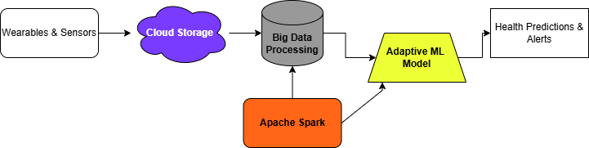

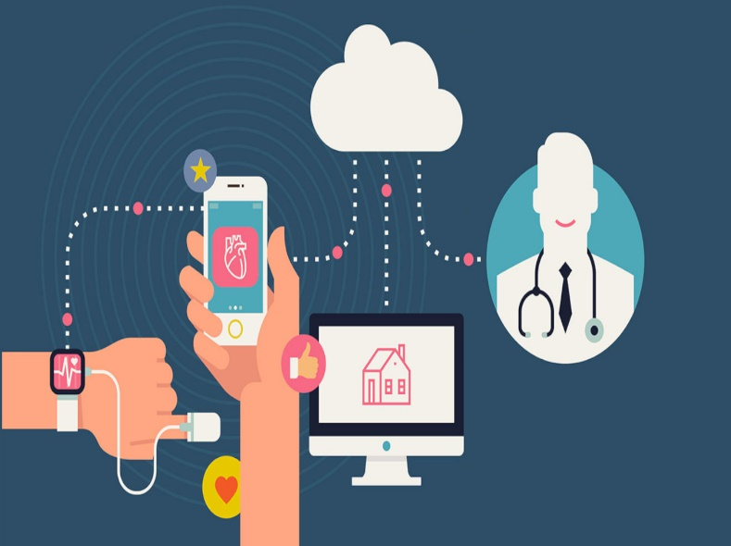

**5 System Implementation & Expected Outcomes**

The proposed system integrates IoT sensors, cloud computing, Big Data processing with Apache Spark, and adaptive machine learning techniques to enhance healthcare monitoring. The implementation consists of the following key components:

* IoT Sensors & Data Collection: Wearable health sensors continuously collect patient data such as heart rate, oxygen saturation, and temperature.
* Cloud Storage: The collected data is securely stored in the cloud, enabling remote access and efficient management.
* Big Data Processing with Apache Spark: Apache Spark processes incoming healthcare data in real time, allowing for faster anomaly detection and decision-making.
* Adaptive Machine Learning: The ML model dynamically learns from new incoming data, refining its predictions and improving accuracy over time.

Expected Outcomes

* Improved Real-Time Health Monitoring: The system ensures continuous tracking of patient health metrics with minimal latency.
* Scalability & Efficient Data Handling: Using Apache Spark enhances the system's ability to process large-scale healthcare data efficiently.
* Accurate Predictive Analytics: Adaptive machine learning enables early detection of health risks and provides personalized recommendations.
* **Seamless Cloud Integration**: Secure cloud storage ensures data accessibility while maintaining patient privacy and security.

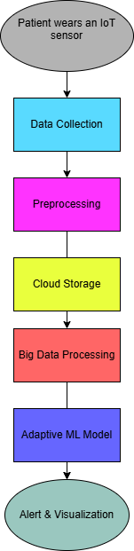

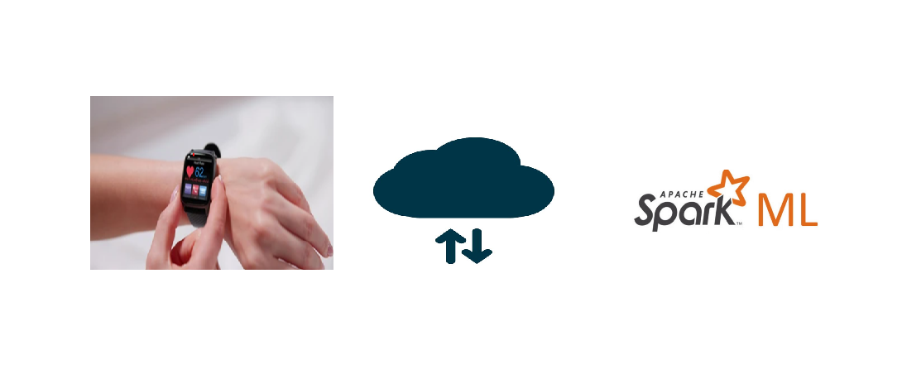

**6 Challenges & Limitations**

* Data Privacy and Security
* Ensuring secure transmission and storage of sensitive patient data is crucial.
* Risk of cyber threats, unauthorized access, and data breaches.
* Real-Time Data Processing Issues
* Handling high-frequency IoT sensor data efficiently in real time.
* High Infrastructure and Maintenance Costs
* Setting up and maintaining cloud storage, IoT devices, and big data infrastructure can be expensive.
* Machine Learning Model Adaptability
* Adaptive ML models need continuous updates to improve prediction accuracy.
* Potential biases in ML models due to incomplete or unbalanced datasets.
* IoT Device Limitations
* Battery life and power consumption constraints in wearable health monitoring devices.
* Possible malfunctions or inaccuracies in sensor readings over time.
* Scalability Issues
* Managing a large number of connected IoT devices efficiently.
* Ensuring the system can handle increasing patient data without performance degradation.

7 Conclusion and Future Scope

The proposed Healthcare Monitoring System successfully integrates IoT, Cloud Computing, Big Data Analytics with Apache Spark, and Adaptive Machine Learning to enhance real-time patient monitoring and predictive healthcare analysis. IoT devices continuously collect patient vitals, which are securely stored in the cloud for real-time access. Big Data processing through Apache Spark ensures efficient handling of large-scale healthcare data, reducing latency and improving decision-making. Adaptive machine learning models further enhance diagnostic accuracy by continuously learning from new patient data.

This system not only improves early disease detection and personalized treatment but also helps in reducing hospital visits and medical costs by enabling remote patient monitoring. The combination of real-time data processing and adaptive learning ensures scalability, efficiency, and robustness in modern healthcare applications.

Although the system demonstrates significant improvements in healthcare monitoring and predictive analytics, several enhancements can be considered in future developments:

* Integration with AI-driven Chatbots: Implementing AI-based virtual assistants for real-time patient guidance and emergency response.
* Enhanced Security Measures: Incorporatingblockchain technology for secure, tamper-proof medical records and improved patient data privacy.
* Multi-Modal Data Fusion: Combining IoT sensor data with medical imaging (X-rays, MRI scans) for comprehensive health analysis.
* Edge Computing for Faster Processing: Deploying ML models on edge devices to reduce cloud dependency and improve real-time decision-making.
* 5G and Smart Wearables: Utilizing high-speed networks and next-gen wearables to enhance the efficiency and accuracy of remote monitoring.
* Government & Healthcare Institution Collaboration: Expanding the system for large-scale implementation in hospitals, clinics, and rural healthcare centres.

By addressing these areas, the system can evolve into a fully automated, AI-driven healthcare solution that enhances early diagnosis, emergency management, and personalized treatments—ultimately improving global healthcare standards.

**REFERENCES**

1. Harshita Bhatia, Surya Narayan Panda, and Dimple Nagpal, “On Internet of Things and its Applications in Healthcare- A Survey,” Phil. Trans. Roy. Soc. London, vol. A247, pp. 529–551, April 1955. *(references)*
2. J. Clerk Maxwell, A Treatise on Electricity and Magnetism, 3rd ed., vol. 2. Oxford: Clarendon, 1892, pp.68–73.
3. I. S. Jacobs and C. P. Bean, “Fine particles, thin films and exchange anisotropy,” in Magnetism, vol. III, G. T. Rado and H. Suhl, Eds. New York: Academic, 1963, pp. 271–350.
4. K. Elissa, “Title of paper if known,” unpublished.
5. R. Nicole, “Title of paper with only first word capitalized,” J. Name Stand. Abbrev., in press.
6. Y. Yorozu, M. Hirano, K. Oka, and Y. Tagawa, “Electron spectroscopy studies on magneto-optical media and plastic substrate interface,” IEEE Transl. J. Magn. Japan, vol. 2, pp. 740–741, August 1987 [Digests 9th Annual Conf. Magnetics Japan, p. 301, 1982].
7. M. Young, The Technical Writer’s Handbook. Mill Valley, CA: University Science, 1989.
8. K. Eves and J. Valasek, “Adaptive control for singularly perturbed systems examples,” Code Ocean, Aug. 2023. [Online]. Available: <https://codeocean.com/capsule/4989235/tree>
9. D. P. Kingma and M. Welling, “Auto-encoding variational Bayes,” 2013, arXiv:1312.6114. [Online]. Available: <https://arxiv.org/abs/1312.6114>
10. S. Liu, “Wi-Fi Energy Detection Testbed (12MTC),” 2023, gitHub repository. [Online]. Available: https://github.com/liustone99/Wi-Fi-Energy-Detection-Testbed-12MTC
11. “Treatment episode data set: discharges (TEDS-D): concatenated, 2006 to 2009.” U.S. Department of Health and Human Services, Substance Abuse and Mental Health Services Administration, Office of Applied Studies, August, 2013, DOI:10.3886/ICPSR30122.v2