**What is Meta-Learning?**

* Traditional deep learning models require large datasets for training.
* Meta-learning enables models to **quickly adapt** to new tasks with minimal training data.
* Example: A model trained with meta-learning on traffic signs can **quickly recognize new road signs** with very few examples.

**Types of Meta-Learning**

* **Metric-Based**
  + Example: **Prototypical Networks, Matching Networks**
  + Uses feature distances to classify new objects.
* **Model-Based**
  + Example: **LSTM-based meta-learner**
  + Learns how to adjust weights quickly.
* **Optimization-Based**
  + Example: **MAML (Model-Agnostic Meta-Learning)**
  + Trains a model that quickly adapts using a few gradient updates.

Important Meta-Learning Papers --- <https://arxiv.org/abs/1703.03400>

Difference and Similarities Between Meta-Learning, Machine Learning, and Deep Learning

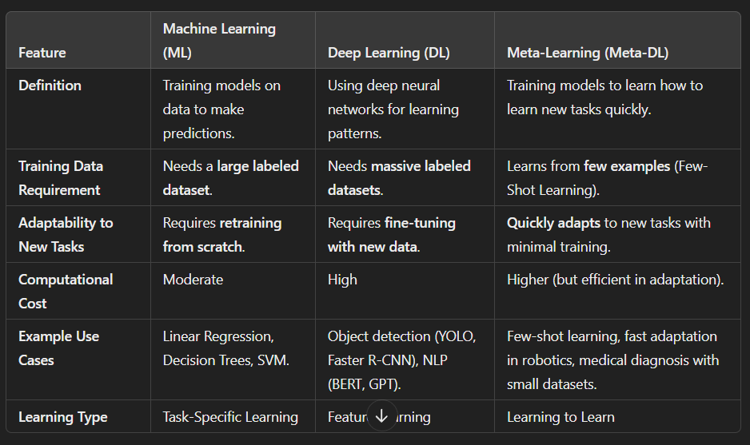

**Key Difference:**

* **ML and DL models specialize in one task** and require **lots of data**.
* **Meta-learning learns across multiple tasks** and can **adapt quickly to new tasks** with minimal data.

**Similarities Between Meta-Learning, Machine Learning, and Deep Learning**

✅ **All three are part of AI**:

* ML is a broad term that includes both DL and Meta-learning.
* DL is a subset of ML that uses deep neural networks.
* Meta-learning builds on **DL techniques** but focuses on fast learning from small data.

✅ **They use optimization techniques**:

* ML: Optimizes models using techniques like **Gradient Descent, Adam, RMSprop**.
* DL: Uses **backpropagation** and deep neural architectures.
* Meta-Learning: Uses **advanced optimization methods** (e.g., MAML trains models to adapt fast with few gradient updates).

✅ **They improve with more data & experience**:

* ML & DL improve by seeing **more data**.
* Meta-learning improves by seeing **more tasks**.

✅ **They require feature extraction & embeddings**:

* ML & DL use feature engineering or CNN embeddings.
* Meta-learning relies on embeddings (e.g., Prototypical Networks).

**Example to Compare ML, DL, and Meta-Learning**

**🛑 Traditional ML/DL Approach: Object Detection in Traffic Analysis**

1. Collect **100,000+ images** of traffic objects.
2. Train a **YOLOv8 model** for object detection.
3. If a **new object appears** (e.g., a **rare road sign**), you must **retrain the model** with more data.

**🚀 Meta-Learning Approach: Few-Shot Learning for Traffic Analysis**

1. Train a meta-learning model (e.g., **MAML or Prototypical Networks**) on **various traffic datasets**.
2. If a **new object appears**, the model **quickly adapts** with **just a few examples**.
3. Instead of retraining the entire model, it **fine-tunes quickly** for the new object.

👉 **Conclusion:**

* Traditional ML/DL requires **large datasets and full retraining**.
* Meta-learning **learns fast** from **small datasets** and is ideal for **real-time adaptation**.