MyNEU

CSYE 7280 – User Experience Design & Testing

PROJECT REPORT

* Vineet Dandekar ([dandekar.v@husky.neu.edu](mailto:dandekar.v@husky.neu.edu))
* Rugved Jahagirdar ([jahagirdar.r@husky.neu.edu](mailto:jahagirdar.r@husky.neu.edu))

**Introduction**

This document is the final report for the project on Redesigning myNEU and its Associated Web Applications. This project is created as part of the curriculum for the User Experience Design & Testing course for the Summer 1 semester of the year 2016. While the previous document (Project Overview) was intended for introducing the project topic, this document will provide a very detailed information about each and every step carried out in designing this User Experience Design project.

We have followed the best practices for designing a user experience project by using the concepts and methods mentioned in the book The Elements of User Experience by Jesse James. As explained in the book, we have designed the project from all the five planes adopting a bottom-up approach i.e., starting with the strategy plane and gradually rising up each planes to scope, structure, skeleton and finally surface. Each component from each plane is well documented in this report with respect to the project.

We have also created wireframes and prototypes for the web application as well as for the mobile devices.

**Problem Definition**

Northeastern University has an internal web portal for its students called myNEU (<http://myneu.neu.edu>). Each and every student who is studying in Northeastern is given myNEU credentials from where s/he can manage a lot of things directly associated with the university. Some of the features provided by myNEU are as follows:

1. Course Registration: Students can look through the course catalog and search for suitable courses to register. They can use the Look Up classes features to search for sections of the courses which are well suited to them. They can Add a new class or Drop an existing class from their schedule.
2. Fees Payment: This portal provides feature which enables the students to pay their tuition and other fees online instead of visiting the financial department for the fee payments.
3. Student Employment: This section of the portal manages the employment details such as new job postings, time sheets for the current jobs, etc. for the students who work on-campus.
4. Blackboard: This is a student learning website which enables student to manage their coursework. Students submit assignments, attempt online quizzes, holds discussions, etc. using this website. Basically, it is a learning management website.
5. Other features include library management, parking, email, tickets, etc.

There are many such features provided by the myNEU portal. But, having said that, it is no way close to being a perfect website in its current form. The myNEU portal does not do good on some aspects from the user experience point of view. Following are some of the issues with the portal:

* Starting with the very first page of myNEU – the Login Page; the page is not very well designed with a lot of space wasted on either sides and have a huge image showing various photos from the university. This does not seem to be a very big issue but when we look at the size of the text fields and the buttons on the page, a lot of us will agree that the page needs a serious makeover.
* The error validations are not handled properly with the user experience point of view. For every error that takes place, the user is taken to a separate error page from where the user has to come back to the login page. This is just one extra click, but it can still become a little frustrating for the users.
* The main website is separated using tabs representing sections and each of these sections have a huge number of links to perform some functions. Even if the links are well segregated on the pages, it becomes very difficult to find some links if you are using the application for the first time.
* Many links open in a new window and this can get messy sometimes if the user accesses a lot of links simultaneously. It becomes very complicated and troublesome to manage so many different windows.
* There is no search functionality on the website and also no way to chat or contact tech-support if the user has issues with their account.
* Also, the above mentioned features like Fess Payment, Student Employment, Blackboard, etc. are available through the myNEU portal, but are different web applications altogether. They are not incorporated inside the myNEU website directly. This makes the maintaining of the websites a tedious job, as multiple applications have to be maintained instead of just one.

Blackboard is another application which we have included in this project and collaborated it inside myNEU application itself. This application currently has a link on myNEU and the Northeastern student can login into Blackboard only with their myNEU credentials. Blackboard is the learning management tool used by Northeastern to enable students and professors to collaborate their work online. As with myNEU, Blackboard also has a lot of user experience issues which are listed below:

* Global Navigation Menu appears too cluttered. Although it’s functionality is unique and it provides a comprehensive view, it also reduces look and feel of the menu bar.
* Statuses for assignments and test do not get updated on the real-time basis. It often happens that a certain assignment is still shown pending even after the user has submitted it. This gets updated once the user logs `in again (creates a fresh session), but such things can be misleading and hence doesn’t go done well with user experience.
* Blackboard has a feature where users can view lectures online. These are recorded classroom lectures which are then uploaded by the professors. Sometimes the picture quality of the videos is not good as the video tends to pixelate. Also, in some cases the buffer rate for the video is very low.
* Contents uploaded by students are only available for the current semester. Once that semester is over, the contents which include assignments, project reports, tests, etc. sometimes become unavailable for the students.
* The information architecture for the website is not efficient enough as there is a lot of redundant data and duplicate links present in lot of pages.

This project aims to fix a lot of the user experience issues pointed out in the above sections and completely redesign the existing myNEU and Blackboard applications. Even if it is stated that the project is about redesigning the existing application, the final product will be a completely new application which will incorporate all the features of myNEU as well as Blackboard and attempt to introduce new conceptual features which are not currently existing in the applications but will certainly enhance the user experience for the product. Along with Blackboard, our project will incorporate various other features like Email, Student Employment, Fees Payments, NUPay, Library Management, etc. In addition to this, we have attempted to design an application for the mobile devices as well.

**Project Team**

We are a team of two – Vineet Dandekar and Rugved Jahagirdar. We both have equal contribution at all levels of developing the project. Instead of separating the work by roles, we distributed the work based on modules. The below chart will explain the work distribution in a better way.

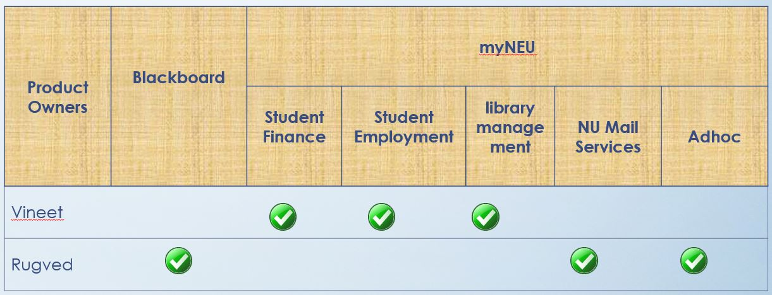

**Product Objectives**

We have stated a list of objectives on behalf of Northeastern University as to what that organization will expect out of this new product and what all factors or reason will they consider for creating a new myNEU application.

1. **Single Platform to manage all the processes related to Northeastern –**

As mentioned above, currently, the myNEU website acts as a portal which provides access to different university related websites. The best example can be Blackboard. It is an individual website which is accessed through myNEU. The Student Financial Services and Library Services are also handled by another website. Similarly, there are many different small websites handling all such small processes. Our goal is to create a website which will integrate all the processes into one application. This will benefit Northeastern with reduced maintenance cost and increased usability for all users associated with Northeastern.

1. **Reduce maintenance cost –**

Maintaining a variety of small websites handling small processes has been a costly and a tedious affair for the university. With this project, we aim to reduce the cost associated with the maintenance of software and hardware in use for the application.

1. **Provide access via multiple devices –**

Currently, there is no mobile application for myNEU which can replicate the existing web application. You can find some applications related to myNEU like NUGO, NU Orientation, Mobile MyNeu, etc. but there is no integrated application which can handle all processes. Our goal is to have the myNEU access on all types of devices.

1. **Optimizing site performance –**

We intend to change some error handling techniques used in MyNEU and its associated applications. We also intend to incorporate some techniques for handling documents and media files.

1. **Brand Identity –**

MyNEU being an internal website is not intended for marketing and increasing brand value of Northeastern. But, by providing a good user experience to its current user, Northeastern can promote its brand to its existing students and employees. This user satisfaction can in turn be converted into increase in new prospective students.

1. **Success Metrics –**

We plan to measure the success rate of our new product by measuring the number of user complaints and the total application downtime in a month. As the graph goes down, we will consider that the product is a success.

**User Needs**

The users for the new MyNEU website ranges from a current student to alumni to professors, employees, etc. There is whole lot variety of users of different roles which will be using the application. But, due to limited time and resources, we have currently considered only the students and professors as the users of the application. We found that instead of demographics or age, it would be better if the users are segmented based on the roles for this product.

As a result, we created three user segments – Full-time Student, Part-time (Online) Student, Professor. We came to a common understanding that these three types of users may need to use the application in a slightly different manner like a full-time student will have more priority on searching and registering for different courses for every semester. Also, he can have multiple roles like a part-time student who will need access to the student employment section. On the other hand, an online student will have want more access to online materials and lectures. A full time student will use the library feature to issue physical books, whereas an online student would want to get access to online material. The way the three different types of users use blackboard will also differ a lot.

In order to get to know what the actual users felt about the current MyNEU application and what they were expecting from the application, we conducted interviews with a lot of current students from different programs and different degree levels. We also conducted an online survey to get to know the feelings of the users about the current application so that we could understand what all changes were needed and what different functionalities should be added, removed or modified. Here’s the link to our survey - <http://goo.gl/forms/cEu7PDY2GUimPWzA2>.

Based on the user research which included interviews and surveys, we created three user personas where each persona represents a user from each segment that we created.

1. **Full-time Student**

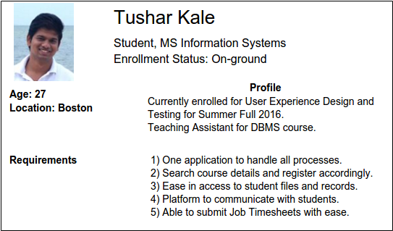

1. **Part-time (Online) Student**

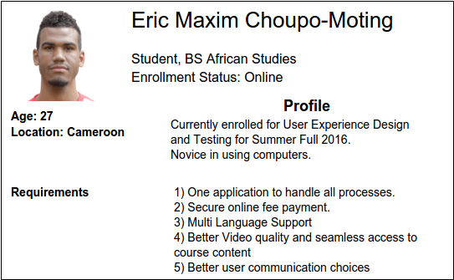

1. **Faculty**

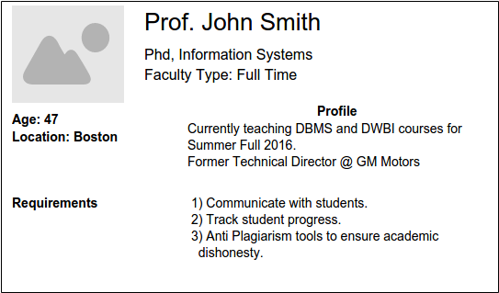

**Functional Specifications**

We studied and analyzed the different users who have been using the existing MyNEU website, conducted several interview sessions with them, conducted several white board sessions among ourselves and finally listed down the functional specifications which need to be incorporated in our product. We have divided these requirements as per different modules, and they are as follows:

1. **Authentication –**

1.1 – The users will be given login credentials by the university in order to authenticate themselves while signing in. The Username will be in the format which it is currently, i.e. lastName.firstNameInitials (dandekar.v) and the Password will be system generated, which the users can change later.

1.2 – In case the users forget their password, they can use the forgot password feature to reset their passwords. Users will enter their username on the Forgot Password page. The system will then send an email to this user on the Northeastern Email ID with the reset password link.

1. **Courses –**

2.1 – The user can view the entire course catalog which will contain all the courses provided by the University according to the different programs

2.2 – For each course where the user is registered for the current semester, he/she can perform following tasks:

2.2.1 – View & submit assignments and course materials

2.2.2 – Attempt a quiz or an online test

2.2.3 – View periodic progress and running grades

2.2.4 – View course materials and online lectures

2.3 – For each course the user has been enrolled throughout the program, he/she can view the registration status for those courses.

1. **Transcripts –**

3.1 – Each user can view his/her final grades for the completed courses.

3.2 – Users can view the unofficial version of their transcripts online. These transcripts will not be in downloadable formats.

3.3 – Users will need to create an online request in order to receive the official versions of their transcripts. These official transcripts can be made available online or as mailed to the users, depending on what user has requested.

3.4 – Once users create requests for official transcripts, they can view the status of their requests.

1. **Registration –**

4.1 – Users can look up for available courses offered in the current semester with all the details about those courses, viz. the day/s and timings, professor teaching the course, the location and pre-requisites.

4.2 – Users can register for a certain course which is offered in the current semester. S/he can also drop the registered course. The penalties for dropping the courses will depend upon the course deadlines set by the different departments.

4.3 – User can request to Apply for Graduation. This feature is a means to notify the university that the student will be graduating in the current or next semester, so that the university takes appropriate measures about it.

1. **Library –**

5.1 – The user can search for and access several online learning materials which is owned by the Northeastern University Library.

5.2 – The user can view the status of the books s/he has rented from the library. The user can also renew his subscription of the rented books.

5.3 – User can reserve rooms in the library. They can search rooms based on the types of rooms or the capacity.5.4 – Users can access Lynda.com from MyNEU directly, which will provide them with unlimited access to all the resources on that website.

1. **Employment –**

6.1 – User can search for job openings within the campus. They can view details about the job and then apply to it.

6.2 – Once the users have applied to the jobs, they can view the status of those jobs.

6.3 – Users can view their current job/s, view salary history and submit timesheets for each job.

1. **Medical –**

7.1 – User can book an appointment with the UHCS to meet a doctor on campus.

7.2 – Users can waive of the health plan which is automatically added to their bills for payment at the start of every semester. If the user opts to waive the health plan, appropriate amount should be deducted from the total balance which is due.

7.3 – Users can browse through various health plans and/or insurance offered and can choose to buy them.

1. **Marketplace –**

8.1 – Northeastern provide various other paid services to the students and staff. Users can buy those additional services. Once bought, users will have an option of adding those services to their bills or can check out immediately using online payments.

8.2 – University also provides a large variety of software which can be downloaded from MyNEU. These softwares can be available for free or at discounted rates. Users can select the appropriate version of the softwares and can download them. They will be billed accordingly.

8.3 - Users can access the Northeastern Online Store and browse and buy products as they do it on other e-commerce websites.

1. **Finance –**

9.1 – Users can view current and previous bills. These bills will include all the details for what the user has been billed for.

9.2 – User can view the balance due and make online payments using credit/debit cards or online banking.

9.3 – Users can view all the payment history9.4 – Users can save their payment methods. Payment methods include bank account details and debit or credit cards.9.5 – Users can check balances and add amount into their Student Husky Card, which can be used throughout the campus to make purchases.

1. **Communications –**

10.1 – Every user who has MyNEU credentials will have an email ID associated with it. Currently, this email ID is setup using the Google Apps Engine and it will continue to stay as it is.

10.2 – User can access their emails using Gmail as well as access it directly inside MyNEU. They can view and send emails from within the website.

10.3 – Users can communicate with other users using the discussion boards.

10.3.1 – Every course for the current semester will have an official discussion board and the students registered to that course will automatically be the members along with the professor and the teaching assistants

10.3.2 – Users can create their own discussion boards where they can add other users.

10.4 – Users can view the announcements which can be made by other users. The announcements displayed to the users will be based on the relevance or user-defined priorities.

1. **User Profile –**

11.1 – User can view and edit following information:

11.1.1 – Personal Details

11.1.2 – Contact Information

11.1.3 – Work Information

11.1.4 – Emergency Contacts

11.2 – Users can change their existing MyNEU Password.

11.3 – Users can set his preferences based on which the dashboards and announcements will be filtered and modified.

11.4 – Users can view any holds if it exists on their account and also a summary of their degree progress.

1. **Events & News –**

12.1 – User can search and view various events organized and/or hosted by the university. He can book tickets for the events which require the user to get a ticket.

12.2 – Users can view various news from the news service hosted by Northeastern. The most recent articles will be flashed on the dashboard in the form of carousals.

1. **Other Services –**

13.1 – Users can search for the available parking spot among many parking lots within the campus, view the cost and then request for a parking space.

13.2 – Users can browse through various meal plans provided by the dining services and then buy a plan.

13.3 – Users can chat with the support team in case of any technical issues with his account. He can also send emails to the customer support team.

**Content Requirements**

MyNEU has a wide variety of different contents inside the website. Some of the content is generated by the system, some resides in the system and some are generated by the users of the website. The type of content ranges from simple texts, e-books, some rich-text documents and flat files to multimedia contents like images, audio and videos. The feature where users can download softwares means a wide variety of executable files also reside in the website. We have set some specifications about these contents in the website.

1. **General –**

1.1 – The website will allow only the audio files with .mp3 extensions to be uploaded to the system and video file with .mp4 extensions.

1.2 – The images will be in the format of jpeg, jpg, gif or png.

1. **Academics –**

2.1 – No specific restriction for the type of files allowed to be uploaded by users in this section apart from the Content Requirement 1.1.

2.2 – All the contents uploaded to the system for a specific course will be archived and will be unable to the users after the end of the semester. Users will have an option to back up their uploaded data to their local system or on cloud.

2.3 – The official transcripts which will be made available to the users will strictly be available in PDF format. The file will remain in the system for 10 business days after the user is notified of the availability.

2.4 – The online lecture recordings will strictly be in mp4 format and will render in 480p resolution to the maximum. The online lectures will be available to the users for viewing until the end of semester.

1. **Services –**

3.1 – The bills will be available to download in PDF format. The downloadable versions of the bills will not reside in the system and will be generated at runtime by the system when the user requests for it.

3.2 – The products or services on sale online in the marketplace will be constantly updated based on the availability.

3.3 – The display images of the products will strictly have the 3:4 aspect ratio

3.4 – Downloadable software should be available for all operating system platforms and in both 32bit and 64bit versions.

1. **Library –**

4.1 – All the available learning material from the library will be only accessible via web and cannot be downloaded by any means.

1. **Communications –**

5.1 – The files which can be transferred through discussion boards will not have format limitations, but a size limitation. Files with maximum 10MB will be allowed to be send.

5.2 – Announcements can make use of images in the form of banners. High definition images with size of more than 1MB will not be allowed to be uploaded.

5.3 – The image uploaded along with an announcement will be archived once the announcement is expired.

1. **Employment –**

6.1 – The resumes to be uploaded by the users for applying to the job will be either in doc/docx or pdf format. No other format of documents will be supported.

6.2 – Users can download the PDF version of their W4 forms. These forms will not reside in the system, but will be generated upon user request.

1. **Events –**

7.1 – High definition images with size of more than 1MB will not be allowed to be uploaded.

7.2 – Downloadable tickets will always be in PDF will and will be system generated at runtime.

7.3 – The news banner will strictly adhere to the 4:3 aspect ratio.

1. **Profile –**

8.1 – The display picture set by the user should have a 4:3 aspect ratio.

8.2 – If the user changes the display picture, the system will not maintain the previous versions.

**Conceptual Models**

The redesigned MyNEU website has multiple conceptual models incorporated in the entire system. Several different modules of the website represent a single conceptual model. We will start from the website as a whole.

The MyNEU website represents the Northeastern University as a whole. This website at the very top level follows the concept of the University. Each module than represent a certain physical aspect inside a university. The course registration and transcript section conceptually represents the Registrar’s Office of a University and the individual course section represents a classroom. The library section represents the university library. The financial services represent the financial department, the marketplace represents the shopping cart and the employment section represents the student employment office of the university.

**Error Handling**

Error handling is always the most important aspect in any website. Especially, when the website is about the university processes where a lot of important and significant events take place, error handling especially becomes the most important part of the website design.

In our website, we have taken a lot of care so that errors caused due to user inputs do not happen at all. All user forms on the website will be validated using both client as well as server side validation. Users will be prompted of errors immediately on the current page only and the error messages will provide clues for the users to correct their errors. Below is the sample example of validations on the login page.

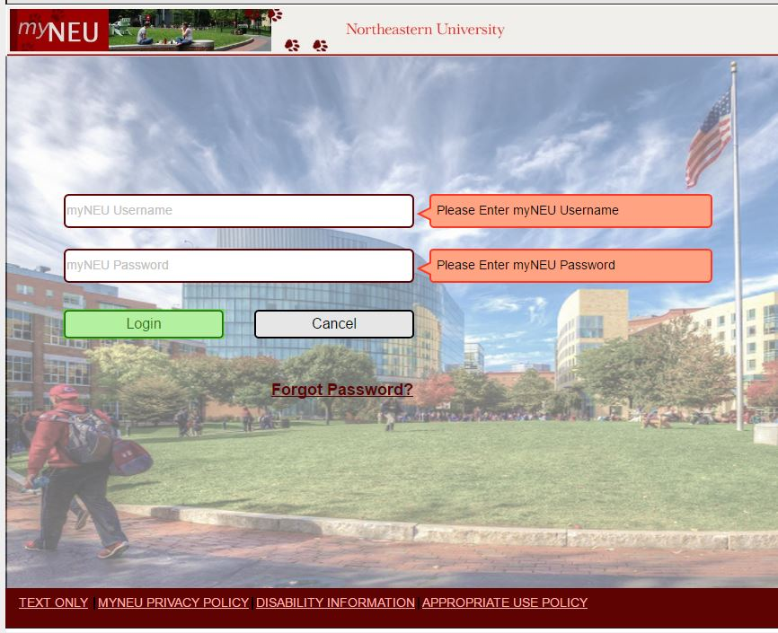

Please note that the above image of the login page is just a wireframe and the actual implementation might look different than this.

**Information Architecture**

The information architecture

**Wireframes**

We have spent a lot of time on creating the wireframes as our main focus was to re-design the existing appearance of MyNEU website. We used the Moqup online tool for creating these wireframes and they can be accessed through <https://app.moqups.com/vineet_ld/slPyteNh/view>. A PDF version of the wireframes is also included in the documents folder by the name Wireframes.pdf.

**Style Guides & Design Specifications**

1. **Branding –**

**logo-ver-2**

We are using these 2 logos throughout our website. The name itself speaks for the brand which is Northeastern University. Red color is used to maintain original theme.

1. **Colors –**

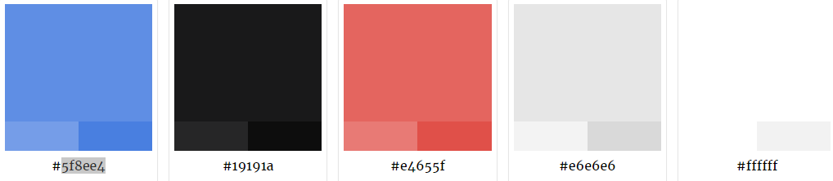

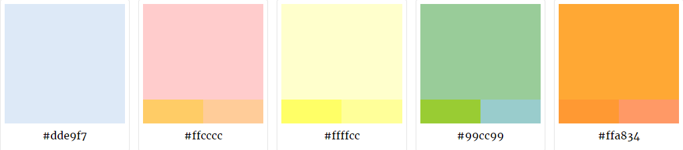

Color Palettes used in the website. Warm colors have been used to depict alerts/important announcements.

1. **Typography –**

|  |
| --- |
| HEADER – Font Arial, Sans-Serif Size 32  SUB-HEADINGS – Font Arial, Sans-Serif Size 26  General Text – Font Arial, Size 16 |

Font type and size specifications implemented in our website.

1. **Buttons –**

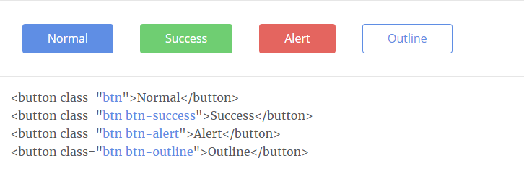

These are few of the buttons (Bootstrap based) used throughout the site.

1. **Icons –**

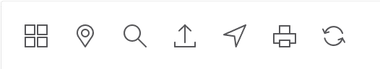

These are few of the icons used throughout the site. Size has been maintained to 35 x 35 px for control based display such as download button etc.

These are few of the icons used throughout the site. Size has been maintained to 24 x 24 px for integrating within table cells/Form Fields.

1. **Form Elements –**

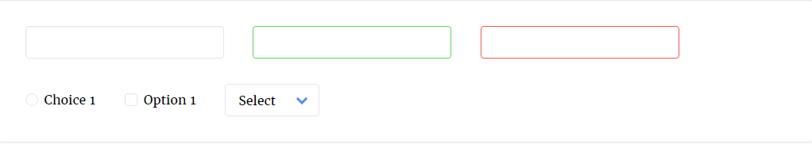

These are the form elements used in our website.

**Prototypes**

**User Research Methods**

There are so many different user research methods used in the industry today. More the research techniques we use in the project, more will be the success rate of the product. Having said that, it is practical impossible and not even feasible to use all of the user research methods. Instead, three or four methods can be implemented properly which can substantial make a difference and make the website successful. For the development of this project we made use of the four user research method.

1. **Interviews –**

Interviews were a very important part of our user research. We conducted interviews with the current Northeastern students who were the regular users of the MyNEU website. We asked each of them several questions regarding their experience of using the current MyNEU and Blackboard websites.

The replies we received from each of the interviewee was very helpful in designing the overall structure of the website. The interviews gave us an insight on what the current users like about the existing application and what are the features which they dislike. We also got to know what the users were expecting out of the new application and what was their view on our product idea.

We used this method at the very beginning when we were forming a strategy for building the project. The interviews helped us to formulate a plan and also list down the requirements.

1. **Surveys –**

Interviews helped us gain the qualitative information required for designing the website. In addition to that, we also needed quantitative research to study the specifics to be included in the website. We wanted to know very specifically what the majority of the user’s preferences were and given two or three options, which option was selected by the majority.

For this purpose, we created a survey using Google Forms and sent it to a large number of current students to record their views and preferences. The result of this survey helped us to prioritize things and come up with the functional requirements which were preferable to the users of MyNEU website.

Again, as with Interviews, we conducted surveys at the strategic phase. Interview and surveys together helped us to get the qualitative as well as quantitative data which was essential to us and which played a very important role in giving shape to the design of our website.

Following are some of the results of the survey which we conducted

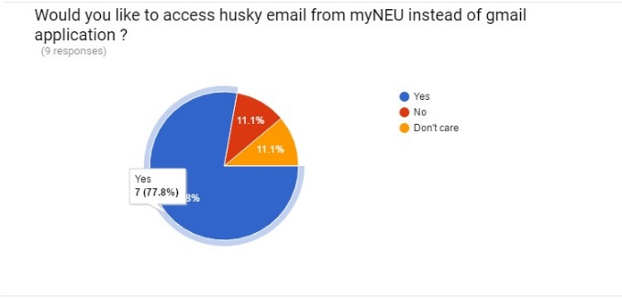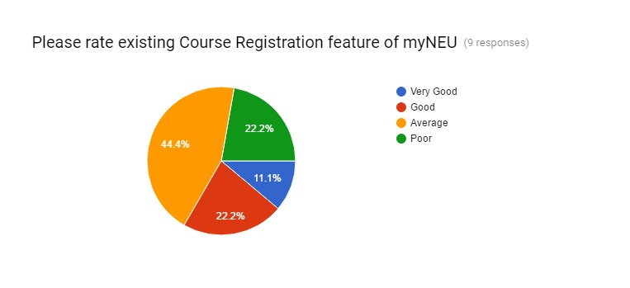

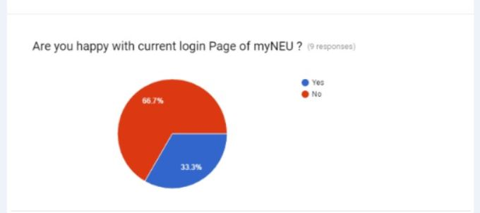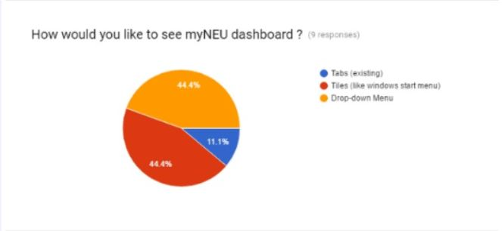

1. **Card Sorting –**

Based on the listed functional requirements, we conducted white board sessions and card sorting technique among ourselves to come up with an Information Architecture which we felt was constructed on the basis of user research. We wanted to validate that the architecture which we created was actually as per user needs. This led us to use the Closed Card Sorting technique.

We used the online card sorting tool provided by OptimalWorkshop to conduct this survey. We created the same cards as we had created when we conducted card sorting among ourselves. We distributed this survey among a lot of current MyNEU students and the result what we got from this survey is on the next page. Basically, we were able to validate our architecture to the user’s card sorting responses and we observed that most of the users’ idea about the placement of cards were similar to our placement of cards.

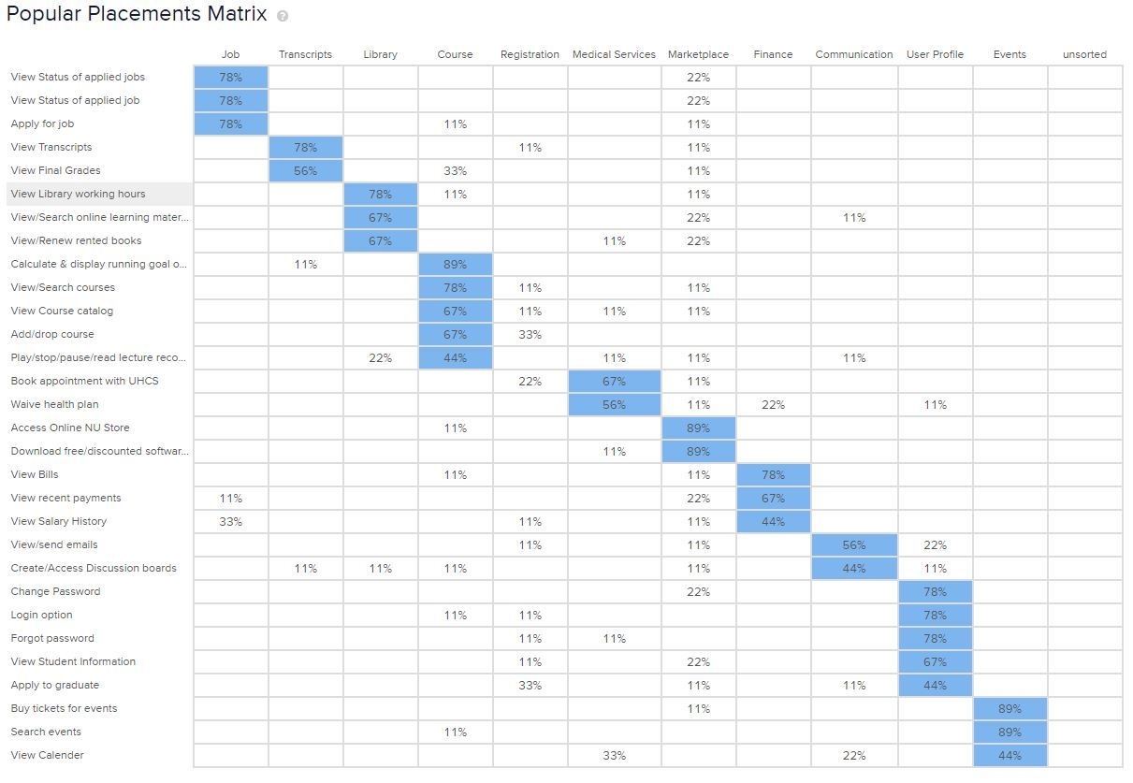

1. **A/B Testing –**

This was the final user research we used to get insights about user preferences. After developing a prototype for the project, our thoughts were conflicting on the existing design of the dashboard. I had designed the original version and Rugved had a different design in mind. Hence, we decided to go with A/B Testing in order to determine which design will be more accepted by the users.

We created two erions of the dashboard page, version 1 which was the original one created by me and version 2 which was created by Rugved. We showed version 1 to five users and the version 2 to other five users. After observing the way users used both the versions, we concluded that the version 1 was more efficient with respect to usability than version 2.

**Usability Testing**