**Docker building Steps:**

Install Docker tool box from:

<https://docs.docker.com/toolbox/toolbox_install_windows/>

2- Run installer and make sure to install **Git** If you don’t have yet and **oracle VM** post docker toolbox installation complete.

3- Check for Kitematic (Alpha) and Docker in start panel and oracle VM virtualBOX.

4- Run Docker Quickstart Terminal. If you already have Git than **browse the path to Git/bin/bash file**.

5- Once Docker window runs, it looks like: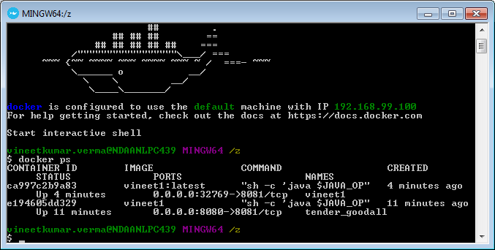

6- check docker status whether it is correctly installed or not with:  **docker –version**

7- **docker ps** to know the docker Image container running.

8- BUILD image steps:

* Check environment variables to set path for docker toolbox, system variable as well.

**C:\Program Files\Docker Toolbox;**

* Write docker file as  inside project or template folder.

**RUN BELOW COMMANDS:**

* Docker build –t <IMAGE-NAME>
* e.g. **$ docker build -t vineet3 C:/Users/vineetkumar.verma/Desktop/work/gitCodebase/svc-notification-email/**
* 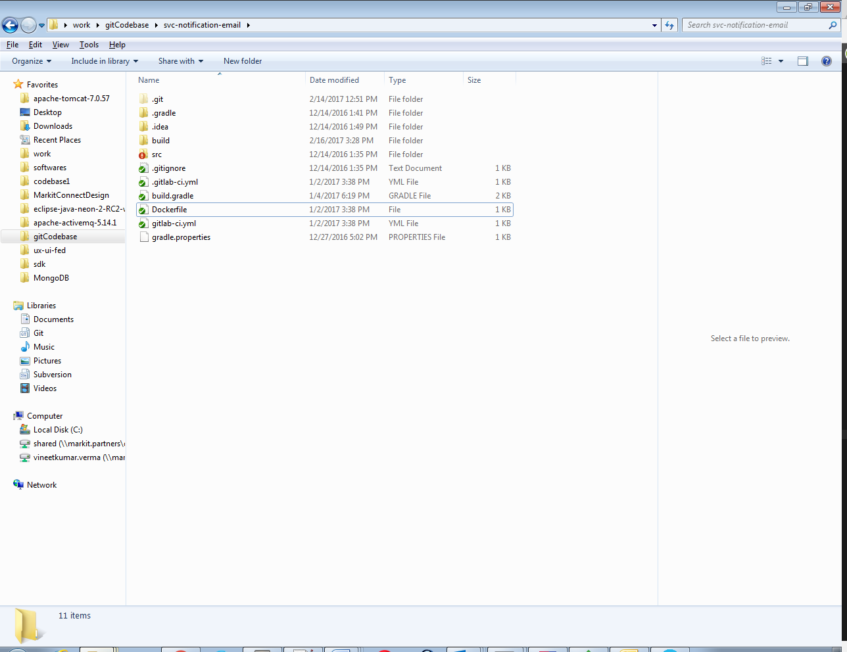
* 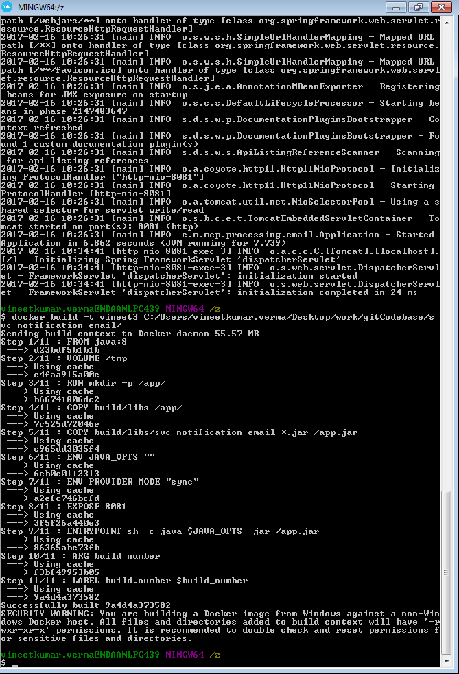
* Check for images with command- $ **docker images**
* 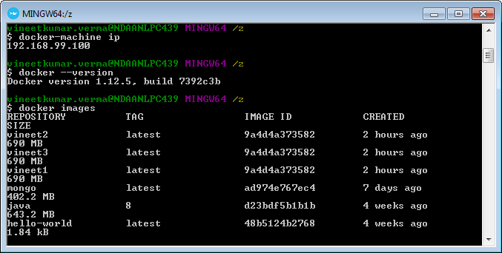
* If image is Listed as above then run command as

**docker run -p 8080:8081 <IMAGE-NAME>** *Here 8081 is port for micro service exposing it as 8080.*

* Wohooooo docker image container is running you can access your api.

Check IP with

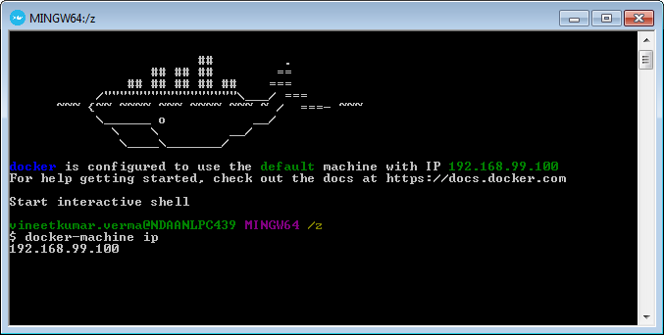

<http://192.168.99.100:8080/mail(API> PATH)

If run by kitematic check with

<http://192.168.99.100:32769/mail>

* open **kitematic** and have view in **My Images**.



