

**About GitHub CLI**

GitHub CLI is an open-source tool for using GitHub from your computer's command line.

GitHub CLI can simplify the process of adding an existing project to GitHub using the command line.

GitHub CLI is a command-line tool that brings pull requests, issues, GitHub Actions, and other GitHub features to your terminal, so you can do all your work in one place.

[**About GitHub CLI**](https://docs.github.com/en/github-cli/github-cli/about-github-cli#about-github-cli)

GitHub CLI is an open-source tool for using GitHub from your computer's command line. When you're working from the command line, you can use the GitHub CLI to save time and avoid switching context.

GitHub CLI includes GitHub features such as:

* View, create, clone, and fork repositories
* Create, close, edit, and view issues and pull requests
* Review, diff, and merge pull requests
* Run, view, and list workflows
* Create, list, view, and delete releases
* Create, edit, list, view, and delete gists
* List, create, delete, and connect to a codespace

For more information about what you can do with GitHub CLI, see the [GitHub CLI manual](https://cli.github.com/manual).

[**Installing GitHub CLI**](https://docs.github.com/en/github-cli/github-cli/about-github-cli#installing-github-cli)

For installation instructions for GitHub CLI, see the [GitHub CLI repository](https://github.com/cli/cli#installation).

[**Sharing feedback**](https://docs.github.com/en/github-cli/github-cli/about-github-cli#sharing-feedback)

If you have feedback or feature requests, you can open an issue in the [cli/cli repository](https://github.com/cli/cli).

**gh** is GitHub on the command line. It brings pull requests, issues, and other GitHub concepts to the terminal next to where you are already working with git and your code.

[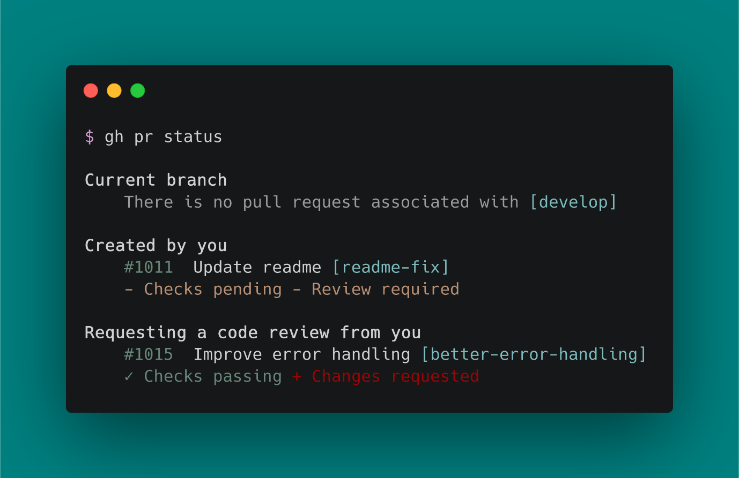](https://user-images.githubusercontent.com/98482/84171218-327e7a80-aa40-11ea-8cd1-5177fc2d0e72.png)

GitHub CLI is available for repositories hosted on GitHub.com and GitHub Enterprise Server 2.20+, and to install on macOS, Windows, and Linux.

**Git Add**

The git add command adds new or changed files in your working directory to the Git staging area.

git add is an important command - without it, no git commit would ever do anything. Sometimes, git add can have a reputation for being an unnecessary step in development. But in reality, git add is an important and powerful tool. git add allows you to shape history without changing how you work.

**When do you use git add?**

git add README.md

As you're working, you change and save a file, or multiple files. Then, before you commit, you must git add. This step allows you to choose what you are going to commit. Commits should be logical, atomic units of change - but not everyone works that way. Maybe you are making changes to files that *aren't* logical or atomic units of change. git add allows you to systematically shape your commits and your history anyway.

**What Does Git Add Do?**

git add [filename] selects that file, and moves it to the staging area, marking it for inclusion in the next commit. You can select all files, a directory, specific files, or even specific parts of a file for staging and commit.

This means if you git add a deleted file the *deletion* is staged for commit. The language of "add" when you're actually "deleting" can be confusing. If you think or use git stage in place of git add, the reality of what is happening may be more clear.

git add and git commit go together hand in hand. They don't work when they aren't used together. And, they both work best when used thinking of their joint functionality.

**How to Use git add**

**Common usages and options for git add**

* git add <path>: Stage a specific directory or file
* git add .: Stage all files (that are not listed in the .gitignore) in the entire repository
* git add -p: Interactively stage hunks of changes

You can see all of the many options with git add in [git-scm's documentation](https://git-scm.com/docs/git-add).

**Examples of git add**

git add usually fits into the workflow in the following steps:

1. Create a branch: git branch update-readme
2. Checkout to that branch: git checkout update-readme
3. Change a file or files
4. Save the file or files
5. Add the files or segments of code that should be included in the next commit: git add README.md
6. Commit the changes: git commit -m "update the README to include links to contributing guide"
7. Push the changes to the remote branch: git push -u origin update-readme

But, git add could also be used like:

1. Create a branch: git branch update-readme
2. Checkout to that branch: git checkout update-readme
3. Change a file or files
4. Save the file or files
5. Add only one file, or one part of the changed file: git add README.md
6. Commit the first set of changes: git commit -m "update the README to include links to contributing guide"
7. Add another file, or another part of the changed file: git add CONTRIBUTING.md
8. Commit the second set of changes: git commit -m "create the contributing guide"
9. (Repeat as necessary)
10. Push the changes to the remote branch: git push -u origin update-readme

**git add All Files**

Staging all available files is a popular, though risky, operation. This can save time, but the risks are two-fold:

**Poorly thought out history**

By staging all available changes, the clarity of your history will likely suffer. Being able to shape your history is one of the greatest advantages of using Git. If your commits are too large, contain unrelated changes, or are unclearly described in the commit message, you will lose the benefits of viewing and changing history.

**Accidentally staging and committing files**

By using an option to add all files at once, you may accidentally stage and commit a file. Most common flags don't add files tracked in the .gitignore file. But, any file not listed in the .gitignore file will be staged and committed. This applies to large binary files, and files containing sensitive information like passwords or authentication tokens.

**Deciding to stage all files**

If the time is right to stage all files, there are several commands that you can choose from. As always, it's very important to know what you are staging and committing.

* git add -A: stages all files, including new, modified, and deleted files, including files in the current directory *and* in higher directories that still belong to the same git repository
* git add .: adds the entire directory recursively, including files whose names begin with a dot
* git add -u: stages modified and deleted files only, NOT new files

|  | **New files** | **Modified files** | **Deleted files** | **Files with names beginning with a dot** | **Current directory** | **Higher directories** |
| --- | --- | --- | --- | --- | --- | --- |
| git add -A | Yes | Yes | Yes | Yes | Yes | Yes |
| git add . | Yes | Yes | Yes | Yes | Yes | No |
| git add -u | No | Yes | Yes | Yes | Yes | Yes |

**git add A Folder or Specific File**

The safest and clearest way to use git add is by designating the specific file or directory to be staged. The syntax for this could look like:

git add directory/: Stage all changes to all files within a directory titled directory  
git add README.md: Stage all changes within the README.md file

**Undo Added Files**

Before undoing a git add, you should first be sure that you won't lose any work. There's no way to "revert" an add in the same way you can revert a commit, but you can move the files out of the staging area.

For example, if you have a staged file, and then you make more changes to that file in your working directory. Now, the versions in your working directory and your staging area are different. If you take action to remove the changed version of the file from the staging area, the changes that were in your working directory *but not* staged will be overwritten.

To avoid this, first stage all changes, then unstage them together, or commit the changes and reset back before the commit happened.

**Using git reset to undo git add**

git reset is a flexible and powerful command. One of its many use cases is to move changes *out* of the staging area. To do this, use the "mixed" level of reset, which is the default.

To move staged changes from the staging area to the working directory without affecting committed history, first make sure that you don't have any additional changes to the files in question as mentioned above. Then, type git reset HEAD (aka git reset --mixed HEAD).

**Related Terms**

* git status: Always a good idea, this command shows you what branch you're on, what files are in the working or staging directory, and any other important information.
* git checkout [branch-name]: Switches to the specified branch and updates the working directory.
* git commit -m "descriptive message": Records file snapshots permanently in version history.
* git push: Uploads all local branch commits to the remote.

**COMMONLY USED GIT COMMANDS IN IT COMPANY :**

Install the GitHub cli winget

**winget install --id GitHub.cli**

Check the version

**git –version**

Login & Authentication

**gh auth login**

Show status of relevant pull requests

**gh pr status**

Clone the Repository

**gh repo clone anandjha90/End-To-End-Data-Analytics-Project**

Add the files or segments of code that should be included in the next commit:

**git add "filename"**

Commit the first set of changes:

***git commit -m "updating files"***

Push the changes to the remote branch:

***git push origin main***

***git push -u origin update-readme***

**GIT CLI OUTPUT :**

