**How to run The Solution:**

# 1. Adding connection string for ThinkBridge

Install Visual Studio 2019, Open the Solution

Go to properties of ThinkBridge.Service project > Debug section.

Under environment variables, click on Add button.

Add **Name** as ‘**DB_CONNECTION_STRING**’ and **Value** as ‘**data source=localhost; initial catalog = thinkbridge; persist security info = True; Integrated Security = SSPI;**’

2. Run the DB Scripts:

Open Sql Server Studio, Login With Windows Authentication.

Open the File DBScripts.Sql, Then Press F5

3. Now open the ThinkBridge Solution,

In Visual Studio, Right Click on Solution > Choose Properies> Under Startup Project > Select Multiple Startup Projects> Select ThinkBridge.Client and ThinkBridge.Service with Action Start

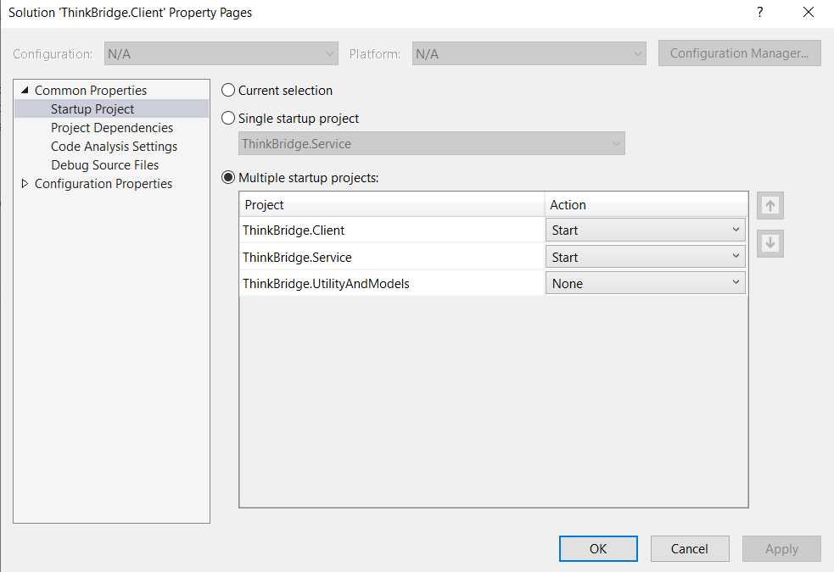

4. Now Run the Solution, Click on Home Button, you will See Add and List Page