Output

1) mean, median and standard deviation of cost of premium economy tickets

aggregate(PricePremium, by = list(int = IsInternational), mean)

int x

1 Domestic 385.900

2 International 1984.909

aggregate(PricePremium, by = list(int = IsInternational), median)

int x

1 Domestic 371

2 International 2084

summary(PricePremium)

Min. 1st Qu. Median Mean 3rd Qu. Max.

86.0 528.8 1737.0 1845.0 2989.0 7414.0

2)mean cost of premium economy tickets by month

month air int x

1 Aug Delta Domestic 352.5000

2 Jul Delta Domestic 517.7000

3 Oct Delta Domestic 334.2727

4 Sep Delta Domestic 339.6667

5 Aug AirFrance International 3052.9500

6 Jul AirFrance International 3114.5833

7 Oct AirFrance International 3056.1000

8 Sep AirFrance International 3057.7273

9 Aug British International 1967.8077

10 Jul British International 2079.6875

11 Oct British International 1887.7547

12 Sep British International 1913.4815

13 Aug Delta International 2676.5000

14 Oct Delta International 2676.5000

15 Sep Delta International 2676.5000

16 Aug Jet International 493.1250

17 Jul Jet International 496.3333

18 Oct Jet International 457.3333

19 Sep Jet International 486.0000

20 Aug Singapore International 1265.4545

21 Jul Singapore International 1146.8750

22 Oct Singapore International 1280.1000

23 Sep Singapore International 1245.5455

24 Aug Virgin International 2722.5000

25 Jul Virgin International 2736.4286

26 Oct Virgin International 2707.1875

27 Sep Virgin International 2722.5000

3) mean travel time

7.577838

4)Plot flight distance and cost of premium economy tickets

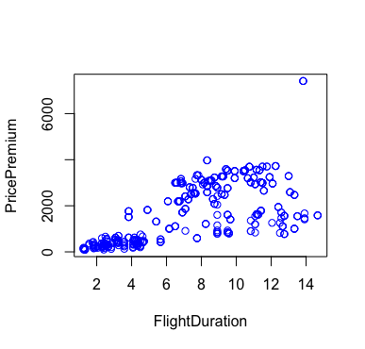

5) Plot to see cost of premium tickets based on number of premium economy seats

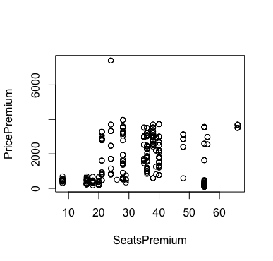

6) boxplots

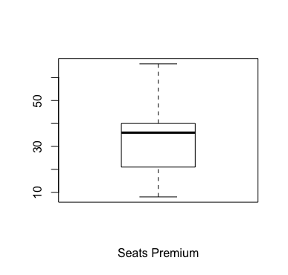

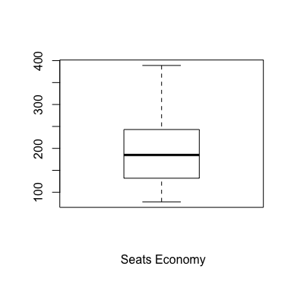

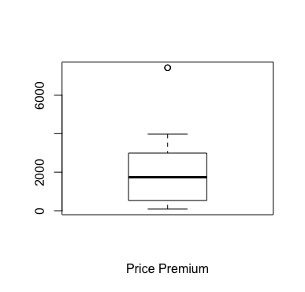



6) Regression

Call:

lm(formula = PricePremium ~ FlightDuration + PriceEconomy + PriceRelative +

PitchDifference + PercentPremiumSeats + Airline)

Residuals:

Min 1Q Median 3Q Max

-796.76 -123.91 -23.55 101.01 1940.72

Coefficients:

Estimate Std. Error t value Pr(>|t|)

(Intercept) -594.43087 135.11498 -4.399 1.36e-05 \*\*\*

FlightDuration -5.52665 6.00351 -0.921 0.357771

PriceEconomy 1.42049 0.02709 52.435 < 2e-16 \*\*\*

PriceRelative 1006.54726 40.16640 25.059 < 2e-16 \*\*\*

PitchDifference -60.74151 19.87828 -3.056 0.002380 \*\*

PercentPremiumSeats -5.76012 3.51679 -1.638 0.102148

AirlineBritish 824.75653 64.08425 12.870 < 2e-16 \*\*\*

AirlineDelta 644.39457 87.69769 7.348 9.64e-13 \*\*\*

AirlineJet 400.71342 105.73044 3.790 0.000171 \*\*\*

AirlineSingapore 569.67771 77.41616 7.359 8.98e-13 \*\*\*

AirlineVirgin 839.76331 65.75999 12.770 < 2e-16 \*\*\*

---

Signif. codes: 0 '\*\*\*' 0.001 '\*\*' 0.01 '\*' 0.05 '.' 0.1 ' ' 1

Residual standard error: 282.8 on 447 degrees of freedom

Multiple R-squared: 0.9529, Adjusted R-squared: 0.9518

F-statistic: 903.7 on 10 and 447 DF, p-value: < 2.2e-16

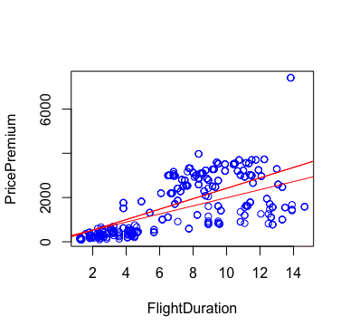

7) Corrogram

