Table of Contents
​ Feature Store 1
​ Feature Store Setup 1
​ Feature Store Configurations – feature_store.yaml 2
​ Feature Store Configurations - feature_definitions.py 3

Feature Store
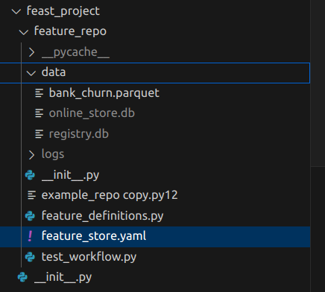

Feature Store Setup
# Step 1: Install Feast, make sure you have activated virtual environment.
pip install feast
# Step 2: Create a feature repository
/home/ksl/code/CustomerChurn-master
feast init feast_project
cd feast_project/feature_repo
# Add code line to save data frame in parquet file
feature_engineering.py: line no 82
df.to_parquet("feast_project/feature_repo/data/bank_churn.parquet", engine="pyarrow", index=False)
# Step 3: Run sample workflow
# Inspecting the raw data using /home/ksl/code/CustomerChurn-master/CustomerChurn/src/07_feature_store/feast_test.py
# Step 4: Register feature definitions and deploy your feature store
create feature defination file as feature_definations.py
# cd /home/ksl/code/CustomerChurn-master/feast_project/feature_repo
feast apply

# Step 5: Generating training data or powering batch scoring models
/home/ksl/code/CustomerChurn-master/CustomerChurn/src/07_feature_store/generating_training_data.py

# Step 6: Ingest batch features into your online store

# Step 7: Fetching feature vectors for inference

# Step 8: Using a feature service to fetch online features instead.

# Step 9: Browse your features with the Web UI
feast ui

# Check features
http://0.0.0.0:8888

Feature Store Configurations – feature_store.yaml
project: feast_project
# By default, the registry is a file (but can be turned into a more scalable SQL-backed registry)
registry: data/registry.db
# The provider primarily specifies default offline / online stores & storing the registry in a given cloud
provider: local
online_store:
type: sqlite
path: data/online_store.db
entity_key_serialization_version: 2
# By default, no_auth for authentication and authorization, other possible values kubernetes and oidc. Refer the documentation for more details.
auth:
type: no_auth

Feature Store Configurations - feature_definitions.py

# This is an feature definition file for Bank Customer Churn

from datetime import timedelta

import pandas as pd

from feast import (
Entity,
Feature,
FeatureService,
FeatureView,
Field,
FileSource,
Project,
PushSource,
RequestSource,
ValueType,
)
from feast.feature_logging import LoggingConfig
from feast.infra.offline_stores.file_source import FileLoggingDestination
from feast.on_demand_feature_view import on_demand_feature_view
from feast.types import Float32, Float64, Int64,Bool

# 01 - Define a project for the feature repo
project = Project(name="feast_project", description="A project for Bank Customer Churn")

# 02 - Define the data source
customer_data_source = FileSource(
path="data/bank_churn.parquet", # Update with actual path
event_timestamp_column="event_timestamp",

)

# 03 - Define the entity
customer = Entity(name="Customer_ID", value_type=ValueType.FLOAT, description="Customer unique identifier")

# 04 - Define the feature view
customer_feature_view = FeatureView(
name="customer_features",
entities=[customer], # Ensure this references the Entity object
ttl=None,
schema=[
Field(name="credit_score", dtype=Float32),
Field(name="Age", dtype=Float32),
Field(name="Tenure", dtype=Float32),
Field(name="Balance", dtype=Float32),
Field(name="Num_Products", dtype=Float32),
Field(name="Has_Credit_Card", dtype=Float32),
Field(name="Is_Active", dtype=Float32),
Field(name="Salary", dtype=Float32),
Field(name="Churn", dtype=Int64),
Field(name="country_Germany", dtype=Bool),
Field(name="country_Spain", dtype=Bool),
Field(name="gender_Male", dtype=Bool),
Field(name="Customer_Tenure_Years", dtype=Float32),
Field(name="Activity_Frequency", dtype=Float32),
Field(name="Avg_Balance_per_Product", dtype=Float32),
Field(name="Credit_Card_Utilization", dtype=Float32),
Field(name="Salary_Normalized", dtype=Float32),
Field(name="Spending_Power_Index", dtype=Float32),
Field(name="High_Value_Customer", dtype=Int64),
],
online=True,
source=customer_data_source,
)

