Table of Contents
​ Storing data to parquet file 1
​ Retrival feature from Parquet file 2
​ Feature Retrival – generating_training_data.py 3

Storing data to parquet file

# Adding event_timestamp column in data framework for feature store
df["event_timestamp"] = [datetime.now() - timedelta(days=i) for i in range(len(df))]
df["event_timestamp"] = pd.to_datetime(df["event_timestamp"], utc=True)
# Ensure correct column order
df = df[["event_timestamp"] + [col for col in df.columns if col != "event_timestamp"]]
# Display DataFrame
print(df)
# df.to_parquet("feast_project/feature_repo/data/bank_churn.parquet", engine="pyarrow", index=False)
df.to_parquet("/home/ksl/code/CustomerChurn-master/feast_project/feature_repo/data/bank_churn.parquet", engine="pyarrow", index=False)

Retrival feature from Parquet file
feast_parquet_file_content_show.py
import pandas as pd
fs_df=pd.read_parquet("feast_project/feature_repo/data/bank_churn.parquet")
#fs_df=pd.read_parquet("/home/ksl/code/CustomerChurn-master/feast_project/feature_repo/data/driver_stats.parquet")
print(fs_df)
print(fs_df.info)

Output:
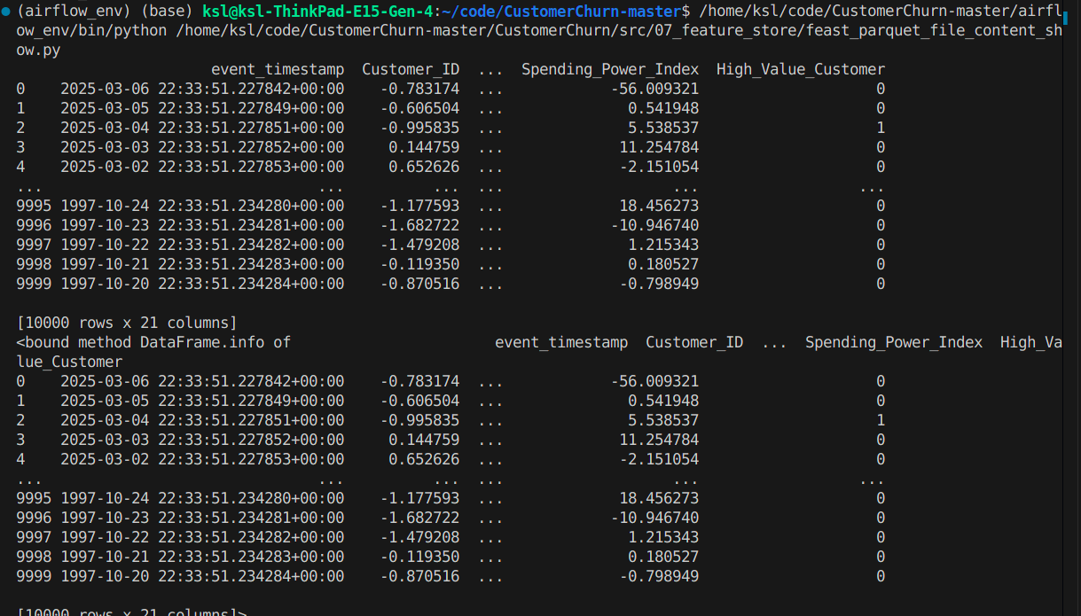

Feature Retrival – generating_training_data.py
from feast import FeatureStore
import pandas as pd

# Initialize the feature store
# store = FeatureStore(repo_path="feast_project/feature_repo") # Update with actual path
store = FeatureStore(repo_path="/home/ksl/code/CustomerChurn-master/feast_project/feature_repo")

# Define the feature references (feature view name and feature names)
feature_refs = [
"customer_features:credit_score",
"customer_features:Age",
"customer_features:Tenure",
"customer_features:Balance",
"customer_features:Num_Products",
"customer_features:Has_Credit_Card",
"customer_features:Is_Active",
"customer_features:Salary",
"customer_features:Churn",
"customer_features:country_Germany",
"customer_features:country_Spain",
"customer_features:gender_Male",
"customer_features:Customer_Tenure_Years",
"customer_features:Activity_Frequency",
"customer_features:Avg_Balance_per_Product",
"customer_features:Credit_Card_Utilization",
"customer_features:Salary_Normalized",
"customer_features:Spending_Power_Index",
"customer_features:High_Value_Customer",
]

# Load entity dataframe with customer_id and event_timestamp
df_entities = pd.DataFrame({
"Customer_ID": [1001, 1002, 1003] # Replace with actual customer IDs
,"event_timestamp": pd.to_datetime(["2024-01-01", "2024-01-02", "2024-01-03"]), # Replace with actual timestamps
})

# Fetch historical features
df_training = store.get_historical_features(
entity_df=df_entities,
features=feature_refs
).to_df()

print("----- Feature schema -----\n")
print(df_training.info())

print()
print("----- Example features -----\n")
print(df_training.head())
Output:
