Week 3 Task

Advanced Data Analysis and Visualization in Logistics
What 6,000 Shipments Can Tell Us About Cost, Delays and Bottlenecks

Prepared by: [VINEET KUMAR]
Program: Yuva Intern | Date: [06-11-26]

1. Introduction
In Week 1 I planned a data-driven approach to last-mile delivery, and in Week 2 I cleaned and prepared the data. This week is where the data starts to speak. Using Python, I explored a hypothetical logistics dataset, calculated summary statistics, looked for relationships between variables, and turned the findings into seven charts.
The aim is not only to make charts, but to answer practical questions a logistics manager would ask. What drives our transport cost? Where and when do deliveries run late? Which hubs, carriers or transport modes are causing problems? And what should we do about it? Every chart in this report is linked to one of these questions.

2. Data Simulation
I built a hypothetical dataset of 6,000 shipments across one year (January to December 2025), handled by three hubs and three carriers, and moved by road, rail or air. The structure is based on typical logistics data such as the public Olist e-commerce delivery dataset. The data is already clean, as in Week 2, so this report focuses on analysis.
Variable | Type | Description
ship_date | Date | Day the shipment was dispatched
hub | Category | Dispatch hub: Hub A, Hub B or Hub C
carrier | Category | FastShip, QuickMove or CityCourier
mode | Category | Transport mode: Road, Rail or Air
distance_km | Numeric | Distance travelled
weight_kg, volume_units | Numeric | Shipment weight and shipment volume
transport_cost | Numeric | Total cost of transporting the shipment
delivery_days | Numeric | Days from dispatch to delivery
promised_days | Numeric | Delivery time promised to the customer
delayed | Binary | 1 if delivery_days is greater than promised_days

Two derived columns were added: cost_per_km (transport cost divided by distance) and month/weekday from the shipment date. The data was generated with realistic relationships, such as air being more expensive per kilometre and peak-season congestion, so that there are real patterns to find.

3. Methodology and Tools
The analysis follows a simple, repeatable process:
- Describe each variable with central tendency (mean, median) and spread (standard deviation, quartiles).
- Check the shape of each distribution using skewness and histograms.
- Measure relationships between numeric variables with a correlation matrix.
- Compare groups (modes, hubs, carriers, months) using grouped averages and delay rates.
- Choose a chart type that matches each question, then interpret it.
Tools used: Python with pandas and NumPy for analysis, and matplotlib and seaborn for the charts. I chose static matplotlib and seaborn charts because they are easy to embed in a report; for a live dashboard, plotly would be a good next step.

4. Exploratory Data Analysis

4.1 Central Tendency and Spread
Variable | Mean | Median | Std. deviation | Skewness
Distance (km) | 543.5 | 361.5 | 532.7 | 2.27
Weight (kg) | 30.2 | 26.1 | 20.5 | 1.30
Transport cost | 991.0 | 365.7 | 1,804.0 | 3.25
Delivery time (days) | 3.30 | 3.04 | 1.33 | 1.13

The key finding here is that the mean is noticeably higher than the median for every variable, and all skewness values are positive. This means the data is right-skewed: most shipments are short, light and cheap, while a smaller number of long-distance or air shipments pull the averages up. The effect is strongest for cost, where the mean (991) is almost three times the median (366). For this reason I use the median when describing a 'typical' shipment, and the mean when thinking about total spending.

4.2 Correlations
- Distance and cost (0.86): a strong positive relationship. Distance is by far the biggest cost driver.
- Distance and delivery time (0.40): moderate. Longer routes take longer, but other factors such as carrier, hub and season also matter.
- Weight and volume (0.95): almost the same information, so only one of them is needed in a predictive model to avoid duplication.
- Weight and cost (0.02): surprisingly close to zero. In this dataset, mode and distance matter far more than parcel weight.
Overall delay rate across all shipments is 11.9%.

5. Visualizations and Interpretation
Each chart below is introduced with the question it answers, the reason I chose that type of chart, and what it shows.

5.1 Distribution of Delivery Time
Question: how long do deliveries usually take, and how much do they vary? Why a histogram with a density line: it shows the whole shape of a numeric variable, which a single average cannot. The mean and median lines are added to compare them directly.
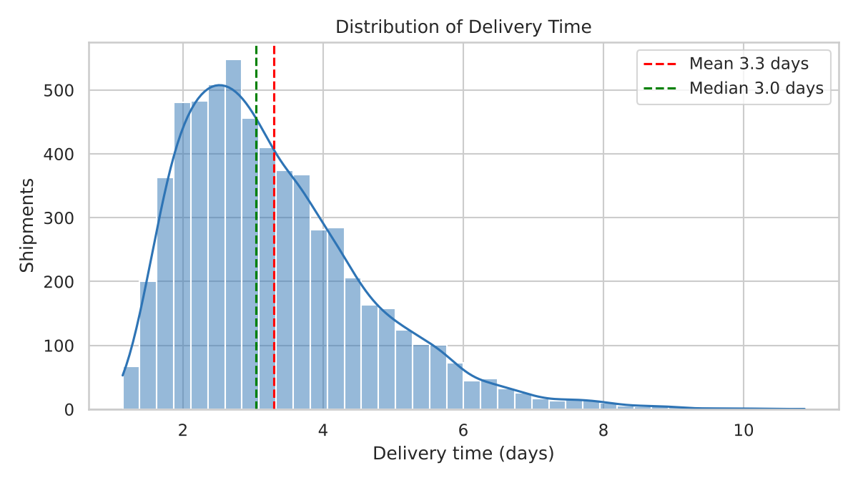
Figure 1: Distribution of delivery time
Most deliveries take between 2 and 4 days, with a median of 3.0 days. The long tail to the right shows a group of shipments taking 6 days or more, and these are the ones that cause late deliveries and unhappy customers. The mean (3.3 days) sits above the median because of that tail.

5.2 Monthly Volume and Delay Rate
Question: are there seasonal patterns? Why a combined bar and line chart: bars suit counts per month, and a line suits a rate over time. Putting them together on two axes lets us see whether delays follow volume.
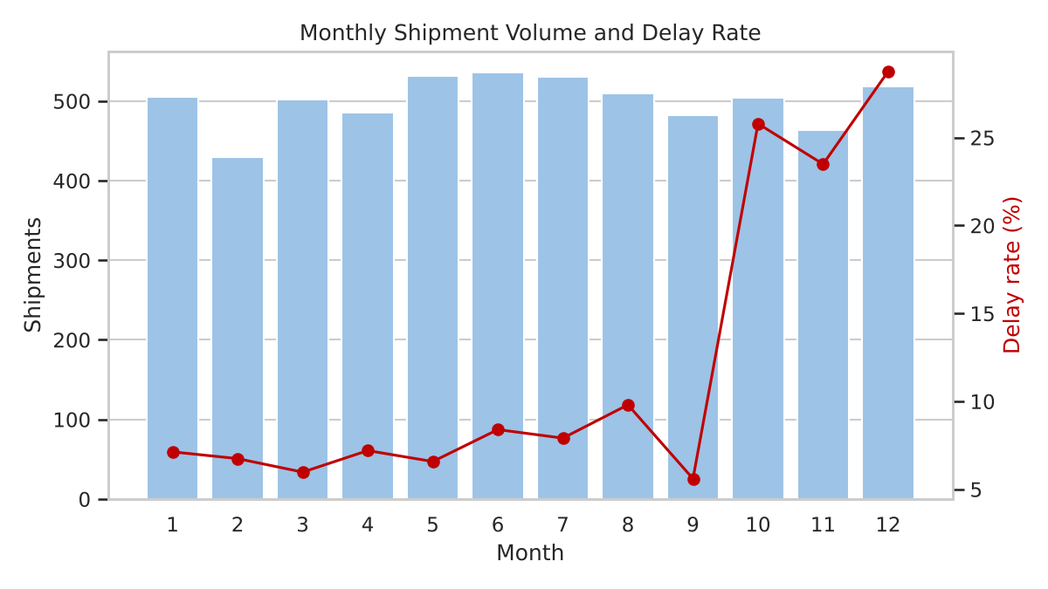
Figure 2: Monthly shipment volume (bars) and delay rate (line)
Shipment volume is fairly steady at roughly 430 to 540 shipments per month. The delay rate, however, jumps from around 6 to 10% for most of the year to 23 to 29% in October, November and December. Since volume did not rise in those months, the likely cause is seasonal congestion or limited capacity in the network, not simply more parcels.

5.3 Transport Cost by Mode
Question: how do the three modes compare on cost? Why a boxplot: it compares several groups at once and shows the median, the spread and outliers, which a bar of averages would hide.
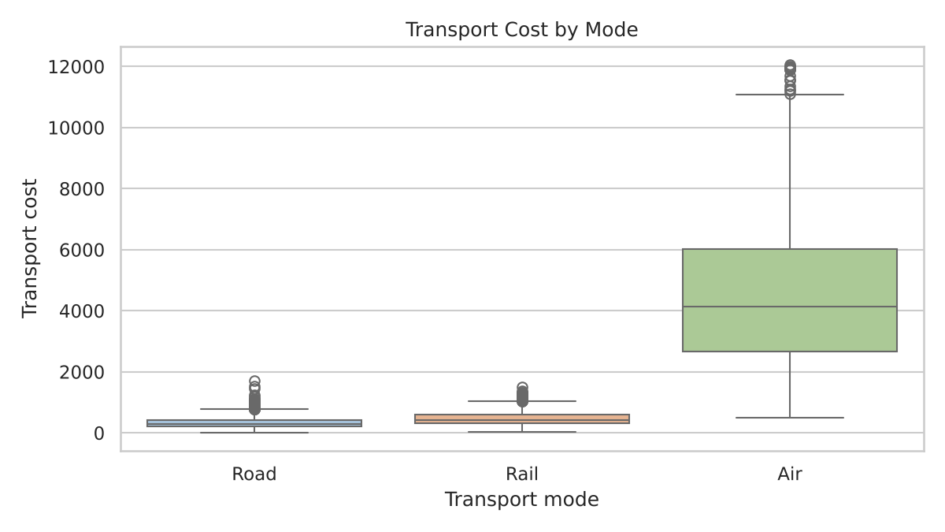
Figure 3: Transport cost by mode
Air is in a different price range from road and rail. The average air shipment costs about 4,612, compared with 473 for rail and 331 for road. Air also has the widest spread, so its cost is the hardest to predict. Air makes up only 14.8% of shipments but accounts for 68.6% of total transport spending.

5.4 Distance vs Transport Cost
Question: how strongly does distance drive cost? Why a scatter plot coloured by mode: a scatter plot is the standard way to show the relationship between two numeric variables, and the colour adds a third variable (mode). A random sample of 1,500 shipments is plotted to avoid overcrowding.
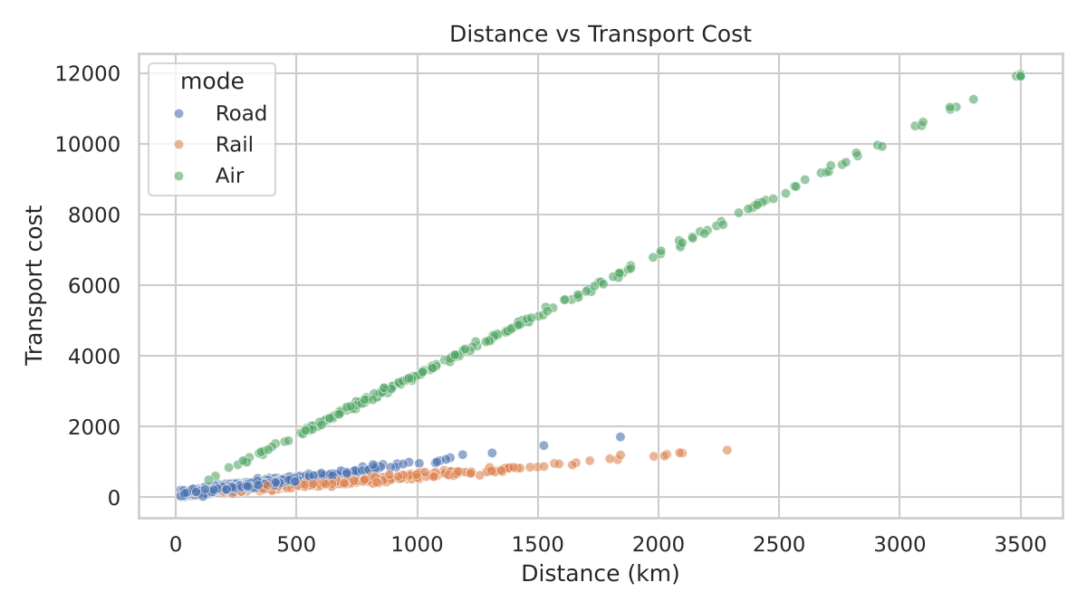
Figure 4: Distance versus transport cost, by mode
Cost rises steadily with distance, but in three separate bands. Each mode has its own slope: air is steepest, road is in the middle and rail is the flattest. The cost per km is about 3.47 for air, 1.23 for road and 0.67 for rail. This means that choosing the mode matters as much as the distance itself.

5.5 Correlation Heatmap
Question: which variables move together? Why a heatmap: it shows every pairwise relationship in one picture, with colour and numbers, so strong relationships are visible immediately.
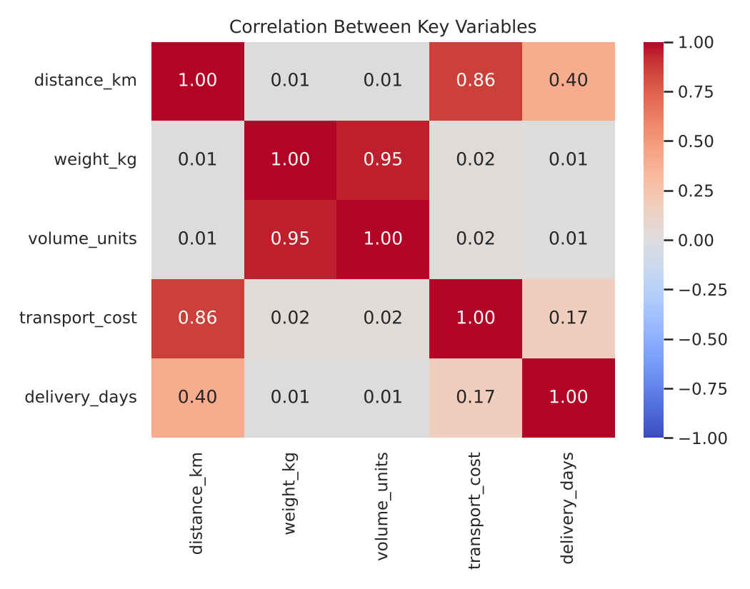
Figure 5: Correlation between key variables
The strong blocks are distance with cost (0.86) and weight with volume (0.95). Delivery time is moderately linked to distance (0.40) and only weakly to cost (0.17), which tells us that paying more does not automatically mean getting faster delivery.

5.6 Delay Rate by Carrier and Hub
Question: who is responsible for late deliveries? Why a grouped bar chart: it compares a rate across two categories side by side, so a carrier problem and a hub problem can be told apart.
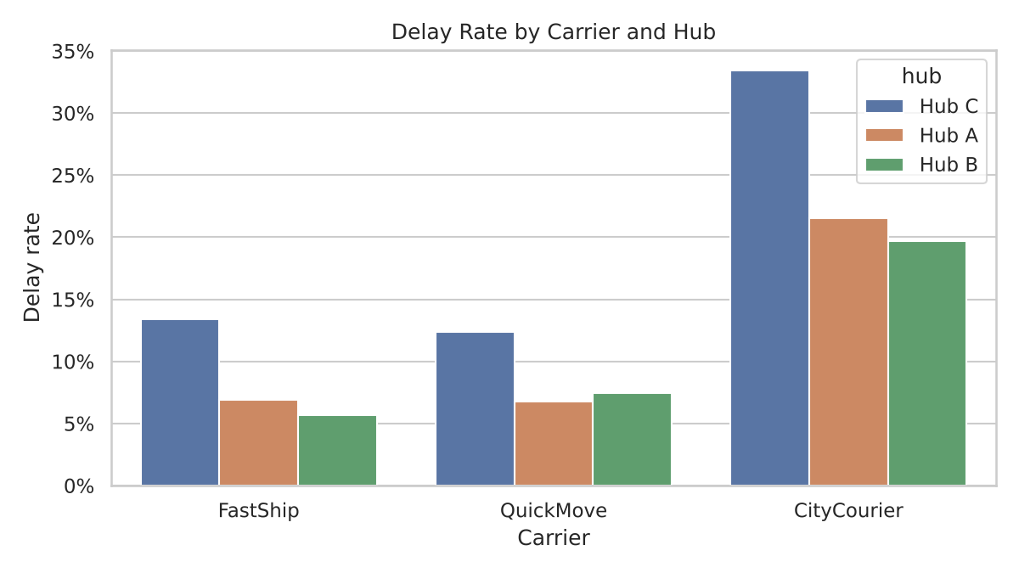
Figure 6: Delay rate by carrier and hub
CityCourier is the clear problem carrier, with a delay rate of 23.8% against about 8% for FastShip and QuickMove. Hub C is also weaker (17.7% overall, against about 10% for Hubs A and B). The worst combination is CityCourier at Hub C, where one in three shipments (33.4%) is late. Because CityCourier is poor at every hub, and Hub C is poor with every carrier, both are separate problems that need separate fixes.

5.7 Cost per km by Hub and Mode
Question: is any hub more expensive to operate? Why a heatmap table: it is a compact way to compare two categories against a numeric value, and the colour intensity highlights the expensive cells.
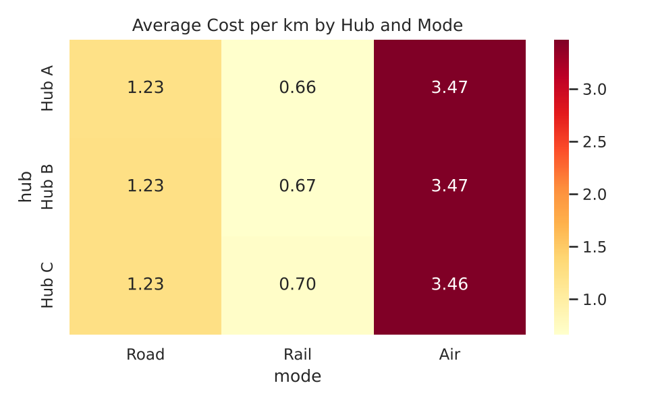
Figure 7: Average cost per km by hub and mode
Costs per km are almost identical across hubs within each mode (for example road is 1.23 at every hub). So hub choice is not a cost driver; the transport mode is. This also shows that Hub C's problem is service quality (delays), not price.

6. Analytical Insights

6.1 Operational Efficiency
- About 88% of shipments are on time, but the delay rate is far from uniform: it is 7% in off-peak months and 26% in October to December.
- Rail has the highest delay rate (22.3%, against 9.9% for road and 6.9% for air). Rail is slower, but the promised delivery window is the same for all modes, so rail shipments often miss it. This points to unrealistic promises rather than purely poor performance.
- The average delivery takes 4.0 days with CityCourier compared with 3.1 days with the other carriers, and 3.7 days at Hub C compared with about 3.2 at the other hubs.

6.2 Cost Drivers
- Distance is the main cost driver (correlation 0.86), followed by transport mode.
- Air freight is the cost hotspot: 14.8% of shipments but 68.6% of total transport spending.
- Parcel weight has almost no effect on cost in this dataset, which suggests pricing is dominated by mode and distance.

6.3 Bottlenecks
- Seasonal capacity: delays quadruple in Q4 without a rise in volume.
- Carrier performance: CityCourier is consistently late at every hub.
- Hub C: slower and later with every carrier, which points to a local issue such as staffing, layout or road access.
- Mode and promise mismatch: rail and long-distance shipments are given the same time promise as faster options.

7. Recommendations
- Prepare for Q4. Add temporary carrier capacity and extra staff from October, and set earlier cut-off times. Targeting a delay rate under 15% in Q4 would be a realistic first goal.
- Review CityCourier. Start a performance review and reduce its share of shipments, especially at Hub C, until delivery times improve.
- Investigate Hub C. Audit dispatch processes, loading times and local road conditions, since the hub is slower with every carrier.
- Control air freight. Reserve air for urgent or high-value shipments and move non-urgent long-distance parcels to rail or road, which could cut a large share of total spending.
- Set mode-specific delivery promises. Give rail and long-distance shipments realistic delivery windows so that customers' expectations match what can be delivered.
- Keep monitoring. Track delay rate by carrier, hub and month on a dashboard, so problems like these are seen early.

8. How the Visualizations Help Interpret Logistics Performance
Looking back at the numbers alone (averages and a correlation table), several of these findings would have been missed. The mean cost of 991 hides the fact that a typical shipment costs 366 and that air is a separate cost world. The overall delay rate of 11.9% hides a 26% rate in Q4. The carrier and hub problems only become obvious in a side-by-side chart. Visualizations therefore turn performance metrics such as on-time delivery rate, cost per kilometre and delivery time into something a manager can read in seconds and act on. The right chart type matters: histograms for distributions, line and bar for trends, boxplots for group comparison, scatter plots for relationships and heatmaps for many comparisons at once.

9. Python Code Excerpts
The full script (eda_visualization.py) and the chart images are available in the GitHub repository. The main parts are shown below.

9.1 Summary Statistics and Correlation
import pandas as pd
import numpy as np
import matplotlib.pyplot as plt
import seaborn as sns

df = pd.read_csv("logistics_dataset.csv", parse_dates=["ship_date"])
num = ["distance_km", "weight_kg", "volume_units", "transport_cost", "delivery_days"]

print(df[num].describe().round(2)) # count, mean, std, quartiles
print(df[num].median().round(2)) # central tendency
print(df[num].skew().round(2)) # shape of distribution
print(df[num].corr().round(2)) # relationships
print("Delay rate: %.1f%%" % (100 * df["delayed"].mean()))

9.2 Histogram of Delivery Time
sns.set_theme(style="whitegrid")
plt.figure(figsize=(8, 4.5))
sns.histplot(df["delivery_days"], bins=40, kde=True, color="#2E74B5")
plt.axvline(df["delivery_days"].mean(), color="red", ls="--", label="Mean")
plt.axvline(df["delivery_days"].median(), color="green", ls="--", label="Median")
plt.title("Distribution of Delivery Time")
plt.xlabel("Delivery time (days)"); plt.ylabel("Shipments")
plt.legend(); plt.tight_layout(); plt.savefig("charts/01_delivery_time_distribution.png", dpi=150)

9.3 Monthly Trend with Two Axes
monthly = df.groupby("month").agg(shipments=("shipment_id", "count"),
delay_rate=("delayed", "mean"))
fig, ax1 = plt.subplots(figsize=(8, 4.5))
ax1.bar(monthly.index, monthly["shipments"], color="#9DC3E6")
ax2 = ax1.twinx()
ax2.plot(monthly.index, monthly["delay_rate"] * 100, color="#C00000", marker="o")
ax1.set_xlabel("Month"); ax1.set_ylabel("Shipments"); ax2.set_ylabel("Delay rate (%)")
plt.title("Monthly Shipment Volume and Delay Rate")

9.4 Boxplot, Scatter Plot and Heatmaps
# Cost by transport mode
sns.boxplot(data=df, x="mode", y="transport_cost", order=["Road", "Rail", "Air"])

# Distance vs cost, coloured by mode
sns.scatterplot(data=df.sample(1500, random_state=1),
x="distance_km", y="transport_cost", hue="mode", alpha=0.6)

# Correlation heatmap
sns.heatmap(df[num].corr(), annot=True, fmt=".2f", cmap="coolwarm", vmin=-1, vmax=1)

# Delay rate by carrier and hub
sns.barplot(data=df, x="carrier", y="delayed", hue="hub", errorbar=None)

# Average cost per km by hub and mode
pivot = df.pivot_table(index="hub", columns="mode", values="cost_per_km", aggfunc="mean")
sns.heatmap(pivot, annot=True, fmt=".2f", cmap="YlOrRd")

10. Conclusion
This report explored a simulated logistics dataset of 6,000 shipments and used seven charts to answer practical operational questions. The main findings are that distance and transport mode drive cost, that air freight takes up more than two thirds of spending, and that delays are concentrated in specific places and times: the October to December peak, the CityCourier carrier and Hub C. Each finding leads to a concrete action, from Q4 capacity planning to realistic delivery promises.
The exercise also showed me that analysis and visualization work together. Statistics give the numbers, and charts reveal the patterns behind them. In a real company, the same workflow could be run on live data and shown on a dashboard to support day-to-day decisions.
Note: the dataset is hypothetical and generated for learning purposes, so the specific figures reflect the patterns built into the simulation and would be replaced by real values in an actual project.

11. References
- Olist. Brazilian E-Commerce Public Dataset. Kaggle. https://www.kaggle.com/datasets/olistbr/brazilian-ecommerce
- World Bank. Logistics Performance Index. https://lpi.worldbank.org
- pandas documentation. https://pandas.pydata.org/docs/
- seaborn documentation. https://seaborn.pydata.org
- matplotlib documentation. https://matplotlib.org

