Week 4 Task

Predictive Modeling and Optimization in Logistics Systems
Predicting Delivery Times and Using the Predictions to Cut Cost

Prepared by: [Your Name]
Program: Yuva Intern | Date: [Date]

1. Introduction
Over the last three weeks I planned a logistics analysis, cleaned the data and explored it with charts. The exploration showed where the problems are: late deliveries in peak season, a weak carrier, a weak hub and expensive air freight. This week I take the next step. Instead of only describing what happened, I build a model that predicts what will happen, and then I use those predictions to make better operational decisions.
The report has two parts. Part one builds and evaluates a model that predicts shipment delivery time. Part two uses that model, together with a cost model, to test two optimization ideas: choosing cheaper transport modes and allocating shipments to carriers within capacity limits. All data is hypothetical, but the workflow is the same one I would follow on real company data.

2. Problem Definition
Business question: how long will a shipment take to reach the customer, and how can we use that knowledge to lower cost without hurting on-time delivery?
Prediction task: a regression problem. The target variable is delivery_days (the number of days from dispatch to delivery), a continuous number.
Why this target: delivery time is the metric customers feel most, and it is the base of KPIs like on-time delivery rate. If we can predict it before dispatch, planners can warn customers, choose a different carrier or mode, and set realistic promises.
Optimization tasks: (A) cut transport cost by switching expensive shipments to cheaper modes where the predicted delivery time still meets the promise; (B) allocate shipments to carriers so that predicted delivery time is as low as possible, while no carrier is overloaded.

3. Hypothetical Dataset
The dataset has 6,000 shipments over one year, generated with realistic relationships (for example, longer distances take longer, air is faster but costly, and the October to December peak season adds delays). It is split into 4,800 training shipments and 1,200 test shipments. The average delivery time is 3.32 days with a standard deviation of 1.32 days.
Feature | Type | Description
hub | Category | Hub A, Hub B or Hub C
carrier | Category | FastShip, QuickMove or CityCourier
mode | Category | Road, Rail or Air
distance_km | Numeric | Distance to the customer
weight_kg | Numeric | Parcel weight
month, weekday | Numeric | Calendar features from the dispatch date
is_peak | Binary | 1 if dispatched in October to December
delivery_days (target) | Numeric | Days from dispatch to delivery
transport_cost | Numeric | Cost of the shipment (used by the cost model in Part 2)

4. Data Preparation
- Train/test split: 80% of the shipments were used to build the model and 20% were locked away as a test set. The test set is touched only once, at the end, so the final scores are honest.
- Encoding: hub, carrier and mode are categories, so they were one-hot encoded into 0/1 columns.
- Scaling: numeric features were standardized for linear regression only, since tree-based models do not need scaling.
- Pipelines: preprocessing and model are bundled in a single scikit-learn pipeline. This way, the same steps are applied automatically during cross-validation and prediction, and information from the validation folds can never leak into training.
Data cleaning was covered in Week 2, so this dataset is assumed to be clean.
import pandas as pd
from sklearn.model_selection import train_test_split
from sklearn.compose import ColumnTransformer
from sklearn.pipeline import Pipeline
from sklearn.preprocessing import OneHotEncoder, StandardScaler

cat = ["hub", "carrier", "mode"]
num = ["distance_km", "weight_kg", "month", "weekday", "is_peak"]
X, y = df[cat + num], df["delivery_days"]

X_train, X_test, y_train, y_test = train_test_split(X, y, test_size=0.2, random_state=42)

def make_pipe(model, scale=False):
prep = ColumnTransformer([
("cat", OneHotEncoder(handle_unknown="ignore"), cat),
("num", StandardScaler() if scale else "passthrough", num),
])
return Pipeline([("prep", prep), ("model", model)])

5. Model Selection and Rationale
I compared four regression models, going from simple to complex. Starting simple is good practice, because a complicated model is only worth using if it clearly beats a simple one.
Model | Why I chose it | Strengths and weaknesses
Linear Regression | Simple baseline that is easy to explain to managers | Fast and interpretable, but assumes straight-line effects and cannot capture interactions
Decision Tree | Captures non-linear patterns and interactions with readable rules | Easy to follow, but a single tree is unstable and can overfit
Random Forest | Averages many trees to reduce overfitting | Robust and accurate, but harder to interpret and slower
Gradient Boosting | Builds trees one after another, each correcting the errors of the last | Often the most accurate on tabular data, but needs tuning

A naive baseline is also useful: always predicting the average delivery time gives a mean absolute error of 1.01 days. Every model has to beat that number to be worth anything.

6. Training, Validation and Tuning

6.1 Cross-Validation
To compare models fairly I used 5-fold cross-validation on the training data. The training set is split into five parts; the model is trained on four parts and checked on the fifth, and this is repeated so that every part is used once for checking. Averaging the five scores is more reliable than a single split. The metric was RMSE (root mean squared error), where lower is better.
from sklearn.model_selection import KFold, cross_val_score
from sklearn.linear_model import LinearRegression
from sklearn.tree import DecisionTreeRegressor
from sklearn.ensemble import RandomForestRegressor, GradientBoostingRegressor

candidates = {
"Linear Regression": make_pipe(LinearRegression(), scale=True),
"Decision Tree": make_pipe(DecisionTreeRegressor(max_depth=6, random_state=42)),
"Random Forest": make_pipe(RandomForestRegressor(n_estimators=200, random_state=42)),
"Gradient Boosting": make_pipe(GradientBoostingRegressor(random_state=42)),
}
kf = KFold(n_splits=5, shuffle=True, random_state=42)
for name, pipe in candidates.items():
rmse = -cross_val_score(pipe, X_train, y_train, cv=kf,
scoring="neg_root_mean_squared_error")
print(name, "CV RMSE:", round(rmse.mean(), 3))

Model | CV RMSE (days) | CV R-squared | Rank
Gradient Boosting | 0.923 | 0.515 | 1
Linear Regression | 0.953 | 0.483 | 2
Random Forest | 0.976 | 0.457 | 3
Decision Tree | 0.977 | 0.456 | 4

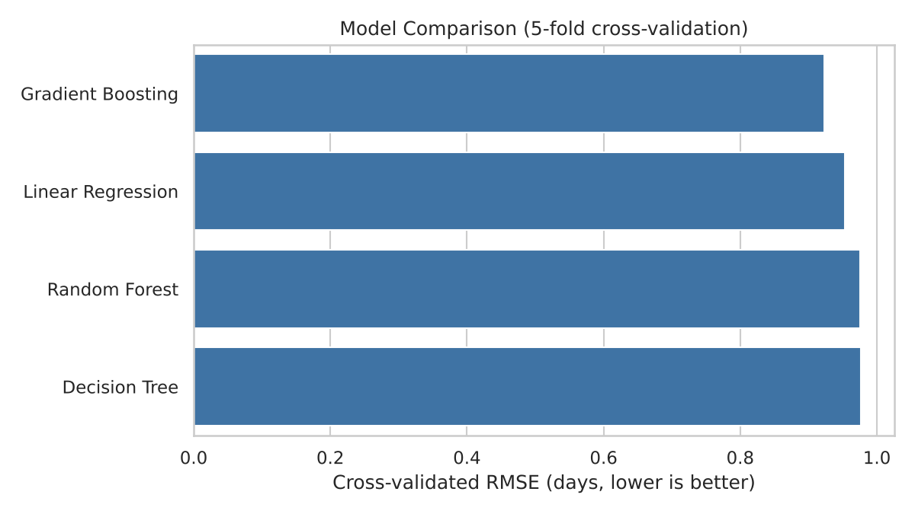
Figure 1: Cross-validated RMSE of the four models
Gradient Boosting came first, but the gap is small. Linear Regression is only 0.03 days behind, which tells me that most of the relationships in the data are fairly simple and additive (distance adds time, peak season adds time, a weak carrier adds time). The single decision tree and the random forest were slightly worse than the linear model, probably because they chase random noise. In a business setting, this is a useful finding: a simple model is almost as good, so it could be used if explainability matters more than the last bit of accuracy.

6.2 Hyperparameter Tuning
I tuned the winning model with a randomized search: 15 random combinations of settings, each scored with 3-fold cross-validation. Randomized search was chosen over a full grid search because it covers a wide range of settings in much less time.
from sklearn.model_selection import RandomizedSearchCV

param_dist = {
"model__n_estimators": [100, 200, 300, 400],
"model__learning_rate": [0.03, 0.05, 0.1, 0.15],
"model__max_depth": [2, 3, 4, 5],
"model__min_samples_leaf": [1, 5, 10, 20],
"model__subsample": [0.7, 0.85, 1.0],
}
search = RandomizedSearchCV(candidates["Gradient Boosting"], param_dist, n_iter=15,
cv=3, scoring="neg_root_mean_squared_error",
random_state=42, n_jobs=-1)
search.fit(X_train, y_train)
best = search.best_estimator_
print(search.best_params_)

The best settings were 300 trees, a learning rate of 0.05, shallow trees (maximum depth 2) and a subsample of 0.85. The preference for shallow trees again suggests that the underlying relationships are simple, and that deeper trees would mostly fit noise.

7. Evaluation on the Test Set

7.1 Metrics Used
- MAE (mean absolute error): the average size of the error in days. Easy to explain: 'on average the prediction is off by this many days'.
- RMSE (root mean squared error): similar to MAE but punishes big mistakes more. It matters in logistics because one very late shipment is worse than several slightly late ones.
- R-squared: the share of the variation in delivery time that the model explains (0 is no better than the average, 1 is perfect).

7.2 Results
from sklearn.metrics import mean_absolute_error, mean_squared_error, r2_score
import numpy as np

pred = best.predict(X_test)
print("MAE :", mean_absolute_error(y_test, pred))
print("RMSE:", np.sqrt(mean_squared_error(y_test, pred)))
print("R2 :", r2_score(y_test, pred))

Model (test set) | MAE (days) | RMSE (days) | R-squared
Linear Regression | 0.727 | 0.953 | 0.465
Decision Tree | 0.736 | 0.967 | 0.449
Random Forest | 0.736 | 0.971 | 0.445
Gradient Boosting (default) | 0.698 | 0.930 | 0.491
Gradient Boosting (tuned) | 0.695 | 0.927 | 0.494

The tuned model predicts delivery time with an average error of 0.70 days, compared with 1.01 days for the naive average guess, a reduction of about 31%. The test scores are very close to the cross-validation scores (RMSE 0.927 against 0.923), which shows the model is not overfitted and should behave similarly on new shipments.
An R-squared of 0.49 means the model explains about half of the variation in delivery time. I think this is reasonable here, because the rest comes from random factors that are not in the data, such as traffic, weather, road works and driver availability. Adding such features would be the most valuable way to improve the model.
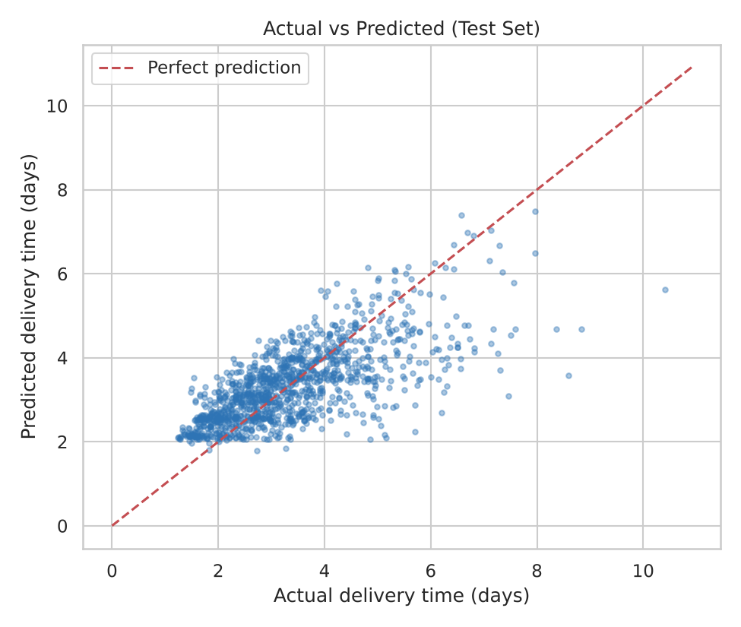
Figure 2: Actual versus predicted delivery time (test set)
The points follow the diagonal line, so the model gets the general level right. The spread around the line is the unexplained part. The model is less accurate for the longest deliveries, which are the rare, extreme cases.
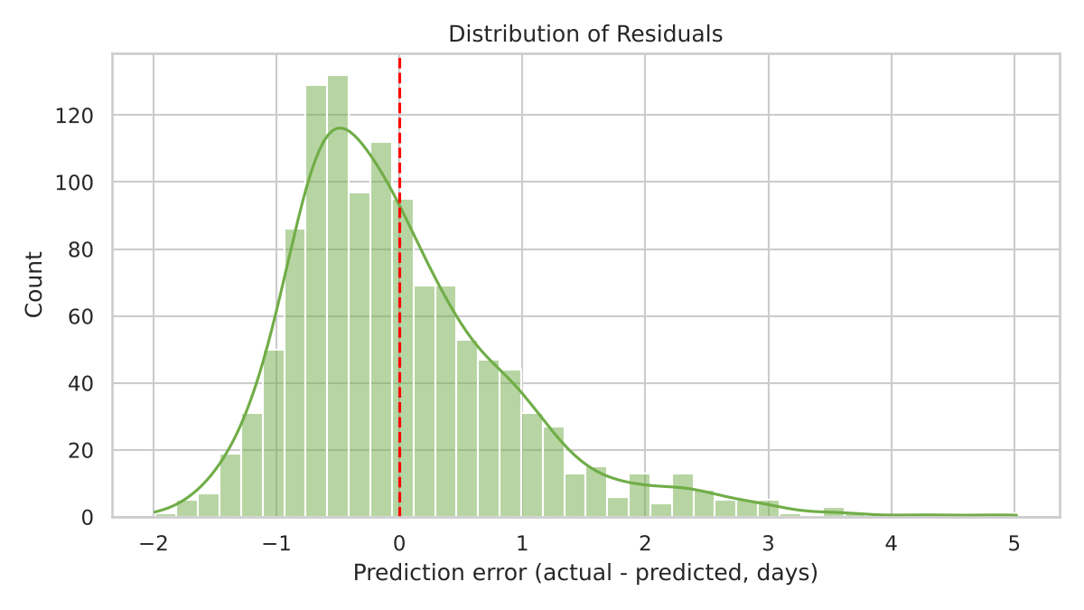
Figure 3: Distribution of prediction errors
Errors are centred on zero, so the model is not systematically too high or too low. The right-hand tail shows that when the model is wrong, it is more often because a delivery took much longer than expected, not shorter. This is typical of delays.

7.3 What Drives Delivery Time?
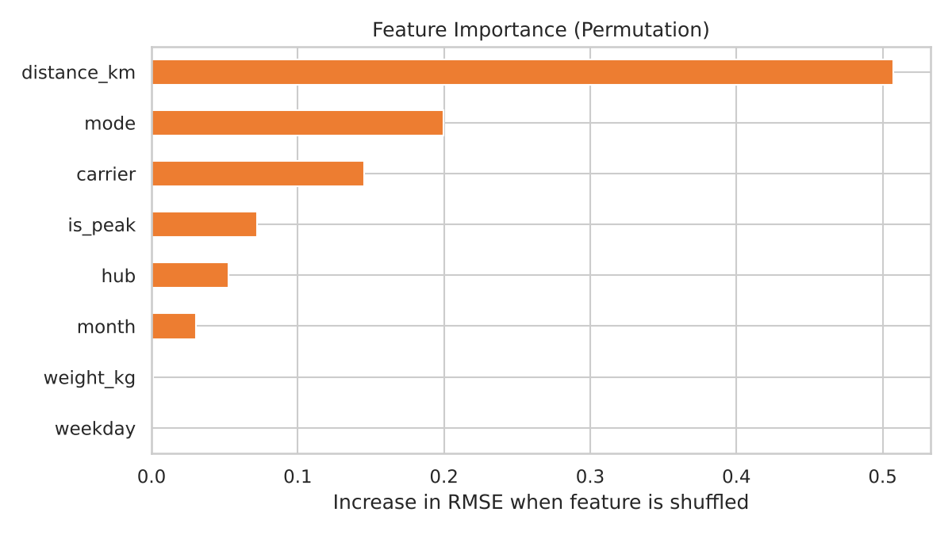
Figure 4: Permutation feature importance
Permutation importance measures how much the error grows when one feature is randomly shuffled. Distance is by far the most important feature (0.51), followed by transport mode (0.20), carrier (0.15), the peak-season flag (0.07) and hub (0.05). Weight and weekday have almost no effect. This matches the findings from the Week 3 analysis and gives the optimization part a clear direction: mode, carrier and season are the levers a manager can actually influence.

8. Optimization Strategies
A prediction is only useful if it changes a decision. I used the tuned time model, plus a second model that predicts transport cost (R-squared 0.999 on the test set, since cost in this dataset is almost a direct function of mode, distance and weight), to answer two 'what if' questions on the 1,200 test shipments.

8.1 Strategy A: Cost Minimization by Mode Choice
Idea: air freight is by far the most expensive mode. If a shipment currently going by air would still arrive on time by road or rail, it should go the cheaper way. Method: for every shipment currently sent by air, the model predicts delivery time and cost under each of the three modes. The cheapest mode is chosen, but only if its predicted time is at least 1 day inside the promised delivery time. That 1-day safety margin is about one RMSE, and it protects against the model's own error. Shipments already on road or rail are left unchanged.
modes = ["Road", "Rail", "Air"]
D, C = [], [] # predicted days and cost per mode
for m in modes:
s = X_test.copy(); s["mode"] = m
D.append(best.predict(s)); C.append(cost_model.predict(s))
D, C = np.column_stack(D), np.column_stack(C)

BUFFER = 1.0 # safety margin (days)
feasible = D <= (promised[:, None] - BUFFER) # fast enough to keep the promise?
masked_cost = np.where(feasible, C, np.inf) # ignore modes that are too slow
best_alt = np.where(feasible.any(axis=1), masked_cost.argmin(axis=1), current)

# only shipments that currently use Air are re-evaluated
choice = np.where(current == modes.index("Air"), best_alt, current)

Result (test shipments) | Current | Optimized | Change
Predicted total cost | 1,349,129 | 895,897 | -33.6%
Predicted on-time rate | 95.1% | 95.1% | No change
Share of shipments by air | 17.1% | 6.0% | -11.1 points
Share by road | 63.3% | 69.4% | +6.1 points
Share by rail | 19.6% | 24.6% | +5.0 points
Shipments whose mode changed | - | 11.1% | -

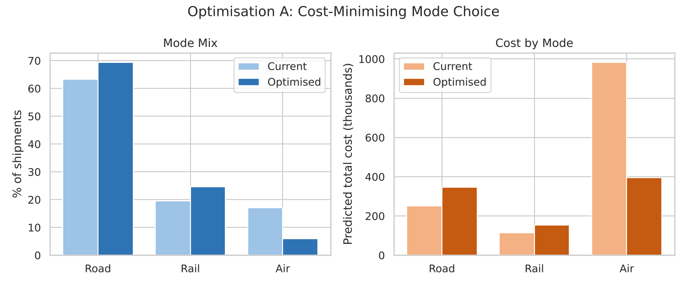
Figure 5: Mode mix and cost by mode, before and after optimization
Moving just 11% of shipments from air to road or rail cuts the predicted transport cost by about one third, because air spending falls from roughly 983,000 to 396,000, while road and rail costs rise only slightly. The predicted on-time rate does not drop, because the safety margin only allows switches that are comfortably within the promise. This agrees with the Week 3 finding that air is a small share of shipments but most of the spending.

8.2 Strategy B: Carrier Allocation as a Linear Program
Idea: the model shows CityCourier adds delay. Simply sending everything to the best carrier is not realistic, since no carrier has unlimited capacity. So this is a resource allocation problem. Method: linear programming. The decision is the share of each shipment given to each carrier. The objective is to minimize the total predicted delivery time. The constraints are that every shipment is assigned exactly once and that no carrier may handle more than 45% of the shipments.
from scipy.optimize import linprog
from scipy.sparse import lil_matrix

carriers = ["FastShip", "QuickMove", "CityCourier"]
# T[i, j] = predicted delivery days if shipment i goes with carrier j
T = np.column_stack([best.predict(X_test.assign(carrier=c)) for c in carriers])
n, k = T.shape

A_eq, A_ub = lil_matrix((n, n * k)), lil_matrix((k, n * k))
for i in range(n):
for j in range(k):
A_eq[i, i * k + j] = 1 # each shipment assigned exactly once
A_ub[j, i * k + j] = 1 # used to cap each carrier's load

res = linprog(T.ravel(), # minimise total predicted days
A_ub=A_ub.tocsr(), b_ub=np.full(k, 0.45 * n), # max 45% per carrier
A_eq=A_eq.tocsr(), b_eq=np.ones(n), bounds=(0, 1), method="highs")
assignment = res.x.reshape(n, k).argmax(axis=1)

Result (test shipments) | Current | Optimized | Change
Average predicted delivery time | 3.33 days | 3.18 days | -0.15 days
Predicted late rate | 4.9% | 4.5% | -0.4 points
FastShip share | 37.5% | 45.0% | +7.5 points
QuickMove share | 37.1% | 45.0% | +7.9 points
CityCourier share | 25.4% | 10.0% | -15.4 points

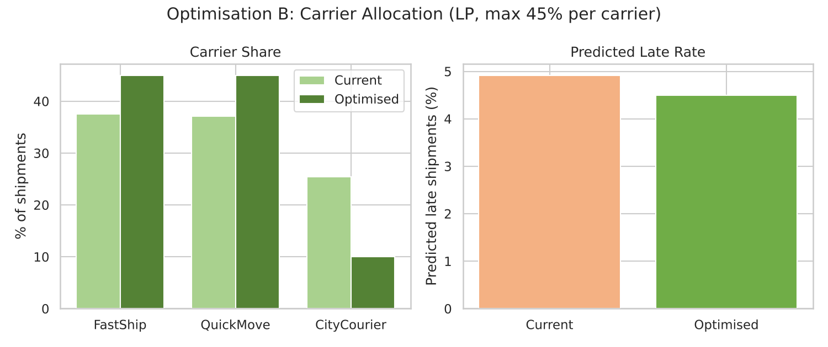
Figure 6: Carrier allocation and predicted late rate, before and after
The solver fills the two better carriers up to their 45% limit and moves the rest, mainly the shipments that suffer most from CityCourier, away from it. Average delivery time falls by 0.15 days (about 4.5%). The gain is modest because the other carriers are also capped, which is a realistic result: capacity limits stop an ideal solution from being possible, and the model shows exactly how much an extra unit of capacity would be worth.

8.3 Strategy C: Route Planning and Resource Allocation (Proposed)
Two further strategies follow from the model and from Week 1, and are proposed rather than coded here:
- Route planning: use the predicted delivery times as travel-time inputs for a Vehicle Routing Problem solved with Google OR-Tools. Routes then account for peak-season slowdowns and slow carriers or hubs, instead of using fixed distances.
- Peak-season resource planning: because is_peak is an important feature, run the model for the coming Q4 shipments in September to estimate how many shipments will exceed their promise, and add temporary capacity where the predicted delays are concentrated.
- Proactive customer communication: flag shipments whose predicted time is close to the promise, so customers can be informed early.

9. Limitations
- Simulated data: the numbers show how the method works, but real data would give different results and likely more noise.
- What-if predictions: the optimization assumes that when we change a shipment's mode or carrier in the model, the model's prediction is correct for that new situation. This is an estimate, and it should be confirmed with a small pilot before a full rollout.
- Predicted, not actual, late rate: the late rates in Strategy B are based on predicted average times, so they are lower than the real late rate in the data (12.4%). They are meant for comparing before and after, not as absolute numbers.
- Random split: I used a random train/test split, because the peak season only occurs in the last three months and a time-based split would have hidden it from the model. With several years of data, a time-based split (such as TimeSeriesSplit) would be better.
- Missing factors: weather, traffic and driver data are not included, which limits R-squared to about 0.5.

10. Recommendations
- Use the model as an early-warning tool. Predict delivery time at dispatch and alert planners when a shipment is likely to miss its promise.
- Review air freight use. Apply the mode rule above: move air shipments to road or rail when the predicted time stays at least a day inside the promise. In the test data this cut predicted cost by about 34% at no loss of on-time performance.
- Rebalance carriers within capacity. Shift volume from CityCourier to FastShip and QuickMove, and discuss extra capacity with them, because the model shows where each additional unit pays off most.
- Enrich the data. Add weather, traffic and driver information to raise R-squared above the current 0.49.
- Pilot first. Test the recommendations on one hub for a few weeks and compare predicted and actual results before a full rollout.
- Retrain regularly. Retrain the model every quarter so that it keeps up with changes in carriers, routes and demand.

11. Conclusion
This report built a predictive model for delivery time and used it for optimization. A tuned Gradient Boosting model predicts delivery time with an average error of 0.70 days, about 31% better than a simple average, and explains roughly half the variation in delivery time. Distance, transport mode, carrier and peak season are the main drivers.
Using the predictions, switching a small share of air shipments to cheaper modes could cut transport cost by about one third without hurting on-time delivery, and a capacity-limited carrier allocation improves average delivery time further. Together with the earlier weeks, this completes a full workflow: plan, prepare, explore, predict and optimize.
Note: the dataset is hypothetical, so the exact figures are illustrative and would need to be re-estimated on real company data.

12. References
- scikit-learn documentation: Model selection and evaluation. https://scikit-learn.org/stable/model_selection.html
- scikit-learn documentation: Ensemble methods. https://scikit-learn.org/stable/modules/ensemble.html
- SciPy documentation: scipy.optimize.linprog. https://docs.scipy.org/doc/scipy/reference/generated/scipy.optimize.linprog.html
- Google. OR-Tools: Vehicle Routing. https://developers.google.com/optimization/routing
- Olist. Brazilian E-Commerce Public Dataset. Kaggle. https://www.kaggle.com/datasets/olistbr/brazilian-ecommerce

