Bollywood Movies & India’s Socio-economy: Trend and Data analysis

Final Project Report by:
Vineet Rai
MS – Data Science, Indiana University - Bloomington
COURSE: DSCI D590: Data Visualization
Instructor Names:
Yong Yeol Ahn
Rachith Aiyappa
Larry Zhang
Vincent Wong
Devin Wright

December 05, 2022

Abstract
Movies have been one of the most influencing and effective modes of entertainment for our society across the world. This medium has been favored time and again to entertain the masses by telling the stories of motivation, romance, drama, action, comedy, and different moods.
The impact of movies on the society and at the same time, the impact of societal conditions and generations on the subjects and genres in movies have been an interesting relation. It is interesting to see how the cinema has been evolving in a developing economy like India, post-independence till recent years, and how does its population and moviemakers adopt the different moods and genres of movies.
Through this research and analysis, I focused to understand the trend of Bollywood movies, its subjects/genres, popularity, and identify the patterns of evolution of Bollywood Cinema during the last 7 decades i.e., 1950-2020.
The motive is to identify what were the popular genres during different times and decades of growing Indian population and economy, as well as the trends of movie making by numbers, wins and nominations. I have tried to identify the patterns and the shifts, as well try to relate to the generational or socio-economic changes based on data analysis and visualization methods.
My research identifies and demonstrates some very interesting observations like how the prevalence of Drama & Romance during 1950s-1970s, took a steep shift towards action genres during the period of 1970s-2000s, and then shifting towards Drama and comedy genres in recent decades.
This is an interesting pattern to be associated with the facts that India as a country and as a society has been making a tremendous growth in terms of population and certainly the living conditions and education, as demonstrated by a consistently improving factor like per capita income, which shows a very progressive curve, especially after the 2000s.
The research also indicates a relation between the generations, people choices, makers choices reflecting as the increasing number of wins and nominations, quiet likely justifying the improving quality and reach of Bollywood cinema.
Key indicators used for socio-economic factors of India: population growth, per capita income over the last 50 years, using the World Bank Data.

Introduction – motivation, background, and objectives
Movies and cinema have a great impact and presence in our lives, not just as an entertainment mode, but also as a reflection of society, culture, and beliefs. I have a strong belief that movies and media historically have a large influence on the society, as well as are influenced by the different phases of societal conditions and generations.
As part of my research, I tried to find data and evidence to formalize this belief and present in a factual manner through analytics and visualization methods.

Motivation & Objectives
Being a cinema and art lover, I have always wondered how the styles of art and expressions have changed or evolved during different ages and generation. We all would have observed and wondered how the ancient art and literature styles are so different than art & literature of current age, or different generations. Similarly, I’m motivated to identify the changes and evolution in the category of cinema and movies as art, genres, and choices.
I want to see if there is a meaningful pattern or relation between the trends of movies making in India, and the socio-economic growth factors.
Bollywood movies having a significant prevalence and getting more attention post-independence of India (August 15th, 1947), is evolving at the national and international levels both.
The public data made available by agencies like IMDB, Wikipedia and world bank have been extremely helpful and stimulating to proceed in this research motivation.
Some key objectives to achieve as part of this research are to identify:
- The genres/subjects trending by volume and popularity during different decades of Indian cinema.
- What may be the possible relations based on available data, to the popular belief of impact and influence between movies and society trends.
- How does the audience in general perceive and rate the Bollywood movies.
- Has the popularity of genres changed with changes in population growth and generational changes.
- Does economic growth or conditions reflect a change or relation between the choice of genres and volume of entertainment options like movies.
- Has the quality of movies over the decades improved and securing more admiration and wins?

Existing work and background:
As I tried researching any existing work or visualizations made available on this idea, I could not find much specific artifacts, though some very impressive articles and insights were found.
Though not very specific to Bollywood Movies and Indian society, some of the ones I find quite relevant and inspirational are as follows:
- https://globaljournals.org/GJHSS_Volume19/3-Art-Cinema-and-Society.pdf
In this journal paper, the author ‘Jonas do Nascimento’ talks about his views on the connection of society and its factors, and impact on art and cinema.
- https://academic.oup.com/screen/article-abstract/12/1/15/1694174?redirectedFrom=PDF
- Something specific to Bollywood movies, at a very high level lacking the deeper insights on genre, nominations, and other trends.
https://en.wikipedia.org/wiki/File:Hindi_movie_production_trend.pdf
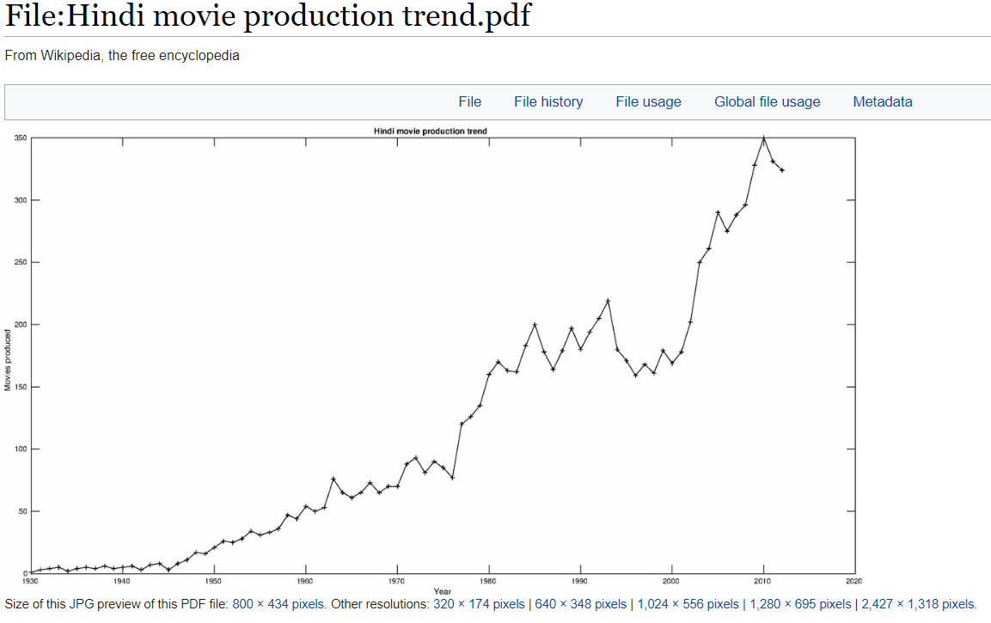
- I also found some misleading data and reports from some very credible organization as an example below published by UNESCO: (Bollywood is mentioned the multi-lingual Indian feature film industry, whereas the fact is that Bollywood (derived from Bombay + Hollywood) is majorly a Hindi language movies production industry. There are several other film production industries or units in India dedicated to different languages.
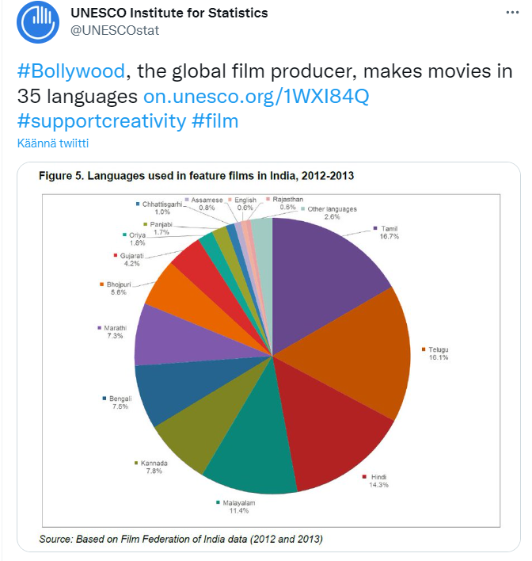
The above-mentioned research journals on existing work and backgrounds, helped me get motivated to further research on this topic. Struggling to find relevant research and insights on this subject, made me believe that the subject of Bollywood movies and Indian social conditions post-independence is not a very well researched or explored topic.
This I feel is an opportunity to do research something new and interesting, and hence used the data available over Bollywood movies and Indian socio-economic conditions to build my analysis explained in next sections in detail.

Process: Data Analysis and Visualization methods
After outlining the approach and objectives of my research topic, I started analyzing several data sources that fits the needs of my research topic.

The key sources I found having the suitable data to do this analysis are as below:

- Movies, genres, crew, nominations, year, and related data from:
https://github.com/pncnmnp/TIMDB/tree/master/1950-2019 (Credits: Parth Parikh)
bollywood_crew.csv
bollywood_crew_data.csv
bollywood_full.csv
bollywood_writers_data.csv
- Socio-economic data for India over last 50 years, through:
https://databank.worldbank.org/reports.aspx?source=2&country=IND
Source data formats:
- IMDB data is available through github in csv formats
- The data for Bollywood movies is having lot of unstructured formats and string data types.
- The data format from world bank is available in csv as well as xml formats.
- Data available from world bank is in columnar formats which will need transformation and reformatting.
Step-by-step process followed:
- Data Sourcing and selection:
- Identify right datasets and size for the analysis.
- Data modeling and relationship to be defined.
- Data format to be standardized and collected at a central location/file.
- Python dataframes created for data aggregation and transformation for analysis
- Data clean up and re-formatting work done, for ex:
    - Splitting the data values in columns wins and nominations
    - After splitting, reformatting the data to replace text and convert the field datatype to numeric
    - Creating separate dataframes per the conditions and filters
    - Splitting the genres with a mixed open text format to category 1, 2 & 3 genres with required assumptions and formatting.
    - World bank data for per capita income - Pivot changed for years to be in rows from columns as a dimension.
    - Splitting and reformatting the Year column values.

- Visualization methods:
Apart from the standard python libraries like pandas and numpy, I utilized other popular python libraries for my visualizations, for ex:
- Matplotlib
- Seaborn
- Plotly

Considering the subject, dimensions and attributes involved for analysis were fit for visualization through following types:

  - Pie Charts/ Donut Charts
  - Line graphs – single and multiple
  - Bar charts
  - Subplot matrices

Based on the datasets available, I created analysis and visualization to demonstrate following key trends:

- Most popular genres in Bollywood over the last 7 decades – both primary and secondary genres
- Identify the trends of movie production genre wise for the top 6 genres
- Identify the ‘Audience perception’ for bolly wood movies, using the IMDB ratings and genres
- Comparative analysis and trend of movies from different genres and overall movies production
- Identify the socio economic and population trend of India, with charts on:
  - Per-capita income
  - Population growth
- Identify the patterns between movies trend and per-capita income and population growth trends, using subplot matrices.

- Result analysis and outcomes:
Based on the outcomes of data and visualizations, the trend analysis and comparative analysis is done. The steps will be explained and demonstrated in next section for more clarity.

- Strengths, Limitations, and future scope:
Strengths and advantages:
  - The data available through imdb (credits to: Parth Parikh/ https://github.com/pncnmnp ) was a fair volume of sample set to be considered.
  - Movies data consisted of all key attributes of the subject like Title, genres, year of release, wins & nominations, imdb_ratings etc.
  - World Bank Public Datasets: The datasets made available were very relevant and detailed corresponding to the needed attributes to identify the socio-economic parameters of any country. (Credits:https://databank.worldbank.org/reports.aspx?source=2&country=IND)
Limitations and challenges:
  - The movie data attributes in the datasets were unstructured to some extent and needed a lot of data clean up and re-formatting.
  - Data splitting and conversion needs were required frequently throughout this exercise for both IMDB and World Bank data.
  - Though the sample data volume was sufficient ranging for 70 years and over 4300+ movies data, I feel more volume would have favored to a stronger analysis.
Future scope:
The scope of this analysis is limited to data analysis using visualization methods. In future, adding a statistical analysis may help bring more insights to the subject.

Results, Insights & Interpretations
This research and analysis focus on the trend of Bollywood movies, it’s subjects, popularity and nominations won over the years. The motive is to analyze the trend and patterns of Bollywood movies and its audience.
I have tried to put my observations to identify if there are any relations between the subjects of the movies, nominations, and the generations over these 7 decades ranging from 1950-2019.
I also tried to identify the socio-economic conditions and trend for India as a country. Just as an experiment, based only over the available data and visualization methods, I try to analyze if there is any pattern and relation we may infer based on movies and socio-economic parameters.
Key indicators for movies data: Movies, imdb ratings/votes (people’s choice), genres, year_of_release, key crew (director, story, producer)
Key indicators used for socio-economic factors of India: population growth, per capita income over the last 50 years.
Datasets and methods: The key sources for data to do this analysis are as below:
- Movies, genres, crew, nominations, year, and related data from: https://github.com/pncnmnp/TIMDB/tree/master/1950-2019 bollywood_crew.csv bollywood_crew_data.csv bollywood_full.csv bollywood_writers_data.csv
- Socio-economic data for India over last 50 years, through: https://databank.worldbank.org/reports.aspx?source=2&country=IND
Let’s look at the data analysis in visualization charts and its interpretation, in next bullets:

  - Shares of different primary genres of the movies in last 7 decades (1950-2020):
(NOTE: Please refer attached code or github link in references section, to learn about the data preparation methods and visualization methods used)
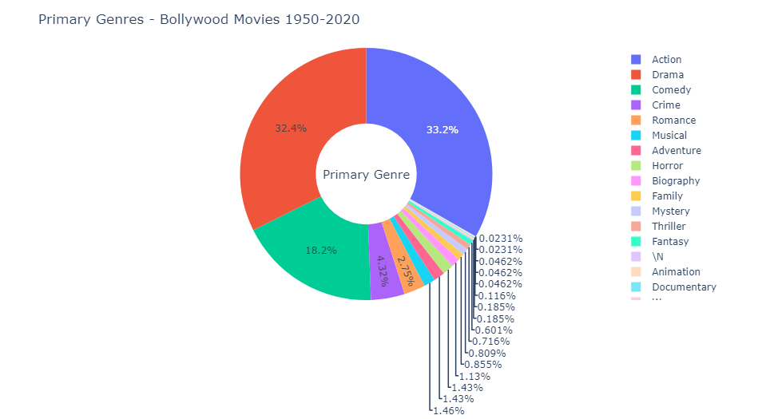
Interpretation: Based on this sample data and pie chart visualization, we can identify that the genres like Action, Drama, Comedy and Romance were the biggest choice of filmmakers and naturally audience during the last 7 decades of Bollywood movies.

  - Shares of different primary genres of the movies in last 7 decades (1950-2020):
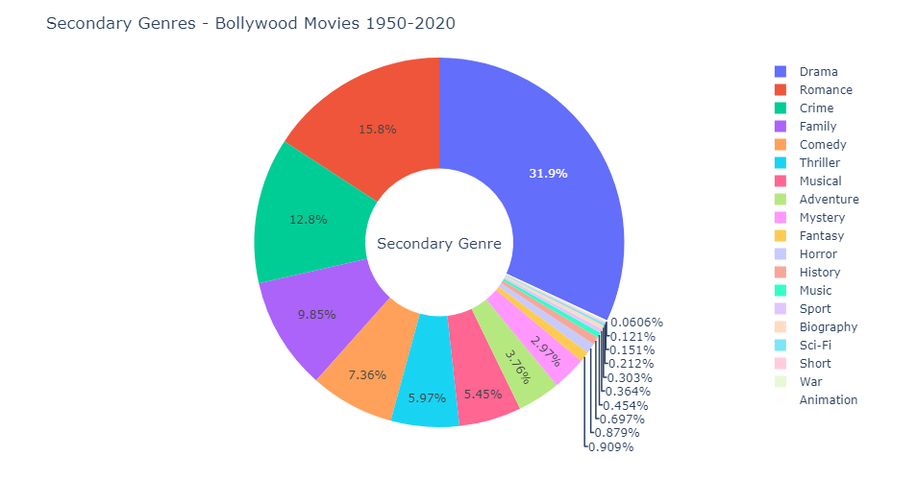
Based on the primary genres as mentioned in the sample movies dataset, we can infer that most popular genres over the last 7 decades as mentioned below with the counts.
(Note the key assumption: The categorization is based on IMDB's definition or categorization as primary genre. To add more insights, I have considered the secondary genres as well, as shown in the pie chart above)

The overall assumption based on above two analysis is to consider below popular genres (counts attached):

Genre Counts

Action 1438
Drama 1401
Comedy 789
Crime 187
Romance 119
Musical 63

Let's focus on these popular genres first for the next set of analyses.

  - Movies production trend for different genres during 1950-2020, and comparative analysis of overall production vs genres:

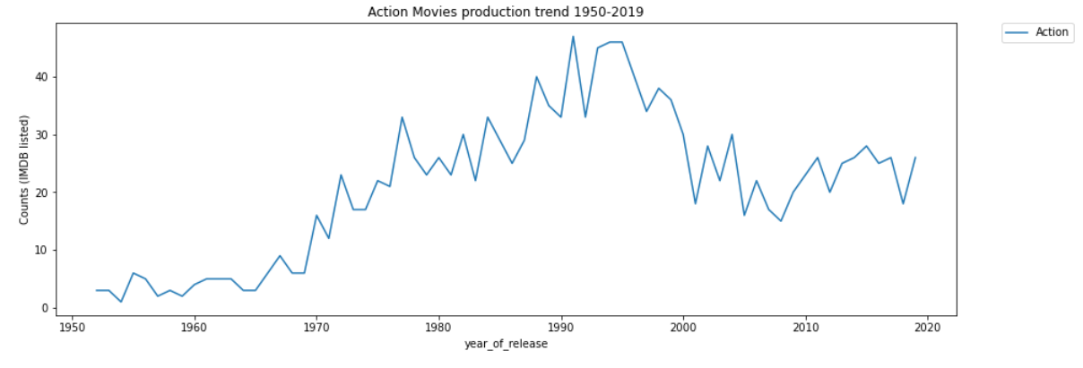
By looking at the above graph, we can deduce some inferences as:
- Action movies overall during the last 7 decades, have shown an increase in production, with a variation of growth trend.
- The peak production years during this selected time period (1950-2019) was the 1990s. During late 80s till late 90s, the production of action movies was at its peak.
- Action movies production took a hit and showed a slowed down pattern post 2000s.

Let's look at the other genres trend, and we can compare these to find more insights.

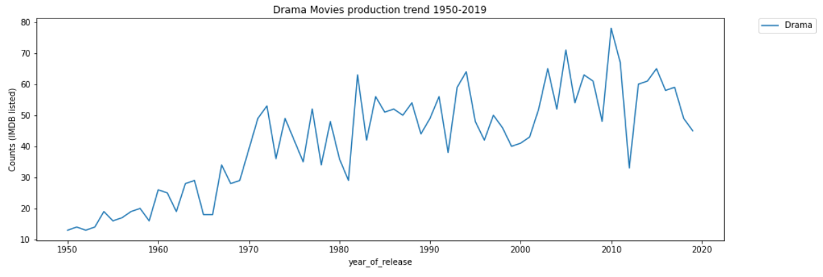
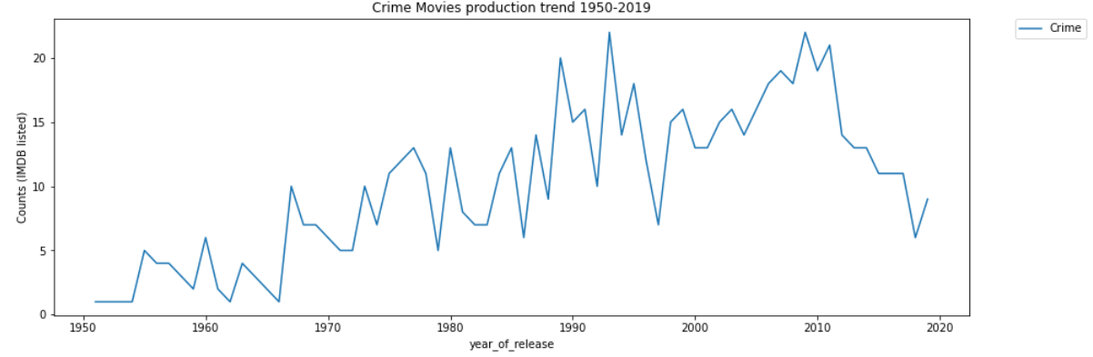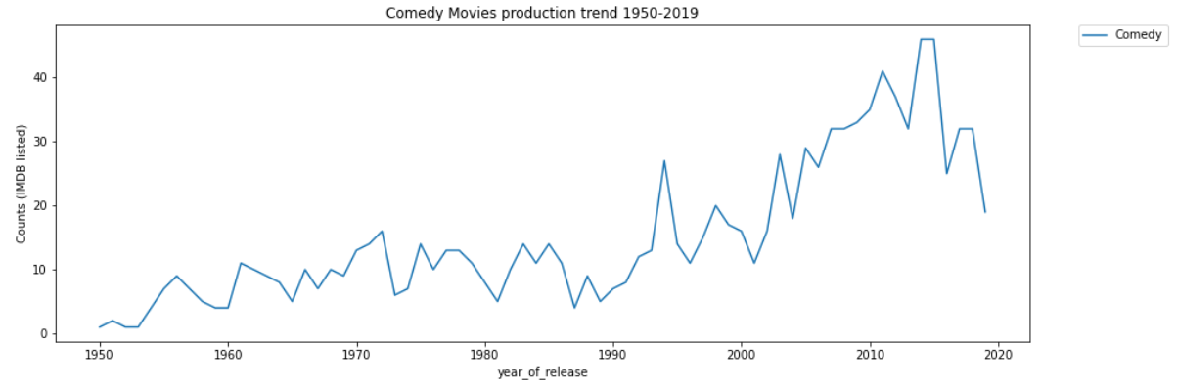
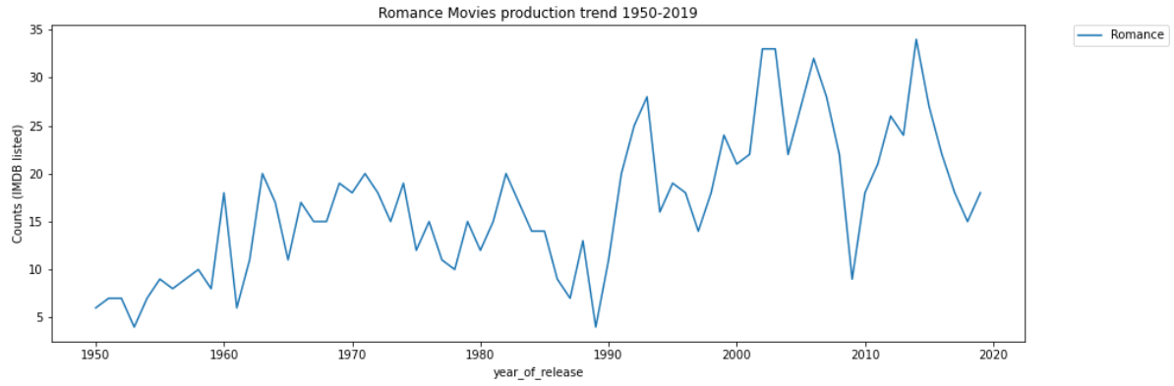
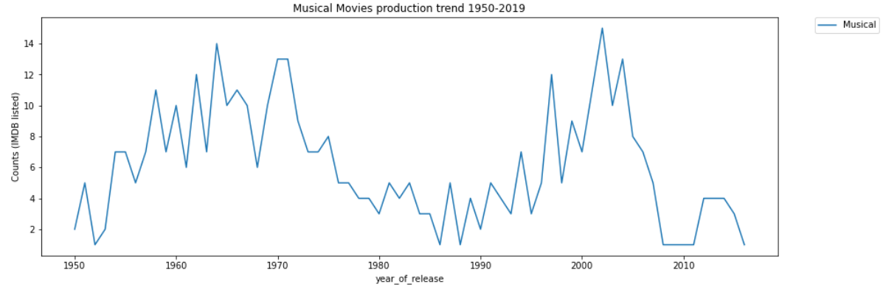

The trend of Musical movies genre is interesting as we can see there is a steep decline during the period 1970s-1990s.
The musical genre gains popularity in production back for a couple of decades starting 1990s-mid 2000s, and then falling again post mid-2000s.
This overlaps with the phase when action movies gained lot steep incline.

Based on the data made available by IMDB's sample dataset, and as we analyzed each of the most popular genres as above, let's try to plot all these genres in a single plot for a comparable analysis and visualization including the overall movies production trend as shown below:
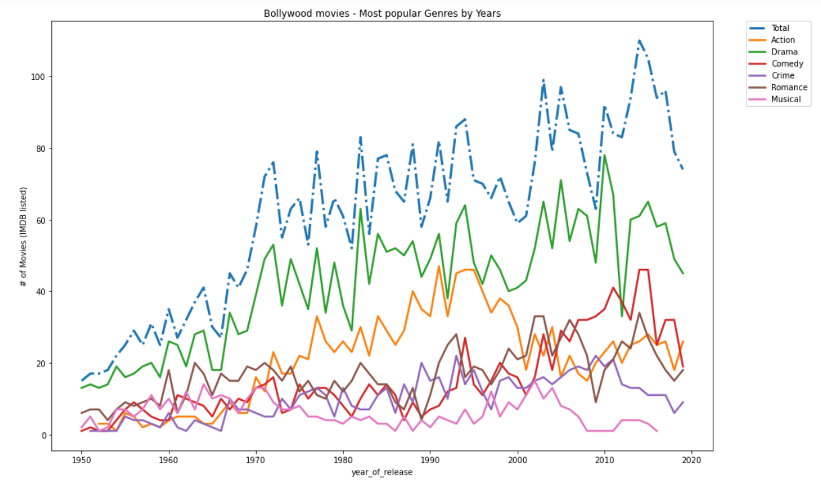
Interpretation:
Looking at the collective graph showing trends of overall movies in the sample dataset, as well as the trend for all the top 6 popular genres, we can infer that:
- There has been a consistent 'overall' growth trend in number of movies produced in last 7 decades.
- The most popular genre in Bollywood movies consistently has been 'Drama'. Afterall, who doesn't love drama!! :)
- Surprisingly, the share of action movies which showed a growth from 1950-1990s, started falling after the late 90s. Does that mean the action heroes started getting old, and were replaced by the romantic young generation?? Very likely!! :)
- Comedy and Romance genres shows a trend of growth but comparatively a slower one. We need to laugh more and be more romantic!! I would like to see a higher growth rate of comedy movies, won't you?? Luckily, after the 2000s, comedy and romance genres are showing steeper rise, which indicates a good sign!
- Musical movies are one of the most fluctuating genres. As we can see that during the period 1950s-1970s there was a nice growth, however the musical movies subject took a big hit during the period 1970-2000, and then an uptick with a steep and down again.

- ‘People perception’ metrics for Bollywood movies:
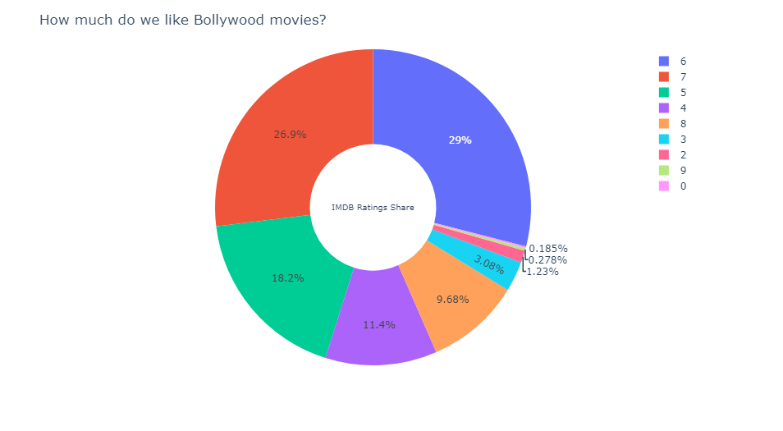

Interpretation:
Looking at this interesting pie chart, we can infer that almost 90% of the Bollywood movies are rated 7 or below. However, approximately 75% of the movies are rated between 5-7, which we can consider as average liking and quality.
On the bright side, approximately 10% of the movies are rated as 8-9. None are rated 10 as per the IMDB ratings.
A lot needs to be done to keep the Bollywood audience happier, and the good thing is that the work is in good progress! How do I know this? Let's have a look at the wins and nominations trend as a next step to know more!

- Trend analysis and comparative analysis for Total nominations won vs total movies produced in each genre:
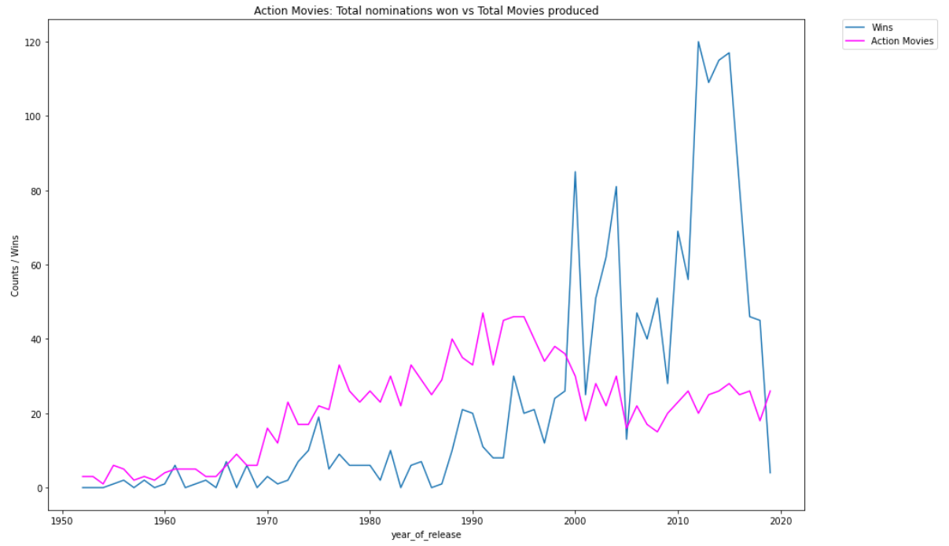
Interpretation:
The above comparative analysis is indeed very interesting. My inferences here are summarized in below points:
- Looking at the trend of number of movies in 'Action' genre, there is an overall growth in numbers and popularity as we can see the overall increasing graph from 1950-2020.
- If we look at the 'Wins' line and trend, it seems the action movies were not winning many nominations during the initial decades from 1950-2000.
- However, we see there is huge spike during the later decades i.e. from 2000-2020.
- The actions movies won a lot of nominations even though the overall number of action movies per year decreased.
- This indicates that Bollywood movie makers, scaled up the movie qualities rather than focused on quantities.
- People loved these action movies, and these action movies won a whopping number of nominations, for ex: Dabangg (2010) - won 50 nominations and similarly movies Kick, Gangs of Wasseypur, Sultan, Chennai Express just changed the trend of winnings by movies in 'Action' Genres.

Let's look at the other popular genres and corresponding wins they secured and the trend in a comparative analysis format:
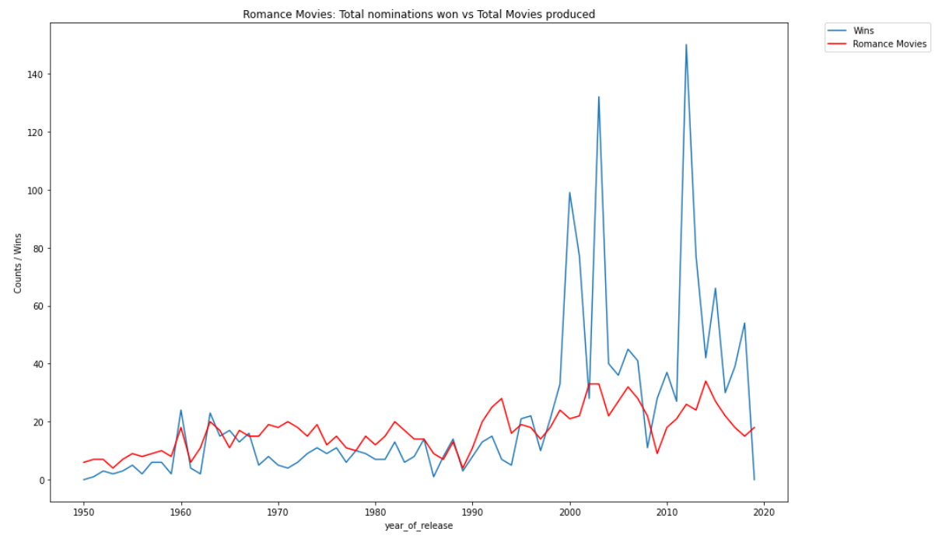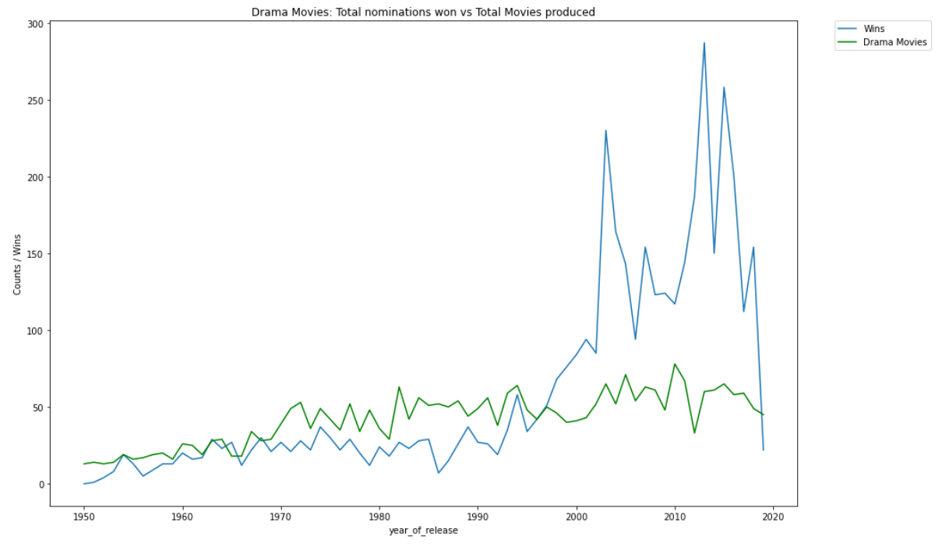
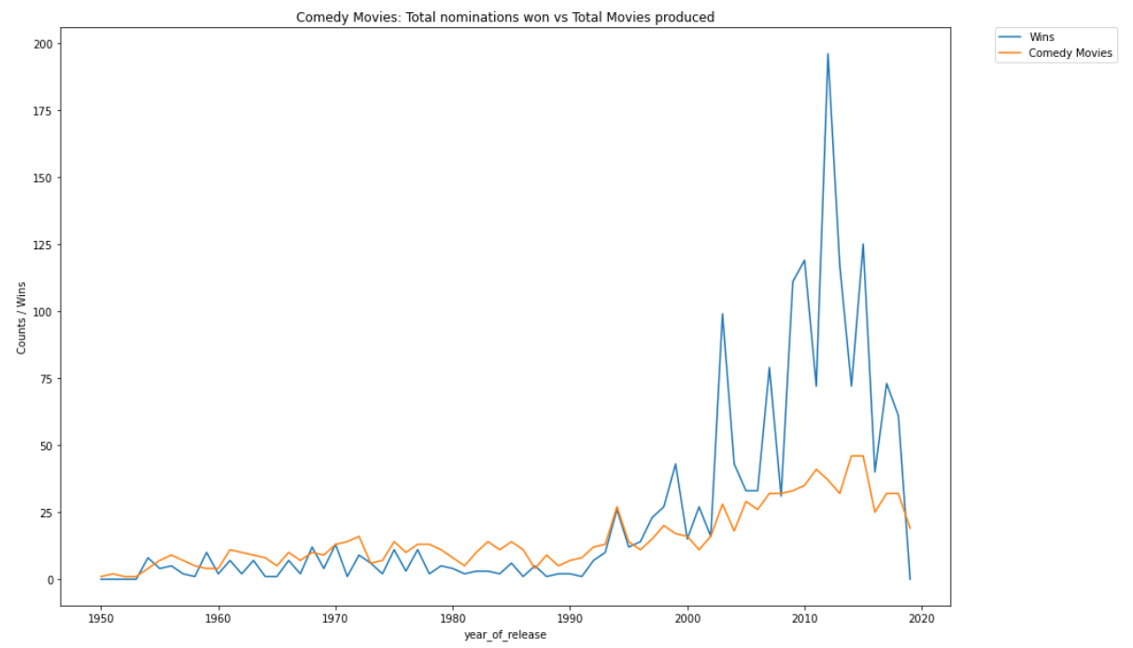
Interpretation:
A very similar trend as we see for Action movies, is what is getting displayed for other 3 genres as well namely Comedy, Drama and Romance. This may be a great indicator of how the quality of Bollywood movies, volume of audience and nomination categories have improved and increased over the period. Certainly, a great positive trend on the quality of movies and viewership!

Let's look at the comparison of how the different genres did among themselves on nomination wins throughout the time period available as part of this sample dataset. We will plot them all together to see the comparative trend. (Just considering the genres - Action, Romance, Drama and Comedy for simplicity and relevance)
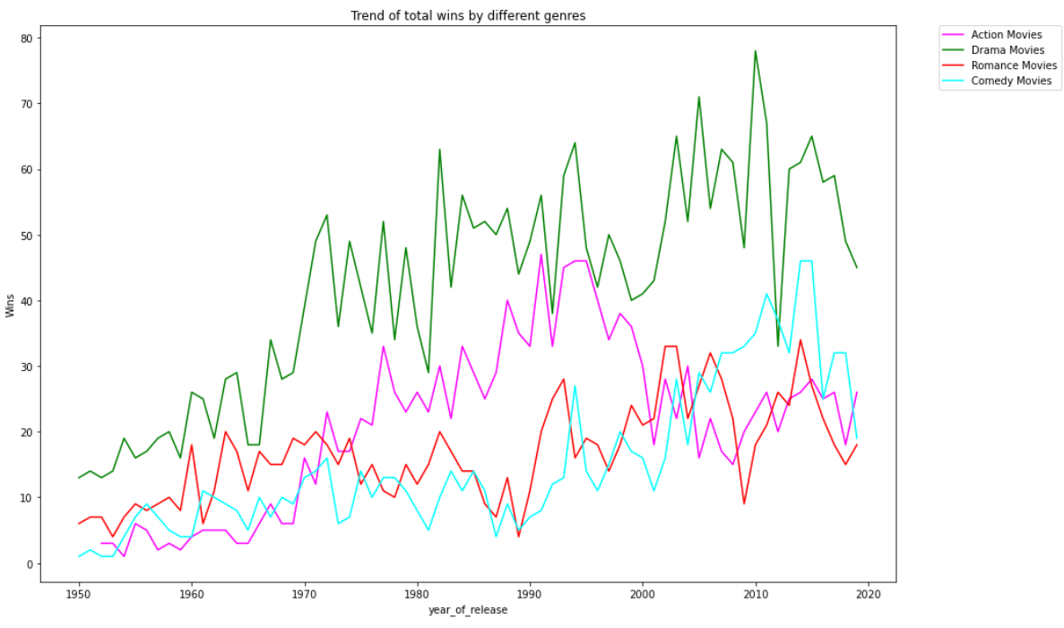
Interpretation:
Quick inferences looking at the wins vs genres trend as above:
- It shows clearly that Bollywood movies under Drama genre are consistently the top winners of nominations.
- The action movies during the 80s and 90s were gaining quiet popularity, however, meets a decline post 2000.
- Comedy movies show an interesting incline in wins post 200s.
Time to think - is the new generation liking more drama and comedy? Quite likely! :)

- World bank Data: Socio-economic analysis based on per-capita income and population growth indexes:
Now, let's have a look at some social factors of the audience and masses in India, that is the movie audience assuming there is a relation and reach of population's choice over the type and quantities of movies made.
Let's analyze the growth trajectory of Per Capita Income of Indian population over the several decades.
May be these assessments give us some visual patterns!
Source of data: Socio-economic data for India over last 50 years, through: https://databank.worldbank.org/reports.aspx?source=2&country=IND

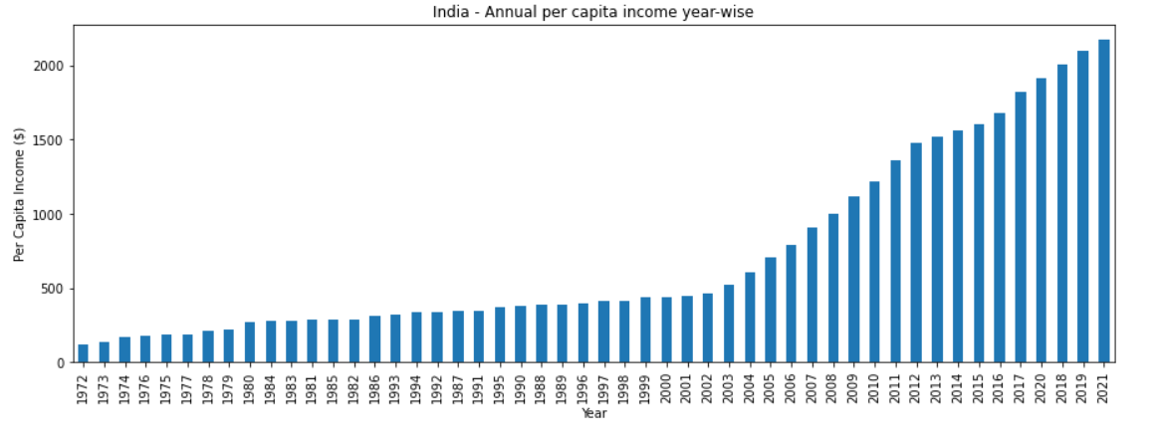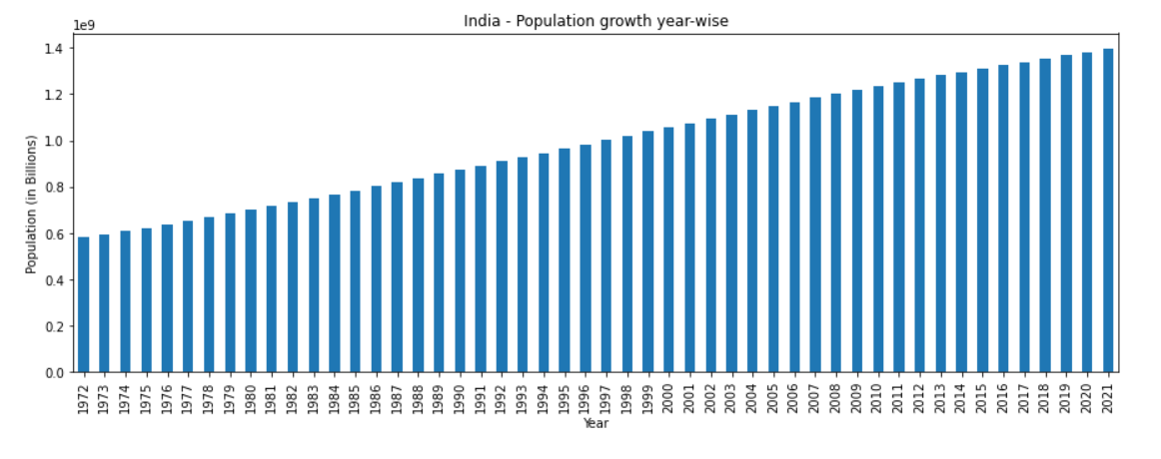

Interpretation:
- We can see that the per-capita income has shown an incline specially a steeper one post 2000s. Let's also look at the 'Population' growth trend over the years 1970-2021.
- Very obviously, the expected population trend was a growth trend, however what is interesting to see here is that it is almost a perfect linear growth trend!

- Comparative analysis of trends in Bollywood Movies vs India’s socio-economic trends:

Let's utilize all the data and analytics above that we have derived till now to see if there is a visual relation or pattern between:
- Overall movies production trend
- India's per capita income growth trend
- Movies genres trend
- India's population growth trend
Let's try to plot 4 graphs side by side to infer the trend and possible correlation based on data visualization only:
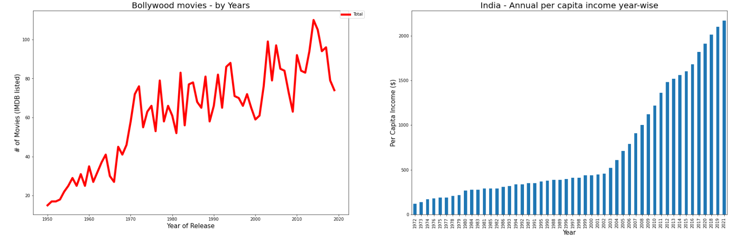
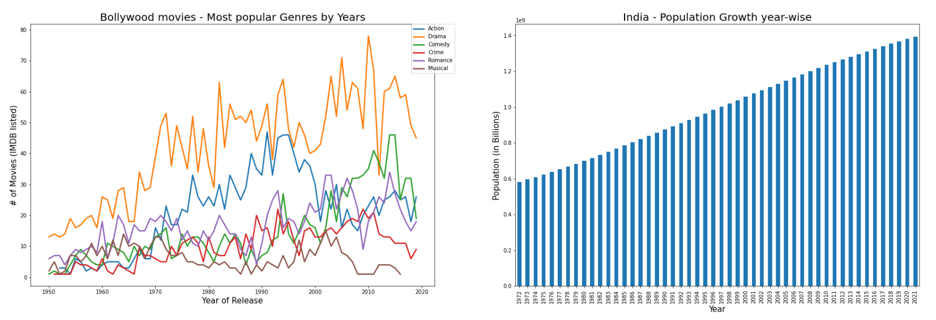

Interpretation:
Looking at the 4 visualizations across movies and socio-economic data, we can draw some key inferences as:
- 1950s - 1970s older generation: Drama and Romance were the top genres
- 1970s - 2000s middle generation: Drama and Action movies were the top genres
- 2000s - 2020 new generation: Drama and Comedy movies are the top two genres by production
- There is a steeper rise in per-capita income of India post 2000s, and coincidentally we see a steep rise in movies being produced the nominations as well won by Indian movies (refer wins and nominations).
- This may be correlated that with higher income to spend, Indian population did find time and money for entertainment through movies, which may be the reason of higher quality and quantity rise in movies.

There may be some more correlation and deeper connections possible, which can be derived using the statistical analysis and correlation algorithms. However, considering the scope of this course and exercise being limited to data visualizations method and analysis, I'll conclude at this point with the above-mentioned inferences.
Conclusions, learnings & future work:
The project idea started with a personal inspiration and thought process having interest in Cinema and Art.
The inspiration was further encouraged by existing scholarly artciles, journals and available data through public domains.
Through this project research, I have some ley learnings on the subject and technical fronts, which I would like to summarize as below:
Conclusion on the subject:
- Identified that the genres like Action, Drama, Comedy and Romance were the biggest choice of filmmakers and naturally audience during the last 7 decades of Bollywood movies.
- Bollywood movies are showing a significant positive growth both Qualitatively and Quantitatively, considering the growth in production numbers and awards won.
- This indicates that the Bollywood movies industry is thriving towards more poular and successful trend.
- The most popular genre in Bollywood movies consistently has been 'Drama'. Afterall, who doesn't love drama!! :)
- The new generation liking more drama and comedy! More fun than action & crime!
- Overall conclusion and finding:
  - 1950s - 1970s older generation: Drama and Romance were the top genres
  - 1970s - 2000s middle generation: Drama and Action movies were the top genres
  - 2000s - 2020 new generation: Drama and Comedy movies are the top two genres by production
- 'People perception' metrics for overall bollywood movies indicate that hardly 10% of the movies are rated 8+, as well as a message for the filmmakers to improve the content and quality to improve the audience perception and staisfaction score.
- While the 'People Perception' metric indicates that a lot needs to be done to keep the Bollywood audience happier, the 'wins & nominations' growth trend shows a positive sign that this work seems to be in good progress!
- There is a steeper rise in per-capita income of India post 2000s, and coincidentally we see a steep rise in movies being produced and the nominations as well won by Indian movies. Great indicators of an improving economy and a happier & better lifestyle trend.
- This may be correlated that with higher income to spend, Indian population did find time and money for entertainment through movies, which may be the reason of higher quality and quantity rise in movies.

Learnings:
It has been a great learning experience working on this project right from the conception of the idea, selection of data, approach build, design, data preparation, build and interpretation of the visualization outcomes.
There are some key learnings that I would like to mention:
  - Learning the process of researching existing work done and getting inspiration to come up with a better approach and new findings.
  - Data selection and analysis of right data sources.
  - Data preparation: It is probably the toughest part of the job! I learned so many methods to clean-up and organize the data, and realized that a clean and structured data is the key to successful data analytics and visualization.
  - Data Visualization methods: Using several python libraries and functions, I learned a lot about the power of python and visualization patterns to express your findings and analysis.
  - The process of writing a paper or report itself is a great stimulation that invokes so many great ideas and thoughts, that we may miss if not gone through this exercise!
  - The importance of building a team. This is a step that somehow, I missed, and could not timely form a team! Having a team makes it lot more fun and education when you have partners to collaborate and share the ideas and learnings.
Future Work and Scope:
The scope of this analysis is limited to data analysis using visualization methods, however in future, adding a statistical analysis may help bring more insights to the subject.
I plan to learn further statistical methods and use the correlation algorithms and techniques to go deeper into identifying and predicting the correlations of movies, art and societal parameters.

References
- https://globaljournals.org/GJHSS_Volume19/3-Art-Cinema-and-Society.pdf
- https://academic.oup.com/screen/article-abstract/12/1/15/1694174?redirectedFrom=PDF
- https://en.wikipedia.org/wiki/File:Hindi_movie_production_trend.pdf
- Movies, genres, crew, nominations, year, and related data from:
https://github.com/pncnmnp/TIMDB/tree/master/1950-2019 (Credits: Parth Parikh)
- Socio-economic data for India over last 50 years, through:
https://databank.worldbank.org/reports.aspx?source=2&country=IND
- https://twitter.com/unescostat/status/715924506066436097?lang=fi
- https://en.wikipedia.org/wiki/File:Hindi_movie_production_trend.pdf
- Vineet's github code repository: https://github.com/vineet9rai/mycodes

