**To setup the local environment**

**Step 1 – Downloading the free open source cross platform web server MAMPP**

**For Windows:** [Click Here](https://drive.google.com/file/d/1Ket9UT6cYbojQNlauShLeTb1JICuYYPa/view?usp=sharing)

**For Mac:** [Click Here](https://drive.google.com/file/d/1KjZSdDQTyCNFMyG4xlkJXLlBKyJdgw5X/view?usp=sharing)

**Step 2 – Install the downloaded package**

* Double click on the .exe file for windows user or .pkg file for mac users.
* The below steps are for the mac users, but a similar popup will appear for windows users as well.
* The following installer window will pop up.

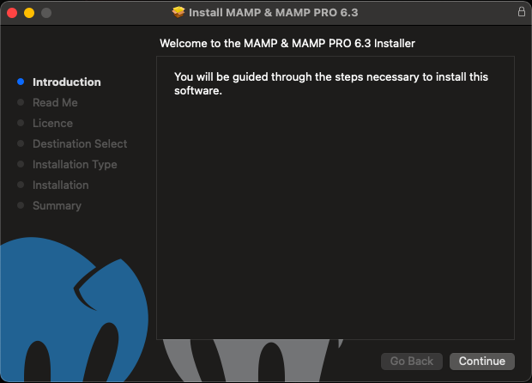

* Keep the default settings and select next at each step until you reach the finish screen

**Step 3 – Download the zipped folder from the repository**

**Repository Link:** [Click Here](https://github.com/shikhar-anand/ApricusBuds)

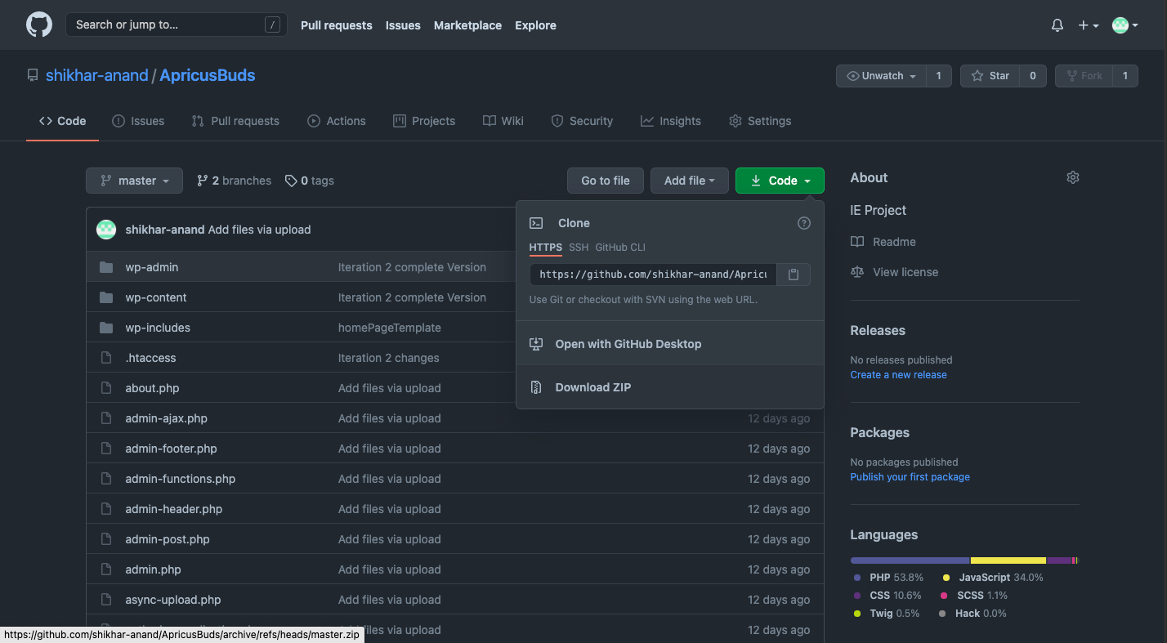

To download the zipped folder, go to code and select download zip

**Step 4 – Extract the downloaded zip**

**Step 5 – Copy all the content**

**Step 6 – Create a folder named apricustravel inside the htdocs folder in MAMP**

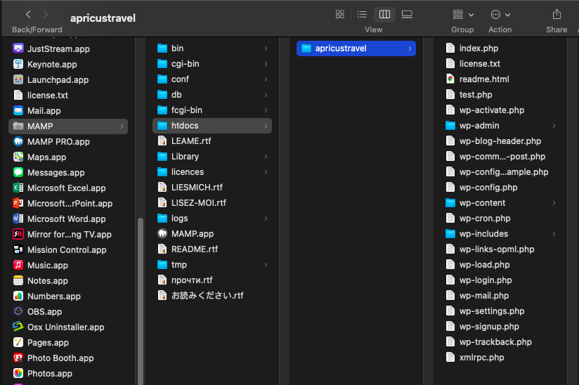

**Step 7 – Paste the copied content in that folder**

**Step 8 – Download the database file localdb.sql:** [Click Here](https://drive.google.com/file/d/1KaI8WueURXXg27-xpZM_IajlJY9SYzIa/view?usp=sharing)

**Step 9 – Select phpMyAdmin in MAMP**

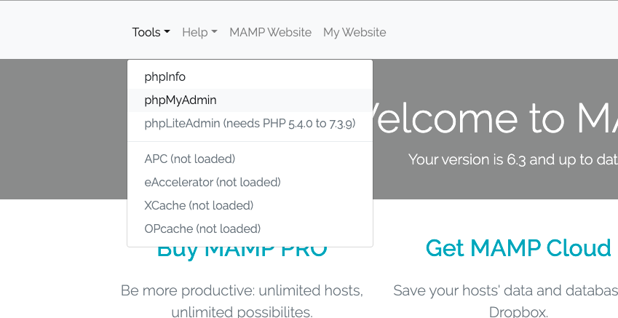

**Step 10 – Once you are in phpMyAdmin, select Import**

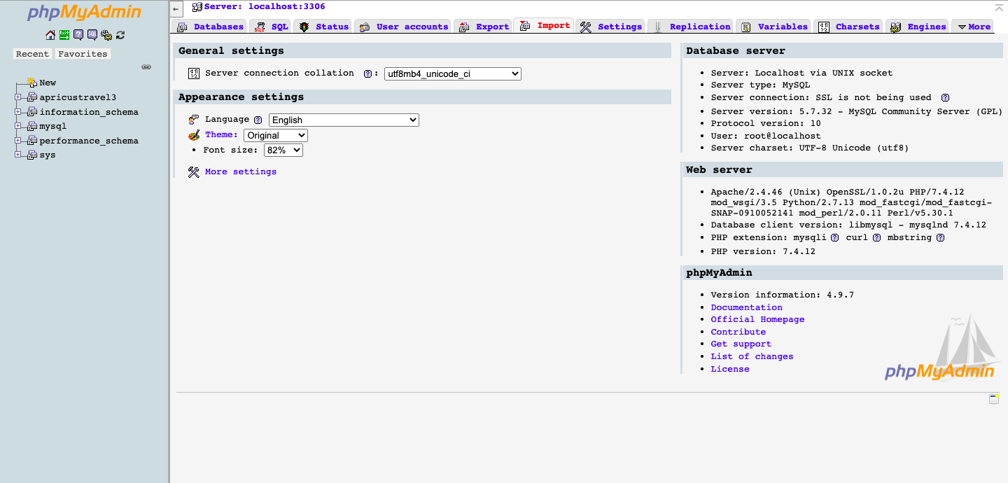

**Step 11 – Upload the downloaded database file localdb.sql from Choose file button and select go**

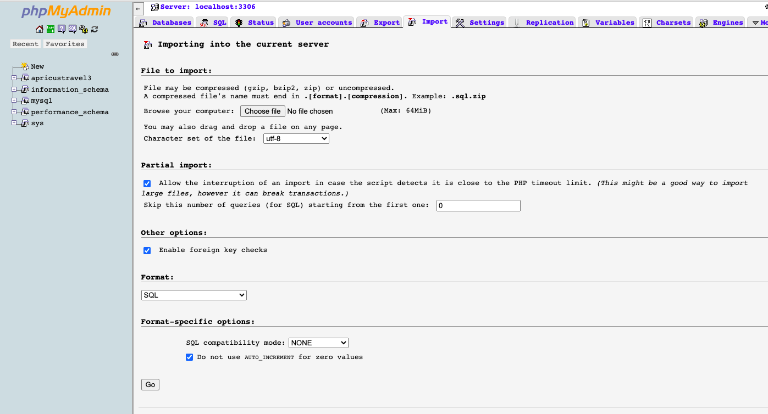

**Step 12 – Stop and Start the MAMP and Click on WebStart**

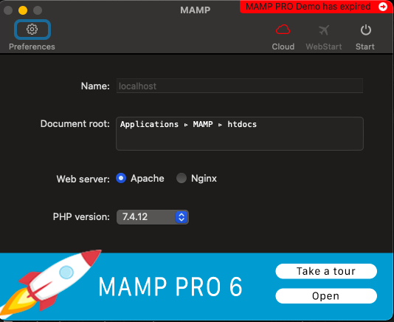

**Step 13: Click on My Website**

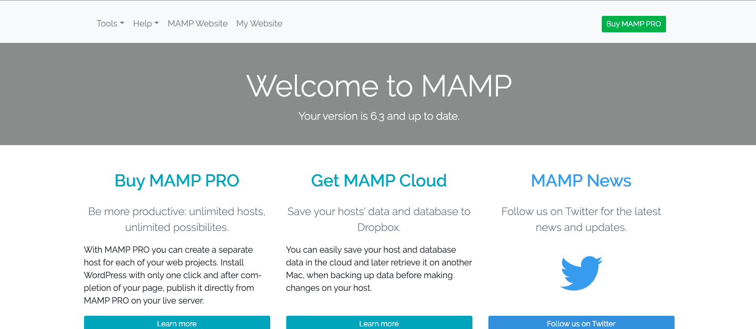

**Step 14:** [Access the website](http://localhost/apricustravel/wp-admin/)

**Step 15: Enter the login credentials**

Admin – admin

Password – Apricus@123

**Step 16 - Start developing and modifying the website.**

THANK YOU