Arduino Fundamentals
& Applications

By: Amit Kumar Mishra



Published by:
BFC Publications Private Limited
CP-61, Viraj Khand, Gomti Nagar,
Lucknow-226010

ISBN:

Copyright (c) – Amit Kumar Mishra (2020)

All rights reserved.

No part of this publication may be copied, reproduced, strode in a retrieval system or transmitted in any form or by any means including photocopying and recording without specific prior permission of the publisher. Any person who does any unauthorized act in relation to the publication of this work may be liable to legal proceedings and civil claims for damages.

The views expressed and the materials provided in this book are solely those of the author and presented by the publisher in good faith. All the names, places, events and incidents are either the product of the author’s imagination or are used fictitiously. Any resemblance is purely coincidental. The author and the publisher will not be responsible for any action taken by a reader based on the content of this book. This work does not aim to hurt sentiment of any religion, class, sect, region, nationality or gender.

Contents
Sr. No. | Chapter Name | Page No.
 | Microprocessors and Microcontrollers | 04
 | Peripheral Interface-I | 18
 | Peripheral Interface-II | 29
 | Labview Programming | 45

CHAPTER-1
MICROPROCESSORS AND MICROCONTROLLERS

The microprocessor and microcontroller are produced by the same individuals and marketed to the same types of device designers and programmers based on the same basic concept. So what is the difference between the two?
Microprocessors
A microprocessor, as it is known, is a digital computer central processing unit for general purposes (CPU). Although widely referred to as a "computer on a chip" the microprocessor is not a complete digital computer in any sense.
A microprocessor block diagram is represented in Figure 1.1.
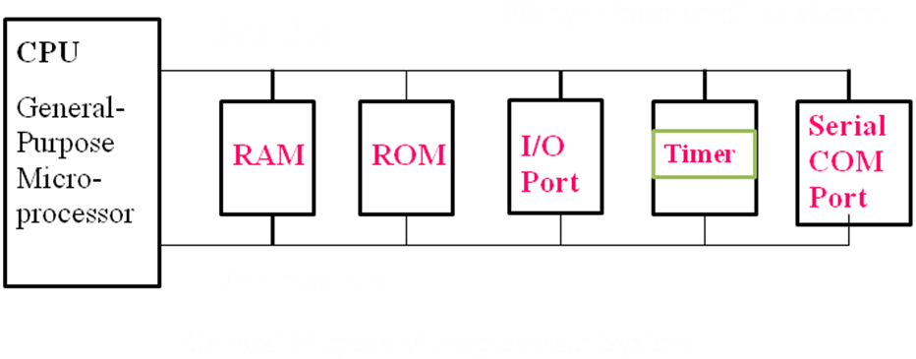
General-Purpose Microprocessor System
The primary use of a microprocessor is to gather information, perform detailed measurements on that information and store those measurements in the mass storage devices or display the results for human use. As the user directs, the programs used by the microprocessors are stored in the mass storage unit and loaded into RAM. The ROM stores a few microprocessor programs. ROM-based programs are mostly small fixed programs that run peripherals and other system-connected fixed devices. In the anticipation of commercial success in the marketplace, the design of the microprocessor is based on the desire to make it as expandable as possible.
Microcontrollers
A computer device is basically a microcontroller and is a single integrated circuit ("silicon chip" or IC) used to form part of a product that integrates control of some software programs. It can be used in applications involving power, operator and user display generation, simple sequencing and many other mundane tasks, as a microcontroller is essential part of a computing device. In the past, the use of large computers may have required the implementation of the control functions made available by microcontrollers, but the continuous trend towards reducing size and low cost has meant that very low unit costs and low implementation costs have been achieved by microcontrollers. As such, the microcontroller is a very versatile electronic instrument to be used in a very wide variety of applications for products and processes. A low cost computing solution is provided by microcontrollers. Alternative computing solutions, including personal computers and programmable logic controllers, come in many types. Personal computers (PCs) are used at high speed to process high data volumes, and microprocessor devices are integrated. These devices may be considered as a 'cousin' of the microcontroller system, but are designed for manipulating high data volumes and providing the facilities for operating at any time for multiple tasks or windows. Due to this high performance capability, microprocessor devices are comparatively high-cost products as compared to microcontrollers. In many different application areas, microcontrollers are found, including domestic appliances such as microwaves, television and television remote control units, stereo units and, increasingly, in motor control vehicles, control units for cabin heaters, display instrumentation and many other tasks. Microcontroller’s widespread availability is a testimony to their flexibility and low unit cost. Some hints as to the potential for their use in any product or process are also provided by a consideration of these application areas. The control of a TV or microwave unit obviously does not require the use of the vast computing power contained in your PC. A study of the simple control facilities is made possible by the use of low-cost microcontroller devices which offers guidelines for the evaluation of your company's use of this technology. It is not easy to describe a microcontroller computer, but a microcontroller unit may generally be regarded as a computing device providing internal memory and a high level of options for input and output (I/O) applications. The use of a microcontroller devices preferably minimizes the number of external devices used in the system and incorporates as much of the external interface as is technically possible with switches, motors or other input/output devices.
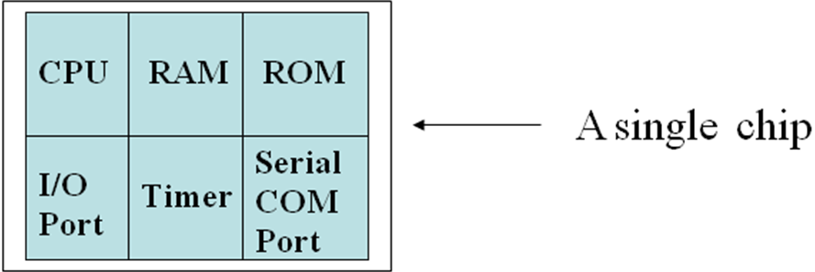

Difference between microprocessor and microcontroller
The comparison between a microcontroller and a microprocessor is best explained by the fact that there are many operating codes for most microprocessors to transfer data from external memory to the CPU; there may be one or two microcontrollers. There might be one or two forms of bit handling instructions for microprocessors; microcontrollers will have several. The microprocessor is concerned, to summarize, with the rapid movement of cade and data from the external address to the chip; the microcontroller is concerned with the rapid movement of bits within the chip. With the inclusion of no outside digital components, the microcontroller will act as a computer, to be usable; the microprocessor must have several external parts.
Microprocessor | Microcontroller
The primary use of μp is to performcomprehensive calculations on thatdata to read information and store those calculations in a mass storage system or display the result for human use. | The primary use of a μc is to monitor a machine's operation using a fixed programme, i.e. stored in ROM, and this does not alter over the life of the device.
μp has no RAM, no ROM, and no I/O chip of its own. | In addition to a set amount of RAM, ROM, I/O port and a timer, μc has a CPU all on one chip.
The μp deals with the rapid transfer of code and details from the external address to the chip. | The μc is concerned with bits moving rapidly inside the chip.
There are a number of extra components needed for μp to be operational. | With the addition of no outside digital components, μc will act as a device.
μp has several operating codes to transfer data to the CPU from external memory. | μc can have one or two instructions to transfer data to the CPU from external memory.
μp can have one to two  types of instruction on bit handling. | μc has several instructions  for handling the bits.
μp is intended as a  digital computer for general use. | Special purpose digital controllers are supposed to be μc.
A CPU, memory addressing ckt and ckt managing interrupt is included in μp. | These features include μc, timers, parallel and serial I/O, internal RAM, ROM,
There are no programmable pin functions available. | Many models have programmable pin features that allow the  loss of I/O functionality to be added to external memory.
High Operating Speed | Low Operating Speed
Example: Intel 8085,8086,80286, Pentium, Motorola’s 680X0 | Example:8048,8051,8031, PIC16X. ARM 7
Application: Personal computers | Applications: Fax machine, remote controls, printer, engine control, security system, camera.

Some product using Microcontroller
- Keyboard
- Printer
- Video game player
- MP3 music players
- Embedded memories to keep configuration information
- Mobile phone units
- Domestic (home) appliances
- Automotive controls
- Toys
- Fax Machine

Classification of Microcontroller
The architecture of microcontrollers is categorized on the basis of different characteristics. Based on a variety of instructions, one very common classification is: CISC (complex instruction set computer), RISC (reduced instruction set computer). Marketing personnel, however have muddled these words a lot. A CISC processor also has several RISC-like characteristics, and it has become very confusing. Another classification is based on how the application and data memory are accessed; the Princeton or Von Neumann architecture is considered as a unified memory model versus the Harvard architecture, which provides separate memory for program storage and data storage. Another classification is on the basis of how within the CPU the internal data is processed and manipulated. The role of a microcontroller is to tamper with data. With the aid of a user program, a microcontroller (or a microprocessor) manipulates data. The foundation of various processor architectures and yet another classification scheme is the way this information is stored and accessed internally in the CPU and the way it is processed. There are four basic Models: stack, accumulator, memory-register, and registration-register (known as load-store).
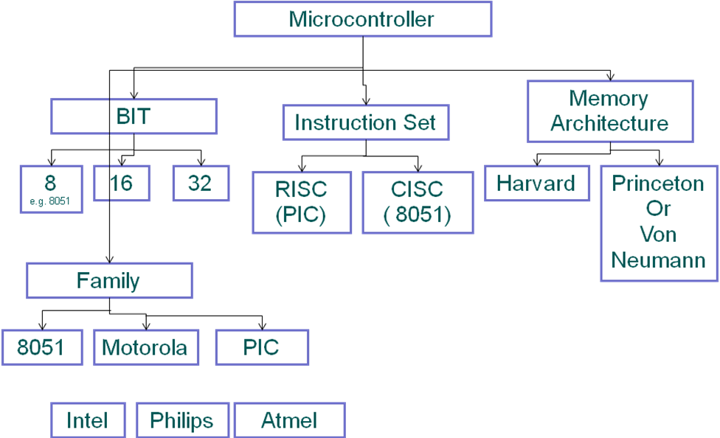

Selecting a Microcontroller Device
Hundreds of microprocessors and microcontrollers are practically on the market, and it can be a nightmare to select a specific one for your application. In general, one begins by listing one's requirements in terms of features and costs and then contrasting them with what is available. Other considerations, such as industry dynamics, business profile, prominence, local system design expertise, etc., can also determine the final selection. Meeting the computing needs of the task efficiently and cost effectively
- Speed,
- The amount of ROM and RAM,
- The number of I/O ports and timers,
- Size, Packaging,
- How easy to upgrade to higher performance or lower power-consumption versions
- Cost per unit

The choice of the optimal microcontroller system is sometimes as confusing as contemplating the variety of PCs provided by businesses in your high street computer sales space, since a microcontroller device is a computing device. Understanding the jargon and setting goals are the secret to choosing the optimum unit.
The most important characteristics of selecting PCs are the memory available, the speed of the processor, and its interface features. This is no different for microcontrollers. Memory capacity is segregated into program space and scratchpad, temporary space; these are termed ROM (read only memory) and RAM (random access memory) respectively.
Technical support requirements define the selection of the microcontrollers. The most important technical selection criteria ensure that your selected device has enough memory. Without adequate memory (especially ROM memory) your program control solutions will not function at all! Program memories can be internal to the device or external to the device. Obviously internal memory offers the most compact design solution, but limits memory size. External memory allows more memory to be used but requires additional inputs and outputs on the microcontroller to physically connect itself to these devices. Internal program memory (ROM memory) can vary in size between the limits of 512 Bytes to 64KBytes, typically. To scale these values into meaningful values, the use of a 512 byte program device would be adequate for the simplest control systems (for example, sensing, processing and controlling one interface), whereas the 64Kbyte memory device would enable multiple, complex control to be provided with a reasonably simple LCD (liquid crystal display) interface. In general, memory size is related to product cost. Therefore the minimum size microcontroller in terms of memory capacity should be used. However, sizing the program size is not an easy process, and requires some experience.
Other technical selection criteria include speed and I/O capability.
Processing speed is not to be measured in the number of MHHZ quoted by the supplier as the ‘clock speed’. This is a guide, but other factors, such as the number of instructions required to perform a time delay, addition or other common instruction may be important. RISC (reduced instruction set complexity) based microcontrollers may often perform simple tasks more effectively than other microcontrollers event though they may be operated at slightly lower clock speeds.
I / O capability are easier to assess. A wide range of I/O options are available, including:
- Analogue inputs (typically 8 bit or 10 bit (<1% accuracy) resolutions).
- Parallel digital outputs, sometimes capable of directly driving LED (light emitting diodes) with < 15mA output capabilities.
- Parallel digital inputs.
- Timer inputs, for use in event or interval counting.
- Timer outputs, often used in PWM (pulse width motor) control.
- Serial communications, for example to interface via RS232 interfaces to PCs.
- Display driver facilities. Although less frequents some microcontroller units integrate LCD drivers into the device.

Analyzing the I/O requirements of a design application is often simpler than estimating program size. A simple list based on the number of physical devices connected to the controller often allows an accurate assessment of microcontroller I/O to be made. For example, itemize the number of sensors (1 analogue input per sensor?), discrete switches (one digital input per switch) etc.
If the total number of inputs and outputs exceeds the available I/O availability of the device then multiplexed solutions may be used (this means using the microcontroller to ‘address’ or select each I/O independently of its neighbours), but this requires additional hardware. This compromise experience to evaluate, and guidance and training from a subcontractor at this stage may be useful. Having conducted this evaluation process, one further complexity arises; the selection of device options. Options include:
- One time programmable (OTP) devices: Devices programmed by the user in the production of the environment at a once only on a basis.
- Re-programmable devices: These were generally based on the windowed UV or electrically erasable devices, and were very convenient for prototyping and trialing designs.
- Flash devices: These are a variation of re-programmable devices, now increasingly becoming popular. They are often in-circuit programmable.
- Masked (ROM) devices: These are the devices with the users code physically incorporated into the device by the device manufacturer. This offers lower costs in high volumes.

It is generally advised to ensure a re-programmable option to support the development of prototype units before conversion to OTP devices. The availability of these devices should be investigated.
RISC AND CISC CPU ARCHITECTURES
Microcontrollers with small instruction set are called reduced instruction set computer (RISC) machines and those with complex instruction set are called complex instruction set computer (CISC). Intel 8051 is an example of CISC machine whereas microchip PIC 18F87X is an example of RISC machine.
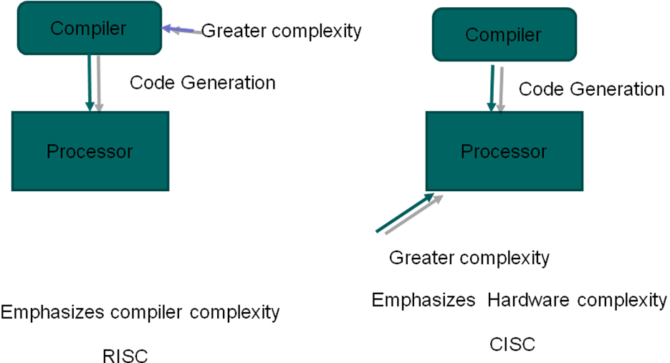
HARVARD & VON- NEUMANN CPU ARCHITECTURE
There are two architectures to remember when considering how memory is accessed at the CPU level. The first one is the architecture of Von Neumann, and the second is the architecture of Harvard. The key difference between the two architectures is that all the memory will store all program elements, data and instructions in a Von Neumann architecture; the memory is split into two memories in a Harvard architecture, one for data and one for instructions.

Harvard Architecture
It can be seen in the block diagrams that the address lines of the memory and file register are distinct from the data paths within the processor. This is referred to as the Harvard architecture; it increases the speed of operation of the processor since the same bus lines do not have to exchange data and addresses. Decoding is also speeded up by the reduced size of the instruction set and the short data path length in a single chip system decreases data transmission time. A 'pipeline' arrangement is often used by the program execution hardware; when one instruction is executed, the next is fetched from program memory, overlapping the processing of instructions and thereby doubling the total execution rate. Compared to traditional microprocessors that use a classical (Von Neumann) architecture, all these features lead to a high speed of operation in which the software and data share the same data bus and memory space.
CPU
Program Memory
Data Memory

Von Neumann architecture
Von Neumann architecture was first published in 1945 by John von Neumann. The Control Unit, Arithmetic and Logic Unit (ALU), Memory Unit, Registers and Inputs/Outputs are the part of his computer architecture design. Von Neumann architecture is based on the idea of a stored computer program, where instruction data and program data are stored in the same memory. In most computers produced today, this design is still used.
CPU
Program Memory and Data Memory

Application Designing with a Microcontroller
Now that we have a little bit of inside knowledge about microcontrollers and what can be achieved with them it is time to figure out how to use these controllers to build applications.

Let us list one of the possible roadmaps for designing a system based on a microcontroller.
- Define the requirements.
- Build adequate documentation in the form of block diagrams, flowcharts, timing diagrams, etc to support the specifications.
- To have the required functionality, look for suitable hardware. This may help the designer to understand whether or not a microcontroller is needed at all.
- If you need a microcontroller, identify an acceptable microcontroller that can serve as the device's brain.
- If you have defined the controller, double-check that the microcontroller actually meets the speed, power consumption, etc. specifications. Otherwise to pick another controller, you would have to iterate once again.
- As a next step, all the instruments to help build the hardware and software would need to be acquired. If you wish to program in a high-level language, these tools can include an assembler and/or a compiler, a controller simulator, a hardware emulator, an evaluation board, a controller programmer, etc.
- You may start designing and constructing a prototype if you are already familiar with this specific controller; otherwise by writing sample programs and checking them on the evaluation board or on the machine simulator; you will have to get acquainted with the controller.
- You can start partitioning the program into manageable blocks once you become familiar with the controller's functionality, which can be written as sub-routines and checked independently. The creation of hardware will go on in parallel, and you reach a stage that could be called the test-and-debug process. This is an iterative process that continues until all the hardware and sub-routines functions as required. In order to complete this level, you have to minimize the number of iterations, as many test equipment and development resources (such as a compiler and an emulator) as possible must be used.
- Finally, you have to integrate and test all the software and hardware again. Then enter the test-and-debug process again before everything works as needed.
- A significant task that should not be skipped is documentation during the writing of the software and constructing the hardware. Not only for keeping a record of your work, but also for testing during system life and potential revisions, recording the design is extremely important.
- The final stage includes the device being implemented in the target environment or the production line that is necessary.

SUMMARY:
- Between microprocessors and microcontrollers, the fundamental differences are:
- Microprocessors are intended to be digital computers for general usage, while microcontrollers are intended to be digital controllers for specific purposes.
- Microprocessors have a CPU, circuits for addressing memory, and circuits for disrupting handling. As well as timers, parallel and serial I/O, and internal RAM and ROM, microcontrollers have these features.
- Many models have programmable pins that allow the inclusion of external memory with the loss of I/O functionality.
- The Von Neumann architecture consists of a single, shared program and data memory, a single memory access bus, an arithmetic unit, and a control unit for the program. Fetching and execution cycles are operated by the Von Neumann processor.
- There are two distinct memory spaces dedicated to program code and data, two corresponding address buses and two data buses for accessing two memory spaces in the Harvard architecture. The Harvard processor provides concurrent fetching and execution.
CHAPTER-2

PERIPHERAL INTERFACE-I

Concept of GPIO in AT mega 328P based Arduino Based
  - A GPIO pin is a general purpose "input/output" pin. This pin has two logic levels high or low. The levels high and low are assigned w.r.t supply nitage e.g if a pin is at 5v it is at logic high and if pin is at 0v it is at logic low.
GPIO pin are arranged in groups called parts.
  - At mega 328 support three I/0 parts. Part B, Part C and Part 0. Part B (PB₀−PB7) is an 8 bit bi-direchoral part. Part C (PC₀−PC6) is a 7 bi-directional part. Part D (PD₀−P₀7) is an 8 bit bi-direthional part. This AT megal 328 P has (.8+7+8) 23 programmable = 10 lines.
  - These 23 I/0 lines can be used for input/output. At instant, a pin can be configured as an input pin or an output pin but not both.

Digital Input and Output
AT mega 328 P has 6 analog Input pins are 14 digital input/output pins from which 6 can be used as PWN output.
13
12
11
10
9
8
g
6
5
6
3
2
1
0
328 P
ATMEGA
A₅
A₄
A₃
A₂
A₁
A₂
A
USB
Power part
Figure 2.1: Analog and Digital I/0 pins on Ardwire
Digital pin

At mega 328P has 23 programmable I/0 lines Howers pin 6 PC6 is used for reset a line pin PB6 and PB7 may be used for crystal oscillators.
1 PCC
2 PD₀
3 PD₁
4 PD₂
5 PD₃
6 PD₄
7 V_{CC}
8 GND
9 PB₆
10 PB₇
11 PD₅
12 PD₆
13 PD₇
14 PB₀
Digital pin 0
Digital pin 1
Digital pin 2
Digital pin 3
Digital pin 4
AT mega 328 P
Crystal
Digital pin 5
Digital pin 6
Digital pin 7
Digital pin 8
Figure 2.2: Digital input and mapping on Arduise
9 Digital I/0 pins
PC₅ 28
PC₄ 27
PC₃ 26
PC₂ 25
PC₁ 24
PC₀ 23
22
A_{REF}²¹
6ND
6 Analog pin
AY_{CC}²⁰
PB₅¹⁹
PB₁¹⁵
PB₂¹⁶
PB₃¹⁷
PB₄¹⁸
Digital pin 9
Digital pin 10
Digital pin 11
Digital pin 12
Digital pin 13
Analog input 5
Analog input 4
Analog input 3
Analog input 2
Analog input 1
Analog input 0
5 Digital I/0 pins

Pin mode ( );
We need to configure a p.n as input or output for using it
Syntax is
PinMode (pin, mode);
Where pin: Digital pin number of pin that were wishes to set.
Mode: Input, output or input pull.

Digital Read ( ),
For reading state of a pin we must use command digital read ( );
Its syntax is digital read (pin);
Where pin: Pin whose state user whishes wishes to Read
Ex: To turn ON/OFF an LED depending on Note of switch (3) digital write ( );
If we want to self/rest a bit after it is configured as input or output, we use the command digital write ( );
Its Syntax is:
Digital write (pin, rate);
Where pin: pin number
A
K
Symbol of LED
Value: High or Low
Ex- To blinc blink an LED
Interfacing of LED_{S}
Method (1)
LED
1 Km
AT mega 328 P
PD_{C}
C

Connect this cathode of LED to ground connect the anode of LED to part pin of AT mega 328, through a resistor. This method required AT mega 328 p to source a mega amount of current required by the LED. But AT mega 328 p is not capable of sourcing a current more than L₁₀ mA. This will make the LED glow very dim thin.
Method (2)
+5V
AT mega 328 P
PD₀
K
A
220 Ω

Connect the anode of LED to V_{CC} through resistor. Connect the cathode of LED to part pin of AT mega 328 p. This method requires AT mega 328 p. to sink a huge current required by LED i.e L10 mA. AT mega 328 p can sink huge current and hence it makes LED glow brighter. Hence we will always use method 2 to interface LED.
Interfacing with Liquid Crystal Display (LCD)
LCD displays are widely used because of its low current consumption as compared to SSD. Also that LCD can be used to display any character as it uses a 5 ×7 dot matrix to display
1 2 3 4 5 6 7 8 9 10 11 12 13 14 15 16
Figure 2.3: Structure of 16 × 2 LCD

V_{C}O
G_{N}^{D}
V_{CC}

LCD pin Description
Ims | Symbol | Function
1 | V_{SS} | Ground
2 | V_{CC} | +5V reply
3 | V_{CE} | Power supply for control counter
4 | RS | Should be '0' for instruction and 1 for dark
5 |  | Should be '0' to write and to read
6 | E | Enable display logic
7 | D0 | Data base bit 0
8 | D1 | Data base bit 1
9 | D2 | Data base bit 2
10 | D3 | Data base bit 3
11 | D4 | Data base bit 4
12 | D5 | Data base bit 5
13 | D6 | Data base bit 6
14 | D7 | Data base bit 7
15 | V_{CC} | +5V supply
16 | V_{CS} | GND

Interfacing LCD module with AT mega 328p micro controlled
PD₀
PD₁
PD₂
PD₃
PD₄
PD₅
PD₆
PD₇
PD₈
PD₉
PD₁₀
GND
V_{CC}
PC₆
AV_{CC}
A_{REF}
V_{DD}
V_{DD}
1MΩ
AT mega 328 p
D₀
D₁
D₂
D₃
D₄
D₅
D₆
D₇
R₅
R
V_{CC}
PND
V_{EE}
V_{CC}
(GND)
10kΩ
LCD Display module
Figure 2.4: Interfacing LCD module with AT mega 328 p (8 bit mode)

LCD released function supported are as follows:
  - Hello world: It displays the ménage "Hello world".
The time closed after reseat is also displayed
  - Cursor: It is used to provide control, are the underscore cursor style.
  - Blink: It is used to provide cursor control.
  - Display: It blanks the display without losing display data.
  - Serial input: It accepts serial inputs and displays it on the LCD.
  - Set cursor: It sets the cursor position on LCD.
  - Scroll: It is used to scroll the test to the left and right directions.
  - Auto scroll: It provides automatic scrolling to the new text.
  - Text direction: It controls the direction is which text flow from the cursor.

Introduction to Serial Communication
Communication specifies data transfer between two points. Data may be digital or analog in meters.
There are two methods of data transfer
Sr. No. | Parallel data transfer | Serial data transfer
1 | 8 bits of data is transferred at a fine | One bit of data is transferred at a time
2 | Data transfer is fast | Data transfer is slow
3 | More advantage over small distance only. | More advantages over long distance

Sr. No. | Asynchroueus | Syncernous Data transfer
1 | It is used to transfer one character at a time | It is used to transfer a block of characters at a time
2 | Used for data transfer rates 52bits/sec. | Used for high data transfer rate 20bits/sec.
3. | V0 Synchronization is required | Synchrogation is required
4. | Speed is less because over heads more per byte (start bit, stop bits etc.) | Speed is high because over heads are speed over a frame or power of data bytes.

Interface an Example Keyboard to micro controlled AT mega 72
Fig. below shows eight keys are connected to POR 7B pins. Each part pin gives the states of key that is connected to that pin.
If a pin shows logic 1 then the key will open otherwise the key will remain closed.
AT mega 328p
PB₀
PB₁
PB₂
PB₃
PB₄
PB₅
PB₆
PB₇
K₇
K₈
K₆
K₅
K₄
K₃
K₂
K₁
R
R
R
R
R
R
R
R
P+5V
Z

Table below gives key codes for keys from PORT B
Key | Key code
 | D₇ | D₆ | D₅ | D₄ | D₃ | D₂ | D₁ | D₀
k₁ | 1 | 1 | 1 | 1 | 1 | 1 | 1 | 0
k₂ | 1 | 1 | 1 | 1 | 1 | 1 | 0 | 1
k₃ | 1 | 1 | 1 | 1 | 1 | 0 | 1 | 1
k₄ | 1 | 1 | 1 | 1 | 0 | 1 | 1 | 1
k₅ | 1 | 1 | 1 | 0 | 1 | 1 | 1 | 1
k₆ | 1 | 1 | 0 | 1 | 1 | 1 | 1 | 1
k₇ | 1 | 0 | 1 | 1 | 1 | 1 | 1 | 1
k₈ | 0 | 1 | 1 | 1 | 1 | 1 | 1 | 1

Ques: Show the interfacing of LED with AT mega 328p with a program to think the LED on PB 5 after every 1 second.
Ans:
D₁₃
D₁₂
D₁₁
D₁₀
D₉
D₈
D₇
D₆
D₅
D₄
D₃
D₂
D₁
D₀
GND
LED
220Ω
AT mega 328 p
A₀
A₁
A₂
A₃
A₄
A₅
PB5 pin of 328 and micro controller is of Digital pin 13 of Ardwire
Z

Program: | Algorithm:
Const int LED PIN = 13; | To interface LED to digital pin of PORT B PB 5 of AT mega 328
Void setup ( ) | 1. Start
{ | 2. Set the direction of PB5 or Digital pin no. 13 of AT mega 328 as output pin using function pin code (13, OUTPUT);
Pin Mode (LED pin, OUT PUT); | 3.Send High Value (logic1) to Digital pin no.13 using function digital write (13, 1+1GH) so LED will get turn ON
} | 4. Provide delay of 1 second using function delay (1000),
void loop ( ) | 5. Send LOW value (logic 0) to Digital pin no.13 using digital write (13, LOW) so L & D will get turn off.
} | 6. Pin code delay of 1 second thing delay (1000);
digital write (LED PIN, 1+1GH); | 7. End;
delay (1000);
digital write (LED PIN, 1+1GH);
delay (1000);
{

Algorithm
  - Start
  - Include Liquid Crystal h Library life
  - Set the interfacing pins of LCD with Arwins based
  - Initialize the 16 × 2 LCD
  - Set cursor to blink at row = 0, column = 0 position
(First Row, First Columns)
  - Display string "Mechanical Engg." on LCD
  - Set cursor to blink at row = 2, column = 0 position
(Second Row, First Position)
  - END;

CHAPTER-3

PERIPHERAL INTERFACE-II

Interfacing DAC, ADC and sensors sem sors :

Anti Abiasing filter
Sample & hold circuit
Quantizer & Encoder
Digital signal processing

Decoder
Reconstruction filter
Analog output
DAC
Figure 3.1: A/D and D/A Converter application
ADC
Analog signal output

Most of the physical quantities such as temperature pressure, displacement, vibration etc. are available are analog form. These quantities are represented accurately in analog form but it is difficult to precise, store or transmits the analog signal because voice easily introduces error.
Hence to reduce these errors it is always better to express these physical quantities in the digital form.
The digital representation of the signal makes storage possible, processing simpler and transmission easier.
Basic Principle of Operation of an ADC
With the help of an ADC (Analog to digital converter)
We can convert the analog signal to digital signal.
(Signal having + contivous values)
(Lite no. of district values)

Samplify
Quantization
Encoder
Figure 3.2: Generation of digital signals with an ADC
Input analog signal
Digital signal
Quantizer signal
Sampled signal

+
+
Sampling function
Sampled signal
Figure 3.3: Sampled signal

1. Sampling

Sample and hold circuit multiplies the analog signal and sampling function in order to produce the sampled signal. After the signal is sampled, it is called as discrete signal
If 'f' is the frequency of sampling function then as per NY guest criferion criterion,
F_{s} (min) = 2fs (max) ⇒NY guest sampling rate
Where f_{s} (min) = freq. of sampling f^{n}
f_{s} (max) = freq. of highest freq. component in the analog signal.
Quantization and Encoding
In quantization, signal amplitude is divided into discrete levels or quantization levels.
For 'n' bit number, the no. of quantization level is 2^{n}.
Suppose a signal has 8 quantization levels.
Then
000 | Level 1
001 | Level 2
010 | Level 3
011 | Level 4
100 | Level 5
101 | Level 6
110 | Level 7
111 | Level 8
8 = 2^{n}
⇒23 = 2n ⇒ each level have three bits
n = 3
Then quantized signal is applied to the end code. The end code converts the quantized signal into an N bit digital word. This process is called as end coding.
ADC Characteristics
1. Conversation Time: It is the total time required to convert the analog input signal into a corresponding digital output. It should be small.
2. Quantization Error:
Digital Output
010
001
000
Analog input
Quantization Error
Quantized Error
Actual output
Figure 3.4: A group of input and output voltages of an ADC

3. Resolution
It is defined as the measure to quantization the analog signal.
Resolution = 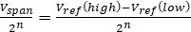
Where V_{span} = Max. voltage of the signal.
n = No. of bit used to represent the signal
For AT mega 328p, n = 1
(Ardvire uno)
Resolution = 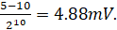
4. Data Rate
Data rate is defined as the no. of data bits per second.
5. Dynamic Range
It is a parameter used to describe the signal to noise ratio or strength of a signal w.r.t to some reference signal.
It is indicated in decibels (dB).
Dynamic range = 20 log 2^{n} dB
n: no. of bits.
For AT mega 328 P, n = 10
∴Dynamic range = 20 log 2¹⁰ dB
= 60.205 dB
Concept of ADC in AT mega 328p based Ardwire Board
ADC for AT mega 328 has following features.
i) It is a 10 bit ADC (n = 10)
ii) Conversation time required is 13 clock cycles for a conversation.
iii) Absolute accuracy is +215 B.
iv) Conversion time is 13-260 us.
v) The input voltage range for ADC is 0 – 1/CC.

Ques: Write a program to read analog input on analog min 2 (0-5V) and print it on the serial monitor of IOE.
Ans:
AT mega 328 p
ADC 2
GND
Z
10kΩ
+5V

void output ( )
{
Serial begin (9600);
}
void loop ( )
{
int value = analog read (A2);
float result = value ;
Serial print in (result);
}

Interfacing with Temperature sensor (LM35)
LM35
Output omv + 10.0mv / °C
V₅
(+L_{1V} to 20 V)
z

LM 35 is precision integrated circuit temperature sensors, whose output voltage is linearly proportional to Celsius (°C) temperature.
LM 34 is precision integrated circuit temperature ten or whose output voltage is linearly proportional to Fahrenheit temperature.
LM 35 is rated to operate over a − 55°C to + 150°C temperature range.
Also the output scale is linear with a change of 10 mv/°C

Interfacing of Temperature sensor LM35 with Ardusino and displaying output on LCD
V_{CC}
A_{C}
A_{PEF}
AV_{CC}
AT mega 328p
PD₀
PD₁
PD₂
PD₃
PD₄
PD₅
PD₆
PD₇
PB₀
PB₁
PB₂
GND
V_{CC}
PC₈
V_{PD}
V_{DB}
100μ
1μF
1μF
D₀
D₁
D₂
D₃
D₄
D₅
D₆
D₇
V_{CC}
V_{EE}
10Kμ
V_{SS}
LCD
E
EW
+5V
R₅
Figure 3.5: Interfacing Diagram of AT mega 328p
z

Ardwine sketch / program for LM 35
# include < liquid crystal.h >
Liquid crystal LCD (12, 11, 5, 4, 3, 2 );
Const int temperature sensor = AO
float tempect ;
float V_{out} ;

void setup ( )
{
Pin Mode (temp_sensor, INPUT) ;
Serial.begin (9600) ;
Ict.begin (16, 2) ;
Delay (500) ;
}
Void loop ( )
{
V_{out} = analog Read (temp_sensor) ;
Vout = (Vout × 5000)/₁₀₂₃ ;
Temp. cel = Vout/10 ;
lcd.setcursor (0,0) ;
lcd.print ("in Degree C = ") ;
}
Accelerometer
In embedded system accelerometer can be very useful to us by
i) Providing us information about fast the object moves and also the direction in which it moves.
ii) It can indicate the bit angle of the object earth.
The direction is very easy to interface with Ardwine micro controller with 3 analog input pins.
The voltage levels function between 0 and +5V

ADXL3 ×× Acc electrometer
It is a 3 anis acc electrometer that can measure acc electrometer along 3 ames i.e x, y and z. The values measured are indicated as change in voltage at the three output pins w.r.t ground.
Self-test
x
y
z
ADXL335
V_{CC}
GND
A₀
A₁
A₂
A₃
A₄
A₅
GND
+5V
D₁
D₂
D₁₁
D₁₀
D₁
D₀
Ardwine (AT mega 328p)

Arduino sketch
int GND = 18;
int V_{CC} = 19;

int z = A₁; 11 x axis of acc electrometer
int y = A₂; 11 y axis of acc electrometer
int z = A₃; 11 z axis of acc electrometer

Void setup ( )
{
Serial-begin (9600);
Pin Mode (GND, OUTPUT);
Pin Mode (VCC, OUTPUT);
digital write (GND, LOW);
digital write (V_{CC}, HIGH);
}
Void loop ( )
{
x = analog Read (A1);
y = analog Read (A2);
z = analog Read (A3);
Serial . print ("x = ");
Serial . print (x);
Serial . print ("y = ");
Serial . print in (y);
Serial . print ("z = ");
Serial . print in (z);
Delay (100);
}

Concept of Rules width Modulation
1/2
3/4 power35%DC
Full power100% DC
Fig: Pulse width modulation Technique

For a fixed load steady speed can be maintained by using a technique called pulse width modulation (PWM)
By changing (modulating) the width of the applied pulse to the DC motor, we can increase or decrease the amount of power provided to the motor, thereby increasing or decreasing the motor speed.
Hence PWN is widely used in DC motor control.
DC Motor Control
The DC motor continuously?????. It is a device that translates electrical pulse into mechanical moments.
It has two terminals i.e. positive and negative. By connecting concernting DC power supply to these terminals the motor rates in one direction. If the polarity of power supply is reversed the direction of rotation is also reverse.
Speed of DC motor is measured in RPM (Revaluation per minutes).

Uni-direction Control
+
−
Clock wise rotation
M
+
−
Anti-clock wise rotation
M
Figure 3.6: DC motor Rotation

Bi-direction Control
SW0
SW1
SW3
z
SW2
M
P + V
Motor not running
Clock wise configuration
z
M
Current flow
SW3
SW1
SW0
SW2
+ V

Invalid configuration (DC motor does not rotate because of short circuit)
z
M
SW3
SW1
SW0
SW2
+ V
SW0
SW1
SW3
z
SW2
M
+ V
Anti-clockwise configuration
Current flow
Current flow

Interfacing DC Motor using L293 W-bridge
1, 2 EN
I/P1
0|P|
Heat sink & ground
D|P2
I|P2
V_{CC2}
1
2
3
4
5
6
7
8
16
15
14
13
12
11
10
9
V_{CC1}
I|P4
O|P4
Heat sink & ground
O|P3
BI|P3
3, 4 EN
Figure 3.7: Pin Diagram of L 293
L293

+5V
V_{CC}
PB₀
PB₁
PB₂
AT mega 328p
+5V
+12V
+12V
+12V
V_{CC1}
V_{CC2}
Enable
L2.93
Input
I|p2
O|p2
O|p
D₁
D₂
D₃
D₄
M
D₁, D₂, D₃, & D₄, are IN4004
Figure: Interface DC motor with L293 and AVR
ILQ74 Opto-iso later
330Ω each

As Signment-6
Ques 1: Draw and explain the interfacing diagram of AT mega 328 to control DC motor.
Ques 2: With the help of block diagram explain the temperature measurement scheme using AT mega 328 micro controller
Ques 3: Write various features of ADC for AT mega 328p.
Ques 4: Explain the following characteristics of an ADC.
(i) Conversion time
(ii) Quantization error
(iii) Resolution
(iv) Data rate
(v) Dynamic range
Ques 5: Explain Basic principle of operation of an ADC.
Ques 6: Design a AT mega 328p based system to interface DC motor to monitor the states of switch connected to pin PD2 and to the following:
(a) If SW = 0, the DC motor moves with 50% Duty cycle pulse
(b) If SW = 1, the DC motor moves with 25% duty cycle pulse.
CHAPTER-4

LABVIEW PROGRAMMING

Case Study: Automatic Irrigation Control System based on Lab-VIEW Arduino Interfacing

INTRODUCTION
LABVIEW Programming
Virtual Instrumentation (VI) can used for the actual instruments labs, as well as for application building, which imitate actual devices and operating instruments, for modeling and animation of the real physical experiment. A vital and noteworthy feature of building view that can be used to improve productive applications in the teaching learning course of action. It gives the essential progress tools for number of applications encompassing data heap, instrument authority, counts, investigation and data exhibit, etc. The main aim of Labview represents the design of virtual instruments. Labview is a system depends on the data flow theory. Such system resides performable nodes that perform only when they obtain all important input data and produce output data instantaneously when they go into performance. [6,7]. Labview (short for Laboratory Virtual Instrumentation Engineering Workbench) is a graphical programming language that uses icon and wires connection which is widely used in industry compare to text based programming. In Labview, a Program is named as Virtual Instrument which has two fragments: Block Diagram (BD) and Front Panel (FP). Block Diagram gives imaginable information of data flow paths among processing blocks. Front Panel gives Graphical User Interface (GUI) which allows modification of various parameters connected with Block Diagram as a VI runs. It is a programming language which avail dataflow programming approach. The learning time is significantly less for one who has some background of basic programming. Also the boundless documentation and massive amount of in built VI are existing that can be use and exploit in addition. LABVIEW software is an appropriate choice for teaching/learning laboratory based work [2]. The non-programmers can easily build programs as it provides the graphical way, in which simple drag and drop of the lab equipment with which they are formerly habitual.
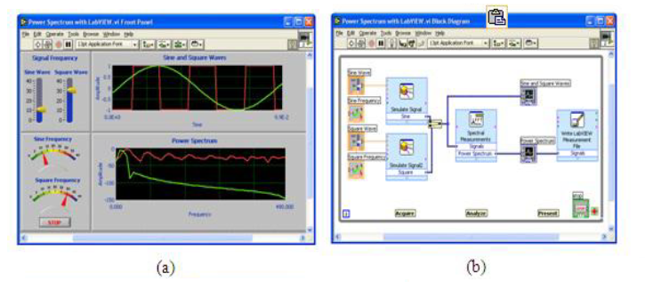

Figure 4.1: Lab VIEW programming environment show
a) Front Panel and b) block diagram

Valuable crop treatment and water management is the major obligatory in most of the cultivating area in semi-arid regions. Monitoring the soils moisture, calculating its relative humidity and controlling pumping motor in accordance with its predictability. It is very difficult to examine and controlling the switching action of pumping motor according to the level of water in tanks. So water level controller and automatic irrigation controller prevents dry running of pumping motor, thus saves electricity, water and manpower.
In this project, as block diagram shows, we assembled automatic water planting circuit using Lab-VIEW and Arduino interfacing. A humidity sensing device monitor the humidity of soil and water level sensing device sense the water level thus turning pump on and off according to different condition according to the soil moisture and level of water in tank. When the humidity of soil is low that is soil is dry, the water pump is on and if humidity is high that is soil is wet, the water pump is off. At same time the sensor used to sense the water level is also consider. When the water level is below the low level the pump is off at any soil condition which prevents the dry running of water pump. Also water level is indicated.

As Arduino uno is open source, it is used to interface sensing devices with Lab-VIEW on personal computer. Lab- VIEW is workbench with a graphical programming language for instrumentation, data-acquisition and analysis, automation and control and communication.
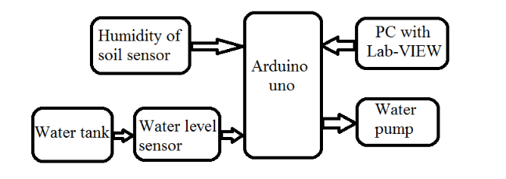
Figure 4.2: Block diagram

The water level sensor senses the level of water and humidity sensor sense the humidity of soil whether it is dry or wet. The reference voltage from both sensors is fed to arduino board and according to the programming done in Lab-VIEW the control signal will be given to the motor. The arduino signal is fed to the Lab-VIEW as an input; this signal is compared with minimum or maximum level of water and threshold level of soil humidity voltage. The output of Lab-VIEW is fed to the digital write of Arduino as an input signal. According to digital write output signal, motor in water tank will be turn ON or OFF. The motor turn ON when the water is sufficient i.e water is at low level or above the low level and when soil is dry. The motor will turn OFF when soil is wet and water is sufficient. When the water is insufficient i.e. water level goes below low level either soil is dry or wet, the motor will remain OFF.

LAB-VIEW ARDUINO INTERFACE
For interfacing Lab-VIEW and an Arduino, the NI LAB- VIEW toolkit [6] provides easy interface. LIFA (Lab-VIEW Interface for Arduino) was developed and tested using an Arduino Uno but should work with most Arduino compatible hardware. It includes not only the opens source firmware for the Arduino but also 100 VIs to access the Arduino functionality from within Lab-VIEW. LIFA is a tethered key and it requires a data connection between Lab-VIEW and the Arduino at all time. This is typically proficient through USB but can also using Xbees or bluetooth. LIFA does not allow the user to deploy Lab-VIEW code the Arduino. Once the data is acquire in deploy Lab-VIEW, we can analyze it with the help of built in libraries functions supported by deploy Lab-VIEW, design the algorithms which will control the arduino hardware and we can display the finding on user interface. Using the built-in library such as common Open, Read/Write, Close convention in LabVIEW, you can access the digital, analog, pulse-width-modulated, I2C, and SPI signals of the Arduino microcontroller [6,7].
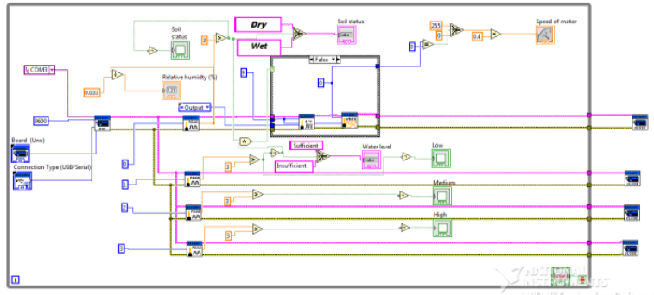
Figure. 4.3: VI in LABVIEW
SOFTWARE IMPLEMENTATION
The software module that is integrated in developing the graphical program structure is Lab-VIEW 2013. It includes the block diagram which is the sequence of icons that are connected with wires in the manner of flow of operation. The front panel is in which the acquired and generated parameters are shown in numerical, graphical waveform or as a control. The required block code is as shown in figure 2. for acquisition data , so it is needed to define Init that includes the VISA resource (COM port, type of arduino board, type of connection (USB/serial), bate rate and at the end define close session. The Design of the software using Lab-VIEW is based on the user graphical programming which helps to communicate with real world data. [5].

HARDWARE IMPLEMENTATION
The hardware consist of the data Acquisition card that is used as a mean between PC and sensors circuit, ATmega32 (Arduino prototyping) platform is used here for this purpose. To exhibit the potential applications of the Arduino based Data Acquisition and control using LabVIEW a simple hardware setup is built as shown in the fig 3.

A. Soil Sensor
The humidity sensor circuit mainly requires an operating voltage of about (5-12 volts). The BC 548 transistor used in this circuit works to switch electronic signals and amplifies them. With the combination of various other resistors constructed as per the circuit diagram shown in fig 4., During the soils damp conditions, the two probes behave as electrodes and therefore current flows in a closed circuit due to the presence of water (which is a good conductor of electricity) content, between the two electrodes. This turns the transistor Q1 to an ON state. The circuits working or conducting condition is indicated by the glowing of the LED due to the passage of current. When dry, it becomes an open circuit because there is no medium for the electricity to flow, the transistor is in the OFF state therefore the LED turns OFF. The output voltage is obtained from the leads that are connected across the collector and ground terminals. The voltage completely drops to zero during the wet condition and in the range of (2.9 V 3.9 V) for the soils dry condition. The output is acquired with the help of Arudino and is interfaced with the LabVIEW software. Two probes will always be in contact with the soil so that it senses the wetness and the dryness of the soil [1,8].
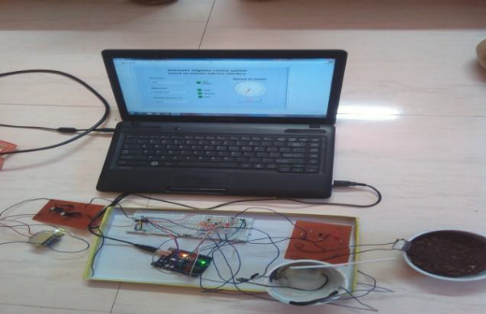

Figure 4.4: Experimental Setup

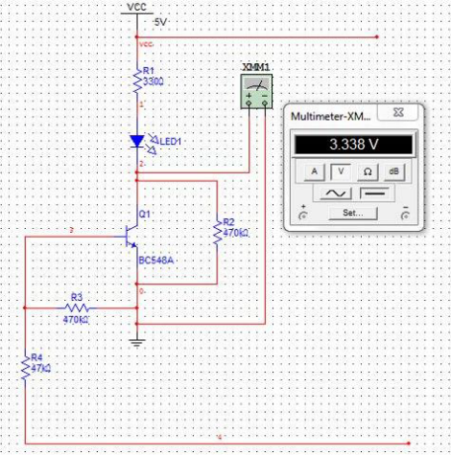
Figure 4.5: Soil Sensor Circuit Diagram

RESULTS AND CONCLUSION
Figure 4.6 shows the Front panel in Lab-VIEW when soil is dry and water is sufficient. Water pump is in ON state. The low, medium, high LED is glow indicate the water level. As motor speed is 100% means the motor is ON.
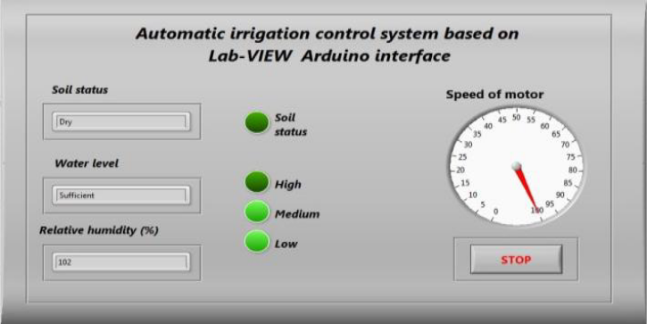
Figure 4.6: Soil Sensor Circuit Diagram

Figure 4.7 shows the Front panel in Lab-VIEW when soil is dry but water is insufficient. Water pump is in OFF state. As the all LED is off, indicates the water level is below the low level i.e. insufficient. Motor at 0

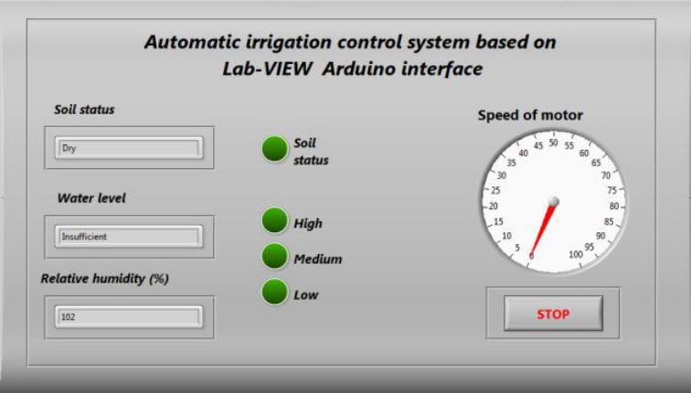

Figure 4.7: The Front panel in Lab-VIEW when soil is dry but water is insufficient
Figure 4.8 shows Front panel in Lab-VIEW when soil is wet but water is sufficient. Water pump is in OFF state. Soil LED glows means soil is wet. Water levels LEDs are glowing which indicate the water level. Speed of motor is 0
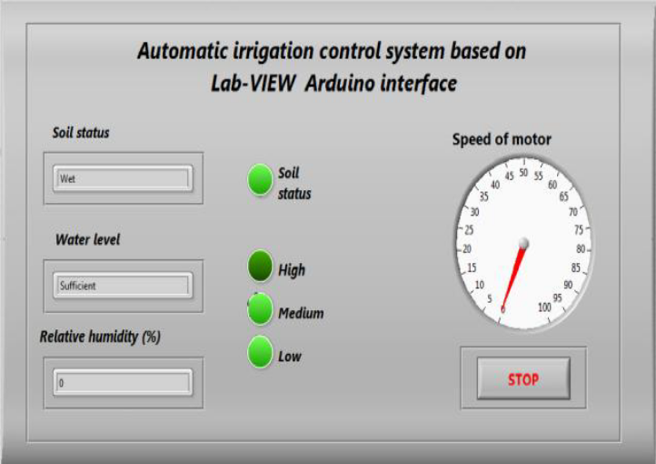

Figure 4.8 : Front panel in Lab-VIEW when soil is wet but water is sufficient.

This chapter shows how to control the motor automatically by using Lab-VIEW and Arduino interface. It provides everything that is needed to build any monitor or control application in significantly in less time. The automatic irrigation system was developed and successfully implemented along with sensors. The system reduces human effort and wastage of water and increase electricity consumption. Lab-VIEW is best for any measurement and control system, with GUI that assist to build a wide range of applications in less time. In future revision, the code is modified to store all input and output data over a long period which is useful to study pattern of water usage due to which we can improve the reduction in water consumption. We can also implement wireless system to avoid the long runs of cables in the field.

REFERENCES
- Arutselvi.S, Sarah Maria Louis, Srinithi.S, “Monitoring and Control of Relative Humidity in Soil using LabVIEW,” International Journal of Engineering Trends and Technology (IJETT) Volume 9 Number 10 - Mar 2014.
- T. Bheema lingaiah, D.Hanumesh Kumar, C.Nagaraja, Solomon Woldet- sadik ,“Development of Humidity and Temperature Measurement Instrumentation System using Lab-VIEW”, International Journal of Advanced Research in Electrical, Electronics and Instrumentation Engineering, Vol. 2, Issue 10, December 2013
- Hosni Abu-Mulaweh, Indiana University-Purdue University-Fort Wayne, “The Use of Lab-VIEW and Data acquisition unit to Monitor & Control Air- Conditioning Processes”, American Society for Engineering Education, 2007.
- S. V. Devika, Sk. Khamuruddeen, Sk. Khamurunnisa, Jayanth Thota, Khalesha Shaik, “Arduino Based Automatic Plant Watering System”, International Journal of Advanced Research in Computer Science and Software Engineering 4(10), Volume 4, Issue 10,October - 2014, pp. 449- 456.
- Diaa Mehdi Faris Mahmood Basil Mahmood, “Data Acquisition of Greenhouse Using Arduino”, Journal of Babylon University/Pure and Applied Sciences/ No.(7)/ Vol.(22): 2014.
- LabVIEW Interface for Arduino [LIFA], decibel.ni.com
- Naveenkumar R, Dr Prasad Krishna, “Low Cost Data Acquisition and Control using Arduino Prototyping Platform and LabVIEW”, International Journal of Science and Research (IJSR), India Online ISSN: 23197064.
- Sarah Maria Louis, S. Srinithi, “Monitoring of Relative Humidity of Soil Using LabVIEW”, International Journal of Innovative Research & Development, Vol 3 Issue 3, March, 2014.

