Technical Design Document
Synthetic Radio Host - Hinglish Podcast Generator

Contents
1. Project Overview 3
1.1 Project Description 3
1.2 Key Features 3
1.3 Use Cases 3
2. System Architecture 4
2.1 High-Level Architecture 4
2.2 Component Diagram 5
2.3 Flow Diagram 6
3. Setup and Deployment Instructions 9
3.1 Prerequisites 9
3.2 Installation Steps 9
Step 1: Install Python Dependencies 9
Step 2: Install and Configure Ollama 9
Step 3: Configure Environment Variables 9
Step 4: Verify Voice IDs 9
3.3 Running the Application 10
3.4 Output Location 10
4. Code Explanations and Assumptions 11
4.1 Core Functions 11
4.1.1 fetch_wikipedia_context() 11
4.1.2 create_hinglish_prompt() 11
4.1.3 check_ollama_connection() 11
4.1.4 generate_script_with_ollama() 12
4.1.5 parse_script() 12
4.1.6 generate_segment() 12
4.1.7 generate_podcast() 13
4.2 Design Decisions 13
4.2.1 Why Ollama over Cloud LLMs? 13
4.2.2 Why ElevenLabs for TTS? 13
4.3 Error Handling Strategy 13
4.4 Limitations and Known Issues 14
5. Technology Stack 14
5.1 Core Technologies 14
5.2 Python Libraries 14

1. Project Overview

1.1 Project Description
The Synthetic Radio Host system is an automated podcast generation platform that:
- Fetches contextual information from Wikipedia for any given topic.
- Generates natural, conversational Hinglish scripts using Ollama LLM.
- Parses and structures dialogue between two hosts.
- Converts text to speech using ElevenLabs API with distinct voices.
- Combines audio segments into a complete podcast MP3 file.
The system demonstrates practical application of LLMs (Ollama) for natural language generation combined with Text-to-Speech APIs (ElevenLabs) to create engaging podcast content in Hinglish (Hindi-English mix).

1.2 Key Features
- Natural Hinglish conversation generation with phonetic spelling
- Emotional tags support ([laughs], [sighs], [giggles]) for realistic audio
- Automatic dialogue parsing with intelligent speaker identification
- Multi-voice podcast generation (male and female hosts)
- Robust error handling for API failures and edge cases
- User confirmation before audio generation to save API costs as Eleven labs APIs are costly.
- Comprehensive logging and progress tracking

1.3 Use Cases
- Educational content creation for topics requiring explanation
- Entertainment podcasts on trending topics
- Multilingual content generation for Indian audiences
- Automated radio show production
- Content creation for social media platforms

2. System Architecture

2.1 High-Level Architecture
The system follows a modular, pipeline-based architecture with clear separation of concerns.
The architecture consists of four main layers:
- Data Acquisition Layer: Fetches context from Wikipedia based on user topic.
- Content Generation Layer: Creates Hinglish conversation script using Ollama LLM ollama3.2
- Processing Layer: Parses and structures dialogue.
- Audio Generation Layer: Converts text to speech and combines audio to prepare a final podcast file.

Architecture Diagram:
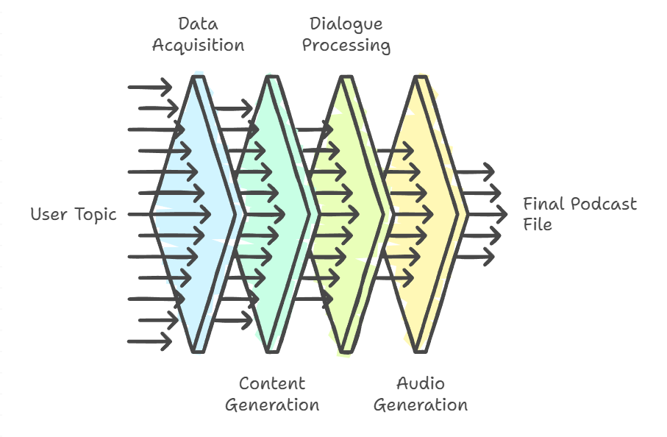

2.2 Component Diagram
The system consists of the following main components and their interactions:

┌──────────────────────┐ ┌──────────────────────┐
│ Wikipedia Context │ │ Prompt Generator │
│ Fetcher │────────▶│ │
│ │ │ • Creates Hinglish │
│ • Fetches topic │ │ • Adds instructions │
│ • Validates page │ │ • Includes example │
└──────────────────────┘ └───────────┬──────────┘
│
▼
┌──────────────────────┐
│ Ollama LLM │
│ Integration │
│ │
│ • llama3.2 model │
│ • Generates script │
└───────────┬──────────┘
│
▼
┌──────────────────────┐
│ Script Parser │
│ │
│ • Parses dialogue │
│ • Identifies hosts │
└───────────┬──────────┘
│
▼
┌──────────────────────┐
│ Eleven Labs TTS │
│ Engine │
│ │
│ • Converts to audio │
│ • Emotion support │
│ • Multiple voices │
└───────────┬──────────┘
│
▼
┌──────────────────────┐
│ Audio Combiner │
│ │
│ • Merges segments │
│ • Creates MP3 │
│ • Cleans up temp │
└──────────────────────┘

Component Details:
Wikipedia Context Fetcher: Fetches topic information from Wikipedia API
Prompt Generator: Creates structured prompts for LLM with Hinglish instructions using one-shot inference.
Ollama LLM Integration: Generates conversational scripts using local/remote Ollama
Script Parser: Parses and structures dialogue with speaker identification
ElevenLabs TTS Engine: Converts text segments to audio with emotion support
Audio Combiner: Merges individual audio segments into final podcast

2.3 Flow Diagram
The system follows this execution flow:

┌────────────┐
│ START │
└──────┬─────┘
│
▼
┌─────────────────────┐
│ 1. Input Validation │
│ • Check topic │
│ • Validate input │
└──────┬──────────────┘
│
▼
┌─────────────────────┐
│ 2. Ollama Check │
│ • Verify service │--FAILS ERROR: OLLAMA IS NOT RUNNING
│ • Test connection │
└──────┬──────────────┘
│
▼
┌─────────────────────┐
│ 3. Fetch Wikipedia │
│ • Get topic info │--FAILS ERROR: Failed to fetch content, exiting.
│ • Extract summary │
└──────┬──────────────┘
│
▼
┌─────────────────────┐
│ 4. Generate Prompt │
│ • Create Hinglish │
│ • Add instructions │
└──────┬──────────────┘
│
▼

┌─────────────────────┐
│ 5. Generate Script │
│ • Call Ollama LLM │--FAILS ERROR: Failed to generate script, exiting.
│ • Get conversation │
└──────┬──────────────┘
│
▼
┌─────────────────────┐
│ 6. Parse Script │
│ • Extract dialogue │--FAILS ERROR: Failed to generate script, exiting.
│ • Identify speakers│
└──────┬──────────────┘
│
▼
┌─────────────────────┐
│ 7. User Confirmation│
│ • Ask for approval │-- User doesn’t enters ‘y’ or ‘Y’, exiting.
│ • Proceed if Yes │
└──────┬──────────────┘
│
▼
┌─────────────────────┐
│ 8. Generate Audio │
│ • For each segment │
│ • Call ElevenLabs │
└──────┬──────────────┘
│
▼
┌─────────────────────┐
│ 9. Combine Audio │
│ • Merge segments │
│ • Create MP3 file │
└──────┬──────────────┘
│
▼
┌─────────────────────┐
│ 10. Cleanup │
│ • Remove temp files│
│ • Finalize output │
└──────┬──────────────┘
│
▼
┌─────────────┐
│ END │
└─────────────┘

Detailed Flow Steps:
Step 1: Input Validation: User provides topic → System validates topic is non-empty
Step 2: Ollama Connection Check: System verifies Ollama service is running and accessible
Step 3: Wikipedia Context Fetch: System retrieves topic summary from Wikipedia (max 2000 chars)
Step 4: Prompt Generation: System creates Hinglish conversation prompt with context and instructions
Step 5: Script Generation: Ollama LLM generates 2-minute Hinglish conversation script
Step 6: Script Parsing: System parses script into structured dialogue segments with speaker tags
Step 7: User Confirmation: System prompts user for audio generation confirmation
Step 8: Audio Generation: For each dialogue segment, ElevenLabs API generates audio
Step 9: Audio Combination: All audio segments are concatenated into final MP3 file
Step 10: Cleanup: Temporary audio files are removed

3. Setup and Deployment Instructions

3.1 Prerequisites
- Python 3.12 or higher
- Ollama installed and running (local or remote) with model 3.2
- ElevenLabs API key

3.2 Installation Steps

Step 1: Install Python Dependencies
Install required packages:
pip install wikipediaapi ollama requests python-dotenv

Step 2: Install and Configure Ollama
1. Download Ollama from https://ollama.com/
2. Install Ollama on your system
3. Start Ollama service:
$ ollama serve

4. Pull the required model:
$ ollama pull llama3.2

Step 3: Configure Environment Variables
Create a .env file with your ElevenLabs API key:
ELLEVENLABS_API_KEY=your_api_key_here

Note: Update the path in syntheticRadioHostScript.py line 17 to point to your .env file

Step 4: Verify Voice IDs
The system uses predefined voice IDs from ElevenLabs. Current configuration:
- Male Host: Mihir voice
- Female Host: Aura voice
Voice IDs are defined in the VOICES dictionary (lines 570-576). You can modify these to use different voices from your ElevenLabs account.

3.3 Running the Application
1. Ensure Ollama is running:
$ ollama serve

2. Run the main script:
$ python syntheticRadioHostScript.py <api-key> <output_file_path_name>

Command also works without any user entries as given below:
$ python syntheticRadioHostScript.py

In this case api-key will be read from env file at location C:/Users/vineet.srivastava/venvGenAIStudy/.env
And output file will be C:/LEARNING/LANGCHAIN/ollama_podcast.mp3

3. The script will:
- Ask to use existing api-key for user confirmation if no api-key is provided.
- Fetch Wikipedia context
- Generate script using Ollama
- Parse dialogue segments
- Ask for user confirmation before audio generation
- Generate and combine audio files

3.4 Output Location
Default path for the final podcast MP3 file is:
C:/LEARNING/LANGCHAIN/ollama_podcast.mp3
This path can be modified in the main() function (line 646).
This path gets over-ridden with the user provided path once provided as an argument while running the script file.

4. Code Explanations and Assumptions

4.1 Core Functions

4.1.1 fetch_wikipedia_context()
Purpose: Retrieves topic information from Wikipedia.
Key Features:
- Validates topic is non-empty
- Checks if Wikipedia page exists
- Returns first 2000 characters of summary
- Handles API exceptions gracefully
Assumptions:
- Wikipedia API is accessible
- Topic exists in English Wikipedia

4.1.2 create_hinglish_prompt()
Purpose: Creates structured prompt for LLM with Hinglish conversation instructions.
Key Features:
- Includes phonetic spelling instructions
- Specifies emotional tags format
- Provides one-shot example for consistency
- Enforces 2-minute conversation length
Assumptions:
- LLM understands Hinglish and phonetic instructions
- Example format guides LLM output structure

4.1.3 check_ollama_connection()
Purpose: Verifies Ollama service is running and accessible.
Implementation:
- Attempts to list models using ollama.list()
- Returns True if response is not None
- Returns False on any exception
Assumptions:
- Ollama runs on default localhost:11434
- Network connectivity to Ollama service

4.1.4 generate_script_with_ollama()
Purpose: Generates Hinglish conversation script using Ollama LLM.
Key Features:
- Uses llama3.2 model by default
- Measures generation time
- Validates script length (minimum 50 characters)
- Returns tuple (script, elapsed_time)
Assumptions:
- llama3.2 model is available in Ollama
- LLM follows prompt instructions for format

4.1.5 parse_script()
Purpose: Parses generated script into structured dialogue segments.
Key Features:
- Handles both double newline (\n\n) and single newline (\n) separators
- Identifies hosts by name matching
- Assigns alternating [Indian English] and [Hindi accent] tags
- Handles intro/outro text and multi-line dialogues
Assumptions:
- Script follows "SpeakerName: text" format

4.1.6 generate_segment()
Purpose: Converts text segment to audio using ElevenLabs API.
Key Features:
- Uses eleven_v3 model for emotion support
- Detects emotional tags and adjusts voice settings
- Returns audio bytes on success (200 status)
- Returns None on API errors
Assumptions:
- Valid ElevenLabs API key with sufficient credits
- Voice IDs exist in ElevenLabs account

4.1.7 generate_podcast()
Purpose: Orchestrates complete podcast generation from dialogue.
Key Features:
- Sanity checks for inputs (API key, dialogue, voice IDs)
- Generates audio for each dialogue segment
- Saves temporary segments to disk
- Combines segments into final MP3
- Cleans up temporary files
- Handles partial failures gracefully
Assumptions:
- Sufficient disk space for temporary files
- Write permissions for output directory

4.2 Design Decisions

4.2.1 Why Ollama over Cloud LLMs?
Ollama was chosen for:
- Privacy: No data sent to external services
- Cost: Free for local usage

4.2.2 Why ElevenLabs for TTS?
ElevenLabs was chosen for:
- High-quality natural voices
- Emotion tag support for realistic conversations
- Indian accent support
- API-based integration for scalability

4.3 Error Handling Strategy
The system implements comprehensive error handling:
- Early validation of inputs
- Graceful degradation (returns None instead of crashing)
- User-friendly error messages
- Connection checks before API calls
- Partial failure handling (continues if some segments fail)

4.4 Limitations and Known Issues
- Hardcoded .env file path (line 49). Can be bypassed by providing eleven labs api key as an argument while running the script.
- Hardcoded output path (line 646). Can be bypassed by providing your system path as an argument while running the script.
- No retry mechanism for API failures
- No audio quality validation

5. Technology Stack

5.1 Core Technologies
Python 3.12+: Programming language
Ollama: Local LLM inference engine
llama3.2: LLM model for script generation
ElevenLabs API: Text-to-Speech service
Wikipedia API: Content source via wikipediaapi library
Audio File Format: MP3.

5.2 Python Libraries
- wikipediaapi: Wikipedia content retrieval
- ollama: Ollama LLM integration
- requests: HTTP requests for ElevenLabs API
- python-dotenv: Environment variable management
- re: Regular expressions for text parsing
- os: File system operations
- time: Timing and rate limiting

