Test Cases Document
Synthetic Radio Host - Comprehensive Test Suite

Contents
1. Executive Summary 4
2. Test Effectiveness Analysis 4
2.1 Coverage Metrics 4
2.2 Test Quality Indicators 4
3. Test Execution 4
4. Test Coverage Overview 5
5. Detailed Test Cases 5
5.1. get_elevenlabs_api_key() - 4 Test Cases 5
Test 1: Returns API key from command-line argument when provided 5
Test 2: Returns API key from environment variable when user confirms 5
Test 3: Exits when user rejects proceeding with environment variable 6
Test 4: Returns None when no API key found in either location 6
5.2 fetch_wikipedia_context() - 4 Test Cases 7
Test 5: Valid topic returns context 7
Test 6: Empty/None topic returns None 7
Test 7: Non-existent topic returns None 7
Test 8: Handles Wikipedia API exceptions gracefully 7
5.3 create_hinglish_prompt() - 3 Test Cases 8
Test 9: Returns formatted prompt with topic and context 8
Test 10: Contains all required instructions and example format 8
Test 11: Handles empty topic/context 8
5.4 check_ollama_connection() - 3 Test Cases 9
Test 12: Returns True when Ollama is accessible 9
Test 13: Returns False when Ollama returns None 9
Test 14: Returns False when Ollama raises exception 9
5.5 generate_script_with_ollama() - 7 Test Cases 10
Test 15: Returns (script, elapsed_time) tuple on success 10
Test 16: Returns (None, elapsed_time) on empty/short script 10
Test 17: Returns (None, 0) on exception 10
Test 18: Measures time correctly 11
Test 19: Handles Ollama API errors 11
Test 20: Output contains emotional tags like [laughs] 12
Test 21: Output contains Hinglish prompts (Hmmm, hmm, umm) 12
5.6 parse_script() - 10 Test Cases (Most Critical) 12
Test 22: Parses double newline separated dialogues 12
Test 23: Parses single newline separated dialogues 13
Test 24: Handles empty/None script 13
Test 25: Identifies male and female hosts correctly 13
Test 26: Handles custom host names and markdown 14
Test 27: Handles multi-line dialogue text 14
Test 28: Handles scripts with intro/outro text 14
Test 29: Handles missing colons and empty text 15
Test 30: Assigns unknown speakers correctly 15
Test 31: Chooses best splitting strategy automatically 15
5.7 generate_segment() - 4 Test Cases 16
Test 32: Returns audio bytes on success (200 status) 16
Test 33: Returns None on API error (non-200 status) 16
Test 34: Returns None on network exception 16
Test 35: Detects emotion tags and sets correct voice settings 17
5.8 validate_output_path() - 3 Test Cases 17
Test 36: Creates directory if it doesn't exist and returns True 17
Test 37: Returns False for path without write permissions 17
Test 38: Handles exceptions gracefully 18
5.9 generate_podcast() - 8 Test Cases 18
Test 39: Returns True on successful generation 18
Test 40: Returns False on invalid inputs 19
Test 41: Returns False on path validation failure 19
Test 42: Generates all segments and combines into final file 20
Test 43: Cleans up temp files 20
Test 44: Handles segment generation failures gracefully 21
Test 45: Handles file I/O errors 22
Test 46: Handles partial segment failures 22
5.10 main() Integration Tests - 5 Test Cases 23
Test 47: Complete flow: context → script → parse → podcast 23
Test 48: Handles missing API key gracefully 24
Test 49: Handles Ollama connection failure 25
Test 50: Handles Wikipedia fetch failure 25
Test 51: Handles user input cancellation 25

Executive Summary
This document provides documentation of the test suite for the Synthetic Radio Host system. The test suite consists of 51-unit tests covering all 10 core functions, ensuring robust error handling, edge case coverage, and integration testing. All tests use mocking to avoid external API dependencies, making them fast, reliable, and repeatable. Test suite is developed using pytest framework. Pytest is a open-source testing framework used for unit, integration, and functional tests in Python.

Test Effectiveness Analysis

2.1 Coverage Metrics
The test suite provides comprehensive coverage across multiple dimensions:
Function Coverage: 100% - All 10 functions have dedicated test classes
Edge Case Coverage: High - Empty inputs, none values, exceptions
Error Handling Coverage: Comprehensive - All error paths tested
Integration Coverage: Complete - End-to-end workflow validated

2.2 Test Quality Indicators
- All external dependencies are mocked (Wikipedia, Ollama, ElevenLabs)
- Tests are isolated and independent - no shared state
- Tests are fast - complete suite runs in seconds
- Tests are repeatable - deterministic results
- Tests validate both happy paths and error scenarios
- Tests include output validation (emotional tags, Hinglish prompts)
- Integration tests verify complete workflows
- Edge cases are thoroughly covered

Test Execution
To execute the test suite:
1. Install test dependencies:
$ pip install -r requirements-test.txt

2. Run all tests:
$ pytest test_syntheticRadioHostScript.py -v -s

Test Coverage Overview
List of test cases ID along with the functionality the test case is testing and validating.
Function | Test Cases | Test IDs
get_elevenlabs_api_key | 4 | 1-4
fetch_wikipedia_context | 4 | 5-8
create_hinglish_prompt | 3 | 9-11
check_ollama_connection | 3 | 12-14
generate_script_with_ollama | 7 | 15-21
parse_script | 10 | 22-31
generate_segment | 4 | 32-35
validate_output_path | 3 | 36-38
generate_podcast | 8 | 39-46
main() Integration | 5 | 47-51

5. Detailed Test Cases

5.1. get_elevenlabs_api_key() - 4 Test Cases

Test 1: Returns API key from command-line argument when provided
Description: Verifies that API key from command-line argument takes priority
Coverage: Input handling - command-line argument
Effectiveness: High - Ensures command-line argument works correctly
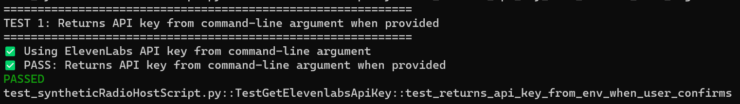

Test 2: Returns API key from environment variable when user confirms
Description: Validates fallback to environment variable when user confirms
Coverage: User interaction - confirmation flow
Effectiveness: High - Ensures fallback mechanism works
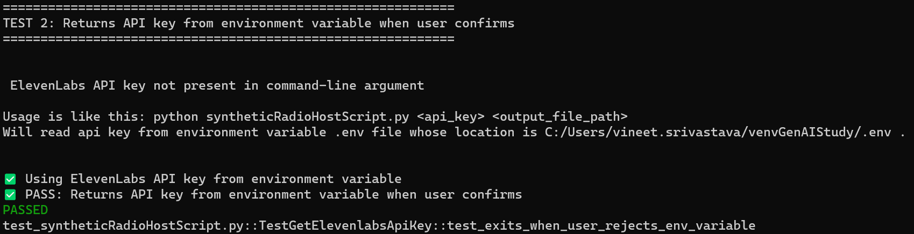

Test 3: Exits when user rejects proceeding with environment variable
Description: Handles user rejection and exits gracefully
Coverage: User interaction - cancellation flow
Effectiveness: High - Prevents unwanted execution
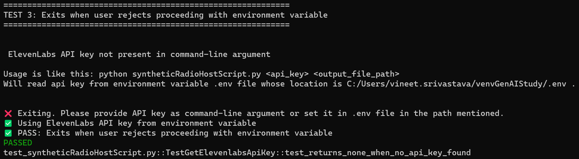

Test 4: Returns None when no API key found in either location
Description: Handles case where API key is not available from any source
Coverage: Error handling - missing configuration
Effectiveness: High - Graceful degradation
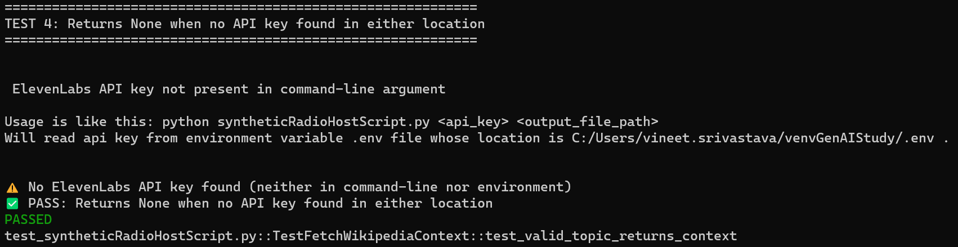

5.2 fetch_wikipedia_context() - 4 Test Cases

Test 5: Valid topic returns context
Description: Verifies that a valid Wikipedia topic returns contextual information
Coverage: Happy path - normal operation
Effectiveness: High - Ensures core functionality works correctly
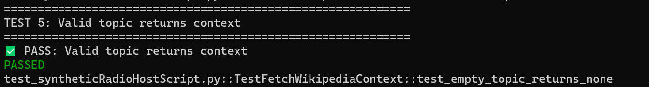

Test 6: Empty/None topic returns None
Description: Validates that empty, None, or whitespace-only topics are rejected
Coverage: Input validation - edge case handling
Effectiveness: High - Prevents errors from invalid inputs
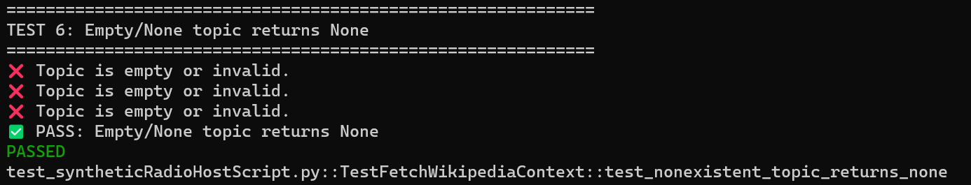

Test 7: Non-existent topic returns None
Description: Handles cases where Wikipedia page does not exist
Coverage: Error handling - API response validation
Effectiveness: High - Graceful degradation on missing content
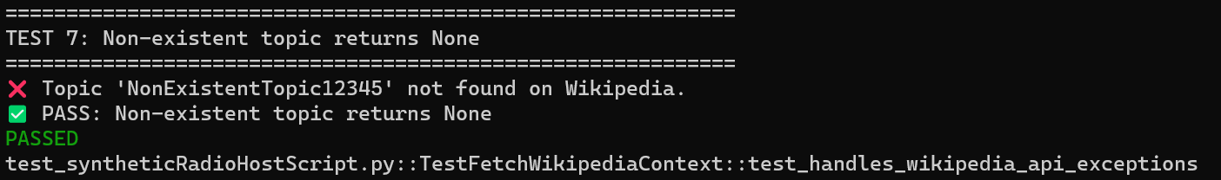

Test 8: Handles Wikipedia API exceptions gracefully
Description: Catches and handles network errors, API failures, etc.
Coverage: Exception handling - robustness
Effectiveness: Critical - Prevents system crashes on API failures
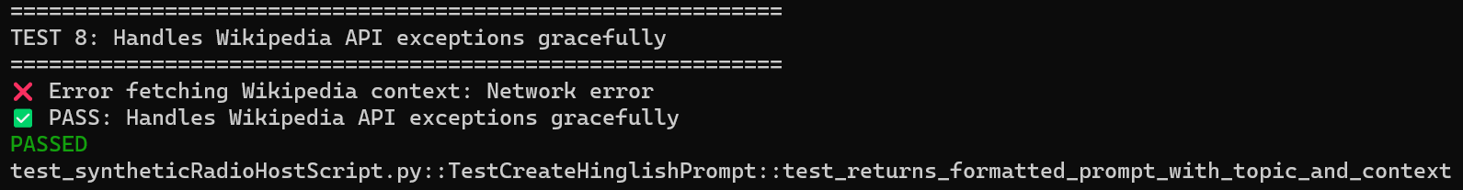

5.3 create_hinglish_prompt() - 3 Test Cases

Test 9: Returns formatted prompt with topic and context
Description: Verifies prompt contains both topic and context information
Coverage: Output validation - data integrity
Effectiveness: High - Ensures prompt structure is correct
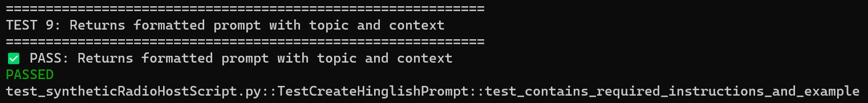

Test 10: Contains all required instructions and example format
Description: Validates prompt includes Hinglish instructions and example
Coverage: Content validation - prompt quality
Effectiveness: High - Ensures LLM receives proper guidance
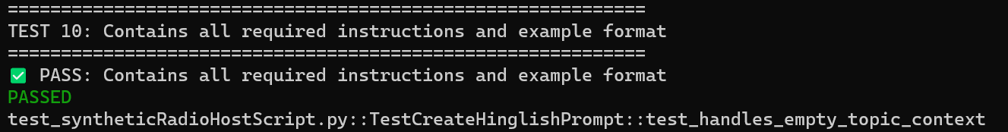

Test 11: Handles empty topic/context
Description: Tests behavior with empty inputs
Coverage: Edge case - input handling
Effectiveness: Medium - Handles edge cases gracefully
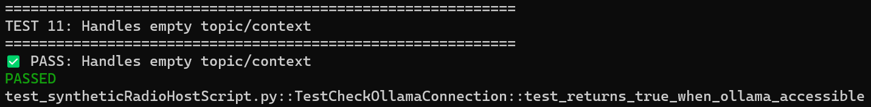

5.4 check_ollama_connection() - 3 Test Cases

Test 12: Returns True when Ollama is accessible
Description: Verifies successful connection to Ollama service
Coverage: Connection validation - service availability
Effectiveness: High - Early detection of service issues
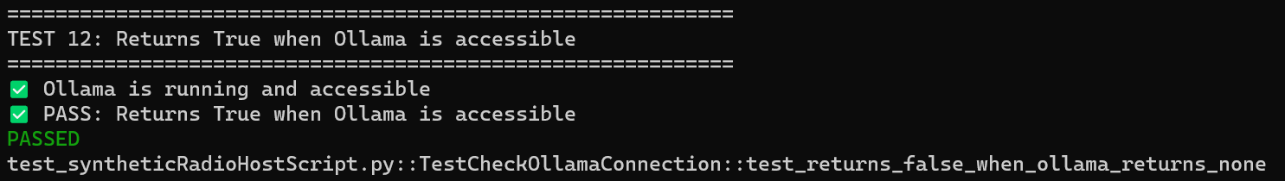

Test 13: Returns False when Ollama returns None
Description: Handles case where Ollama service is not responding
Coverage: Error detection - service state
Effectiveness: High - Prevents wasted API calls
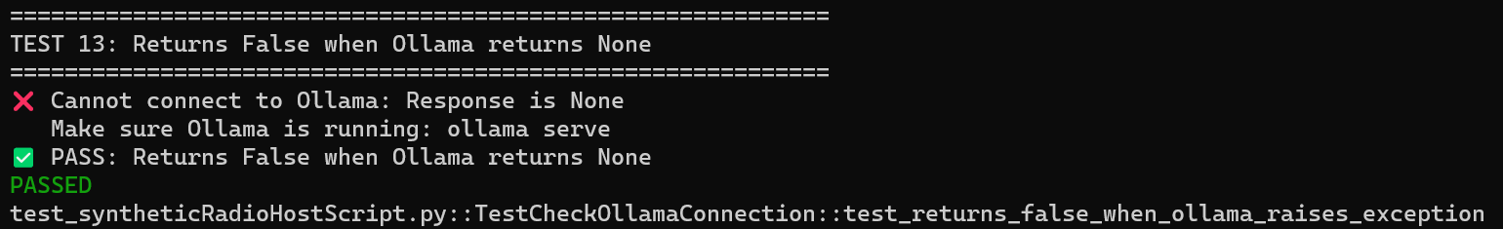

Test 14: Returns False when Ollama raises exception
Description: Catches network errors and connection failures
Coverage: Exception handling - robustness
Effectiveness: Critical - Prevents crashes on connection failures
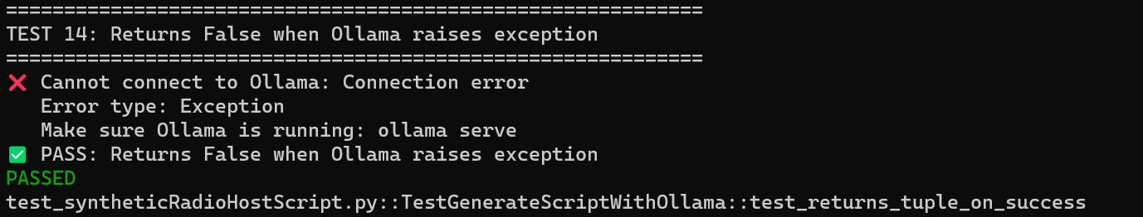

5.5 generate_script_with_ollama() - 7 Test Cases

Test 15: Returns (script, elapsed_time) tuple on success
Description: Verifies correct return type and structure
Coverage: Output validation - return type
Effectiveness: High - Ensures API contract is maintained
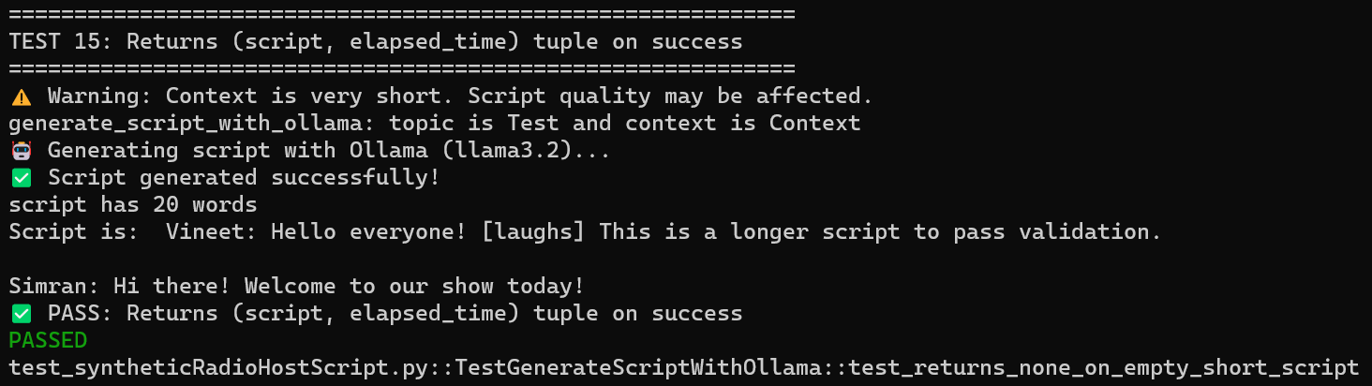

Test 16: Returns (None, elapsed_time) on empty/short script
Description: Handles cases where LLM generates insufficient content
Coverage: Quality validation - output length
Effectiveness: High - Prevents processing of invalid scripts
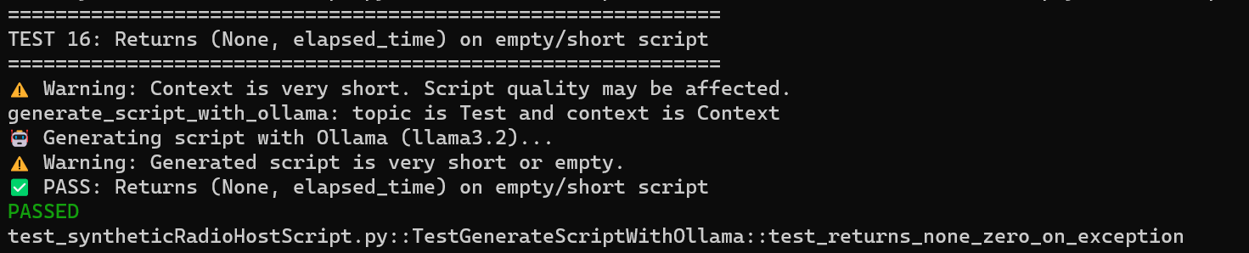

Test 17: Returns (None, 0) on exception
Description: Handles API errors and exceptions
Coverage: Exception handling - error recovery
Effectiveness: Critical - Prevents system crashes
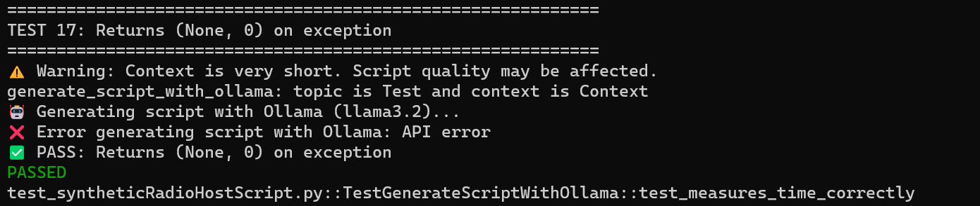

Test 18: Measures time correctly
Description: Validates timing measurement accuracy
Coverage: Performance monitoring - metrics
Effectiveness: Medium - Useful for performance analysis
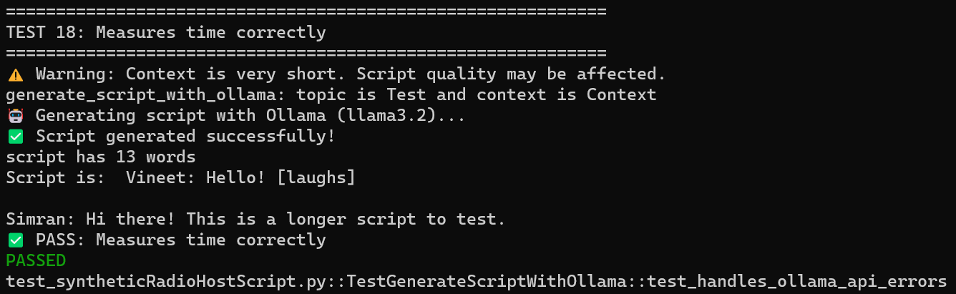

Test 19: Handles Ollama API errors
Description: Catches and handles specific API errors
Coverage: Error handling - API failures
Effectiveness: High - Robust error handling
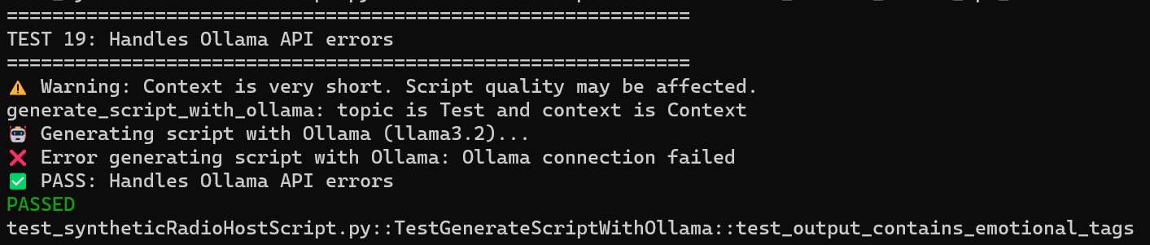

Test 20: Output contains emotional tags like [laughs]
Description: Validates LLM output includes required emotional tags
Coverage: Output validation - content quality
Effectiveness: High - Ensures script quality for audio generation
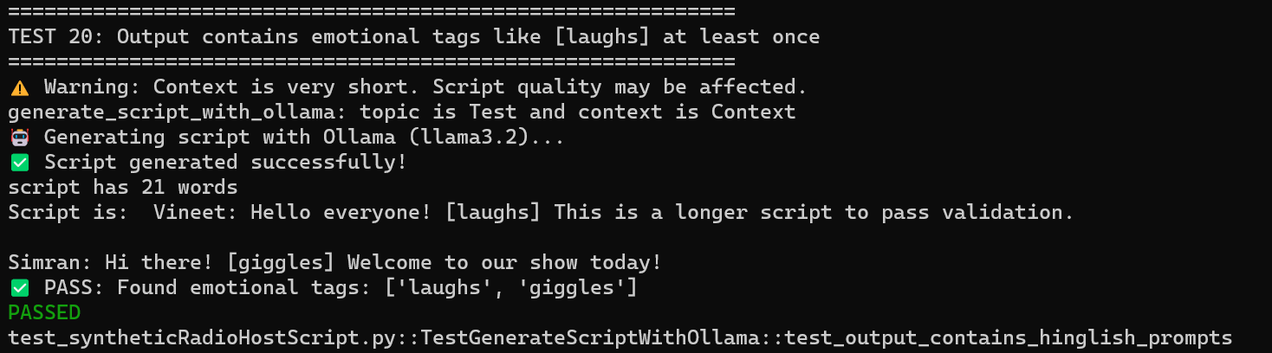

Test 21: Output contains Hinglish prompts (Hmmm, hmm, umm)
Description: Validates LLM output includes natural conversation fillers
Coverage: Output validation - naturalness
Effectiveness: High - Ensures natural-sounding conversations
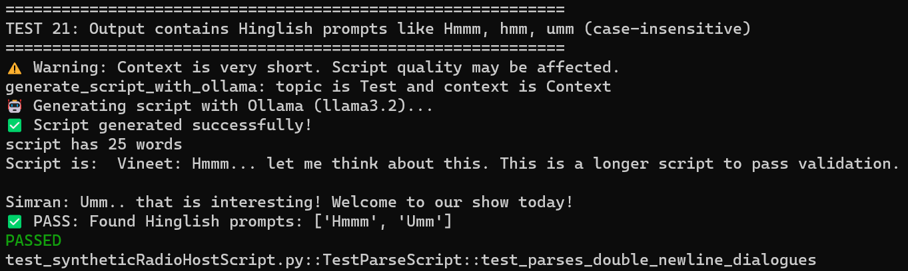

5.6 parse_script() - 10 Test Cases (Most Critical)

Test 22: Parses double newline separated dialogues
Description: Handles scripts with \n\n separators
Coverage: Format parsing - primary format
Effectiveness: Critical - Core functionality
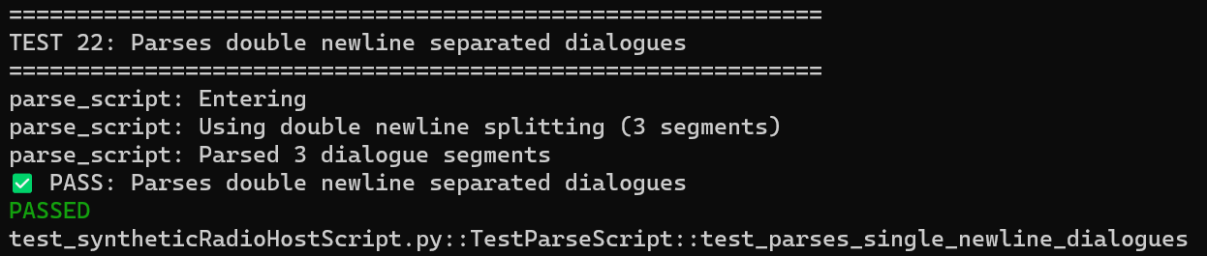

Test 23: Parses single newline separated dialogues
Description: Handles scripts with \n separators
Coverage: Format parsing - alternative format
Effectiveness: High - Format flexibility
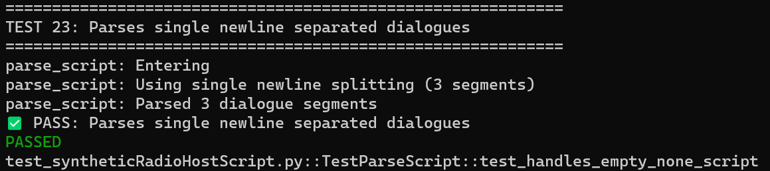

Test 24: Handles empty/None script
Description: Validates empty input handling
Coverage: Input validation - edge case
Effectiveness: High - Prevents errors
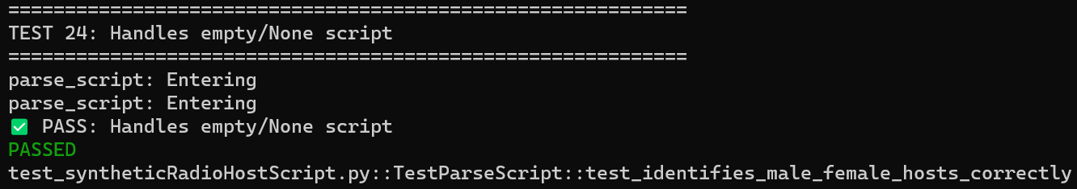

Test 25: Identifies male and female hosts correctly
Description: Correctly assigns host1/host2 based on names
Coverage: Logic validation - speaker identification
Effectiveness: Critical - Correct voice assignment
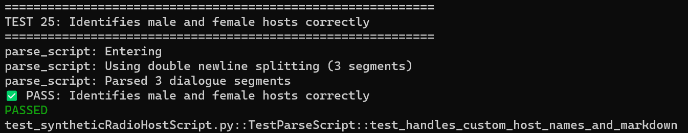

Test 26: Handles custom host names and markdown
Description: Removes markdown and handles custom names
Coverage: Format handling - robustness
Effectiveness: High - Format flexibility
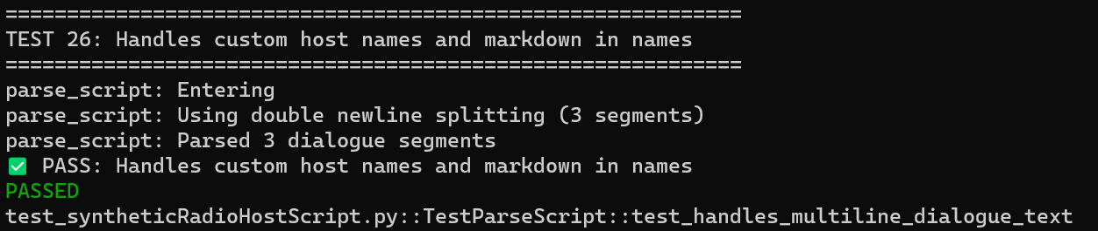

Test 27: Handles multi-line dialogue text
Description: Preserves multi-line dialogue content
Coverage: Content preservation - data integrity
Effectiveness: High - Maintains script quality
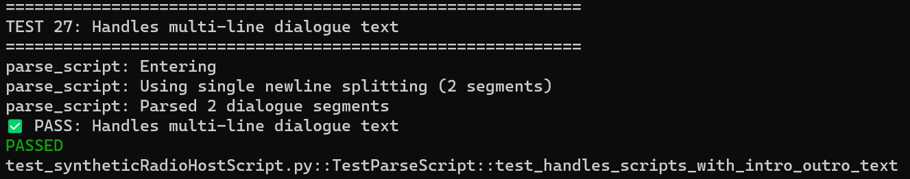

Test 28: Handles scripts with intro/outro text
Description: Skips non-dialogue content
Coverage: Content filtering - noise removal
Effectiveness: High - Handles real-world LLM output
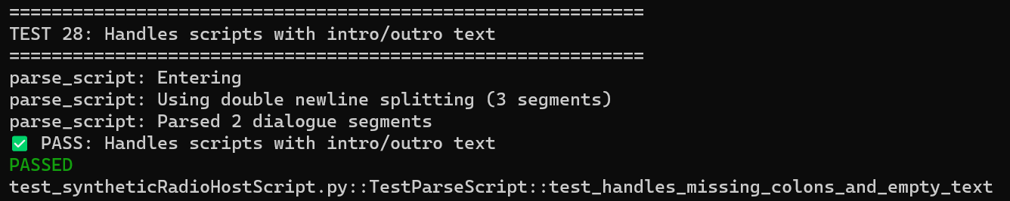

Test 29: Handles missing colons and empty text
Description: Skips malformed segments
Coverage: Error handling - malformed input
Effectiveness: High - Robustness
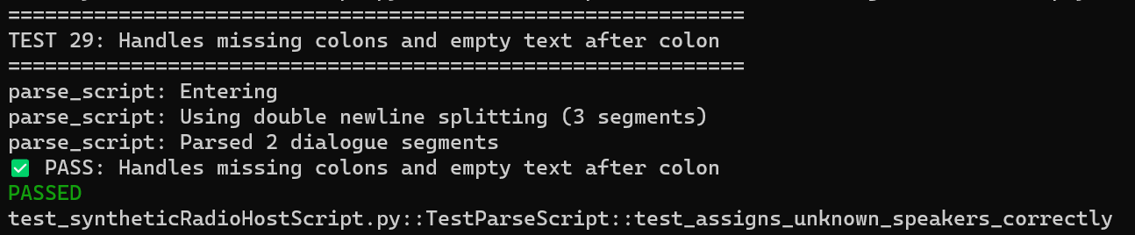

Test 30: Assigns unknown speakers correctly
Description: Handles speakers not matching expected names
Coverage: Logic validation - fallback behavior
Effectiveness: High - Handles edge cases
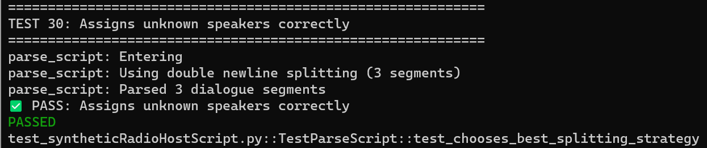

Test 31: Chooses best splitting strategy automatically
Description: Selects optimal parsing method based on script format
Coverage: Algorithm validation - intelligent parsing
Effectiveness: High - Adaptive behavior
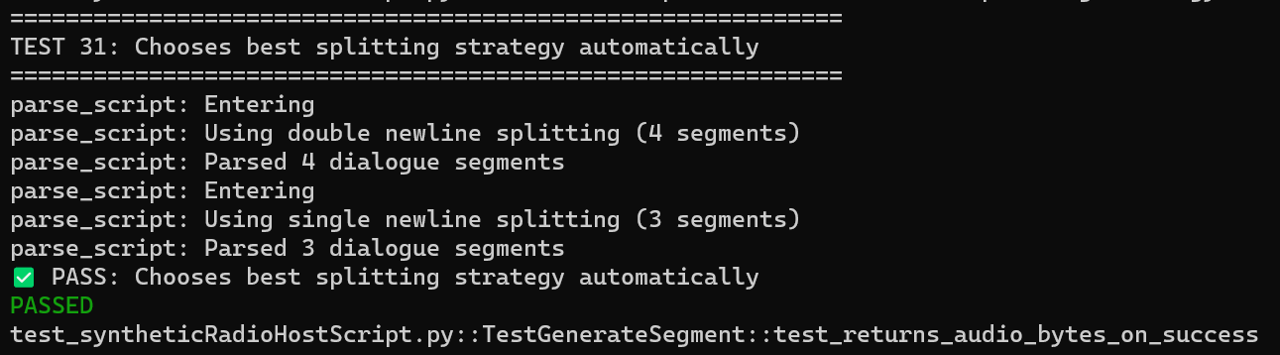

5.7 generate_segment() - 4 Test Cases

Test 32: Returns audio bytes on success (200 status)
Description: Verifies successful audio generation
Coverage: Happy path - normal operation
Effectiveness: High - Core functionality
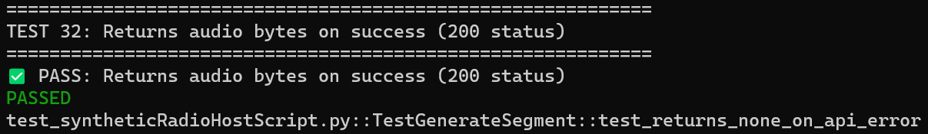

Test 33: Returns None on API error (non-200 status)
Description: Handles API errors gracefully
Coverage: Error handling - API failures
Effectiveness: High - Prevents crashes
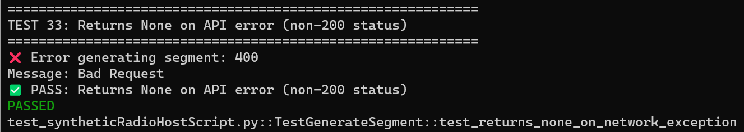

Test 34: Returns None on network exception
Description: Catches network errors
Coverage: Exception handling - network issues
Effectiveness: High - Robustness
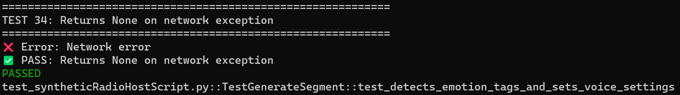

Test 35: Detects emotion tags and sets correct voice settings
Description: Validates emotion detection and voice configuration
Coverage: Feature validation - emotion support
Effectiveness: High - Ensures quality audio output
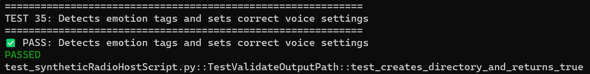

5.8 validate_output_path() - 3 Test Cases

Test 36: Creates directory if it doesn't exist and returns True
Description: Validates directory creation and write permissions
Coverage: File system - directory management
Effectiveness: High - Prevents file write errors
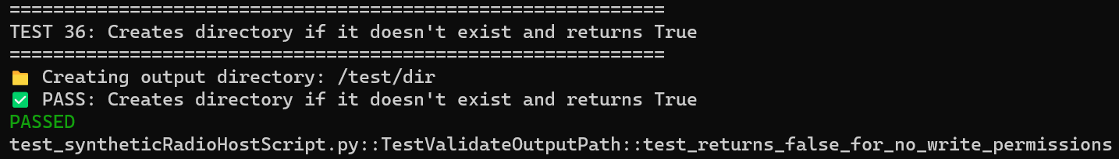

Test 37: Returns False for path without write permissions
Description: Detects permission issues
Coverage: Error detection - permission validation
Effectiveness: High - Early error detection
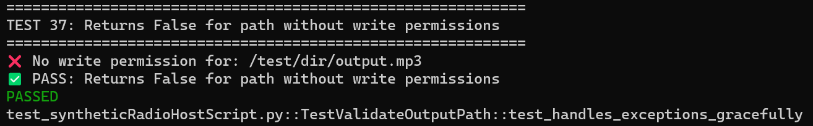

Test 38: Handles exceptions gracefully
Description: Catches file system exceptions
Coverage: Exception handling - robustness
Effectiveness: High - Prevents crashes
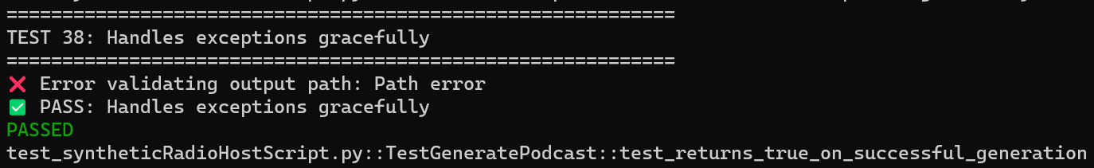

5.9 generate_podcast() - 8 Test Cases

Test 39: Returns True on successful generation
Description: Verifies complete podcast generation workflow
Coverage: Integration - end-to-end flow
Effectiveness: Critical - Core functionality
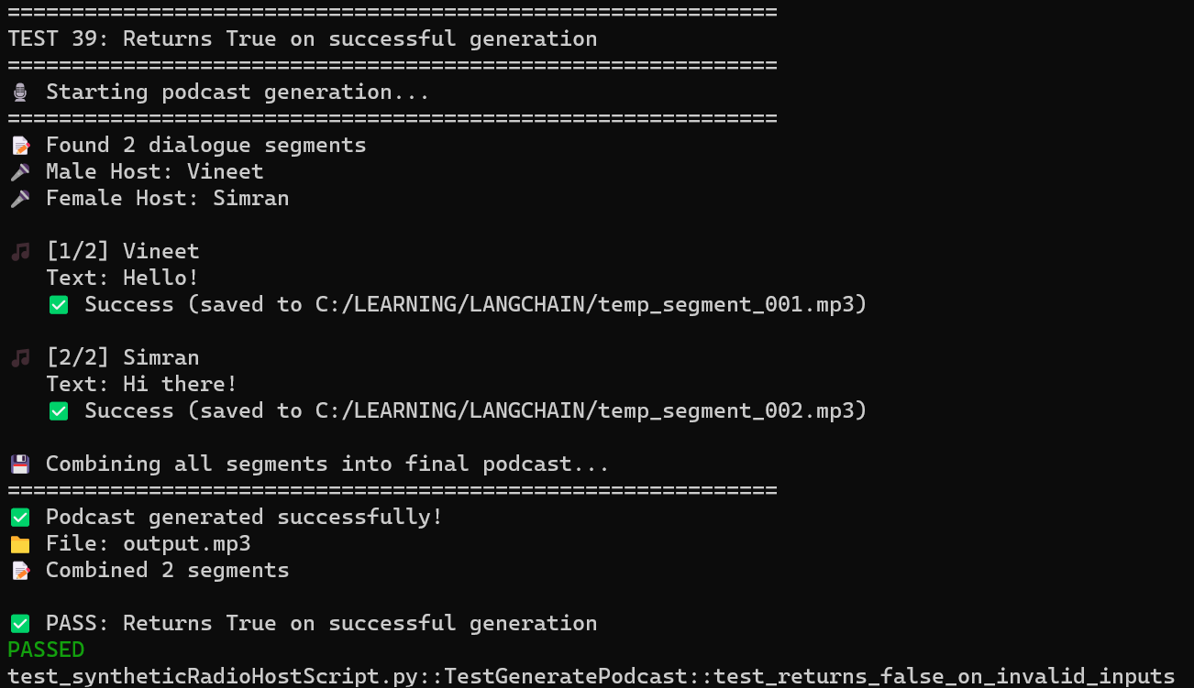

Test 40: Returns False on invalid inputs
Description: Validates API key, dialogue, and voice IDs
Coverage: Input validation - parameter checking
Effectiveness: High - Prevents invalid operations
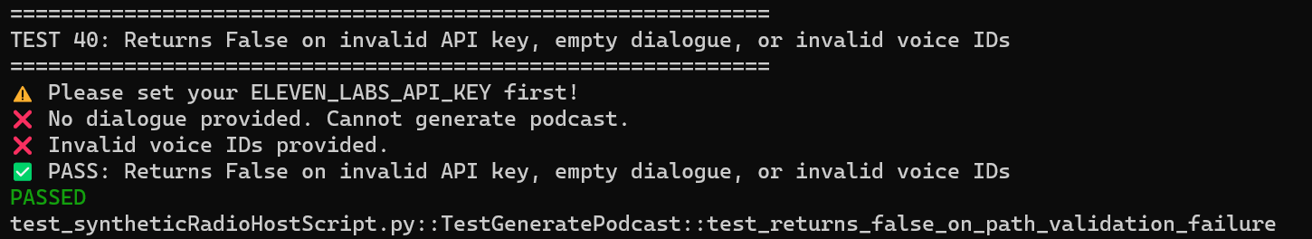

Test 41: Returns False on path validation failure
Description: Handles file system validation errors
Coverage: Error handling - path validation
Effectiveness: High - Prevents file errors
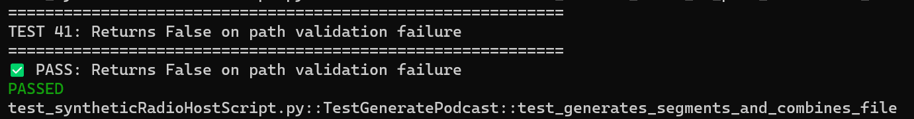

Test 42: Generates all segments and combines into final file
Description: Verifies complete audio generation and combination
Coverage: Integration - workflow completion
Effectiveness: Critical - End-to-end validation
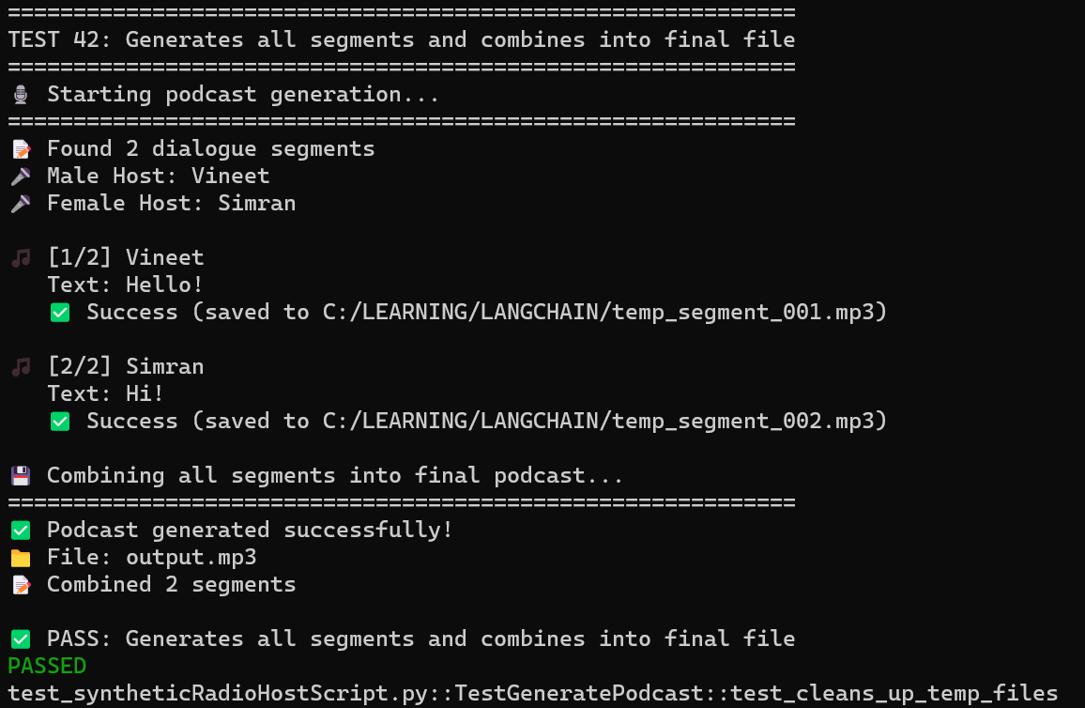

Test 43: Cleans up temp files
Description: Verifies temporary file removal
Coverage: Resource management - cleanup
Effectiveness: High - Prevents disk space issues
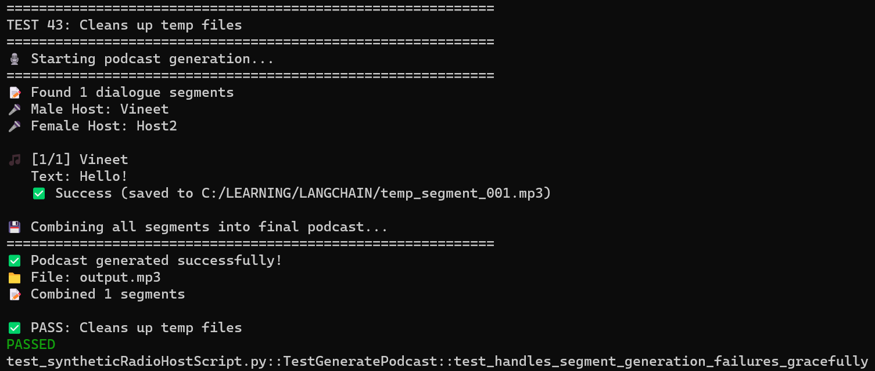

Test 44: Handles segment generation failures gracefully
Description: Continues processing even if some segments fail
Coverage: Error handling - partial failures
Effectiveness: High - Robustness
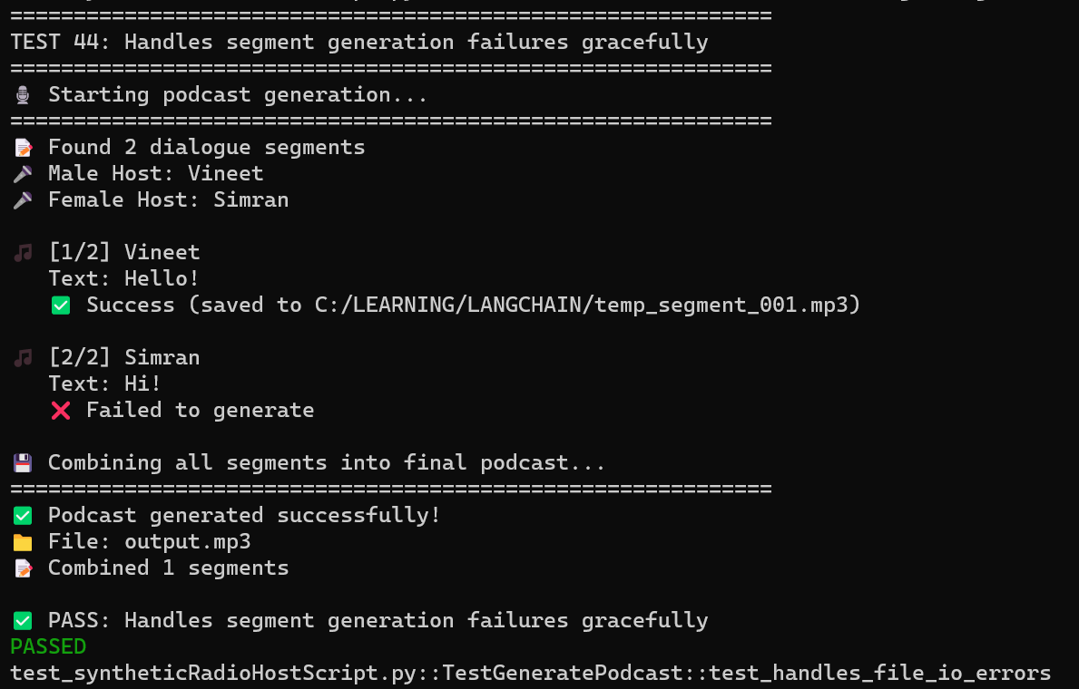

Test 45: Handles file I/O errors
Description: Catches file read/write exceptions
Coverage: Exception handling - I/O errors
Effectiveness: High - Prevents crashes
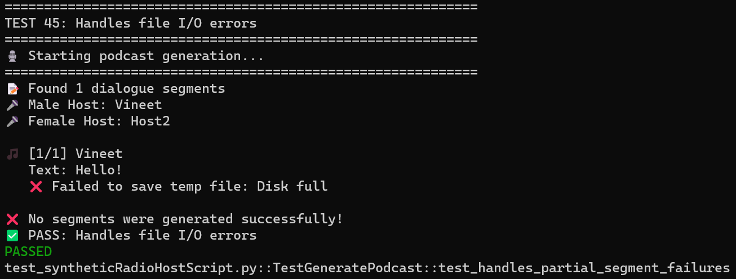

Test 46: Handles partial segment failures
Description: Handles mixed success/failure scenarios
Coverage: Error handling - complex scenarios
Effectiveness: High - Real-world robustness
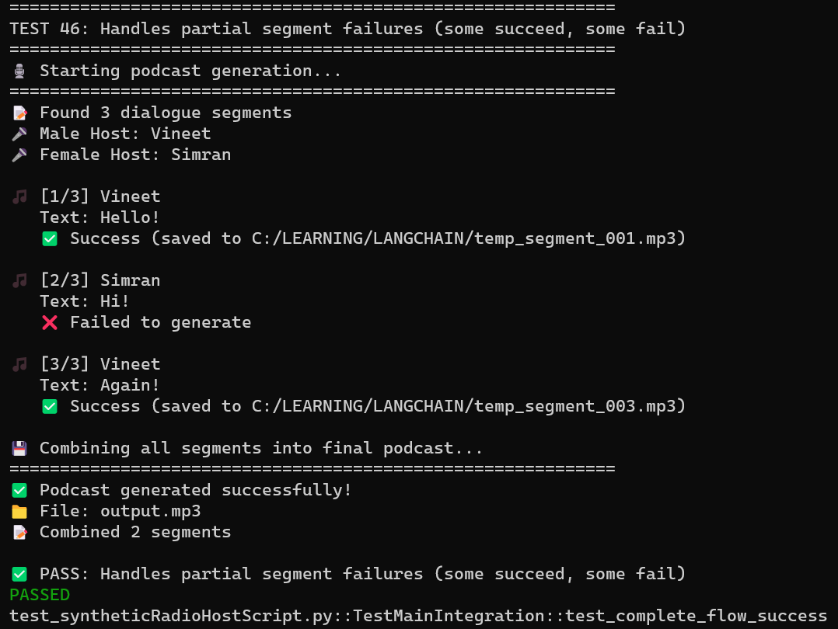

5.10 main() Integration Tests - 5 Test Cases

Test 47: Complete flow: context → script → parse → podcast
Description: Tests entire system workflow end-to-end
Coverage: Integration - full system test
Effectiveness: Critical - System validation
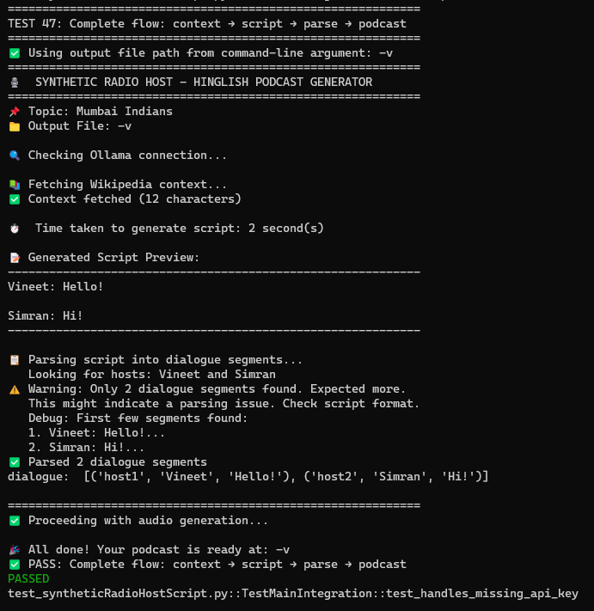

Test 48: Handles missing API key gracefully
Description: Validates behavior when API key is missing
Coverage: Error handling - configuration issues
Effectiveness: High - User experience
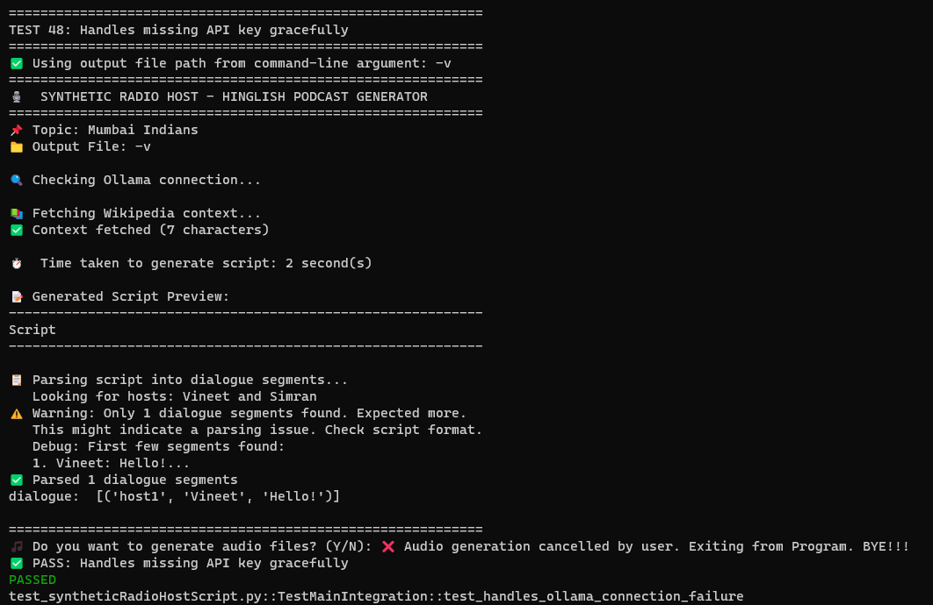

Test 49: Handles Ollama connection failure
Description: Tests early exit on service unavailability
Coverage: Error handling - service availability
Effectiveness: High - Prevents wasted processing
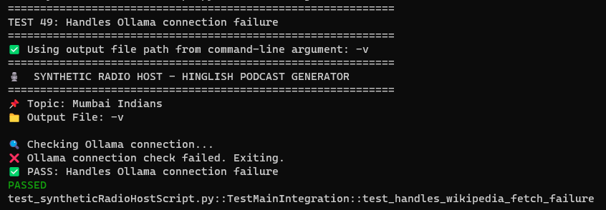

Test 50: Handles Wikipedia fetch failure
Description: Tests behavior when content cannot be fetched
Coverage: Error handling - content retrieval
Effectiveness: High - Graceful degradation
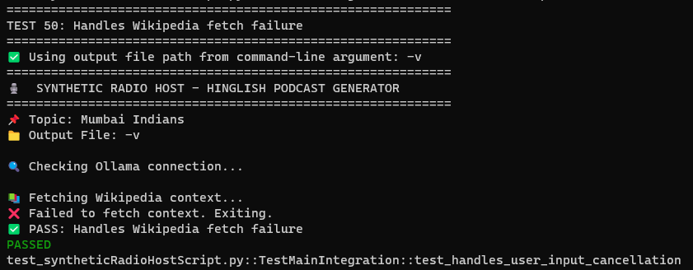

Test 51: Handles user input cancellation
Description: Tests user cancellation of audio generation
Coverage: User interaction - cancellation flow
Effectiveness: High - User experience and cost control
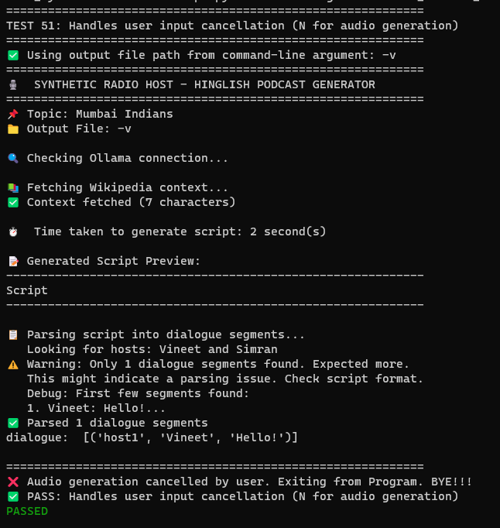

AND FINALLY, THE OUTPUT COMES LIKE AS GIVEN BELOW:

