M3 Project Report
Name: Vineet Kumar Srivastava

Contents
Abstract 2
Classification Methods 2
Empirical results 2
Logistic Regression 2
K Nearest Neighbors 3
Support Vector Machines 3
Decision Trees 3
Random Forest 4
Naive Bayes 5
Impact of PCA on Classification Methods 5
PCA Configuration 5
Empirical Results 5
Detailed Impact Analysis 6
Overall Summary 6

Abstract
Performance of All classification methods described in the class needs to be compared using the MNIST dataset. Classification methods covered in this report are: Logistic Regression, K Nearest Neighbors, Support Vector Machines, Decision Trees, Random Forest and Naive Bayes.

Classification Methods

Empirical results
Empirical results are as follows:
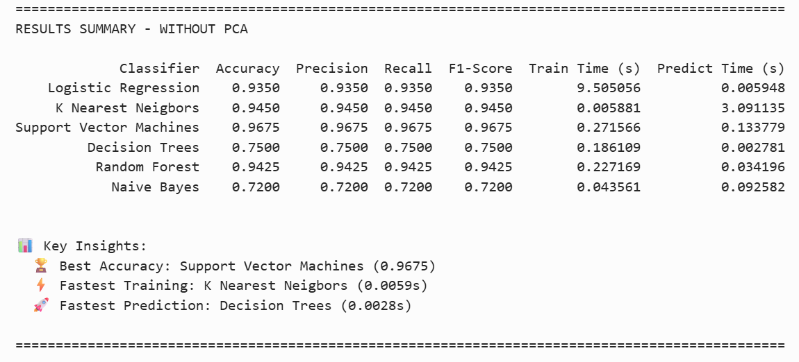
Fig 1. Classification Methods Performance Summary.

Logistic Regression
Pros:
- Strong Accuracy 93.5% competitive with KNN and Random Forest.
- Very Fast prediction
- Interpretable: Provides coefficients and probabilities, making decisions explainable.
- Good baseline

Cons:
- Slowest training time.
- Moderate performance on MNIST (93.5%)
- Lower accuracy than SVM.
- Assumes linear decision boundaries
- May underfit complex patterns
- Requires feature scaling

K Nearest Neighbors
Pros:
- Fastest training time 0.005 seconds.
- Simple and intuitive
- High accuracy on MNIST (94.5%)
- Adapts to local patterns: Uses local neighbourhoods, effective for varied class distributions.

Cons:
- Very slow prediction time.
- High memory requirements (stores entire dataset)

Support Vector Machines
Pros:
- Highest accuracy among classical ML methods (96.5%)
- Fast Training – much faster than Logistic Regression
- Fast prediction time.
- Handles non-linear patterns via kernel functions.
- Good generalization: Strong performance suggests same.
- Works well with clear margin of separation

Cons:
- Slower training than of the alternatives i.e. KNN, Decision Trees, Random Forest and Naïve Bayes.
- Slower predictions than fastest models Decision Trees, Logistic Regression and Random Forest.
- Harder to explain.
- Limited scalability: Training time can grow significantly with large datasets.

Decision Trees
Pros:
- Fastest prediction time: 0.0028 seconds — fastest among all models, suitable for real-time inference.
- Fast training: 0.1861 seconds — much faster than Logistic Regression (9.51s), competitive with other models.
- Interpretable: Visualizable tree structure; easy to explain decisions.
- Feature importance: Provides insights into which features matter most.

Cons:
- Second Lowest accuracy: 75.00% — worst among all models except Naïve Bayes.
- Overfitting risk: Despite max_depth=20, still shows lower generalization than ensemble methods.
- High variance: Sensitive to small data changes; Random Forest (ensemble) performs better (94.25%).
- Struggles with high-dimensional data: 784 features may lead to suboptimal splits.
- Less effective than ensemble: Random Forest (100 trees) achieves 94.25% vs 75.00% for a single tree.

Random Forest
Pros:
- High accuracy: 94.25% — second best after SVM (96.75%), better than Logistic Regression (93.50%) and Decision Trees (75.00%).
- Fast training: 0.23 seconds — much faster than Logistic Regression (9.51s), competitive with SVM (0.27s) and Decision Trees (0.19s).
- Fast prediction: 0.034 seconds — good for real-time use, faster than KNN (3.09s) and Naive Bayes (0.09s).
- Handles high dimensionality: Works with 784 features without dimensionality reduction.
- Good balance: Strong accuracy with reasonable training and prediction times.

Cons:
- Lower accuracy than SVM: 94.25% vs 96.75% — SVM performs better on this dataset.
- Memory intensive: Stores 100 decision trees, requiring more memory than single models.
- Less interpretable than single models: Harder to explain than Logistic Regression or a single Decision Tree.
- Slower than some models: Training (0.23s) is slower than KNN (0.006s) and Naive Bayes (0.04s).
- Not the fastest predictor: Prediction (0.034s) is slower than Logistic Regression (0.006s) and Decision Trees (0.003s).

Naive Bayes
Pros:
- Very fast training: 0.0436 seconds — among the fastest.
- Simple and interpretable: Probabilistic model with clear assumptions; easy to understand and explain.
- Works well with small datasets: Can perform reasonably even with limited training data.
- Low memory usage: Only stores mean and variance per feature per class.
- No hyperparameter tuning needed: Works out-of-the-box with default parameters.
- Probabilistic outputs: Provides class probabilities, not just predictions.

Cons:
- Lowest accuracy: 72.00% — worst among all classifiers.
- Independence assumption: Assumes features are independent, which is violated for image pixels (spatial correlations exist).
- Slower prediction than some.
- Poor fit for image data: Gaussian Naive Bayes assumes Gaussian distributions per feature, which doesn’t match pixel value distributions well.
- Not suitable for high-dimensional correlated data: With 784 correlated pixel features, the independence assumption is strongly violated.
- Limited feature interactions: Cannot capture complex relationships between pixels.

Impact of PCA on Classification Methods

PCA Configuration
PCA Configuration used:
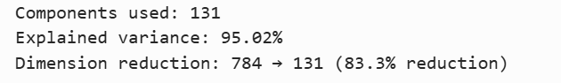
Fig 2. PCA Configuration Used.

Empirical Results
Results are as follows:
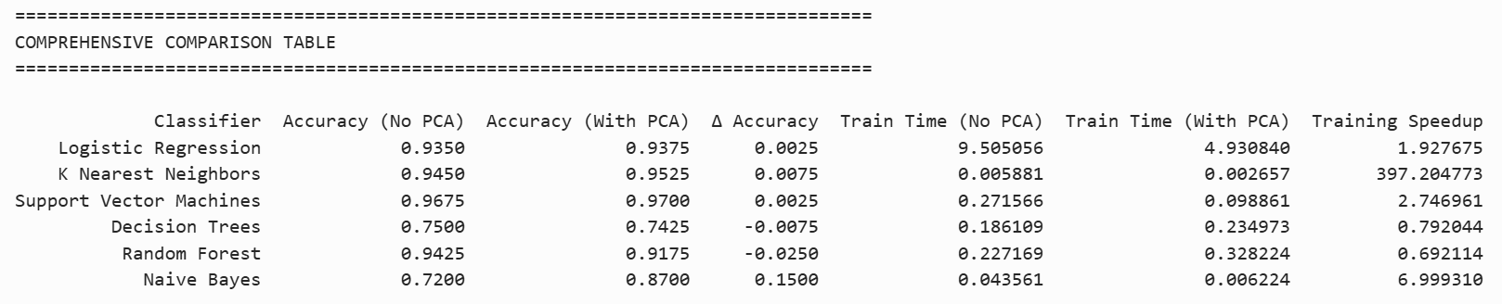
Fig 3. Results with PCA

Detailed Impact Analysis
Impact analysis w.r.t Accuracy and Speed is as given below:
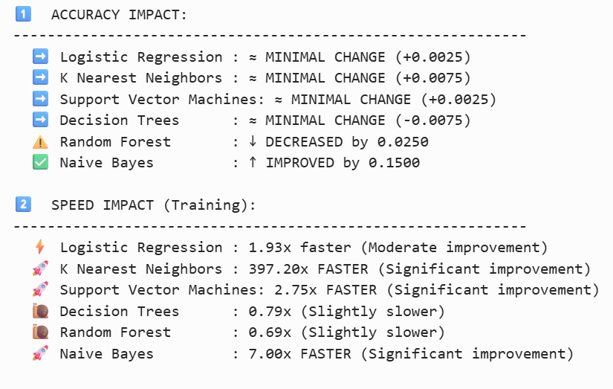
Fig 4. Impact Analysis

Overall Summary
Key findings are as follow:
- Without PCA the best performer was SVM with accuracy of 96.75% and Training time of 0.2716s.
- With PCA also the best performer is SVM with accuracy of 97% and less training time too.
- Effect of PCA w.r.t speed was the best on KNN with speed improvement of about 397%.
- Best overall accuracy achieved with classification methods is 97% and method is SVM.

