Name: Vineet Gajjelli
Roll no: 2420030375
Section - 1
Trello Tool
Step 1: Sign up Trello.com
https://trello.com/

Step 2: Click on Create Workspace, Name it College Event Management System
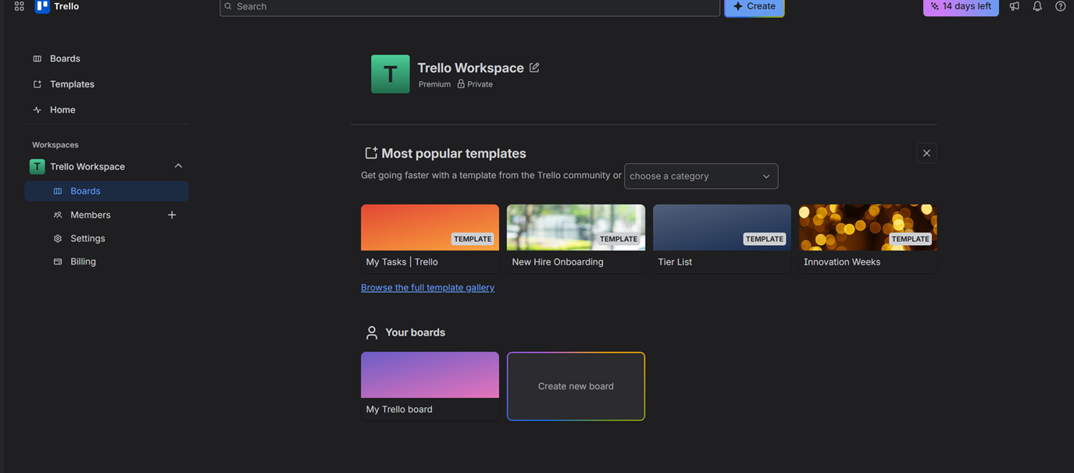
Step 3: Invite team members
Click on Members on left dashboard-->click on Invite Workspace Members and add
For example added(team members)

Step 4: Create Project Board-->Board Name College Event Sprint Board
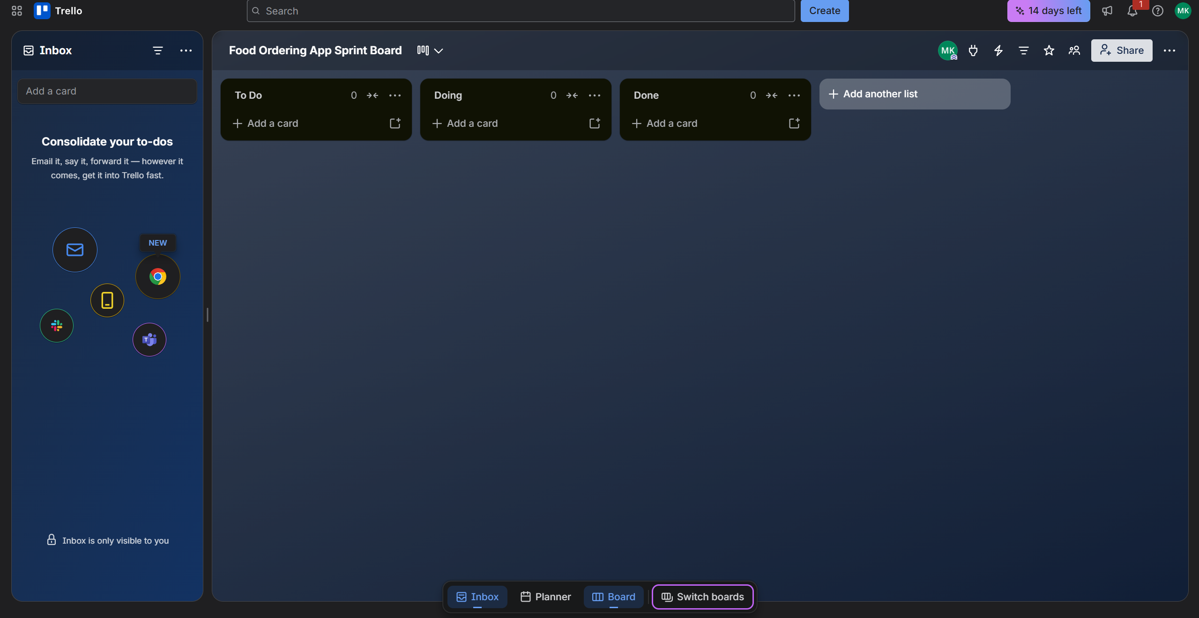
Step 5: Create Lists
Product Backlog
Sprint Backlog
To Do
In Progress
Code Review
Testing
Done

Create all List as follows
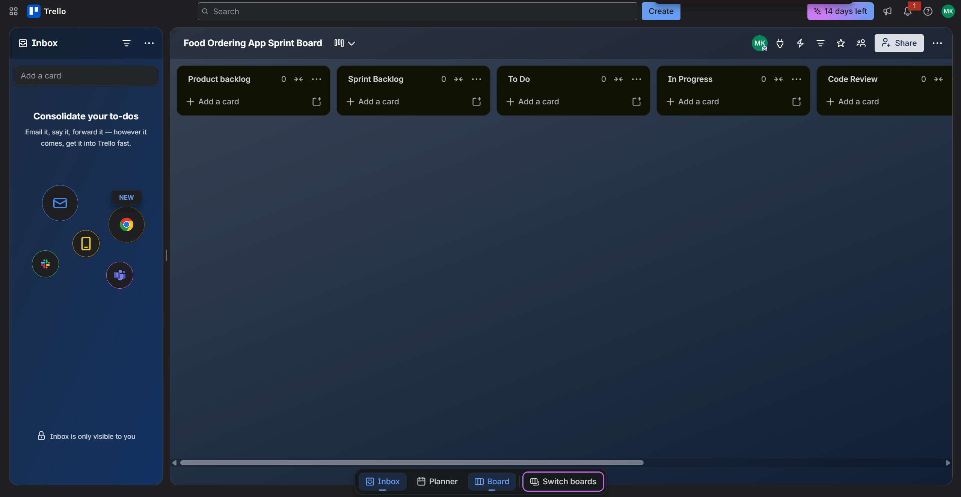

Step 6: Create Card under List

Create cards under Product Backlog.
User Story 1
As an event coordinator,
I want to create an event workspace,
So that I can manage college events.

User Story 2
As an event coordinator,
I want to log in securely,
So that I can access the event workspace.

User Story 3
As an event coordinator,
I want to view upcoming events,
So that I can plan activities efficiently.

User Story 4
As an event coordinator,
I want to add tasks to the event board,
So that I can organize event activities.

User Story 5
As an event coordinator,
I want to track event expenses,
So that I can manage the event budget.
User Story 6
As an event coordinator,
I want to track event progress,
So that I know the current project status.
