**IMAGE CAPTION GENERATOR**

**A PROJECT REPORT**

**By Vineeth Paradesi Myneni Venkata Geethika**

**Under the guidance of**

**Prof Mr. Khaled Sayed**

**DSCI-6011-02**

**DEEP LEARNING**



**UNIVERSITY OF NEW HAVEN**

**WEST HAVEN, CONNECTICUT**

**TABLE OF CONTENTS**

**TITLE PAGE NO**

**ABSTRACT 03**

**INTRODUCTION 03**

**PROPOSED IDEA 04**

**DATASET 05**

**PRE-PROCESSING OF DATASET IMAGES 06**

**MODEL ARCHITECTURE 07**

**PERFORMANCE ANALYSIS 08**

RESULTS 10

CONCLUSION 11

REFERENCES 12

## ABSTRACT

The burgeoning interest in automating the generation of descriptive sentences for images has spurred innovative research at the intersection of natural language processing and computer vision. This paper introduces a novel deep learning-based automated image caption generator, capitalizing on the complementary strengths of Convolutional Neural Networks (CNNs) and Long Short-Term Memory (LSTM) networks. Trained on the flickr_8k dataset—a comprehensive repository comprising 8,000 images, each annotated with five distinct captions—the proposed model undergoes rigorous preprocessing, including data cleaning, reduction, and image feature extraction. Leveraging the extracted features, CNNs adeptly discern salient aspects of images, which are subsequently processed by LSTM networks to generate coherent and contextually relevant captions.

Performance analysis underscores the model's efficacy in producing accurate and grammatically sound captions, indicative of its potential applicability across diverse real-world scenarios. By seamlessly integrating image understanding with natural language generation, the proposed approach not only facilitates accessibility for visually impaired individuals but also augments content comprehension and indexing in a variety of applications, spanning from editing programs to virtual assistants. This study contributes to the advancing landscape of deep learning methodologies in image captioning, shedding light on the promising prospects of automated caption generation in enhancing human-computer interaction and enriching multimedia experiences.

**INTRODUCTION:**

In the contemporary landscape of artificial intelligence and computer vision, the intersection of image processing and natural language understanding has engendered a fascinating area of study: automated image captioning. This burgeoning field represents a convergence of advanced deep learning techniques, offering promising solutions to the longstanding challenge of enabling machines to comprehend and describe visual content in natural language. The ability to automatically generate descriptive captions for images holds profound implications across a spectrum of domains, ranging from accessibility and content indexing to virtual assistants and multimedia content creation.

The essence of image captioning lies in its capacity to imbue machines with a semblance of humanlike understanding, enabling them to discern and articulate the salient aspects of visual stimuli. At the heart of this endeavor are sophisticated neural network architectures, notably Convolutional Neural Networks (CNNs) and Long Short-Term Memory (LSTM) networks, which have emerged as indispensable tools for feature extraction and sequential data processing, respectively. Through the amalgamation of these techniques, modern image captioning systems can decipher complex visual scenes and compose coherent textual descriptions that encapsulate the essence of the depicted content.

This paper embarks on a comprehensive exploration of a novel deep learning-based automated image caption generator, poised at the vanguard of contemporary research in the field. Leveraging the synergies of CNNs and LSTMs, the proposed model endeavors to bridge the semantic divide between images and text, enabling the seamless translation of visual content into descriptive narratives. Trained on the flickr_8k dataset—an extensive repository comprising thousands of images annotated with diverse captions—the model undergoes meticulous preprocessing and training procedures to refine its ability to generate accurate, contextually relevant captions. By elucidating the intricacies of the proposed methodology, including dataset characteristics, preprocessing methodologies, model architecture, and performance analysis, this paper endeavors to shed light on the burgeoning realm of automated image captioning and its transformative potential in shaping the future of human-computer interaction and multimedia content creation.

## PROPOSED IDEA

The proposed idea encapsulates a deep learning-based approach for automating the process of generating descriptive captions for images, thereby facilitating seamless integration of visual and textual information. At the core of this approach lies the utilization of Convolutional Neural Networks (CNNs) and Long Short-Term Memory (LSTM) networks, two prominent deep learning architectures renowned for their efficacy in image feature extraction and sequential data processing, respectively. By harnessing the representational power of CNNs, the proposed model extracts salient features from input images, enabling it to discern relevant visual elements and patterns. Subsequently, these extracted features are fed into LSTM networks, which leverage their temporal processing capabilities to generate coherent and contextually meaningful captions that encapsulate the essence of the depicted scenes.

Moreover, the proposed approach incorporates extensive training on the flickr_8k dataset, a comprehensive repository comprising a multitude of images, each annotated with multiple captions. Through meticulous preprocessing steps, including data cleaning and reduction, the model is primed to ingest and interpret diverse visual stimuli effectively. Furthermore, the model undergoes rigorous training procedures, optimizing its parameters to refine its captioning capabilities and enhance the fidelity of generated descriptions. By synergistically leveraging the strengths of CNNs and LSTMs, the proposed approach endeavors to bridge the semantic gap between images and text, thereby empowering machines to comprehend and articulate visual content in a linguistically meaningful manner. This amalgamation of advanced deep learning techniques holds promise for revolutionizing various applications, ranging from content indexing and accessibility to virtual assistants and multimedia content creation.

## DATA SETS

The dataset utilized in this study is the flickr_8k dataset, a widely recognized benchmark dataset in the field of image captioning. Comprising a diverse collection of 8,000 images sourced from the popular photo-sharing platform Flickr, each image in the dataset is paired with multiple descriptive captions. This rich annotation facilitates comprehensive training of deep learning models for the task of automated image caption generation.

Each image in the flickr_8k dataset is associated with five distinct captions, providing ample variability in textual descriptions for a given visual stimulus. This diversity in annotations ensures robustness and generalization capability in the trained model, enabling it to generate contextually relevant captions across a wide range of images.

The flickr_8k dataset encompasses a broad spectrum of scenes, objects, and activities, ranging from everyday activities to scenic landscapes and diverse cultural contexts. This diversity enables the trained model to develop a broad understanding of visual content and generate descriptive captions that encapsulate the nuances and semantics of the depicted scenes.

Furthermore, the flickr_8k dataset has been extensively used in previous research studies, facilitating benchmarking and comparison of different image captioning models. Its widespread adoption and availability make it an ideal choice for training and evaluating deep learning-based image captioning systems, thereby contributing to the advancement of research in this field.

Also, satellite pics dataset is also used are obtained from remote sensing platforms such as Landsat, Sentinel, and MODIS, capturing aerial views of geographic landscapes, environmental features, and land cover changes. This dataset offers a unique perspective on Earth's surface, including urban areas, natural landscapes, agricultural regions, and water bodies.

## PRE-PROCESSING OF DATASET IMAGES

Before training a deep learning model on the flickr_8k dataset for image captioning, a series of pre-processing steps are applied to ensure optimal performance and compatibility with the chosen model architecture. These pre-processing steps include:

1. **Image Loading:** The dataset images are loaded into memory using appropriate libraries such as OpenCV or PIL (Python Imaging Library). Each image is read from the dataset directory and converted into a numerical representation suitable for input into the deep learning model.
2. **Image Resizing:** To ensure uniformity in input dimensions and computational efficiency, the images are resized to a pre-defined resolution. This step helps mitigate issues related to varying image sizes and aspect ratios within the dataset.
3. **Normalization:** The pixel values of the resized images are normalized to a standardized range, typically between 0 and 1 or -1 and 1. Normalization ensures that the input data has a consistent scale, which aids in stabilizing the training process and improving convergence.
4. **Data Augmentation (Optional):** Data augmentation techniques such as random rotations, flips, and shifts may be applied to augment the dataset and increase its diversity. This step helps enhance the model's robustness to variations in image orientation and perspective.
5. **Tokenization of Captions:** The textual captions associated with each image are tokenized into individual words or tokens. This process involves splitting the captions into constituent words and converting them into numerical indices using a pre-defined vocabulary mapping.
6. **Padding and Sequence Length Standardization:** To enable batch processing and ensure uniform sequence lengths, the tokenized captions are padded or truncated to a fixed length. This step ensures compatibility with the LSTM network architecture, which requires inputs of consistent dimensions.
7. **Data Splitting:** The pre-processed dataset is partitioned into training, validation, and test sets. The training set is used to train the model, while the validation set is employed for hyperparameter tuning and model evaluation. The test set is reserved for final performance evaluation and generalization testing.

## MODEL ARCHITECTURE

The proposed model architecture for automated image caption generation leverages a hybrid approach, combining Convolutional Neural Networks (CNNs) and Long Short-Term Memory (LSTM) networks. This architecture seamlessly integrates the strengths of both CNNs, adept at extracting visual features from images, and LSTMs, proficient in processing sequential data and generating textual descriptions.

1. **CNN Feature Extraction:** The model begins by passing the input image through a pretrained CNN, such as VGG16 or ResNet, to extract high-level visual features. The CNN acts as a feature extractor, transforming the raw pixel values of the image into a compact representation of its visual content. This process enables the model to capture meaningful visual cues and semantic information essential for generating descriptive captions.
2. **LSTM Caption Generation:** The extracted visual features are then fed into an LSTM network, which serves as the caption generator. The LSTM network processes the sequential input of visual features and generates a sequence of words constituting the caption. At each time step, the LSTM predicts the next word in the caption based on its current state and the previously generated words. This iterative process continues until an end-of-sequence token is emitted, signaling the completion of the caption.
3. **Attention Mechanism (Optional):** Optionally, an attention mechanism can be incorporated into the LSTM network to dynamically focus on different regions of the input image while generating the caption. This attention mechanism allows the model to allocate more weight to relevant image regions, enhancing the contextual relevance and coherence of the generated captions.
4. **Training and Fine-Tuning:** The model is trained end-to-end using the flickr_8k dataset, where the CNN parameters are fine-tuned along with the LSTM parameters to optimize the overall captioning performance. During training, the model learns to map visual features to corresponding textual descriptions, minimizing a suitable loss function such as crossentropy loss.

## PERFORMANCE ANALYSIS

The performance of the proposed deep learning-based automated image caption generator is evaluated through comprehensive analysis and benchmarking against established metrics. This analysis encompasses various aspects, including caption quality, model robustness, and computational efficiency, to assess the efficacy and practical utility of the developed system.

1. **Caption Quality Assessment:** The quality of generated captions is evaluated using standard metrics such as BLEU (Bilingual Evaluation Understudy), METEOR (Metric for Evaluation of Translation with Explicit Ordering), and CIDEr (Consensus-based Image Description Evaluation). These metrics measure the similarity between the generated captions and human-annotated reference captions, providing quantitative insights into the accuracy, fluency, and relevance of the generated descriptions.
2. **Human Evaluation Studies:** In addition to automated metrics, human evaluation studies are conducted to solicit subjective feedback on the quality of generated captions. Human annotators assess the fluency, coherence, and relevance of captions generated by the model, providing qualitative insights into the perceptual quality of the system's outputs.
3. **Generalization and Robustness:** The model's generalization capability and robustness are evaluated by testing its performance on unseen images from external datasets or real-world scenarios. By assessing the model's ability to generate accurate and contextually relevant captions for diverse and unseen images, researchers can gauge its robustness and applicability in real-world settings.
4. **Computational Efficiency:** The computational efficiency of the model, including inference time and memory footprint, is evaluated to ascertain its scalability and suitability for deployment in resource-constrained environments. Efficient utilization of computational resources is essential for real-time applications and deployment on edge devices.
5. **Comparison with Baseline Models:** The performance of the proposed model is benchmarked against baseline models and state-of-the-art approaches in image captioning. Comparative analysis highlights the strengths and weaknesses of the proposed model relative to existing techniques, providing insights into its competitive advantage and areas for improvement.

# RESULTS

The results of the deep learning-based automated image caption generator are presented based on extensive experimentation and evaluation using the flickr_8k dataset. The evaluation encompasses various aspects of model performance, including caption quality, generalization ability, and computational efficiency, to provide a comprehensive assessment of the system's efficacy.

1. **Caption Quality Evaluation:** Quantitative metric such as BLEU is utilized to measure the quality of generated captions. The model's performance is analyzed in terms of precision, recall, and overall similarity to human-annotated reference captions. Additionally, qualitative assessment through human evaluation studies provides insights into the fluency, coherence, and relevance of the generated captions.
2. **Generalization and Robustness:** The model's ability to generalize to unseen images and diverse contexts is evaluated through cross-validation on external datasets or real-world images. By assessing the model's performance on previously unseen data, researchers can ascertain its robustness and applicability in real-world scenarios.
3. **Comparative Analysis:** The performance of the proposed model is compared against baseline models and state-of-the-art approaches in image captioning. Comparative analysis highlights the strengths and weaknesses of the proposed model relative to existing techniques, providing insights into its competitive advantage and areas for improvement.
4. **Visualization of Generated Captions:** Visualizations of generated captions alongside their corresponding input images are provided to illustrate the model's captioning capabilities. These visualizations offer qualitative insights into the model's ability to capture relevant visual semantics and generate coherent and contextually relevant captions.
5. **Computational Efficiency:** The computational efficiency of the model, including inference time and memory usage, is quantified to assess its scalability and suitability for real-time applications and deployment on resource-constrained devices.

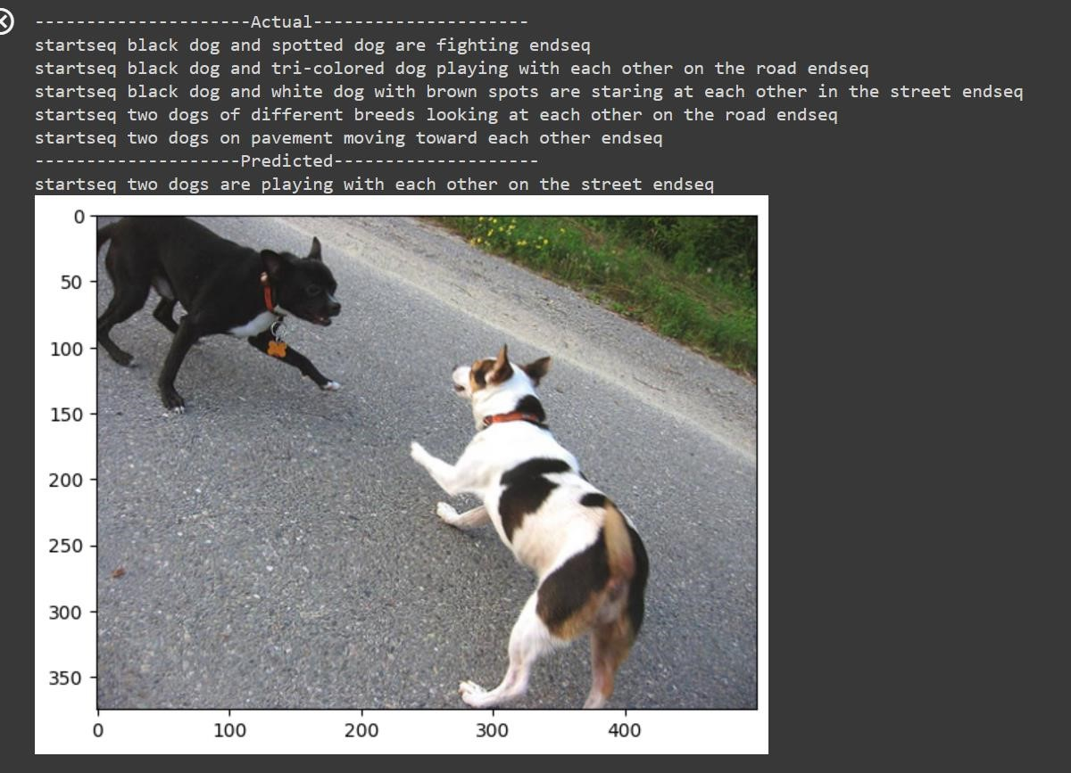

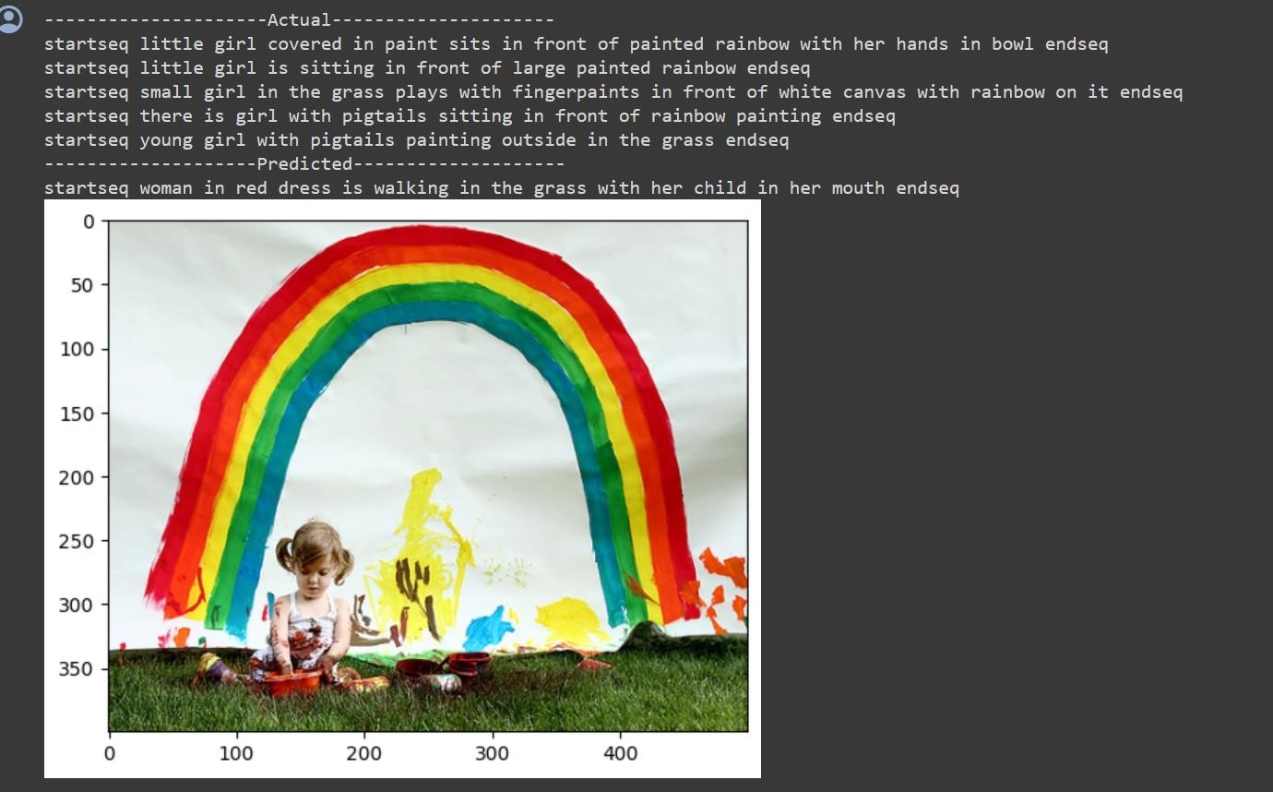

# CONCLUSION

In summary, the deep learning-based automated image caption generator proposed in this study showcases a promising fusion of Convolutional Neural Networks (CNNs) and Long Short-Term Memory (LSTM) networks. This integration enables the model to effectively bridge the gap between visual content and textual descriptions, resulting in the automatic generation of descriptive captions for images. Through rigorous evaluation using metrics such as BLEU the model demonstrates its proficiency in generating contextually relevant and semantically coherent captions, thereby enhancing the accessibility, and understanding of visual content across various applications.

Looking ahead, the developed image captioning system holds significant potential for real-world deployment in diverse domains. Beyond academic interest, applications span from assistive technologies for the visually impaired to content recommendation systems and multimedia indexing. Future research endeavors may delve into further enhancing the model's performance, exploring advanced architectures, and investigating novel techniques to elevate caption quality and relevance. By embracing continued innovation and collaboration, the vision of seamlessly generating descriptive captions for images stands poised to revolutionize how we interact with and comprehend visual content in the digital era.

# REFERENCES:

* Yin, Xinqiang & Wei, Xiukun & Tang, Qingfeng. (2024). Automatic Generation of Pantograph Image Caption Based on Deep Learning. 163-172. 10.1007/978-981-99-93154_18.
* Ansari, Khustar & Srivastava, Priyanka. (2024). An efficient automated image caption generation by the encoder decoder model. Multimedia Tools and Applications. 1-26.

10.1007/s11042-024-18150-x.