**Collaborative Whiteboard**

**Collaborative Whiteboard**

There are various habits by which scattered systems can help human benefit. Organized printers license us to share resources. Circled record systems can give us speedy trustworthy admittance to our information. Exactly when people need to participate over immense partitions they consistently go to PC maintained pleasant work programming, for progressing work see [1]. Normal uses fuse gathering visit applications and social occasion report adjusting. Perhaps the most mainstream delineation of an application is Google Docs [2] which, as it happens, was used to make this report. Though acclaimed Google Docs is just the latest entry into collective archive sharing business area [3] including Lotus Notes [4], Xerox DocuShare [5], and Seven Mountains Integrate. In this undertaking we developed an application from a clear related domain: dispersed whiteboards, for an early application see [5]. A scattered whiteboard is a typical visual record publication chief, where a couple of customers can at the same time draw on a canvas using various apparatuses and tones. Potential uses range from shared work on a touch of cutting edge workmanship to representatives of an association arranging the work-stream for an endeavor online whiteboard makes you energize your gathering practices when dealing with the web. It urges you to improve helpful cycles when working remotely.

Gatherings can manage a common burden up and picture all that they do continuously. They engage you to do a workshop completely progressed and indirectly.

**Architecture**

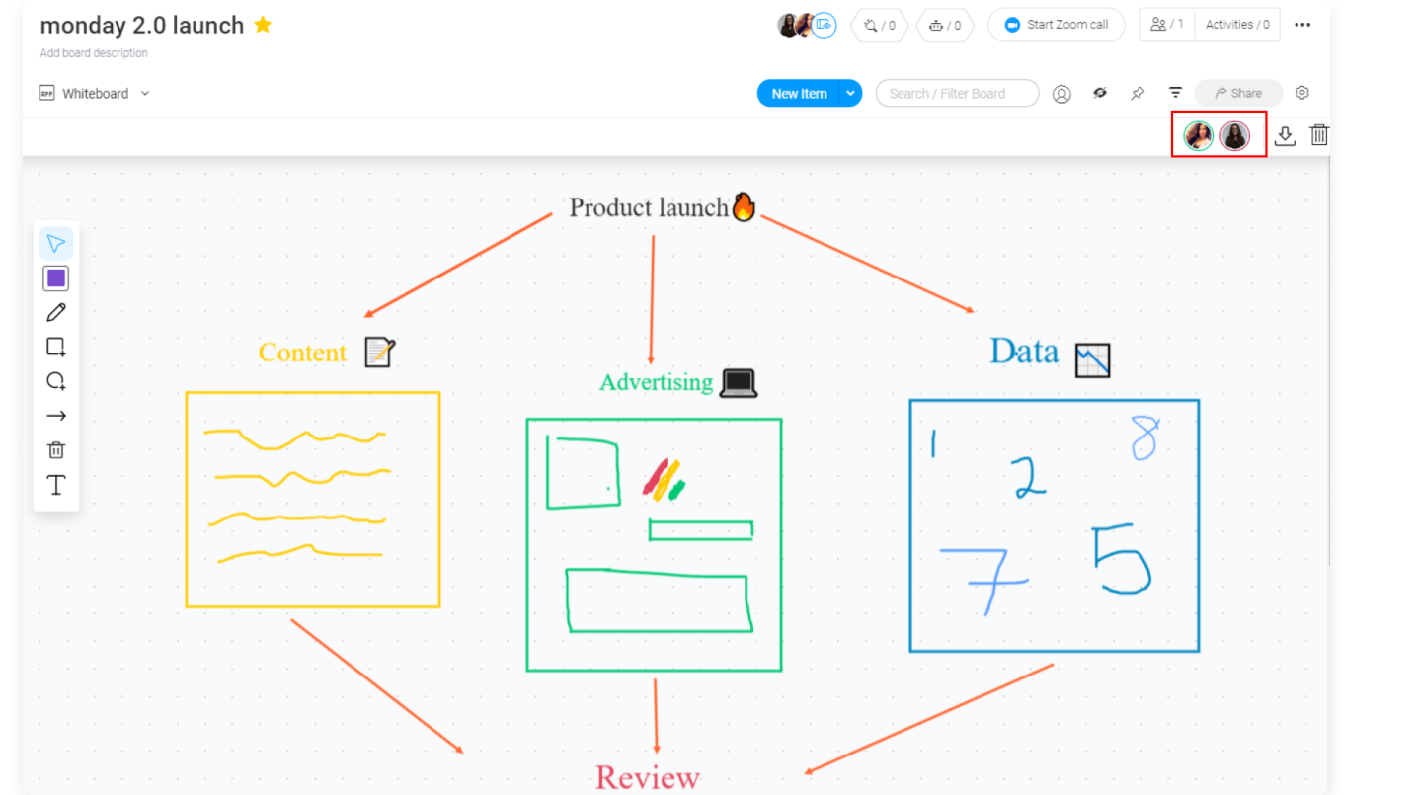

Online Whiteboards are eminent on the off chance that you need to finish network arranged cycles in your web meeting.

Features

• Full force of an online whiteboard, it should have at any rate these features:

• Endless or gigantic canvas (this is the certified progressed whiteboard)

• Backing plotting, drawing and handwriting with a modernized pen

• Tacky notes and workshops cards in various shapes and shadings

• Interactive media content like pictures, chronicles and sound records

• Transfer documents like PDF and other office reports

• Connectors to make mind-maps, thought aides and plan work measures

• Shapes, text and various instruments to design content on the board

• Access rights the chiefs capacities to restrict exercises on the main gathering of individual people if necessary.

With the online whiteboard, you can move away from fundamentally sharing substance by sharing your screen and start characteristic social occasions with your entire get-together. You can utilize an online whiteboard for your get-togethers in several different manners:

**Technology Choices Made**

**Node.js** is an exceptionally incredible JavaScript-put together stage worked with respect to Google Chrome's JavaScript V8 Engine. It is utilized to create I/O escalated web applications like video real time destinations, single-page applications, and other web applications. Node.js is open source, totally free, and utilized by a huge number of designers around the globe

Node.js runs in a solitary string mode, yet it utilizes an occasion driven worldview to deal with simultaneousness. It additionally encourages production of kid cycles to use equal handling on multi-center CPU based frameworks**.**

**Child processes** measures consistently have three streams child.stdin, child.stdout, and child.stderr which might be imparted to the stdio surges of the parent cycle.

**Node** gives child_process module which has the accompanying three significant approaches to make a kid cycle.

SocketIo

A simple collaborative whiteboard using socketIO with drawing tools which enables multiple users to draw at the same time. Open links in two seperate tabs in your browser or Open link in another computer try drawing simultaneously in both.

**Service Implementation Details**

**Install the App**

You can run this app with and without docker

Without Docker

install the latest NodeJs (version >= 12)

Clone the app

Run npm ci inside the folder

Run npm run start:prod

Surf to http://YOURIP:3000

With Docker

docker run -d -p 8080:8080 /whiteboard

Surf to <http://YOURIP:8080>

$ npm install

```

```

$ node serverjs

```

And open `http://localhost:ur server adderess` in browser. Optionally, specify a port by supplying the `PORT` env variable

URL: - <https://localhost:3000>

**Screenshots**

**Starting npm**

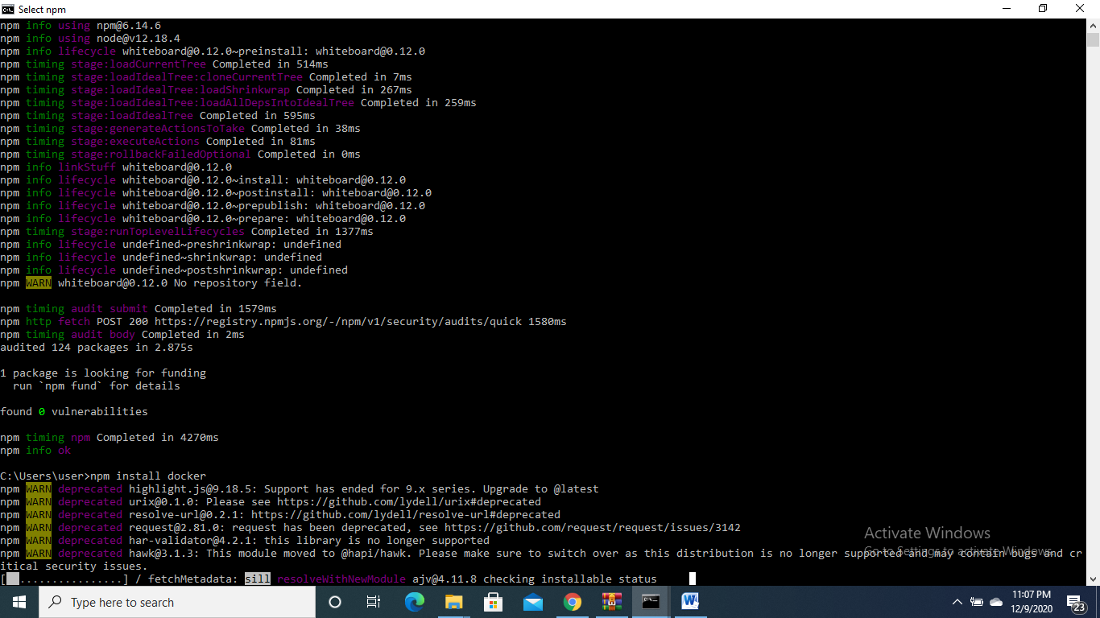

**Installing dependencies**



**Starting local host**

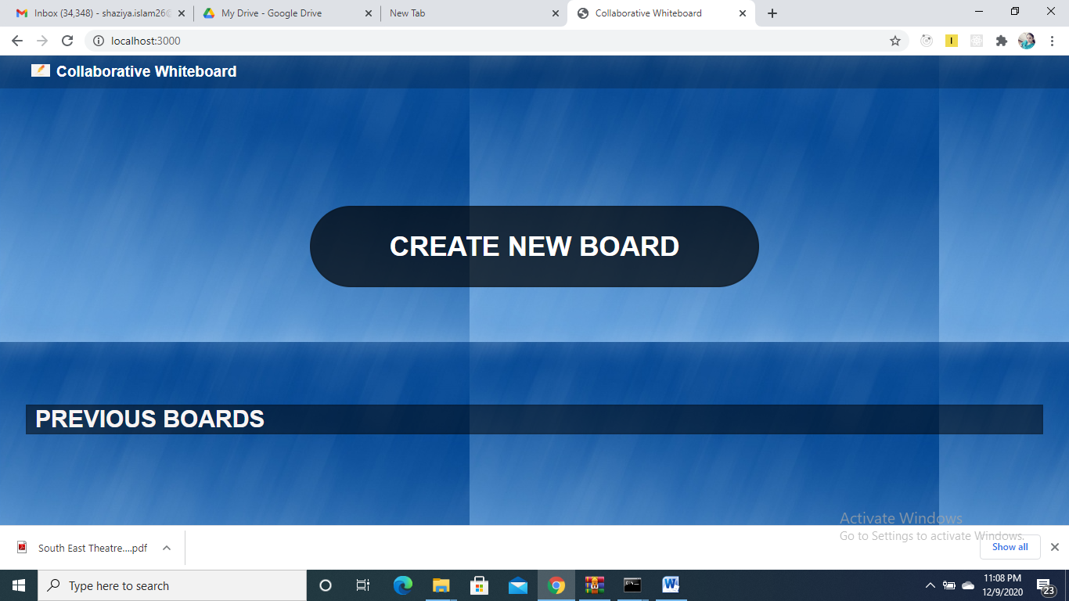

**Clicking on create New board**

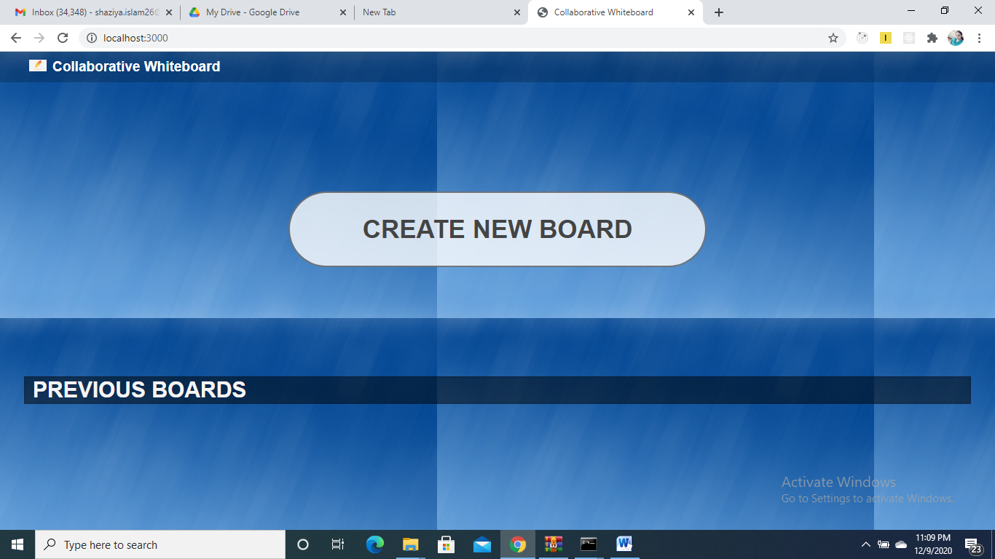

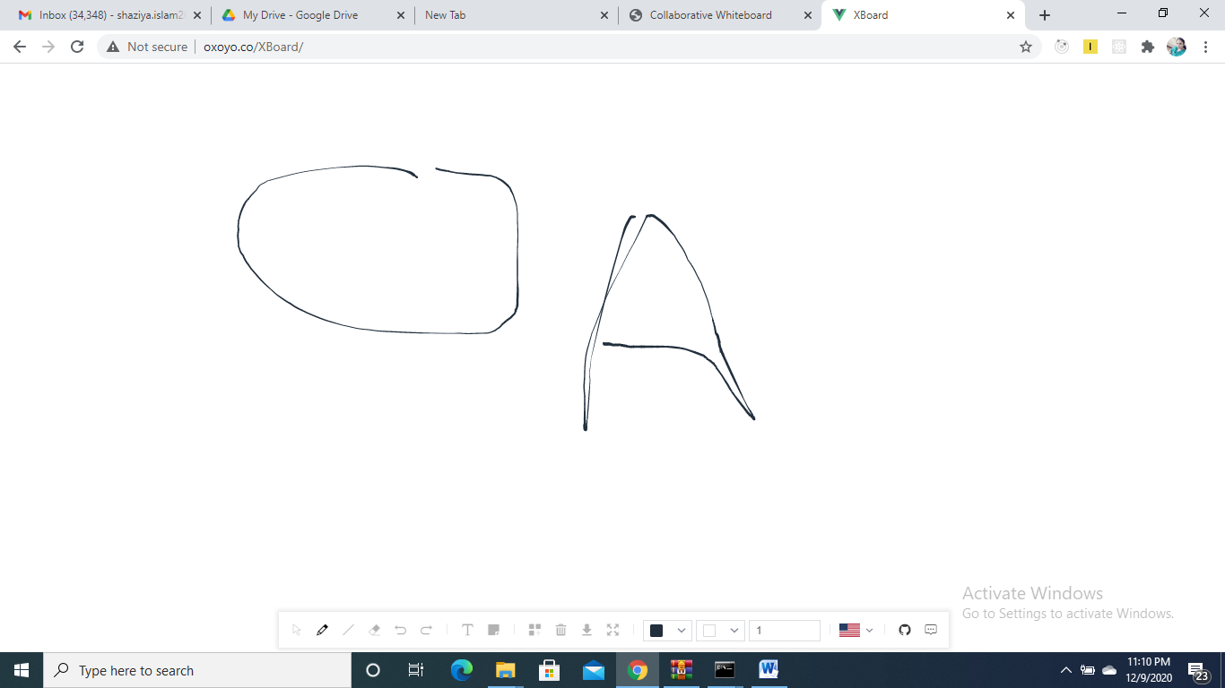

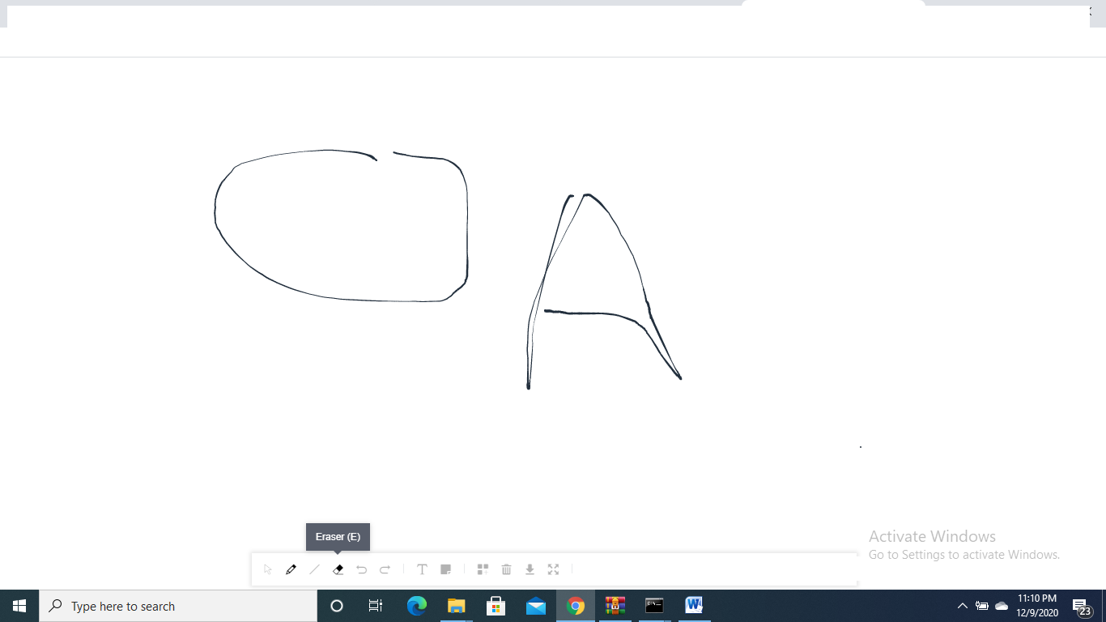

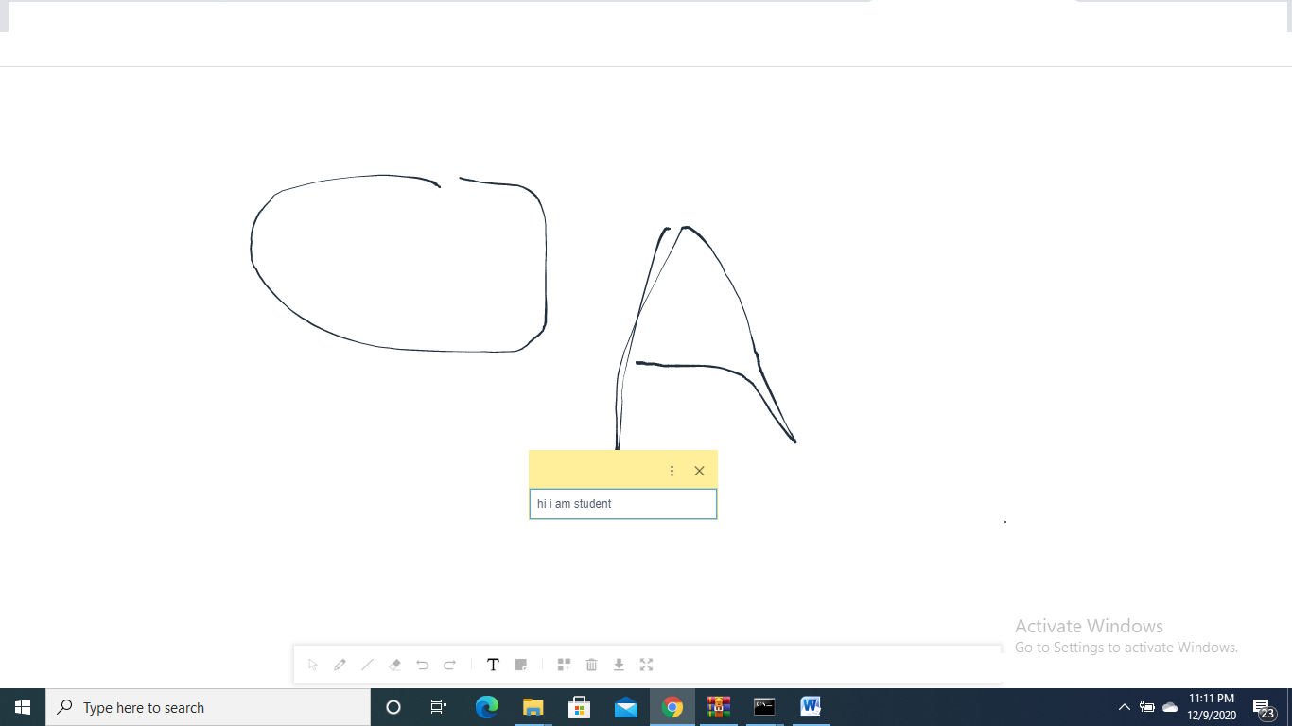

**Code**



**References:**

[1] Proceedings of the ACM 2006 Conference on Computer Supported Cooperative Work, SanDiego, California, November 2008. ACM.

[2] http://www.google.com/google-d-s/tour1.html

[3] D. Eseryel, R. Ganesan, G. S. Edmonds, "Audit of Computer-Supported CollaborativeWork Systems", Educational Technology and Society (2002)

[4] <http://www-01.ibm.com/programming/lotus/>

[5] http://docushare.xerox.com

References:

[1] Proceedings of the ACM 2006 Conference on Computer Supported Cooperative Work, SanDiego, California, November 2008. ACM.

[2] http://www.google.com/google-d-s/tour1.html

[3] D. Eseryel, R. Ganesan, G. S. Edmonds, "Review of Computer-Supported CollaborativeWork Systems", Educational Technology & Society (2002)

[4] http://www-01.ibm.com/software/lotus/[5] http://docushare.xerox.comk, San

Diego, California, November 2008. ACM.

[2] http://www.google.com/google-d-s/tour1.html

[3] D. Eseryel, R. Ganesan, G. S. Edmonds, "Review of Computer-Supported Collaborative

Work Systems", Educational Technology & Society (2002)

[4] http://www-01.ibm.com/software/lotus/

[5] http://docushare.xerox.com

References:

[1] Proceedings of the ACM 2006 Conference on Computer Supported Cooperative Work, San

Diego, California, November 2008. ACM.

[2] http://www.google.com/google-d-s/tour1.html

[3] D. Eseryel, R. Ganesan, G. S. Edmonds, "Review of Computer-Supported Collaborative

Work Systems", Educational Technology & Society (2002)

[4] http://www-01.ibm.com/software/lotus/

[5] http://docushare.xerox.com