**Final Exam Instructions**

**OBJECT-ORIENTED PROG**

* This is a take-home exam. You can use any resources that are available for you to finish this exam, except
  + Outsourcing the exam to any person or to any third party websites
  + Copying from other students work
  + Copying direct quotes from the books or internet
* Do not lose your opportunity to learn while working on the exam. Understand the concept and write answers on your own.
* Usually, in life, we have several choices. Unfortunately, you don’t have any choice on this exam. You have to answer all the questions and each part of the problem.
* All the topics on this exam were discussed in class . So, you cannot claim that the questions are out of the syllabus!
* Refer to Microsoft Word tutorials for proper formatting
* Points will be deducted for grammatical and spelling mistakes
* No two brains think alike unless you are soulmates. Definitely your answers will not be same as other students.
* Read the code of academic integrity before you start the exam. <https://www.nwmissouri.edu/policies/academics/Academic-Integrity.pdf>
* Push your source code to GitHub and provide your GitHub link at the end of the document and in the comment section.
* Don’t use examples that already explained in class or worksheets.
* Provide the input and output screenshots for every program.

**Final Exam OBJECT-ORIENTED PROG 01FA20 150 pts**

1. (20-Points) Define the terms abstract classes and interfaces. What are the similarities and differences between abstract classes and interfaces? Why interfaces are preferred over abstract classes? Explain and demonstrate with examples.

**Answer for the Question1**:

Data abstraction is the procedure of hiding the implementation and displaying limited useful data to the user. Abstraction can be accomplished with either abstract classes or interfaces.

An **Abstract class** is a class which is declared with the keyword Abstract. It is a restricted class which cannot be used for creating objects.

A boundary or interconnection between two entities is referred to as an **interface**. Interfaces specify what a class should do but not how. It is the blueprint of the class. In an interface, all the methods are abstract and public. Interfaces can have constants but no instance variables. Recently, from java 1.8 default methods are introduced in the interfaces. A class implementing an interface, inherits the abstract methods of the interface.

|  |  |
| --- | --- |
| **Abstract Class** | **Interface** |
| Similarities:   1. Abstract classes have abstract methods. 2. Abstract classes cannot be instantiated. 3. Don’t have default constructor. 4. All the abstract methods must be overridden by subclass. | Similarities:   1. Interfaces can have abstract methods. 2. Interface can not be instantiated. 3. Don’t have default constructor. 4. All the methods of the interface must be overridden by the implementing sub class. |
| Differences:   1. an abstract class can be extended using the keyword “extends”. 2. Abstract class does not support multiple inheritance as we cannot extend more than one class. 3. Abstract classes can have normal non-abstract methods. 4. No methods are created default with the word ‘default’. 5. An abstract class may contain non-final variables. 6. Abstract class can have final, non-final, static and non-static variables. 7. Abstract class can provide the implementation of the interface. | Differences:   1. A Java interface can be implemented using the keyword “implements”. 2. We can achieve multiple inheritance using interface as we can implement multiple interfaces to any class. 3. Interfaces cannot have non-abstract methods. 4. Interfaces can have default methods created with the word ‘default’. 5. Variables declared in a Java interface are by default final. 6. The interface has only static and final variables. 7. Interface can’t provide the implementation of an abstract class. |

**Interfaces are preferred over abstract classes :**Multiple inheritance isn't supported in Java, so you can't have a class that implements two abstract classes at the same time. When you want several classes to implement the interface and don't want to inherit default behavior, an interface is **preferable** to an abstract class.  **Interfaces** are better in situations in which you do not need to inherit implementation from a base class. In addition, abstract classes cannot provide data abstraction 100% where as interfaces provide 100% abstraction.

**Code for Example 1:**

ItIndustry Interface

|  |
| --- |
| /*  * To change this license header, choose License Headers in Project Properties.  * To change this template file, choose Tools | Templates  * and open the template in the editor.  */  package question1;  /**  *  * @author Vineetha Batchu  */  public interface ItIndustry {  public static final double hours=20.0;  public abstract double calculatesalary();        } |

Abstract Class Tester

|  |
| --- |
| /*  * To change this license header, choose License Headers in Project Properties.  * To change this template file, choose Tools | Templates  * and open the template in the editor.  */  package question1;  /**  *  * @author Vineetha Batchu  */  public abstract class Tester implements ItIndustry  {  private String fname,lname;  public Tester(String fname, String lname) {  this.fname = fname;  this.lname = lname;  }  public String getFname() {  return fname;  }  public void setFname(String fname) {  this.fname = fname;  }  public String getLname() {  return lname;  }  public void setLname(String lname) {  this.lname = lname;  }  @Override  public String toString() {  return "Tester{" + "fname=" + fname + ", lname=" + lname + '}';  }    public abstract void testingType();  } |

Administrative Tester

|  |
| --- |
| /*  * To change this license header, choose License Headers in Project Properties.  * To change this template file, choose Tools | Templates  * and open the template in the editor.  */  package question1;  /**  *  * @author Vineetha Batchu  */  public class AdministrativeTester extends Tester{  @Override  public void testingType() {  System.out.println("Testing Type: Administrative Testing");  }  public AdministrativeTester(String fname,String lname) {  super(fname,lname);  }  @Override  public double calculatesalary() {  return ItIndustry.hours*30.0;  }    } |

Technical Tester

|  |
| --- |
| /*  * To change this license header, choose License Headers in Project Properties.  * To change this template file, choose Tools | Templates  * and open the template in the editor.  */  package question1;  /**  *  * @author Vineetha Batchu  */  public class TechnicalTester extends Tester{  @Override  public void testingType() {  System.out.println("Testing Type: Technical Testing");  }  public TechnicalTester(String fname,String lname) {  super(fname,lname);  }  @Override  public double calculatesalary() {  return ItIndustry.hours*40.0;  }    } |

Driver Class

|  |
| --- |
| /*  * To change this license header, choose License Headers in Project Properties.  * To change this template file, choose Tools | Templates  * and open the template in the editor.  */  package question1;  /**  *  * @author Vineetha Batchu  */  public class TesterDriver {  /**  * @param args the command line arguments  */  public static void main(String[] args) {  // TODO code application logic here  System.out.println("***********************************");  Tester t1=new AdministrativeTester("Lohith", "Gurram");  System.out.println(t1);  t1.testingType();  System.out.println("Salary: "+t1.calculatesalary());  System.out.println("***********************************");    Tester t2=new TechnicalTester("Vineetha", "Batchu");  System.out.println(t2);  t2.testingType();  System.out.println("Salary: "+t2.calculatesalary());  System.out.println("***********************************");      }    } |

**Output for Example1 in Question1:**

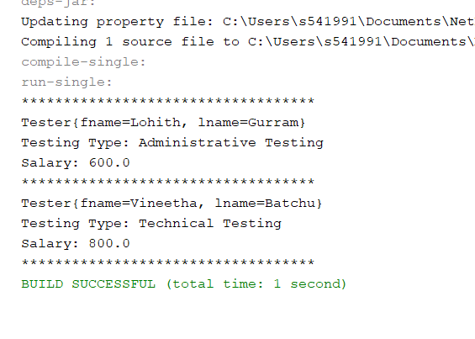

**Explanation for Example1 in Question1:**

In this Example,

* An Interface named ItIndustry is created with a constant named hours and an abstract method calculatesalary().
* A new abstract class named Tester is created which implements interface ItIndustry with two String variables fname,lname and it has an abstract method testingType().
* Sub Classes AdministrativeTester,TechnicalTester which extends Tester the class an implements calculatesalary() and testingType().
* Now in the Driver Class, objects for both the sub class are created. If we invoke calculatesalary() and testingType()methods, sub class will be invoked because implementation for these provide in the sub classes.

**Example2 for Interfaces:**

**Code**

Interface1

|  |
| --- |
| /*  * To change this license header, choose License Headers in Project Properties.  * To change this template file, choose Tools | Templates  * and open the template in the editor.  */  package question1Example2Interface;  /**  *  * @author Vineetha Batchu  */  public interface Dress {  default void clothingtype(){  System.out.println("Clothing Type: Dress");  }  } |

Interface2

|  |
| --- |
| /*  * To change this license header, choose License Headers in Project Properties.  * To change this template file, choose Tools | Templates  * and open the template in the editor.  */  package question1Example2Interface;  /**  *  * @author Vineetha Batchu  */  public interface MaterialSilk {  default void materialtype(){  System.out.println("Material Type: Silk");  }  } |

Driver Class implementing both the interfaces

|  |
| --- |
| /*  * To change this license header, choose License Headers in Project Properties.  * To change this template file, choose Tools | Templates  * and open the template in the editor.  */  package question1Example2Interface;  /**  *  * @author Vineetha Batchu  */  public class SilkDress implements MaterialSilk,Dress{  /**  * @param args the command line arguments  */  public static void main(String[] args) {  // TODO code application logic here  SilkDress s=new SilkDress();  s.materialtype();  s.clothingtype();  }    } |

**Output for Example2 Interfaces:**

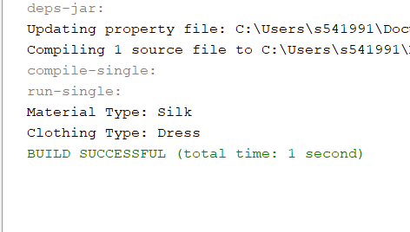

**Explanation for Example 2 Interfaces:**

This is an example of multiple inheritance which allows a class to implement two interfaces. In this Example, Dress and MaterialSilk are the interfaces with default methods clothingtype,materialtype() resectively. Now SilkDress class will implemement both the interfaces. In the main method when we create an object both the method implements in the class SilkDress are invoked.

**Example2 for Abstract Classes:**

**Code**

Abstract Class

|  |
| --- |
| /*  * To change this license header, choose License Headers in Project Properties.  * To change this template file, choose Tools | Templates  * and open the template in the editor.  */  package question1Example2AbstractClass;  /**  *  * @author Vineetha Batchu  */  public abstract class Music {  public void display() {  System.out.println("In Music Class");  }  public abstract void getMusicType();  } |

Subclass 1

|  |
| --- |
| /*  * To change this license header, choose License Headers in Project Properties.  * To change this template file, choose Tools | Templates  * and open the template in the editor.  */  package question1Example2AbstractClass;  /**  *  * @author Vineetha Batchu  */  public class Rock extends Music {  @Override  public void getMusicType() {  System.out.println("Music Type : Rock");  }  } |

SubClass 2

|  |
| --- |
| /*  * To change this license header, choose License Headers in Project Properties.  * To change this template file, choose Tools | Templates  * and open the template in the editor.  */  package question1Example2AbstractClass;  /**  *  * @author Vineetha Batchu  */  public class Pop extends Music{  @Override  public void getMusicType() {  System.out.println("Music Type: Pop");  }    } |

Driver Class

|  |
| --- |
| /*  * To change this license header, choose License Headers in Project Properties.  * To change this template file, choose Tools | Templates  * and open the template in the editor.  */  package question1Example2AbstractClass;  /**  *  * @author Vineetha Batchu  */  public class Driver {  /**  * @param args the command line arguments  */  public static void main(String[] args) {  // TODO code application logic here  Rock r1=new Rock();  System.out.println("Invoking a non abstract method of the abstract class");  System.out.println("*******************************************************");  r1.display();  System.out.println("\nInvoking an abstract method of the abstract class");  System.out.println("*******************************************************");  r1.getMusicType();      //from another sub class  Pop p1=new Pop();  System.out.println("\nInvoking a non abstract method of the abstract class");  System.out.println("*******************************************************");  p1.display();  System.out.println("\nInvoking an abstract method of the abstract class");  System.out.println("*******************************************************");  p1.getMusicType();  }    } |

**Output for Example 2 Abstract Classes:**

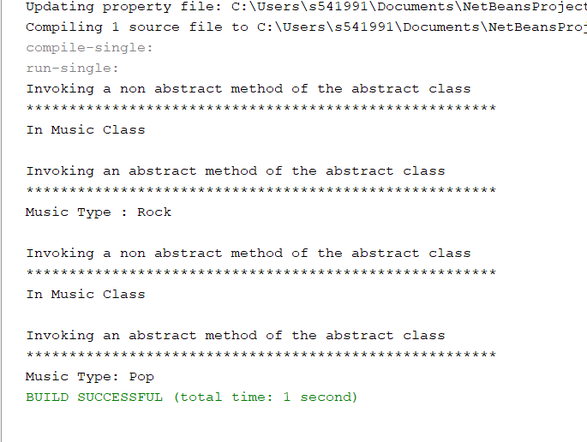

**Explanation for Example2 Abstract Classes:**

* Create an abstract class named Music with a normal method display() and an abstract method getMusicType ().
* Create sub classes Pop and Rock using extends key word and implement the abstract method getMusicType ().
* Now in the main class, we will be creating objects for the sub classes(Pop, Rock) and invoke the non-abstract methods of super class (as abstract classes cannot be instantiated) and abstract methods that were implemented in the sub class.

1. (10-Points) Design an interface named Colorable with a void method named howToColor(). Every class of a colorable object must implement the Colorable interface. Design a class named Square that extends GeometricObject and implements Colorable Implement howToColor to display the message Color all four sides.

Draw a UML diagram that involves Colorable, Square, and GeometricObject. Write a test program that creates an array of five GeometricObjects. For each object in the array, display its area and invoke its howToColor method if it is colorable.

**Answer for the Question2:**

Colorable Interface

|  |
| --- |
| /*  * To change this license header, choose License Headers in Project Properties.  * To change this template file, choose Tools | Templates  * and open the template in the editor.  */  package question2;  /**  *  * @author Vineetha Batchu  */  public interface Colorable {  void howToColor();    } |

Geometric Object abstract class

|  |
| --- |
| /*  * To change this license header, choose License Headers in Project Properties.  * To change this template file, choose Tools | Templates  * and open the template in the editor.  */  package question2;  /**  *  * @author Vineetha Batchu  */  public abstract class GeometricObject {  public abstract double area();  } |

Square Class

|  |
| --- |
| /*  * To change this license header, choose License Headers in Project Properties.  * To change this template file, choose Tools | Templates  * and open the template in the editor.  */  package question2;  /**  *  * @author Vineetha Batchu  */  public class Square extends GeometricObject implements Colorable {  private double sidelength;  private boolean colorable;  public Square(double sidelength, boolean colorable) {  this.sidelength = sidelength;  this.colorable = colorable;  }  public double getSidelength() {  return sidelength;  }  public boolean isColorable() {  return colorable;  }  @Override  public void howToColor() {  System.out.println("Color all four sides");  }  @Override  public double area() {  return sidelength * sidelength;  }  } |

Driver Class

|  |
| --- |
| /*  * To change this license header, choose License Headers in Project Properties.  * To change this template file, choose Tools | Templates  * and open the template in the editor.  */  package question2;  /**  *  * @author Vineetha Batchu  */  public class Driver {  /**  * @param args the command line arguments  */  public static void main(String[] args) {  // TODO code application logic here  GeometricObject[] squares = {new Square(8, true), new Square(20, false),  new Square(25, true), new Square(30, true), new Square(55, false)};  for (GeometricObject o : squares) {  System.out.println("-----------------------------");  System.out.println("Area is " + o.area());  Square s = (Square) o;  if (s.isColorable()) {  s.howToColor();  }  System.out.println("-----------------------------");    }  }  } |

**UMLdiagram for Question 2:**

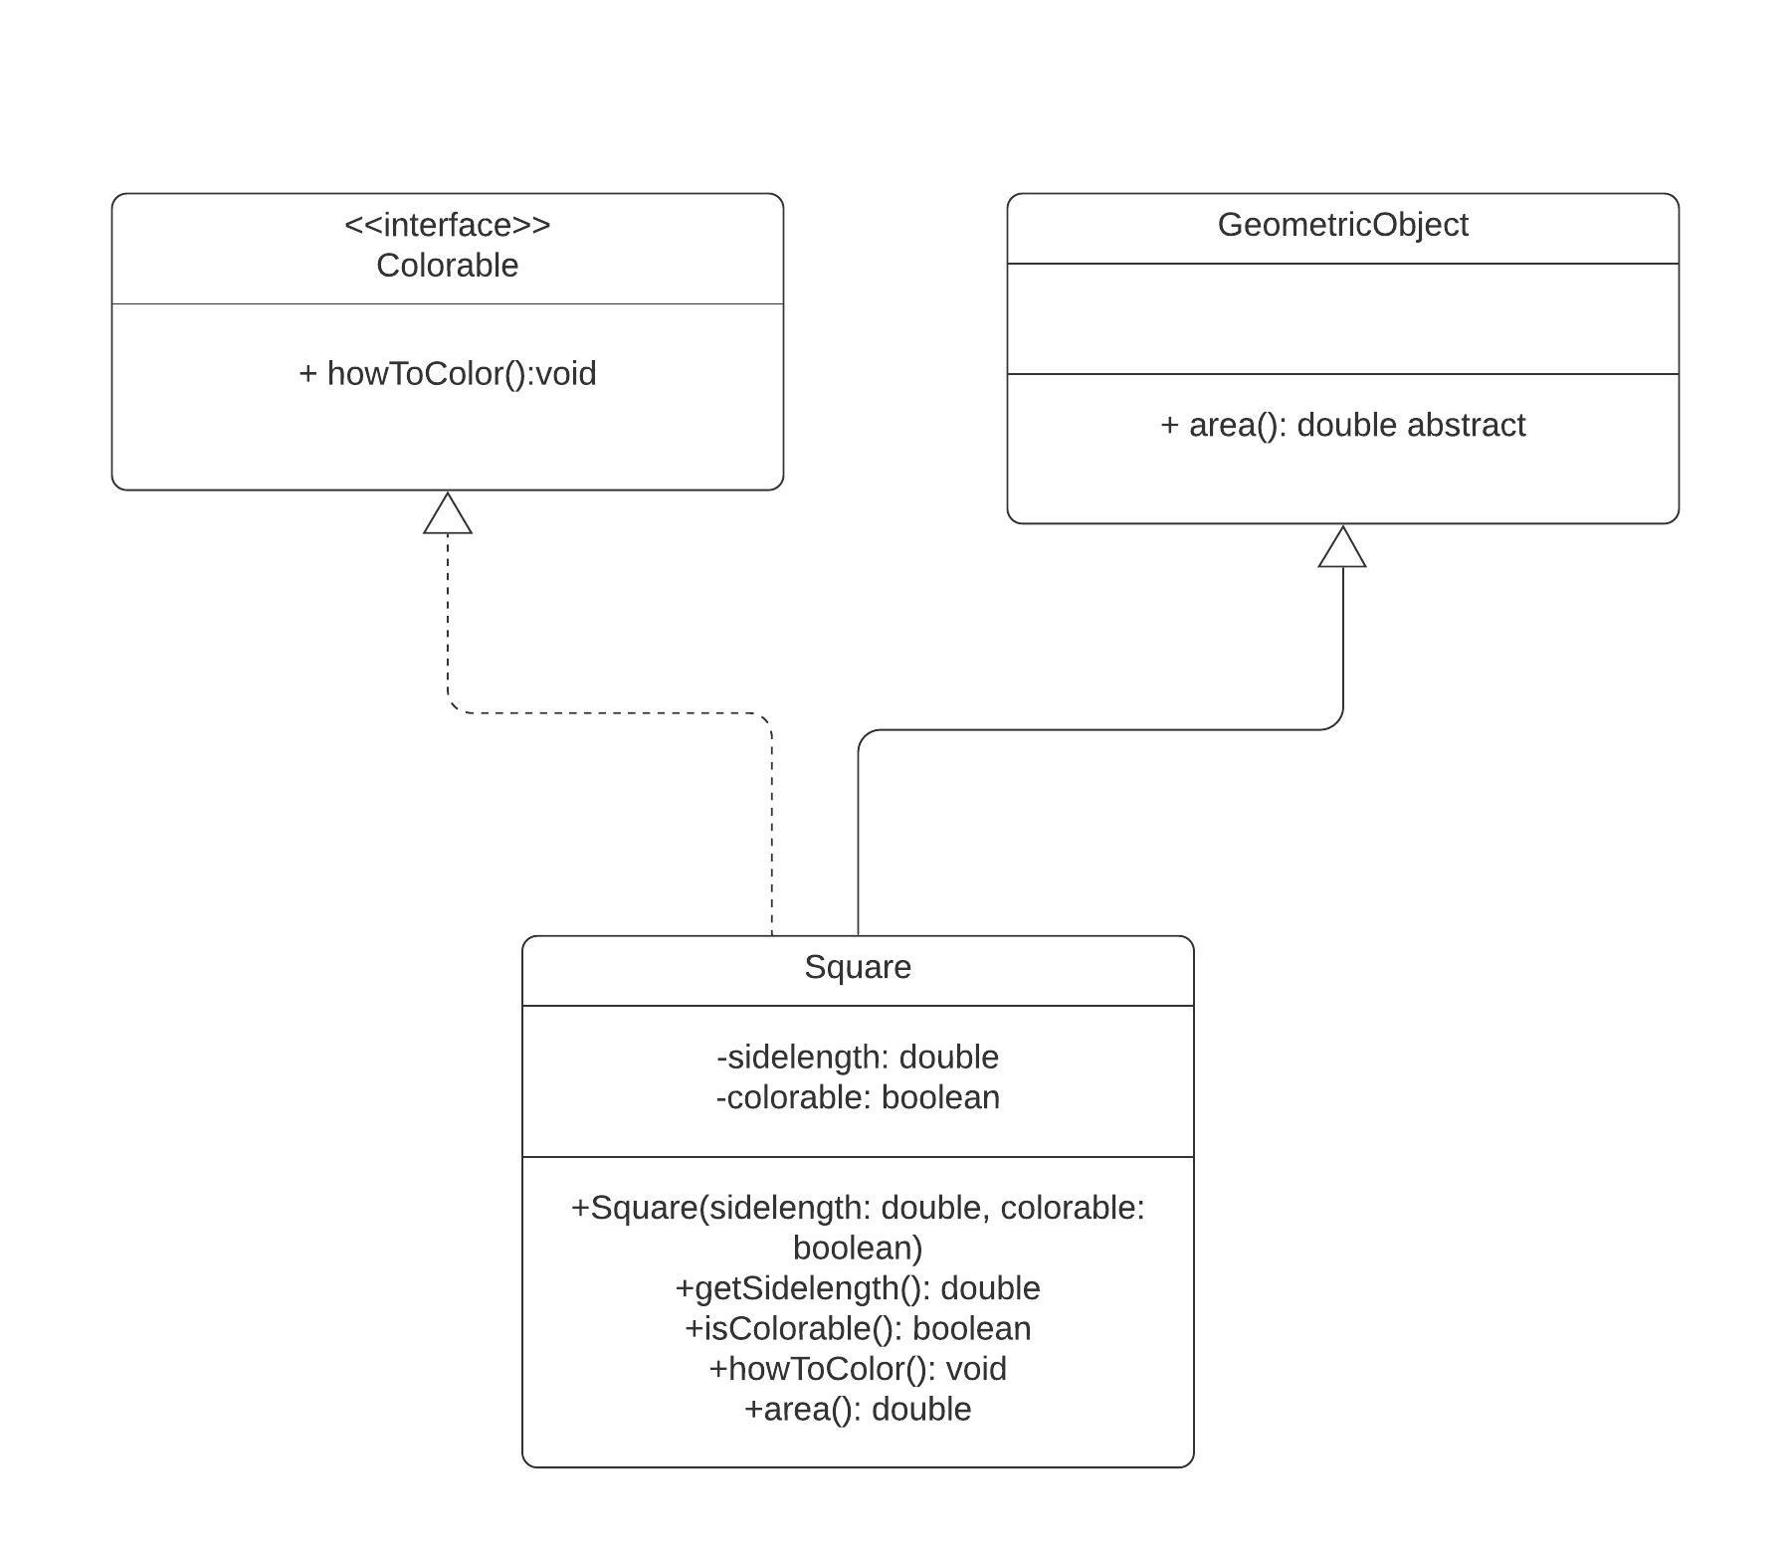

**Output Screenshot for Question 2:**

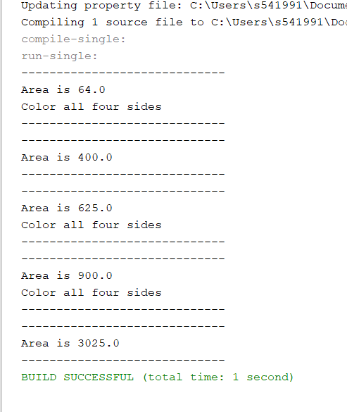

1. (10-Points) What is casting? What are different types of casting? Explain and demonstrate with examples.

**Answer for question3:**

**Definition:** The process of converting the value of one data type to another data type is called type casting. There are two types of casting

1. **Widening Type Casting**
2. **Narrowing Type Casting**

**Widening Type Casting:** Widening style casting is the process of converting a lower data type to a higher one. It's also known as casting down or implicit conversion. It's done automatically. It is safe because there is no risk of data loss.

**Example for Widening Type Casting:** In this example int is converted to double and this is done automatically.

**Explanation for the below example:** In this example, an integer variable ‘number’ is created. Now this integer is converted into double by assigning. Java does this conversion automatically because it is widening type.

Code

|  |
| --- |
| /*  * To change this license header, choose License Headers in Project Properties.  * To change this template file, choose Tools | Templates  * and open the template in the editor.  */  package question3widening;  /**  *  * @author Vineetha Batchu  */  public class WideningDriver {  /**  * @param args the command line arguments  */  public static void main(String[] args) {  // TODO code application logic here  // create integer type variable  int number = 20;  System.out.println("The integer value: " + number);  // convert integer into double type  double newdouble = number;  System.out.println("The double value: " + newdouble);  }  } |

**Output for the above example1:**

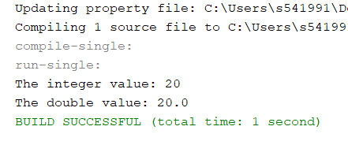

**Narrowing Type Casting:** Narrowing type casting is the process of converting a higher data type to a lower one. It's also known as casting up or explicit conversion. The programmer performs this task manually. The compiler will give a compile-time error if we do not perform casting.

**Example for Narrowing Type Casting(Example 2)** In this example double is converted to int.

**Explanation for the below example:** In this example, a double variable ‘number’ is created. Now this double is converted into int by assigning using paranthesis int convertedNumber = (int) number.

Code

|  |
| --- |
| /*  * To change this license header, choose License Headers in Project Properties.  * To change this template file, choose Tools | Templates  * and open the template in the editor.  */  package quetion3Narrowing;  /**  *  * @author Vineetha Batchu  */  public class NarrowingDriver {  /**  * @param args the command line arguments  */  public static void main(String[] args) {  // TODO code application logic here  double number = 10.99;  System.out.println("The double value: " + number);  // convert into int type  int convertedNumber = (int) number;  System.out.println("The integer value: " + convertedNumber);  }  } |

Output for the Example2:

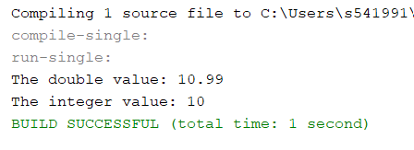

Example 3: This **type** **casting** is applicable for **objects** too. Let us consider the following example where a super class object is converted into sub class object through typecasting.

**Explanation for Example3**: In this example, SmartPhone s1=(SmartPhone)m; using this statement sub class object m is converted to (SmartPhone) sub class object. But for casting m=s; this assigning statement is mandatory. If we assign any random class object to the super class, then Class Cast Exception will occur.

|  |
| --- |
| /*  * To change this license header, choose License Headers in Project Properties.  * To change this template file, choose Tools | Templates  * and open the template in the editor.  */  package question3;  /**  *  * @author Vineetha Batchu  */  public class MobilePhone {  private String name;  public MobilePhone(String name) {  this.name = name;  }  public String getName() {  return name;  }  public void setName(String name) {  this.name = name;  }  @Override  public String toString() {  return "MobilePhone{" + "name=" + name + '}';  }      } |

|  |
| --- |
| /*  * To change this license header, choose License Headers in Project Properties.  * To change this template file, choose Tools | Templates  * and open the template in the editor.  */  package question3;  /**  *  * @author Vineetha Batchu  */  public class SmartPhone extends MobilePhone {  private boolean istouch;  public SmartPhone(boolean istouch, String name) {  super(name);  this.istouch = istouch;  }  public boolean isIstouch() {  return istouch;  }  public void setIstouch(boolean istouch) {  this.istouch = istouch;  }  @Override  public String toString() {  return "SmartPhone{" + "istouch=" + istouch + "Name "+super.getName()+ '}';  }      } |

|  |
| --- |
| /*  * To change this license header, choose License Headers in Project Properties.  * To change this template file, choose Tools | Templates  * and open the template in the editor.  */  package question3;  /**  *  * @author Vineetha Batchu  */  public class Driver {  /**  * @param args the command line arguments  */  public static void main(String[] args) {  // TODO code application logic here  MobilePhone m=new MobilePhone("Samsung");  System.out.println(m);  SmartPhone s=new SmartPhone(true, "Iphone");  System.out.println(s);  m=s;  //type casting  SmartPhone s1=(SmartPhone)m;  System.out.println("Type Casting");    System.out.println(s1);  }  } |

**Output for the Example3**:

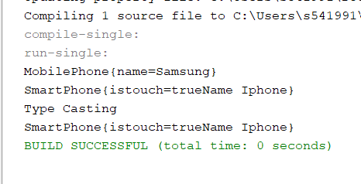

1. (15-Points) Suppose that Fruit, Apple, Orange, GoldenDelicious, and McIntosh are defined in the following inheritance hierarchy:

Fruit

Orange

Apple

GoldenDelicious

McIntosh

Assume that the following code is given:

Fruit fruit = new GoldenDelicious();

Orange orange = new Orange();

Answer the following questions and explain why these Statements are legal or illegal.

1. Is fruit instanceof Fruit?

True because the class Fruit is the super class of GoldenDelicious and a GoldenDelicious is a Fruit.

1. Is fruit instanceof Orange?

False , we are assigning the GoldenDelicious object to Fruit super class reference, so it is not an instance of orange.

1. Is fruit instanceof Apple?

True because a GoldenDelicious is an apple(Apple is the super class of GoldenDelicious).

1. Is fruit instanceof GoldenDelicious?

True because we are assigning the GoldenDelicious object to the fruit reference.

1. Is fruit instanceof McIntosh?

False because GoldenDelicoius is not McIntosh.

1. Is orange instanceof Orange?

True because an orange is an Orange( an orange object is assigned to orange reference).

1. Is orange instanceof Fruit?

True because an Orange is a Fruit(Fruit is super class of Orange).

1. Is orange instanceof Apple?

False because an Apple cannot be Orange

i. Suppose the method makeAppleCider is defined in the Apple class. Can fruit invoke this method? Can orange invoke this method? Fruit can invoke the makeAppleCider() because fruit is an instance of Apple, but orange cannot invoke makeAppleCider() because orange is not an instance of apple.

j. Suppose the method makeOrangeJuice is defined in the Orange class. Can orange invoke this method? Can fruit invoke this method? Orange can invoke this method because orange is an instance of Orange. But fruit cannot invoke because fruit is not an instance of orange.

k. Is the statement Orange p = new Apple() legal?

Iilegal because we cannot assign any random object to any reference.

l. Is the statement McIntosh p = new Apple() legal?

Iilegal because we cannot assign a super class object to a sub class reference.

m. Is the statement Apple p = new McIntosh() legal?

Legal because we can assign a sub class object to a super class reference.

1. (10-Points) Define a class named ComparableCircle that extends Circle and implements Comparable. Draw the UML diagram and implement the compareTo method to compare the circles on the basis of area. Write a test class to find the larger of two instances of ComparableCircle objects.

**Answer for Question 5:**

Code

Circle Class

|  |
| --- |
| /*  * To change this license header, choose License Headers in Project Properties.  * To change this template file, choose Tools | Templates  * and open the template in the editor.  */  package question4;  /**  *  * @author Vineetha Batchu  */  public class Circle {  private double radius;  public Circle(double radius) {  this.radius = radius;  }  public double getRadius() {  return radius;  }  public void setRadius(double radius) {  this.radius = radius;  }  @Override  public String toString() {  return "Circle{" + "radius=" + radius + '}';  }  public double getArea() {  return (Math.PI * this.radius * this.radius);  }  } |

ComparableCircle Class

|  |
| --- |
| /*  * To change this license header, choose License Headers in Project Properties.  * To change this template file, choose Tools | Templates  * and open the template in the editor.  */  package question4;  /**  *  * @author Vineetha Batchu  */  public class ComparableCircle extends Circle implements Comparable<Circle> {  public ComparableCircle(double radius) {  super(radius);  }  @Override  public int compareTo(Circle c1) {  return Double.compare(this.getArea(), c1.getArea());  //throw new UnsupportedOperationException("Not supported yet."); //To change body of generated methods, choose Tools | Templates.  }  } |

Driver Class

|  |
| --- |
| /*  * To change this license header, choose License Headers in Project Properties.  * To change this template file, choose Tools | Templates  * and open the template in the editor.  */  package question4;  import java.util.Scanner;  /**  *  * @author Vineetha Batchu  */  public class TestDriver {  /**  * @param args the command line arguments  */  public static void main(String[] args) {  // TODO code application logic here  Scanner sc=new Scanner(System.in);  System.out.print("Enter the radius of Circle 1: ");  double r1=sc.nextDouble();  System.out.print("Enter the radius of Circle 2: ");  double r2=sc.nextDouble();  ComparableCircle c1 = new ComparableCircle(r1);  ComparableCircle c2 = new ComparableCircle(r2);  if (c1.compareTo(c2) > 0) {  System.out.println("Larger object is" + c1);  } else if (c1.compareTo(c2) ==0) {  System.out.println("Both objects " + c1 + " and " + c2 + " are equal");  } else {  System.out.println("Larger Object is " + c2);  }  }  } |

**Output for the question5:**

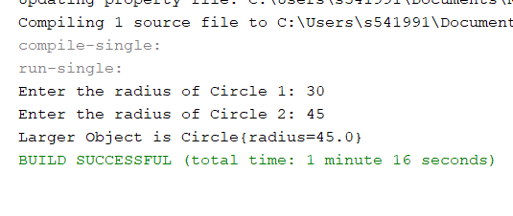

**UML for question 5:**

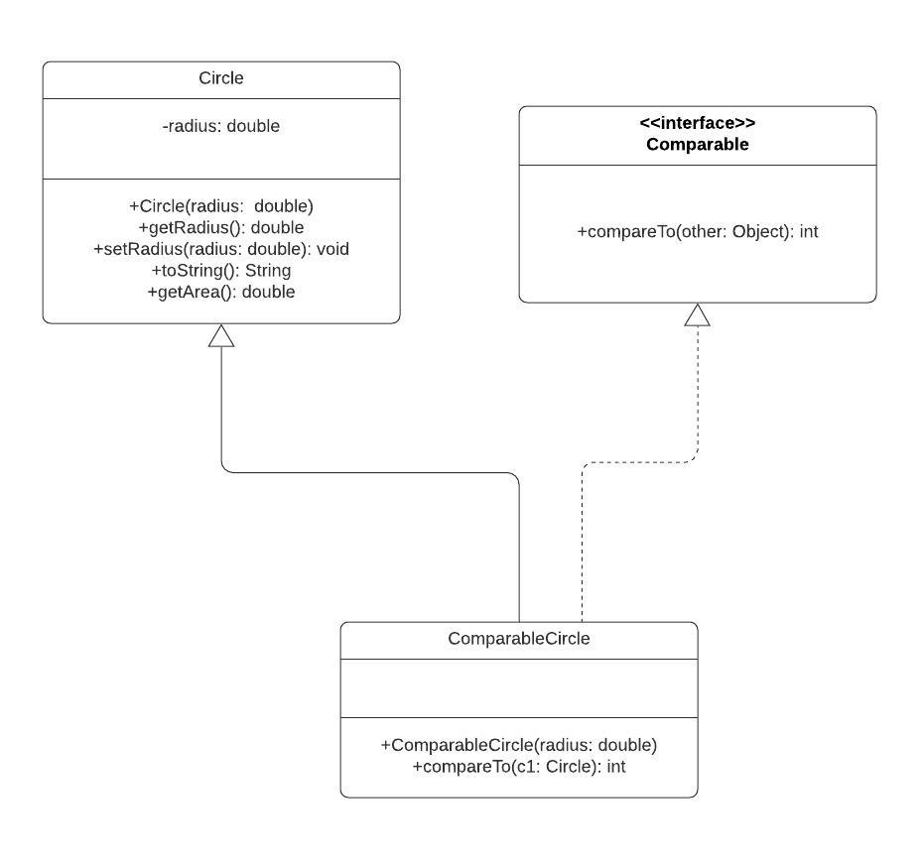

1. (15-Points) What is an exception? What are checked and unchecked exceptions? Explain and demonstrate with examples.

**Answer for Question 6:**

An exception is an unexpected event, that occurs during the run time (which means during the execution of a program), so these exceptions disrupt the flow of the program. Exception is different from errors because errors are serious problems that an application cannot try catch. There are two types of exceptions:

**1**.**Checked Exception:** These exceptions are checked at compile time. The classes that directly extends the Throwable class other than Runtime Exception and Error are known as checked exceptions such as IOException, SQLException etc. If a part of code in a method throws a checked exception, then that method should either handle the exception or it must specify the exception using keyword ‘throws’, else the program would give a compilation error.

**2**.**Unchecked Exception**: These are not checked at compile time which means is a program has an unchecked exception, it doesn’t show any compilation error during run time. Therefore, these are called Runtime Exceptions. Unchecked Exceptions are NullPointerException, ArrayIndexOutOfBoundsException, ArithmeticException, IllegalArgumentException, NumberFormatException.

The following image is the hierarchy of Exceptions:

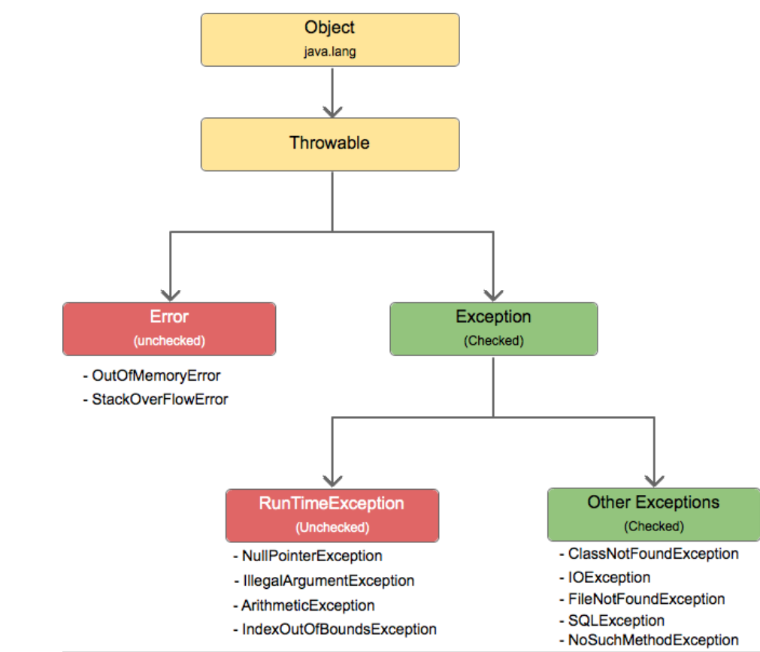

**Checked Exception Example Explanation for question6:**

These represent errors outside the control of the program. In this example we are reading the file input.txt and displaying its content on the screen. These checked exceptions must be advertised using keyword ‘throws’ as shown in the following example.

**Code:**

|  |
| --- |
| /*  * To change this license header, choose License Headers in Project Properties.  * To change this template file, choose Tools | Templates  * and open the template in the editor.  */  package question6;  import java.io.File;  import java.io.FileNotFoundException;  import java.util.Scanner;  /**  *  * @author Vineetha Batchu  */  public class CheckedExample {  /**  * @param args the command line arguments  */  public static void main(String[] args) throws FileNotFoundException{  // TODO code application logic here  Scanner sc= new Scanner(new File("input1.txt"));  String id = null,fname = null,lname = null;  while(sc.hasNext()){  id=sc.next();  fname=sc.next();  lname=sc.next();    }  System.out.println("Details of student are\n"+"Student id: "+id+"\nFirst Name: "  +fname+" Last Name: "+lname);  }    } |

**Output for the Checked Exception example in question 6:**

If the input file does not exist in the given folder, the output occurs as follows

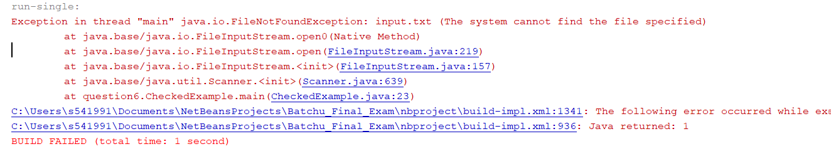

If the file exits in the given path, then output is as follows:

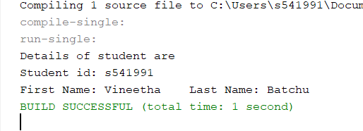

**Unchecked Exception Example:**

If a program throws unchecked exception, then it has some error in the logic. For example, if we access an element of array with the index -1 or greater than the size of the array, then Array IndexOutOfBoundsException occur. So, the code which might result in an unchecked or runtime exception must be handled using try and catch block.

**Code:**

|  |
| --- |
| /*  * To change this license header, choose License Headers in Project Properties.  * To change this template file, choose Tools | Templates  * and open the template in the editor.  */  package question6;  /**  *  * @author Vineetha Batchu  */  public class UncheckedExample {  /**  * @param args the command line arguments  */  public static void main(String[] args) {  // TODO code application logic here    String ar[] = {"vinee","Lohith" ,"vyshu", "chandhu"};  try {      for (int i = 0; i <= ar.length; i++) {  System.out.println(ar[i]);  }  }  catch (ArithmeticException e) {  System.out.println(e+" Message: "+e.getMessage());  }  finally{  System.out.println("End of the list");  }  }  } |

**Output for Unchecked Exception Example for question 6:**

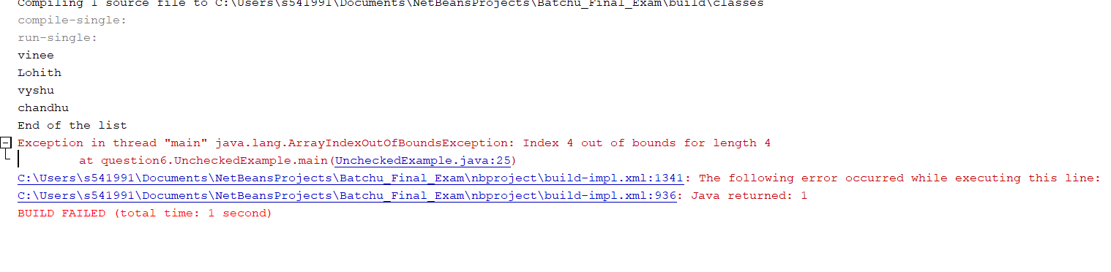

1. (10-Points) Write a program that meets the following requirements:

* Creates an array with 100 randomly chosen integers.
* Prompts the user to enter the index of the array, then displays the corresponding element value. If the specified index is out of bounds, display the message Out of Bounds.

**Answer for Question 7:**

Code:

|  |
| --- |
| /*  * To change this license header, choose License Headers in Project Properties.  * To change this template file, choose Tools | Templates  * and open the template in the editor.  */  package question7;  import java.util.Scanner;  /**  *  * @author Vineetha Batchu  */  public class Question7Driver {  /**  * @param args the command line arguments  */  public static void main(String[] args) {  // TODO code application logic here  Scanner input = new Scanner(System.in);  //creating an integer IntegerArray  int[] IntegerArray = new int[100];  for (int i = 0; i < IntegerArray.length; i++) {  IntegerArray[i] = (int) (Math.random() * 100) + 1;  }  // ask the user to enter the index  System.out.print("Enter the index of the array: ");  try {  // Display that index element value  System.out.println("The corresponding element value is "  + IntegerArray[input.nextInt()]);  } catch (ArrayIndexOutOfBoundsException e) {  System.out.println("Out of Bounds.");  }  }  } |

**Output for question 7:**

**Screenshot1**

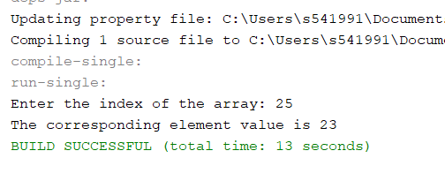

**Screenshot2**

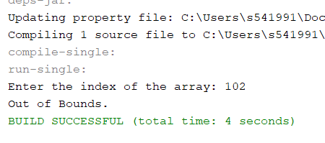

1. (10-Points) What is the purpose of declaring exceptions? How do you declare an exception, and where? Can you declare multiple exceptions in a method header? Explain and demonstrate with examples.

**Answer for Question 8:**

**Purpose**: The main purpose of declaring exceptions is to specify Java Runtime system that which part of code can go wrong. The main method which starts executing the java program and every method must declare the checked exceptions that those methods might throw.

**Exceptions can be declared** using **throws** keyword in the **declaration of method,** Like public void display() throws IOException.

**Yes, Multiple Exceptions** can be declared in the method header, separated by commas.

**Example1 for question 8:**

**Explanation for Example1:** In this example two exceptions may occur, one while accessing the file and the other in the line Class.forName("Example");.So, these multiple exceptions FileNotFoundException, ClassNotFoundException are declared using throws in the declaration of method.

**Code:**

|  |
| --- |
| /*  * To change this license header, choose License Headers in Project Properties.  * To change this template file, choose Tools | Templates  * and open the template in the editor.  */  package question8;  import java.io.File;  import java.io.FileNotFoundException;  import java.util.Scanner;  /**  *  * @author Vineetha Batchu  */  public class ThrowsMultiExceptions {  /**  * @param args the command line arguments  */  public static void main(String[] args) throws FileNotFoundException, ClassNotFoundException {  // TODO code application logic here  Scanner sc = new Scanner(new File("input.txt"));  String id = null,fname = null,lname = null;    System.out.println("Contents of File");  while (sc.hasNext()) {  id = sc.next();  fname = sc.next();  lname = sc.next();  }  System.out.println("Details of student are\n" + "Student id: " + id + "\nFirst Name: "  + fname + " Last Name: " + lname);  Class.forName("Example");  }  } |

**Output Screenshot for example 1 in question 8:**

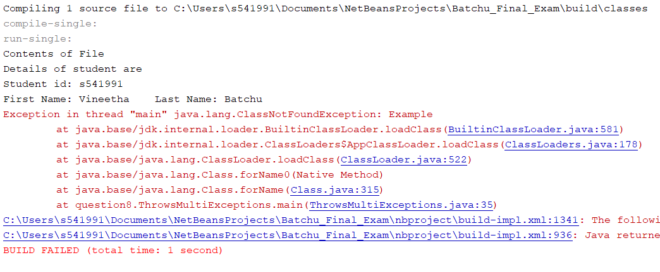

**Example 2 for question 8:**

**Explanation for Example 2 in question 8:** In this example, while executing these lines double a[] = new double[10];

a[12] = 67.8 / 0;

ArrayIndexOutOfBoundsException and ArithmeticException two exceptions may occur as these are runtime exceptions they cannot be declared. So, multiple catch must be declared to handle these exceptions. As we are getting ArrayIndexOutOfBoundsException in the first line , that catch will get invoked and prints the statement in the catch block.

**Code**

|  |
| --- |
| /*  * To change this license header, choose License Headers in Project Properties.  * To change this template file, choose Tools | Templates  * and open the template in the editor.  */  package question8;  /**  *  * @author Vineetha Batchu  */  public class MultiCatchExample {  /**  * @param args the command line arguments  */  public static void main(String[] args) {  // TODO code application logic here  try {  double a[] = new double[10];  a[12] = 67.8 / 0;  } catch (ArrayIndexOutOfBoundsException e) {  System.out.println("ArrayIndexOutOfBounds Exception has occured");  } catch (ArithmeticException e) {  System.out.println("Arithmetic Exception has occured");  } catch (Exception e) {  System.out.println("Exception occured");  }  System.out.println("end of the code");  }  } |

**Output for Example 2 in question 8:**

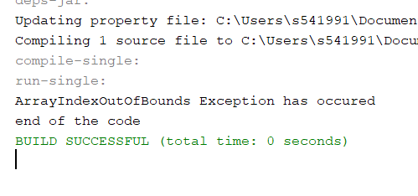

1. (10-Points) What is the keyword throw used for? What is the keyword throws used for? Can you throw multiple exceptions in one throw statement? Explain with examples.

**Answer for Question 9:**

**Throw** keyword is used inside the function. It is used when it is necessary to throw an Exception logically. Syntax wise throw keyword is followed by the instance variable. Checked exception cannot be propagated using throw only. Unchecked exception can be propagated using throw.

**Throws** keyword is in the declaration of the method. It is used when the method has some statements which can lead to some exceptions. Syntax wise throws keyword is followed by exception class names. For the propagation checked exception must use throws keyword followed by specific exception class name.

**Throw** keyword is used to throw an exception explicitly. It can throw only **one exception** at a time. In one throw statement multiple exceptions cannot be thrown. **Throws** keyword can be used to declare multiple exceptions, separated by comma.

**Example 1 for question 9:**

**Explanation for example1 in question 9:**

In this example, two exceptions may occur if parameter value is 1, then IOException occurs. else ClassNotFoundException occurs. So, multiple exceptions IOException, ClassNotFoundException are thrown using **throws** key word in the method header.

**Code**

|  |
| --- |
| /*  * To change this license header, choose License Headers in Project Properties.  * To change this template file, choose Tools | Templates  * and open the template in the editor.  */  package question9;  import java.io.IOException;  import java.util.Scanner;  /**  *  * @author Vineetha Batchu  */  public class MultiThrowsExample {  public static void myMethod(int n) throws IOException, ClassNotFoundException {  if (n == 1) {  throw new IOException("IOException Occurred");  } else {  throw new ClassNotFoundException("ClassNotFoundException");  }  }  /**  * @param args the command line arguments  */  public static void main(String[] args) {  // TODO code application logic here  Scanner sc=new Scanner(System.in);  System.out.print("Enter an integer value: ");  int n=sc.nextInt();  try {    myMethod(n);  } catch (Exception ex) {  System.out.println(ex);  }  }  } |

**Output Screenshots for example1 in question 9:**

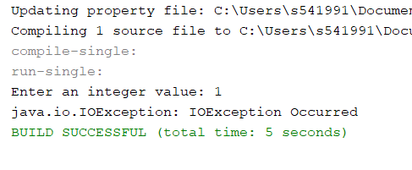

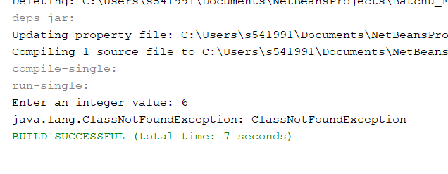

**Example2 for question 9:**

**Explanation for Example2 in question9:** In this example, checkTheAge() method checks the aged if it is grater than 18, then prints “welcome to vote” , else throws an exception that it is “not valid”.

**Code**

|  |
| --- |
| /*  * To change this license header, choose License Headers in Project Properties.  * To change this template file, choose Tools | Templates  * and open the template in the editor.  */  package question9;  import java.util.Scanner;  /**  *  * @author Vineetha Batchu  */  public class ThrowExample {  /**  * @param args the command line arguments  */  public static void checkTheAge(int age) {  if (age < 18) {  throw new ArithmeticException("not valid");  } else {  System.out.println("welcome to vote");  }  }  public static void main(String[] args) {  // TODO code application logic here  Scanner sc = new Scanner(System.in);  System.out.print("Enter the age: ");  int age = sc.nextInt();  checkTheAge(age);  System.out.println("end of the code...");  }  } |

**Output Screenshots for Example 2 in question 9:**

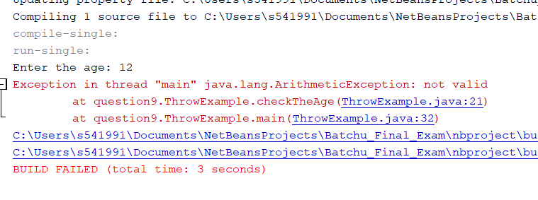

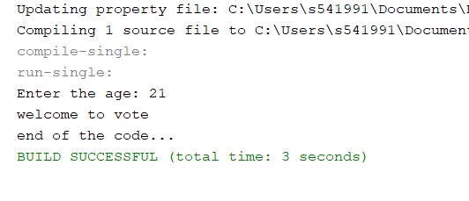

1. (15-Points) What is a recursive method? What is an infinite recursion? Explain and demonstrate with examples. Implement the search (element) in a list using recursion.

**Answer for question 10:**

The process in which a method calls itself directly or indirectly is called recursion and the corresponding function is called as **recursive** function.

If a **recursion** never reaches a base case, it will go on making **recursive** calls forever and the program will never terminate. ... This is known as **infinite recursion or stack overflow.**

1. (10-Points) Write a java program that illustrates how equals() and hashCode() methods work? Explain your code in comments.
2. (15-Points) Design Employee class and Employee driver class as follows:
3. **Employee Class implements Comparable<Employee**>

* Data fields named empId, empName and empSalary
* A constructor with parameters, listed in the same order as above.
* Create getter methods for all the parameters.
* A toString method that prints the empId, empName and empSalary. There should be one space between each value output.
* Because Employee implements the Comparable interface, you must also implement the compareTo method as defined by the Comparable interface. Define this method in such a way that the natural ordering of employees will be by id number, in ascending order.

1. **EmployeeDriver Class**

* Begin by filling an ArrayList with at least 5 employees. Add employees in random order – not by id number, not by name, and not by salary. The original list should not be in order by any of these attributes.
* Use an enhanced for loop to print the original list.
* Call the one-parameter sort method of the Collections class to sort the list by its natural order (empId number) and then print the list again.
* Call the two-parameter sort method of the Collections class, supplying a new Comparator<Employee> that sorts by salary. Print the list again.
* Call the two-parameter sort method of the Collections class, supplying a new Comparator<Employee> that sorts by name. Print the list again.