**Week 4 and Final Assessment Devops(Maven,Junit, Git,Sonarqube,Docker,Jenkins) implementation for Microservice Customer Producer application**

1. Push the code through IDE (STS or Eclipse) into github remote repository backend.

URL for git: <https://github.com/vineetha-vinnu/Assignment-LTI-Training/tree/master>

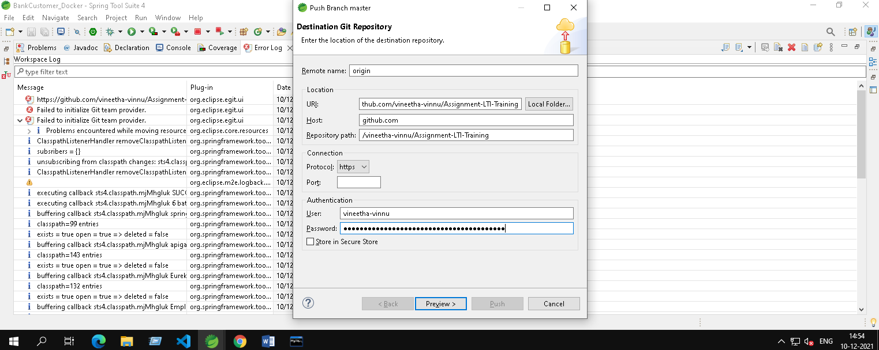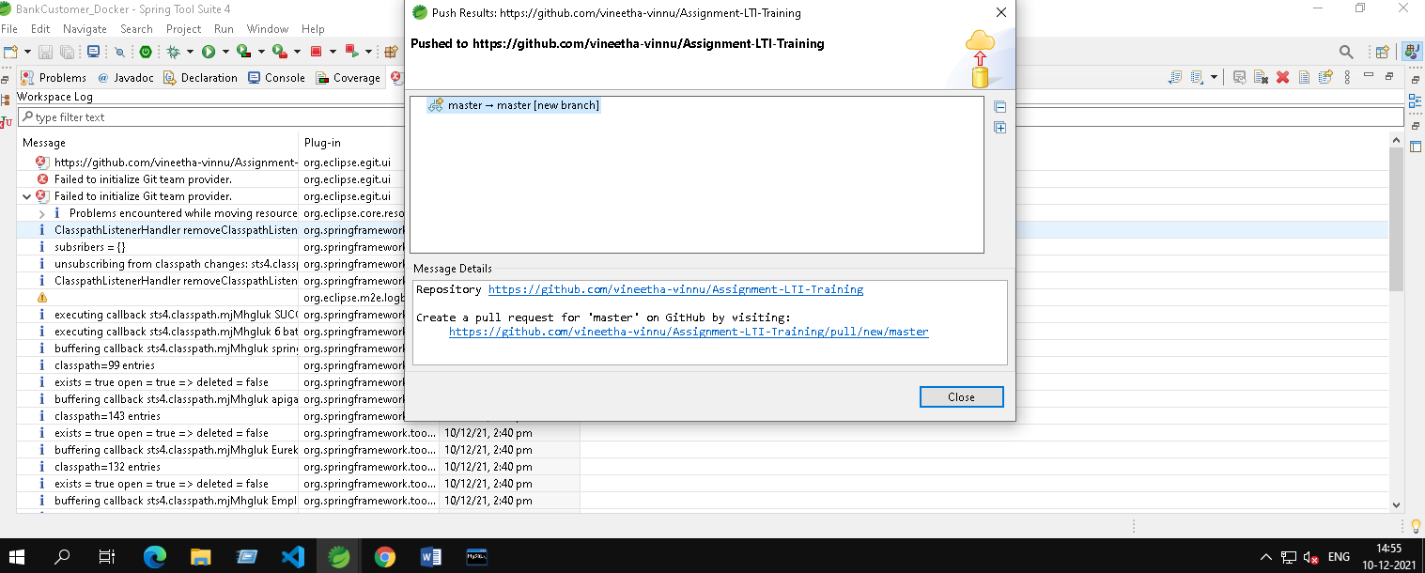

1. Push Frontend code also into git command line

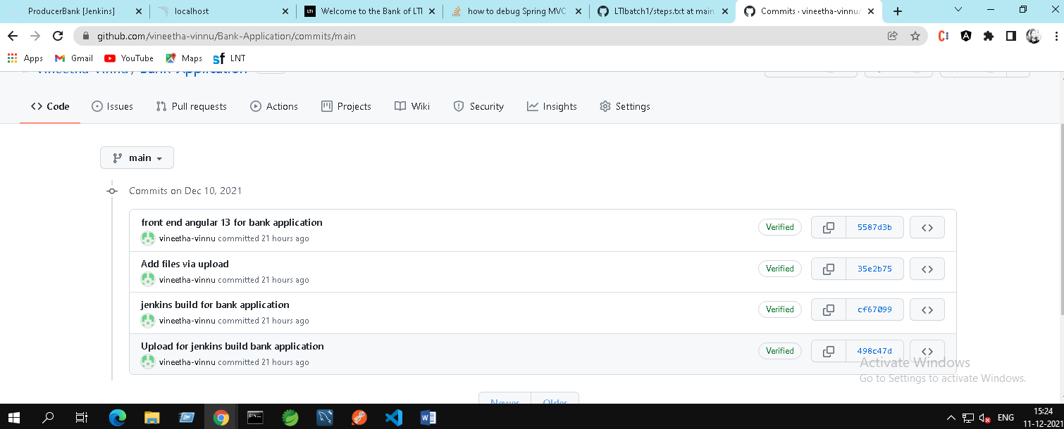

1. Run the possible number of Junit test case ( positive+ negative )- screenshots required

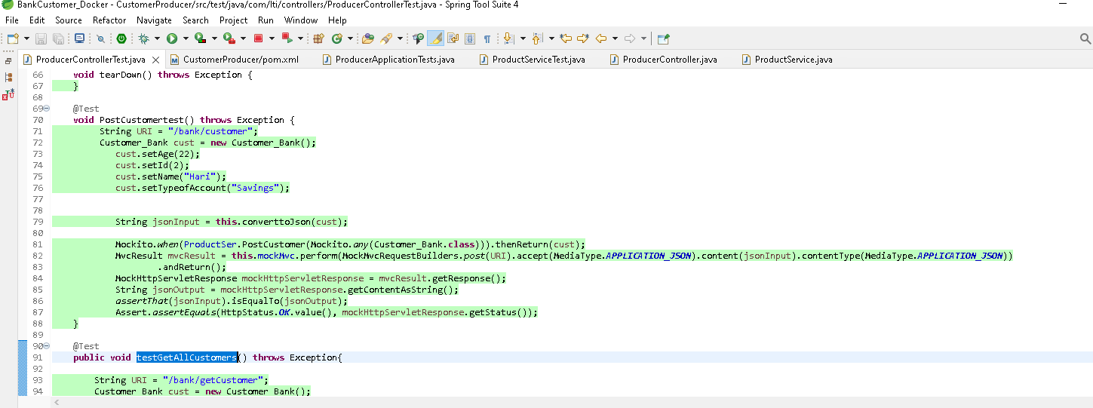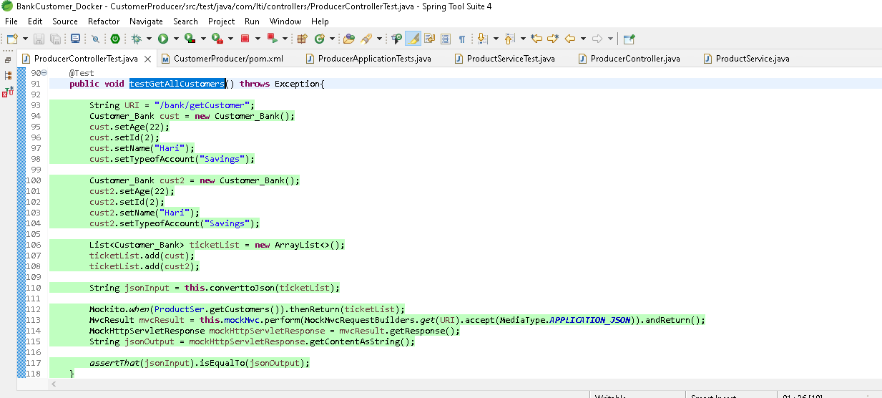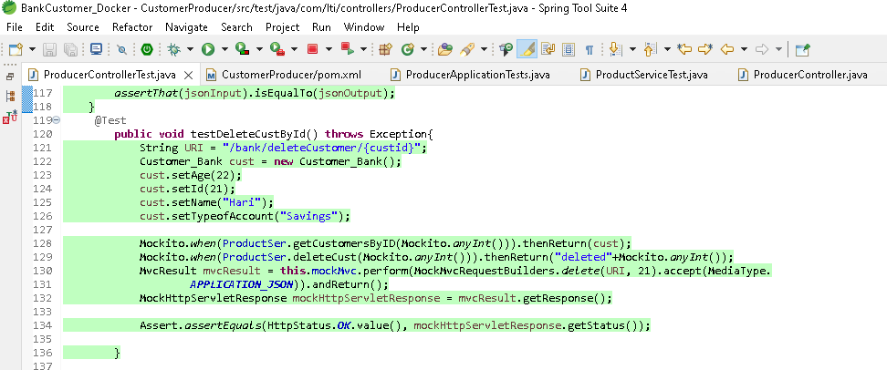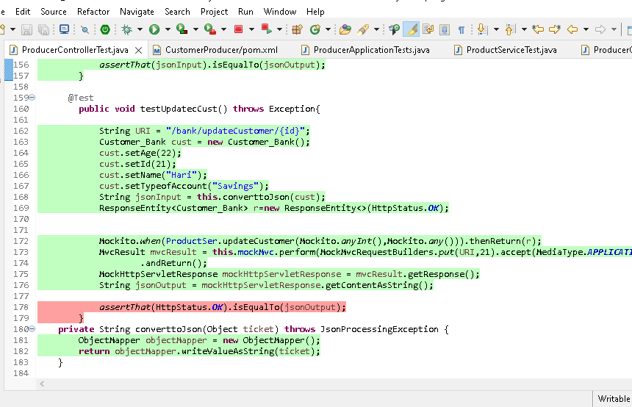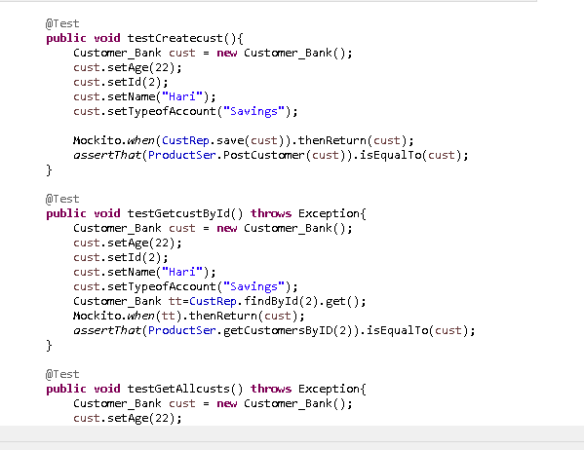

1. Jacoco test coverage in STS - screenshots required-optional

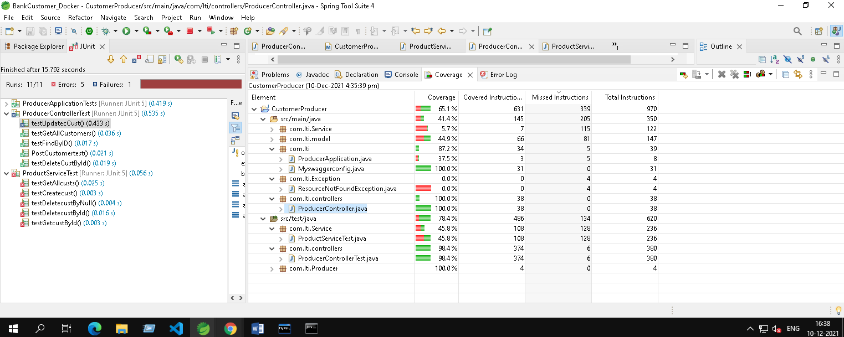

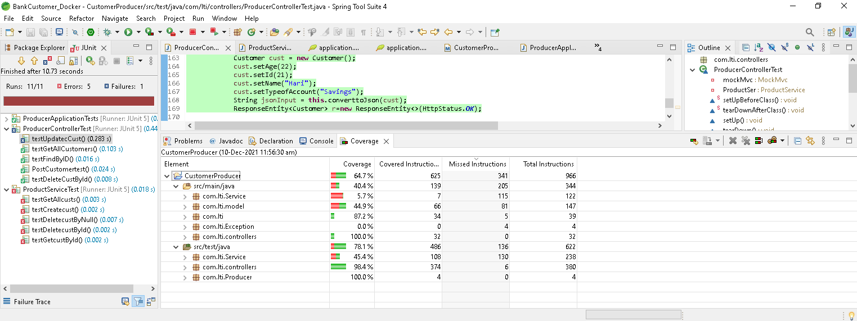

**Devops**

1. Loggers( Log4j or Logback) and be implemented for all the backend java classes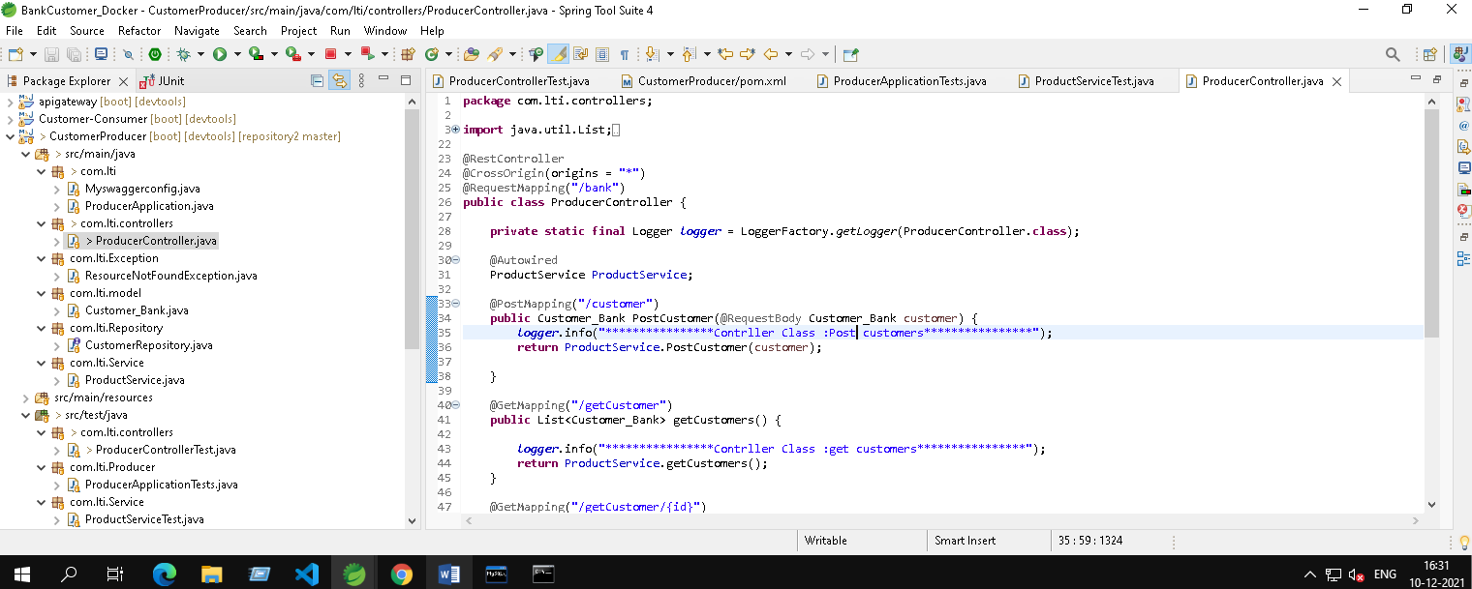
2. Debugging can be done with screenshot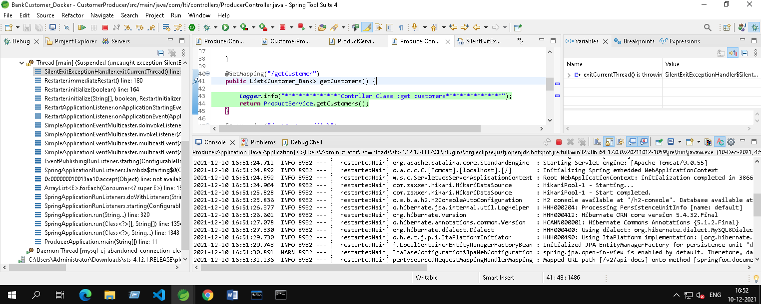
3. Code quality can be checked for backend code-SonlarLint /Checkstyle -screenshots required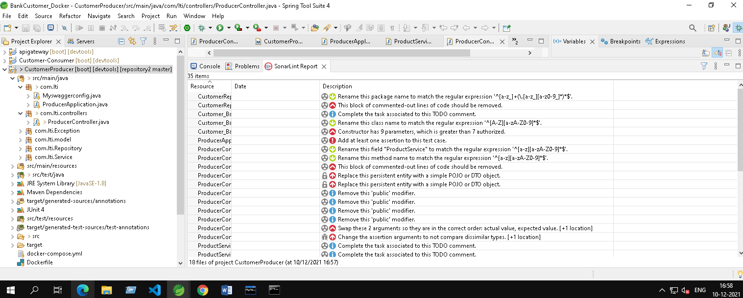
4. Project can be imported in Sonarqube for bugs and vulnerabilities- screenshots required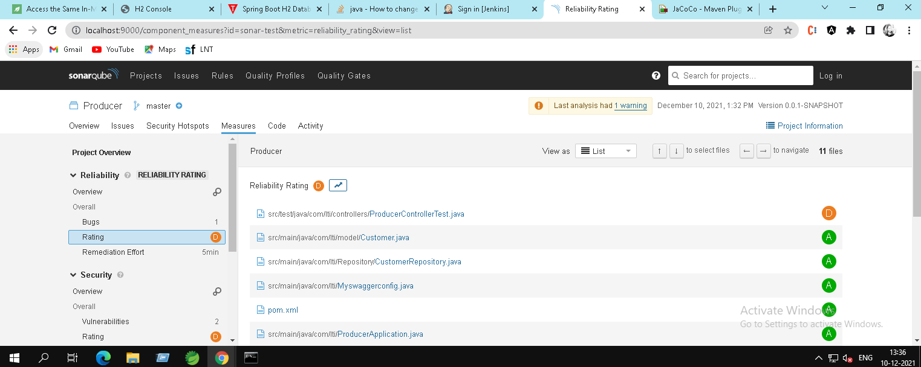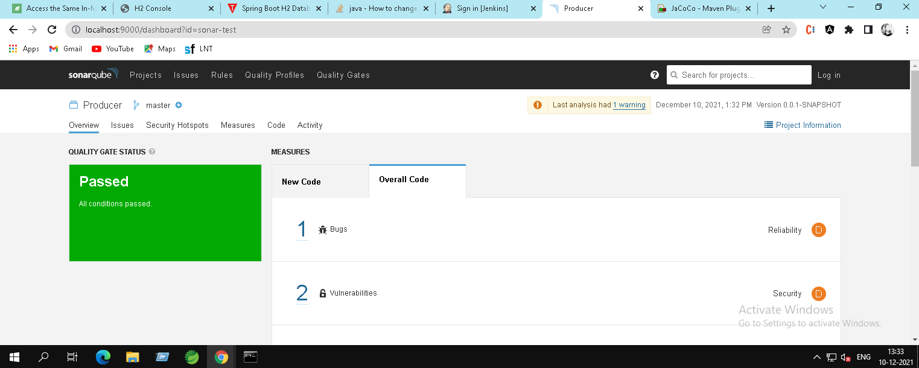
5. Create Maven build-mvn clean install

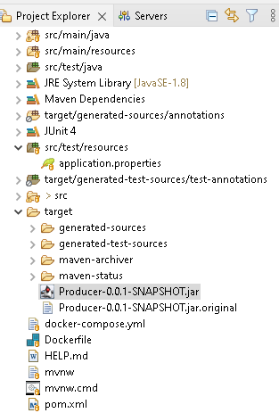

1. Docker image and container creation and deployment in Dockerhub - screenshots required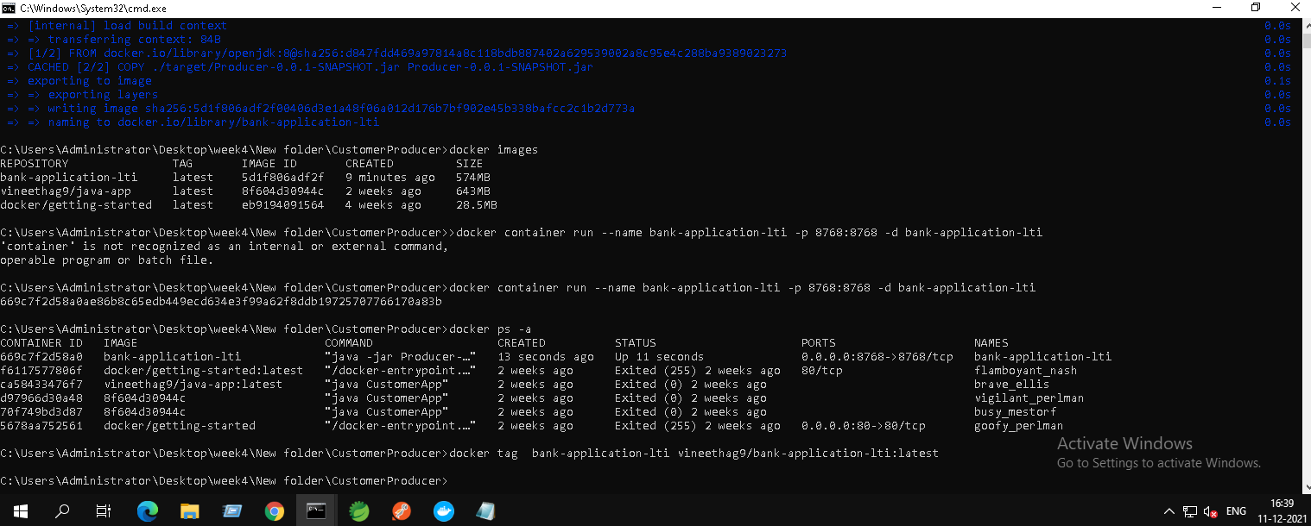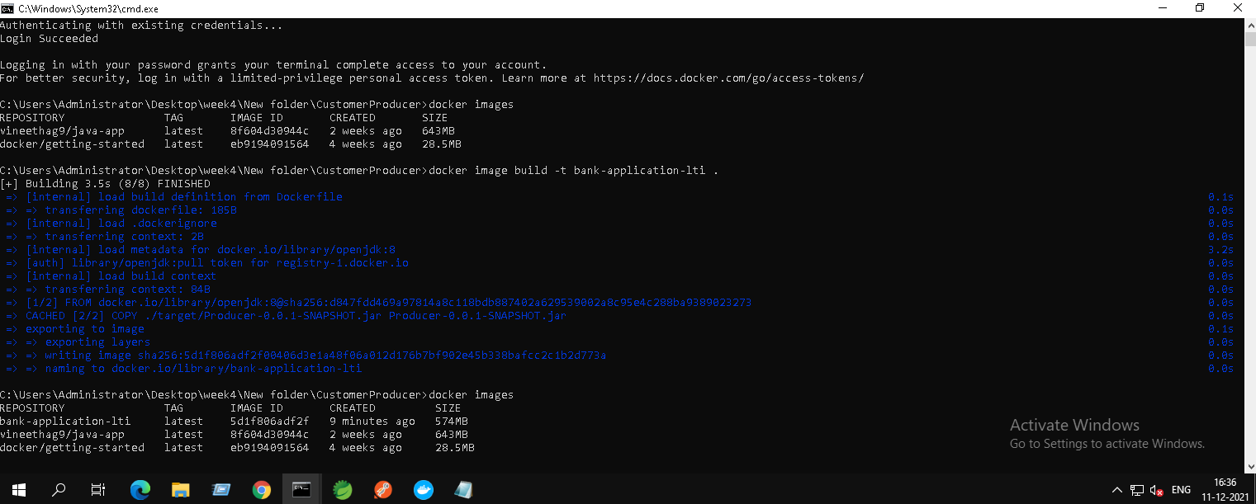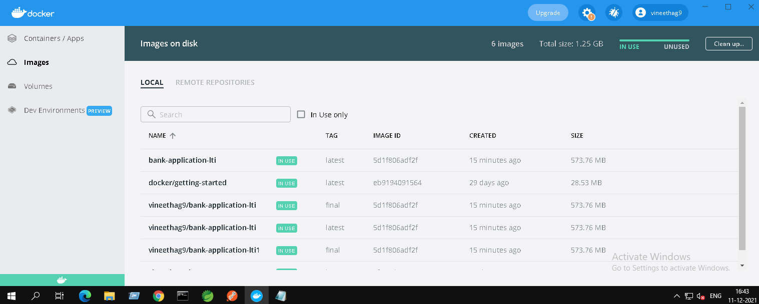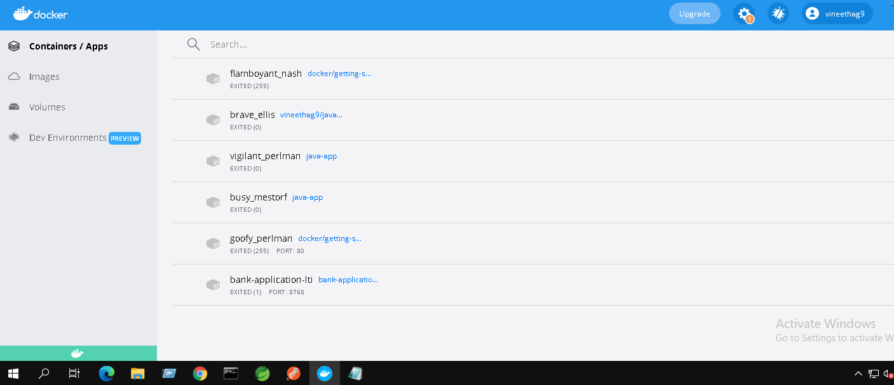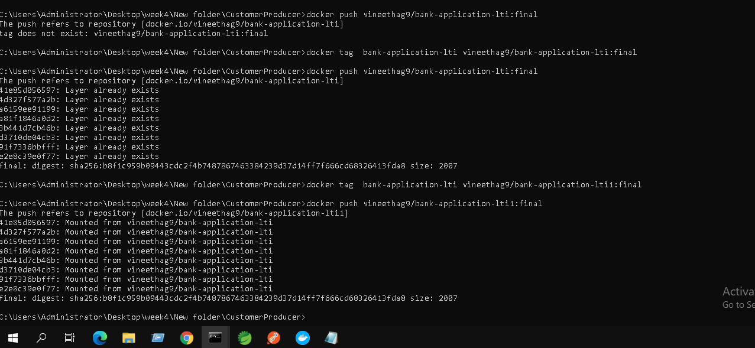
2. Jenkins code pipeline can be created with minimum 3 stages - screenshots required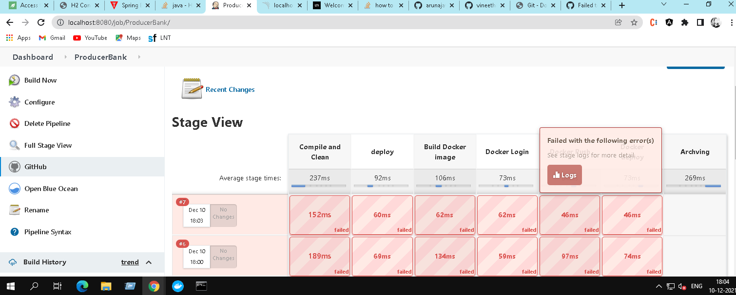

**AWS**:

1. Use S3 bucket to deploy Frontendcode – share URL and screenshots

**Amazon S3 Bucket URL** : <http://lti-bank-front-end.s3-website.us-east-2.amazonaws.com/Customers>

I have integrated Amazon S3 with the Back-end AWS through Elastic BeanStalk where RDS is used as the Database Please find Screenshots of the service URLs and RDS properties screenshots. 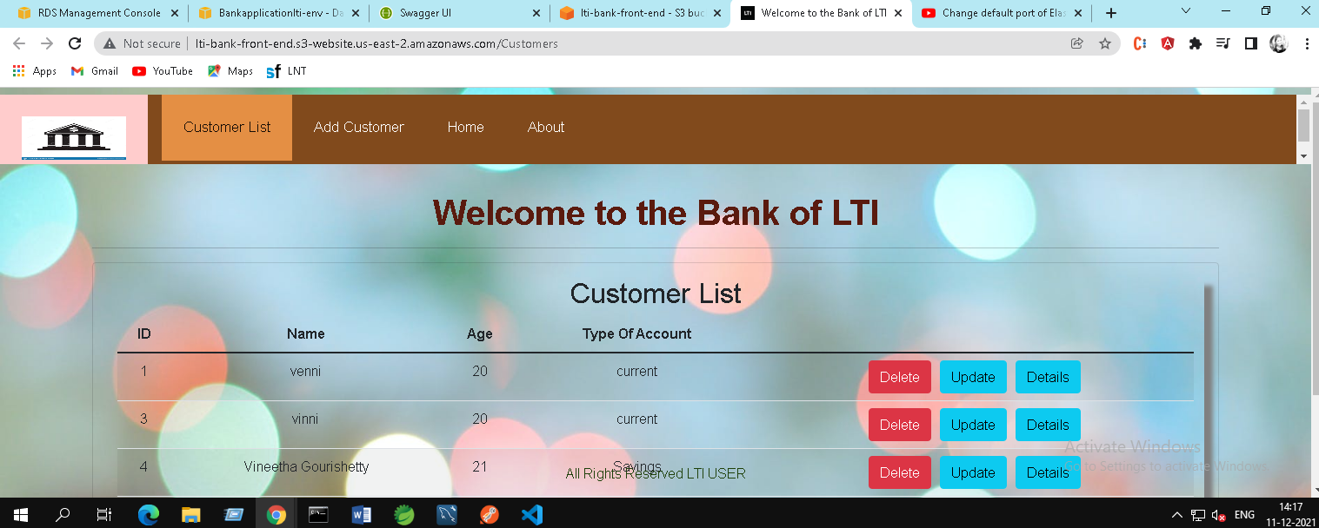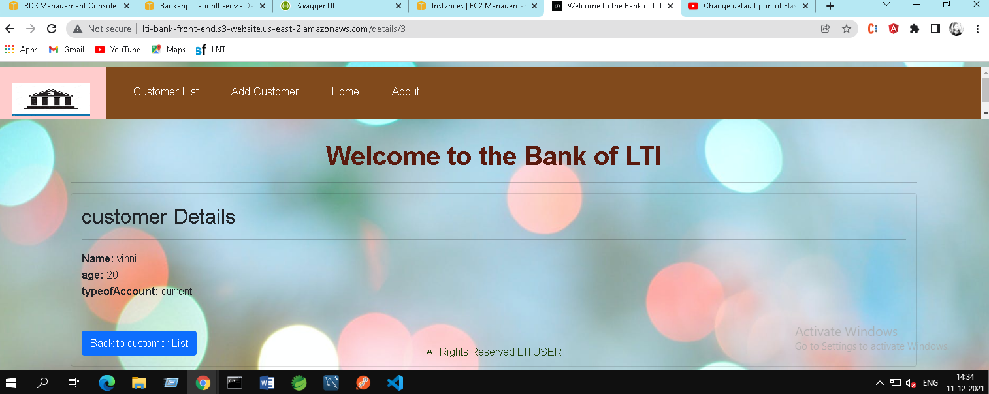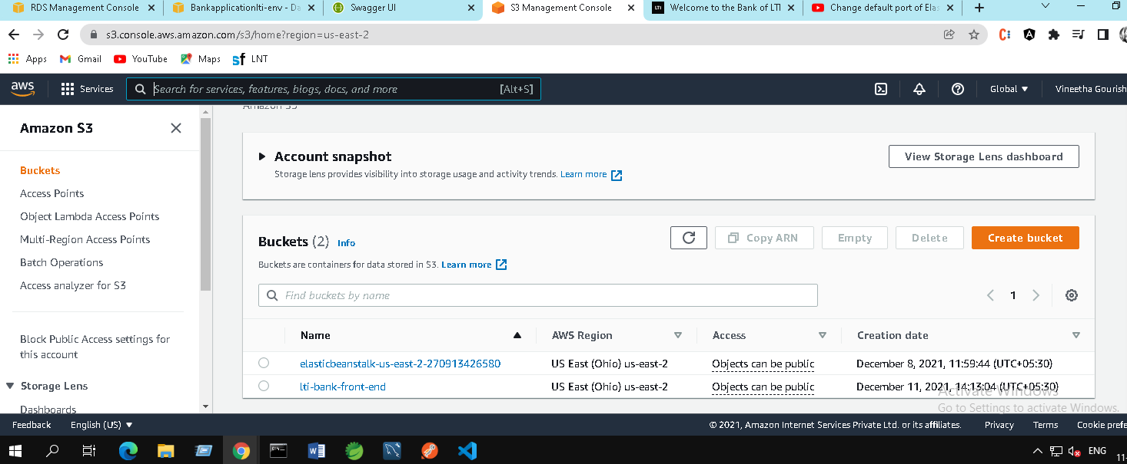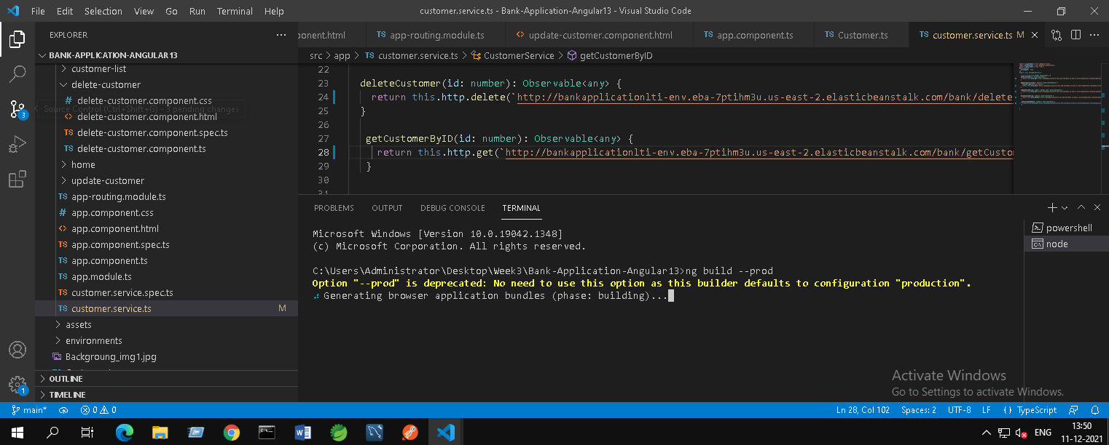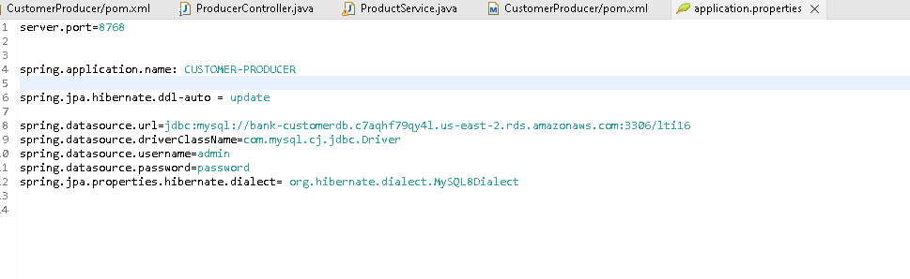

1. Use RDS instance to connect to Mysql instance. – share URL and screenshots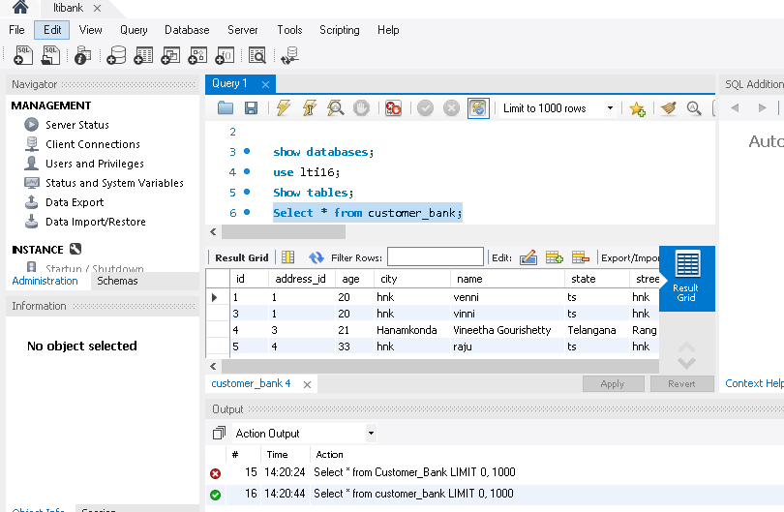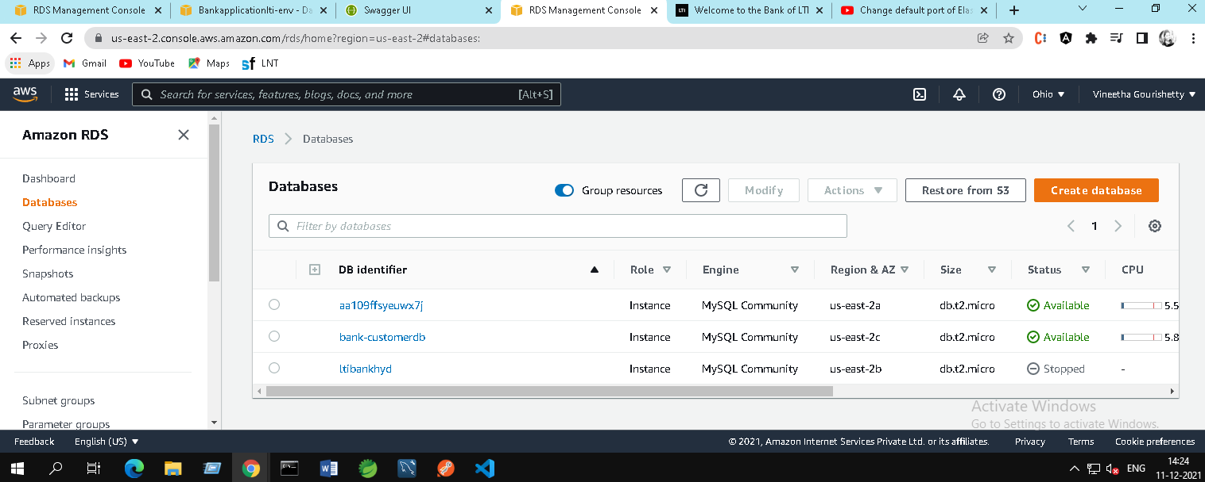
2. Use EC2 instance for deployments with Docker and Jenkins -Optional requirements

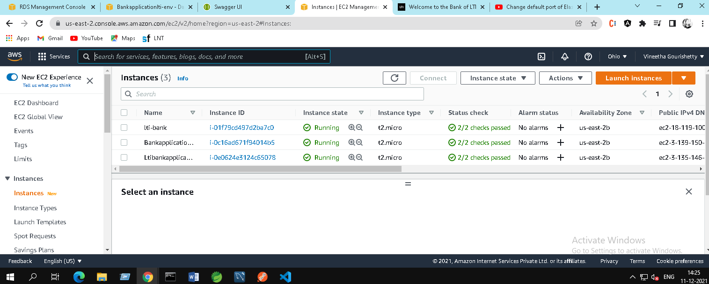

If facing issues with Jenkins in EC2 use Docker and Jenkins local .

15. Used Elastic BeanStalk to deploy Back endcode and integrated with RDS – share URL and screenshots

ElasticBean URL for accessing the backend without using frontend :

<http://bankapplicationlti-env.eba-7ptihm3u.us-east-2.elasticbeanstalk.com/swagger-ui.html>

