**Project-1: Issuer Callable Contingent Coupon Barrier Notes**

Group:

*Venu Madhav Menday (vmenday2)*

*Vineeth Kotala (vkotala2)*

**Contents**

Introduction: 2

Value: 2

Data: 2

Bloomberg data: 4

Binomial Option Pricing Model: 5

Assumptions: 5

Model: 5

Conclusion 7

Sensitivity analysis: 7

Boundary plot: 9

**UBS AG $900,000 Trigger Callable Contingent Yield Notes**

# Introduction:

## Value:

The estimated value of a note is **$974.5**

## Data:

Most of the data is picked from the term sheet while data on interest rates, underlying volatility and dividend yield are taken from the Bloomberg portal.

|  |  |  |  |
| --- | --- | --- | --- |
|  |  | Time (Yrs) | Days |
| *Trade Date* | 1/20/2023 | 0.000 | 0 |
| *Settlement Date* | 1/25/2023 | 0.014 | 5 |
| *Final Valuation Date* | 7/21/2025 | 2.501 | 913 |
| *Maturity Date* | 7/24/2025 | 2.510 | 916 |

|  |  |
| --- | --- |
| ***Underlying asset*** | **The common stock of Signature Bank**  **SBNY** |
| *Principal Amount / Face Value* | $1,000.00 |
| *Underlying Initial value* | $127.79 |
| *Coupon Barrier 50% of the initial value* | $63.90 |
| *Downside threshold 50% of the initial value* | $63.90 |
| *Annual Contingent Coupon rate* | 15.50% |
| *Monthly coupon rate* | 0.012917 |
| *Coupon dollar amount* | $12.9167 |
| **Data collected from Bloomberg (*refer to screenshots)** | |
| *Volatility* | 0.4780 |
| *Risk neutral rate* | 0.037395 |
| *Risk-free rate* | 0.03738 |
| *Dividend yield (annual)* | 0.02912 |

|  |  |  |  |
| --- | --- | --- | --- |
| **Observation Dates** | **Days** | **Coupon Payment Dates** | **Days** |
| 21-Feb-23 | 32 | 24-Feb-23 | 35 |
| 20-Mar-23 | 59 | 23-Mar | 62 |
| 20-Apr-23 | 90 | 25-Apr-23 | 95 |
| 22-May-23 | 122 | 25-May-23 | 125 |
| 20-Jun-23 | 151 | 23-Jun | 154 |
| 20-Jul-23 | 181 | 25-Jul-23 | 186 |
| 21-Aug-23 | 213 | 24-Aug-23 | 216 |
| 20-Sep-23 | 243 | 25-Sep-23 | 248 |
| 20-Oct-23 | 273 | 25-Oct-23 | 278 |
| 20-Nov-23 | 304 | 24-Nov-23 | 308 |
| 20-Dec-23 | 334 | 26-Dec-23 | 340 |
| 22-Jan-24 | 367 | 25-Jan-24 | 370 |
| 20-Feb-24 | 396 | 23-Feb-24 | 399 |
| 20-Mar-24 | 425 | 25-Mar-24 | 430 |
| 22-Apr-24 | 458 | 25-Apr-24 | 461 |
| 20-May-24 | 486 | 23-May-24 | 489 |
| 20-Jun-24 | 517 | 25-Jun-24 | 522 |
| 22-Jul-24 | 549 | 25-Jul-24 | 552 |
| 20-Aug-24 | 578 | 23-Aug-24 | 581 |
| 20-Sep-24 | 609 | 25-Sep-24 | 614 |
| 21-Oct-24 | 640 | 24-Oct-24 | 643 |
| 20-Nov-24 | 670 | 25-Nov-24 | 675 |
| 20-Dec-24 | 700 | 26-Dec-24 | 706 |
| 21-Jan-25 | 732 | 24-Jan-25 | 735 |
| 20-Feb-25 | 762 | 25-Feb-25 | 767 |
| 20-Mar-25 | 790 | 25-Mar-25 | 795 |
| 21-Apr-25 | 822 | 24-Apr-25 | 825 |
| 20-May-25 | 851 | 23-May-25 | 854 |
| 20-Jun-25 | 882 | 25-Jun-25 | 887 |
| 21-Jul-25 | 913 | 24-Jul-25 | 916 |

## Bloomberg data:

Figure Discount factors for Interest rates

Figure Volatility

Figure Dividend Yield

# Binomial Option Pricing Model:

## Assumptions:

1. We considered Signature bank’s common stock as our underlying asset. And we assumed the implied volatilities of European options from Bloomberg as the volatility for our pricing model.
2. USD OIS rates are taken as Interest rates. Two different rates are considered.
   1. Risk-neutral rate (r1), used for estimating the risk-neutral probabilities, is calculated between the Trade date and the Valuation date, by linear interpolation of discount factors available for dates in Bloomberg.
   2. Similarly risk-free rate (r2), used for discounting the value of options between steps of the binomial tree, is calculated between the Trade date and Maturity date
3. Dividends are assumed to be distributed biannually at regular intervals; in total, we have taken 5 dividend dates spread across the time horizon.

## Model:

**Defining parameters:**

1. For better convergence, we have selected 10,000 steps for our tree, N = 10000.

**Defining Function:**

We have defined a function “Bin-icall” with 13 input parameters given below.

**Bin_icall(N, S0, Face, ratio, sigma, r1, r2, T, cpn, tco, tac, DIV, TD)**

Where,

1. N is the number of steps for building tree
2. S0 is the price of the underlying asset at time T = 0
3. Face is the principal amount as defined in the note
4. Ratio is the factor defined in the note for coupon barrier and downside threshold (same in our case)
5. Sigma is the volatility of the underlying asset
6. Risk-neutral rate used for calculating probabilities is defined as r1
7. Risk-free rate used for discounting values between time steps is defined as r2
8. T is the time till maturity
9. The monthly coupon rate is defined as cpn
10. The list of coupon dates is defined as ‘tco’
11. The list of observation dates is defined as ‘tac’
12. DIV is the dividend yield for six months.
13. TD is the list of dividends dates

Note: The function includes a subfunction Stock_tree for creating stock tree before calculating the option values.

We have created four temporary lists jco1, jco & jac1, jac for matching the j in the for-loop with coupon dates and observation dates.

Option value at maturity is the payoff at maturity which is the Principle amount + Coupon or Principle (1+underlying return) when the underlying is below the threshold as given in the term sheet.

We have discounted the maturity values for three days since the maturity date is 3 days after the valuation date.

And a separate for loop is used to create values of options at different steps denoted by j in the function moving 1 step backward each time starting from N-1.

And at each j we iterated for ‘i starting from 0 to j’ to estimate value of option_value[j,i]. Intermediary variables ‘cont’ and ‘exe’ are used to calculate option values for different conditions as given below;

When the j matches with the list of integer values of observation dates and meets the required condition that the underlying is above the barrier, the discounted coupon value is added to the temporary option value cont estimated using risk-neutral probability q and option values one step ahead.

And we take the minimum of temporary option values cont & exe (option value if executed immediately) and update the final option_value[j,i].

We have evaluated the option tree values with a smaller number of steps and confirmed the boundary, but as discussed in the later section our boundary is serrated which is attributed to the additional discounted coupons added to the option value.

**Other formulae:**

$$∆t= \frac{T}{N}$$

$$u= e^{r_{1}∆t + σ √∆t }$$

$$d= e^{r_{1}∆t - σ √∆t }$$

$$q= \frac{{(e}^{r_{1}∆t}- d)}{(u-d)}$$

$$V_{\left[j,i\right]}= e^{{-r}_{2}∆t}\{q V_{\left[j+1, i+1\right]}+\left(1-q\right)V_{\left[j+1, i\right]}\}$$

$$cont= V_{\left[j,i\right]}+Face ×cpn × e^{{-r}_{2}∆t*}$$

*Where delta t* is the time between jth step and the coupon date*

# Conclusion

## Sensitivity analysis:

We have evaluated the value of options using a range of steps (100 – 1000). It is evident from the plot given below, that there is huge variance in the values of options, a clear sign of non-linearity. But over a large number of steps, 10010 we observed a convergence at 974.5.

Figure Option value vs steps

We can also observe, that variance persists even after selecting either only even numbers or only odd number of steps.

Figure Even steps

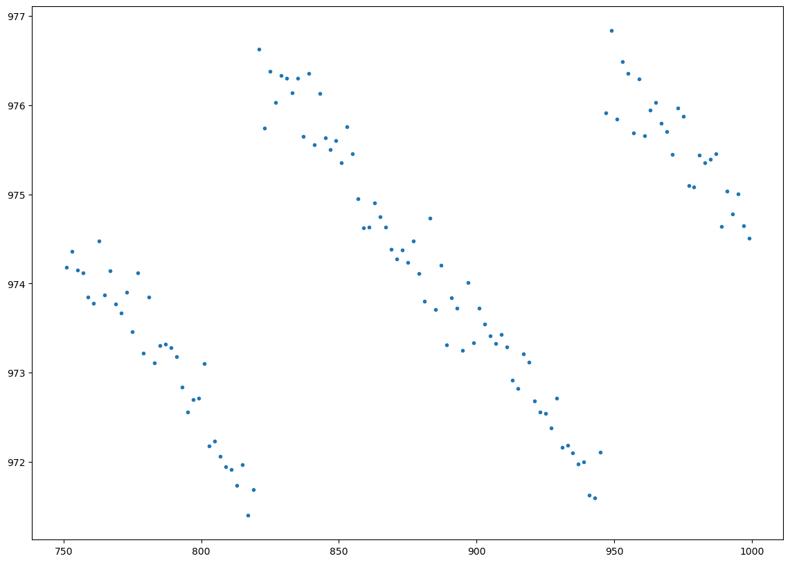

Figure Odd Steps

## Boundary plot:

As we can observe from the below plot the serrated boundary, i.e., the price of a later period dropping and again increasing is not expected. It is due to the addition of discounted coupons on the coupon dates thus causing the option value to jump. This irregular option price movement with respect to time steps is one of the significant factors for the variance in the option value with respect to number of steps.

Figure Boundary plot