Image and Video Processing : Lab Assignment 2

Name : M.Vineeth

Batch : EB03

Enrol : E18CSE095

1. 1. RGB to Gray-scale conversion of images
2. Read any RGB image as input and convert it into grayscale image using direct function/library in Python. Show input and output together using subplot function

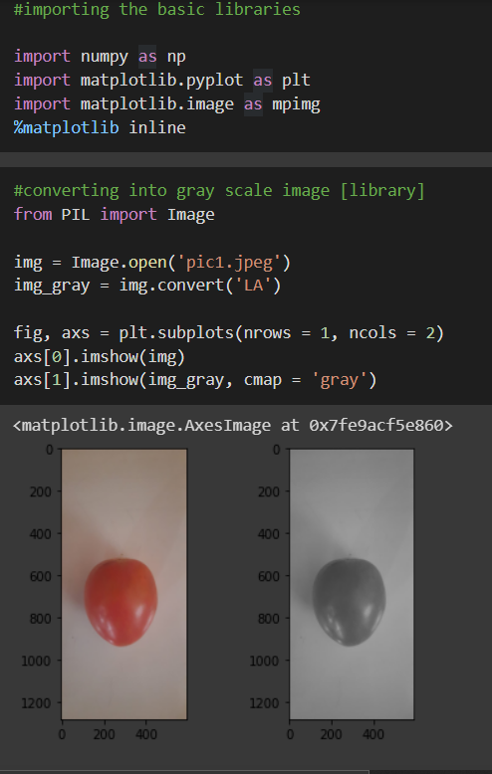

1. RGB to grayscale Image conversion using numpy and matplotlib only. No other special Python library can be used. Explain the steps in your own words

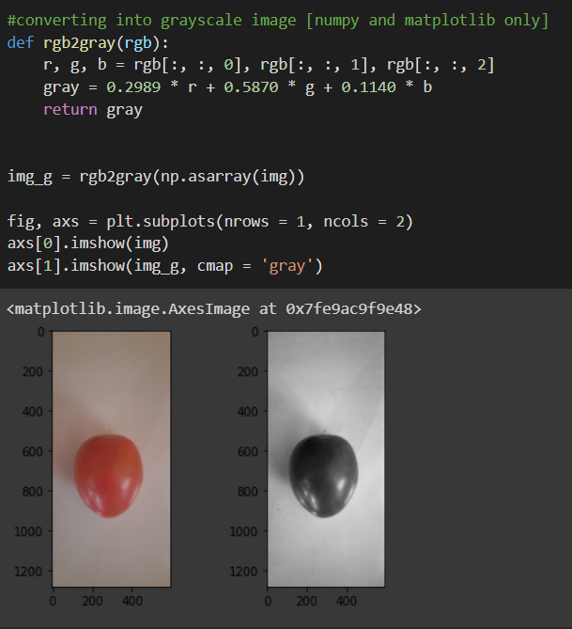

To do the grayscaling of an image manually, we need to simply manipulate the pixel values.

A normal RGB image has 3 channels ie. Red, Green and Blue.

A grayscaled image has only 1 channel.

So we need to account these 3 channels into 1.

There are two methods :

1. Averaging :

Grayscale = (red + blue + green) / 3

In this process, we find that the image turns out to be black.

Since the 3 colours have different wavelengths and have their own contribution in the formation of the image, so we have to take the average according to their contribution and not directly their average.

1. Weighted method or Luminosity method :

Grayscale = 0.3 \* red + 0.59 \* green + 0.11 \* blue

1. Take two images and perform Image subtraction, addition, and multiplication of those images using arrays.

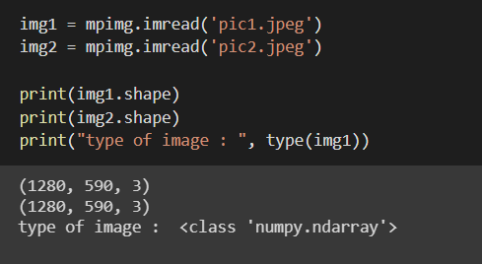

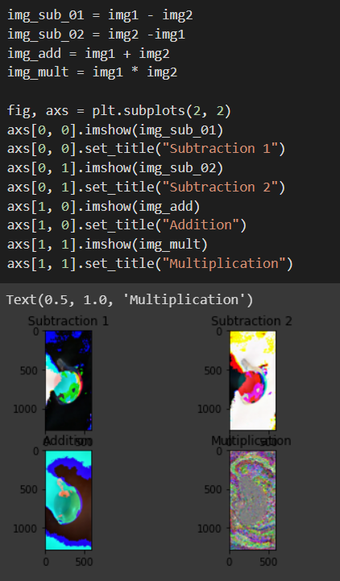

1. Converting from one color space into another (RGB to HSV conversion)

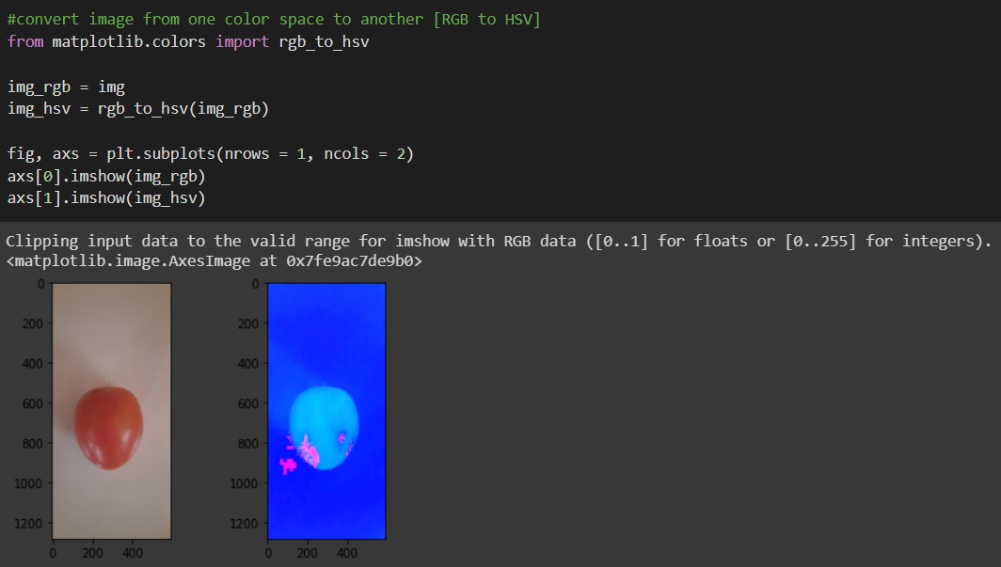

1. Image resizing using bilinear, bicubic and nearest neighbour interpolation methods. What is your observation about the outputs of these methods; can you see any difference in outputs? Write it in your own words.

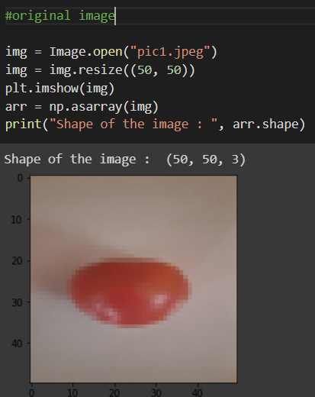

This is an image scaling / resizing technique. Without these techniques, there is a high probability for losing certain critical information.

In linear interpolation, it uses the 4 neighbours, N4(P), ie the north, south, east and west in the closest 2 x 2 matrix region.

Finally the value of the new pixel is taken to be the average of it’s 4 neighbouring pixel values.

According to me this seems to be like a better option for smaller scales of rescaling up or down.

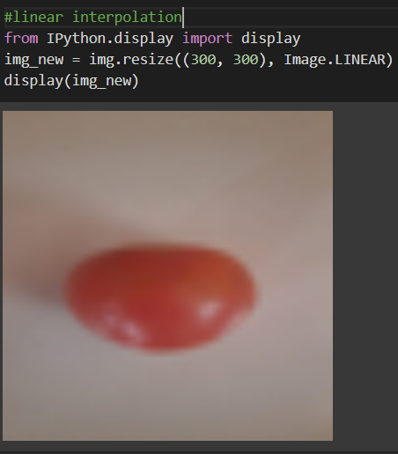

This method is used to preserve the sharpness and retain the details of the image.

It takes the values of point on a grid and interpolate it to approximate the value of its surrounding point.

According to me, this picture has the highest clarity.

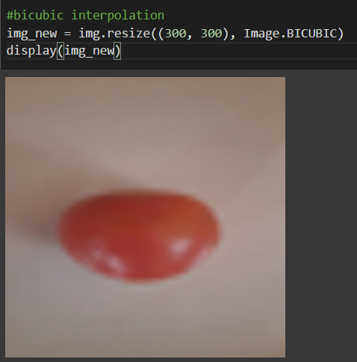

As the name suggests, instead of selecting the values of the nearest neighbours (many)

It selects the single value of the nearest pixel.

This basically gets more and more distorted as we scale the image more.

