**Name: M.Vineeth**

**Batch: EB03**

**Enrol: E18CSE095**

Lab Assignment 01

In this lab, you will write an algorithm and draw a flowchart to solve few problems.

1. **Find the roots of a quadratic equation (flowchart)**

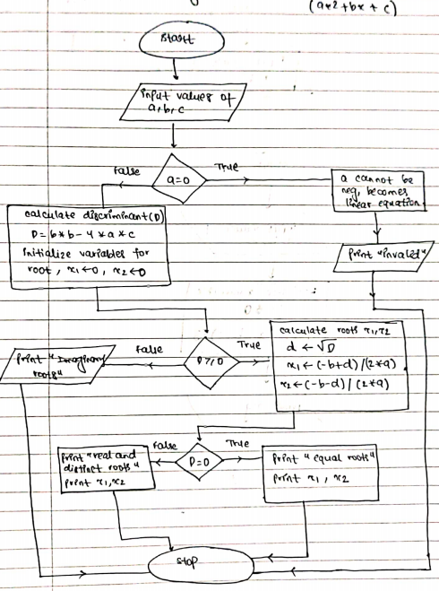

1. **Find the average of the 3 numbers input by a user (flowchart)**

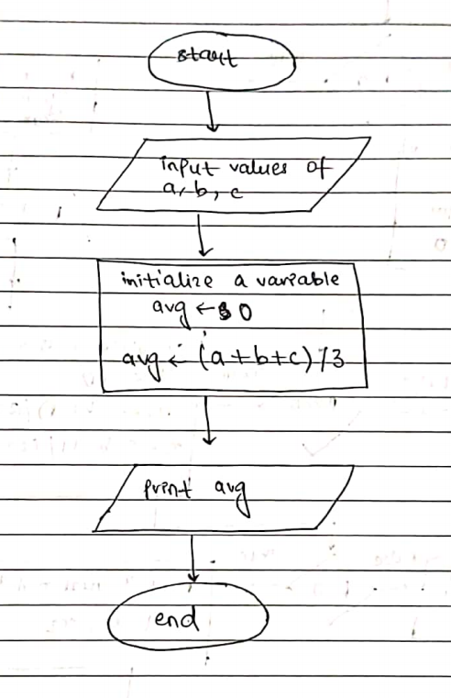

1. **Find whether the given triangle is isosceles or not (algorithm)**

**Solution:**

A triangle is said to be isosceles if two of its angles / sides are equal.

Since the input is the 3 sides of the triangle, {a, b, c}, then the given triangle will be isosceles if one of the following cases hold true:

(a = b) or (b = c) or (c = a)

**Note:** All equilateral triangles are also isosceles.

**Algorithm:**

1. Input the 3 sides from the user.
2. Check if all the 3 sides are positive.
3. If any side is found to be negative then return “false” as sides cannot be negative.
4. Return “true” if any one of the following condition holds true:
   1. (a == b) or
   2. (b == c) or
   3. (c == a)
5. If all the conditions in step 3. Fails then return “false”.
6. **Find the sum of digits of a given integer number (algorithm)**

**Solution:**

Sum of the digits of a number (integer base 10) can be easily solved in O(no of digits in number) time complexity. In each iteration we can do a modulus operation (%10) to fetch the last digit.

We can keep a track of the sum of these digits in a sum variable. To discard the digit, we can perform division operation (/10).

We can keep repeating this process till the number becomes 0.

**Note:** If we are given a negative number, we can take absolute value of the number before following the steps of the algorithm.

Example:

Input: 123 🡪 Output: 6

Input: -123 🡪Output: 6

**Algorithm:**

1. Input the number from the user.
2. If the input is negative, take its absolute value by multiplying the number with -1.
3. Initialize a variable called sum with 0.
4. Fetch the last digit by taking modulus operation by 10.
5. Add the result to the sum variable.
6. Discard the last digit by dividing the number by 10.
7. Repeat steps 4 to 6 while the number is greater than 0.