DIGITAL SIGNAL PROCESSING

EEE834

MATHANGI VINEETH

B00828528

MSC-INTERNET OF THINGS

[Mathangi-V@ulster.ac.uk](mailto:Mathangi-V@ulster.ac.uk)

Course work_2

**PROCESSING THE ECG’S CLEAN AND NOISY SIGNALS :**

**AGENDA:**

* INTRODUCTION
* SIGNAL PROCESS ANALYSIS OF ECG’S
* CONCLUSION

**INTRODUCTION:**

* **Electrocardiogram (ECG) is a kind of diagnostic tool that records data and measures the electrical activity of the heart. And it works by attaching the sensors (electrodes ) to the skin and then used to detect the complete electrical signals from that person and monitored via displays. Well, The electrocardiogram has been in existence to the individuals for over a century .lets check the following figure**

* **The (P wave) in an ECG complex indicates atrial depolarization(chambers of the heart). And the (QRS) is responsible for ventricular de polarization(it is produced by the two ventrices) . lastly , T wave is ventricular repolarization.**

**NOISE: Baseline wander is a low-frequency noise component that present in the ECG signal . And This mainly due to body movement . However , this low frequency noise, causes problem in detection and analysis of peak. ECG noise removal is very complicated due to the time varying of ECG signals and order to remove the frequency noise filters are required.**

* **The main reason to filter a signal is to reduce and smooth the out higher-frequency noise associated with flow, pressure or temperature .**
* **In this scenario, we must clean the noise signals with the help of different kind of filters which are suitable for signals.**

**TOPIC :**

**This piece of coursework requires signal processing techniques to be applied to a noise-corrupted electrocardiogram (ECG) signal file. The corruption consists of low and high-frequency narrowband noise. The sampling frequency is 200Hz. The analysis ECG files will be provided by the tutor via Blackboard learn.**

* **Lets get into the topic by step by step analysis as per the agenda.**

SIGNAL PROCESS ANALYSIS OF ECG’S :

STEP 1 : **IMPORTATION OF ECG SIGNAL**:

**At the initial stage the complete process involved in importing of the clean and noisy signal to MATLAB for the further analysis and also some visualizations on the data. Following code applied for importing audio files in WAV format.**



* **After importing the both noisy and clean ECG signals , further step is to find the 4000 data points with sampling frequency of 200hz,as given in question.**
* **Secondly, plotted the imported ECG signals one against another as we can see in the following figure**

\***figure was plotted clean ECG against noisy ECG . where by comparing both, analysed that a lot of unwanted signal is present in the noisy signal.**

**\* Time domain (t) both has to be upto 20 sec should not exceed because sampling frequency is giveas as 200hz.**

**\* And the key goal of this project is to remove all the unnecessary signals which are not needed present in noisy signal.**

**\*final result has to be as close as possible to the clean signal.**

**METHODODLOGY:**

**Q1.**

|  |
| --- |
| **Compute the maximum and minimum values in the clean and noisy ECG signals.** |

**As per the question , we need to compute the min and max for both clean and noisy signals.**

**RESULTS:**

**\*signal properties of clean signal**

**\*Now minimum and maximum for the clean ECG**

|  |  |
| --- | --- |
| SIGNAL STRENGTH | VALUES |

|  |  |
| --- | --- |
| **MINIMUM OF CLEAN ECG** | 0.2940 |
| **MAXIMUM OF CLEAN ECG** | 0.5948 |

\***signal properties of noisy signal**

**\*Now maximum and minimum for noisy ECG**

|  |  |
| --- | --- |
| SIGNAL STRENGTH | VALUES |

|  |  |
| --- | --- |
| **MINIMUM OF NOISY ECG** | -0.2282 |
| **MAXIMUM OF NOISY ECG** | 0.6376 |

**Q2**

|  |
| --- |
| **Compute the DC components of the clean and noisy ECG signals and remove them, noting in each case their values. Now plot in the same plot area the first 1000 sample points of the clean ECG compared with the noisy ECG, before and after removing their DC components.** |

**DC-COMPONENT : when the voltage level in a digital signal is constant for a while , signal creates a very low frequencies. these frequencies around zero called as DC component , these creates a problem that cannot allow the low pass frequencies.**

**\*so in order to remove the unwanted signals , this might be the first process to remove dc components. For further study I had some results.**

**\*That results shows the complete comparison between before and after removal of DC components.**

\***by comparing the above subplot, with DC component of clean ECG is in between 0.35 to 0.4.and by looking the without DC , realised that signals frequency is near to -0.05.**

**# NOW LETS COMPARE FOR NOISY WITH AND WITHOUT DC COMPONENT:**

**\*By comparing the noisy ECG with and without DC component upto 4000 data points, mostly similar .**

**\* Now plot in the same plot area the first 1000 sample points of the clean ECG compared with the noisy ECG, before and after removing their DC components.**

**As mentioned in the question plotted the first 1000 sample points of the clean ECG and noisy ECG.**

**Above figure shows the comparison between clean and noisy ECGs with DC component only with 1000 points, and from taking 4000 points there might be less noisy in 1000 points. now run the same process but without dc component in figure**

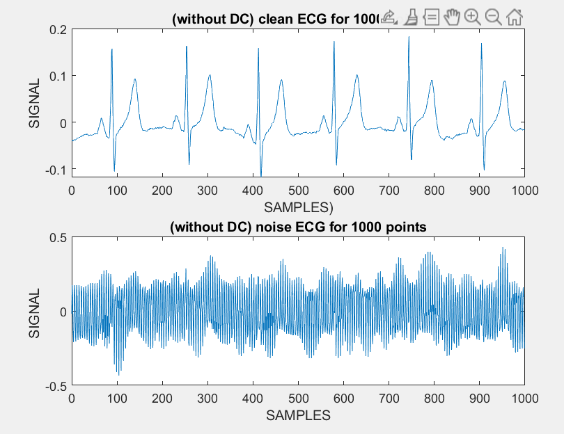

**By plotting the above conditions with and with out DC component , realised that in DC component noise has more when compared to after removing DC .In addition, dc component noise signals is in between 0 to 0.4 but after removing the DC the signals is less in between -0.5 to 0.5.**

**Q3.**

|  |
| --- |
| **Compute a 1024 point FFT from the initial 1024 samples segment of the noisy ECG without DC component. Then, from the obtained FFT, plot the absolute value (magnitude) of** **the frequency spectrum of the noisy ECG (without DC component) expressing the x-axis (horizontal) in units of frequency (Hz).** |

**FFT: A FFT (FAST FOURIER TRANSFORM) is an algorithm that computes the sequence of Discrete Fourier transform . Moreover Fourier analysis coverts its original time domain to representation in frequency domain.**

**\* FFTs are often used to sharpen edges , remove noise are widely used to turn number series into waves representation. In the below figure ,we can see formulas for both inverse FT and FT functions.**

**\*As per the question the initial samples 1024 is applied for both Noisy and clean ECGs without DC component.**

**\* Once FFT (Fast Fourier transform) of the signal successfully completed two different kind of noises are present . after removing step wise there is a huge difference in with and without DC component.**

**\*As we can see above figure**

* **Noisy ECG had a specific interference frequency at 40 HZ.**
* **Secondly, a various range of noisy frequency signals were identified at 70 HZ to 90 HZ.**

**. And for analysing these signals to remove the unnecessary signals further filtering are required.**

**Q4**

|  |
| --- |
| **Based on the frequency spectrum obtained in (3) above, identify the noise components to be removed and by using Butterworth, band stop, digital filters of an appropriate order of your justified choice, remove the unwanted noise, taking care of not removing much of the useful ECG waves (P, QRS and T). Plot the frequency spectrum (absolute value) of the denoised signal. Also, plot the denoised time-domain signal (first 1000 samples).** |

**FILTERS : In signal processing , filtering is a process that used to remove the unnecessary or the unwanted components or noises from a signal. Exact words are removing some unwanted frequency bands. And I had used some of the following filters which are required.**

**Filters are generally used in different ways, from signal clean up to analysis. Well, filters can be used in different ways they are:**

* **Anti aliasing filters: it is used to remove the signals which cannot be in the form of digital.**
* **Noise removal: it removes unwanted signals. this is the one we are opted for.**

**We can see digital filters are divided in to two ,IIR and FIR filters.lets discuss about IIR.**

**IIR(infinite Impulse response):Well filter can be designed by the tasks that depends upon its conditions and there are commonly classified into LOWPASS, HIGHPASS, BAND PASS and BAND STOP.**

**There are some following methods which I had used to rectify the spectral frequencies in noisy signal**

* **HIGH PASS: The high pass filter is used to isolate the signals which had lower than the cut off frequencies.**
* **LOW PASS**  **: the low pass filters are also used to isolate the signals which have higher than cut off frequency. For instance , this could be used to remove high frequency hiss from an audio recording.**
* **BAND PASS– A BPF or PBF is known as band pass filters and it is a device that allows all frequencies with a specific range and unfortunately it rejects the attenuation outside range.**
* **BAND STOP – A band stop filter is used to remove frequency content over a specified range .As per this project we commonly used IIR filters.**

**In these filter I came up with bandpass filter of different models such as Butterworth , elliptic and Chebyshev type I ,type II.**

**Butterworth:** **The Butterworth filter is one kind of signal processing filter design. and It is designed to have a frequency response which is as flat as mathematically possible in the pass band it is known as butterworth .**

**\*by using the filter design in matlab I had filtered in 20th order to specify**

*As we can perfectly see from above figure that magnitude is -13.98 and phase passband is from 14.871

Here I had specified the sampling frequency is 200 and the first cutoff1 is 70 and fc2 (second cut off) is 90.and its clear that both magnitude and the phase is touches at in between 60 HZ to 70 HZ.

Then design is exported to the MATLAB, as you can see the following code obtained

**I feel that Butterworth Bandpass is best suitable filter for this particular project, because it reduces the unwanted signal than the other filters.**

**Elliptic:** **Elliptic is a signal processing filter it consists of equalized ripple behavior in the both stopband and pass band, well in each band the amount of ripple is quietly adjustable and no other filter have any faster transition in gain . As the ripple approaches to zero in stopband the filter becomes Chebyshev type 1 filter .similarly , ripple in the passband approaches to zero the filter becomes Chebyshev type 2.**

**As we can see from above figure ,I had used the Elliptic bandpass and the order 30 that mean 2n(2*15).and to specify sampling frequency is 200,fpass1 70 HZ lastly f -pass 2 90HZ.**

**As you can see both magnitude and phase touches at 70HZ frequency. However , the result is not up to expectations ,magnitude is -40 and the phase response is -12.556 which is not our result.**

**CHEBYSHEV : Chebyshev filters are nothing but Analog or Digital filters. These filters are divided into two types they are Type-1 filter contains more pass band ripple and Type-2 filter contains more stop band ripple than Butterworth filters And main feature of Chebyshev filter is their speed, it is normally way faster than the windowed-SINC. All these because of filters are carried out by recursion than the convolution. Lets discuss in detail of two types**

**TYPE I: In the type 1 filter the Gain response is an Nth order of the angular frequency function of low pass filter and it is equal to the transfer function hn (jw)**

**TYPE II: It is also known as inverse filter and this type is very rare .And it has eqi ripple in the stopband but there is no ripple in the pass band .Gain is**

**Well this is filter design of the type 1 of Chebyshev filter which magnitude response of the band stops at 90 HZ which is close to expectations . And the specified order is 300 which is N. 2*150.similarly lets check the type II filter .**

**This figure shows the filter designed in type II Chebyshev , the magnitude and phase response is touches at 70 HZ and 90HZ.structure is DIRECT FORM II with specified order of 300.**

**SUMMARY OF METHODOLOGY:**

**IMPORTATION OF SIGNAL: initial process both clean and Noisy was imported to the MATLAB .**

**MINIMUM AND MAXIMUM: This is the second step and here both Maximum and Minimum values are noted.**

**REMOVING DC COMPONENT: for the accurate results both withDC component and with out Dc component are compared and rremoved for the better results.**

**FREQUENCY ANALYSIS: Analysis was carried out to the both ECG clean and noisy signals by using the FFT over 1024 sample points.**

**FILTERING: As by analysing each steps noisy signals has specific interference frequency at 40HZ .so needed to remove and performed some tests .**

**RESULTS:**

* **By assuming the Butterworth Bandpass filter poles and zeros are stable and they are inside the circle. And the structure is Direct Form II second order sections.Gain is around 0.29.**

**AS per my work by comparing all the filters Butterworth Bandpass filter is more suitable than the other tests with order of 20th.**

**CONCLUSION:**

**To be concluded, this presentation is processed on ECG signals of both Clean and Noisy , at initial stage the Noisy ECG had more unwanted signals which needed to be remove. However by involving and comparing the both ECGS step by step analysis and removing the DC components and by adding the FFT realised that still had a specific interference frequency at 40 HZ and also noisy signals from 70HZ to 90Hz are present . In order to remove these, filtering the signals are required .For further filtering I had used Butterworth Band pass ,Elliptic and Chebyshev type I ,type II . and by comparing these I feel that Butterworth is suitable and removes the most of the unnecessary noisy signals.**