**Name: VINEETH P**

**Roll No: 50**

**Batch: BATCH B**

**Date: 03-06-2022**

**ADVANCED DBMS LAB**

**Experiment No.: 8**

**Aim**

To familiarize with the installation of MongoDB and CRUDE operations

**QUESTIONS**

1. Create a database in MongoDB
2. Create a collection
3. Insert some documnents
4. Display or read the documents
5. Update any document object
6. Delete a documentobject

**PROCEDURE**

1. **Installing mongoDB**

First, double-click the downloaded file to launch the setup wizard. Click the Next button to start setting up MongoDB.

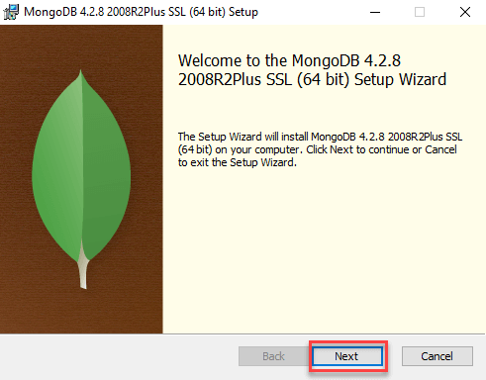

Second, accept the terms in the License Agreement and click the Next button:

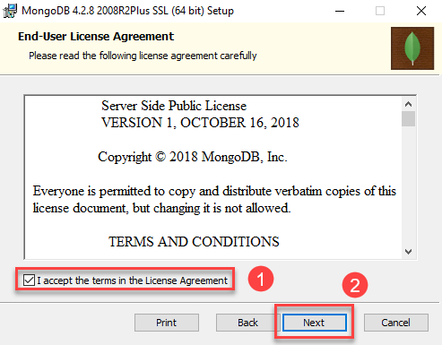

Third, click the **Complete** button to install all program features. If you want to select which features to install and where they will be installed, select the Custom button. However, this option is recommended for advanced users only.

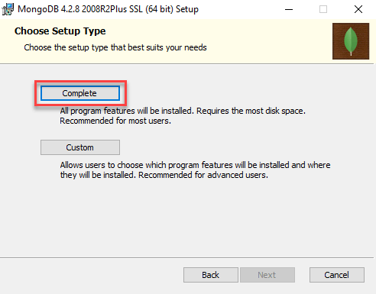

Fourth, select Install MongoD as a service and click the Next button.

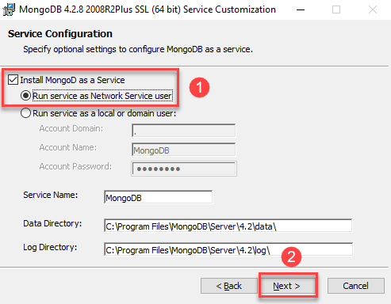

Fifth, ensure that the **Install MongoDB Compass** checkbox is checked and click the **Next**button. If you select it, the setup wizard will also install the MongoDB Compass with the community version.

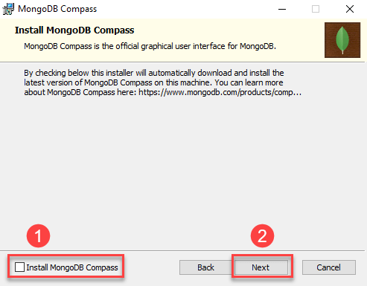

Sixth, click the Install button to start the installation.

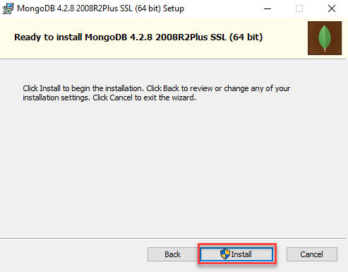

The install will take some minutes to complete.

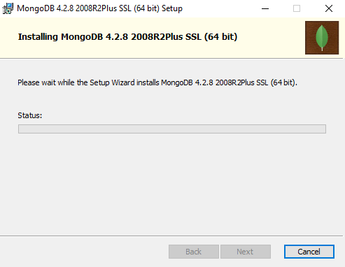

Seventh, click the **Finish** button to exit the setup wizard.

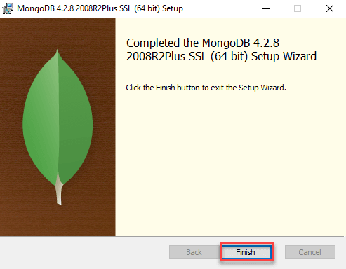

1. **Execute queries for CRUDE operations:**
2. use vineeth
3. db.createcollection(“student”)
4. db.student.insert([{fname:"vijay",lname:"vishnu",age:20,course:"mca"},])

for inserting many documents,

db.student.insertMany([{fname:"vishnu",lname:"sadasivan",age:18,course:"bca"},{fname:"yedhukrishnan",lname:"k j",age:20,course:"bca"},{fname:"vishnu",lname:"mohan",age:19,course:"bsc"},{fname:"shamjad",lname:"mazood naser",age:22,course:"mca"}])

1. db.student.find()

for a clear and pretty output, db.student.find().pretty()

1. db.student.update({"fname":"shamjad"},{$set:{"fname":"anil"}})
2. db.student.remove({"fname":"vishnu"})

**Output Screenshot**

1. 
2. 
3. 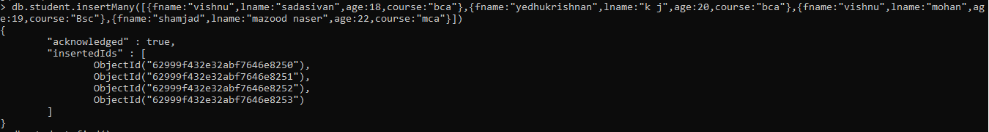
4. 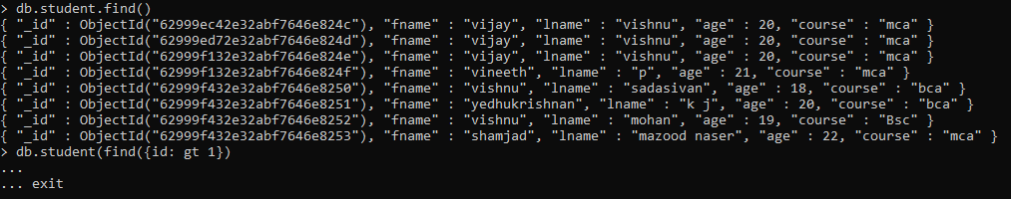
5. 
6. 