**Name: Vineeth P**

**Roll No: 50**

**Batch: MCA B**

**Date: 21-03-2022**

**NETWORKING & SYSTEM ADMINISTRATION LAB**

**Experiment No.: 1**

**Aim**

Install the latest version of Ubuntu on an Oracle VM VirtualBox.

**Procedure**

1. Install virtual box

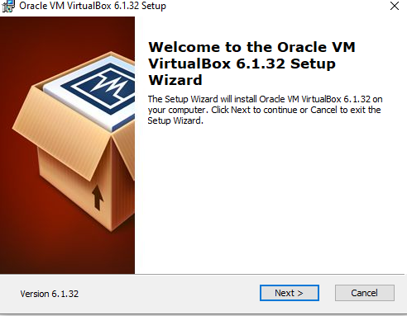

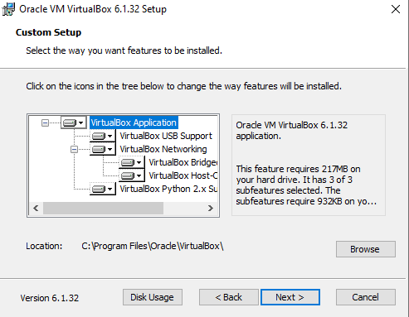

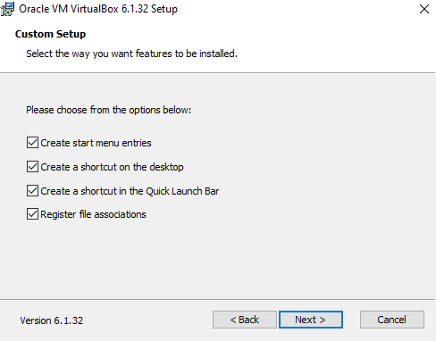

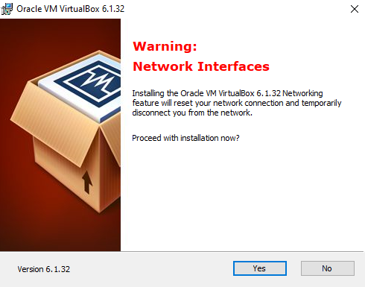

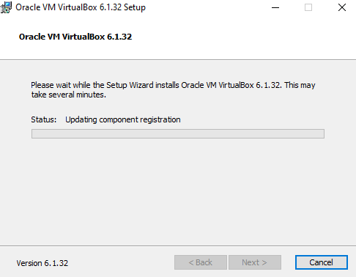

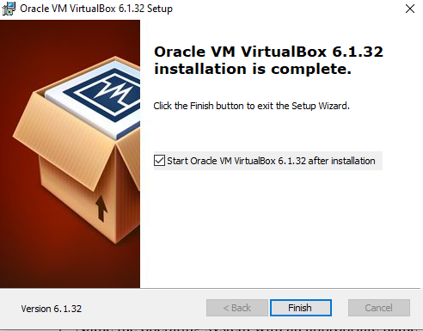

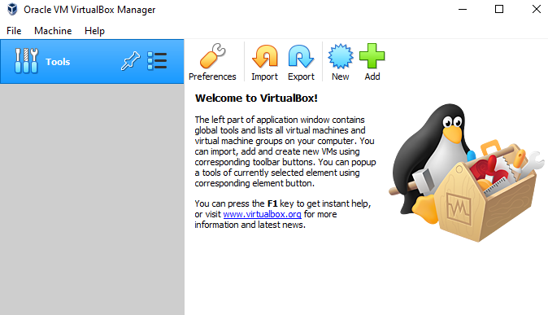

1. Click New to add OS(Ubuntu) to your virtual box and name the os with appropriate name

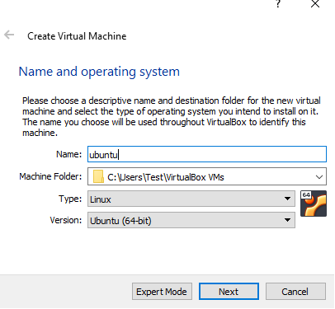

1. Create a memory (RAM) for VM

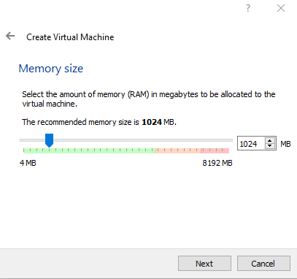

1. Select the hard disk file type and size

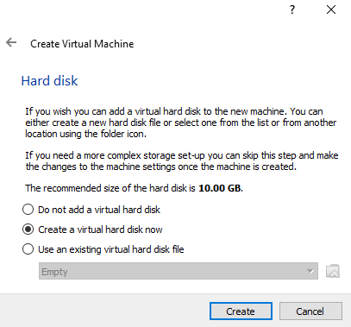

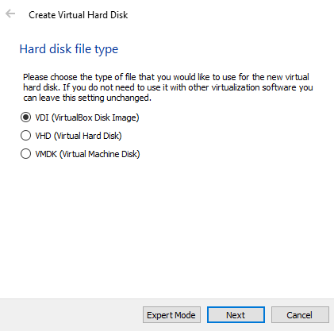

1. Choose allocation type

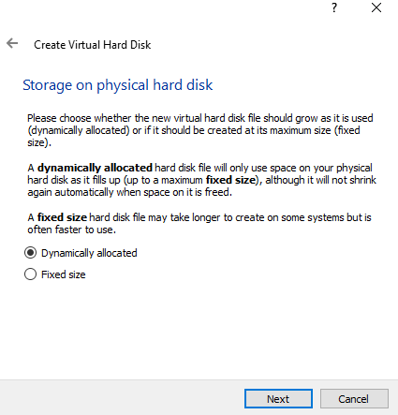

1. Set file location and size

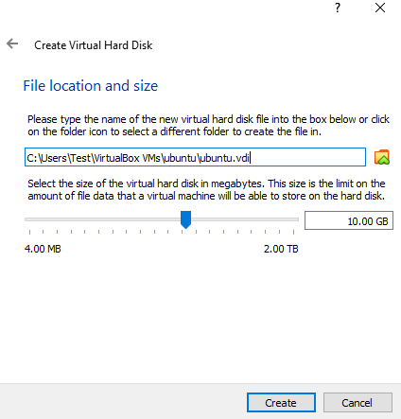

1. Click on the storage option

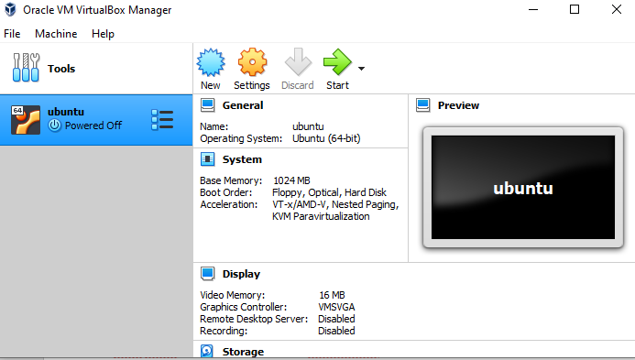

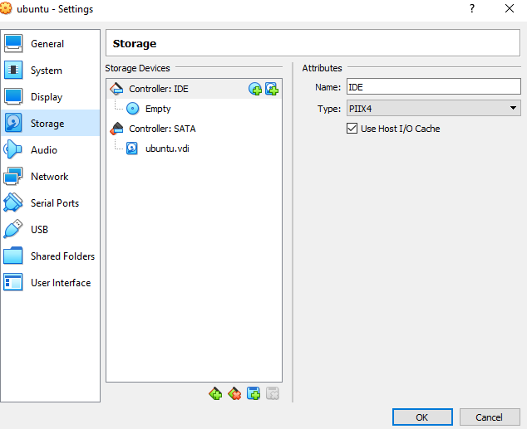

1. Select empty disc uder controller-IDE

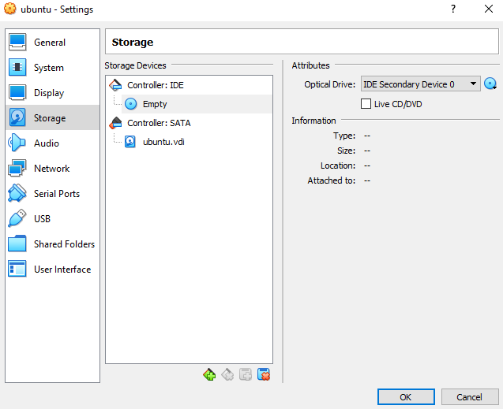

1. Through optical drive option , choose ISO file of Ubuntu

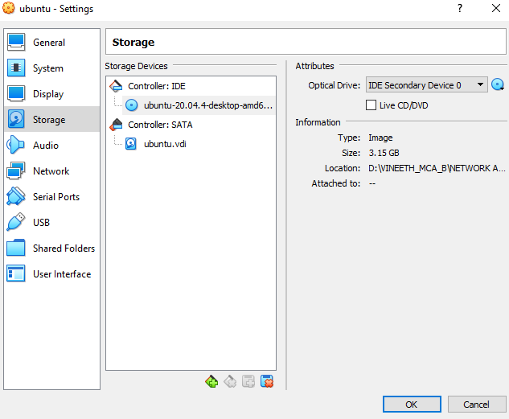

1. Click on start to begin os installation

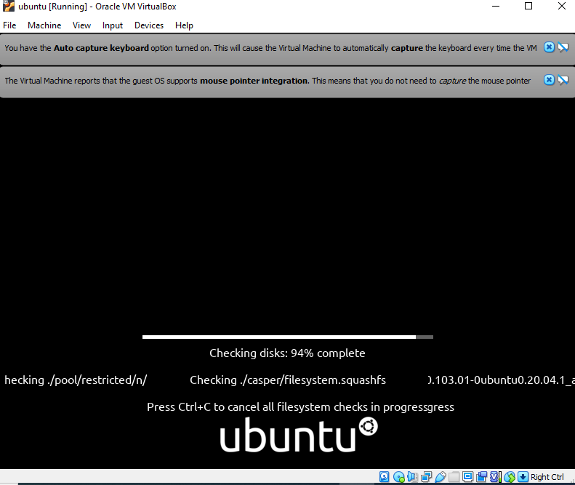

1. Click on install Ubuntu option

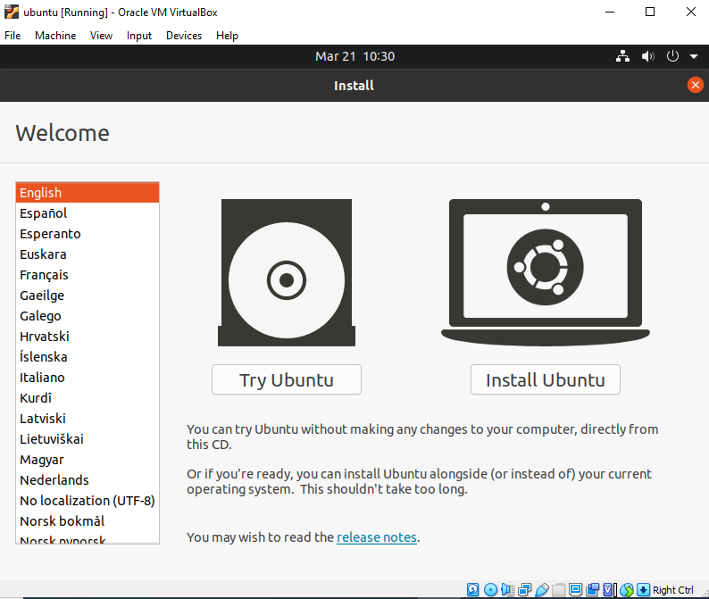

1. Choose a keyboard

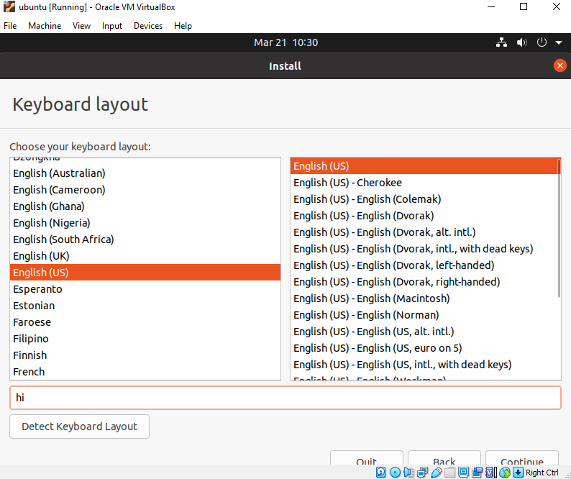

1. Select normal installation and press continue

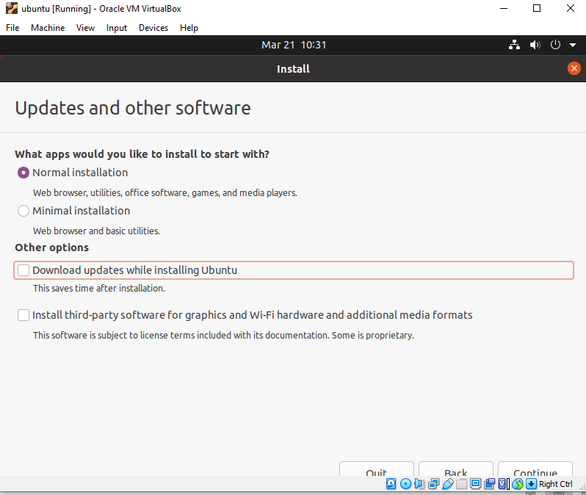

1. Choose ‘erase disk and install Ubuntu’

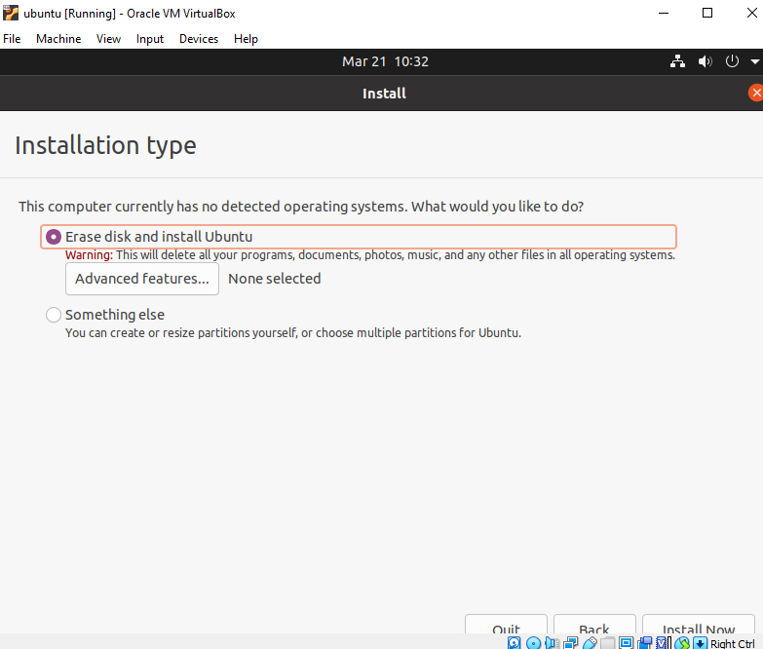

1. Click ‘ok’ when a dialog box ‘write the changes to disk?’ is open

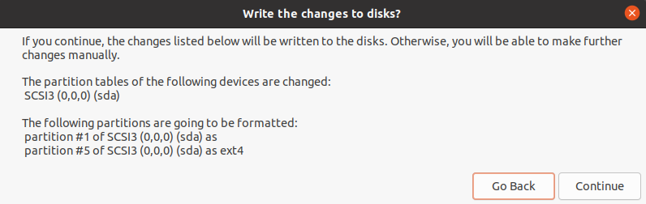

1. Select a time zone (eg. India Time )

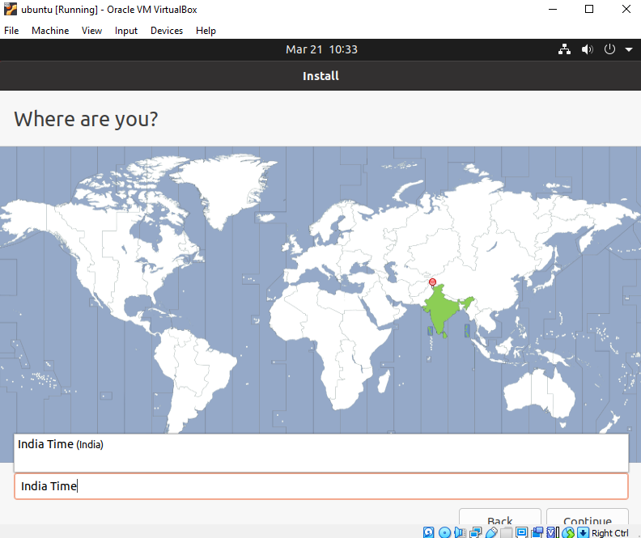

1. Set a login name and password

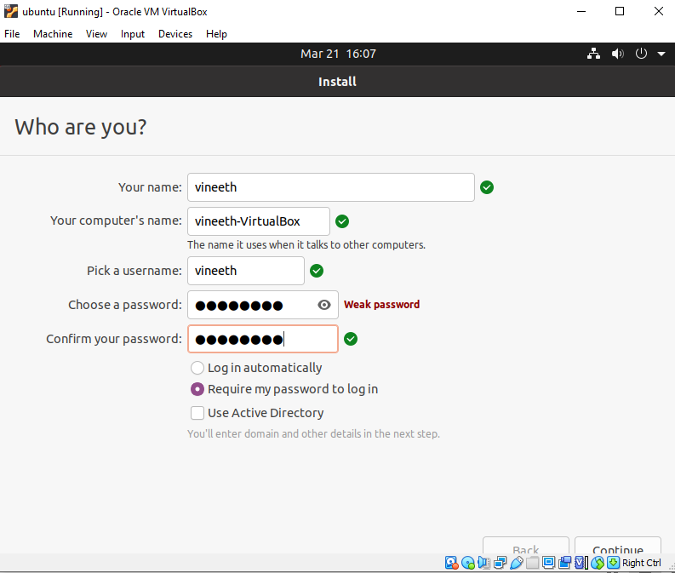

1. Click the continue button

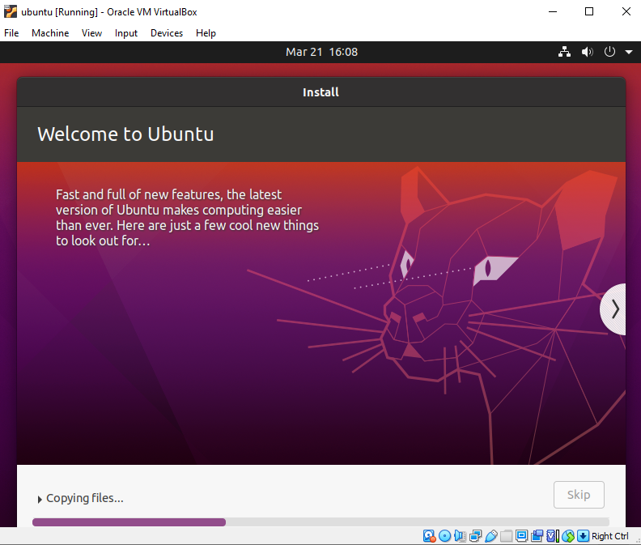

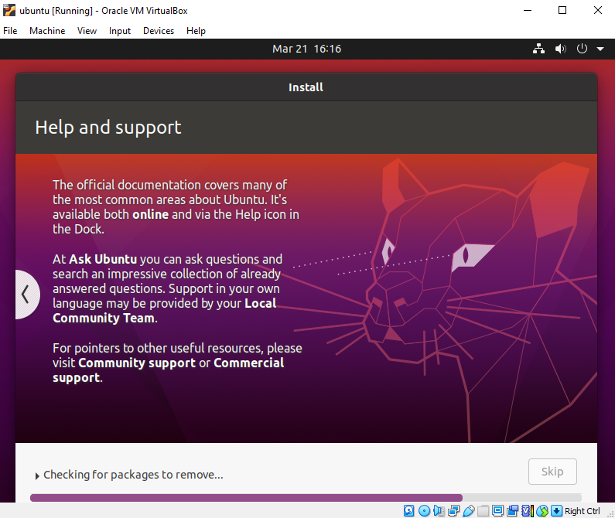

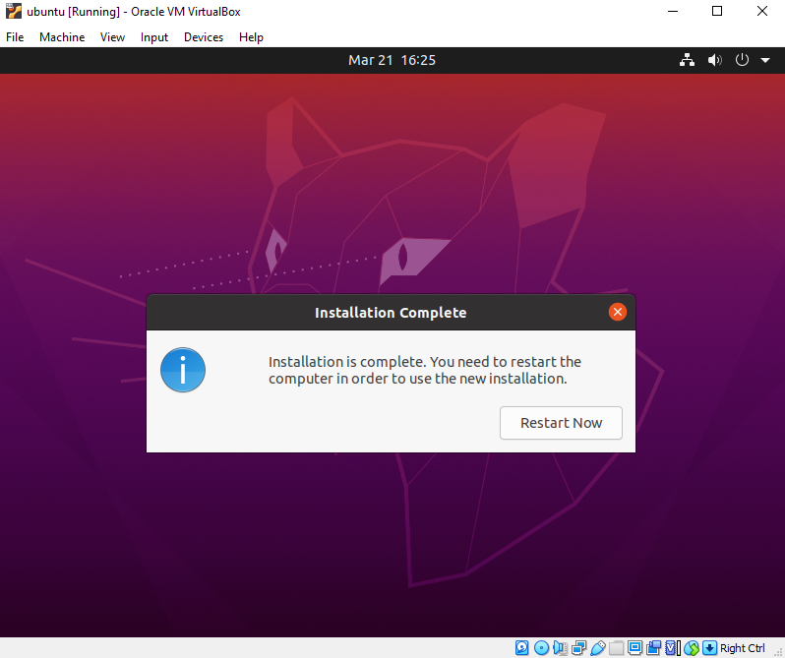

**Output Screenshot**

