**Name: Vineeth P**

**Roll No: 50**

**Batch: MCA B**

**Date:25-03-2022**

**NETWORKING & SYSTEM ADMINISTRATION LAB**

**Experiment No.: 3**

**Aim**

Familiarization of basic linux commands

**Procedure**

1.$ pwd

Shows the present working directory

**Syntax**: $pwd

**Output**:

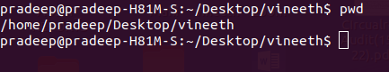

2.$mkdir

Make a directory

**Syntax:** $mkdir <directory_name>

**Output:**

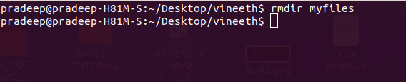

3.$ ls

List the contents of a directory , By default it display all the contents of present working directory.

**Syntax:** $ls

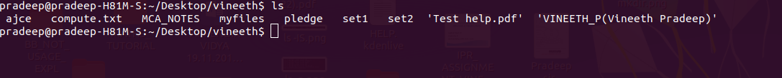

4.$ ls -l

Used for long listing. List all the files in sub-directories as well

**Syntax:** $ls -l

**Output:**

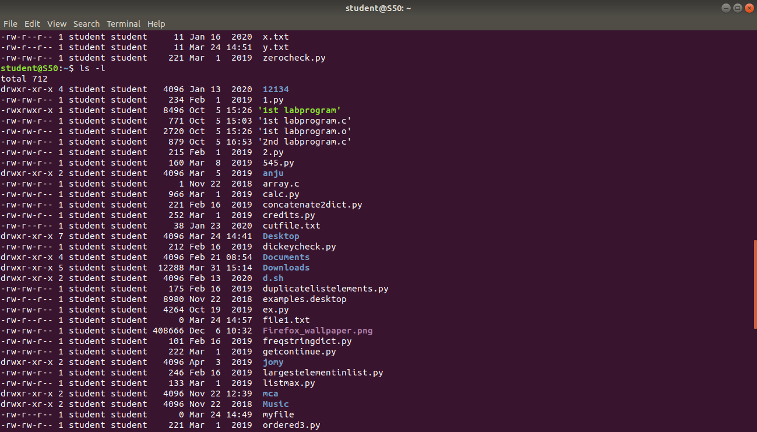

6.$ ls -F

List files and directories with ‘/’ character at the end

**Syntax:** $ls -F

**Output:**

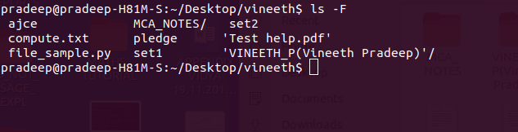

7.$ ls -r

List files in reverse order in linux

**Syntax:** $ls -r

**Output:**

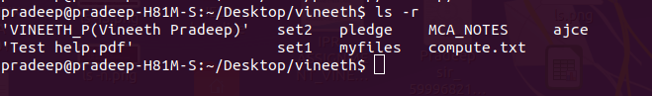

8.$ls -R

Recursively list sub-directories in linux

**Syntax:** $ls -R

**Output:**

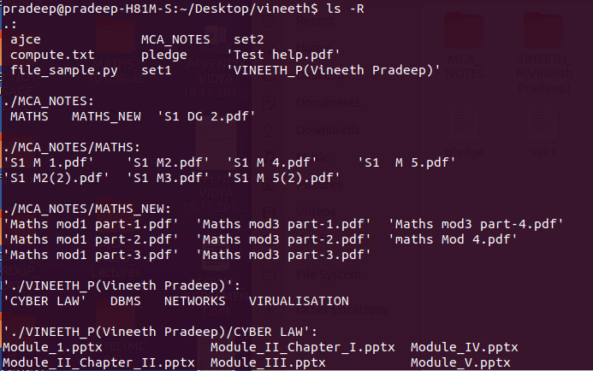

9.$ ls -ltr

List files and directories in reverse order in linux

**Syntax:** $ls -ltr

**Output:**

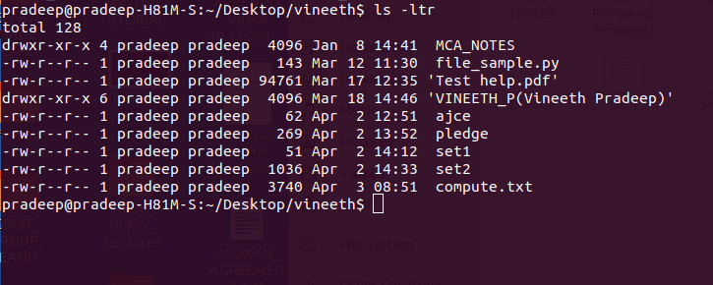

10.$ ls -lS

Sort files by file size in linux

**Syntax:** $ls -IS

**Output:**

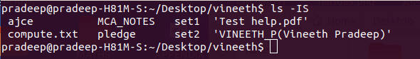

11.$ ls -i

Display inode number of file or directory

**Syntax:** $ls -i

**Output:**

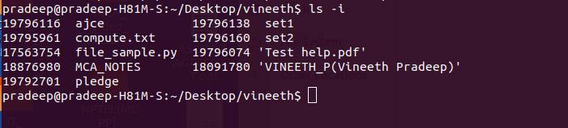

12.$ls -a

This command is used to display all files including hidden files.

**Syntax:** $ls -a

**Output:**

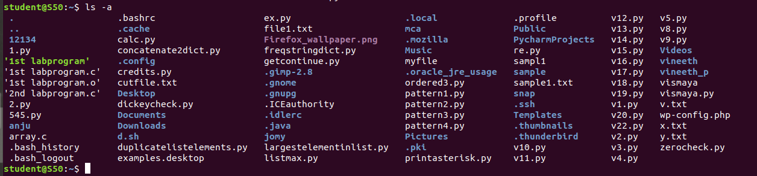

13. $ls -al

This command will list all the files and directories with detailed information like

Permission,size,owner etc.

**Syntax:** $ls -al

**Output:**

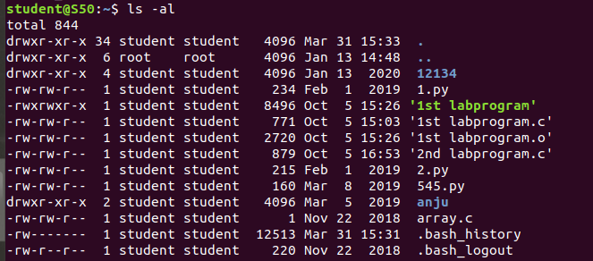

14. $ls -t

The command used to display the files sorted in the order of last modification

**Syntax:** $ls -t

**Output:**

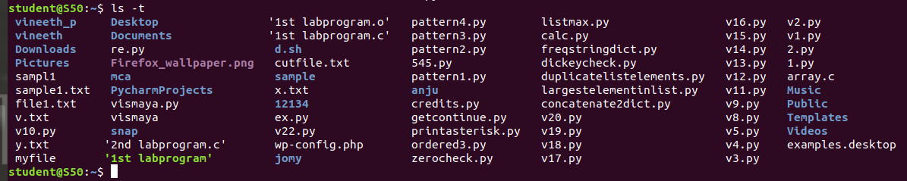

15.$ ls –version

Shows version of ls command

**Syntax:** $ls –version

**Output:**

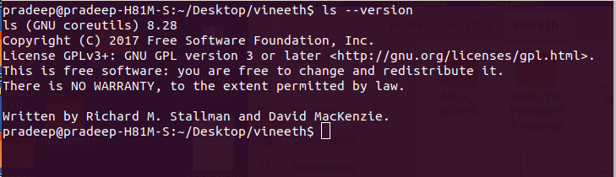

16.$ ls --help

Show ls command help page

**Syntax:** $ls –help

**Output:**

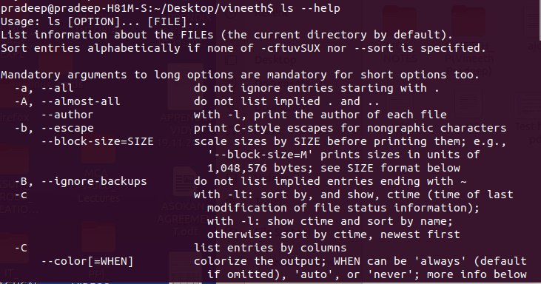

17.$ ls -l /tmp

List directory information in linux

**Syntax:** $ls -l /tmp

**Output:**

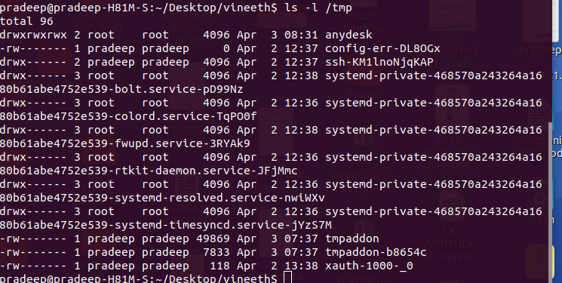

18.$ ls -n

Display UID and GID of files

**Syntax:** $ls -n

**Output:**

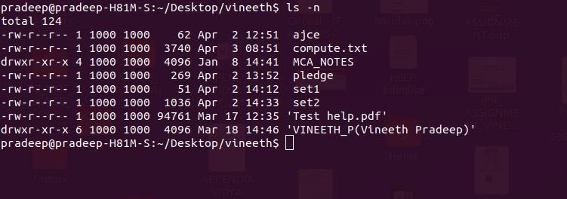

19.$ cd

Change directory

**Syntax:** $cd <path>

**Output:**

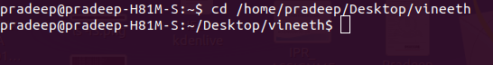

20.$ mkdir <foldername>

To make new directory

**Syntax:** $mkdir <directoryname>

**Output:**



18.$ touch <filename>

To create a file in a directory

**Syntax:** $touch <filename>

**Output:**



19.$ rm <filename>

To delete a file from the directory

**Syntax:** $rm <filename>

**Output:**



21. $cat > filename

This command is used to create a file and add contents to it if necessary

**Syntax:** $cat > filename

**Output:**

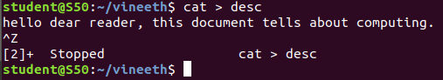

22. $cat >> filename

This command is used to add some contents to an already existing file

**Syntax:** $cat >> filename

**Output:**

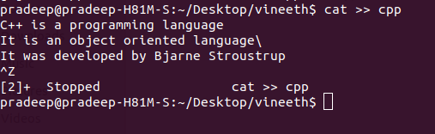

23. $cat filename1 > filename2

This command is used to copy the content of one file to another file

**Syntax:** $cat filename1 > filename2

**Output:**

