**Name: Vineeth P**

**Roll No: 50**

**Batch: MCA B**

**Date: 21-03-2022**

**NETWORKING & SYSTEM ADMINISTRATION LAB**

**Experiment No.: 4**

**Aim**

Familiarization of basic Linux commands part 2

**Procedure**

**1. cut -d ‘ ‘ f2**

This commands in Linux allows you to select the second part of the content that split by ‘ ‘ delimiter.

**Syntax:-** $ cut -d ‘ ‘ f2 filename.txt

**Output:-**

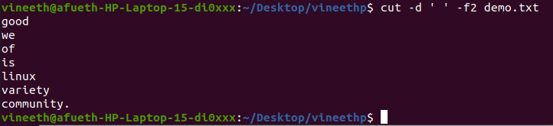

**2. cut -b 2**

This command in Linux allows to select only these bytes.

**Syntax:-** $ cut -b 2 filename

**Output:-**

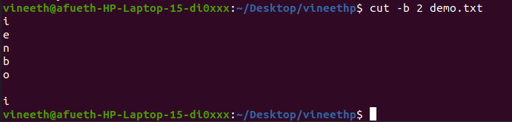

**3.** **cut –complement**

This command helps to exclude given bytes.

**Syntax:-** $ cut –complement -c 1 filename

**Output:-**

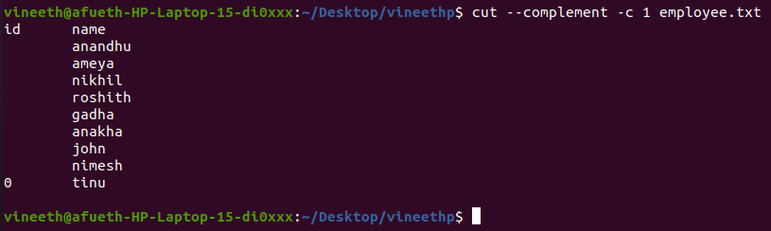

**4. paste**

This command helps to paste contents to other file

**Syntax:-** $ paste filename > filename2

**Output:-**

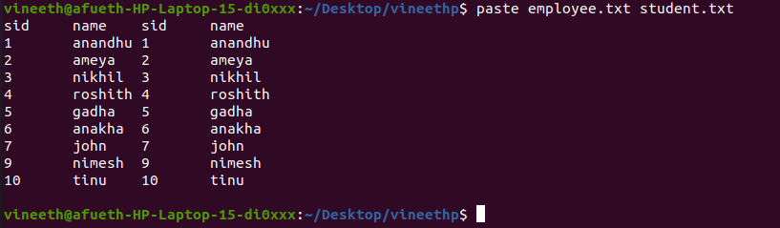

**5. paste a b > c**

This command helps to paste from multiple files.

**Syntax:-** $ paste file1 file2 > file3

**Output:-**  

**6. paste -d ‘ ‘**

This command helps to paste contents with ‘ ‘ delimiter.

**Syntax:-** $ paste -d ‘ ‘ file1 file 2 > file3

**Output:-**

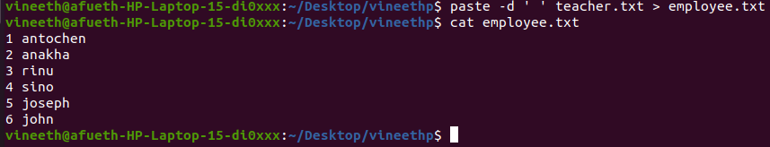

**7. paste -d ‘-‘**

This command helps to contents from multiple files with ‘-‘ delimiter.

**Syntax:-** $ paste -d ‘-‘ file1 file2 > file3

**Output:-**

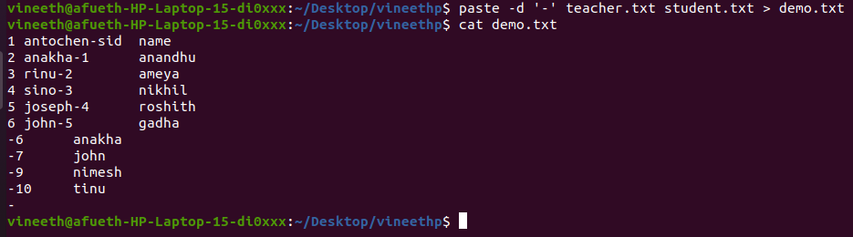

**8. paste -s**

This command helps to paste on file at a time instead of in parallel.

**Syntax:-** $ paste -s file1 file2 > file3.

**Output:-**



**9. more**

More command is used to view the text files in the command prompt, displaying one screen at a time in case the file is large.

**Syntax:-** $ more filename.

**Output:-**

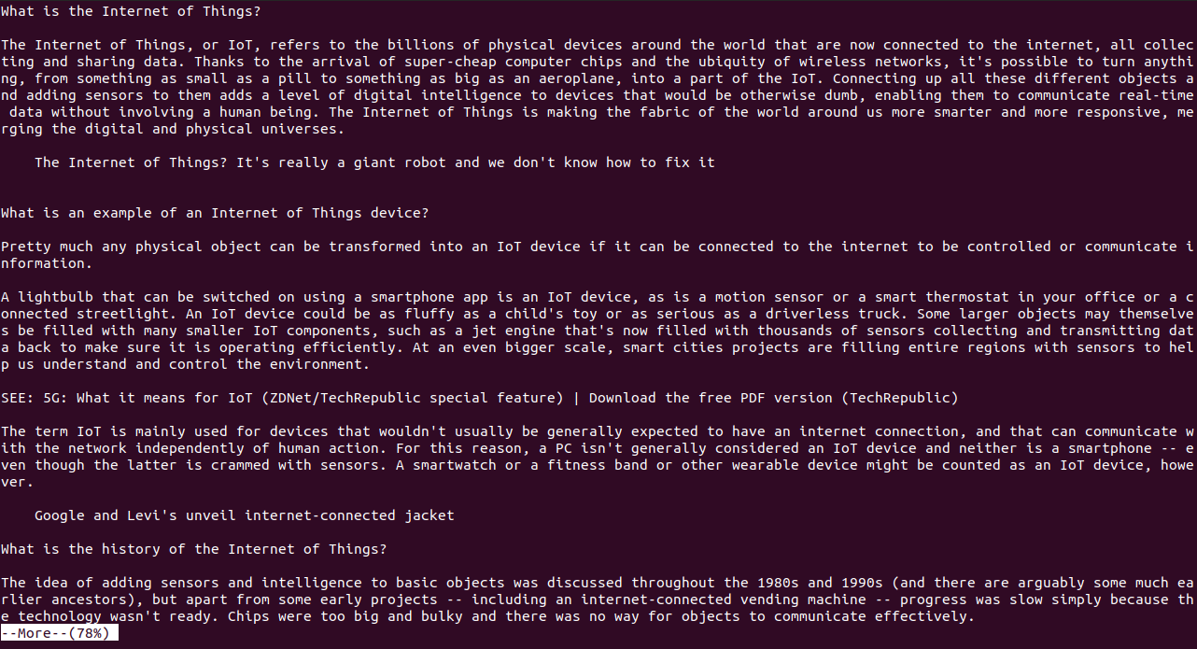

**10. more -s**

This command is used to squeeze multiple blank lines into one.

**Syntax:-** $ more -s filename.

**Output:-**

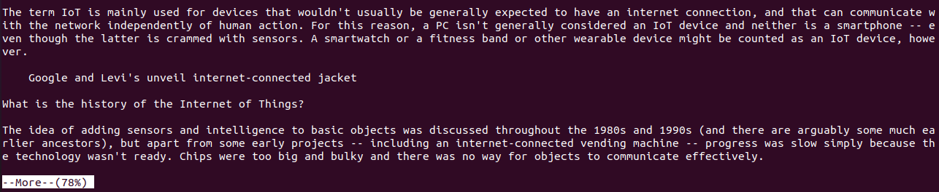

**11. more –(no.)**

This command helps to view content based on specified number of lines.

**Syntax:-** $ more -4 filename.

**Output:-**

