**Name: Vineeth P**

**Roll No: 50**

**Batch: MCA B**

**Date: 04-04-2022**

**NETWORKING & SYSTEM ADMINISTRATION LAB**

**Experiment No.: 5**

**Aim**

Familiarization of basic Linux commands part 3

**Procedure**

**1. cp**

This commands in Linux allows you to copy a file or an entire directory to another

Directory specified.

**Syntax:-** $ cp file_to_be_copied directory_name

**Output:-**

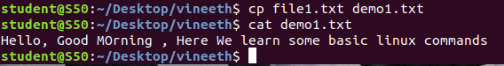

**2. cp –r**

This command in Linux allow us to copy an entire directory into another directory

**Syntax:-** $ cp –r source_directory destination_directory

**Output:-**

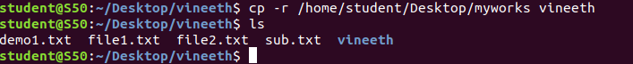

**3.** **cp - i**

This command helps to make a decision regarding overwrite that may happen in case of copying a same named file (but different in content) from the source folder to the destination folder.

**Syntax:-** $ cp - i filename destination_folder

**Output:-**

C:\Users\Student\Desktop\screenshots\3(i).png

C:\Users\Student\Desktop\screenshots\3(2).png

**4. mv**

This command will move a specific file or directory to another directory

**Syntax:-** $ mv file_name/directory_name destination_directory

**Output:-**

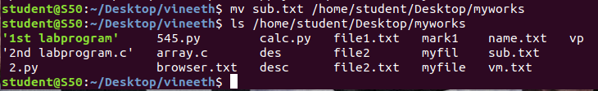

**5. mv -i**

This command enables a dialog to take a wise decision about overwrite in case of moving

A file with the same name as that of one already exist in the destination directory.

**Syntax:-** $ mv - i filename destination_path

**Output:-**

**C:\Users\Student\Desktop\screenshots\5(1).png**

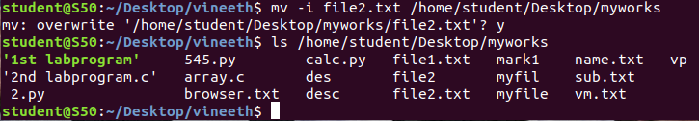

**6. touch filename**

touch command is used to create a new blank file.

**Syntax:** $ touch filename

**Output:-**

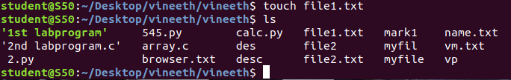

**7. echo content**

The echo command will append a content from the console to a specified text file

**Syntax:** $ echo content >> filename

**Output:-**

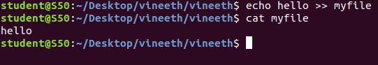

**8. head filename**

The command which display first 10 lines of a specified file by default.

**Syntax:** $ head filename

**Ouput:-**

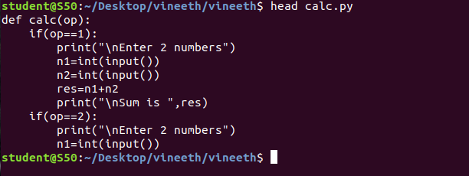

**9. head –n filename**

The command which display specified number of lines from the beginning of

a specified file.

**Syntax:** $head –n filename

**Output:-**

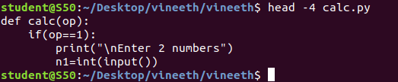

**9. tail**

The command which prints last 10 lines of a specified file

**Syntax:** $ tail filename

**Output:-**

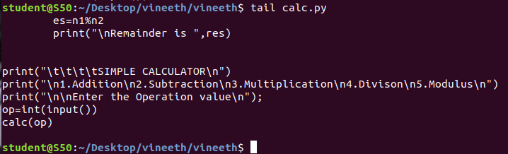

**10. tail –n filename**

The command which display the specified number of lines residing at the end of

a file.

**Syntax:** $ tail –n filename

**Output:-**

