

**NETWORKING & SYSTEM ADMINISTRATION LAB**

**Experiment No.: 6**

**Aim**

Familiarization of basic Linux commands part 4

**Procedure**

**1. read**

This commands in Linux allows you to store a string in a variable

**Syntax:-** $ read variable_name content

**Output:-**

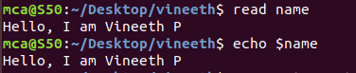

**2. locate**

This command in Linux allow us to locate a specific file from anywhere in the system.

**Syntax:-** $ locate filename

**Output:-**

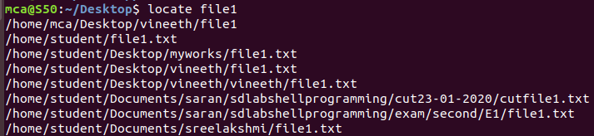

**3.** **locate –i**

This command helps to make a case insensitive search for a file in the system

**Syntax:-** $ locate –i filename

**Output:-**



**4. find**

This command is used to search for a file that locates within the present working directory.

**Syntax:-** $ find filename

**Output:-**

C:\Users\Student\Desktop\exp6\screenshots\find.png

**5. wc –l**

This command enables us to print the number of lines contains in a file

**Syntax:-** $ wc –l filename

**Output:-**

**C:\Users\Student\Desktop\exp6\screenshots\wc -l.png**

**6. wc –w**

This command enables us to print the number of words in a file

**Syntax:-** $ wc –w filename

**Output:-**

**C:\Users\Student\Desktop\exp6\screenshots\wc -w.png**

**7. wc –c**

This command enables us to print the number of characters containing in a file.

**Syntax:-** $ wc –c filename

**Output:-**

**C:\Users\Student\Desktop\exp6\screenshots\wc -c.png**

**8. wc –m**

This command enables us to print the number of bytes occupied by a file,

**Syntax:-** $ wc –m filename

**Output:-**

**C:\Users\Student\Desktop\exp6\screenshots\wc -m.png**

**9. grep**

This command will let you search for a specific word or string in particular text file

**Syntax:-** $ grep word filename

**Output:-**



**10. grep -i**

The command used for case insensitive search for a word contains in a file

**Syntax:-** $ grep –i word filename

**Output:-**



**11. grep –v**

This command enables us to print all the lines in a file that doesn’t contain the specified

Word.

**Syntax:-** $ grep –v word filename

**Output:-**

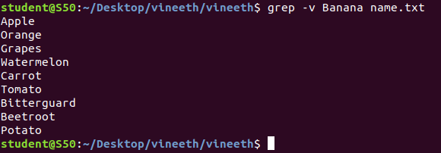

**12. grep –A**

This command enables us to print two lines including the first line have the first occurrence of searched word (after the result)

**Syntax:-** $ grep –A1 word filename

**Output:-**

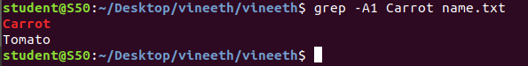

**13. grep –B1**

This command enables us to print the lines including one which holds searched word from the position before it. (before the result)

**Syntax:-** $ grep –B1 word filename

**Output:-**

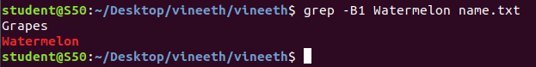

**14. grep –C1**

This command enables us to print one line before and one line after the line including

Itself containing the specified word.(before and after)

**Syntax:-** $ grep –C1 word filename

**Output:-**

