**Name: Vineeth P**

**Roll No: 50**

**Batch: MCA B**

**Date: 05-05-2022**

**NETWORKING & SYSTEM ADMINISTRATION LAB**

**Experiment No.: 8**

**Aim**

program to display the details of a student using shell script

**Procedure**

echo "enter your name"

read name

echo "enter your phone no"

read phno

echo "enter your age"

read age

echo "enter your course"

read course

echo "enter your address"

read address

echo "NAME : ".$name

echo "PHONE: ".$phno

echo "ADDRESS: ".$address

echo "AGE : ".$age

echo "COURSE: ".$course

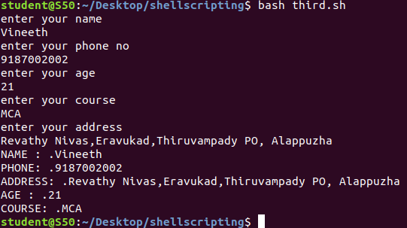**Output:**