[Cloudera Manager Documentation](http://www.cloudera.com/documentation/enterprise/latest.html) provides the following instruction for each node in a soon-to-be cluster:

* Disable Selinux
* Setup NTP
* Disable firewall
* Define host names

Disable Selinux

* Run the following in the command line:
  + sudo sed -i 's/^\(SELINUX\s*=\s*\).*$/\1disabled/' /etc/selinux/config
* This command modifies Selinux's config file disabling Selinux service.

Setup NTP

* NTP service is required to keep system clock on each server synchronized with global time and with each other. Do the following to setup it:
  + sudo yum -y install ntp
  + sudo chkconfig ntpd on
  + sudo service ntpd start
  + sudo hwclock –systohc

Disable Firewall

* + sudo service iptables stop
  + sudo service ip6tables stop
  + sudo chkconfig iptables off

VM swappiness

* Set vm swapinees to 10
* vi /proc/sys/vm/swappiness and set the value to 10

Define host names

Edit /etc/hosts

* The /etc/hosts file should have the following inside it:

127.0.0.1 localhost  
10.211.55.101 cloudera-1  
10.211.55.102 cloudera-2  
10.211.55.103 cloudera-3  
10.211.55.104 cloudera-4

Install Mysql Server

* + yum -y install mysql-server mysql
  + chkconfig mysqld on
  + service mysqld start
* Download mysql connector and extract it and copy to the below location
  + wget <https://cdn.mysql.com//Downloads/Connector-J/mysql-connector-java-5.1.44.tar.gz>
  + tar zxvf mysql-connector-java-5.1.44.tar.gz
  + cp mysql-connector-java-5.1.44/mysql-connector-java-5.1.44-bin.jar /usr/share/java/mysql-connector-java.jar
  + mysql -u root -e "create database scm" mysql
  + mysql -u root -e "grant all on *.* to 'scm'@'%' identified by 'scm' with grant option;" mysql

Install Cloudera Manager

Setup Cloudera repository:

* wget -O /etc/yum.repos.d/cloudera-manager.repo <http://archive.cloudera.com/cm5/redhat/6/x86_64/cm/cloudera-manager.repo>
* yum -y update

Install packages:

* yum -y install oracle-j2sdk1.7 cloudera-manager-server cloudera-manager-daemons
* yum -y install mysql-connector-java

Prepare Cloudera Manager Database:

* vi /etc/cloudera-scm-server/db.properties  and make the necessary changes

# The database host

# If a non standard port is needed, use 'hostname:port'

com.cloudera.cmf.db.host=

# The database name

com.cloudera.cmf.db.name=

# The database user

com.cloudera.cmf.db.user=

# The database user's password

com.cloudera.cmf.db.password=

# The db setup type

# By default, it is set to INIT

# If scm-server uses Embedded DB then it is set to EMBEDDED

# If scm-server uses External DB then it is set to EXTERNAL

com.cloudera.cmf.db.setupType=EXTERNAL

Start Cloudera Manager server:

* service cloudera-scm-server star

Install Cloudera Manager Agents and CDH

* Go to [http://cloudera-1:7180](http://cloudera-1:7180/)
* This is Cloudera Manager login page. Use admin/admin as login/password

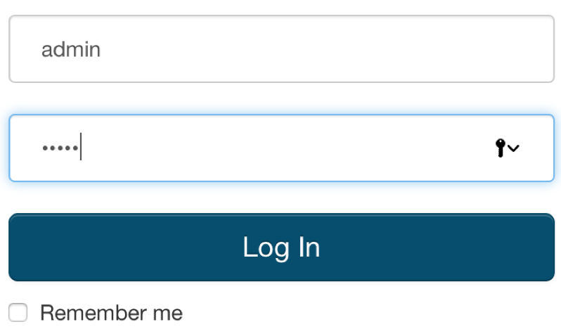

* Then read and accept the license agreement and choose "Cloudera Enterprise Data Hub Edition Trial" on the next page.
* After that you'll be offered to setup a new cluster. Use the following pattern to search all the nodes for the new cluster:
* cloudera-[1-4]
* That will find all 4 servers we have prepared before.

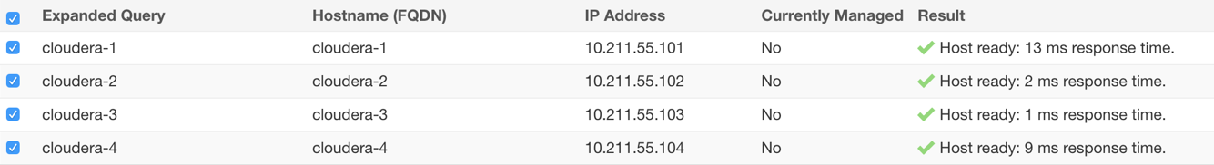

* Select all of them and press "Continue" button. Accept the default CDH repository settings. "Continue". Accept installing Java:



* Do not choose the single user mode. Just press "Continue".
* Provide Cloudera Manager with a root password for all the servers. If you have used Vagrant approach for servers preparation the password is "vagrant". If you prepared your servers manually, use the password you created:

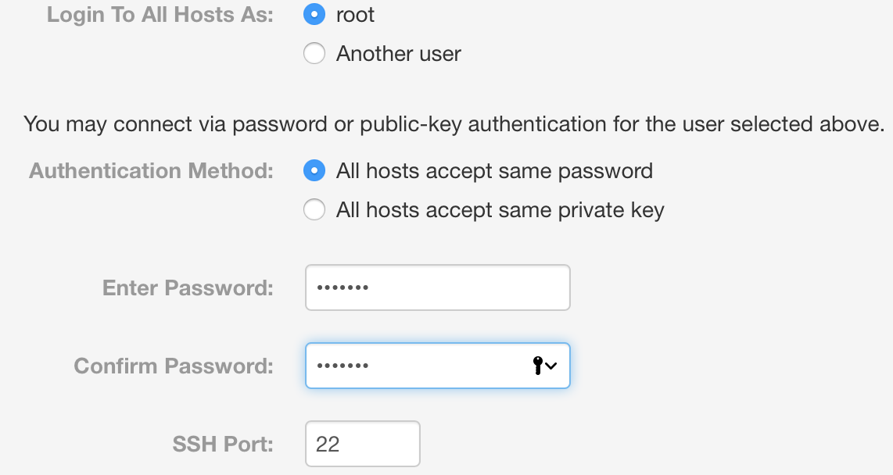

Then just wait for Cloudera Manager to finish agents and CDH installation.

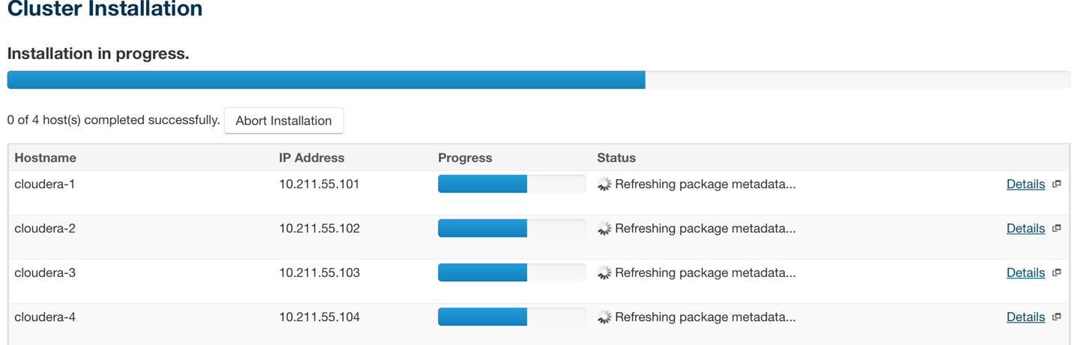

* Press "Continue" and wait for distribution and activation.



* Press "Continue" and wait for Cluster Inspector to finish the inspection.

Install Hadoop cluster

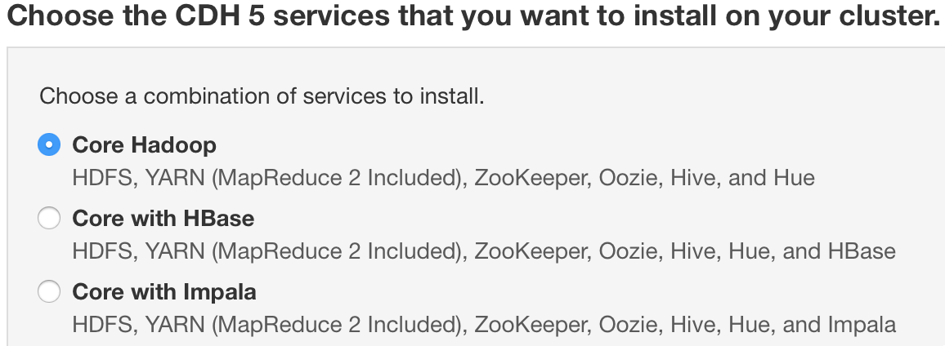

* On the next page choose Core Hadoop installation.
* Then you can choose the cluster roles distribution across the cluster. Accept the default options.

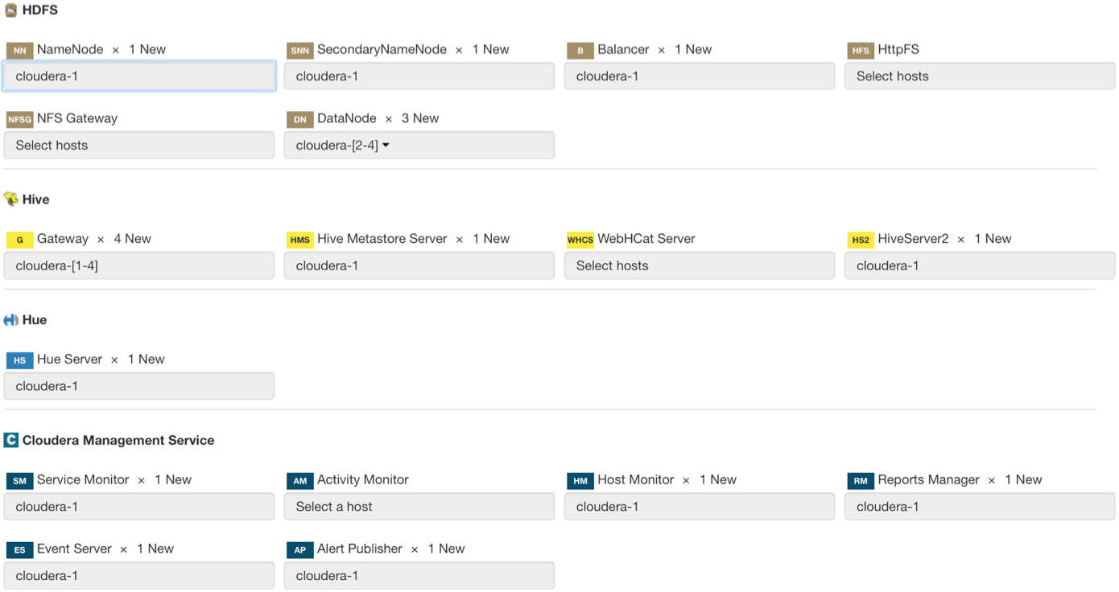

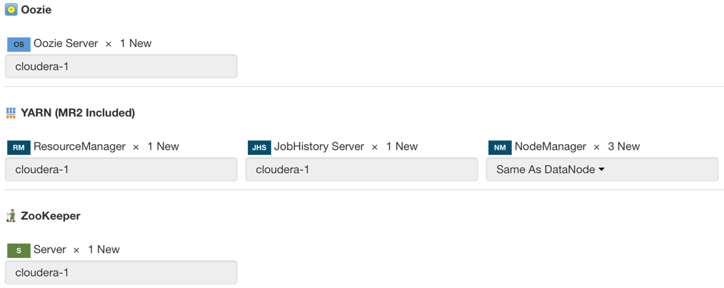

* Then you have to define SQL server for the services. If you have used Vagrant for server preparation use the following parameters:
  + Host Name: cloudera-1
  + Database Type: MySQL
  + Database Name: scm
  + Username: scm
  + Password: scm
* In case you prepared SQL server manually use your own parameters.

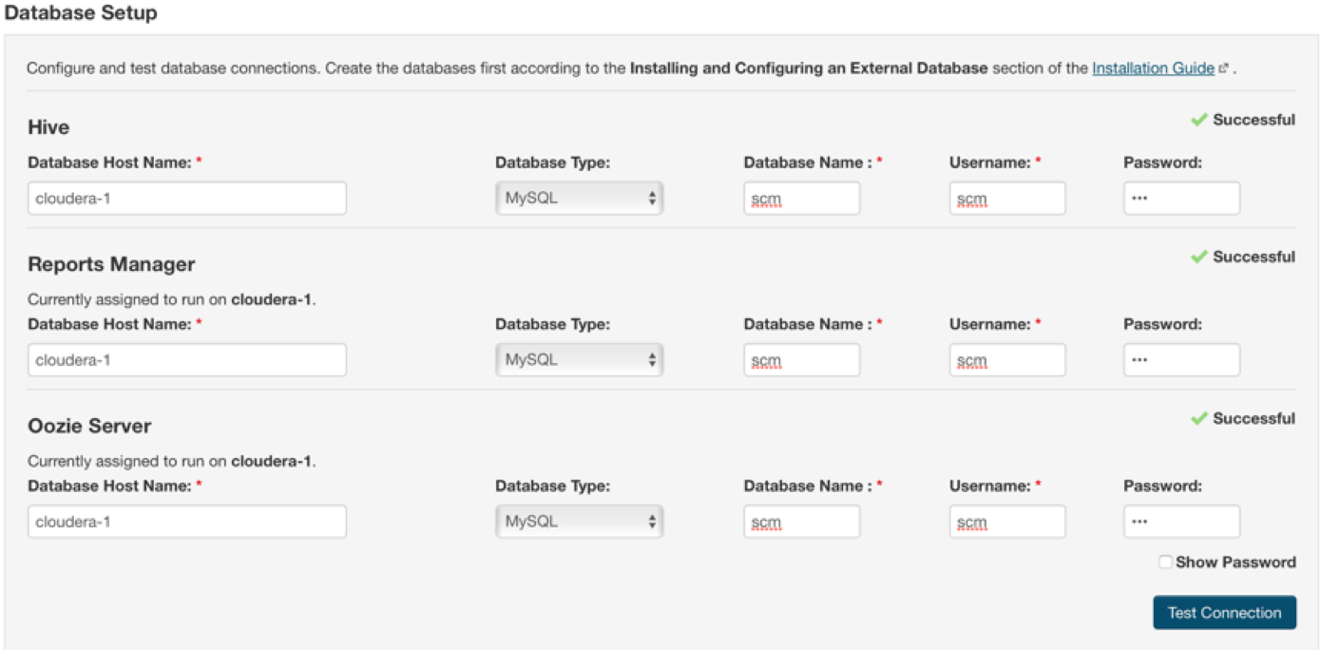

* Press "Continue".
* On the page with changes review accept the default settings and press "Continue".
* Wait for the Cloudera Manager to setup the cluster roles.