Inequity in distributed energy resource adoption is technology-specific, not uniform
Danielle Knutson¹, Vineet Jagadeesan Nair¹*, and Anuradha Annaswamy
¹Massachusetts Institute of Technology, Cambridge, MA, USA
Corresponding author: jvineet9@mit.edu

Abstract
Distributed energy resources are central to decarbonization, resilience, and electrification, but their benefits may be unevenly shared. Evidence of racial disparity in adoption comes almost entirely from rooftop solar and is often assumed to generalize. We test this across 1,390 California ZIP Code Tabulation Areas, comparing rooftop photovoltaics, battery storage, and electric-vehicle charging under common outcomes and controls. The technologies do not share a disparity pattern. Areas with larger Black and Asian population shares hold less solar and less storage net of income and poverty; local housing type and tenure explain a quarter to a half of those gaps. Storage gaps persist most: Black- and Asian-share gaps survive the strictest specification, versus only Asian share for solar and none for charging. Public charger counts are, if anything, higher in poorer areas, but measure infrastructure, not household access. Equity planning must be technology-specific and track usable access, not deployment counts.
As electricity systems decarbonize, distributed energy resources (DERs) are becoming central to emissions reduction, local resilience and electrification. Policy debate often treats them as a single category, but they deliver different benefits. Rooftop photovoltaics (PV) reduce bills for the household that hosts them. Battery storage delivers backup power and outage protection, which matter most where wildfire shutoffs and grid stress are common. Charging infrastructure determines who can take part in transport electrification, but only if it sits where people live and park. The clean energy transition is therefore not only a deployment problem but a distributional one: where access depends on financing, housing conditions, siting decisions, permitting, interconnection or neighborhood infrastructure, the transition can reproduce existing inequities rather than reduce them.
Evidence that the transition does so comes almost entirely from rooftop solar. Lukanov and Krieger show that California PV deployment is patterned by neighborhood socioeconomic conditions [1], and Sunter, Castellanos and Kammen show that racial and ethnic disparities in rooftop PV persist after accounting for income [2]. Kurdgelashvili and colleagues model county-level adoption in the same state [3], while Reames and Darghouth et al. document uneven rooftop access across communities and Sigrist et al. argue that inequitable siting reduces the carbon value of residential solar [4][5][6]. A parallel literature explains why race should be modeled explicitly rather than assumed away: race-linked inequities in energy burden persist net of income [7], transition planning cannot be treated as race-neutral when the underlying burdens are not [8], and structural barriers limit participation in California's DER programs even where they are designed for low-income households [9]. Because rooftop solar measurably reduces energy burden for low- and moderate-income adopters [10], unequal access to DERs also means unequal access to bill relief and resilience.
What this literature does not establish is whether inequity in DER adoption is a solar-specific phenomenon or a general feature of the transition. The distinction matters because the barriers differ. Rooftop PV depends on roof control, housing tenure, financing and installer availability. Storage overlaps with PV but adds stronger dependence on upfront capital, resilience value and program design; it has been framed as an equity asset that can either broaden resilience or entrench advantage depending on ownership [11][12]. Charging depends far more on siting, commercial activity and host context. Adoption is also gated by the grid itself: hosting-capacity constraints in California are socially patterned and limit deployment in disadvantaged communities [13], a problem that fairness-aware allocation schemes are only beginning to address [14], and that interconnection roadmaps identify as a national bottleneck [15]. A community adopting solar at the state average may still lack the storage that protects it during an outage, or the charging that lets its residents switch vehicles. Collapsing all three into one undifferentiated measure of “DER access” can hide exactly these offsetting patterns.
Three gaps follow. First, the evidence base for racial disparity net of income is solar-only, so we do not know whether inequity is a property of solar adoption or of the transition. Second, work that looks beyond PV treats each technology in isolation, under different data, geographies and specifications, which prevents direct comparison. Third, no harmonized, race-inclusive, multi-technology dataset exists at fine spatial granularity for a single high-penetration market, because DER data are fragmented across technologies and agencies [16][17].
This paper addresses all three. We assemble a California ZIP Code Tabulation Area (ZCTA) dataset integrating rooftop PV, battery storage and EV charging with American Community Survey demographics, climate and resource data, utility territory and electricity demand, and estimate one consistent set of specifications across all three, retaining race in every model rather than assuming socioeconomic controls absorb it. California is an informative case because it combines high DER penetration, ambitious climate policy, substantial socioeconomic diversity and pronounced spatial inequality. The study is area-level and cross-sectional; we report conditional associations, not causal effects. We find that the form of inequity changes by technology: storage shows the most persistent racial and ethnic gaps, independent of solar adoption; solar gaps are partly explained by the local housing stock; and for charging, the standard metric — the count of installed public units — does not measure what equity policy assumes it measures.

Results

Each technology shows a different disparity pattern
Racial and socioeconomic disparities are not uniform across technologies. Deployment of all three is spatially uneven before any adjustment (Fig. 1). In the baseline specification (Table 1), rooftop photovoltaics and battery storage are both lower in ZCTAs with larger shares of Black and Asian residents after conditioning on income and poverty; storage is also lower where Hispanic share is higher, whereas solar is higher. EV charging departs from both: charger deployment is negatively associated with Hispanic share and positively associated with poverty rate. Coefficients reported throughout use standardized predictors, so a coefficient is the change in the log(1 + rate) outcome associated with a one-standard-deviation change in the predictor; one standard deviation is 6.4 percentage points for Black share, 23.9 for Hispanic share and 14.1 for Asian share, and a coefficient near −0.10 corresponds to roughly a 10 percent lower deployment rate (Supplementary Table S3).
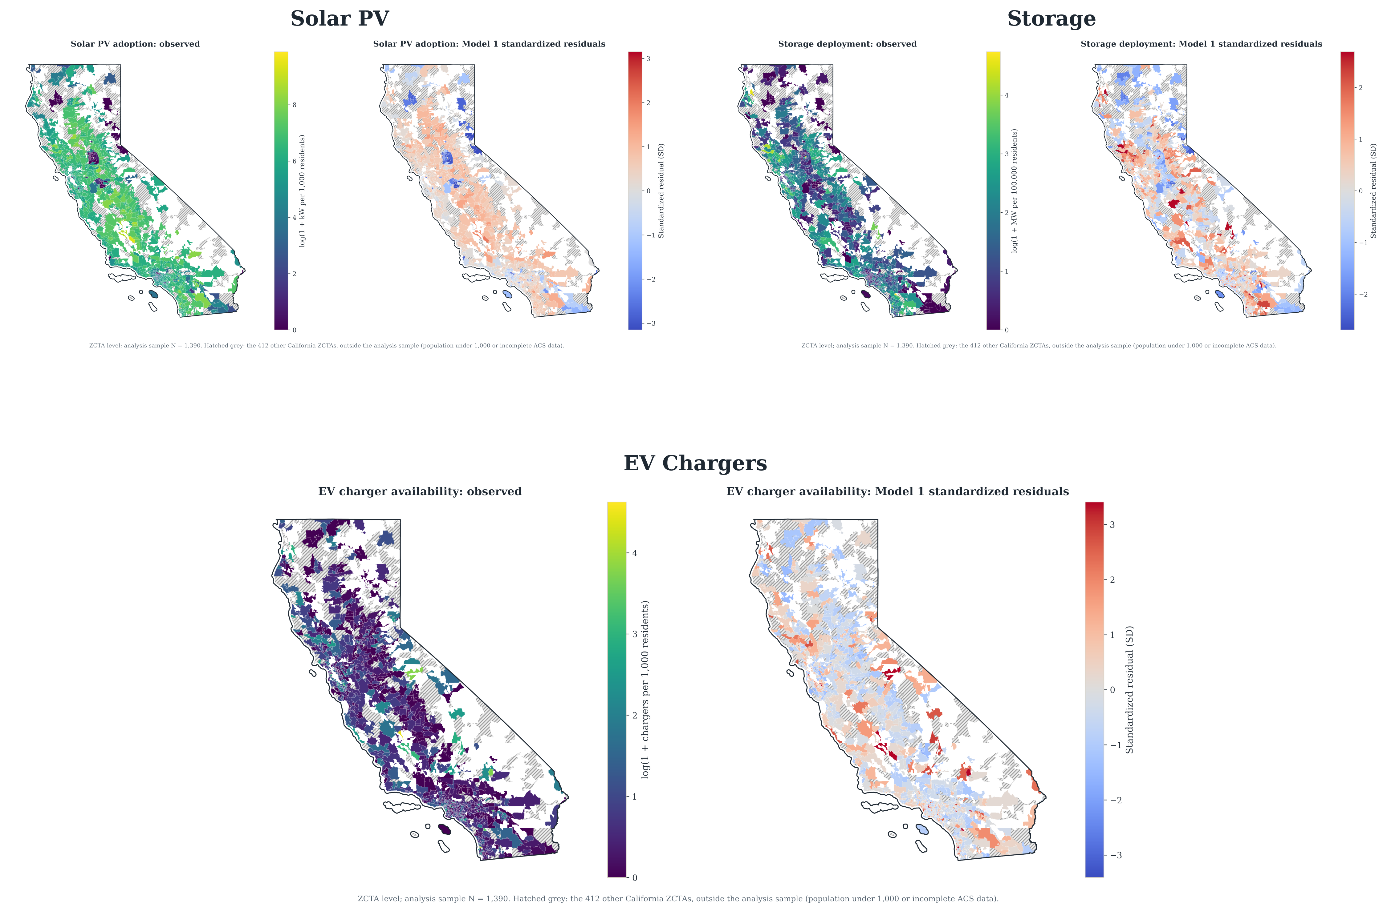
Fig. 1 | Distributed energy deployment across California ZIP Code Tabulation Areas. Observed deployment intensity (left of each pair) and baseline (Model 1) standardized residuals (right) for rooftop photovoltaics, battery storage and aggregate EV charging; N = 1,390 ZCTAs. Observed values are log(1 + rate): kW of PV per 1,000 residents, MW of storage per 100,000 residents and public chargers per 1,000 residents. Hatched grey areas are outside the analysis sample (population under 1,000 or incomplete ACS data).
Table 1 | Baseline associations between neighborhood composition and distributed energy deployment. Standardized predictors; heteroskedasticity-robust (HC1) standard errors in parentheses. Full coefficient tables for every specification in the model series are in Supplementary Note S1. *p < 0.05, **p < 0.01, ***p < 0.001.
Predictor | Rooftop PV | Battery storage | EV charging
Log median household income | 0.439*** (0.084) | 0.390*** (0.042) | 0.070 (0.039)
Black share | −0.219*** (0.047) | −0.120*** (0.018) | 0.001 (0.022)
Hispanic share | 0.220*** (0.059) | −0.215*** (0.027) | −0.091*** (0.025)
Asian share | −0.298*** (0.043) | −0.246*** (0.021) | 0.059** (0.021)
Poverty rate | −0.042 (0.081) | −0.008 (0.035) | 0.150*** (0.037)
Resource / climate control | GHI 0.102* (0.044) | CDD −0.022 (0.026); HDD −0.033 (0.031) | CDD −0.120*** (0.022); HDD −0.014 (0.029)
N | 1,390 | 1,390 | 1,390
R² | 0.074 | 0.322 | 0.080
Fig. 2 traces the five focal coefficients across the model series, in which each specification adds or substitutes one control block against a fixed core. The storage coefficients are the most stable: race and ethnicity shares stay negative and separated from zero across every specification. The solar coefficients move more, particularly where county fixed effects or housing controls enter. The charging coefficients behave differently again: poverty rate stays positive throughout, the Black- and Hispanic-share terms cross zero, and the Asian-share term falls to zero once housing structure and tenure enter (Fig. 3). Whatever is producing inequity is not one mechanism operating at three intensities.
Baseline explanatory power is modest, from 0.07 to 0.32 across the three outcomes. The objective is coefficient stability under conditioning rather than prediction, and area-level cross-sections of this kind carry substantial local heterogeneity that no set of ZCTA-level covariates absorbs. As controls accumulate, R² rises to 0.49 for solar, 0.53 for storage and 0.27 for charging (Supplementary Table S5).
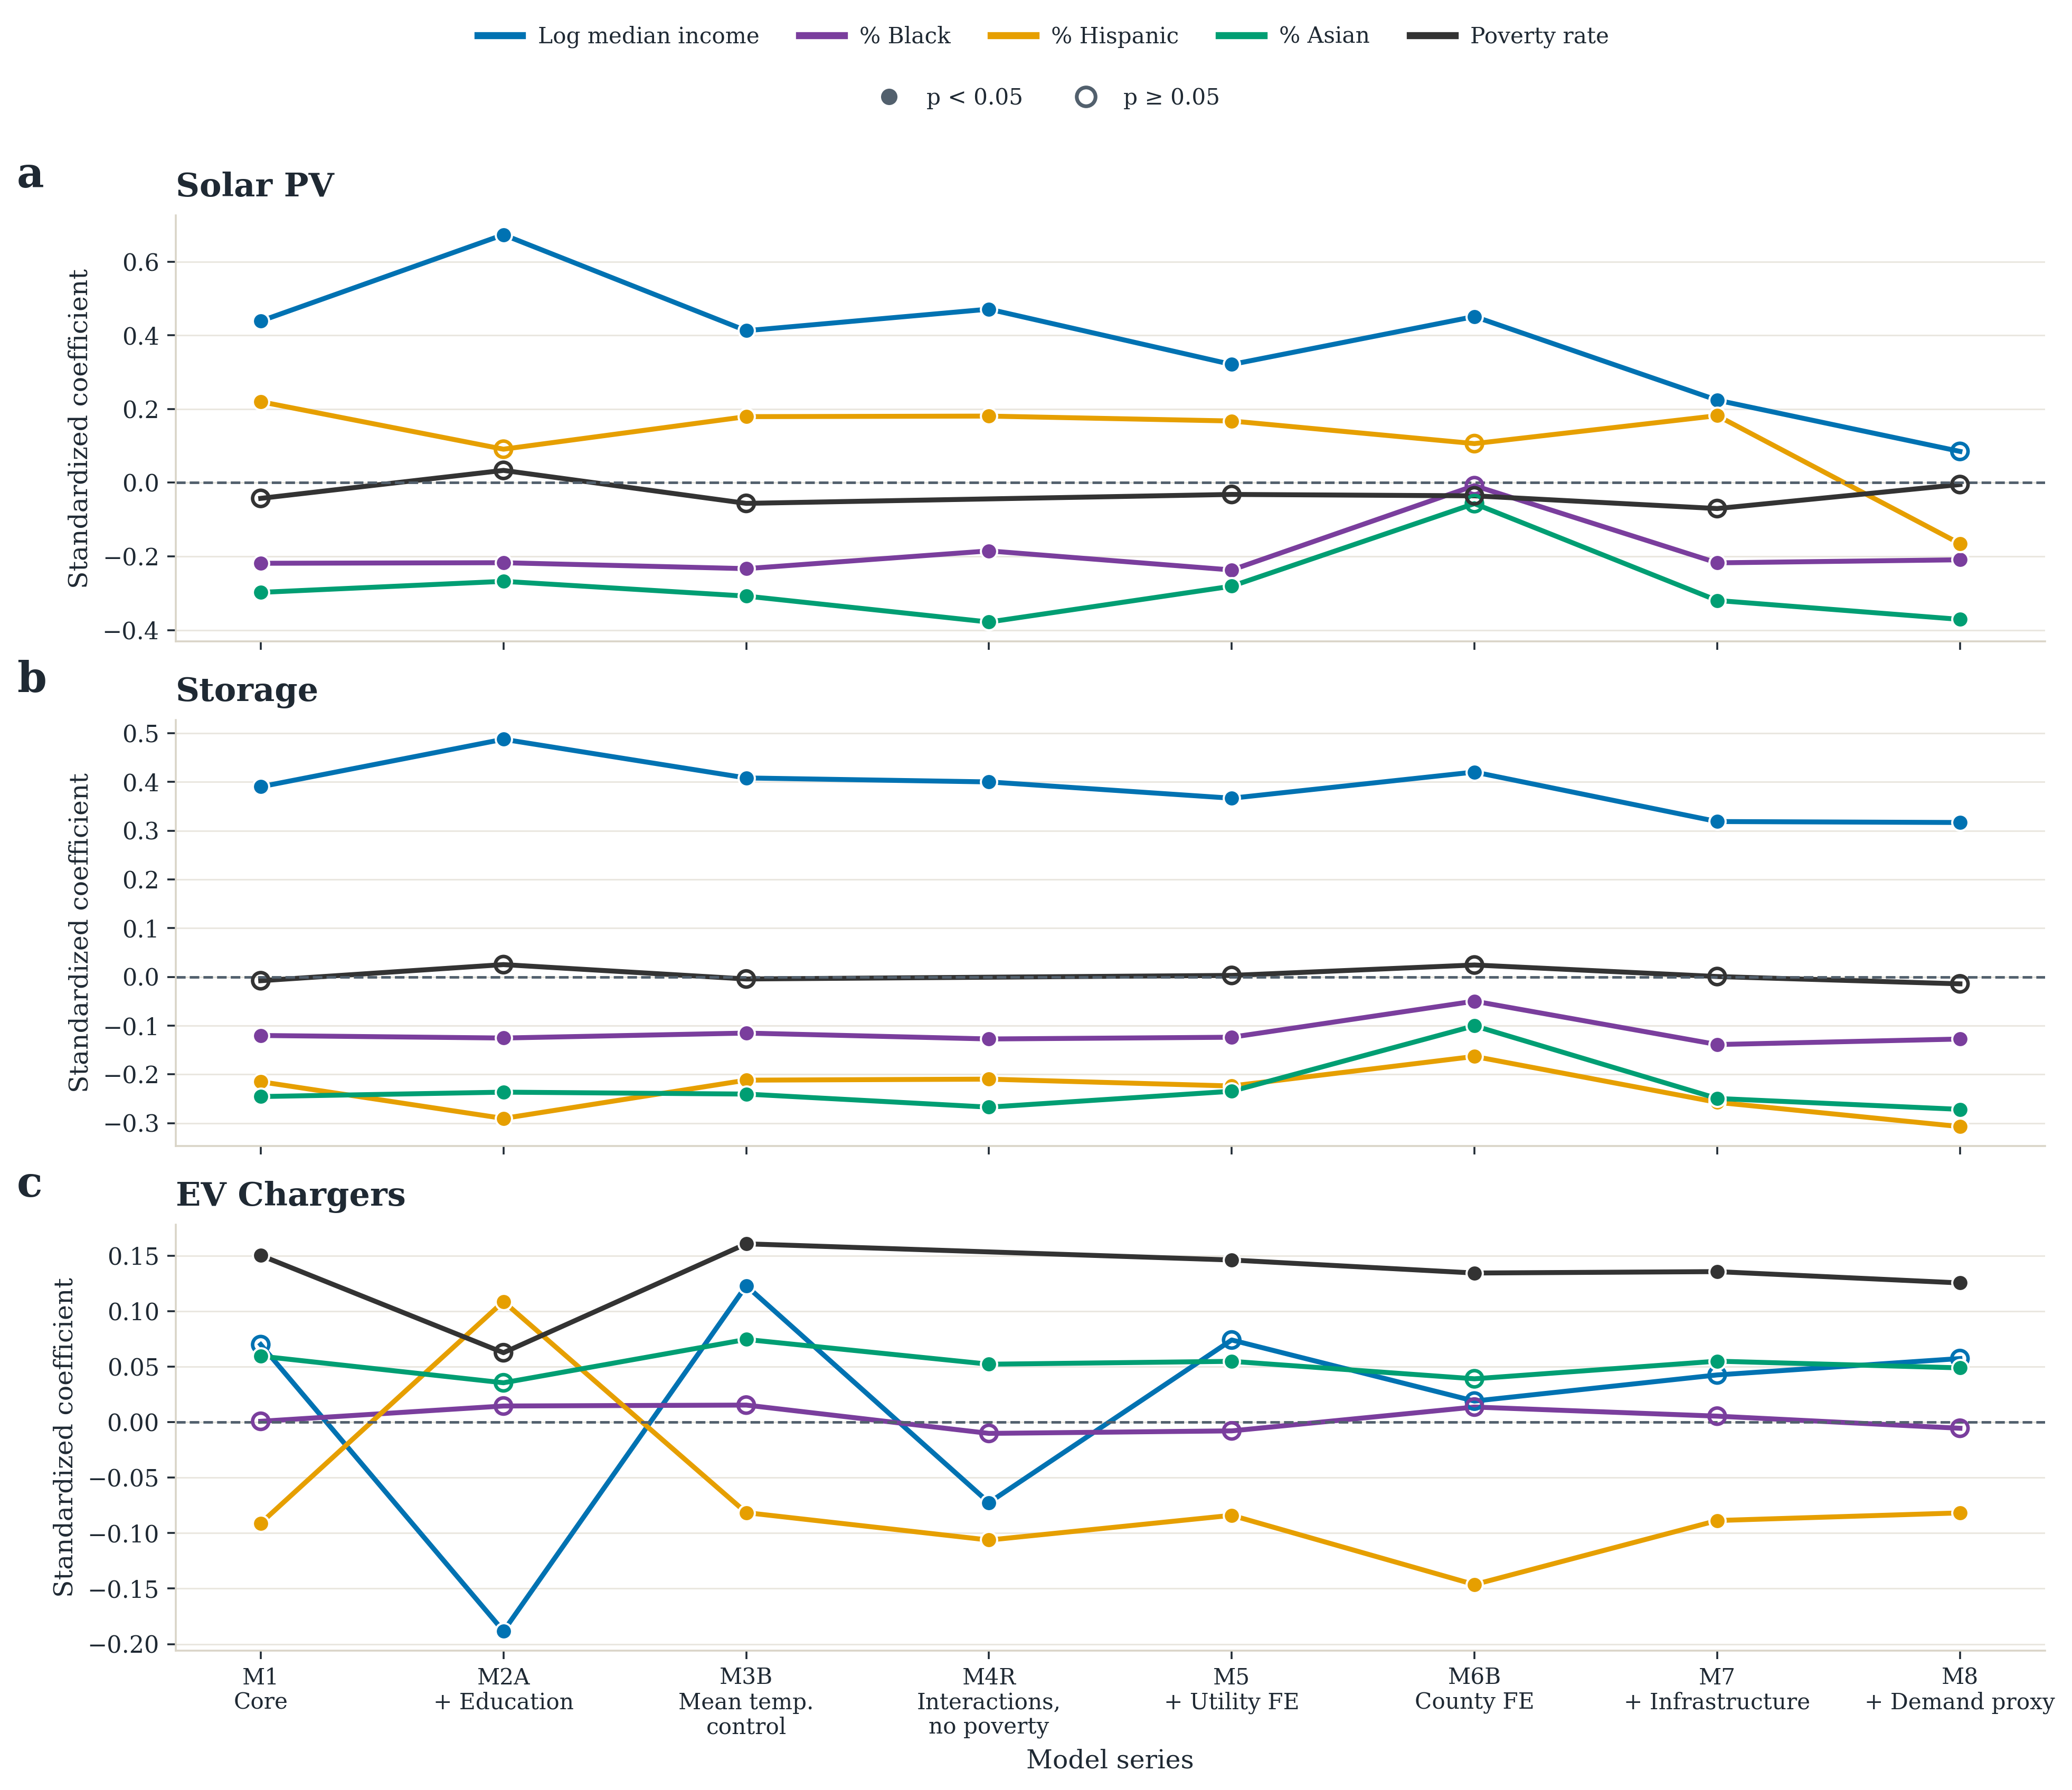
Fig. 2 | Only the storage disparities hold across every specification. Focal coefficients across the model series for rooftop solar (a), battery storage (b) and aggregate EV charging (c); standardized predictors. Each specification adds or substitutes one control block against a fixed core of income, race and ethnicity shares, poverty rate and the outcome-specific resource control; specifications are siblings rather than nested rungs. Tick labels give the variant drawn, as defined in Supplementary Table S1; poverty rate is omitted in M4R. Filled markers denote p < 0.05, hollow p ≥ 0.05. The storage race and ethnicity coefficients (b) stay clear of zero throughout; the solar Hispanic-share coefficient and the charging Black- and Hispanic-share coefficients cross it.

Storage disparities are the most persistent
Storage carries the most persistent disparity pattern in the study. In the baseline, income is strongly positive while Black, Hispanic and Asian shares are all negative and precisely estimated. What sets storage apart is not the size of these coefficients but their stability: the pattern does not depend on any single control block. It survives educational attainment, housing value, housing structure and tenure, utility and county fixed effects, county clustering, infrastructure context and the electricity-demand proxy, and every race and ethnicity coefficient in Fig. 2b stays clear of zero (confidence bands in Supplementary Fig. S2). Housing composition attenuates the Black- and Asian-share coefficients but leaves all three negative and significant (Fig. 3).
The pattern also holds across the other robustness families, with one exception. Under Conley spatially robust standard errors all three race coefficients hold at the 0.1 percent level at every distance cutoff. Across all 48 valid combinations of the six confounder blocks, the Asian- and Hispanic-share coefficients are significant and same-signed in all 48, and Black share in 36 — the highest counts for any deployment outcome. The exception is the Oster bound: δ is 0.81 for Asian share, 0.62 for Hispanic share and 0.63 for Black share, all below the conventional threshold of one, so unobserved selection somewhat weaker than observed selection could explain them away (Table 2; Supplementary Note S4). A Poisson model fitted to raw capacity with a population offset, and a spatial error model, reproduce all three signs and significances (Supplementary Tables S8 and S10).
Adding local solar deployment to the most controlled storage specification leaves the race coefficients negative and significant, so the storage gap is not the solar gap restated further down a shared adoption pathway. That model conditions on a parallel outcome of the same predictors and is therefore not a better-identified estimate of the storage gap; it answers only that narrower question (Supplementary Table S6).
Storage inequity is therefore the most robust result in the study, and it is not a by-product of unequal solar adoption. Because storage is the technology that provides backup power during outages and wildfire shutoffs, this is a gap in resilience, and solar programs alone will not close it.

Housing stock explains part of the solar gap
For rooftop solar, ZCTAs with higher median household income show higher adoption intensity, while those with larger Black and Asian population shares show substantially lower intensity — in the baseline, about 20 and 26 percent less installed capacity per resident for a one-standard-deviation higher Black and Asian share, respectively. Solar resource potential behaves as expected: mean global horizontal irradiance is positive and significant, so the racial gradient does not reflect poorer solar resource. Hispanic share runs the other way: positive and significant in the baseline, unstable in sign across the wider set of specifications, and never part of a consistent negative gradient (Table 2). We therefore treat the solar racial gradient as a Black- and Asian-share result rather than a general non-white one.
Housing is tested directly rather than left as a proposed mechanism. Adding each area's mix of housing types, with single-family units as the reference, and its owner-occupancy rate, with renters as the reference, moves the Black- and Asian-share coefficients for solar and storage toward zero without eliminating any of them (Fig. 3). Area-level housing composition absorbs roughly a quarter to a half of these four coefficients, most for the solar Black share and least for the storage Asian share (Supplementary Table S2). These models observe the area's housing stock, not household-level tenure or roof access.
The two solar race coefficients are not equally robust. The Asian-share coefficient is significant at the 0.1 percent level at every Conley distance cutoff, same-signed and significant in 34 of 48 specification-curve combinations, and clears the Oster threshold at δ = 1.56. The Black-share coefficient is weaker on all three measures — not significant once residuals may covary over distances of 50 km or more, significant in 28 of 48 combinations, and δ = 0.32. We report both, and rest the solar conclusion on the Asian-share result.
High-Asian-share ZCTAs are also among the highest-income areas in the sample (Supplementary Note S8), so their low solar and storage deployment cannot be read as an income effect. They concentrate in dense metropolitan submarkets where multifamily housing and lower owner occupancy limit roof control. The same density favors commercial charging siting, consistent with the positive Asian-share coefficient for charging in the baseline and its collapse to zero once housing enters (Fig. 3). For solar, then, a substantial part of the racial gap is a housing-stock gap, and the robust remainder is carried by Asian share.
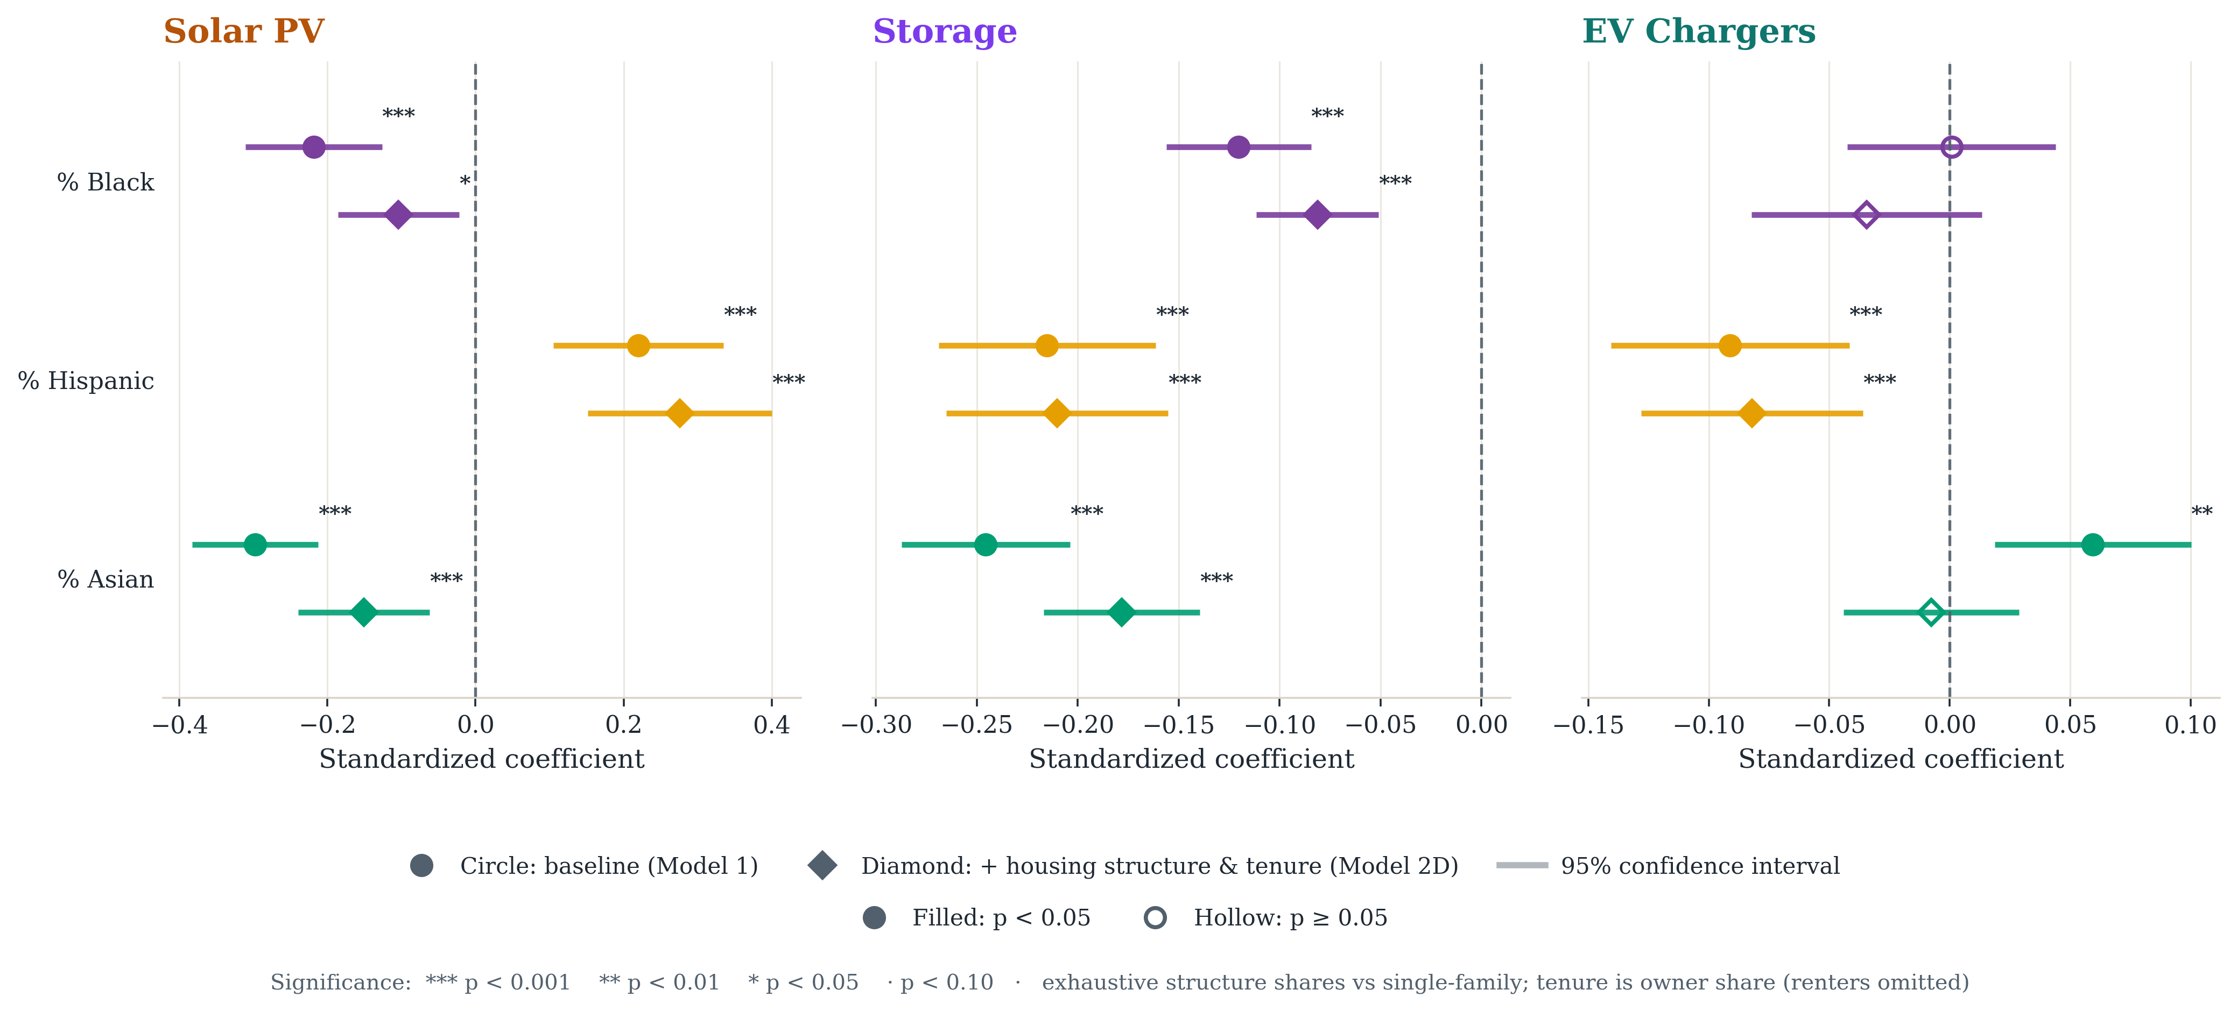
Fig. 3 | Housing stock absorbs part of the solar and storage racial gaps. Race-coefficient attenuation after adding housing structure and tenure. Circles are the baseline specification; diamonds add the area's housing-structure shares (single-family reference) and owner-occupancy rate (renter reference). Housing composition absorbs roughly a quarter to a half of the solar and storage Black- and Asian-share coefficients without eliminating any; the charging Asian-share coefficient falls to zero. Filled markers denote p < 0.05; bars are 95 percent confidence intervals.

Charger counts measure infrastructure, not household access
The charging results are the least like a conventional access gradient. The aggregate baseline has a positive but not significant income coefficient, a near-zero Black-share coefficient, a negative Hispanic-share coefficient and a positive Asian-share coefficient, while poverty rate is strongly positive. The positive Asian-share coefficient is not stable: under Conley standard errors it remains significant only at the 5 percent level, and it falls to zero once housing structure and tenure enter, so we build no interpretation on it. The Black-share coefficient is significant in none of the 48 specification-curve combinations. The poverty association is also absorbed once housing structure and tenure enter (Table 2), so higher charger counts in poorer areas track their denser, more rented housing stock rather than poverty as such.
The charger-type decomposition clarifies what the aggregate is measuring. The positive association with poverty is driven by Level 2 units; for DC fast chargers the coefficient is positive but imprecisely estimated (Fig. 4; Supplementary Table S4). Level 1 units cannot be tested at all: 97.8 percent of ZCTAs report zero, against a statewide total of 256 Level 1 ports compared with 40,078 Level 2 and 13,852 DC fast. We therefore report the Level 1 zero share rather than a coefficient, and the aggregate-versus-Level 2 contrast carries the argument.
Two features of the charger data govern how these counts should be read. The inventory records public and shared-use stations only — every station row is flagged public access — so residential charging is unobserved, and no measure in this study speaks to whether a household can charge where it parks overnight. And because the association concentrates in Level 2 units, the pattern is consistent with siting driven by commercial activity and density rather than by household-serving provision. This siting interpretation is a hypothesis: the data carry no charger-host or facility-type field. What the data do establish is narrower but consequential: a higher public charger count in a poorer ZCTA is not evidence of better household charging access, because the counts exclude home charging altogether.
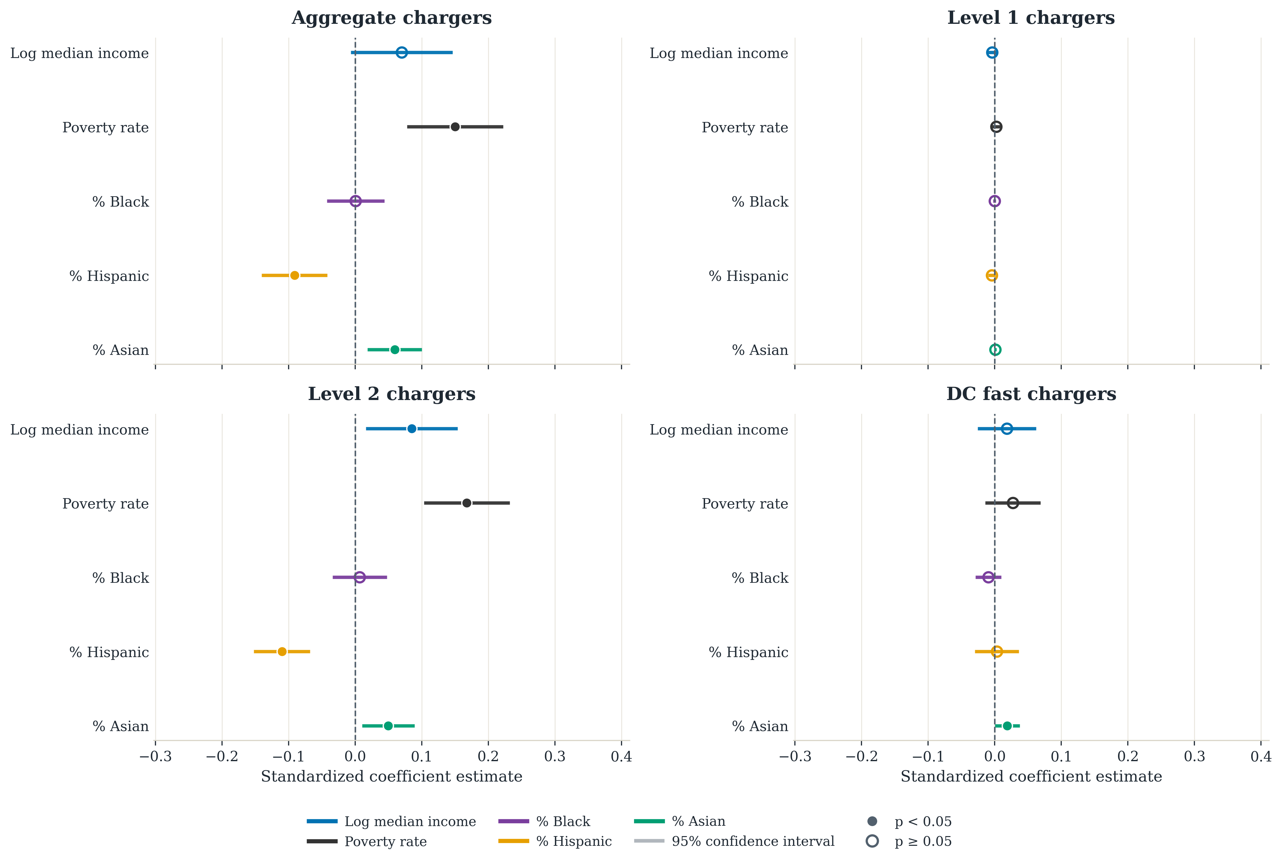
Fig. 4 | The charging–poverty association is carried by Level 2 units. Baseline coefficients for aggregate charging and for Level 1, Level 2 and DC fast units separately; filled markers denote p < 0.05. Level 1 is zero in 97.8 percent of ZCTAs and is shown for completeness only.

The strictest specification preserves the same ordering
The model series varies one control block at a time, which isolates what each block absorbs but cannot show whether the blocks jointly account for the race coefficients. We therefore also fit a nested cumulative ladder in which each rung is a strict superset of the last, from a core specification through education and housing value, housing structure and tenure, utility fixed effects, and finally county fixed effects with county-clustered standard errors. All rungs are fitted on one frozen sample of 1,160 ZCTAs across 42 county clusters, identical at every rung, so movement reflects controls rather than sample drift. The 230 excluded ZCTAs are lower-income, which is why C1 differs from Table 1 (Supplementary Note S2, Supplementary Fig. S4 and Supplementary Table S5).
Coefficients shrink by roughly 40 to 90 percent between the first and last rungs, and what survives tracks the ordering above. For storage, Black and Asian share remain negative and significant, at −0.045 (p = 0.010) and −0.115 (p < 0.001); Hispanic share stays negative at −0.102 but falls short of the 5 percent level (p = 0.094). For solar, only Asian share survives, at −0.114 (p = 0.010); the Black-share coefficient falls to −0.017 and is no longer distinguishable from zero (p = 0.472). For aggregate charging, no race term survives, and neither does the poverty association, which falls from 0.127 to 0.009. The fully stacked estimates are the conservative reading of the same pattern the model series shows, and they rank the technologies in the same order: storage, then solar, then charging (Table 2).
Table 2 | Robustness of the focal coefficients. β C1 and β C5 are the bottom and top rungs of the nested cumulative ladder (standardized predictors, frozen sample of 1,160 ZCTAs, 42 county clusters). Conley HAC reports significance under spatially robust standard errors at distance cutoffs from 50 to 200 km. Spec curve counts specifications, out of 48 confounder-block combinations, in which the coefficient is significant and same-signed as the median. Oster δ is reported only where adding controls attenuates the coefficient. *p < 0.05, **p < 0.01, ***p < 0.001.
Outcome | Term | β C1 | β C5 | Conley HAC | Spec curve (n/48) | Oster δ
Rooftop PV | Black share | −0.155*** | −0.017 | not significant | 28 | 0.32
 | Hispanic share | −0.058 | 0.047 | not significant | 31 | —
 | Asian share | −0.303*** | −0.114** | significant, 0.1%, every cutoff | 34 | 1.56
 | Log income | 0.174** | 0.188 | significant, 0.1%, every cutoff | 46 | —
Battery storage | Black share | −0.118*** | −0.045* | significant, 0.1%, every cutoff | 36 | 0.63
 | Hispanic share | −0.272*** | −0.102 | significant, 0.1%, every cutoff | 48 | 0.62
 | Asian share | −0.260*** | −0.115*** | significant, 0.1%, every cutoff | 48 | 0.81
 | Log income | 0.324*** | 0.183** | significant, 0.1%, every cutoff | 48 | 1.34
EV charging | Black share | −0.006 | −0.008 | not significant | 0 | —
 | Hispanic share | −0.094*** | −0.037 | significant, 5% | 21 | 1.58
 | Asian share | 0.046* | 0.013 | significant, 5% | 4 | 0.94
 | Poverty rate | 0.127** | 0.009 | significant, 1% | — | —

Energy burden is itself demographically patterned
The energy-burden outcomes provide affordability context rather than orthogonal controls: burden is strongly negatively correlated with income (−0.75) and positively with poverty (0.54). Income is strongly negative for both burden measures and Hispanic share positive, so affordability stress is itself demographically structured, and high-Hispanic-share areas combine greater cost stress with lower storage deployment. The per-capita affordability gap is severely skewed, and main-text estimates exclude the 134 ZCTAs whose gap exceeds $1,000 per capita; the exclusion removes a previously apparent positive Asian-share association that we therefore do not report as a finding (Supplementary Table S11 and Supplementary Note S9).

Discussion

What the multi-technology comparison shows
The clean energy transition does not reproduce inequality in the same way across technologies, and comparing them directly yields four findings. First, storage shows the most persistent disparities: its race and ethnicity coefficients are the most consistent across specifications, and its gap is not explained by unequal solar adoption. Second, rooftop solar shows racial gaps that housing composition partly explains, with a robust remainder carried by Asian share rather than Black share. Third, charging does not fit an underserved-versus-served story at all: public charger counts are, if anything, higher in poorer areas, but they exclude home charging and track the housing stock rather than household access. Fourth, because the patterns differ, progress in one technology is not evidence of progress in another: a community that appears well served on one aggregate metric may still be underserved in the specific benefit that matters — bill savings from PV, resilience from storage, or charging it can actually use.

Plausible mechanisms
For rooftop PV, the persistence of negative coefficients after income controls is consistent with barriers beyond household income: roof access, housing tenure, installer market penetration, credit constraints, and permitting and interconnection frictions. For storage, more stable disparities are consistent with higher upfront capital requirements and programmatic complexity that advantages already well-positioned households; that the gap survives conditioning on local solar suggests these barriers operate beyond bundled solar-plus-storage pathways.
One result runs against the expected direction. Adding the full confounder set does not shrink the PV income coefficient: it is essentially unchanged between the core and fully stacked specifications (0.174 and 0.188), though less precisely estimated. Because the coefficient does not attenuate, the Oster bound is not interpretable for that term. One plausible reading is that these controls are absorbing variation that suppresses the income gradient — dense, high-value, high-income submarkets with low owner occupancy — and that once housing is held fixed, the remaining income effect reflects financing and adoption capacity more directly. If so, the barrier is access to capital and to installers rather than price alone, a mechanism these data do not test directly.
For charging, the positive poverty association appears in Level 2 units and disappears once housing structure and tenure are controlled, which is consistent with siting driven by density and commercial activity rather than household-serving provision. Aggregate charger counts are therefore not neutral measures of equitable access: they can record infrastructure abundance in places where practical charging access for residents, particularly renters and multifamily residents, remains limited.

Implications for how equity is measured
If equity is measured too coarsely, policy can mistake infrastructure counts for access, or progress in one technology for progress in another. The charging result is the sharpest measurement case: a deployment target expressed in chargers per capita can be met entirely through commercial siting while household-serving access does not move. The storage result is the sharpest equity case: communities with larger Black, Hispanic and Asian shares have less of the technology that buffers outages and wildfire shutoffs, and that gap does not follow solar access. Whether it coincides with outage exposure is not tested here and is a priority for future work. The affordability results already point to a double burden: high-Hispanic-share communities carry greater energy-cost stress and also have less access to backup power.
That racial disparities persist after income controls, for storage in nearly every specification we examined, is the reason these results bear on race-neutral planning. Eligibility rules keyed only to income or to generic disadvantaged-community designations can miss communities that are underserved on race-correlated dimensions. This is an area-level finding and does not describe individual household behavior, but eligibility rules are themselves written at area level.

Policy levers differ by technology
The implication is not that disadvantaged places need more DERs in the aggregate, but that the three technologies require different instruments. For rooftop solar, the persistence of disparities after observed controls supports targeted incentives, community-solar expansion, financing support and outreach that reduce adoption frictions; the income result above, if it reflects financing, suggests financing access and installer presence matter more than headline incentive levels. For storage, which warrants the sharpest targeting, resilience rebates, backup-power provisioning and community-storage programs should weight toward communities exposed to outages and wildfire shutoffs rather than ride on solar programs, since the storage gap does not follow solar access. For charging, procurement targets should measure usable residential access through multifamily, curbside and renter-serving deployment rather than aggregate counts, which can overstate access.
Two further levers sit outside consumer programs. Adoption is partly gated by hosting-capacity and interconnection frictions that are themselves socially patterned [13][14]; operators can publish hosting-capacity and interconnection-queue outcomes disaggregated by community demographics and pilot fairness-aware allocation so that grid upgrades do not concentrate where adoption is already high. And persistent PV and storage gaps after income controls point to non-price barriers — installer market penetration, financing access, split incentives for renters — that third-party ownership, on-bill and inclusive financing, and community solar-plus-storage can address where subsidies alone do not.

Conclusions
California is both an empirical case and an early warning. As decarbonization expands, the question is not only how quickly DERs diffuse but whether the benefits of that diffusion reduce inequality or reproduce it in new forms. Our results are area-level associations, not causal effects, and household-level and longitudinal data are needed to identify mechanisms. The central lesson, however, does not depend on mechanism: inequity in DER adoption is technology-specific, so it cannot be tracked with one aggregate metric or with deployment counts. Planning should measure, for each technology, who can use, benefit from and rely on it. Income-keyed eligibility rules, undifferentiated deployment targets and race-neutral planning defaults each need revisiting if the transition is to narrow existing gaps rather than widen them.

Methods

Empirical approach
This paper uses a cross-sectional regression framework to examine whether racial/ethnic and socioeconomic differences are associated with distributed energy resource adoption across California ZCTAs. The goal is not prediction but to test whether disparities in DER adoption persist after accounting for differences in adoption capacity, geography, demographic context, and observed energy-system conditions. To do this, we use a sequence of models for each DER outcome. This stepwise model series makes the results easier to interpret because changes in the coefficients of interest can be linked to specific added controls rather than to one opaque specification. It also supports direct comparison across technologies, which is central to the paper’s multi-DER framing.
We report the model series as a sequence of separate specifications rather than as one fully stacked model, and complement it with the nested cumulative ladder described below (Table 2; Supplementary Note S2). Housing structure, existing infrastructure, and electricity demand are shaped by the same development and siting processes that produce the deployment patterns we measure, so entering them together would condition the race and ethnicity coefficients on partial outcomes and hide which block moves the estimates. Each specification answers a different conditional question, and we report the full sequence so that the sensitivity of each coefficient to the conditioning set is explicit rather than assumed.
The three main outcomes are ZCTA-level deployment intensity for rooftop solar PV, battery storage, and EV charging. Each is population-normalized and transformed using a log(1 + rate) specification to reduce skew and retain observations with zero deployment. The main explanatory variables of interest are racial/ethnic composition measures and socioeconomic indicators. We then add contextual controls that capture climate, renewable resource potential, utility territory, built-environment structure, and broader installed-energy context. The coefficients therefore describe how DER deployment differs across ZCTA areas with different demographic and socioeconomic characteristics, conditional on the included controls. They should not be read as causal effects of race or income on any individual household’s technology adoption decision.

Data and measures

Unit of analysis
The unit of analysis is the ZIP-code level, implemented using Census ZIP Code Tabulation Areas (ZCTAs), which are geographic entities defined by the U.S. Census Bureau to approximate ZIP code service areas. ZCTA geography is the most practical common denominator across the DER, demographic, and contextual assembled source files. The analysis is therefore framed as a 2023 cross-section using the most recent aligned observations available through that year. Variables used as outcomes, predictors and controls are defined in Supplementary Table S14.

Descriptive distributions
Deployment is uneven across the state for all three technologies (Fig. 1). The three DER outcomes are right-skewed, while the socioeconomic context variables span materially different neighborhood conditions (Supplementary Fig. S8). Supplementary Table S15 summarizes the analysis sample so that model comparisons can be read against the observed scale of the data.

Dataset construction and sample
Two properties of the source data govern how the outcomes should be read. The EV charging inventory records public and shared-use stations only: every station row in the source file carries a public access flag, and the statewide Level 1 total is 256 ports against 40,078 Level 2 and 13,852 DC fast. Residential charging is therefore unobserved, and no charging measure in this study speaks to whether a household can charge where it parks. The storage series is drawn from the record-level export of the California Energy Commission storage system survey: 252,880 records, of which 249,338 are residential, 3,332 commercial and 210 utility. The outcome sums residential and commercial systems of up to 5 MW each that were approved by the end of 2023, matching the Tracking the Sun cutoff, and excludes utility-sector records: 150,506 systems and 1,614 MW statewide, 64 percent of it residential. The size limit is applied to individual systems before aggregation. Restricting the outcome to residential records reproduces every sign and significance of the baseline (Supplementary Table S12).
The analysis uses a California ZCTA-level dataset created by merging multiple DER source files with demographic, climate, utility, and infrastructure controls. The final merged file combines measures of solar PV capacity, battery storage capacity, and EV charging infrastructure with American Community Survey variables and place-based controls. The data-construction pipeline and analysis code are available at https://github.com/vineetjnair9/distributed-energy-resources-equity-CA under the MIT License. The harmonized ZCTA analysis file is deposited as a separate Zenodo record under CC-BY-4.0 (https://doi.org/10.5281/zenodo.22053001).
DER measures are first constructed separately by technology and then aggregated to the ZCTA level. Solar PV capacity is derived from Tracking the Sun installation records [18]. Battery storage is built from a California storage dataset containing location and capacity information [19]. EV charging infrastructure is constructed from charger-level records that include charger type and location [20]; charger rows without a valid source ZIP are excluded from ZCTA charger outcomes rather than reassigned using latitude/longitude, while valid source-ZIP rows are retained even if descriptive fields are blank or say No information. Wind capacity and turbine counts come from the USGS wind turbine database [21], power-plant capacity from the EIA power plants layer [22], interconnection records from California Distributed Generation Statistics [23], ZCTA boundaries from Census TIGER/Line shapefiles [24], and energy burden measures from the California Energy Commission energy equity indicators [25]. Fig. 1 visualizes the resulting statewide geography and shows that some ZCTAs are absent because the underlying merged sample is incomplete in those places. In the regression stage, ZCTAs with total population below 1,000 are excluded from outcome construction to avoid unstable per-capita rates in very small areas. Supplementary Table S15 summarizes the resulting analysis sample.
After source-specific cleaning, the DER measures are merged with contextual predictors. Demographic and socioeconomic variables come from the 2023 American Community Survey 5-year estimates [26]. Housing structure (ACS table B25024) enters as exhaustive shares of single-family, multifamily, mobile-home and boat/RV/van/other units, with single-family as the reference. Tenure (ACS table B25003) uses owner occupancy, with renter occupancy as its complement. Climate and renewable-resource controls come from NASA POWER [27]; utility territory uses a ZIP-to-utility spatial crosswalk; and annualized utility usage provides the electricity-demand proxy [28].

Outcome variables
To make outcomes comparable across technologies, we convert each DER measure into a population-normalized deployment intensity metric and then transform it using log(1 + x). This helps reduce skew and allows ZCTAs with zero deployment to remain in the sample. The three main outcomes are defined as follows. Their definitions and units are also collected in Supplementary Table S14.
For EV charging:
$$chargers_per_1k = (total_chargers × 1000) / population$$$y_chargers = log(1 + chargers_per_1k)$ (1)
For solar PV:
$$pv_kW_per_1k = (PV_system_size_DC × 1000) / population$$$y_pv = log(1 + pv_kW_per_1k)$ (2)
For battery storage:
$$storage_MW_per_100k = (storage_capacity_mw × 100000) / population$$$y_storage = log(1 + storage_MW_per_100k)$ (3)
Storage is scaled per 100,000 residents rather than per 1,000 in Equation (3) because storage deployment is much smaller and more uneven at the ZIP level, so the larger denominator keeps the raw rate in a more interpretable range before transformation. In supplementary analysis, we also examine more disaggregated charging outcomes, including Level 1, Level 2, and DC fast chargers separately, along with a wind-capacity outcome used mainly as contextual comparison. The main text focuses on the three outcomes above.
Deployment is zero in a non-trivial share of ZCTAs, and the share differs sharply by technology: 5.3 percent for PV, 7.1 for storage, 19.0 for aggregate charging, 22.3 for Level 2 and 44.2 for DC fast, but 97.8 percent for Level 1 and 97.5 percent for wind capacity (Supplementary Table S13). Level 1 charging and wind are therefore too sparse to support a coefficient at this geography and are reported descriptively rather than modeled in the main text.

Key explanatory variables
The main explanatory variables fall into two groups: racial/ethnic composition and socioeconomic status. The race/ethnicity variables are ZCTA-level shares of the population identifying as Black, Hispanic/Latino, and Asian. We include these variables to test whether DER deployment differs systematically across communities in ways not fully explained by socioeconomic conditions alone. For descriptive LOWESS plots, we also summarize these patterns using a combined non-white share, but the regressions keep the disaggregated race variables to avoid collapsing distinct demographic patterns into one coefficient.
The socioeconomic variables are intended to proxy for adoption capacity and broader social advantage. The core measures are log median household income and poverty rate. Additional socioeconomic variables used in extended specifications include percent bachelor’s degree or higher and log median housing value. Education is therefore treated primarily as a control rather than as the paper’s headline predictor: it captures information, housing-market position, and adoption capacity that overlap with income.
The central empirical question is whether the race/ethnicity coefficients weaken substantially once these socioeconomic proxies are included, or whether meaningful disparities remain after accounting for them. If the race coefficients remain negative and statistically distinguishable from zero in richer models, that is evidence against a purely race-neutral account of observed DER deployment patterns.

Contextual controls
We include several categories of place-based controls to account for non-demographic factors that may shape DER deployment. First, we include climate and resource controls. Baseline models use heating and cooling degree days to capture broad climatic differences across California. Alternative specifications use more technology-specific contextual variables, including global horizontal irradiance for solar PV and wind speed measures for wind-related outcomes. Temperature controls are also used in some robustness checks.
Second, we include institutional controls through utility territory fixed effects. Utility territories matter because rates, interconnection processes, incentive administration, and historical investment can differ substantially across service areas. Including utility fixed effects helps isolate within-utility differences in deployment.
Third, we include broader geographic controls in selected specifications, including total population, latitude and longitude, and county-based adjustments. These help account for large-scale regional gradients and spatially correlated unobservables. When we refer below to county-clustered standard errors, we mean that inference is adjusted for within-county error correlation rather than assuming each ZCTA contributes an independent disturbance.
Fourth, we include electricity demand and infrastructure-context controls in later models. Annual electricity consumption serves as a proxy for underlying load and commercial activity, especially relevant for EV charging. Existing plant, wind, and storage assets are used as installed-energy-context proxies. They are informative about the local energy landscape, but they are not direct measures of grid infrastructure, feeder capacity, or hosting capacity.
Resource control differs by outcome, with each technology using the physical suitability measure that governs it: global horizontal irradiance for photovoltaics, heating and cooling degree days for storage and charging, and hub-height wind speed for wind. Holding one common resource control across all three would mis-specify at least two of them. Because the control differs, cross-technology comparison rests on the standardized scale and on the nested ladder, in which the control is held fixed within each outcome, rather than on an identical right-hand side.

Baseline regression specification
The main estimation approach is ordinary least squares regression using the transformed ZCTA-level deployment outcomes. The baseline specification is:
y_z = β₀ + β₁ Income_z + β₂ Black_z + β₃ Hispanic_z + β₄ Asian_z + β₅ Poverty_z + γX_z + ε_z (4)
where y_z is the DER deployment outcome in ZCTA z, Income_z is log median household income, Black_z, Hispanic_z, and Asian_z are race/ethnicity population shares, Poverty_z is the ZCTA poverty rate, X_z is a vector of contextual controls for ZCTA z, and ε_z is the error term. Estimates of Equation (4) for the three headline outcomes are reported in Table 1.
All models are estimated with heteroskedasticity-robust HC1 standard errors by default, which keep inference robust to unequal residual variance across ZCTAs. In selected specifications, we also cluster standard errors at the county level to allow for within-county correlation in errors. Because deployment in one ZCTA may be related to deployment in its neighbors, we also report Conley heteroskedasticity- and autocorrelation-consistent (HAC) standard errors [29], which allow residuals to be correlated across nearby areas rather than treating each ZCTA as independent. Spatially robust alternatives to both estimators are reported in Supplementary Table S19.

Model series and nested cumulative ladder
We estimate two complementary families of specifications. The first is a model series: each specification varies exactly one control block against a fixed core of income, race and ethnicity shares, poverty rate and the outcome-specific resource control. The blocks are education (Model 2A), housing value (Model 2B), housing structure (Model 2C), tenure (Model 2D), alternative climate and resource measures (Models 3A–3C), centered income-by-race interactions (Model 4, with Model 4R dropping the poverty control), utility fixed effects (Model 5, with Model 5C clustering by county), geographic controls (Models 6A–6B), infrastructure context (Model 7) and an electricity-demand proxy (Model 8). The series answers which single block moves which coefficient, not whether the blocks jointly absorb an effect. Specifications are listed in Supplementary Table S1, and every coefficient is traced across the series in Supplementary Figs. S1 to S3.
The second is a nested cumulative ladder in which each rung is a strict superset of the last: C1 adds nothing to the core; C2 adds educational attainment and median housing value; C3 adds ACS housing structure and tenure; C4 adds utility fixed effects; and C5 adds county fixed effects with county-clustered standard errors, dropping the ZCTA-level climate control that county fixed effects very nearly absorb. County and utility fixed effects are not stacked with climate in one design matrix. The model uses rows that exist on every variable used anywhere in the ladder, plus the minimum cluster-size filter, so N and cluster count are identical at every rung and coefficient movement reflects controls alone. A separate model adds the electricity-demand proxy and infrastructure capacity. Two further robustness families accompany the ladder. A specification curve fits every subset of the six confounder blocks — 48 of the 64 combinations, excluding those that stack county and utility fixed effects together — and records, for each focal term, in how many specifications it is significant and same-signed as the median. Oster δ bounds compare the core specification with the saturated one, with R² max set to 1.3 times the saturated R², capped at one; δ is reported only where adding controls attenuates the coefficient, since the bound is not interpretable otherwise.

Estimation and inference
The main quantities of interest are the coefficients on the race/ethnicity variables and how those coefficients change across specifications. We compare both the direction and relative magnitude of these coefficients across solar PV, storage, and EV charging outcomes. The interpretation is comparative rather than at the individual level. A negative coefficient on a racial/ethnic population share does not imply anything about the behavior of an individual resident. Instead, it indicates that ZCTA areas with larger shares of that population tend to have lower DER deployment intensity, conditional on the model's controls. If the coefficient decreases after additional controls are added, that suggests part of the disparity is explained by those factors. This comparison across DERs is central to the paper. If the same communities appear underserved across multiple technologies, that points to broader structural inequities in the clean energy transition. If the patterns differ by technology, that suggests more technology-specific barriers.

Robustness and diagnostic checks
In addition to the model series and nested ladder, we conduct several supporting checks. We examine variance inflation factors (VIFs) to monitor multicollinearity across specifications (Supplementary Table S17), compare alternative climate and resource control blocks to test the stability of the results, estimate county-clustered standard errors to assess whether statistical significance is sensitive to local spatial clustering, and generate descriptive maps, distribution plots, and coefficient comparison figures to visualize both the raw patterns and the modeled results (Fig. 1, Supplementary Fig. S8, and Fig. 2). Residual spatial dependence and spatially robust inference are examined in Supplementary Note S12 (Supplementary Tables S18 and S19).
VIF screening informs the model inventory, but it is not used as a rigid mechanical inclusion rule. Some richer specifications show elevated VIF values (Supplementary Table S17), especially once multiple SES and contextual controls are introduced. We retain predictors when they correspond to substantively distinct constructs that are central to the modeling objective rather than treating any moderate VIF increase as evidence that the model is unusable. The relevant question for this paper is therefore whether the coefficients of interest remain interpretable and stable, not whether every rich specification minimizes collinearity by design.
In exploratory analysis, we compare linear specifications to more flexible predictive models, including polynomial regression, random forest, and gradient-boosted trees, using cross-validation (Supplementary Fig. S14, Supplementary Fig. S15, and Supplementary Fig. S16). These models are not the basis for the paper’s main claims. Instead, they serve as a diagnostic check for whether simple linear models miss strong nonlinear structure. The substantive conclusions rest on the interpretable OLS results.
Four additional checks are reported in the Supplementary Information. Poisson pseudo-maximum-likelihood models fitted to raw counts with a population offset address the zero-inflation that a log(1 + rate) transformation handles only implicitly. Population-weighted estimates test whether unweighted ZCTA regressions are driven by small areas. A spatial error model with eight-nearest-neighbor weights addresses spatially structured omitted variables, which Conley standard errors correct for in inference but not in the conditional mean. Finally, because six outcomes are estimated across a series of specifications, individual p-values close to conventional thresholds should not be read in isolation; the specification curve and the Oster bounds are reported precisely so that robustness does not rest on any single test.
The per-capita energy affordability gap is the California Energy Commission affordability-gap series divided by ZCTA population, entered as log(1 + gap per capita). Its distribution is severely skewed — median about $75, maximum above $236,000, with the top 100 ZCTAs accounting for 92 percent of the statewide total — which we attribute to error in the source series. Main-text affordability estimates exclude the 134 ZCTAs above $1,000 per capita; full-sample estimates are in Supplementary Table S11. Mean energy burden in the matched sample is about 2.2 percent, below commonly cited household energy-burden estimates because the Commission series covers electricity costs rather than total household energy expenditure, and it should be read as a relative affordability-stress index rather than a total-burden measure.

Limitations
This study identifies area-level conditional associations, not causal effects. Area-level housing structure and tenure are observed in Models 2C and 2D, but unmeasured confounding may remain around household tenancy, roof suitability, installer availability, local permitting, program participation, and technology-specific incentive access.
Additionally, using ZCTA geography is a practical strength for harmonizing multiple datasets, but it also introduces limitations. ZCTAs can blur substantial within-area heterogeneity, and ecological inference problems remain. The analysis therefore cannot describe the behavior of individual households or residents. In addition, some raw source files required spatial assignment from latitude and longitude, manual ZIP corrections, or source-specific cleaning decisions, all of which may introduce measurement error. For EV chargers specifically, rows without valid source ZIPs are excluded from ZCTA outcomes rather than rescued from coordinates (see Dataset construction and sample), so the charger outcomes should be interpreted as valid-source-ZIP charger records.
There are also technology-specific measurement limitations. Aggregate charger counts mix charger types and host contexts that may not represent equivalent forms of access. The charger-type decomposition (Supplementary Table S4 and Fig. 4) helps, but even that does not fully distinguish residential, workplace, corridor, and municipal use cases. Wind outcomes are also less directly comparable to behind-the-meter technologies, which is why the paper treats wind capacity as supplementary context rather than a headline equity result (Supplementary Note S10; Supplementary Fig. S13).
Finally, the paper is a California 2023 cross-sectional snapshot. The results may not generalize mechanically to other states, years, or regulatory contexts. Future work would benefit from longitudinal analysis, property- or household-level tenancy and roof-suitability measures, direct data on technology-specific access mechanisms, and place-based measures such as transit and corridor intensity.

Supplementary information
The supplementary information reports the specifications and robustness evidence behind these results as thirteen notes. Supplementary Note S1 defines every specification in the model series and traces each coefficient across it (Supplementary Figs. S1 to S3, Supplementary Table S1); Note S2 the nested cumulative ladder (Supplementary Fig. S4, Supplementary Tables S5 and S6); Note S3 the specification curve (Supplementary Fig. S5); Note S4 the Oster bounds (Supplementary Table S7); and Note S5 the alternative functional form, weighting and spatial specifications (Supplementary Tables S8 to S10). Note S6 reports the housing-attenuation coefficients (Supplementary Table S2), Note S7 the descriptive gradients and raw distributions (Supplementary Figs. S6 to S8), Note S8 the exploratory neighborhood typology (Supplementary Fig. S9, Supplementary Table S16), Note S9 the energy-burden and affordability models (Supplementary Figs. S10 to S12), and Note S10 the wind comparison (Supplementary Fig. S13). Note S11 reports the cross-validated predictive model comparisons and spatial residual maps (Supplementary Figs. S14 to S17); Note S12 the multicollinearity, spatial-autocorrelation and spatially robust standard-error diagnostics (Supplementary Tables S17 to S19); and Note S13 the data-construction decisions, including zero shares by outcome, the storage customer-sector sensitivity, variable definitions, summary statistics, predictor standard deviations and charger-subtype estimates (Supplementary Tables S3, S4 and S12 to S15).

Data availability
The harmonized ZCTA analysis dataset is deposited at Zenodo under CC-BY-4.0 (https://doi.org/10.5281/zenodo.22053001). All underlying sources are public and are listed in the Supplementary Information.

Code availability
Data-construction and analysis code is available at https://github.com/vineetjnair9/distributed-energy-resources-equity-CA under the MIT License.

Author contributions
[To be completed.]

Competing interests
The authors declare no competing interests.

Acknowledgements
[To be completed.]

References

[1] B. R. Lukanov and E. M. Krieger, “Distributed solar and environmental justice: Exploring the demographic and socio-economic trends of residential PV adoption in California,” Energy Policy, vol. 134, 2019, doi:10.1016/j.enpol.2019.110935.
[2] D. A. Sunter, S. Castellanos, and D. M. Kammen, “Disparities in rooftop photovoltaics deployment in the United States by race and ethnicity,” Nat. Sustain., vol. 2, no. 1, pp. 71–76, Jan. 2019, doi:10.1038/s41893-018-0204-z.
[3] L. Kurdgelashvili, C. H. Shih, F. Yang, and M. Garg, “An empirical analysis of county-level residential PV adoption in California,” Technol. Forecast. Soc. Change, vol. 139, 2019, doi:10.1016/j.techfore.2018.11.021.
[4] T. G. Reames, “Distributional disparities in residential rooftop solar potential and penetration in four cities in the United States,” Energy Res. Soc. Sci., vol. 69, p. 101612, Nov. 2020, doi:10.1016/J.ERSS.2020.101612.
[5] N. R. Darghouth, E. O’Shaughnessy, S. Forrester, and G. Barbose, “Characterizing local rooftop solar adoption inequity in the US,” Environmental Research Letters, vol. 17, no. 3, p. 034028, Feb. 2022, doi:10.1088/1748-9326/AC4FDC.
[6] C. Sigrist, A. Lechowicz, J. Champ, N. Bashir, and M. Hajiesmaili, “Lost in Siting: The Hidden Carbon Cost of Inequitable Residential Solar Installations,” Jan. 2025, [Online]. Available:http://arxiv.org/abs/2501.13868
[7] A. Drehobl, L. Ross, R. Ayala, A. Zaman, and J. Amann, “How high are household energy burdens? An assessment of national and metropolitan energy burden across the United States,” American Council for an Energy-Efficient Economy, Report U2006, Sep. 2020.
[8] The Greenlining Institute, “Demystifying Equity in California’s Energy Grid Transition,” Jul. 25, 2024. [Online]. Available:https://greenlining.org/2024/demystifying-equity-in-californias-energy-grid-transition/
[9] T. Light, E. McIntosh, and O. Stephenson, “Advancing Equity in Access to Distributed Energy Resources in California,” Journal of Science Policy & Governance, 2022, doi:10.38126/jspg200106.
[10] S. P. Forrester, C. C. Montañés, E. O’Shaughnessy, and G. Barbose, “Modeling the potential effects of rooftop solar on household energy burden in the United States,” Nat. Commun., vol. 15, p. 4676, Jun. 2024, doi:10.1038/s41467-024-48967-x.
[11] B. Tarekegne, R. O’Neil, and J. Twitchell, “Energy Storage as an Equity Asset,” 2021. doi:10.1007/s40518-021-00184-6.
[12] M. Alipour, E. Irannezhad, R. A. Stewart, and O. Sahin, “Exploring residential solar PV and battery energy storage adoption motivations and barriers in a mature PV market,” Renew. Energy, vol. 190, 2022, doi:10.1016/j.renene.2022.03.040.
[13] A. M. Brockway, J. Conde, and D. Callaway, “Inequitable access to distributed energy resources due to grid infrastructure limits in California,” Nat. Energy, vol. 6, no. 9, 2021, doi:10.1038/s41560-021-00887-6.
[14] B. Aydin, R. Holt, and M. Almassalkhi, “Fairness-aware Dynamic Hosting Capacity and the Impacts of Strategic Solar PV Curtailment,” Apr. 2025, [Online]. Available:http://arxiv.org/abs/2504.18905
[15] U.S. Department of Energy, “Distributed energy resource interconnection roadmap,” i2X initiative, 2023. [Online]. Available: https://www.energy.gov/eere/i2x
[16] R. Haider, Y. Xu, and W. Yang, “Towards closing the data gap: A project-driven distributed energy resource dataset for the U.S. Grid,” in e-Energy 2023 Companion - Proceedings of the 14th ACM International Conference on Future Energy Systems, 2023. doi:10.1145/3599733.3600250.
[17] L. Ge, T. Du, C. Li, Y. Li, J. Yan, and M. U. Rafiq, “Virtual Collection for Distributed Photovoltaic Data: Challenges, Methodologies, and Applications,” 2022. doi:10.3390/en15238783.
[18] Lawrence Berkeley National Laboratory, "Tracking the Sun: public data file," 2024. [Online]. Available: https://emp.lbl.gov/tracking-the-sun
[19] California Energy Commission, "California energy storage system survey," 2024. [Online]. Available: https://www.energy.ca.gov/data-reports/energy-almanac/california-electricity-data/california-energy-storage-system-survey
[20] California Energy Commission, "Zero emission vehicle and infrastructure statistics," 2024. [Online]. Available: https://www.energy.ca.gov/data-reports/energy-almanac/zero-emission-vehicle-and-infrastructure-statistics-collection/electric
[21] B. D. Hoen, J. E. Diffendorfer, J. T. Rand, L. A. Kramer, C. P. Garrity, and H. E. Hunt, "United States wind turbine database," U.S. Geological Survey data release, 2018, doi: 10.5066/F7TX3DN0.
[22] U.S. Energy Information Administration, "Power plants," 2023. [Online]. Available: https://atlas.eia.gov/datasets/eia::power-plants/explore
[23] California Distributed Generation Statistics, "Interconnected project sites report, 31 December 2023," 2023. [Online]. Available: https://www.californiadgstats.ca.gov/downloads/
[24] U.S. Census Bureau, "TIGER/Line shapefiles," 2023. [Online]. Available: https://www.census.gov/geographies/mapping-files/time-series/geo/tiger-line-file.html
[25] California Energy Commission, "Energy equity indicators: deep dive energy," 2023. [Online]. Available: https://www.energy.ca.gov/data-reports/data-exploration-tools/energy-equity-indicators-dashboard-collection/deep-dive-energy
[26] U.S. Census Bureau, "American Community Survey 5-year estimates, detailed tables," 2023. [Online]. Available: https://api.census.gov/data/2023/acs/acs5
[27] NASA Langley Research Center, "Prediction of Worldwide Energy Resources (POWER)," 2023. [Online]. Available: https://power.larc.nasa.gov/
[28] Pacific Gas and Electric Company, Southern California Edison, and San Diego Gas and Electric, "Electric usage by ZIP code, 2023 quarterly datasets," 2023. [Online]. Available: https://pge-energydatarequest.com/public_datasets
[29] T. G. Conley, "GMM estimation with cross sectional dependence," Journal of Econometrics, vol. 92, no. 1, pp. 1-45, Sep. 1999, doi: 10.1016/S0304-4076(98)00084-0.

