Supplementary Information
This Supplementary Information reports the material that does not fit within the main text's display-item limit, together with the robustness analyses the main text summarizes. It is organized as thirteen Notes. Notes S1 to S5 document the specifications and the robustness evidence behind the main results. Notes S6 to S10 carry the descriptive and secondary analyses. Notes S11 to S13 report predictive model comparisons, statistical diagnostics, and the data-construction decisions that govern how the outcomes should be read. Every item here is cited at least once in the main text.

Supplementary Note S1 | The model series
The main results are estimated as a model series: each specification varies exactly one control block against a fixed core of log median household income, Black, Hispanic and Asian population shares, poverty rate, and the resource control appropriate to the outcome. The specifications are siblings rather than nested rungs — some substitute a control rather than adding one — so the series answers which single block moves which coefficient. It does not, on its own, establish whether the blocks jointly absorb an effect; that is what the cumulative ladder in Note S2 is for.
Model 1 is the baseline: income, race and ethnicity shares, poverty rate, and a limited set of climate controls. It provides a first-pass estimate of area-level disparities after accounting for basic socioeconomic status and broad geographic conditions.
Model 2 has four variants. Models 2A and 2B add bachelor's attainment and median housing value respectively. Model 2C adds exhaustive housing structure composition — multifamily, mobile-home and boat/RV/van/other shares, with single-family units omitted as the reference. Model 2D further adds owner occupancy, with renters as the omitted tenure reference. Because the four ACS B25024 structure shares sum to one, omitting single-family makes every reported structure coefficient an interpretable contrast with a true single-family base; tenure is kept as its own block so Model 2D shows what tenure adds beyond building type.
Model 3 tests whether the results depend on how geographic context is captured. For solar we substitute global horizontal irradiance alone (Model 3C); elsewhere we compare heating and cooling degree days (Model 3A) against mean temperature alone (Model 3B). For wind outcomes we use wind resource measures. Because Model 3 substitutes rather than adds, it is a sensitivity check on the resource control and not a more demanding specification.
Model 4 tests whether the income gradient differs across communities by adding interactions between income and race and ethnicity shares. These are mean-centered before interaction so the main effects stay interpretable; a reduced variant, Model 4R, omits the poverty control to confirm the interaction is not absorbing it.
Model 5 adds utility territory fixed effects to absorb institutional differences across service areas — rates, interconnection processes, incentive administration and historical investment all differ by territory. Model 5C re-estimates the baseline with county-clustered standard errors as a robustness check on inference rather than on the conditional mean.
Model 6 introduces broader geographic controls: latitude and longitude (Model 6A) or county fixed effects (Model 6B), testing whether the main patterns simply reflect regional gradients within California rather than more local disparities.
Model 7 adds measures of existing energy infrastructure, with a variant scaling those measures by population (Model 7PC), to examine whether local deployment patterns are partly explained by the surrounding energy-system context. Model 8 adds a demand proxy based on annual electricity consumption, which is particularly relevant for charging, where deployment may track commercial activity and underlying load as much as residential adoption potential. The demand proxy enters positively where it is significant — 0.215 (p < 0.001) for solar and 0.061 (p < 0.001) for storage — and is not distinguishable from zero for aggregate charging (0.007, p = 0.308). It is available for 1,196 of the 1,390 analysis ZCTAs, of which 1,159 report positive consumption; most remaining gaps fall outside the three investor-owned utility territories for which ZIP-level usage is published.
Model 9 adds local solar deployment to the storage model, testing whether storage disparities persist after conditioning on upstream solar deployment. Model 9A instead adds DER deployment terms to the energy-burden outcomes. These are two distinct specifications with different outcomes and different control sets, and both condition on variables that are themselves outcomes of the same predictors, so each answers a narrow question rather than providing a better-identified estimate.
The specifications above are stated formally below. Equation (4), the baseline estimating equation, is given in the Methods; the remaining specifications follow the same notation, in which y_z is the outcome in ZCTA z, RaceSES_z collects income, the race and ethnicity shares and poverty rate, X_z is the vector of contextual controls, and ε_z is the error term.
y_z = β₀ + β RaceSES_z + γ Climate_z + ε_z (5)
y_z = β₀ + β RaceSES_z + θ SESextra_z + γ Climate_z + ε_z (6)
y_z = β₀ + β RaceSES_z + θ ResourceClimateAlt_z + ε_z (7)
y_z = β₀ + β RaceSES_z + δ(Income_z × Race_z) + γX_z + ε_z (8)
y_z = β₀ + β RaceSES_z + γX_z + δ Utility_z + ε_z (9)
y_z = β₀ + β RaceSES_z + γX_z + θ Geo_z + ε_z (10)
y_z = β₀ + β RaceSES_z + γX_z + δ County_z + ε_z (11)
y_z = β₀ + β RaceSES_z + γX_z + λ Infrastructure_z + ε_z (12)
y_z = β₀ + β RaceSES_z + γX_z + λ Infrastructure_z + ϕ Demand_z + ε_z (13)
y_z = β₀ + β RaceSES_z + γX_z + λ Infrastructure_z + ϕ Demand_z + ψ DER_z + ε_z (14)
Supplementary Figures S1 to S3 trace every coefficient across this series for the three headline outcomes, one panel per coefficient, with 95 percent confidence bands. Read against Figure 2 in the main text, which compresses the same information into one panel per outcome, they show which specific control block is responsible for each movement.
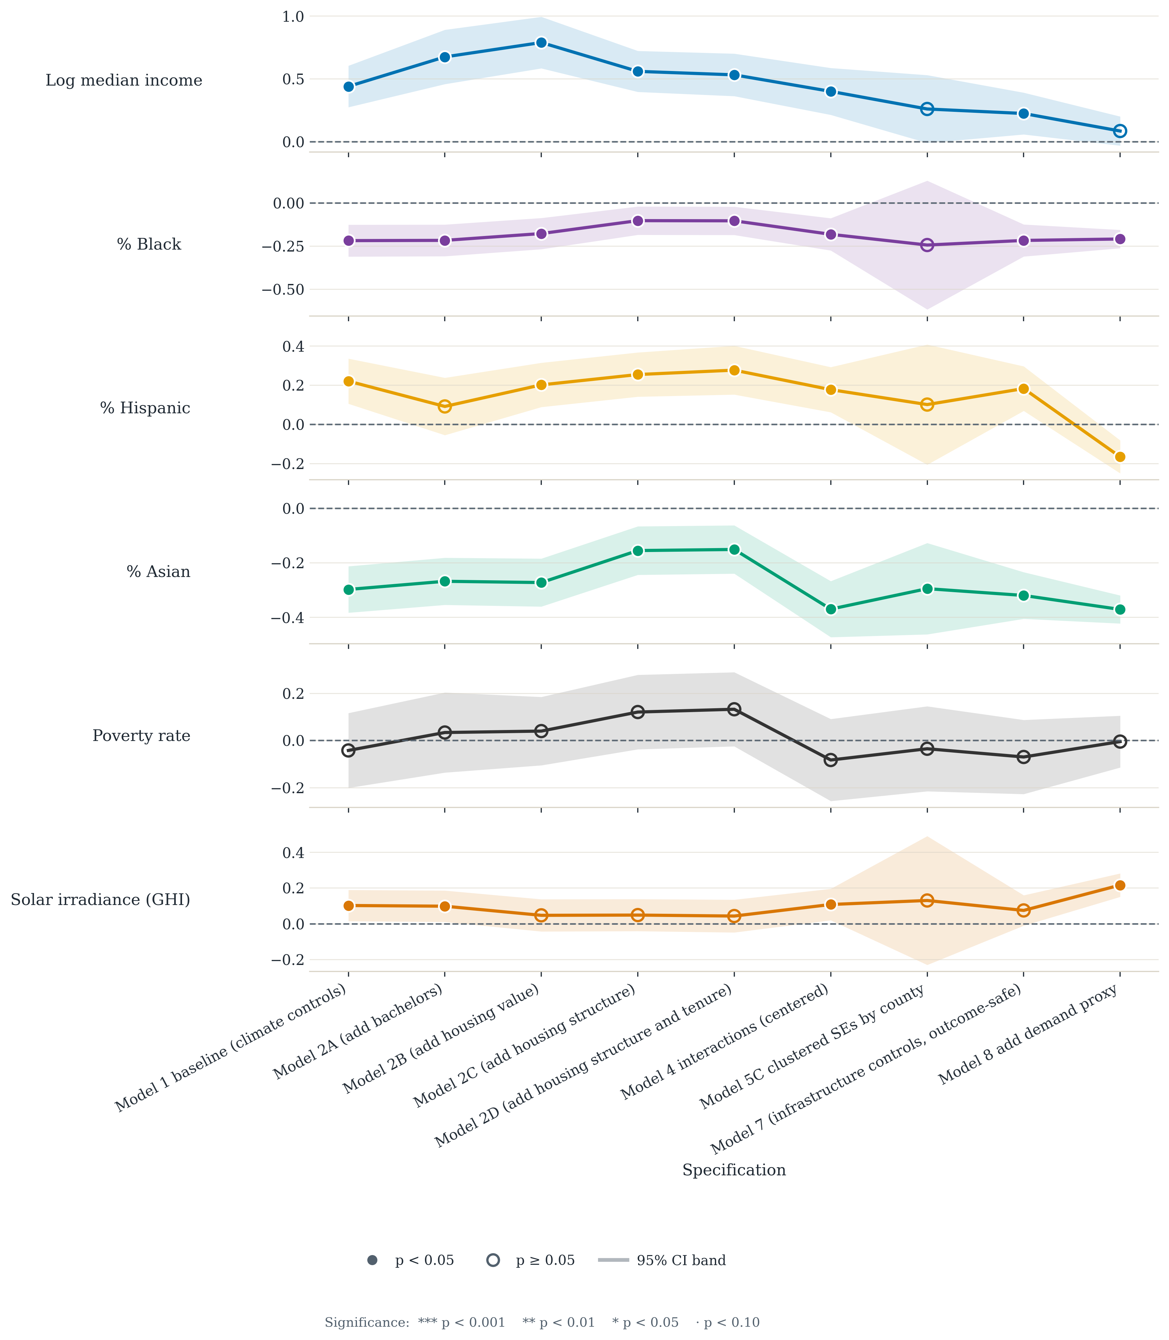
Supplementary Fig. S1 | Rooftop solar: every coefficient across the model series. One panel per coefficient, with 95 percent confidence bands; filled markers denote p < 0.05.
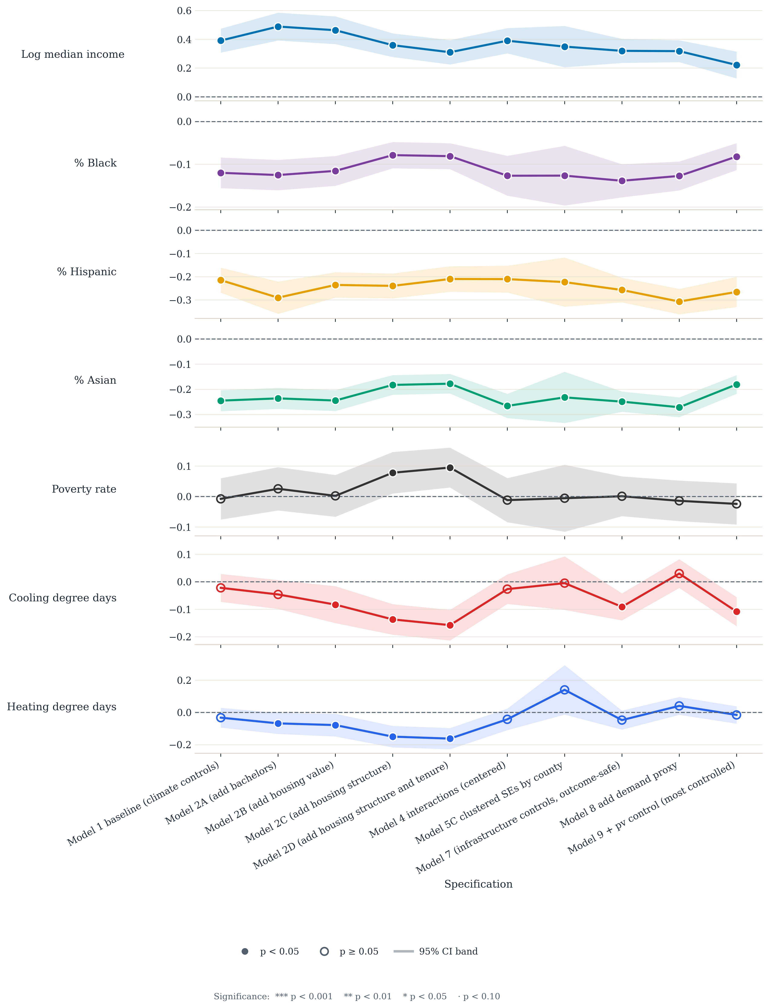
Supplementary Fig. S2 | Battery storage: every coefficient across the model series. The race and ethnicity bands stay clear of zero across every specification, which is the basis for treating storage as the strongest result in the study.
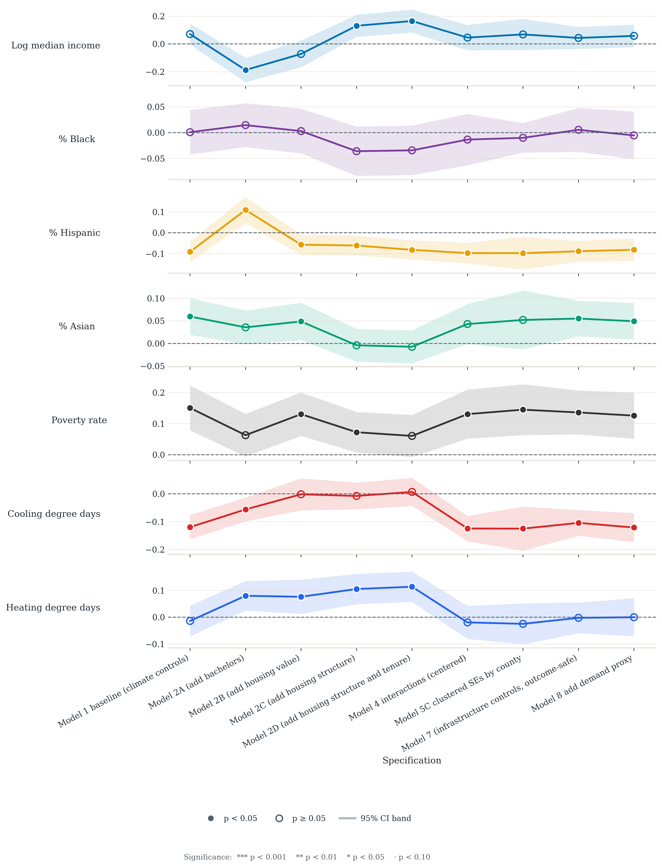
Supplementary Fig. S3 | Aggregate EV charging: every coefficient across the model series. Poverty rate is the only consistently signed predictor; the race terms cross zero.
Supplementary Table S1 | Specifications in the model series. Each varies one control block against the fixed core of income, race and ethnicity shares, poverty rate and the outcome-specific resource control.
Label | Deviation from the core
M1 | Core specification
M2A / M2B | Adds educational attainment, or median housing value
M2C / M2D | Adds exhaustive housing structure, or structure and tenure
M3A / M3B / M3C | Resource control substituted: degree days, mean temperature, or global horizontal irradiance
M4 / M4R | Adds centered income-by-race interactions; M4R drops the poverty control
M5 / M5C | Adds utility fixed effects; M5C re-estimates the core with county-clustered standard errors
M6A / M6B | Replaces the resource control with latitude and longitude, or with county fixed effects
M7 / M7PC | Adds installed infrastructure capacity, in levels or per capita
M8 | Adds the logged electricity-demand proxy
M9 | Storage only: adds local solar deployment
M9A | Energy-burden outcomes: adds DER deployment terms

Supplementary Note S2 | The nested cumulative ladder
Because the model series is not nested, it cannot answer whether the control blocks jointly absorb the race coefficients. We therefore fit a second structure in which each rung is a strict superset of the last. Model C1 is the core specification. C2 adds educational attainment and median housing value. C3 adds housing structure and tenure. C4 adds utility fixed effects. C5 adds county fixed effects with county-clustered standard errors, dropping the ZCTA-level climate control that county fixed effects very nearly absorb; county and utility fixed effects are not stacked with climate in a single design matrix.
Two design decisions matter for how the ladder should be read. First, the cumulative rungs use only pre-treatment confounders. Electricity demand and installed infrastructure capacity sit on the causal path from income and race to adoption, so conditioning on them estimates a direct rather than a total effect; they enter only a separate model, reported as a conservative lower bound and never as the headline estimate. Second, all rungs are fitted on one intersected, listwise-deleted sample — rows non-missing on every variable used anywhere in the ladder, plus the minimum cluster-size filter — so N and cluster count are identical at every rung and coefficient movement reflects controls alone. Interactions stay out of the cumulative ladder and remain their own arm in the model series.
The frozen sample is 1,160 ZCTAs across 42 county clusters, and 1,150 for the two affordability outcomes. It keeps the ZCTAs with complete data on every variable used anywhere in the ladder, in counties with at least five such ZCTAs, which drops 230 of the 1,390 in the baseline sample. 194 lack the electricity-demand proxy, which comes from the ZIP-level usage files of the three investor-owned utilities: half of these have no investor-owned-utility match and lie mostly in Los Angeles, Sacramento and Imperial counties, where municipal and irrigation-district utilities serve much of the load, and the rest are absent from the utilities’ files. A further 9 lack a utility match or housing value, and 27 sit in counties with fewer than five eligible ZCTAs. The dropped ZCTAs are poorer than those retained (median household income $77,600 against $96,400), so the core rung C1 is not Model 1 on a smaller sample of the same population, and some baseline coefficients move between Table 1 and C1 for that reason alone: the solar income coefficient falls from 0.439 to 0.174 and the solar Hispanic-share coefficient from 0.220 to −0.058. Within the ladder the sample is fixed, so movement between rungs reflects controls only. R² climbs monotonically as controls accumulate, from 0.11 to 0.49 for solar, 0.37 to 0.53 for storage and 0.07 to 0.27 for aggregate charging; the largest single jump is the addition of county fixed effects for solar and storage, and of education and housing value for aggregate charging. Supplementary Figure S4 traces the coefficient paths and Supplementary Table S5 reports every coefficient.
The result is weaker than the baseline models imply and is reported that way in the main text. Coefficients attenuate by roughly 40 to 90 percent between C1 and C5. For storage, Black and Asian share survive and Hispanic share stays negative but falls short of the 5 percent level (p = 0.094); for solar only Asian share survives; for aggregate charging none does. This ordering is the same one the model series, the specification curve, the Conley standard errors and the spatial error model produce. The Oster bounds are the exception (Note S4).
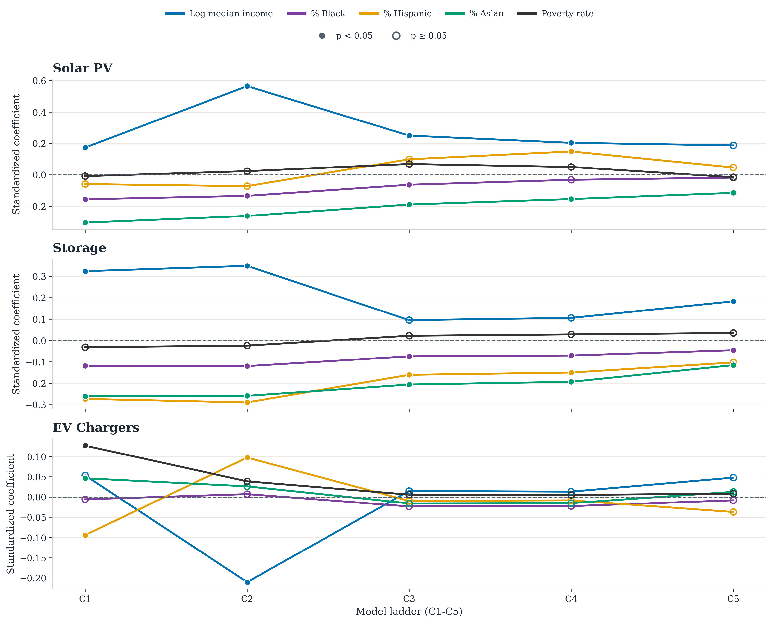
Supplementary Fig. S4 | Coefficients across the nested cumulative ladder, C1 to C5. Standardized predictors; frozen common sample of 1,160 ZCTAs at every rung, so movement reflects added controls rather than sample composition.
Supplementary Table S5 | Nested cumulative ladder, C1 to C5. Standardized predictors; frozen common sample of 1,160 ZCTAs and 42 county clusters, identical at every rung. C5 uses county-clustered standard errors. *p < 0.05, **p < 0.01, ***p < 0.001.
Outcome | Term | C1 | C2 | C3 | C4 | C5
Rooftop solar | Log income | 0.174** | 0.565*** | 0.250** | 0.204* | 0.188
Rooftop solar | Black share | -0.155*** | -0.133*** | -0.062* | -0.031 | -0.017
Rooftop solar | Hispanic share | -0.058 | -0.071 | 0.100 | 0.150* | 0.047
Rooftop solar | Asian share | -0.303*** | -0.261*** | -0.188*** | -0.153*** | -0.114**
Battery storage | Log income | 0.324*** | 0.349*** | 0.095 | 0.106 | 0.183**
Battery storage | Black share | -0.118*** | -0.119*** | -0.074*** | -0.070*** | -0.045*
Battery storage | Hispanic share | -0.272*** | -0.289*** | -0.160*** | -0.150*** | -0.102
Battery storage | Asian share | -0.260*** | -0.258*** | -0.205*** | -0.193*** | -0.115***
EV charging | Log income | 0.054 | -0.210*** | 0.015 | 0.013 | 0.048
EV charging | Black share | -0.006 | 0.007 | -0.023 | -0.022 | -0.008
EV charging | Hispanic share | -0.094*** | 0.097** | -0.010 | -0.008 | -0.037
EV charging | Asian share | 0.046* | 0.026 | -0.016 | -0.015 | 0.013

Supplementary Table S6 | Battery storage conditional on local solar deployment. This model conditions on a parallel outcome of the same predictors and is not a better-identified estimate of the storage gap. Standardized predictors; HC1 standard errors.
Predictor | Coefficient | Robust SE | p-value
log_median_household_income | 0.221*** | 0.048 | < 0.001
pct_black | -0.082*** | 0.016 | < 0.001
pct_hispanic | -0.266*** | 0.033 | < 0.001
pct_asian | -0.181*** | 0.019 | < 0.001
pct_bachelors_plus | 0.017 | 0.043 | 0.692
y_pv | 0.523*** | 0.048 | < 0.001

Supplementary Note S3 | Specification curve
A specification curve asks how much a reported coefficient depends on which controls happened to be included. We enumerate every subset of the six confounder blocks and fit each on every ZCTA with complete data for that combination (1,282 to 1,390 ZCTAs; unlike the nested ladder, the sample is not held fixed), recording the four focal terms. Of the 64 possible combinations, 16 stack county and utility fixed effects together — near-collinear, near-exhaustive partitions of the same ZCTAs — and are excluded, leaving 48 valid specifications per outcome.
Supplementary Figure S5 plots, for each outcome and each race and ethnicity term, the sorted standardized coefficient with its 95 percent confidence band, with the block-membership matrix below. The summary counts appear in Table 2 of the main text: the number of specifications, out of 48, in which a coefficient is both significant at the 5 percent level and same-signed as the median across all 48.
Three readings are worth drawing out. Storage is the most reproducible result in the study: Asian share is significant and same-signed in 48 of 48, Hispanic share in 48, Black share in 36. Solar is intermediate, at 34, 31 and 28. Aggregate charging is fragile on race terms: the Black-share coefficient is significant in 0 of 48, the Asian-share coefficient in 4 and the Hispanic-share coefficient in 21. Wind is weakest of all, at 0 of 48 on every term, consistent with its treatment as contextual rather than headline material.
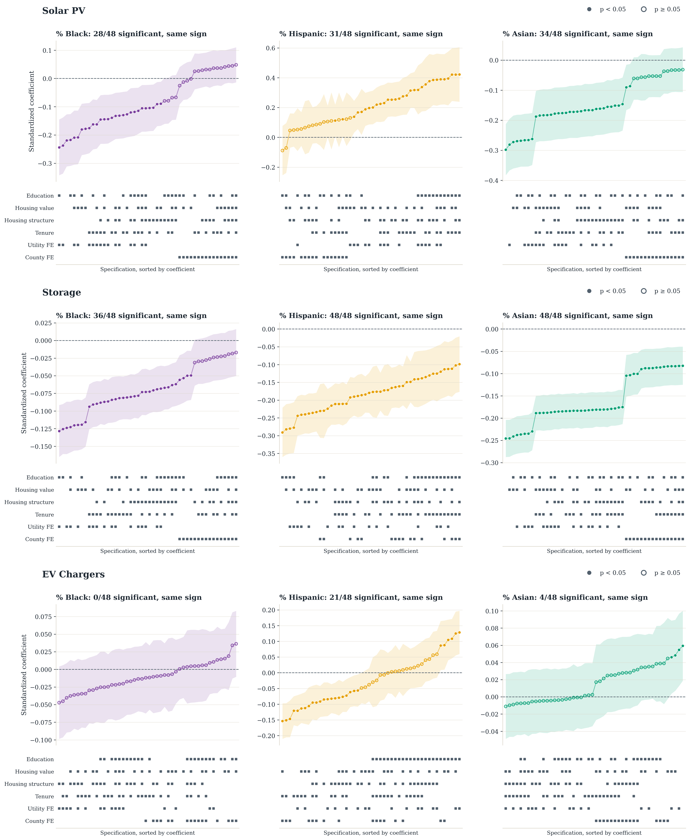
Supplementary Fig. S5 | Specification curves for the race and ethnicity coefficients. Rows are rooftop solar, battery storage and aggregate EV charging; columns are Black, Hispanic and Asian share. Each panel sorts the standardized coefficient across all 48 valid combinations of the six confounder blocks, with its 95 percent confidence band above and the block-membership matrix below. Filled markers denote p < 0.05, hollow p ≥ 0.05. Panel titles give the number of specifications in which the coefficient is significant and same-signed as the median, as reported in Table 2.

Supplementary Note S4 | Oster bounds on omitted-variable bias
Oster's δ asks how strong selection on unobservables would have to be, relative to selection on the observed confounders, to drive a coefficient to zero. We compare the core specification with the saturated confounder model, setting R²max to 1.3 times the saturated R² and capping it at one. A value of δ ≥ 1 is the conventional robustness threshold: the omitted-variable bias would have to exceed the observed selection.
Three coefficients clear that threshold: solar Asian share at 1.56, charging Hispanic share at 1.58 and storage income at 1.34. The storage race terms do not: δ is 0.81 for Asian share, 0.62 for Hispanic share and 0.63 for Black share, so selection on unobservables somewhat weaker than selection on the observed confounders would be enough to zero them out. The storage result therefore rests on the stability of its coefficients across specifications and on spatially robust inference, not on this bound.
δ is not interpretable everywhere, and that is itself informative. The formula assumes that adding controls moves a coefficient toward zero. For the solar income term and for aggregate charging the full confounder set increases the coefficient instead — solar income moves from 0.43 to 0.47 on the raw scale — so the returned values (−35.1 and +21.2) do not mean what δ normally means. We report δ only where the sign behaves as the method assumes, and treat the non-attenuation as a separate qualitative finding, discussed in the main text. Supplementary Table S7 reports every cell with the underlying β and R² values.
Supplementary Table S7 | Oster δ bounds, core specification versus the saturated confounder model. δ ≥ 1 is the conventional robustness threshold. Negative or very large values indicate that adding controls increased rather than attenuated the coefficient, so the bound does not apply.
Outcome | Term | β restricted | β full | R² restricted | R² full | δ
Rooftop solar | Log income | 0.432 | 0.467 | 0.109 | 0.492 | -35.10
Rooftop solar | Black share | -2.418 | -0.265 | 0.109 | 0.492 | 0.32
Rooftop solar | Hispanic share | -0.243 | 0.198 | 0.109 | 0.492 | -1.17
Rooftop solar | Asian share | -2.145 | -0.806 | 0.109 | 0.492 | 1.56
Battery storage | Log income | 0.805 | 0.456 | 0.369 | 0.533 | 1.34
Battery storage | Black share | -1.848 | -0.701 | 0.369 | 0.533 | 0.63
Battery storage | Hispanic share | -1.138 | -0.428 | 0.369 | 0.533 | 0.62
Battery storage | Asian share | -1.838 | -0.812 | 0.369 | 0.533 | 0.81
EV charging | Log income | 0.133 | 0.119 | 0.072 | 0.268 | 21.22
EV charging | Black share | -0.088 | -0.127 | 0.072 | 0.268 | -8.07
EV charging | Hispanic share | -0.393 | -0.154 | 0.072 | 0.268 | 1.58
EV charging | Asian share | 0.328 | 0.091 | 0.072 | 0.268 | 0.94

Supplementary Note S5 | Functional form, weighting and spatial models
Three features of the design invite objections that can be tested directly rather than argued about.
Functional form: The outcomes are population-normalized rates entered as log(1 + rate), which keeps ZCTAs with zero deployment in the sample but handles the zeros only implicitly. Supplementary Table S8 reports Poisson pseudo-maximum-likelihood models fitted to the raw counts with log population as an offset, which handle the zeros directly. Every headline sign and significance is reproduced: solar Black share −2.13 and Asian share −1.99, storage Black share −1.53, Hispanic share −0.82 and Asian share −1.76, all at p < 0.01, with aggregate charging Black share indistinguishable from zero and Hispanic share negative. Negative binomial fits agree for solar and storage; for aggregate charging the Hispanic-share coefficient stays negative but is not significant.
Weighting: The population floor is 1,000 residents, so unweighted regressions give a 1,100-person ZCTA the same leverage as a 90,000-person one. Supplementary Table S9 reports population-weighted estimates. The solar and storage race coefficients hold, attenuating modestly. Two charging coefficients move: Black share becomes negative and significant under weighting, and Asian share becomes indistinguishable from zero, which is further reason not to build an interpretation on the aggregate charging race terms.
Spatial structure: Conley standard errors correct inference for spatial dependence but leave the conditional mean untouched, so spatially structured omitted variables — installer density, permitting regimes, local program administration — can still bias the coefficients. Supplementary Table S10 reports maximum-likelihood spatial error models on eight-nearest-neighbor weights. The spatial autoregressive parameter is large (λ = 0.85 for solar, 0.70 for storage, 0.45 for charging), confirming that a great deal of the structure is spatial. All three storage race coefficients remain negative and significant; solar survives for Asian share (−0.070, p = 0.012) but not Black share (p = 0.259); charging survives for Hispanic share and, with a positive sign, for Asian share. Two methods that treat spatial structure very differently therefore produce the same ordering.
Supplementary Table S8 | Poisson pseudo-maximum-likelihood models on raw counts with a population offset. Fitted directly to counts rather than to a log(1 + rate) transformation, so structural zeros are handled without transformation. HC1 standard errors.
Outcome | Term | Coefficient | Std. error | p | N
chargers (aggregate) | Log income | 0.892 | 0.251 | 0.000 | 1390
chargers (aggregate) | Black share | -0.577 | 0.745 | 0.439 | 1390
chargers (aggregate) | Hispanic share | -1.367 | 0.262 | 0.000 | 1390
chargers (aggregate) | Asian share | 0.235 | 0.301 | 0.435 | 1390
Level 2 chargers | Log income | 1.068 | 0.302 | 0.000 | 1390
Level 2 chargers | Black share | -0.137 | 0.846 | 0.871 | 1390
Level 2 chargers | Hispanic share | -1.536 | 0.328 | 0.000 | 1390
Level 2 chargers | Asian share | 0.375 | 0.356 | 0.292 | 1390
DC fast chargers | Log income | 0.294 | 0.247 | 0.234 | 1390
DC fast chargers | Black share | -1.583 | 0.922 | 0.086 | 1390
DC fast chargers | Hispanic share | -0.732 | 0.263 | 0.005 | 1390
DC fast chargers | Asian share | -0.094 | 0.272 | 0.730 | 1390
storage MW | Log income | 1.196 | 0.143 | 0.000 | 1390
storage MW | Black share | -3.197 | 0.699 | 0.000 | 1390
storage MW | Hispanic share | -1.104 | 0.210 | 0.000 | 1390
storage MW | Asian share | -1.767 | 0.243 | 0.000 | 1390
PV capacity | Log income | 0.477 | 0.138 | 0.001 | 1390
PV capacity | Black share | -2.127 | 0.534 | 0.000 | 1390
PV capacity | Hispanic share | -0.509 | 0.138 | 0.000 | 1390
PV capacity | Asian share | -1.986 | 0.192 | 0.000 | 1390
Supplementary Table S9 | Population-weighted versus unweighted baseline estimates. Standardized predictors; weights are ZCTA total population.
Outcome | Term | Unweighted | p | Weighted | p | N
Rooftop solar | Log income | 0.439 | 0.000 | 0.651 | 0.000 | 1390
Rooftop solar | Black share | -0.219 | 0.000 | -0.141 | 0.003 | 1390
Rooftop solar | Hispanic share | 0.220 | 0.000 | 0.179 | 0.021 | 1390
Rooftop solar | Asian share | -0.298 | 0.000 | -0.272 | 0.000 | 1390
Battery storage | Log income | 0.390 | 0.000 | 0.420 | 0.000 | 1390
Battery storage | Black share | -0.120 | 0.000 | -0.084 | 0.000 | 1390
Battery storage | Hispanic share | -0.215 | 0.000 | -0.155 | 0.000 | 1390
Battery storage | Asian share | -0.246 | 0.000 | -0.187 | 0.000 | 1390
EV charging | Log income | 0.070 | 0.073 | 0.157 | 0.000 | 1390
EV charging | Black share | 0.001 | 0.974 | -0.041 | 0.008 | 1390
EV charging | Hispanic share | -0.091 | 0.000 | -0.139 | 0.000 | 1390
EV charging | Asian share | 0.059 | 0.004 | 0.010 | 0.617 | 1390
Supplementary Table S10 | Spatial error model, maximum likelihood, eight-nearest-neighbor weights. Standardized predictors; λ is the spatial autoregressive error parameter.
Outcome | Term | Coefficient | Std. error | p | λ | N
Rooftop solar | Log income | 0.203 | 0.036 | 0.000 | 0.85 | 1390
Rooftop solar | Black share | -0.028 | 0.025 | 0.259 | 0.85 | 1390
Rooftop solar | Hispanic share | -0.045 | 0.030 | 0.127 | 0.85 | 1390
Rooftop solar | Asian share | -0.070 | 0.028 | 0.012 | 0.85 | 1390
Battery storage | Log income | 0.418 | 0.041 | 0.000 | 0.70 | 1390
Battery storage | Black share | -0.086 | 0.028 | 0.002 | 0.70 | 1390
Battery storage | Hispanic share | -0.277 | 0.033 | 0.000 | 0.70 | 1390
Battery storage | Asian share | -0.171 | 0.030 | 0.000 | 0.70 | 1390
EV charging | Log income | 0.001 | 0.052 | 0.985 | 0.45 | 1390
EV charging | Black share | 0.025 | 0.033 | 0.442 | 0.45 | 1390
EV charging | Hispanic share | -0.119 | 0.039 | 0.002 | 0.45 | 1390
EV charging | Asian share | 0.083 | 0.036 | 0.021 | 0.45 | 1390

Supplementary Note S6 | Housing structure and tenure
Housing is tested directly rather than left as a proposed mechanism. Model 2C adds the exhaustive ACS B25024 structure composition and Model 2D adds B25003 owner occupancy. Structure coefficients use single-family housing as the omitted reference, and tenure uses renters as the omitted reference.
Supplementary Table S2 reports the coefficient pairs behind the attenuation figure in the main text. Area-level housing composition absorbs 52 percent of the solar Black-share coefficient, 49 percent of the solar Asian-share coefficient, 32 percent of the storage Black-share coefficient and 27 percent of the storage Asian-share coefficient. For aggregate charging the Asian-share coefficient collapses from positive to indistinguishable from zero.
Movement toward zero is attenuation associated with area-level housing composition. These models observe the housing stock of an area, not the tenure or roof access of any household, so they cannot identify the household-level mechanism; what they establish is that a substantial share of what reads as a racial gap tracks the housing stock, and that a substantial share does not.
Supplementary Table S2 | Race-coefficient attenuation after adding housing structure and tenure. Standardized coefficients; baseline versus the specification adding exhaustive ACS B25024 structure shares and B25003 owner occupancy.
Outcome | Term | Baseline | + structure & tenure | Attenuation
Rooftop solar | Black share | −0.219 | −0.104 | 52%
Rooftop solar | Asian share | −0.298 | −0.151 | 49%
Battery storage | Black share | −0.120 | −0.081 | 32%
Battery storage | Asian share | −0.246 | −0.178 | 27%
Aggregate charging | Asian share | 0.059 | −0.008 | not distinguishable from zero

Supplementary Note S7 | Descriptive gradients
The regression tables summarize conditional associations, but the raw outcome gradients are also informative. Supplementary Figure S6 plots a combined non-white racial share against the three headline outcomes using deterministic LOWESS smoothing with seeded 95 percent bootstrap confidence intervals. The fitted gradients are negative for all three technologies, with the largest descriptive decline for storage. Over the middle 90 percent of the observed predictor range, the fitted endpoint change is about −1.04 for solar, −1.64 for storage and −0.05 for aggregate charging. These are descriptive summaries rather than causal effects, but they reinforce the regression finding that more heavily non-white ZCTAs tend to be less served across multiple outcomes.
Supplementary Figure S7 provides the corresponding education view. The LOWESS fits show a negative unconditional gradient for solar (−0.60) but positive gradients for storage (1.67) and charging (1.17). The corresponding standardized Model 2 charging regression also estimates a positive education coefficient (0.435, p < 0.001), indicating that bachelor's attainment is positively associated with aggregate charger deployment. Education is treated throughout as a control rather than as a headline predictor: it captures information, housing-market position and adoption capacity that overlap with income, and the central question is whether race remains associated with deployment once those proxies are included.
Supplementary Figure S8 shows the underlying distributions. The three outcomes are strongly right-skewed and the socioeconomic context variables span materially different neighborhood conditions, which is the reason for both the log(1 + rate) transformation and the standardized reporting scale.
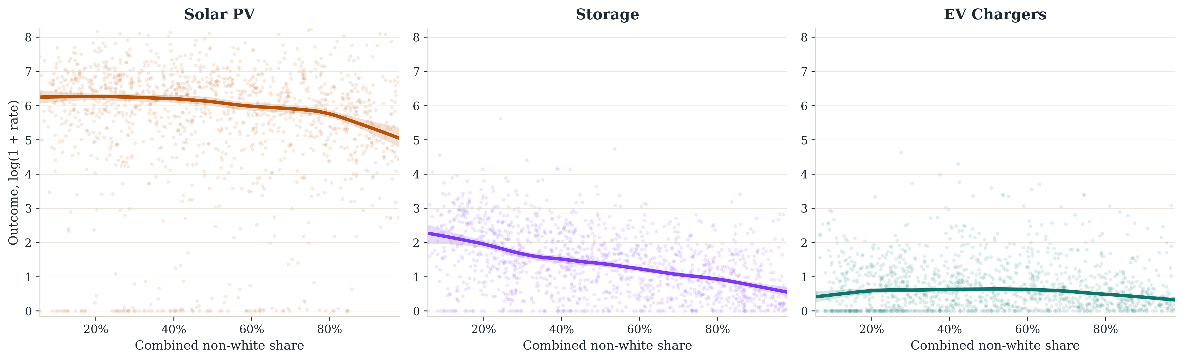
Supplementary Fig. S6 | Descriptive LOWESS gradients between combined non-white share and the three headline outcomes. Shaded ribbons are 95 percent bootstrap confidence intervals; these panels do not condition on the full control set.
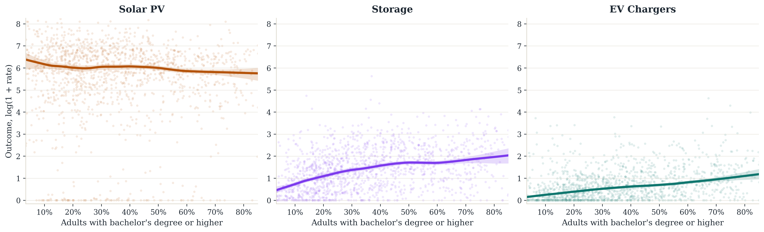
Supplementary Fig. S7 | Descriptive LOWESS gradients between bachelor’s-degree attainment and the three headline outcomes.
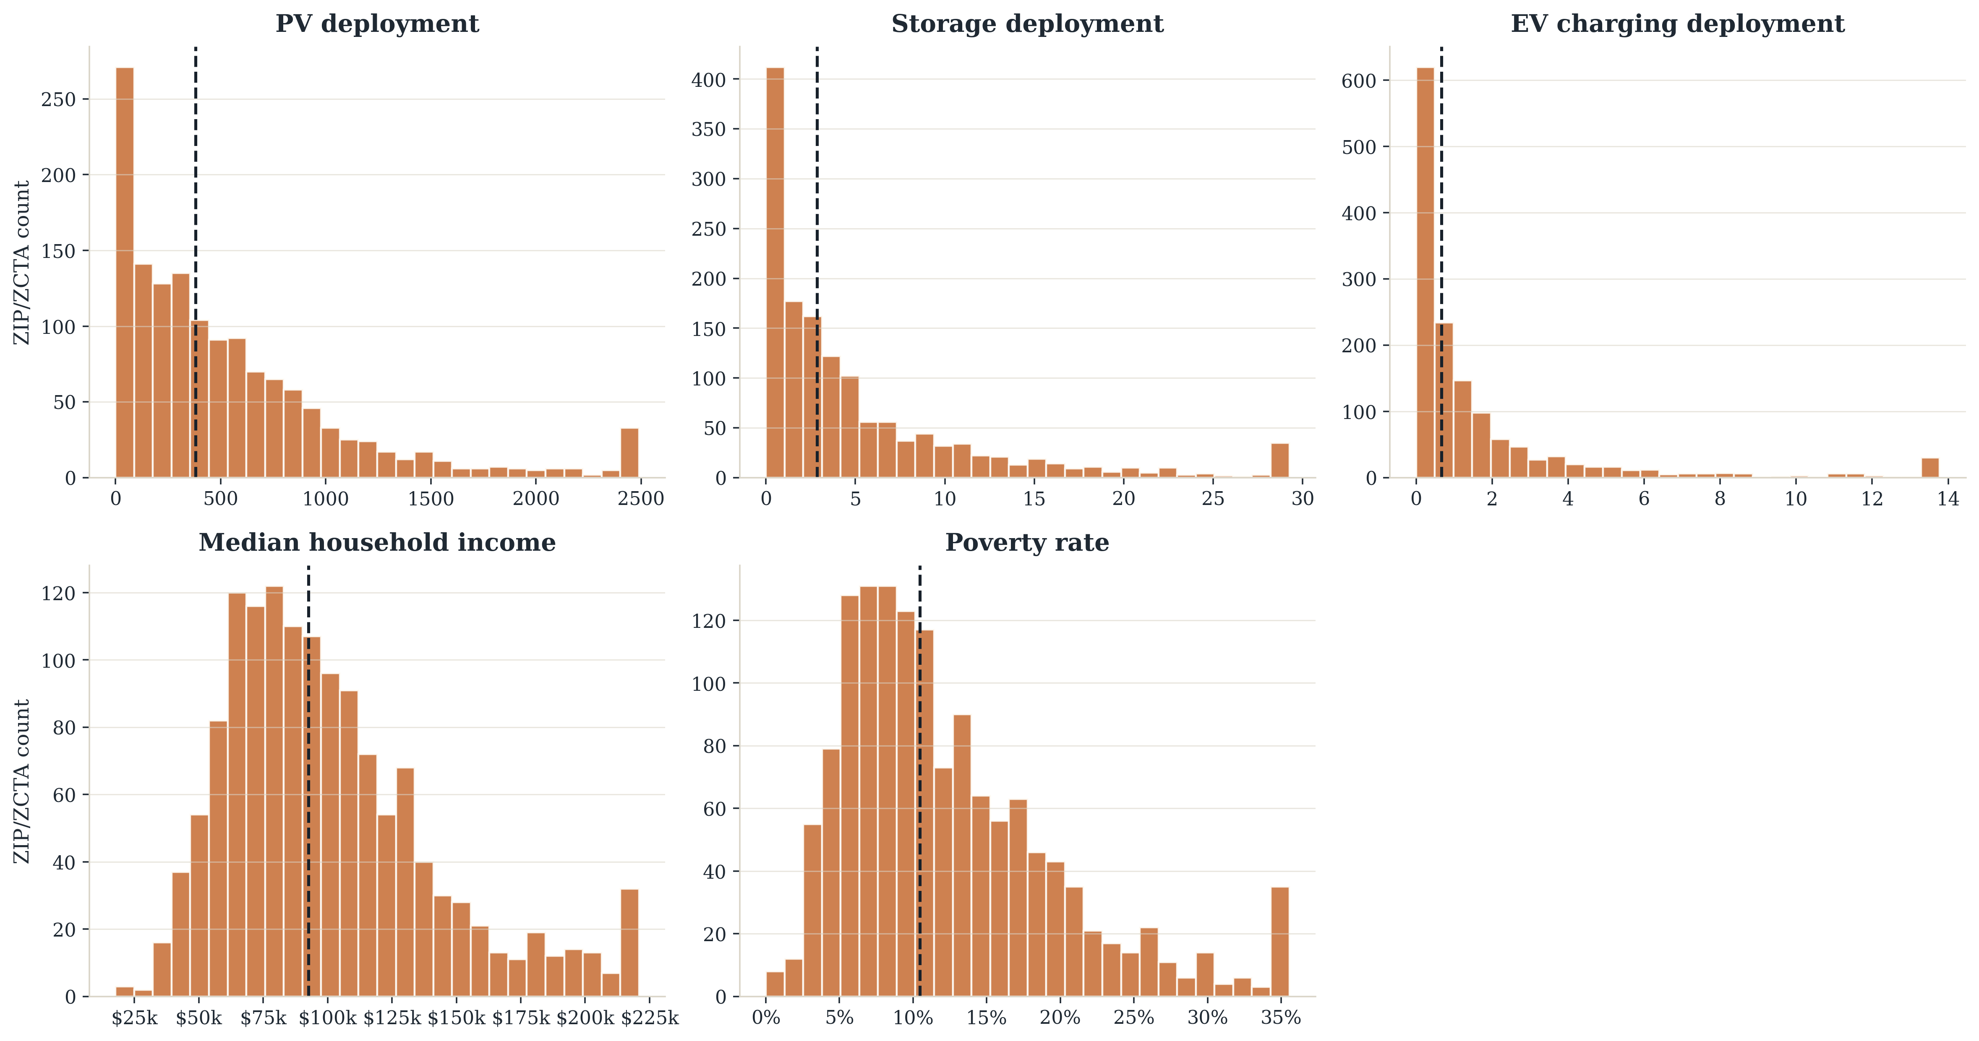
Supplementary Fig. S8 | Distributions of raw deployment rates together with median household income and poverty rate.

Supplementary Note S8 | Underlying patterns behind neighborhoods
In addition to the regression work, we use principal component analysis and K-means clustering to summarize ZCTA contexts in the statewide sample. This is descriptive rather than causal. The cluster map in Supplementary Figure S9 shows that the resulting profiles are spatially coherent rather than randomly scattered. Cluster identifiers are ordered by mean household income for stable interpretation. Supplementary Table S16 shows that clusters 1 and 2 are the lowest-income and most heavily Hispanic profiles; cluster 5 combines high income, the largest Asian share and the strongest charging outcome; and cluster 6 is the highest-income profile and has the strongest storage outcome. Two features are worth noting against the main results. The highest-Asian-share clusters are also the highest-income clusters, which is what makes an income-based reading of their low solar and storage deployment hard to sustain. And the cluster with the strongest charging outcome is not the cluster with the strongest storage outcome, which is the typology-level version of the paper's central point: technology access is shaped by bundles of demographic, economic, housing and infrastructural conditions rather than by one variable in isolation.
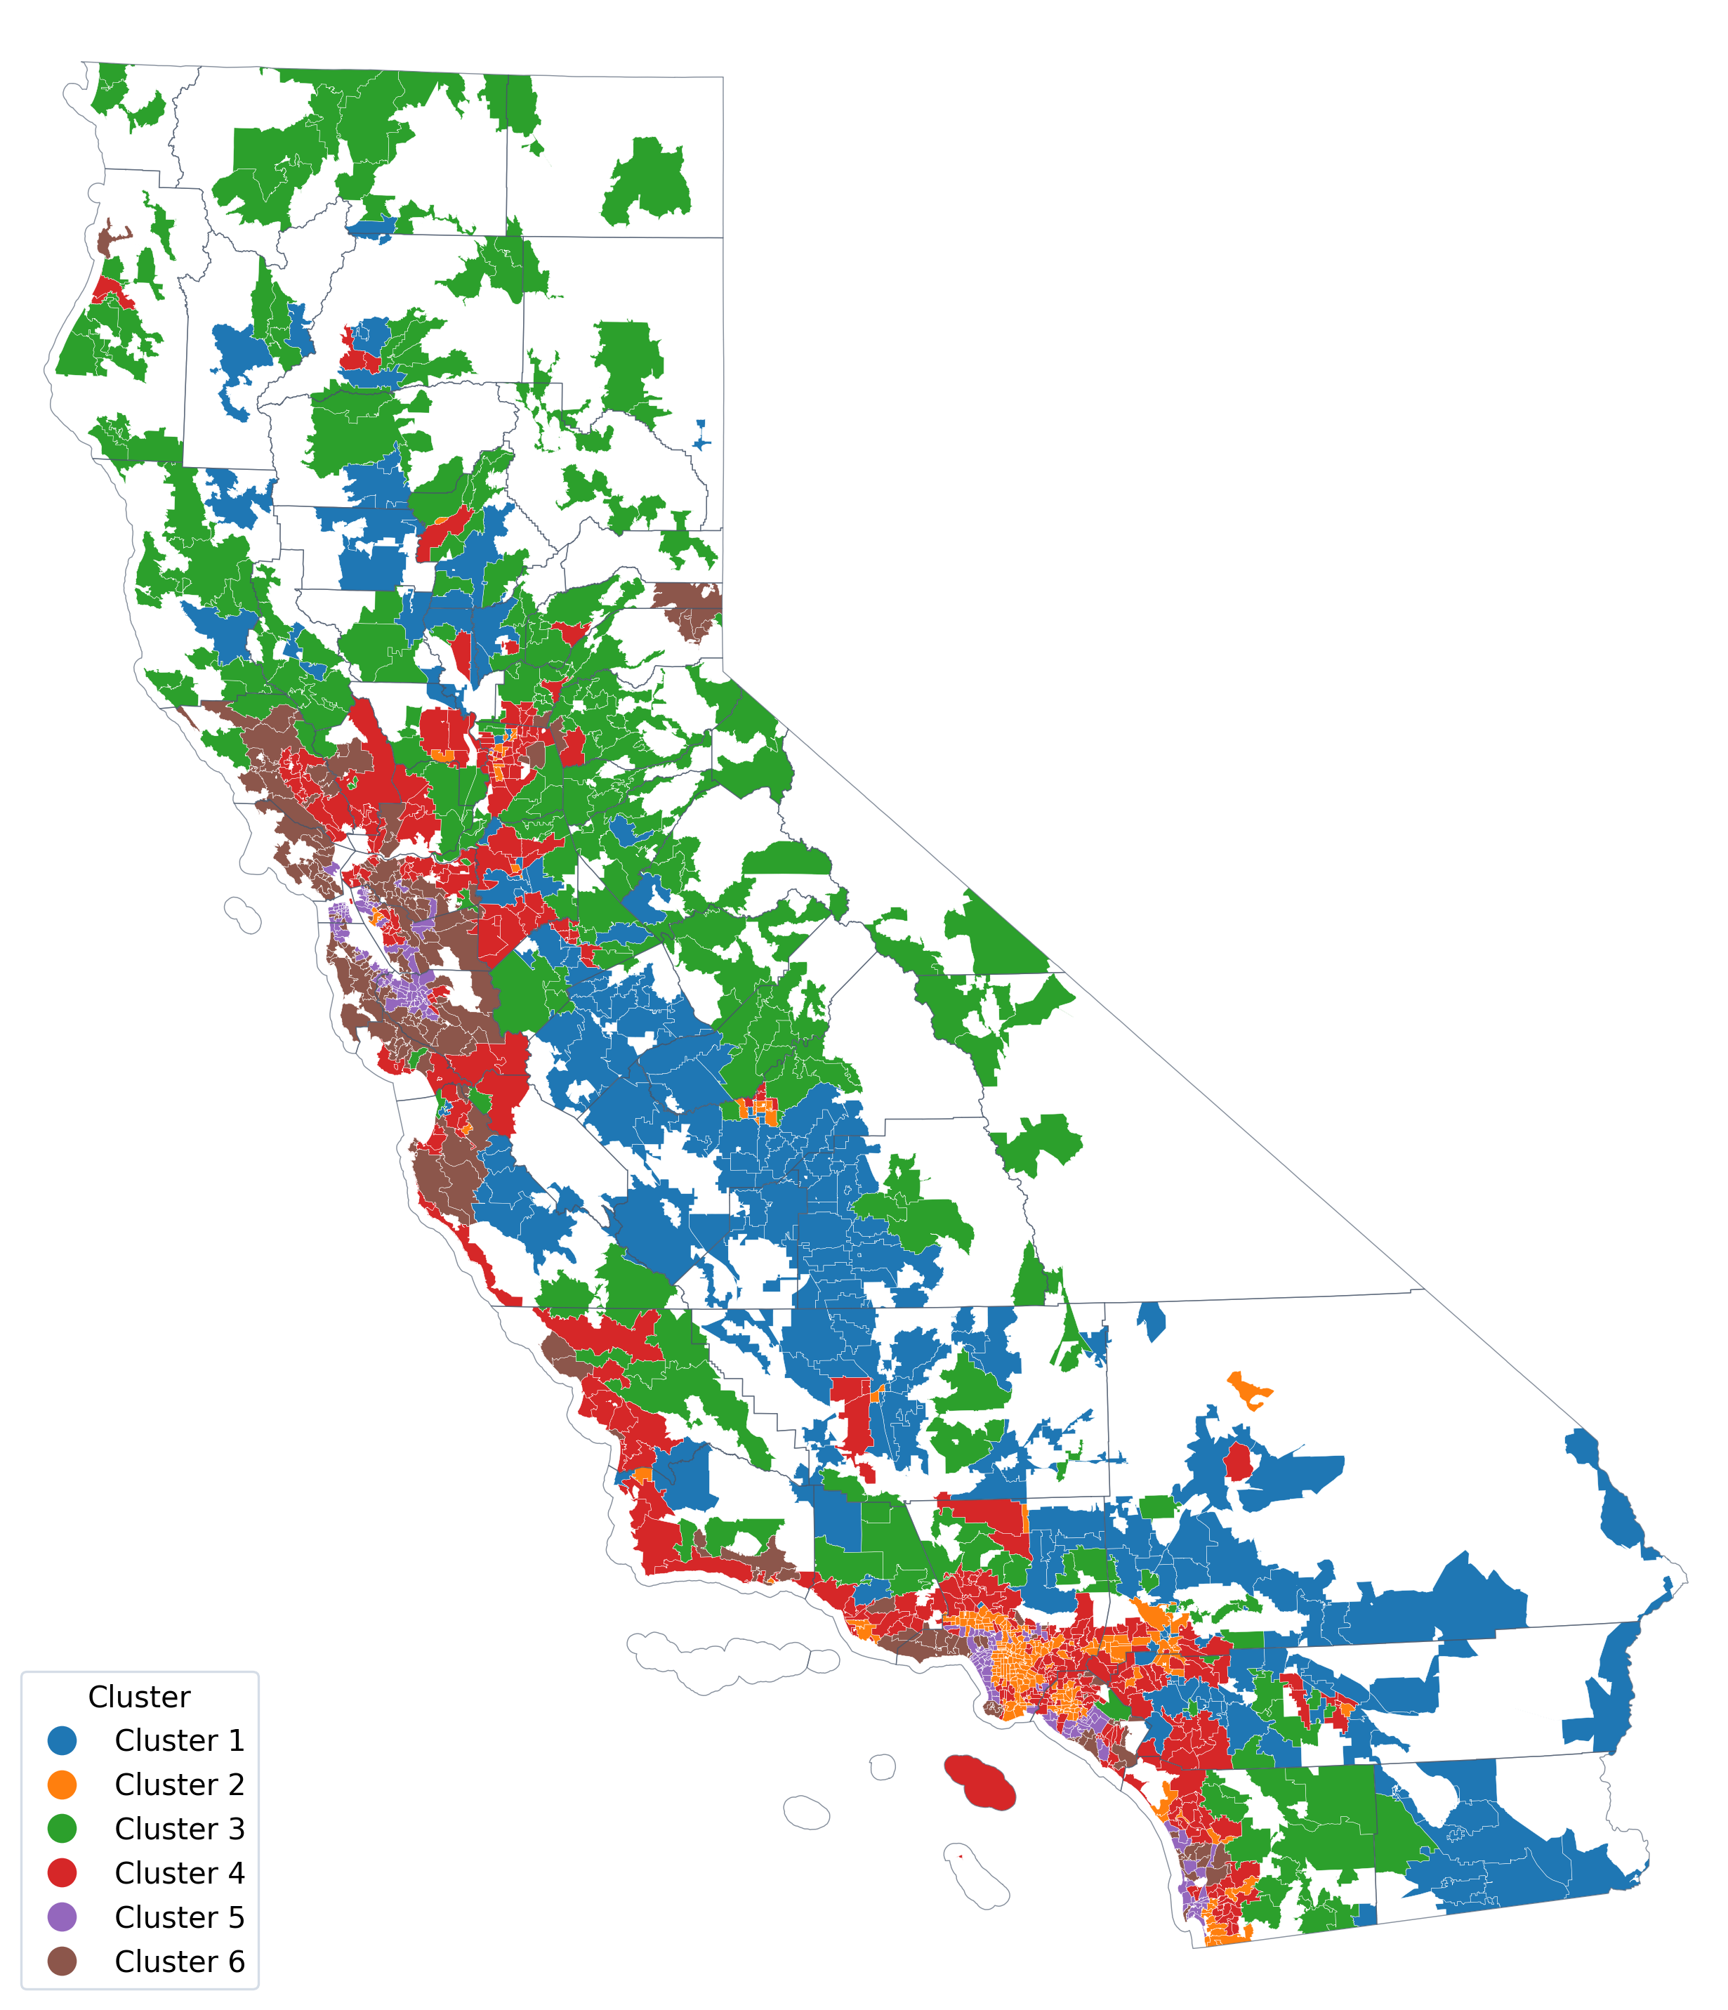
Supplementary Fig. S9 | California ZCTA clusters from exploratory principal-component and K-means analysis. Cluster identifiers run from lowest to highest mean household income.
Supplementary Table S16 | Cluster-profile means from the principal-component and K-means assignment.
Cluster | N ZIPs | Income | Poverty | Black | Hispanic | Asian | Residual white/other share | PV kW / 1k | Storage / 100k | Chargers / 1k
Cluster 1 | 219 | $61.3k | 20.5% | 3.6% | 60.5% | 3.7% | 32.2% | 1,027 | 2.23 | 1.32
Cluster 2 | 210 | $71.6k | 17.5% | 8.5% | 55.0% | 12.3% | 24.2% | 214 | 1.63 | 1.91
Cluster 3 | 254 | $85.6k | 11.2% | 1.2% | 21.6% | 2.2% | 75.0% | 840 | 8.71 | 1.65
Cluster 4 | 353 | $105.1k | 9.4% | 5.0% | 34.4% | 14.3% | 46.4% | 492 | 4.41 | 1.09
Cluster 5 | 172 | $132.4k | 9.6% | 4.8% | 18.0% | 26.0% | 51.2% | 250 | 4.13 | 4.65
Cluster 6 | 182 | $165.2k | 6.2% | 1.9% | 14.8% | 17.0% | 66.3% | 647 | 13.41 | 2.45

Supplementary Note S9 | Energy burden and affordability
The energy-burden outcomes provide affordability context for the DER results rather than cleanly orthogonal controls. In the matched sample, mean energy burden is about 2.2 percent with an interquartile range from roughly 1.5 to 2.8 percent, and burden is strongly negatively correlated with log median household income (−0.746) and positively correlated with poverty rate (0.544). The level sits below commonly cited household energy-burden estimates because the California Energy Commission series covers electricity costs rather than total household energy expenditure; it should be read as a relative affordability-stress index rather than a total-burden measure. Supplementary Figure S10 shows the descriptive gradients linking neighborhood characteristics to both affordability outcomes.
In the baseline model with energy burden as the outcome, income is strongly negative (−0.0097, p < 0.001), Hispanic share is positive (0.0033, p < 0.001) and Asian share is negative (−0.0079, p < 0.001), while the Black share and poverty rate are close to zero after the included controls. Supplementary Figure S12 traces these coefficients across the model series.
The per-capita affordability gap requires care. Its distribution is severely skewed: the median ZCTA reports about $75 while the maximum exceeds $236,000, and the top 100 ZCTAs account for 92 percent of the statewide total. We attribute this to error in the source series rather than to real variation. Main-text estimates therefore exclude the 134 ZCTAs whose per-capita gap exceeds $1,000, a threshold roughly thirteen times the median; Supplementary Table S11 reports both samples. In the full sample, Asian share is positively associated with the affordability gap (0.243, p = 0.010); with the outliers removed, the association disappears entirely (−0.045, p = 0.477), and R² rises from 0.32 to 0.45, so we do not report that original association as a finding.
Model 9A reverses the direction of the question and adds the DER outcomes as predictors of affordability. Aggregate charging is the clearest case, with a negative association with energy burden (−0.0010, p < 0.001) and a positive association with the logged affordability gap (0.997, p < 0.001). Solar is positive for energy burden (0.0008, p < 0.001) but not for the affordability gap. Storage is negative for energy burden (−0.0011, p < 0.001) but not significant for the affordability gap (p = 0.384), and the demand proxy is not significant for either outcome. Because the DER terms are themselves outcomes of the same demographic predictors, these coefficients describe associations and should not be read causally. Supplementary Figure S11 reports them.
Taken together these results reinforce the main text's interpretation: affordability stress is itself spatially and demographically structured, but it does not make the DER outcomes interchangeable. Solar and storage remain tied to different race and income patterns than aggregate charging, and the charging result still appears to reflect a mix of infrastructure siting and household-serving access rather than a single uniform affordability channel.
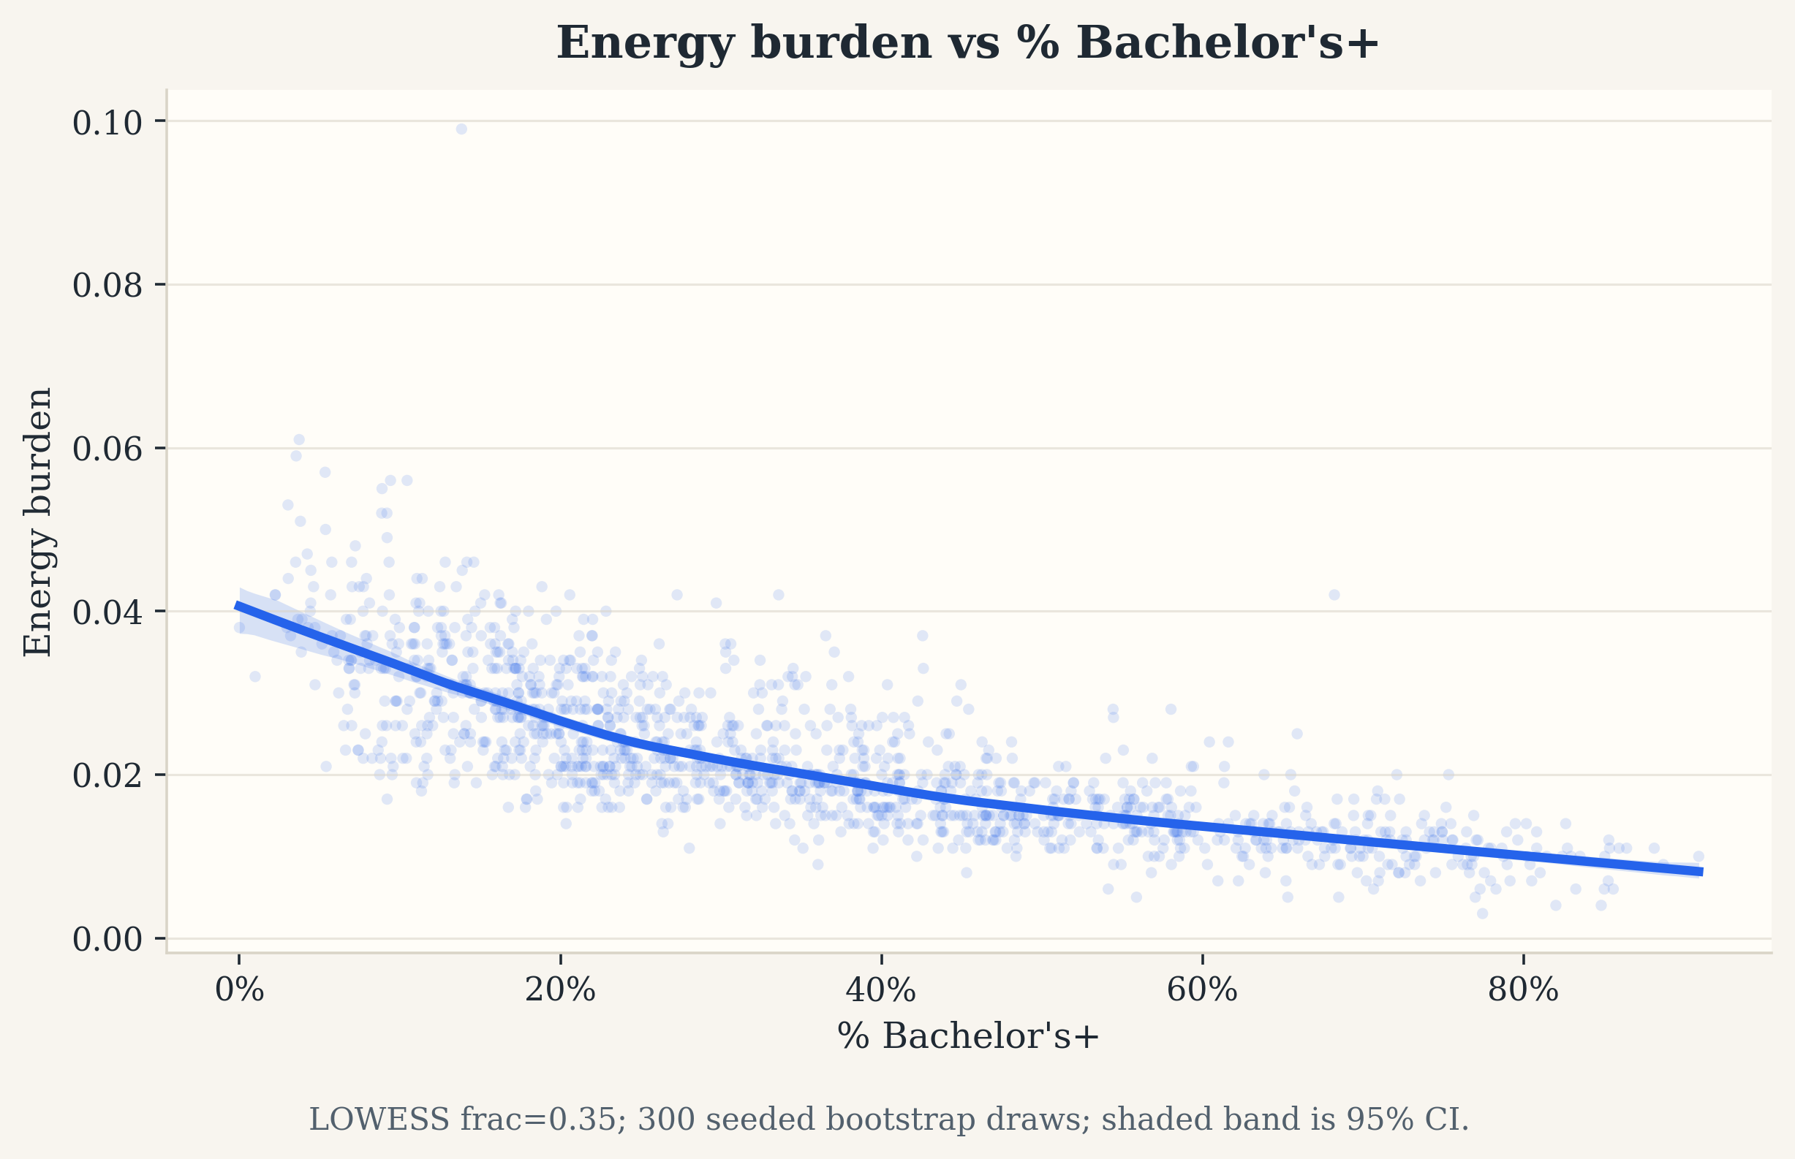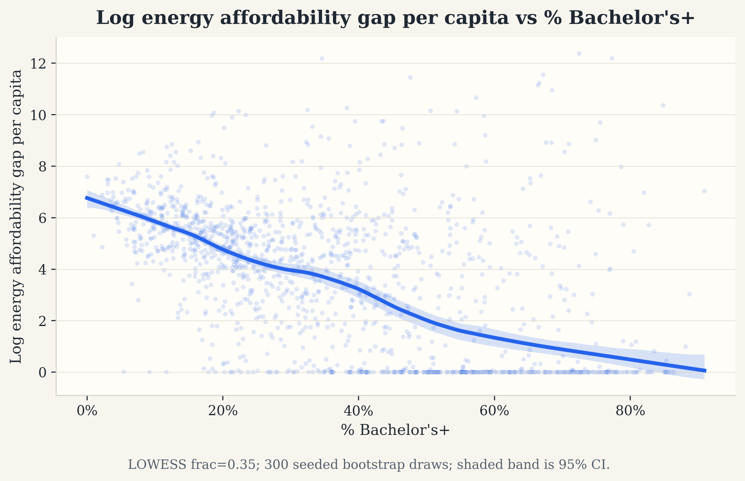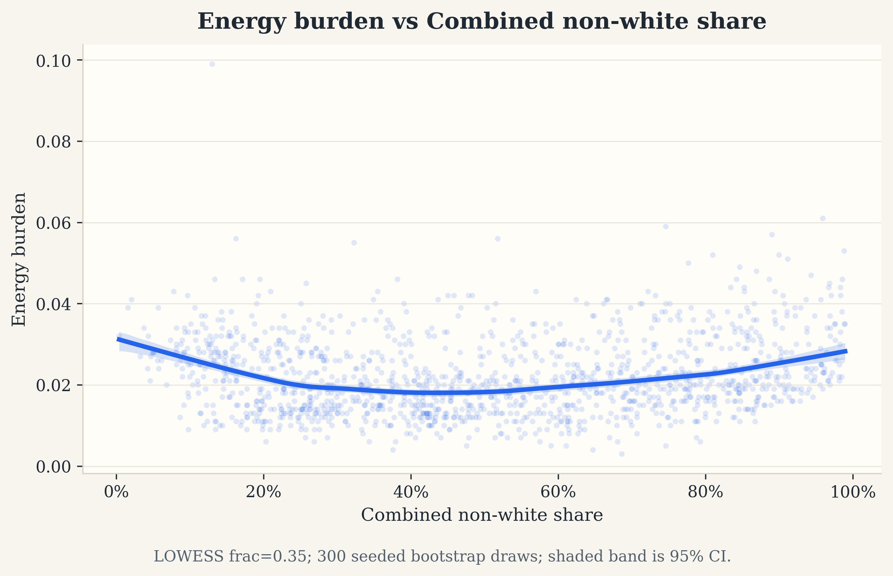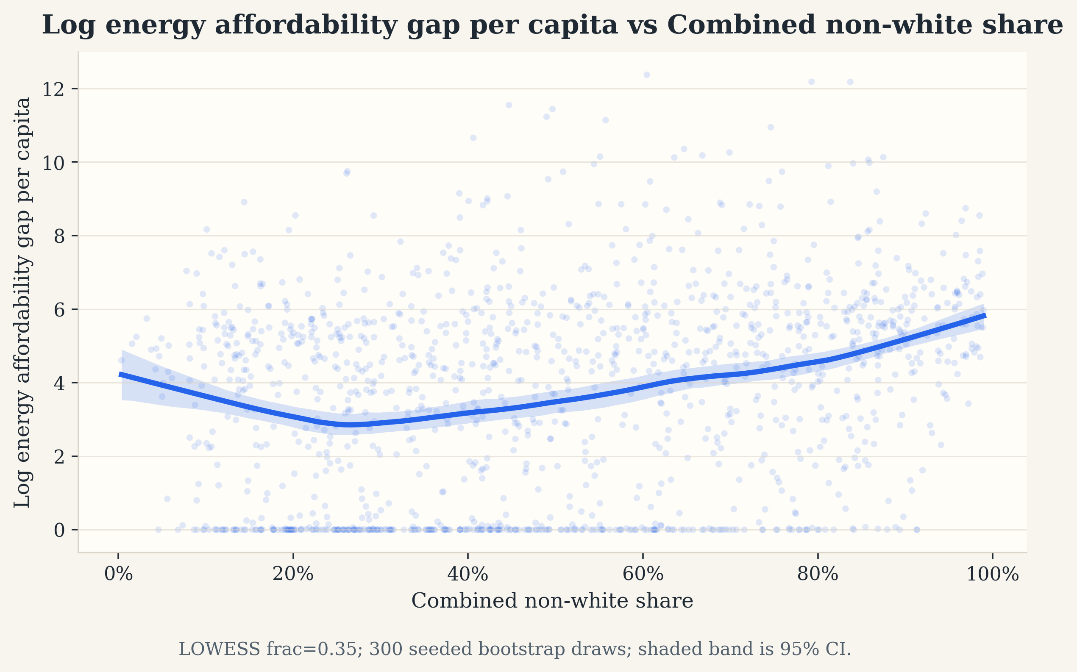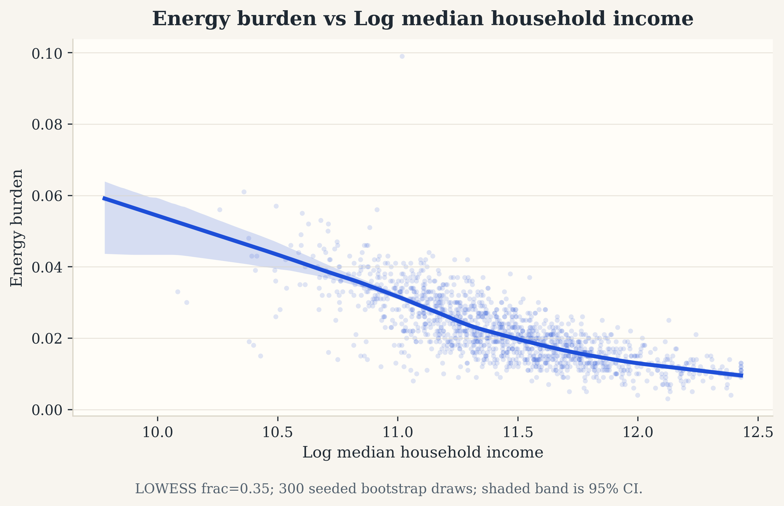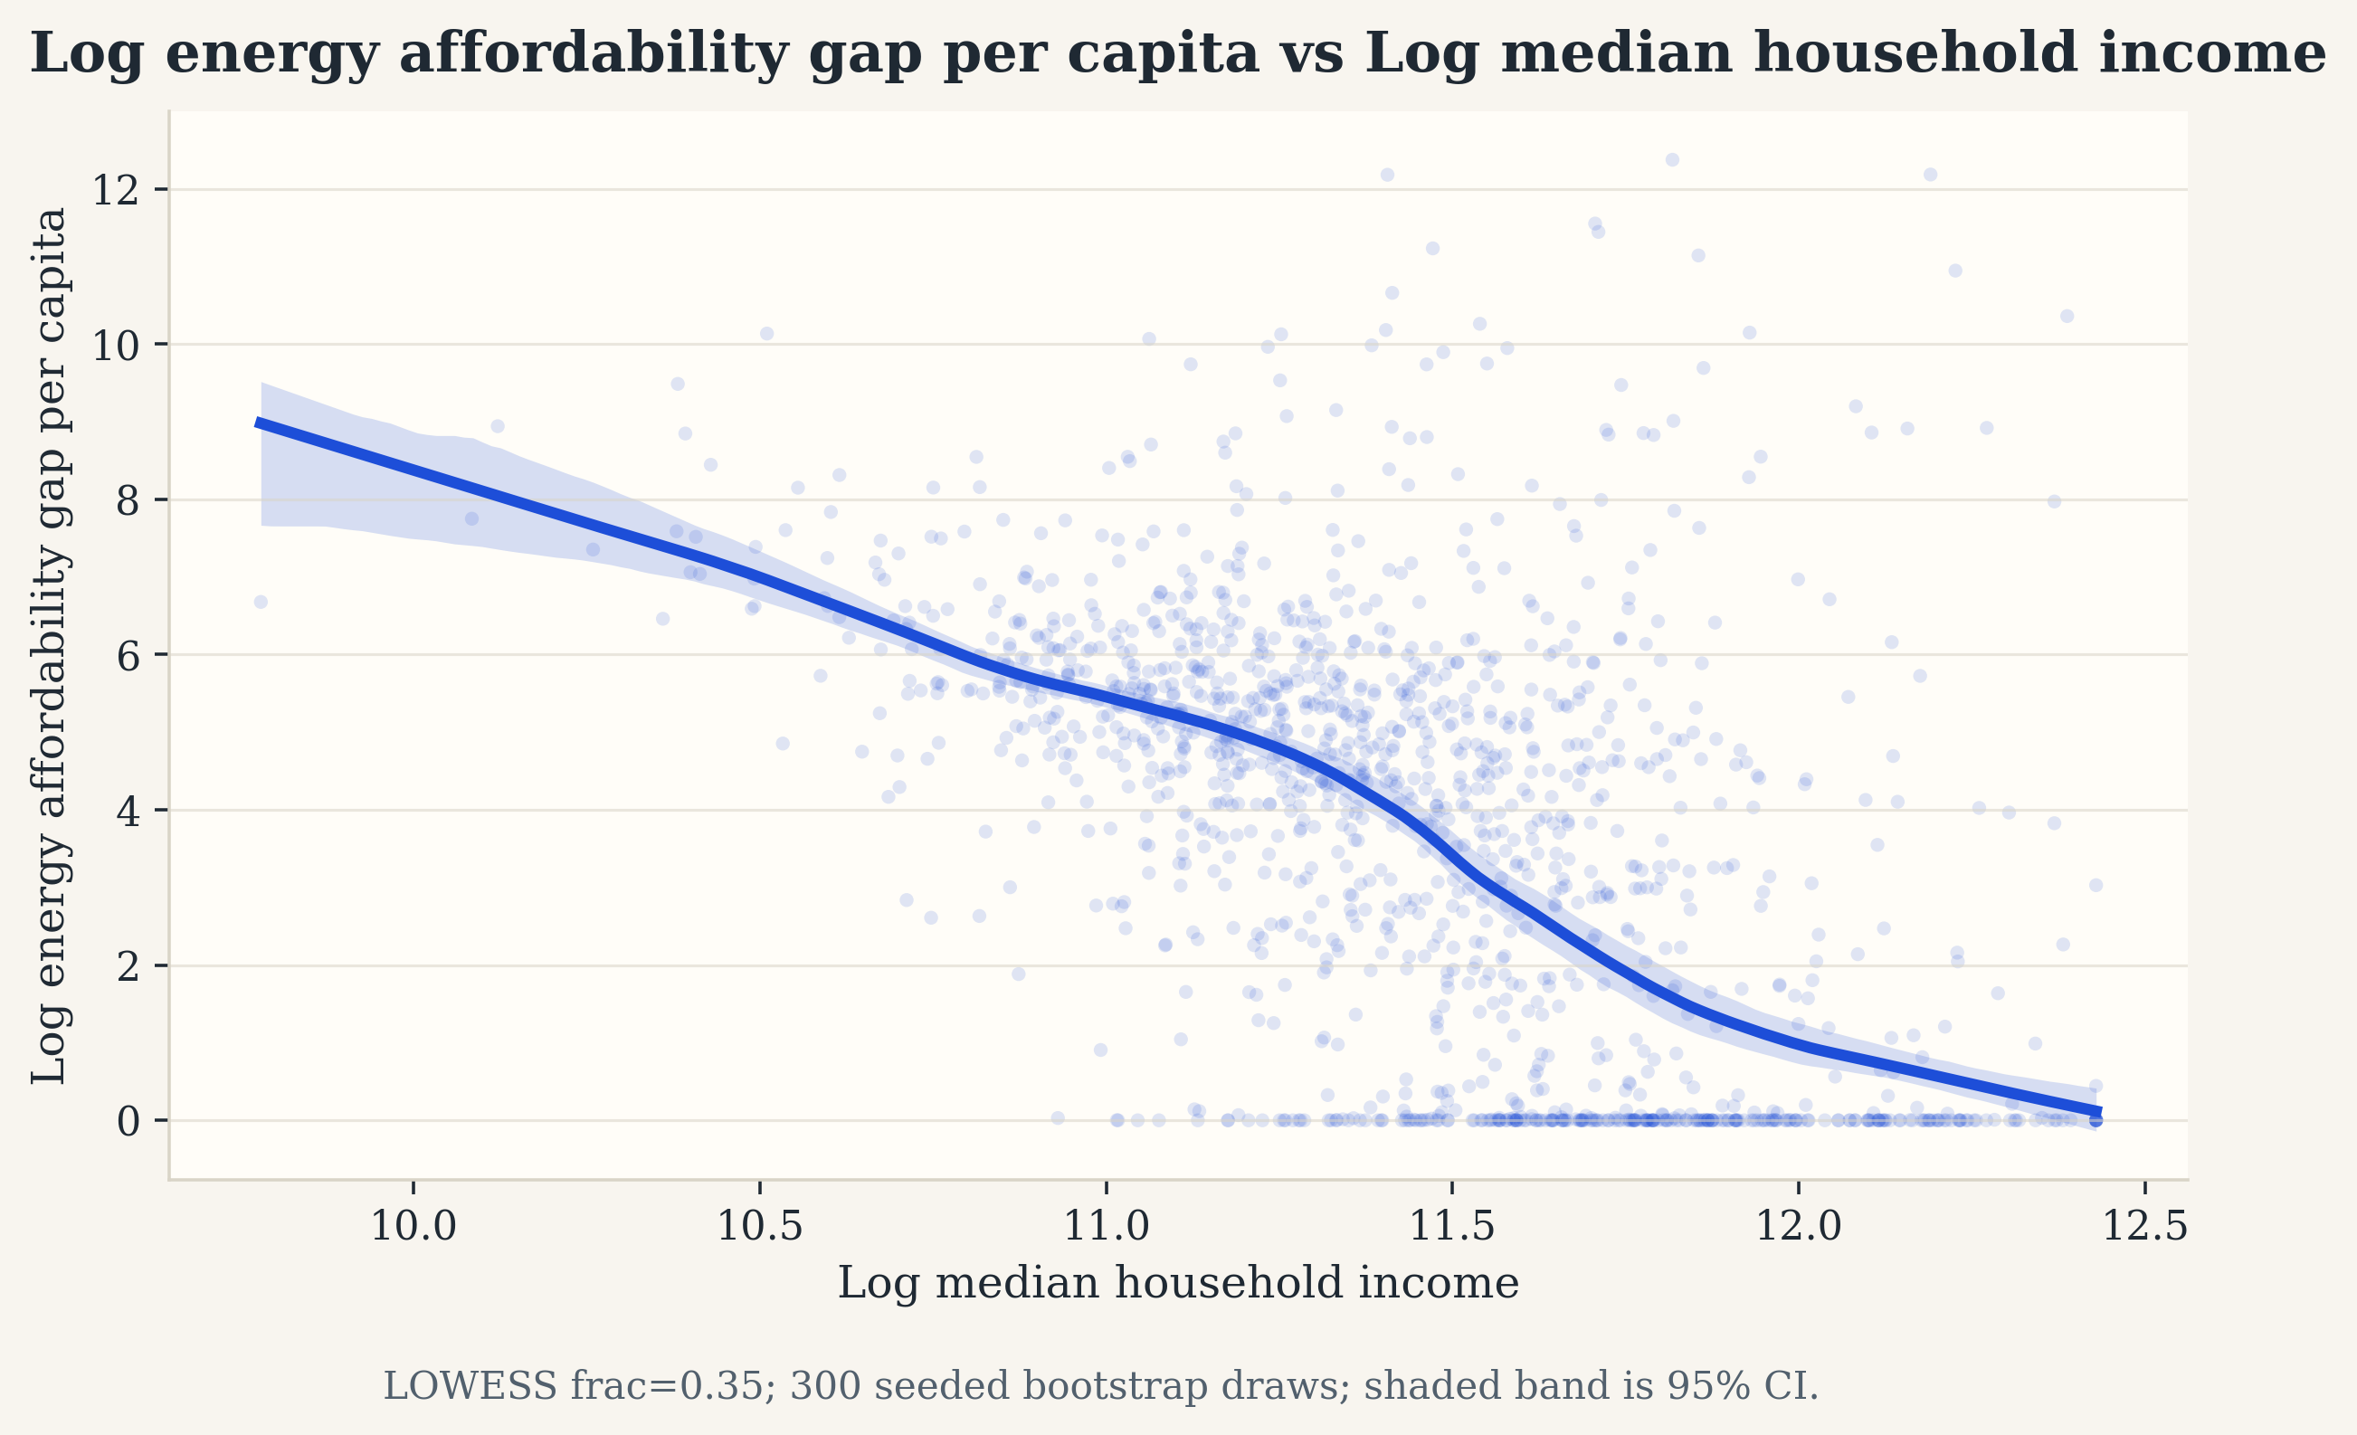
Supplementary Fig. S10 | Descriptive LOWESS gradients between neighborhood characteristics and the two energy-affordability outcomes.
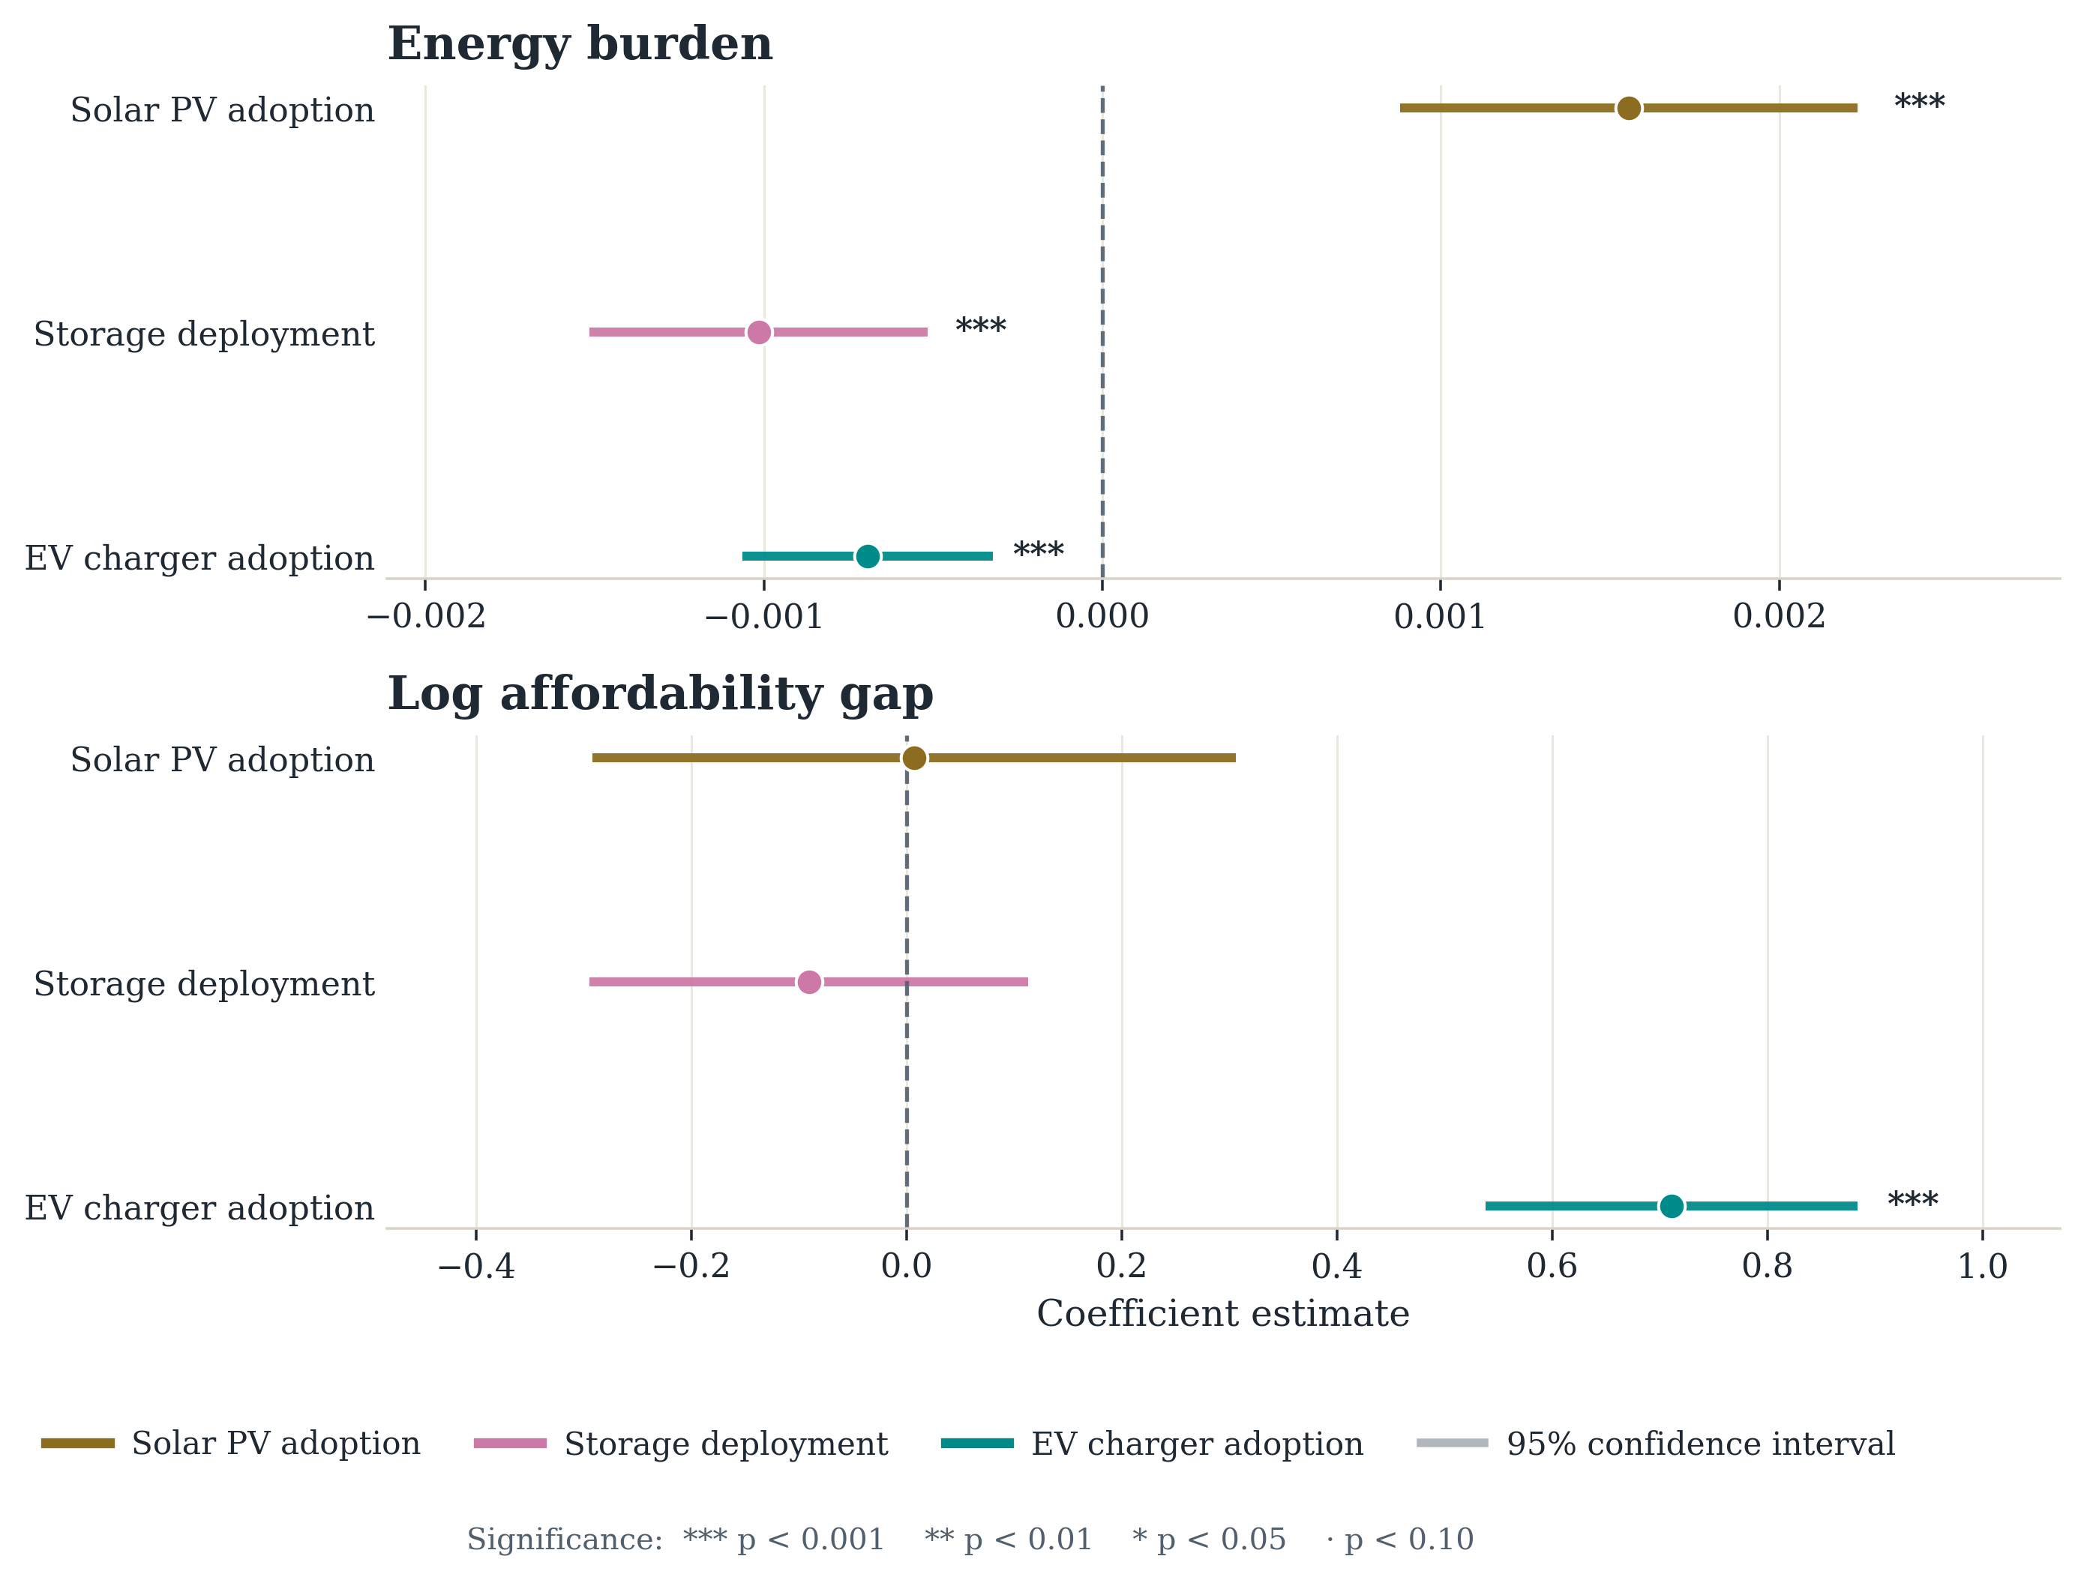
Supplementary Fig. S11 | DER predictors in the energy-burden and affordability-gap models. Points are coefficient estimates; horizontal lines are 95 percent confidence intervals.
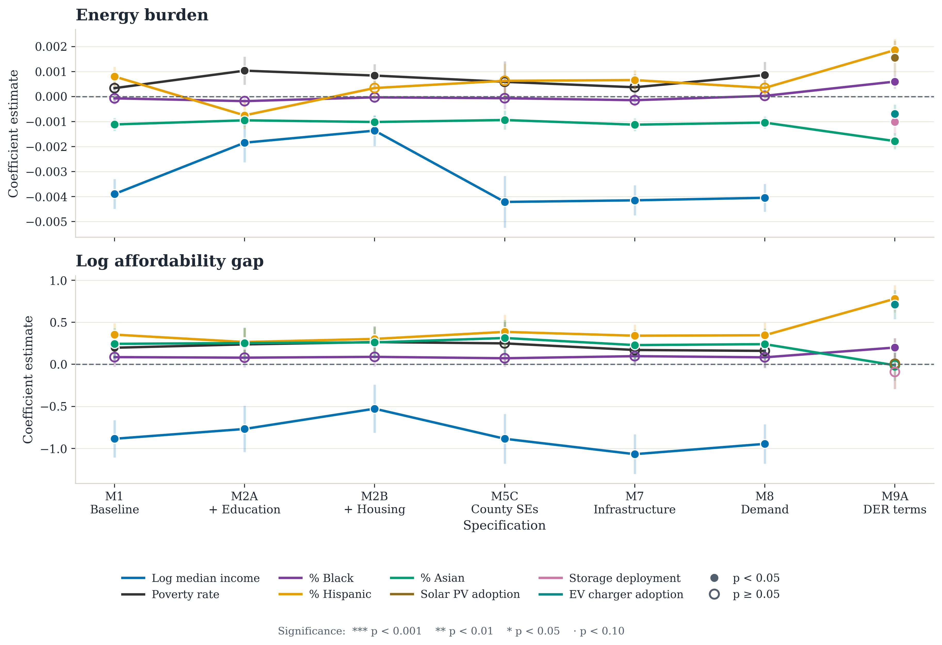
Supplementary Fig. S12 | Coefficient stability for the energy-burden and affordability-gap outcomes across the model series.
Supplementary Table S11 | Energy-affordability models with and without the 134 ZCTAs whose per-capita affordability gap exceeds $1,000. Standardized predictors.
Outcome | Sample | Term | Coefficient | p | N | R²
Energy burden | full sample | Log income | -0.004 | 0.000 | 1374 | 0.735
Energy burden | full sample | Black share | -0.000 | 0.548 | 1374 | 0.735
Energy burden | full sample | Hispanic share | 0.001 | 0.000 | 1374 | 0.735
Energy burden | full sample | Asian share | -0.001 | 0.000 | 1374 | 0.735
Energy burden | excl. gap outliers | Log income | -0.004 | 0.000 | 1242 | 0.753
Energy burden | excl. gap outliers | Black share | 0.000 | 0.566 | 1242 | 0.753
Energy burden | excl. gap outliers | Hispanic share | 0.001 | 0.000 | 1242 | 0.753
Energy burden | excl. gap outliers | Asian share | -0.001 | 0.000 | 1242 | 0.753
Affordability gap | full sample | Log income | -0.879 | 0.000 | 1374 | 0.317
Affordability gap | full sample | Black share | 0.086 | 0.142 | 1374 | 0.317
Affordability gap | full sample | Hispanic share | 0.351 | 0.000 | 1374 | 0.317
Affordability gap | full sample | Asian share | 0.243 | 0.010 | 1374 | 0.317
Affordability gap | excl. gap outliers | Log income | -0.850 | 0.000 | 1242 | 0.450
Affordability gap | excl. gap outliers | Black share | 0.078 | 0.159 | 1242 | 0.450
Affordability gap | excl. gap outliers | Hispanic share | 0.375 | 0.000 | 1242 | 0.450
Affordability gap | excl. gap outliers | Asian share | -0.045 | 0.477 | 1242 | 0.450

Supplementary Note S10 | Wind as contextual comparison
The wind-capacity outcome is useful as a contextual comparison but is not part of the paper's equity argument. For wind capacity, the most consistent predictor is mean hub-height wind speed, which is positive and statistically significant across all examined models (Supplementary Figure S13). The social variables are weaker and less stable, and in the specification curve, wind returns 0 of 48 significant same-signed specifications on every focal term, which is the weakest result in the study.
This suggests that wind siting is far more tightly tied to physical resource conditions than the consumer-facing outcomes. Wind capacity is also zero in 97.5 percent of ZCTAs, so a linear model on the logged rate is effectively a rare-event fit; the binary turbine-presence outcome is estimated as a linear probability model and is likewise not foregrounded. Because wind is not a behind-the-meter or consumer-facing resource, it is not directly comparable to the three headline technologies and is reported here as context only. Its cross-validated model comparison is in Supplementary Figure S16.
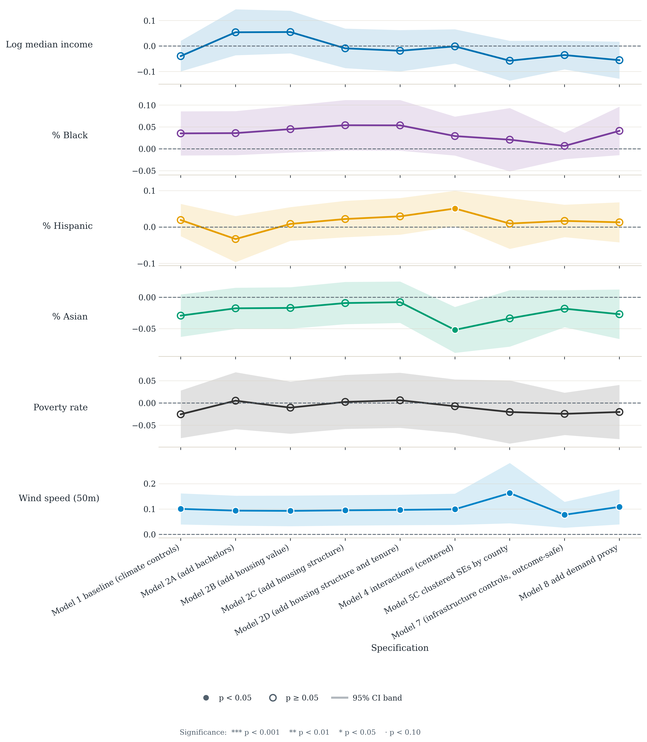
Supplementary Fig. S13 | Wind capacity: coefficients across the model series, included as contextual material. Wind capacity is zero in 97.5 percent of ZCTAs.

Supplementary Note S11 | Predictive model comparison and spatial output
In exploratory analysis, we compare the linear specifications against more flexible predictive models such as polynomial regression, random forest, and gradient-boosted trees using cross-validation. These are not the basis for any claim in the paper. They serve as a diagnostic for whether the linear models miss strong nonlinear structure. Supplementary Figures S14 and S15 report the storage and aggregate charging comparisons, with error bars of ±1 standard deviation across five cross-validation folds, and Supplementary Figure S16 reports wind.
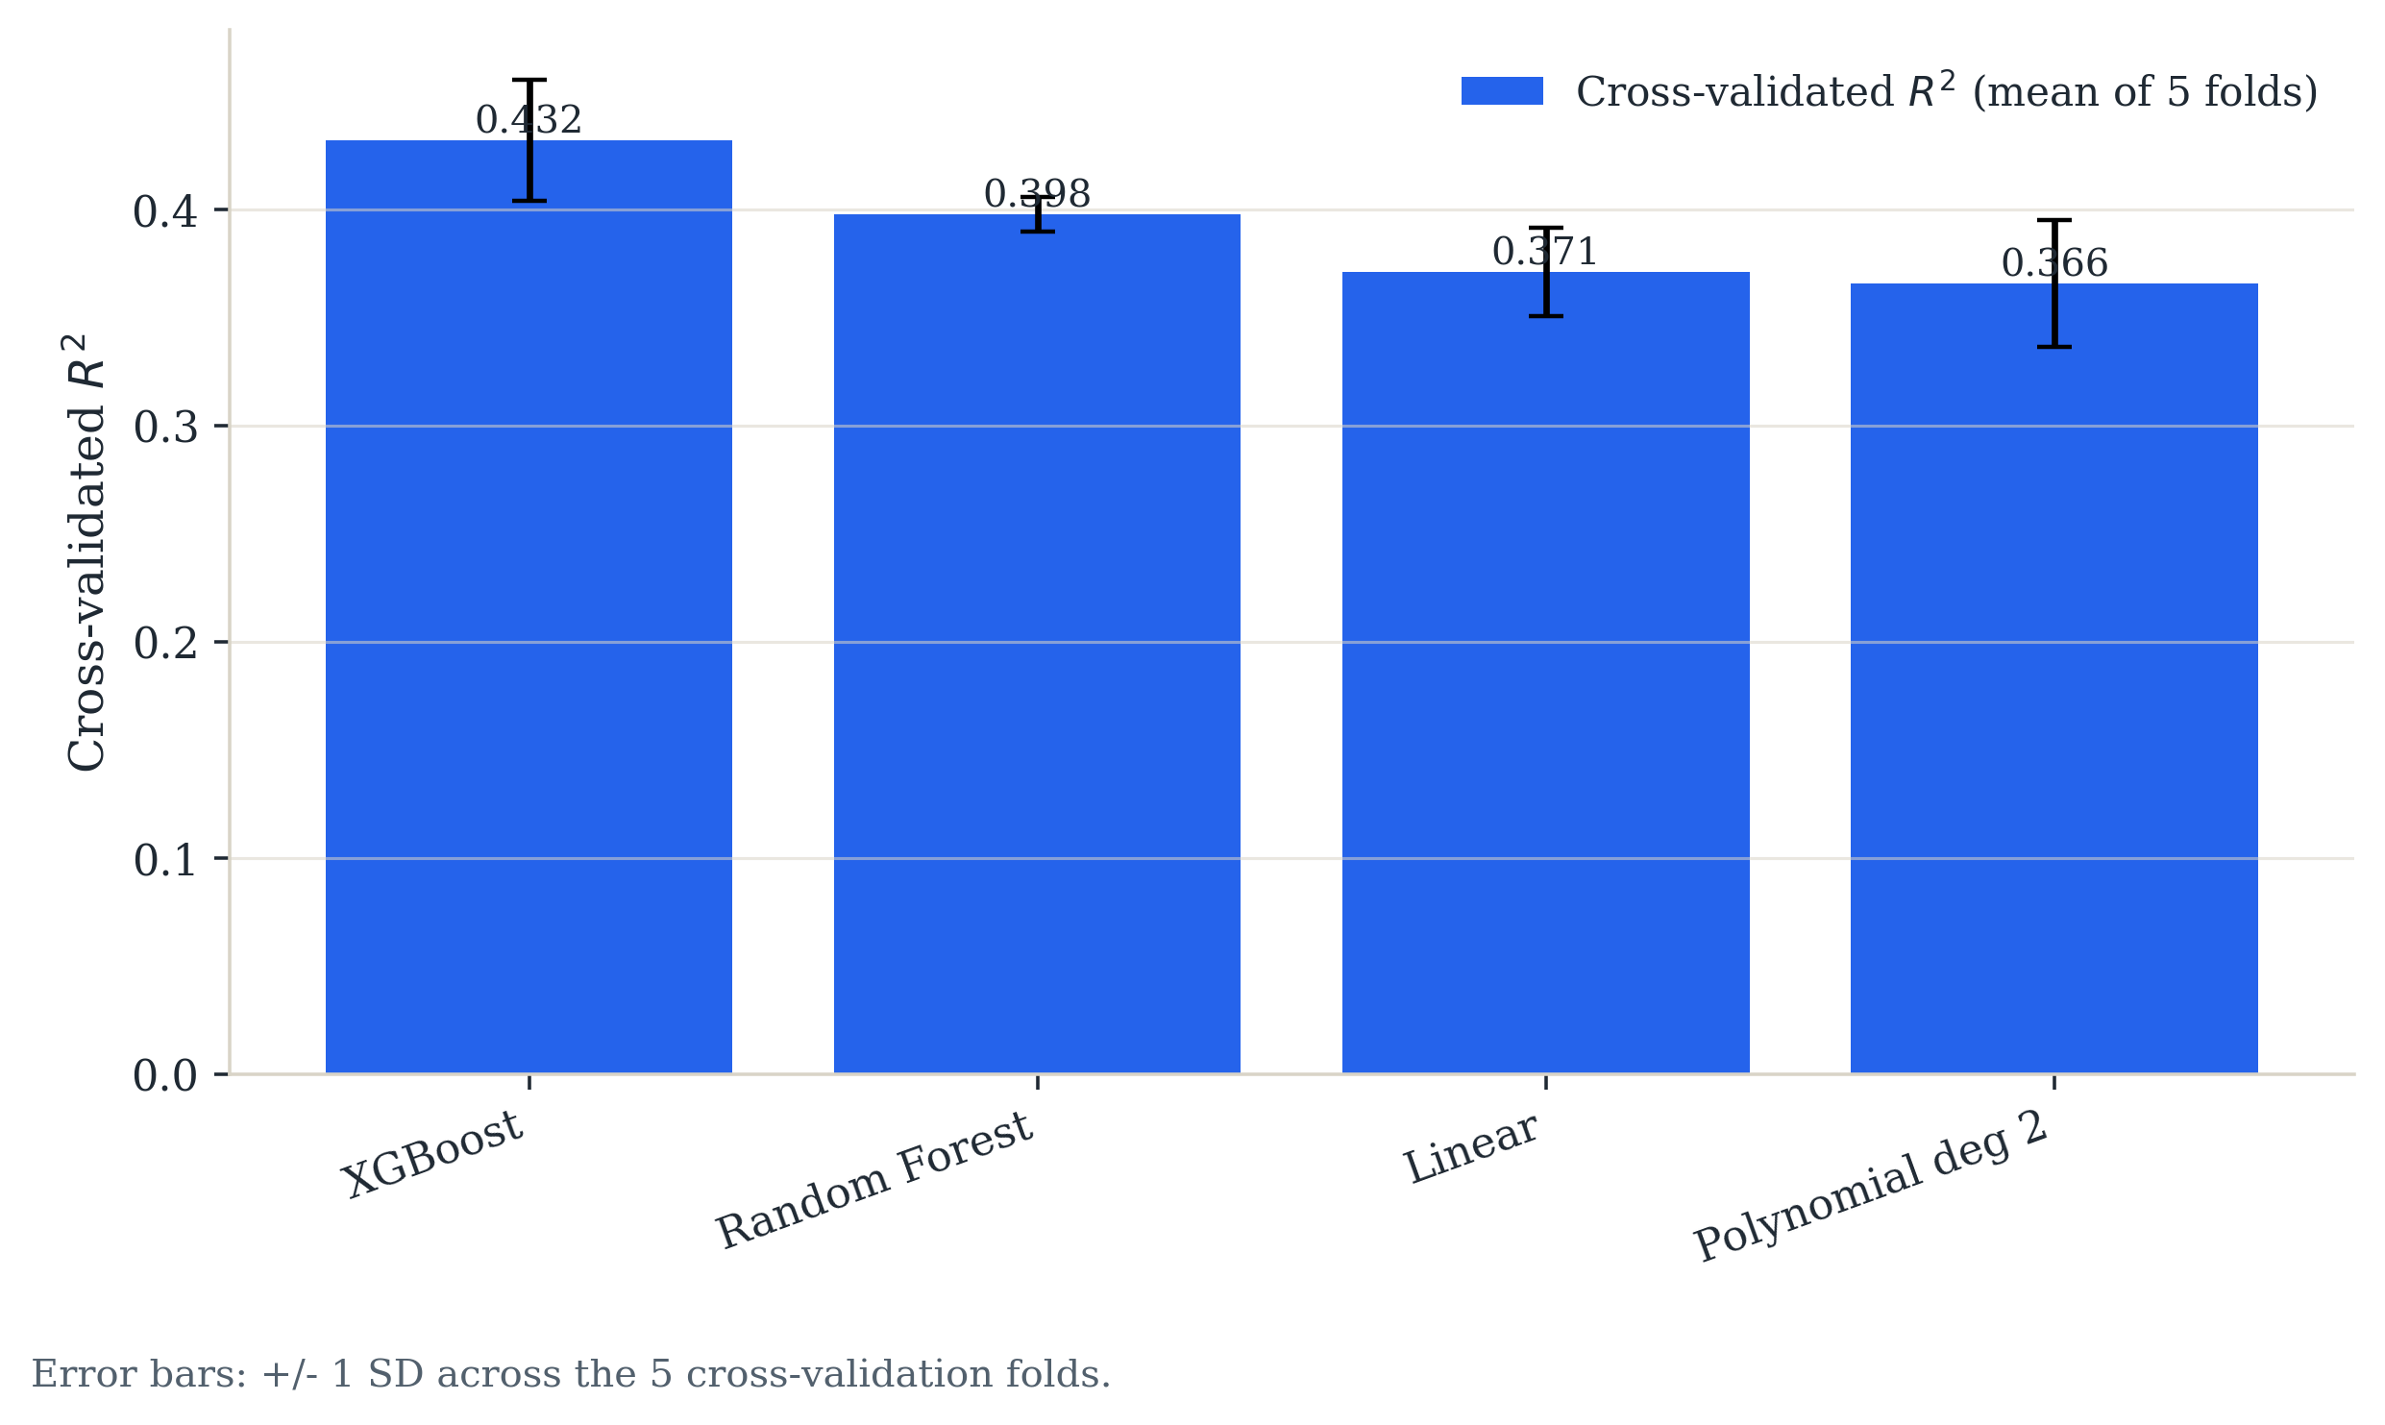
Supplementary Fig. S14 | Battery storage: cross-validated predictive comparison of linear and nonlinear models. Error bars are ±1 s.d. across five cross-validation folds.
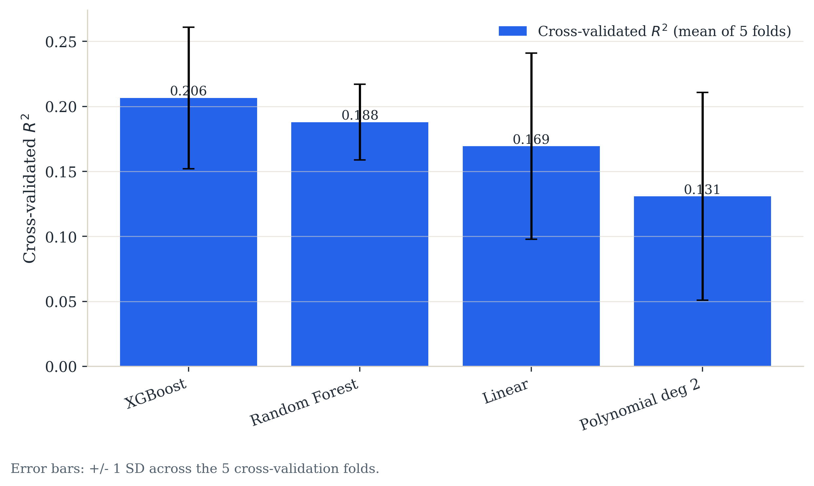
Supplementary Fig. S15 | Aggregate EV charging: cross-validated predictive comparison of linear and nonlinear models.
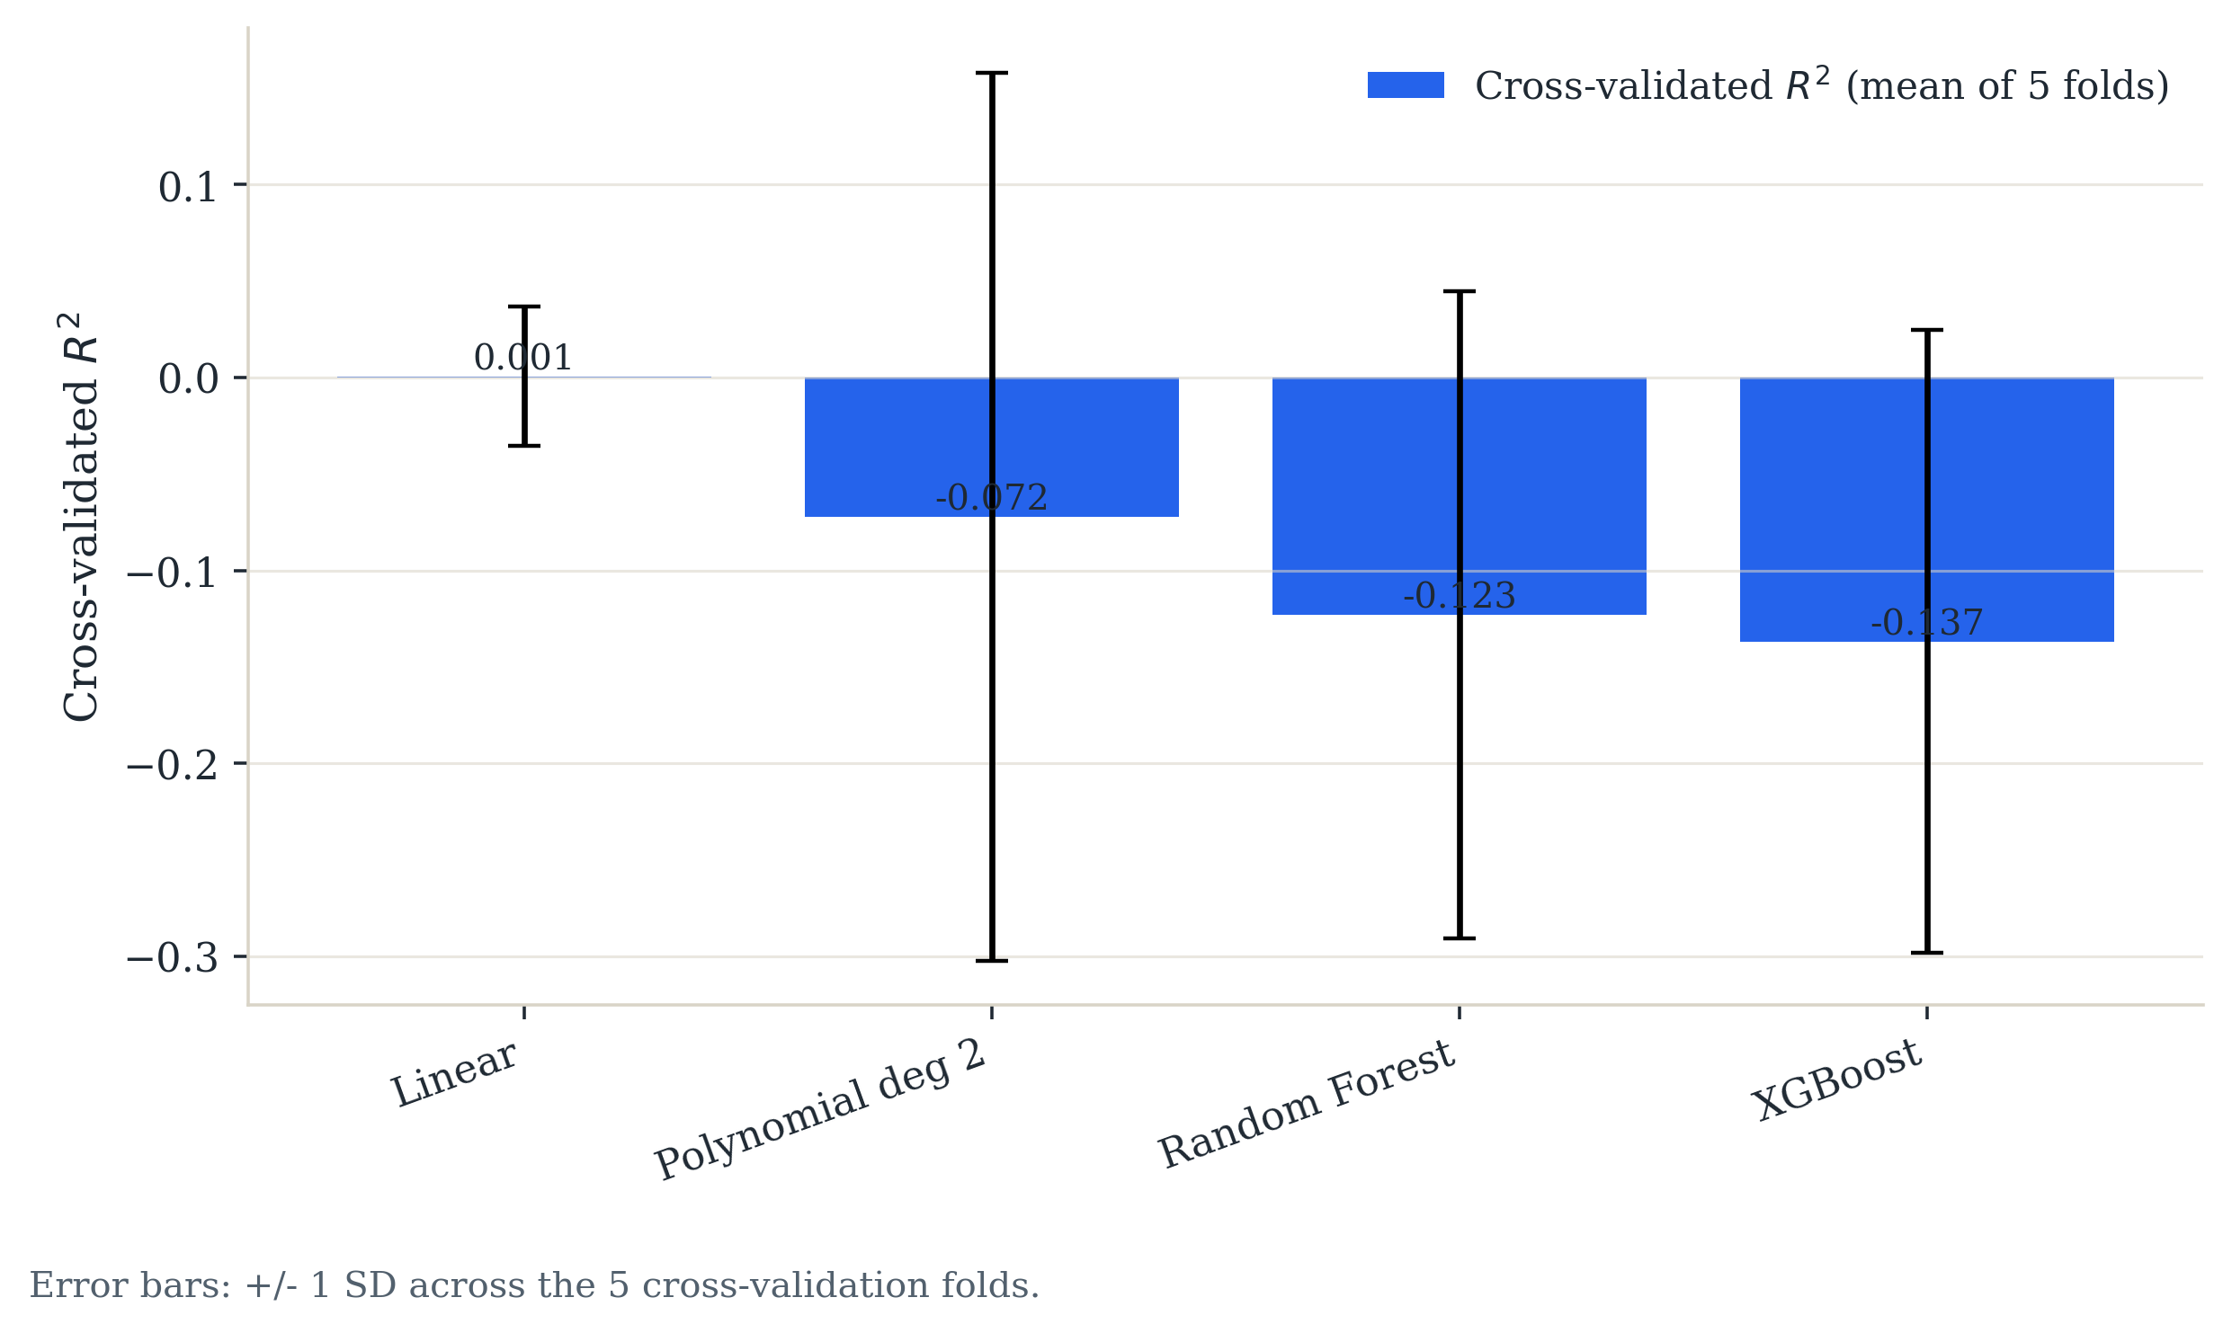
Supplementary Fig. S16 | Wind capacity: cross-validated predictive comparison of linear and nonlinear models.
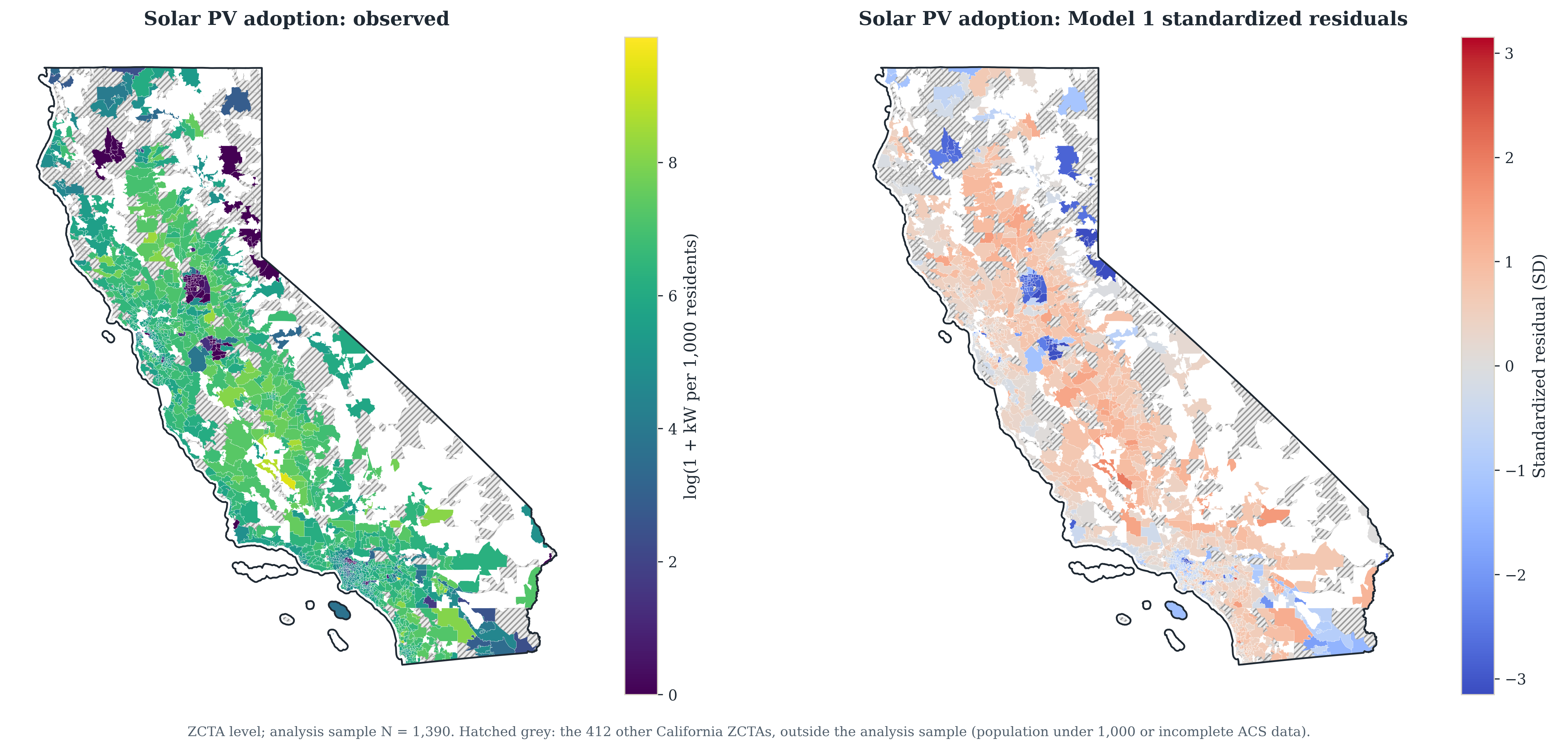
Supplementary Fig. S17 | Rooftop solar: observed adoption and baseline standardized residuals by ZCTA. The clustering visible in the residual panel is what the Moran’s I statistics in Note S12 quantify.
Supplementary Figure S17 shows representative baseline spatial output for rooftop solar: observed adoption and the baseline standardized residuals by ZCTA, side by side. The residual map is the visual counterpart to the Moran's I statistics in Note S12. Because the residuals are visibly clustered rather than scattered and the model fails to explain the clustering, this motivates the spatially robust standard errors and the spatial error model. The statewide observed geography for all three outcomes is shown in Figure 1 in the main text.

Supplementary Note S12 | Statistical diagnostics
This Note reports diagnostic checks on the estimating equations. They do not alter any point estimate; they characterize how much confidence the standard errors deserve and where the specification is strained.
For multicollinearity, variance inflation factors (VIFs) for the solar models (Supplementary Table S17) show both a well-conditioned specification and a cautionary case. VIF is computed with the intercept retained in the auxiliary regressions, so raw and standardized diagnostics agree. The housing structure and tenure controls in Model 2D have a maximum VIF of 5.30, despite owner occupancy correlating −0.83 with multifamily share. In the per-capita infrastructure specification, wind MW per 100k and turbines per 100k reach 27.40 and 27.38; their individual coefficients should not be read separately. Across the cumulative ladder no focal term exceeds a VIF of 7.93 at any rung, so collinearity is not a threat to the coefficients the paper reports. VIF tables for every model and outcome are exported alongside the coefficient tables.
To test spatial autocorrelation, Moran's I measures whether what a model fails to explain is clustered in space. It runs from roughly −1 to 1, where 0 means residuals are scattered independently of location and positive values mean neighboring ZCTAs carry similar residuals. Positive residual autocorrelation matters because it breaks the independence assumption behind heteroskedasticity-robust standard errors, which are then too small and overstate precision. We compute it on the OLS residuals using row-standardized eight-nearest-neighbor weights over ZCTA centroids, with pseudo p-values from 999 permutations (Supplementary Table S18). All 72 tests — six outcomes by four specifications by three neighbor counts — return p ≤ 0.001, so residual spatial dependence is present throughout.
Two patterns are worth noting: including latitude and longitude linearly absorbs almost none of the dependence, and for energy burden it is slightly worse than the baseline, so that specification should not be read as a geographic robustness check. County fixed effects remove 57 percent of the dependence for solar and 60 percent for storage, which indicates clustering at a finer scale than counties. County-clustered standard errors therefore address the right concern at too coarse a resolution. Results are stable across four, eight, and sixteen neighbors.
Because neighboring locations share unobserved traits, baseline models can easily understate uncertainty. To account for this spatial correlation, we recalculate our standard errors following Conley (1999), weighting geographic relationships by straight-line distance using a Bartlett kernel (Supplementary Table S19). This leaves our point estimates untouched by design since it only adjusts our margin of error. Since choosing a single distance threshold can be arbitrary, we test several cutoffs. Accounting for spatial spillover increases our standard errors by up to three times relative to standard HC1 estimates, but the increase levels off between 100 and 200 kilometers, which is a range that neatly matches the scale of metropolitan areas and utility service territories.
The conclusions hold, but their relative strength changes. The Asian-share coefficients for solar and storage remain significant at the 0.1 percent level at every cutoff and are the most robust results in the paper. The storage Black-share coefficient remains negative and significant at the 0.1 percent level at every cutoff; the solar Black-share coefficient is significant only at the 25 km cutoff and not at 50 km or beyond, so it is less robust than the HC1 errors imply. The positive poverty coefficient for aggregate charging, which underpins the charger-composition argument, survives at the 1 percent level. The positive Asian-share coefficient for aggregate charging is significant at the 5 percent level at every cutoff but falls to zero once housing structure and tenure enter, so we do not interpret it. The Hispanic-share coefficients for storage and aggregate charging remain negative and significant at every cutoff, at the 0.1 percent level for storage and the 5 percent level for charging, while the solar coefficient, positive under HC1 errors, is indistinguishable from zero at every Conley cutoff.
Supplementary Table S17 | Variance inflation factors across four rooftop solar specifications. Values above about 10 indicate a coefficient is not separately identified.
Predictor | M1 baseline | M2 + housing value | M2D + structure/tenure | M7 per-capita infrastructure
Log median income | 3.10 | 4.94 | 3.64 | 3.26
Poverty rate | 2.59 | 2.68 | 2.80 | 2.61
% Hispanic | 1.42 | 1.43 | 1.61 | 1.47
% Asian | 1.26 | 1.29 | 1.37 | 1.33
Solar irradiance (GHI) | 1.15 | 1.18 | 1.18 | 1.16
% Black | 1.04 | 1.05 | 1.13 | 1.06
Log housing value | — | 2.84 | — | —
% owner-occupied | — | — | 5.30 | —
% multifamily units | — | — | 4.63 | —
% mobile-home units | — | — | 1.56 | —
% boat/RV/van/other units | — | — | 1.11 | —
Wind MW per 100k | — | — | — | 27.39
Turbines per 100k | — | — | — | 27.37
Storage MW per 100k | — | — | — | 1.22
Plant MW per 100k | — | — | — | 1.02
Maximum VIF | 3.10 | 4.94 | 5.30 | 27.39
Supplementary Table S18 | Moran’s I on OLS residuals, eight-nearest-neighbor weights. Every entry is significant at p < 0.001 by permutation test.
Outcome | M1 baseline | M6A + lat/lon | M6B county FE | M8 + demand proxy
Solar PV | 0.637 | 0.633 | 0.275 | 0.389
Storage | 0.354 | 0.348 | 0.141 | 0.246
EV chargers (aggregate) | 0.143 | 0.134 | 0.080 | 0.128
EV chargers (Level 2) | 0.165 | 0.154 | 0.103 | 0.150
Energy burden | 0.352 | 0.436 | 0.279 | 0.284
Log affordability gap | 0.150 | 0.138 | 0.108 | 0.127
Supplementary Table S19 | Conley spatial HAC standard errors, Bartlett kernel over great-circle distance. Coefficients are identical across columns; only the standard errors differ.
Term | Coefficient | HC1 | Conley 50 km | Conley 100 km | Conley 200 km
Solar PV
Log median income | 1.091 | 0.209*** | 0.305*** | 0.308*** | 0.253***
% Black | -3.417 | 0.735*** | 1.813 | 2.115 | 2.213
% Hispanic | 0.919 | 0.245*** | 0.632 | 0.654 | 0.615
% Asian | -2.106 | 0.308*** | 0.510*** | 0.610*** | 0.546***
Poverty rate | -0.572 | 1.089 | 1.171 | 1.246 | 1.339
Storage
Log median income | 0.970 | 0.105*** | 0.141*** | 0.133*** | 0.109***
% Black | -1.878 | 0.285*** | 0.413*** | 0.483*** | 0.552***
% Hispanic | -0.898 | 0.114*** | 0.217*** | 0.236*** | 0.244***
% Asian | -1.736 | 0.150*** | 0.301*** | 0.382*** | 0.396***
Poverty rate | -0.105 | 0.465 | 0.612 | 0.575 | 0.475
EV chargers (aggregate)
Log median income | 0.173 | 0.097 | 0.126 | 0.116 | 0.096
% Black | 0.011 | 0.344 | 0.278 | 0.298 | 0.289
% Hispanic | -0.380 | 0.105*** | 0.157* | 0.167* | 0.177*
% Asian | 0.420 | 0.147** | 0.203* | 0.212* | 0.192*
Poverty rate | 2.022 | 0.497*** | 0.637** | 0.670** | 0.685**

Supplementary Note S13 | Data construction and measurement
Three properties of the source data govern how the outcomes should be read. The charging inventory is public and shared-use only. Every station record in the California Energy Commission charging file carries a public access flag, and the statewide Level 1 total is 256 ports against 40,078 Level 2 and 13,852 DC fast. Residential charging is therefore unobserved: no charging measure in this study speaks to whether a household can charge where it parks overnight. This is the reason the main text reads charger counts as a measure of infrastructure rather than of usable access. Charger records without a valid source ZIP are excluded from ZCTA outcomes rather than reassigned from coordinates, so the charging outcomes should be interpreted as valid-source-ZIP records.
The storage series is overwhelmingly customer-sited. The California Energy Commission storage system survey covers utility-scale alongside behind-the-meter systems, and the distinction matters because the resilience interpretation in the main text holds only for customer-sited capacity. The outcome is built from the record-level export of the survey: 252,880 records, of which 249,338 are residential, 3,332 commercial and 210 utility. Residential and commercial systems of up to 5 MW each that were approved by the end of 2023 are summed by ZCTA, and utility-sector records are excluded, so the outcome measures customer-sited capacity: 150,506 systems and 1,614 MW statewide, 64 percent of it residential. The 2023 cutoff matches the one applied to Tracking the Sun; the export runs to March 2025, and the 102,159 later records hold about a third of customer-sited capacity. The 5 MW limit is applied to each system before aggregation. An earlier build applied it to ZIP-level totals instead, which removed all residential storage from the 49 ZIPs whose residential total exceeded 5 MW, among them some of the highest-adoption areas in the state; every storage result reported here uses the corrected aggregation. Supplementary Table S12 re-fits the storage baseline on customer-sited capacity and on residential records only; every sign and significance is reproduced in the residential-only specification, so the behind-the-meter reading of the storage results is supported by the source.
Deployment is zero in a non-trivial share of ZCTAs, and the share differs sharply by technology: 5.3 percent for solar, 7.1 for storage, 19.0 for aggregate charging, 22.3 for Level 2 and 44.2 for DC fast, but 97.8 percent for Level 1 and 97.5 percent for wind capacity (Supplementary Table S13). Level 1 charging and wind are therefore too sparse to support a coefficient at this geography, and are reported descriptively rather than modeled in the main text. The zero shares are also why the Poisson specifications in Note S5 matter: they fit the counts directly rather than through a transformation.
Supplementary Table S14 gives variable definitions for every outcome, predictor and control, and Supplementary Table S15 gives summary statistics for the analysis sample. Supplementary Table S3 reports the predictor standard deviations used to convert standardized coefficients into percentage-point changes.
Supplementary Table S13 | Share of ZCTAs reporting zero deployment, by outcome. Level 1 charging and wind capacity are too sparse to support a coefficient at this geography.
Outcome | Source variable | N | % zero | Median | Maximum
Rooftop solar | PV_system_size_DC | 1422 | 5.3 | 6.38 | 142.1
Battery storage | storage_capacity_mw | 1422 | 7.1 | 0.60 | 12.5
EV charging | total_chargers | 1422 | 19.0 | 16.00 | 800.0
Level 1 chargers | level1_chargers | 1422 | 97.8 | 0.00 | 52.0
Level 2 chargers | level2_chargers | 1422 | 22.3 | 9.00 | 768.0
DC fast chargers | dc_fast_chargers | 1422 | 44.2 | 2.00 | 235.0
Wind capacity | wind_capacity_mw | 1422 | 97.5 | 0.00 | 1542.5

Supplementary Table S12 | Storage sensitivity by customer sector. The record-level California Energy Commission export holds 249,338 residential, 3,332 commercial and 210 utility records. Standardized predictors; models re-fitted on customer-sited capacity (residential and commercial systems of up to 5 MW each approved by the end of 2023, the main-text outcome) and on residential records only, with the same cutoffs.
Term | Residential + commercial | p | Residential only | p
Log income | 0.390 | 0.000 | 0.412 | 0.000
Black share | -0.120 | 0.000 | -0.108 | 0.000
Hispanic share | -0.215 | 0.000 | -0.289 | 0.000
Asian share | -0.246 | 0.000 | -0.295 | 0.000
Poverty rate | -0.008 | 0.822 | -0.012 | 0.667

Supplementary Table S14 | Variable definitions for the main outcomes, predictors and controls.
Variable | Meaning | Scale / notes
y_pv | Solar PV deployment intensity | log(1 + PV kW DC per 1,000 residents)
y_storage | Battery storage deployment intensity | log(1 + storage MW per 100,000 residents)
y_chargers | EV charging availability | log(1 + total chargers per 1,000 residents)
pct_black | Share of ZIP/ZCTA population identifying as Black | ACS 2023 5-year estimate
pct_hispanic | Share of ZIP/ZCTA population identifying as Hispanic or Latino | ACS 2023 5-year estimate
pct_asian | Share of ZIP/ZCTA population identifying as Asian | ACS 2023 5-year estimate
log_median_household_income | Logged median household income | Socioeconomic/adoption-capacity proxy
poverty_rate | Share of residents below the poverty line | Socioeconomic control
pct_bachelors_plus | Share of adults with a bachelor’s degree or higher | Education and adoption-capacity control
ghi_mean_kwh_m2_day_2023 | Mean daily global horizontal irradiance | Solar resource / physical suitability control
cdd65_2023 | Cooling degree days relative to 65°F | Climate control
hdd65_2023 | Heating degree days relative to 65°F | Climate control
log_kwh | Logged annual electricity consumption | Demand/load proxy
energy_burden_pct | Household energy burden | ZIP-level energy costs as a share of income; used in the energy-burden outcome model
log_energy_gap_per_capita | Logged per-capita energy affordability gap | Scale-adjusted burden-gap measure used alongside energy_burden_pct

Supplementary Table S15 | Summary statistics for the main outcomes and key predictors in the analysis sample.
Variable | N | Mean | Median | P25 | P75
y_pv | 1,390 | 5.473 | 5.955 | 4.949 | 6.641
y_storage | 1,390 | 1.410 | 1.369 | 0.623 | 2.082
y_chargers | 1,390 | 0.694 | 0.515 | 0.142 | 1.027
pct_black | 1,390 | 0.042 | 0.020 | 0.007 | 0.049
pct_hispanic | 1,390 | 0.347 | 0.277 | 0.151 | 0.498
pct_asian | 1,390 | 0.119 | 0.066 | 0.023 | 0.156
log_median_household_income | 1,390 | 11.440 | 11.435 | 11.169 | 11.703
poverty_rate | 1,390 | 0.123 | 0.104 | 0.070 | 0.161
pct_bachelors_plus | 1,390 | 0.359 | 0.324 | 0.191 | 0.505
ghi_mean_kwh_m2_day_2023 | 1,390 | 5.118 | 5.104 | 4.855 | 5.339
log_kwh | 1,196 | 17.270 | 18.016 | 16.672 | 18.883
energy_burden_pct | 1,374 | 0.022 | 0.020 | 0.015 | 0.028
log_energy_gap_per_capita | 1,374 | 3.786 | 4.342 | 1.072 | 5.648

Supplementary Table S3 | Predictor means and standard deviations on the 1,390-ZCTA regression sample, for converting standardized coefficients to percentage-point changes. Population standard deviations, as used to standardize the predictors in every model.
Predictor | Mean | Standard deviation | One s.d. in percentage points
Log income | 11.440 | 0.403 | —
Black share | 0.042 | 0.064 | 6.4
Hispanic share | 0.347 | 0.239 | 23.9
Asian share | 0.119 | 0.141 | 14.1

Supplementary Table S4 | EV charger subtype comparison in baseline models. Standardized predictors; HC1 standard errors in parentheses. *p < 0.05, **p < 0.01, ***p < 0.001.
Predictor | Aggregate | Level 1 | Level 2 | DC Fast
log_median_household_income | 0.070 (0.039) | -0.004 (0.004) | 0.085* (0.035) | 0.018 (0.022)
pct_black | 0.001 (0.022) | -0.000 (0.001) | 0.007 (0.021) | -0.009 (0.010)
pct_hispanic | -0.091*** (0.025) | -0.004 (0.003) | -0.110*** (0.021) | 0.003 (0.017)
pct_asian | 0.059** (0.021) | 0.001 (0.001) | 0.050* (0.020) | 0.019* (0.010)
poverty_rate | 0.150*** (0.037) | 0.002 (0.004) | 0.168*** (0.033) | 0.027 (0.021)
N | 1,390 | 1,390 | 1,390 | 1,390
R² | 0.080 | 0.006 | 0.117 | 0.013

