Racial and Socioeconomic Disparities in Distributed Energy Resource Adoption: Evidence from California ZIP/ZCTA Areas Across Solar, Storage, and EV Charging
Danielle Knutson • Massachusetts Institute of Technology

Abstract
As distributed energy resources (DERs) such as rooftop solar, battery storage, and EV charging become more central to decarbonization, resilience, and electrification planning, the benefits they deliver are not guaranteed to be shared evenly. Prior work on rooftop PV shows that adoption can remain stratified by race and ethnicity even after accounting for income and related socioeconomic characteristics (Sunter et al. 2019). This paper extends that framing to a multi-DER setting and asks whether demographic and infrastructure factors shape inequitable access to different DER types across California ZIP/ZCTA areas. I build a California ZIP/ZCTA-level dataset that integrates rooftop PV, storage, EV charging, and contextual controls from ACS, NASA POWER, utility territory, and electricity demand sources. Using a consistent model ladder, I show that race remains statistically associated with DER adoption across multiple technologies and that the resulting disparity patterns differ meaningfully across PV, storage, and charging. The results support a race-aware interpretation of DER equity and challenge the assumption that race-neutral planning frameworks are sufficient for equitable clean energy deployment.

1. Introduction

1.1 Motivation and problem
As the electricity system decarbonizes, distributed energy resources (DERs) are becoming central to emissions reduction, local resilience, and electrification. In this paper, DERs are treated conceptually as behind-the-meter resources below 5 MW, even though some source-specific processing rules use tighter operational cutoffs to isolate DER-scale observations in the current pipeline. These technologies are often discussed together in policy debates, but the benefits they deliver are heterogeneous: rooftop PV can reduce bills, storage can provide outage resilience, and charging infrastructure shapes who can participate in transportation electrification.
The clean energy transition is therefore not just a deployment problem. It is also a distributional problem. If access depends on financing, housing conditions, local markets, siting decisions, permitting, interconnection, or neighborhood infrastructure, then the transition can reproduce existing inequities rather than reduce them. Prior work on rooftop solar already suggests that adoption is not race-neutral, but a narrower solar-only lens cannot tell us whether inequity is repeating across multiple DER types or whether each technology introduces its own pattern of exclusion.
California is an especially useful case because it combines high DER penetration, ambitious climate policy, substantial socioeconomic diversity, and pronounced spatial inequality. A practical obstacle, however, is that DER data are fragmented across technologies, agencies, and geographies. A core contribution of this project is therefore to assemble a consistent California ZIP/ZCTA-level dataset across multiple DER categories so the equity question can be tested under comparable outcomes, controls, and modeling assumptions.

1.2 Research question
The central research question is: how do demographic and infrastructure-related factors shape inequitable access to different types of DERs in California? A related question is whether race remains statistically significant once socioeconomic, climate, institutional, and infrastructure-related controls are added, and if so whether that result challenges current race-neutral planning frameworks for DER policy.
Three more specific questions guide the empirical analysis. First, are disparities similar across solar PV, battery storage, and EV charging, or does the equity story change by technology? Second, when income, education, and other adoption-capacity proxies are included, do racial and ethnic composition variables still explain meaningful differences in deployment intensity? Third, how much of the observed variation is absorbed by place-based and institutional factors such as utility territory, demand, and installed energy-system context, and how much remains after those adjustments?

1.3 Contributions
This paper contributes in three ways. First, it builds a multi-DER California ZIP/ZCTA dataset designed for equity analysis and later public reuse. Second, it applies a consistent model ladder across DER types so disparities can be compared directly rather than technology by technology under unrelated specifications. Third, it provides evidence that race remains statistically associated with DER adoption across multiple technologies, which supports the argument that race should be explicitly considered in DER-related policymaking and equity planning frameworks rather than treated as outside the scope of race-neutral design.

2. Background and Prior Work

2.1 Foundational DER and PV adoption work
The closest foundational studies focus on distributed solar adoption. Lukanov and Krieger (2019) analyze California PV deployment using place-based socioeconomic factors and show that adoption is patterned by neighborhood conditions. Sunter, Castellanos, and Kammen (2019) extend the equity lens by showing that racial and ethnic disparities in rooftop PV deployment persist even after accounting for income and related socioeconomic variables. At a different spatial scale, Kurdgelashvili, Kwon, and Larsen (2019) demonstrate how adoption can be modeled empirically at the county level in California. Together, these studies provide the methodological starting point for the present paper.

2.2 Why the equity lens needs to extend beyond PV
What those studies do not answer is whether inequity in DER adoption is a solar-specific phenomenon or a broader pattern across multiple technologies. That distinction matters because the meaning of adoption differs by DER type. Rooftop PV depends heavily on roof control, housing tenure, financing, and installer availability. Storage overlaps with PV but adds stronger dependence on upfront capital, resilience value, and program design. EV charging depends much more on siting, commercial activity, public infrastructure, and host context. A multi-DER analysis therefore matters not just because it broadens the dataset, but because it tests whether inequity repeats across technologies or changes form with each technology.

2.3 Race, energy burden, and race-neutral policy critiques
A broader equity literature also motivates the explicit inclusion of race. ACEEE’s work on racial disparities in energy burden shows that race-linked inequities can persist even after controlling for income, which is relevant to DER adoption even when DERs themselves are not the dependent variable. Greenlining’s Demystifying Equity in California’s Energy Grid Transition similarly argues that infrastructure and transition planning cannot be treated as race-neutral if the underlying burdens and access conditions are not race-neutral. This literature supports the central premise of the current paper: if race remains statistically significant after standard socioeconomic controls, that result has implications for how DER equity should be addressed in policy.

2.4 Infrastructure constraints and technical limits
Another branch of the literature emphasizes that adoption disparities are not explained by demographics alone. Brockway et al. (2021) show that hosting-capacity constraints in California are socially patterned and can limit DER deployment in disadvantaged communities. Related work by Caballero-Peña et al. (2022) and FERC Staff (2018) reinforces the point that technical and locational constraints can amplify preexisting inequities. The present paper does not model circuit-level hosting capacity directly, but it treats institutional context, demand, and installed-energy proxies as part of the broader environment within which adoption occurs.

2.5 Other DERs, storage, flexible loads, and planning frameworks
Recent work also encourages expanding the equity conversation beyond solar PV alone. Clean Energy Group (2021) frames storage as an equity asset that can reduce energy burden and improve resilience if deployed inclusively. Flexible-DER coordination work at NREL and related DOE planning studies show how equity concerns can be embedded into operational and planning frameworks rather than treated as separate from system design. Stokes and Warshaw (2022), Borenstein and Bushnell (2016), Gridworks (2022), SEIA/Vote Solar community-solar critiques, CPUC roadmap documents, and broader socio-technical planning papers all reinforce the same point: equitable DER deployment depends on both social conditions and institutional design choices.

2.6 Gap and contribution
This paper is not a causal identification study. It is an area-level, cross-sectional contribution that extends the equity literature in three ways: by broadening the technology set beyond PV, by applying the analysis at California ZIP/ZCTA granularity, and by explicitly retaining race in the empirical framework. To my knowledge, the combination of a multi-DER lens and a race-inclusive ZIP/ZCTA analysis has not previously been implemented in this form. The contribution is therefore both substantive and infrastructural: a replicable analytical framework and a dataset that can support future policy-relevant equity work.

3. Data and Measures

3.1 Unit of analysis
The unit of analysis is the ZIP-code level, implemented using Census ZIP Code Tabulation Areas (ZCTAs). ZIP/ZCTA geography is the most practical common denominator across the DER, demographic, and contextual source files used in the repo. The analysis is therefore an area-level California snapshot rather than a household panel, and it is framed as a 2023 cross-section using the most recent aligned observations available through that year.

3.2 Outcomes
To make outcomes comparable across technologies, each DER measure is converted into a population-normalized intensity metric and then transformed using log(1 + rate) . The three primary outcomes are y_chargers , based on total chargers per 1,000 residents; y_pv , based on PV system size in kW DC per 1,000 residents; and y_storage , based on storage capacity in MW per 100,000 residents. Supplementary analysis also examines charger subtypes and a wind-capacity outcome used as contextual evidence rather than as a headline policy result.

3.3 Key predictors
The main explanatory variables fall into two categories. The first is racial and ethnic composition, measured using ZIP/ZCTA population shares such as pct_black , pct_hispanic , and pct_asian . The second is socioeconomic status, including log_median_household_income , poverty_rate , and in expanded specifications variables such as educational attainment and housing value. For descriptive smoothing plots, I also use a combined non-white share equal to the sum of the Black, Hispanic, and Asian shares in the merged ACS export.

3.4 Controls
Controls are included to account for non-demographic differences across places that may shape DER deployment. These include climate and resource variables, utility territory, broader geographic adjustments, installed-energy-context proxies, and an annual electricity demand proxy. Together these controls are intended to separate demographic disparities from observed variation in physical suitability, institutional context, and underlying load. They should not be read as a full measurement of circuit-level grid infrastructure or hosting capacity.
The repo’s conceptual framing treats DERs as behind-the-meter resources below 5 MW, but several source-specific cleaning steps use tighter thresholds in code. The empirical analysis therefore follows the processed dataset as built by the repo rather than imposing one different threshold on every raw source.
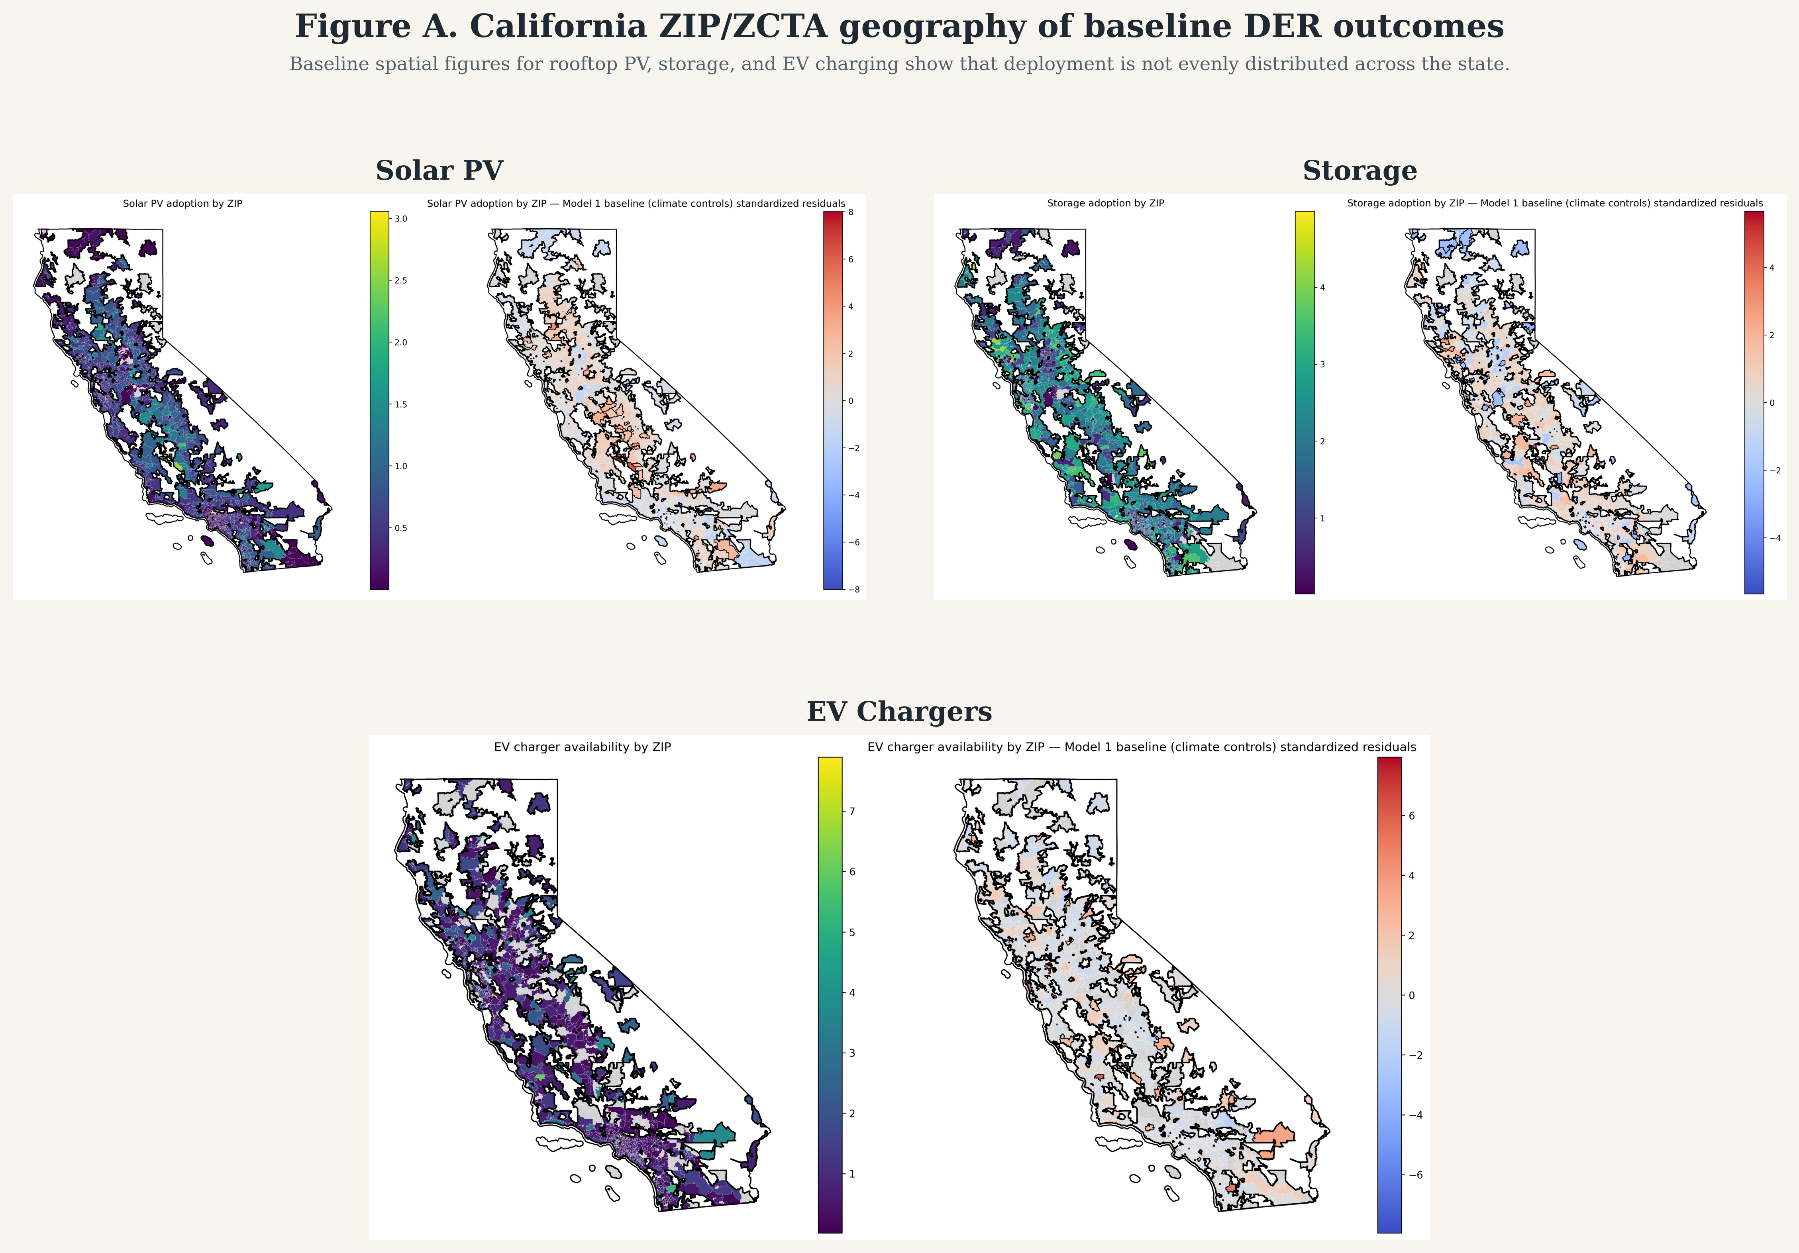
Figure A. Baseline California ZIP/ZCTA geography for rooftop PV, storage, and aggregate EV charging. As shown here, deployment is spatially uneven before any regression adjustments are introduced. Blank areas indicate missing or excluded observations, unmatched geography, or unavailable source data; they should not be interpreted automatically as zero deployment.

3.5 Descriptive distributions
Before turning to regression coefficients, it is useful to see how uneven the raw distributions already are. Figure A1 shows that the three DER outcomes are right-skewed, while the socioeconomic context variables span materially different neighborhood conditions. Table 1 then summarizes the analysis sample numerically so the later model comparisons can be interpreted relative to the observed scale of the data.
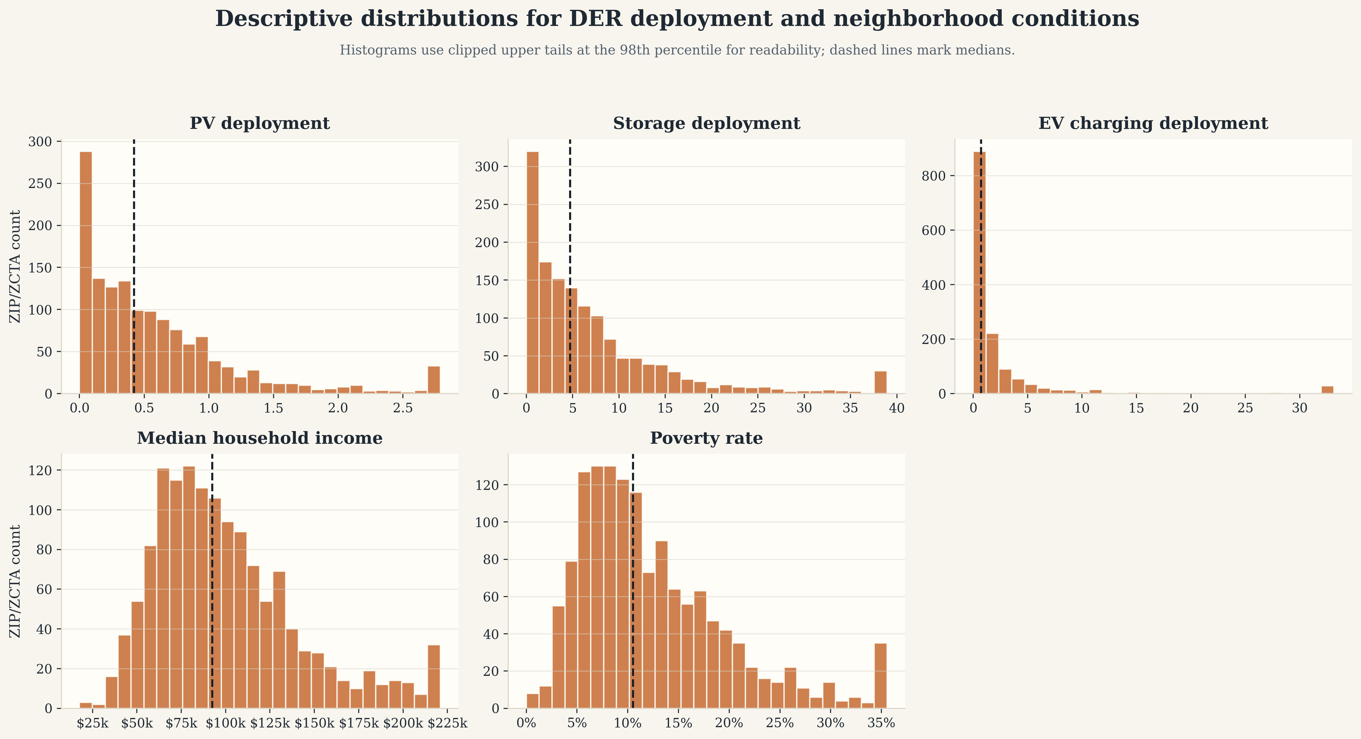
Figure A1. Descriptive distributions for raw DER deployment rates together with median household income and poverty rate. The figure is included as an EDA bridge so readers can see the underlying spread in deployment and neighborhood conditions before moving into conditional models.
Table 1A. Variable definitions for the main outcomes, predictors, and controls.
Variable | Meaning | Scale / notes
y_pv | Solar PV deployment intensity | log(1 + PV kW DC per 1,000 residents)
y_storage | Battery storage deployment intensity | log(1 + storage MW per 100,000 residents)
y_chargers | EV charging availability | log(1 + total chargers per 1,000 residents)
pct_black | Share of ZIP/ZCTA population identifying as Black | ACS 2023 5-year estimate
pct_hispanic | Share of ZIP/ZCTA population identifying as Hispanic or Latino | ACS 2023 5-year estimate
pct_asian | Share of ZIP/ZCTA population identifying as Asian | ACS 2023 5-year estimate
log_median_household_income | Logged median household income | Socioeconomic/adoption-capacity proxy
poverty_rate | Share of residents below the poverty line | Socioeconomic control
pct_bachelors_plus | Share of adults with a bachelor’s degree or higher | Education and adoption-capacity control
ghi_mean_kwh_m2_day_2023 | Mean daily global horizontal irradiance | Solar resource / physical suitability control
cdd65_2023 | Cooling degree days relative to 65°F | Climate control
hdd65_2023 | Heating degree days relative to 65°F | Climate control
log_kwh | Logged annual electricity consumption | Demand/load proxy

Table 1. Summary statistics for the main outcomes and key predictors in the analysis sample.
Variable | N | Mean | Median | P25 | P75
y_pv | 1,341 | 0.438 | 0.380 | 0.174 | 0.616
y_storage | 1,325 | 1.809 | 1.822 | 1.161 | 2.404
y_chargers | 1,161 | 0.960 | 0.703 | 0.354 | 1.272
pct_black | 1,418 | 0.043 | 0.021 | 0.007 | 0.052
pct_hispanic | 1,418 | 0.345 | 0.275 | 0.152 | 0.492
pct_asian | 1,418 | 0.119 | 0.066 | 0.023 | 0.156
log_median_household_income | 1,386 | 11.440 | 11.434 | 11.169 | 11.705
poverty_rate | 1,403 | 0.127 | 0.105 | 0.070 | 0.163
pct_bachelors_plus | 1,418 | 0.359 | 0.324 | 0.188 | 0.506
ghi_mean_kwh_m2_day_2023 | 1,418 | 5.118 | 5.158 | 4.855 | 5.339
log_kwh | 1,240 | 8.329 | 0.000 | 0.000 | 18.231

4. Methods

4.1 Empirical Approach
This paper uses a cross-sectional regression framework to examine whether racial/ethnic and socioeconomic differences are associated with distributed energy resource deployment intensity across California ZIP/ZCTA areas. The main goal is not pure prediction. Instead, it is to test whether disparities in DER adoption persist after accounting for differences in adoption capacity, geography, physical suitability, institutional context, and observed energy-system conditions.
To do this, I estimate a consistent sequence of models for each DER outcome. This stepwise model ladder makes the results easier to interpret because changes in the coefficients of interest can be linked to specific added controls rather than to one opaque saturated specification. It also supports direct comparison across technologies, which is central to the paper’s multi-DER framing.
The three main outcomes are ZIP/ZCTA-level deployment intensity for rooftop solar PV, battery storage, and EV charging. Each is population-normalized and transformed using a log(1 + rate) specification to reduce skew and retain observations with zero deployment. The main explanatory variables of interest are racial/ethnic composition measures and socioeconomic indicators. I then add contextual controls that capture climate, renewable resource potential, utility territory, built-environment structure, and broader installed-energy context.
Because the analysis is ecological and cross-sectional, the results are interpreted as area-level disparities rather than as individual household adoption behavior. The coefficients therefore describe how DER deployment differs across ZIP/ZCTA areas with different demographic and socioeconomic characteristics, conditional on the included controls. They should not be read as causal effects of race or income on any individual household’s technology adoption decision.

4.2 Dataset Construction and Sample
The analysis uses a California ZIP/ZCTA-level dataset created by merging multiple DER source files with demographic, climate, utility, and infrastructure controls. The final merged file combines measures of solar PV capacity, battery storage capacity, and EV charging infrastructure with American Community Survey variables and place-based controls.
DER measures are first constructed separately by technology and then aggregated to the ZIP/ZCTA level. Solar PV capacity is derived from Tracking the Sun installation records. Battery storage is built from a California storage dataset containing location and capacity information. EV charging infrastructure is constructed from charger-level records that include charger type and location. Where source files include latitude/longitude rather than directly usable ZIP codes, records are spatially assigned to ZIP/ZCTA polygons before aggregation. Figure A visualizes the resulting statewide geography and also makes clear that some ZIP/ZCTAs are absent because the underlying merged sample is incomplete in those places.
After source-specific cleaning, the DER measures are merged with contextual predictors. Demographic and socioeconomic variables come from the 2023 American Community Survey 5-year estimates and include total population, median household income, median housing value, educational attainment, poverty, and race/ethnicity shares. Climate and renewable resource controls are derived from NASA POWER and include temperature-based measures, degree days, solar irradiance, and wind resource variables. Utility territory is assigned using a ZIP-to-utility spatial crosswalk, and electricity demand is proxied using annualized utility usage data aggregated to ZIPs.
The unit of analysis is the ZIP/ZCTA. I use ZCTAs because they provide the most practical common geography across the available DER and demographic sources. The study is designed as a 2023 cross-sectional snapshot, using the most recent data aligned as closely as possible to that year. In the regression stage, ZIP/ZCTAs with total population below 1,000 are excluded from outcome construction to avoid unstable per-capita rates in very small areas.

4.3 Outcome Variables
To make the outcomes comparable across technologies, each DER measure is converted into a population-normalized deployment intensity metric and then transformed using log(1 + x) . This helps reduce skew and allows ZIP/ZCTAs with zero deployment to remain in the sample.
The three main outcomes are defined as follows.
For EV charging:
chargers_per_1k = (total_chargers × 1000) / population
y_chargers = log(1 + chargers_per_1k)
For solar PV:
pv_kW_per_1k = (PV_system_size_DC × 1000) / population
y_pv = log(1 + pv_kW_per_1k)
For battery storage:
storage_MW_per_100k = (storage_capacity_mw × 100000) / population
y_storage = log(1 + storage_MW_per_100k)
Storage is scaled per 100,000 residents rather than per 1,000 because storage deployment is much smaller and more uneven at the ZIP level, so the larger denominator keeps the raw rate in a more interpretable range before transformation.
In supplementary analysis, I also examine more disaggregated charging outcomes, including Level 1, Level 2, and DC fast chargers separately, along with a wind-capacity outcome used mainly as contextual comparison. The core paper, however, focuses on the three outcomes above.

4.4 Key Explanatory Variables
The main explanatory variables fall into two groups: racial/ethnic composition and socioeconomic status.
The race/ethnicity variables are ZIP/ZCTA-level shares of the population identifying as Black, Hispanic/Latino, and Asian. These variables are included to test whether DER deployment differs systematically across communities in ways that are not fully explained by socioeconomic conditions alone. For descriptive LOWESS plots, I also summarize these patterns using a combined non-white share, but the regressions keep the disaggregated race variables to avoid collapsing distinct demographic patterns into one coefficient.
The socioeconomic variables are intended to proxy for adoption capacity and broader social advantage. The core measures are log median household income and poverty rate. Additional socioeconomic variables used in extended specifications include percent bachelor’s degree or higher and log median housing value. Education is therefore treated primarily as a control rather than as the paper’s headline predictor: it captures information, housing-market position, and adoption capacity that overlap with income, but the central research question is whether race remains statistically associated with DER deployment after those proxies are included.
The central empirical question is whether the race/ethnicity coefficients weaken substantially once these socioeconomic proxies are included, or whether meaningful disparities remain after accounting for them. If the race coefficients remain negative and statistically distinguishable from zero in richer models, that is evidence against a purely race-neutral account of observed DER deployment patterns.

4.5 Contextual Controls
I include several categories of place-based controls to account for non-demographic factors that may shape DER deployment. First, I include climate and resource controls. Baseline models use heating and cooling degree days to capture broad climatic differences across California. Alternative specifications use more technology-specific contextual variables, including global horizontal irradiance for solar PV and wind speed measures for wind-related outcomes. Temperature controls are also used in some robustness checks.
Second, I include institutional controls through utility territory fixed effects. Utility territories matter because rates, interconnection processes, incentive administration, and historical investment can differ substantially across service areas. Including utility fixed effects helps isolate within-utility differences in deployment.
Third, I include broader geographic controls in selected specifications, including total population, latitude and longitude, and county-based adjustments. These help account for large-scale regional gradients and spatially correlated unobservables. When I refer below to county-clustered standard errors, I mean that inference is adjusted for within-county error correlation rather than assuming each ZIP/ZCTA contributes an independent disturbance.
Fourth, I include electricity demand and infrastructure-context controls in later models. Annual electricity consumption serves as a proxy for underlying load and commercial activity, especially relevant for EV charging. Existing plant, wind, and storage assets are used as installed-energy-context proxies. They are informative about the local energy landscape, but they are not full direct measures of grid infrastructure, feeder capacity, or hosting capacity.

4.6 Baseline Regression Specification
The main estimation approach is ordinary least squares regression using the transformed ZIP/ZCTA-level deployment outcomes. The baseline specification is:
y_z = β_0 + β_1 Income_z + β_2 Black_z + β_3 Hispanic_z + β_4 Asian_z + β_5 Poverty_z + γX_z + ε_z
where y_z is the DER deployment outcome in ZIP/ZCTA z , Income_z is log median household income, Black_z , Hispanic_z , and Asian_z are race/ethnicity population shares, Poverty_z is the ZIP/ZCTA poverty rate, X_z is a vector of contextual controls for ZIP/ZCTA z , and ε_z is the error term.
All models are estimated with heteroskedasticity-robust HC1 standard errors by default. In plain language, HC1 means the standard errors are adjusted so inference is less sensitive to unequal residual variance across ZIP/ZCTAs. In selected specifications, I also cluster standard errors at the county level to allow for within-county correlation in errors.
Rather than relying on one preferred specification, I estimate a staged model ladder. This matters because the paper is not only asking whether disparities appear in one model, but whether they persist as increasingly demanding controls are introduced. The modeling objective is therefore coefficient stability and interpretability across related specifications, not selection of a single best predictive model.

4.7 Model Series

Baseline Equity Specification
The baseline model includes log median household income, race/ethnicity shares, poverty rate, and a limited set of climate controls. This model provides a first-pass estimate of area-level disparities after accounting for basic socioeconomic status and broad geographic conditions.

Additional Socioeconomic Controls
I then add another socioeconomic proxy, typically percent bachelor’s degree or higher or log median housing value, to test whether the race/ethnicity coefficients are sensitive to richer measures of social and housing advantage. This step is important because income alone may not fully capture adoption capacity.

Alternative Climate and Resource Controls
To test whether results depend on a particular way of capturing geographic context, I estimate alternative versions of the baseline model with different climate or physical-suitability controls. For PV, this includes solar irradiance. For some outcomes, I compare degree-day controls to mean temperature-based controls. For wind-related outcomes, I use wind resource measures.

Race-by-Income Interactions
I test whether the income gradient in DER deployment differs across communities by including interaction terms between income and race/ethnicity shares. These variables are mean-centered before interaction so that the main effects remain interpretable.

Utility Fixed Effects and Inference Robustness
I estimate specifications with utility territory fixed effects to absorb institutional differences across service areas. I also estimate county-clustered standard errors as a robustness check for inference.

Geographic Robustness
Additional specifications introduce latitude and longitude or county fixed effects to test whether the main patterns are simply reflecting broad regional gradients within California rather than more local disparities.

Infrastructure Context Controls
I add measures of existing energy infrastructure to examine whether local deployment patterns are partly explained by the surrounding energy-system context. These models test whether communities with more existing infrastructure also mechanically appear to have more DER deployment.

Electricity Demand Controls
Finally, I add a demand proxy based on annual electricity consumption. This is particularly relevant for EV charging, where infrastructure deployment may track commercial activity and underlying load as much as residential adoption potential.
Taken together, this model ladder allows me to ask a structured question: do racial/ethnic disparities shrink meaningfully once I account for socioeconomic status, geography, utility context, and infrastructure, or do they remain persistent across specifications?

4.8 Estimation and Inference
The main quantities of interest are the coefficients on the race/ethnicity variables and how those coefficients change across specifications. I compare both the direction and relative magnitude of these coefficients across solar PV, storage, and EV charging outcomes.
The interpretation is comparative rather than individual-level. A negative coefficient on a racial/ethnic population share does not imply anything about the behavior of an individual resident. Instead, it indicates that ZIP/ZCTA areas with larger shares of that population tend to have lower DER deployment intensity, conditional on the controls in the model. If the coefficient becomes smaller after additional controls are added, that suggests part of the disparity is explained by those added factors.
This comparison across DERs is central to the paper. If the same communities appear underserved across multiple technologies, that points to broader structural inequities in the clean energy transition. If the patterns differ by technology, that suggests more technology-specific barriers.

4.9 Robustness and Diagnostic Checks
In addition to the main regression ladder, I conduct several supporting checks. I examine variance inflation factors (VIFs) to monitor multicollinearity across specifications, compare alternative climate and resource control blocks to test the stability of the results, estimate county-clustered standard errors to assess whether statistical significance is sensitive to local spatial clustering, and generate descriptive maps, distribution plots, and coefficient comparison figures to visualize both the raw patterns and the modeled results.
VIF screening informs the model inventory, but it is not used as a rigid mechanical inclusion rule. Some richer specifications show elevated VIF values, especially once multiple SES and contextual controls are introduced. I retain predictors when they correspond to substantively distinct constructs that are central to the modeling objective rather than treating any moderate VIF increase as evidence that the model is unusable. The relevant question for this paper is therefore whether the coefficients of interest remain interpretable and stable, not whether every rich specification minimizes collinearity by design.
In exploratory analysis, I compare linear specifications to more flexible predictive models, including polynomial regression, random forest, and gradient-boosted trees, using cross-validation. These models are not the basis for the paper’s main claims. Instead, they serve as a diagnostic check on whether simple linear models are missing strong nonlinear structure. The substantive conclusions remain grounded in the interpretable OLS results.

4.10 Methodological Limitations
This methodology is designed to identify area-level associations, not causal effects. The results should therefore be interpreted as descriptive disparities conditional on observed controls. Unmeasured confounding may remain, especially around housing tenure, installer presence, permitting, and technology-specific incentive access.
There are also limitations tied to geography and measurement. ZIP/ZCTA aggregation is a practical compromise that enables multi-DER harmonization, but it can blur within-area heterogeneity and raises the usual ecological inference problem. In addition, some source files require spatial assignment or manual cleaning steps, which may introduce measurement error. Even so, using a consistent geography and model structure across technologies provides a useful basis for comparative equity analysis.

5. Results
The results section begins with the descriptive evidence that most closely parallels the comparison papers: smooth adoption-versus-covariate views and compact baseline regression tables. As shown in Figure B and Table 2, the baseline patterns already suggest that race and income are associated with DER outcomes differently across technologies. The later figures then ask whether those patterns persist as the model ladder becomes more demanding.
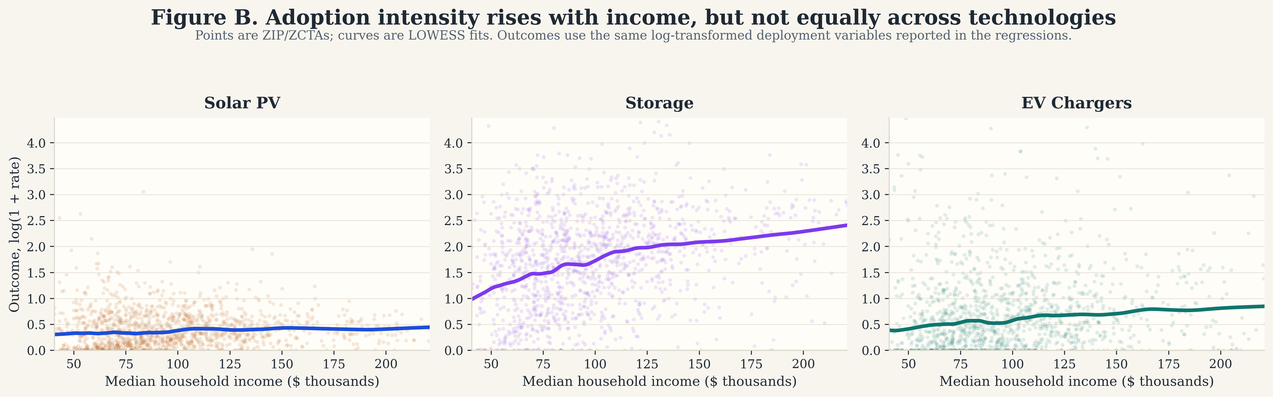
Figure B. Outcome-by-income descriptive gradients for rooftop PV, storage, and EV charging. Outcomes are shown on the transformed log(1 + rate) scale. Where shaded bands are shown in the LOWESS figures below, they indicate 95% bootstrap confidence intervals around the fitted smooth.
Table 2. Baseline regression summary across the three headline DER outcomes.
Predictor | y_pv | y_storage | y_chargers
log_median_household_income | 0.111*** (0.041) | 0.742*** (0.111) | 0.241 (0.151)
pct_black | -0.873*** (0.116) | -1.727*** (0.318) | -1.077** (0.442)
pct_hispanic | -0.039 (0.052) | -0.685*** (0.118) | -0.889*** (0.151)
pct_asian | -0.669*** (0.049) | -1.775*** (0.154) | -0.118 (0.209)
poverty_rate | 0.004 (0.237) | -0.277 (0.529) | 3.552*** (0.788)
Key climate/resource control | GHI: 0.158*** (0.030) | HDD65: 0.0001*** (0.0000) | HDD65: 0.0001*** (0.0000)
N | 1,320 | 1,314 | 1,148
R² | 0.118 | 0.227 | 0.103

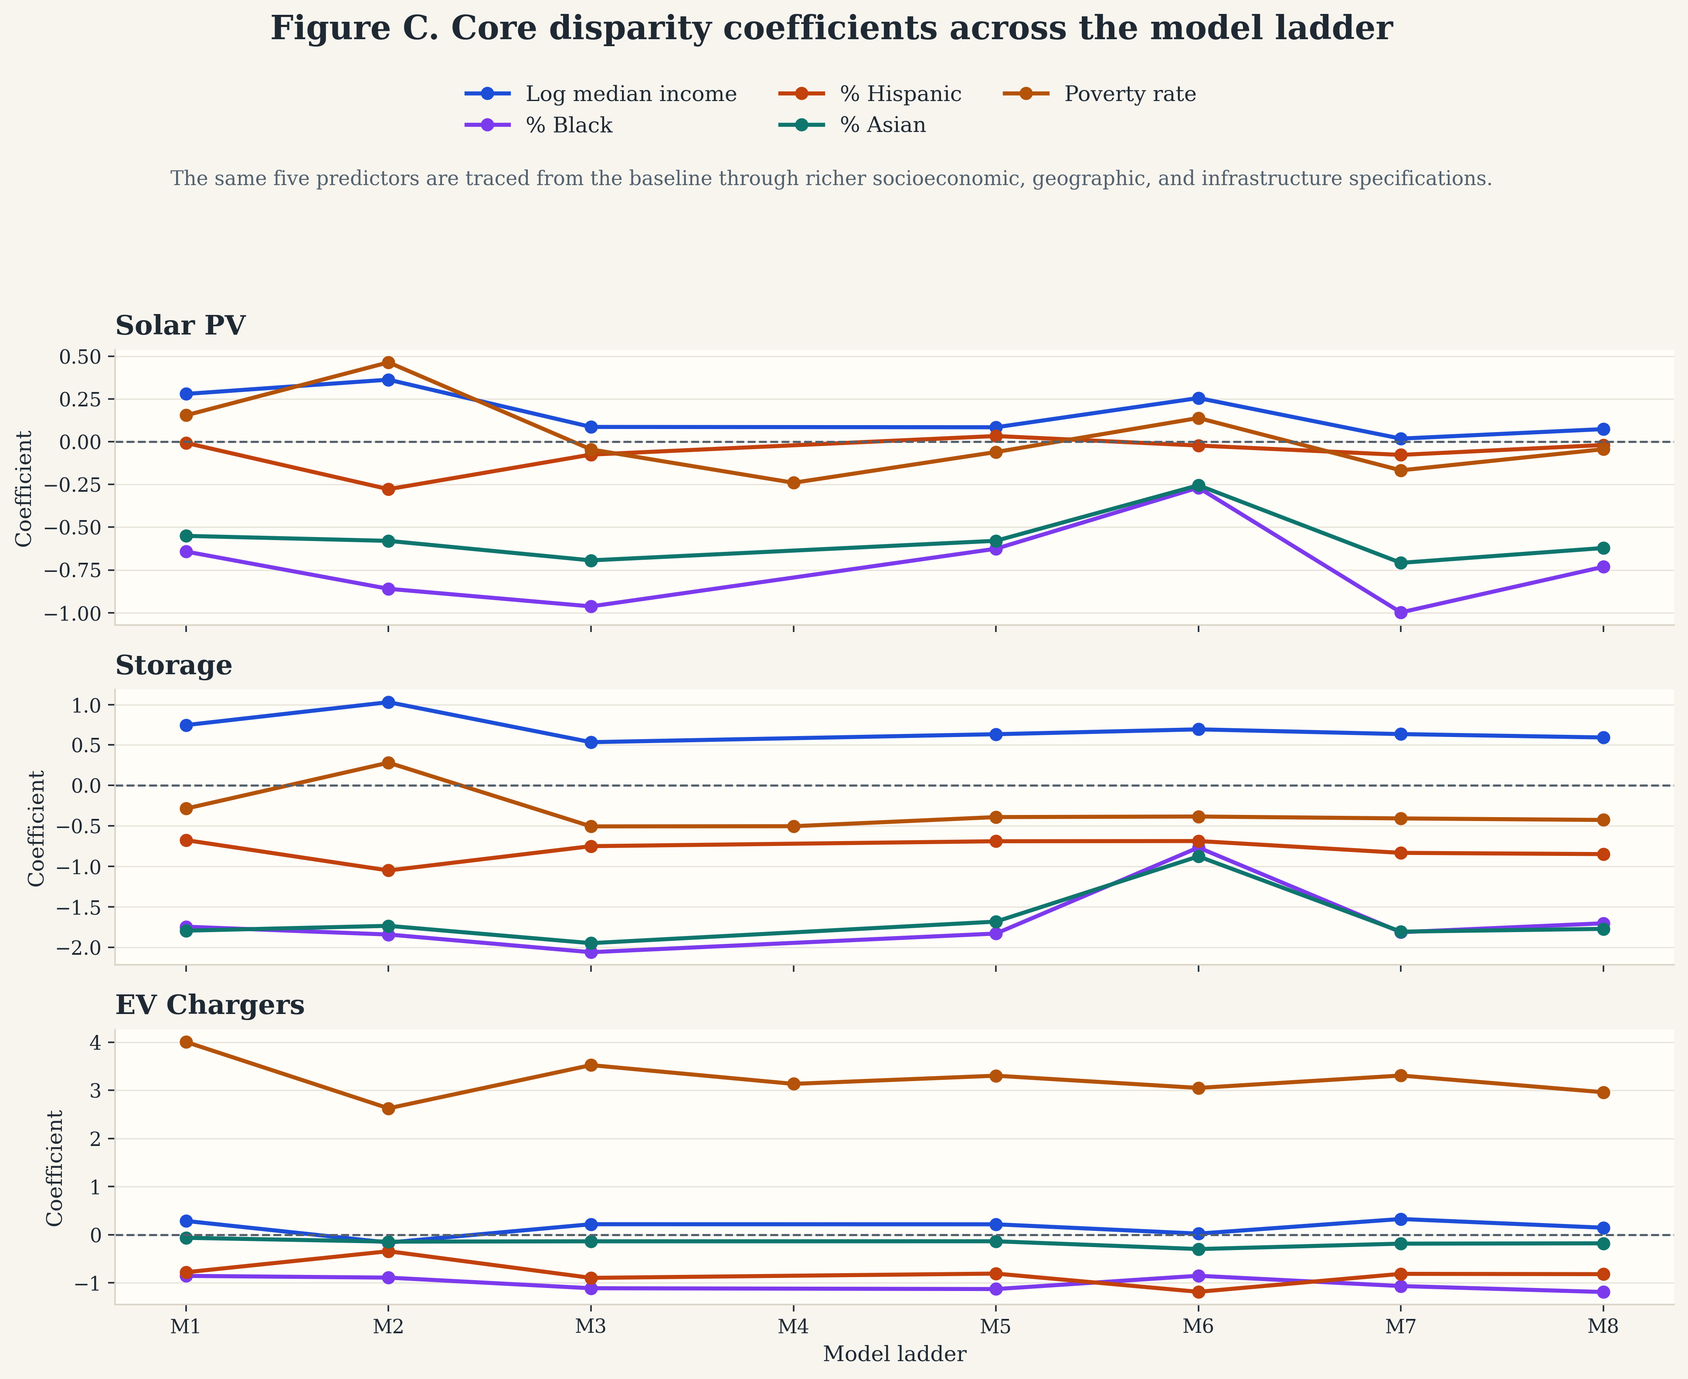
Figure C. Coefficient paths for the five main disparity predictors across the eight-model ladder. This condenses the paper’s central identification claim into one visual: some coefficients attenuate as controls are added, but the overall cross-technology disparity pattern remains.

5.1 Baseline patterns across DER types
A consistent pattern across the main specifications is that racial and socioeconomic disparities are not uniform across technologies. Table 2 and Figure C show that solar PV and battery storage display the clearest and most persistent negative associations with ZIP/ZCTA shares of Black and Asian residents even after controlling for income and poverty. EV charging shows a different pattern: charger deployment is negatively associated with Hispanic share and, to a lesser extent, Black share, but the aggregate charger outcome also shows a positive association with poverty rate. This makes EV charging substantively different from the PV and storage results and suggests that “charger availability” may be capturing a different mix of infrastructure types and siting logics than household-centered DER adoption.
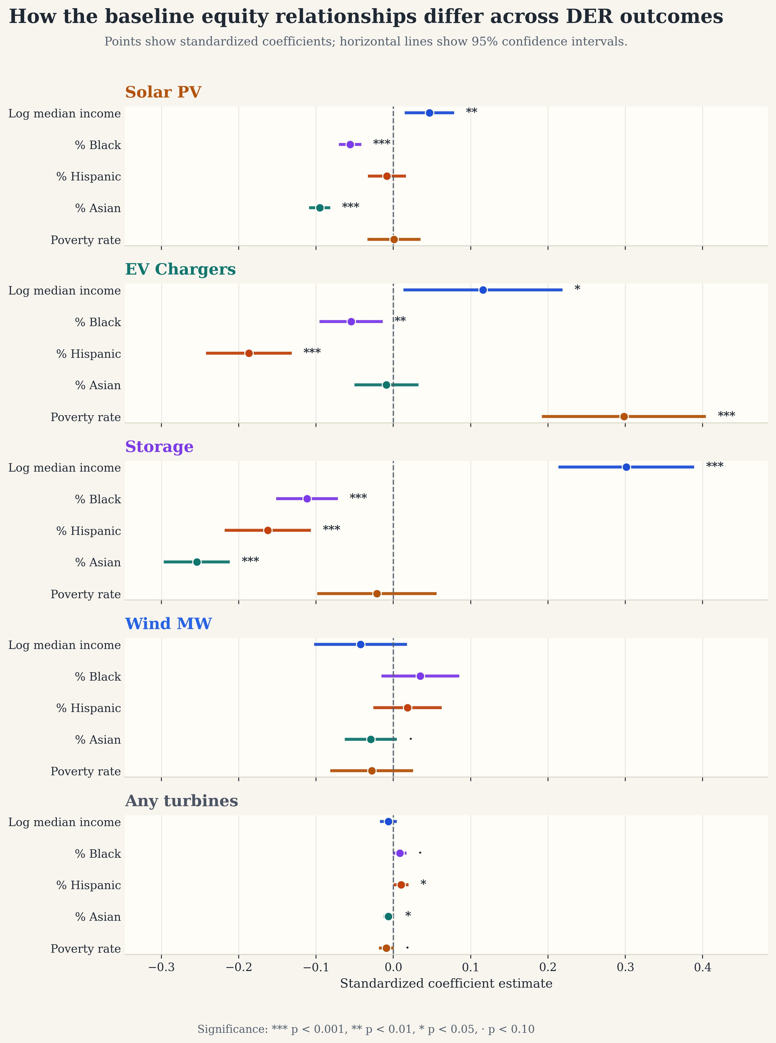
Figure 1. Cross-outcome dot-whisker comparison from the standardized model outputs for Solar PV, Storage, EV Chargers, and Wind MW. This figure summarizes how core predictors such as log_median_household_income , pct_black , pct_hispanic , pct_asian , and poverty_rate vary across the continuous DER outcomes, excluding the binary turbine-presence outcome. Source file: outputs/standardized_figures/baseline_der_outcomes_dot_whisker.svg .

5.2 Solar PV: persistent disparities after resource controls
For solar PV, the baseline specification indicates that ZIP/ZCTAs with higher median household income have higher PV adoption intensity, while ZIP/ZCTAs with larger Black and Asian population shares have substantially lower PV adoption intensity. As summarized in Figure 2, the coefficient on log_median_household_income is positive and statistically significant in the baseline model, while pct_black and pct_asian are strongly negative. Solar resource potential behaves as expected: ghi_mean_kwh_m2_day_2023 is positive and highly significant, suggesting that physical suitability is an important predictor of deployment.
These disparities remain substantively present as the model becomes more demanding. Adding educational attainment ( Model 2 ) strengthens the estimated income effect and makes the coefficient on pct_hispanic negative and statistically significant as well, while the negative coefficients on pct_black and pct_asian remain large. In the county-clustered specification ( Model 5C ), the income effect attenuates and becomes marginal, but the negative coefficient on pct_asian remains strongly significant and the negative coefficient on pct_black remains statistically distinguishable from zero. In the infrastructure-control and demand-proxy models ( Models 7 and 8 ), the PV results continue to show large negative associations for pct_black and pct_asian , indicating that these patterns are not explained away by existing energy infrastructure or underlying electricity demand.
Substantively, the solar results are the clearest evidence in the paper that demographic disparities persist even after accounting for major “ability to adopt” and resource variables. The persistence of the race/ethnicity coefficients after controlling for income, poverty, and solar irradiance suggests that the PV gap is not simply a byproduct of lower-income areas having worse solar resource conditions.
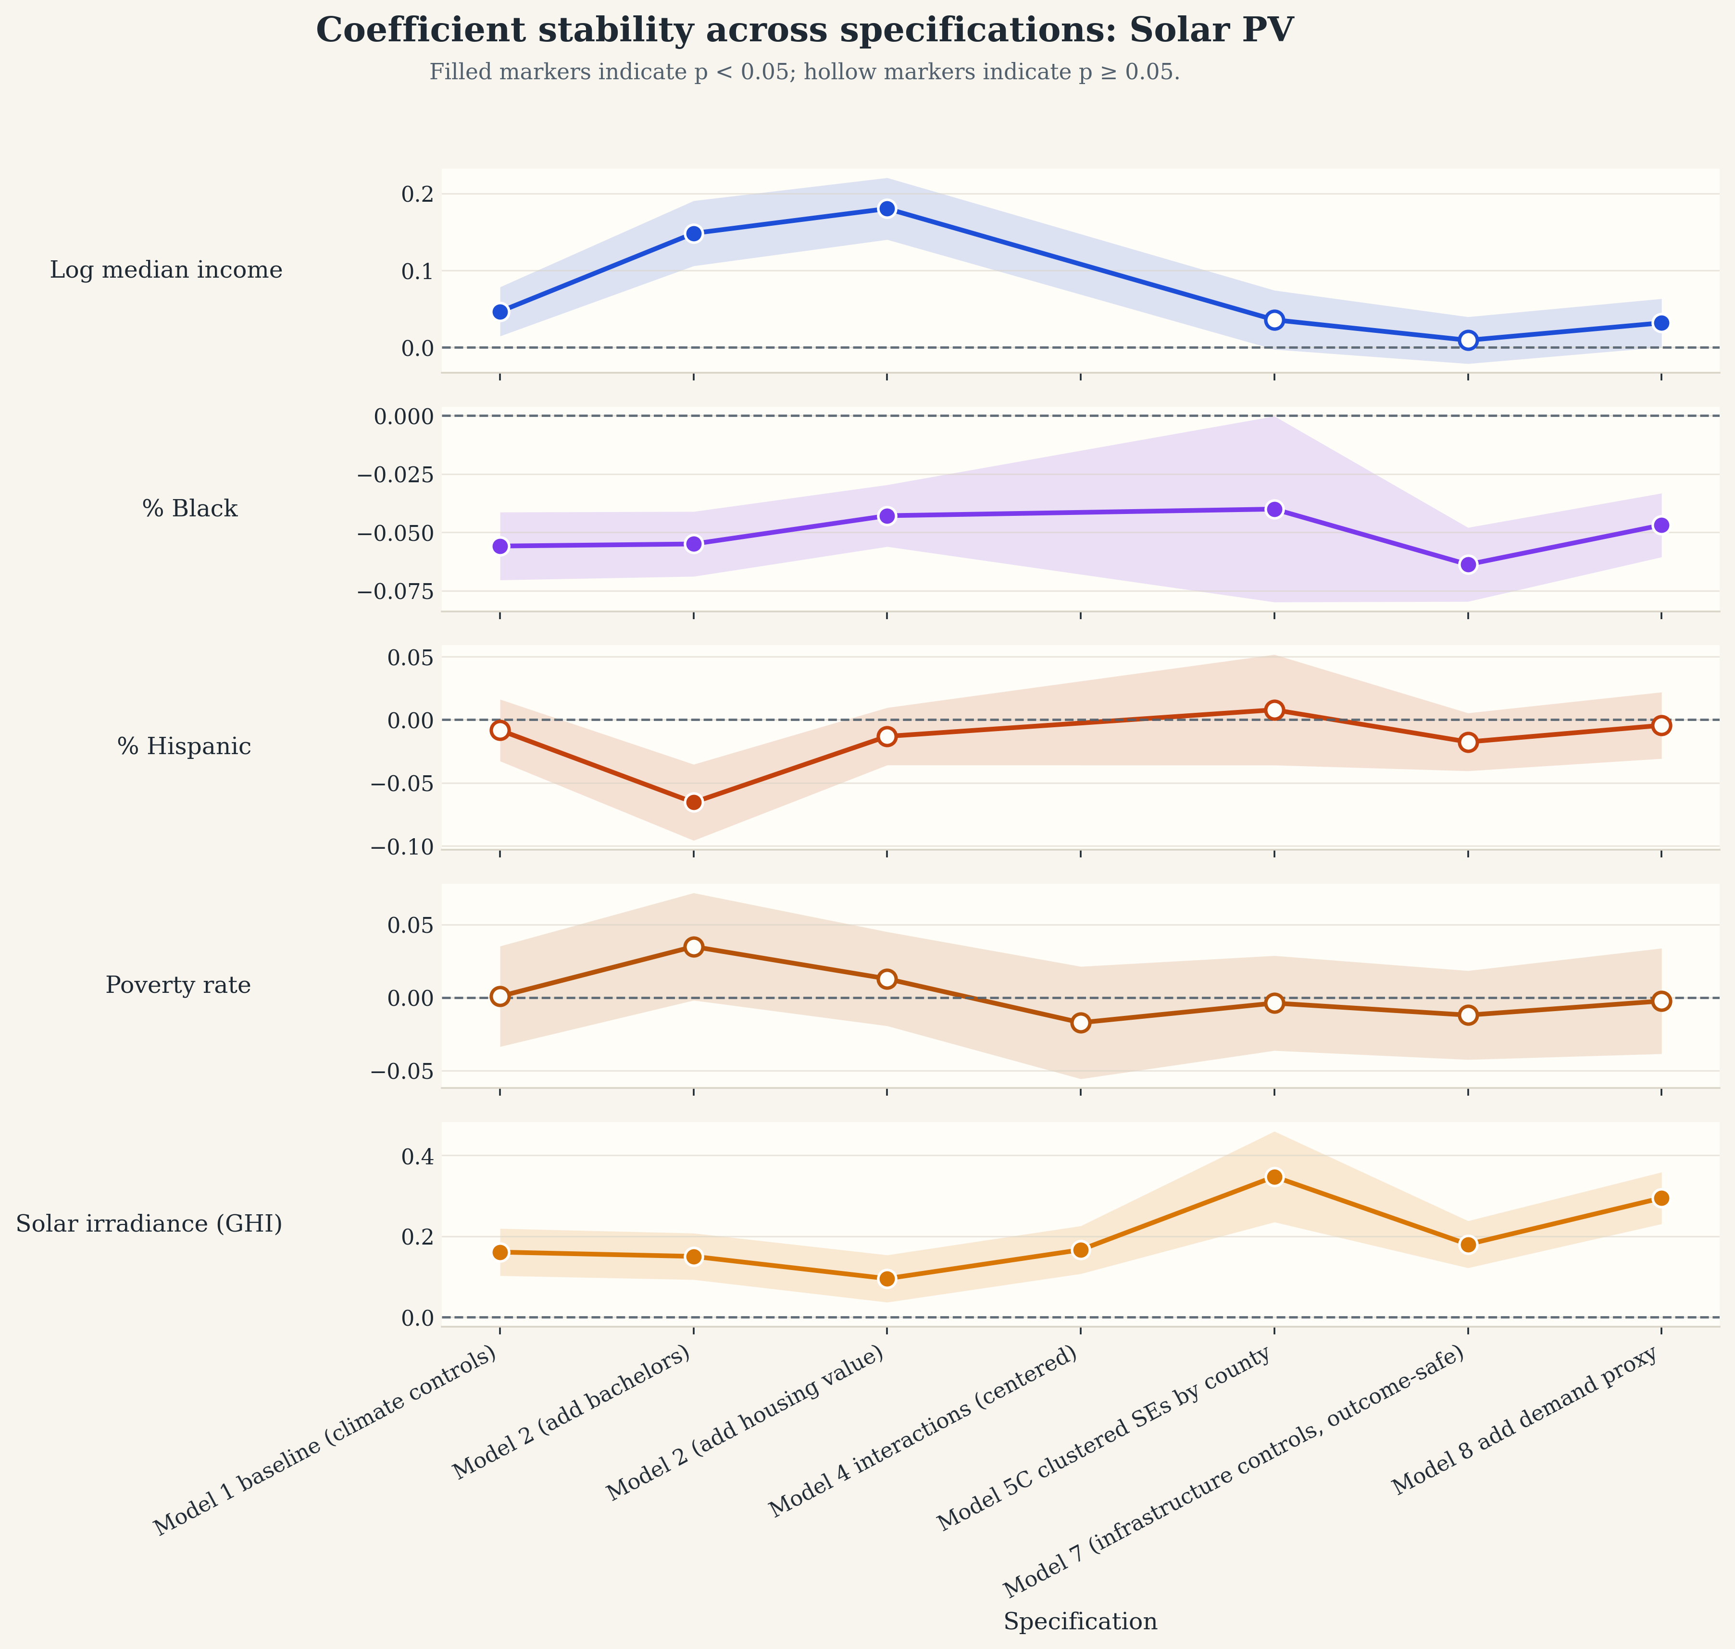
Figure 2. Standardized robustness summary for y_pv . This is the closest existing exported figure to a coefficient-stability view of the rooftop PV results across the model ladder. Source file: outputs/standardized_figures/y_pv_robustness.svg .

5.3 Storage: the strongest and most consistent inequities
Battery storage exhibits the strongest and most stable disparity pattern of the main DER outcomes. Figure 3 shows that in the baseline storage model log_median_household_income is strongly positive, while pct_black , pct_hispanic , and pct_asian are all negative. Compared with the PV results, the storage coefficients are larger in magnitude and remain negative across nearly every robustness check examined.
This pattern survives the addition of extra socioeconomic controls, clustered standard errors, infrastructure variables, and electricity demand. In Model 2 , the income effect becomes even larger, and the negative coefficients on pct_black , pct_hispanic , and pct_asian remain large and precisely estimated. In the county-clustered specification ( Model 5C ), all three race/ethnicity variables remain negative and statistically significant. The same is true in the infrastructure-control and demand-proxy models. Unlike the EV charging outcome, the storage pattern does not appear to hinge on one especially unstable control or one fragile specification; it is persistent across the model ladder.
I also estimate an additional robustness model, Model 9 , that adds y_pv to the most controlled storage specification to ask whether storage inequities persist after conditioning on local PV deployment intensity. The PV term is large and positive ( 1.148 , p < 0.001 ), as expected for a solar-plus-storage pathway, but the race coefficients remain negative and statistically significant: pct_black = -1.080 ( p < 0.001 ), pct_hispanic = -1.012 ( p < 0.001 ), and pct_asian = -1.097 ( p < 0.001 ). This is an important result for the paper’s policy argument because it suggests that the storage gap is not explained solely by unequal PV deployment upstream.
Table 3. Storage Model 9 PV-control robustness.
Predictor | Coefficient | Robust SE | p-value
log_median_household_income | 0.462*** | 0.128 | < 0.001
pct_black | -1.080*** | 0.253 | < 0.001
pct_hispanic | -1.012*** | 0.136 | < 0.001
pct_asian | -1.097*** | 0.139 | < 0.001
pct_bachelors_plus | -0.446* | 0.219 | 0.041
y_pv | 1.148*** | 0.109 | < 0.001

These results suggest that storage adoption is not only income-sensitive but also more unevenly distributed across communities than EV charging and at least as unequal as PV, if not more so. Because storage is often discussed in terms of resilience, backup power, and outage protection, this result has especially important implications for energy equity: the communities with the greatest vulnerability to outages may not be the ones receiving the greatest access to storage.
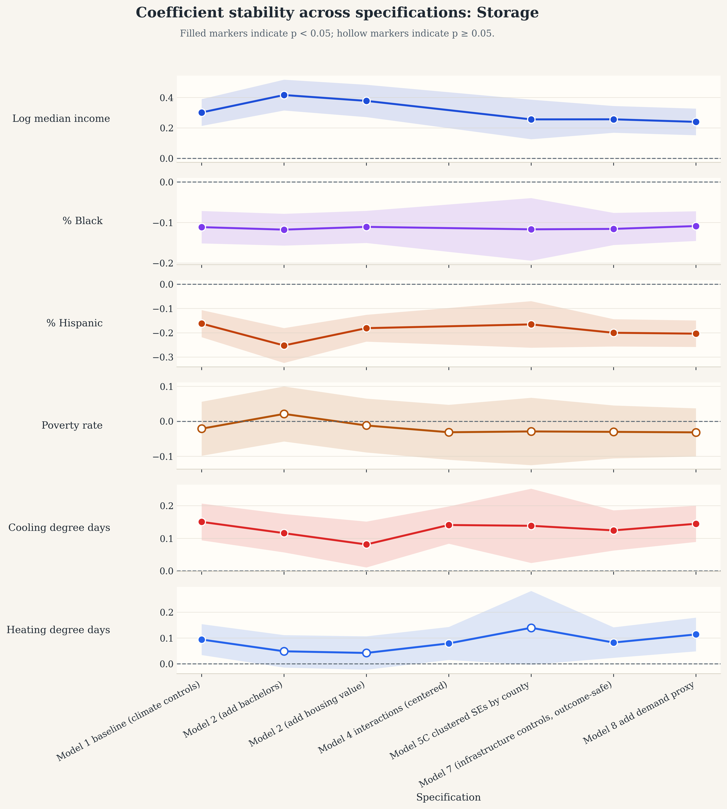
Figure 3. Standardized robustness summary for y_storage . Read together with Figure 2 and the Model 9 table, this figure highlights that the storage coefficients are generally larger and more persistent than the PV coefficients. Source file: outputs/standardized_figures/y_storage_robustness.svg .

5.4 EV charging: aggregate disparities mask charger-type composition
The EV charging results are more complex than the PV and storage findings. As shown in Figure 4, the aggregate charger model yields a positive and statistically significant income coefficient in the baseline specification, while pct_black and pct_hispanic are negative. At the same time, poverty_rate is strongly positive. That positive poverty coefficient persists across several robustness checks, including county-clustered, infrastructure-control, and demand-proxy models.
The charger-type decomposition helps clarify what is going on. In the standardized baseline models, the positive aggregate association with poverty_rate is not present for y_level1_chargers , where the coefficient is small and statistically insignificant ( 0.087 , p = 0.285 ). Instead, the aggregate pattern appears to be driven primarily by y_level2_chargers , where poverty_rate is strongly positive and highly significant ( 4.483 , p < 0.001 ). For y_dc_fast_chargers , the coefficient on poverty_rate is also positive, but it is imprecisely estimated in the standardized baseline model ( 0.390 , p = 0.345 ).
Taken together, Figure 5 and Table 4 suggest that the positive poverty-rate relationship in the aggregate charger outcome is composition-driven rather than reflecting uniformly greater charging access across all charger types.
This matters for interpretation. A positive coefficient in the aggregate charger model should not be read as straightforward evidence that poorer communities have better household-serving charging access. The subtype results are more consistent with a siting story in which Level 2 and, to a lesser extent, DC fast infrastructure are concentrated in commercial, corridor, workplace, municipal, or otherwise non-residential locations that may be more common in poorer or more industrial ZIP/ZCTA areas. In that sense, the aggregate charger count is partly measuring infrastructure composition rather than a uniform access benefit.
This is one of the most interesting findings in the paper because it shows that EV charging equity cannot be interpreted from a single aggregate charger metric alone. Disaggregating charger types changes the substantive meaning of the result and suggests that charger composition should be treated as central, not peripheral, in future equity work.
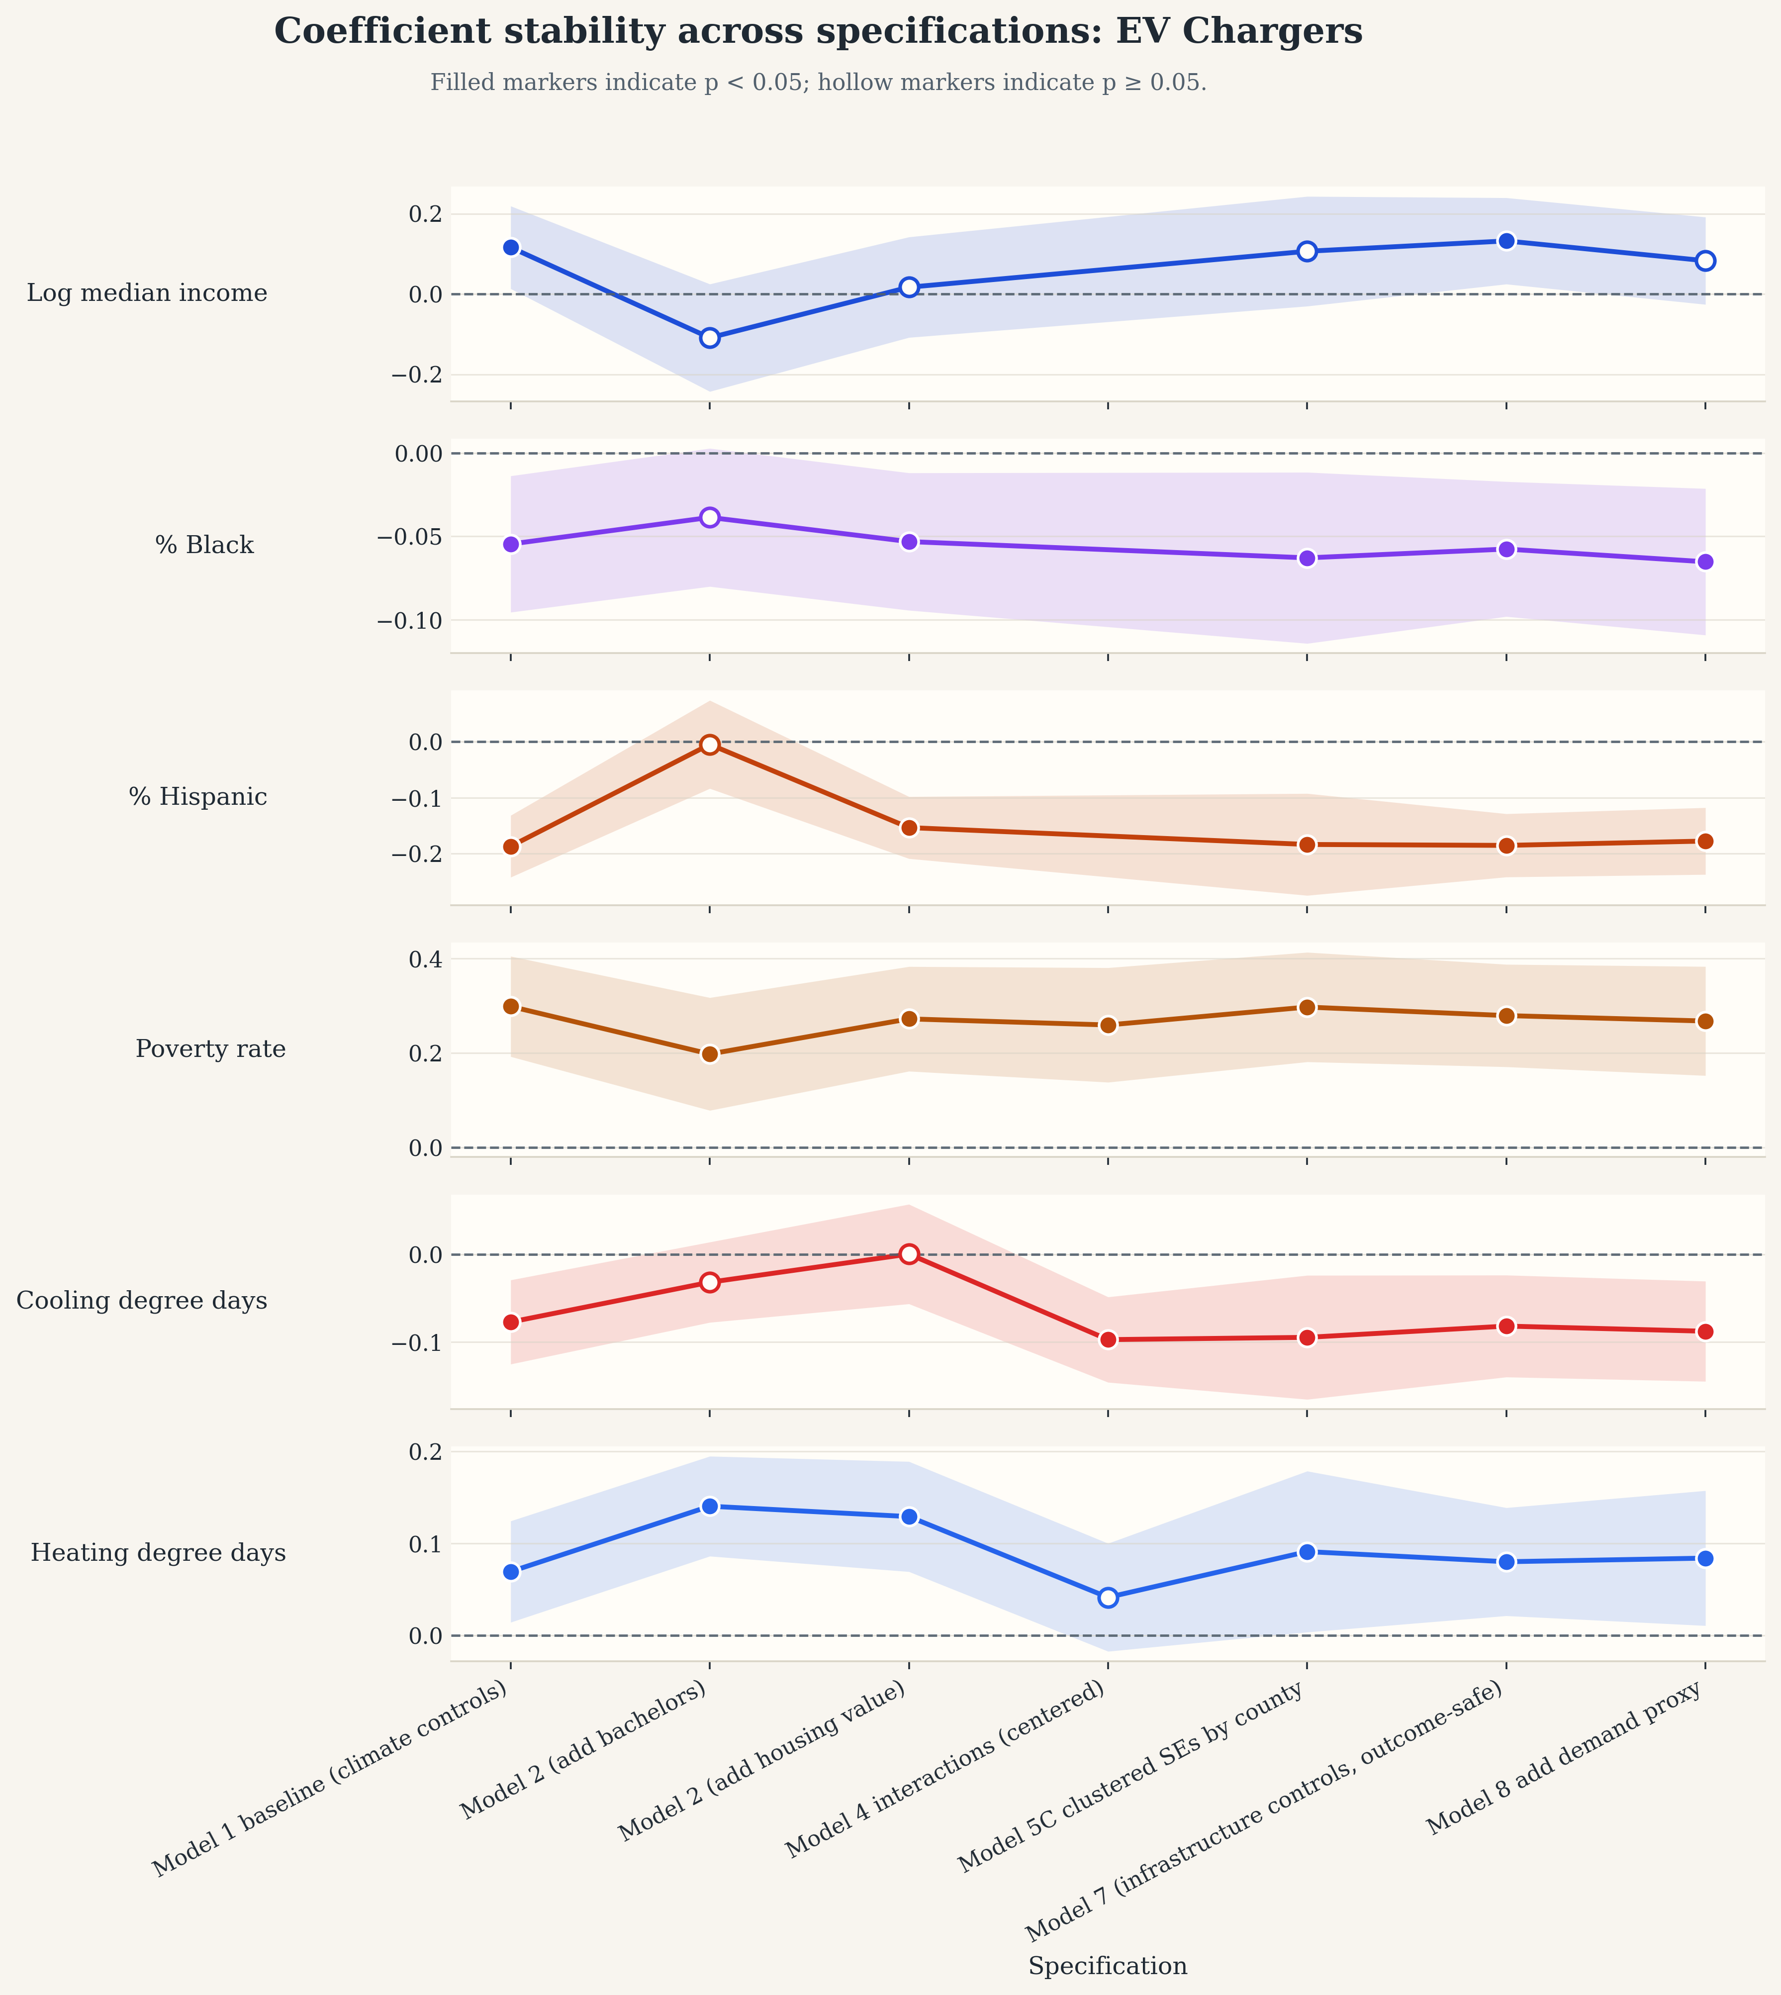
Figure 4. Standardized robustness summary for aggregate y_chargers . This figure shows how the aggregate EV charging result behaves across specifications, but it does not by itself separate Level 1, Level 2, and DC fast charging. Source file: outputs/standardized_figures/y_chargers_robustness.svg .
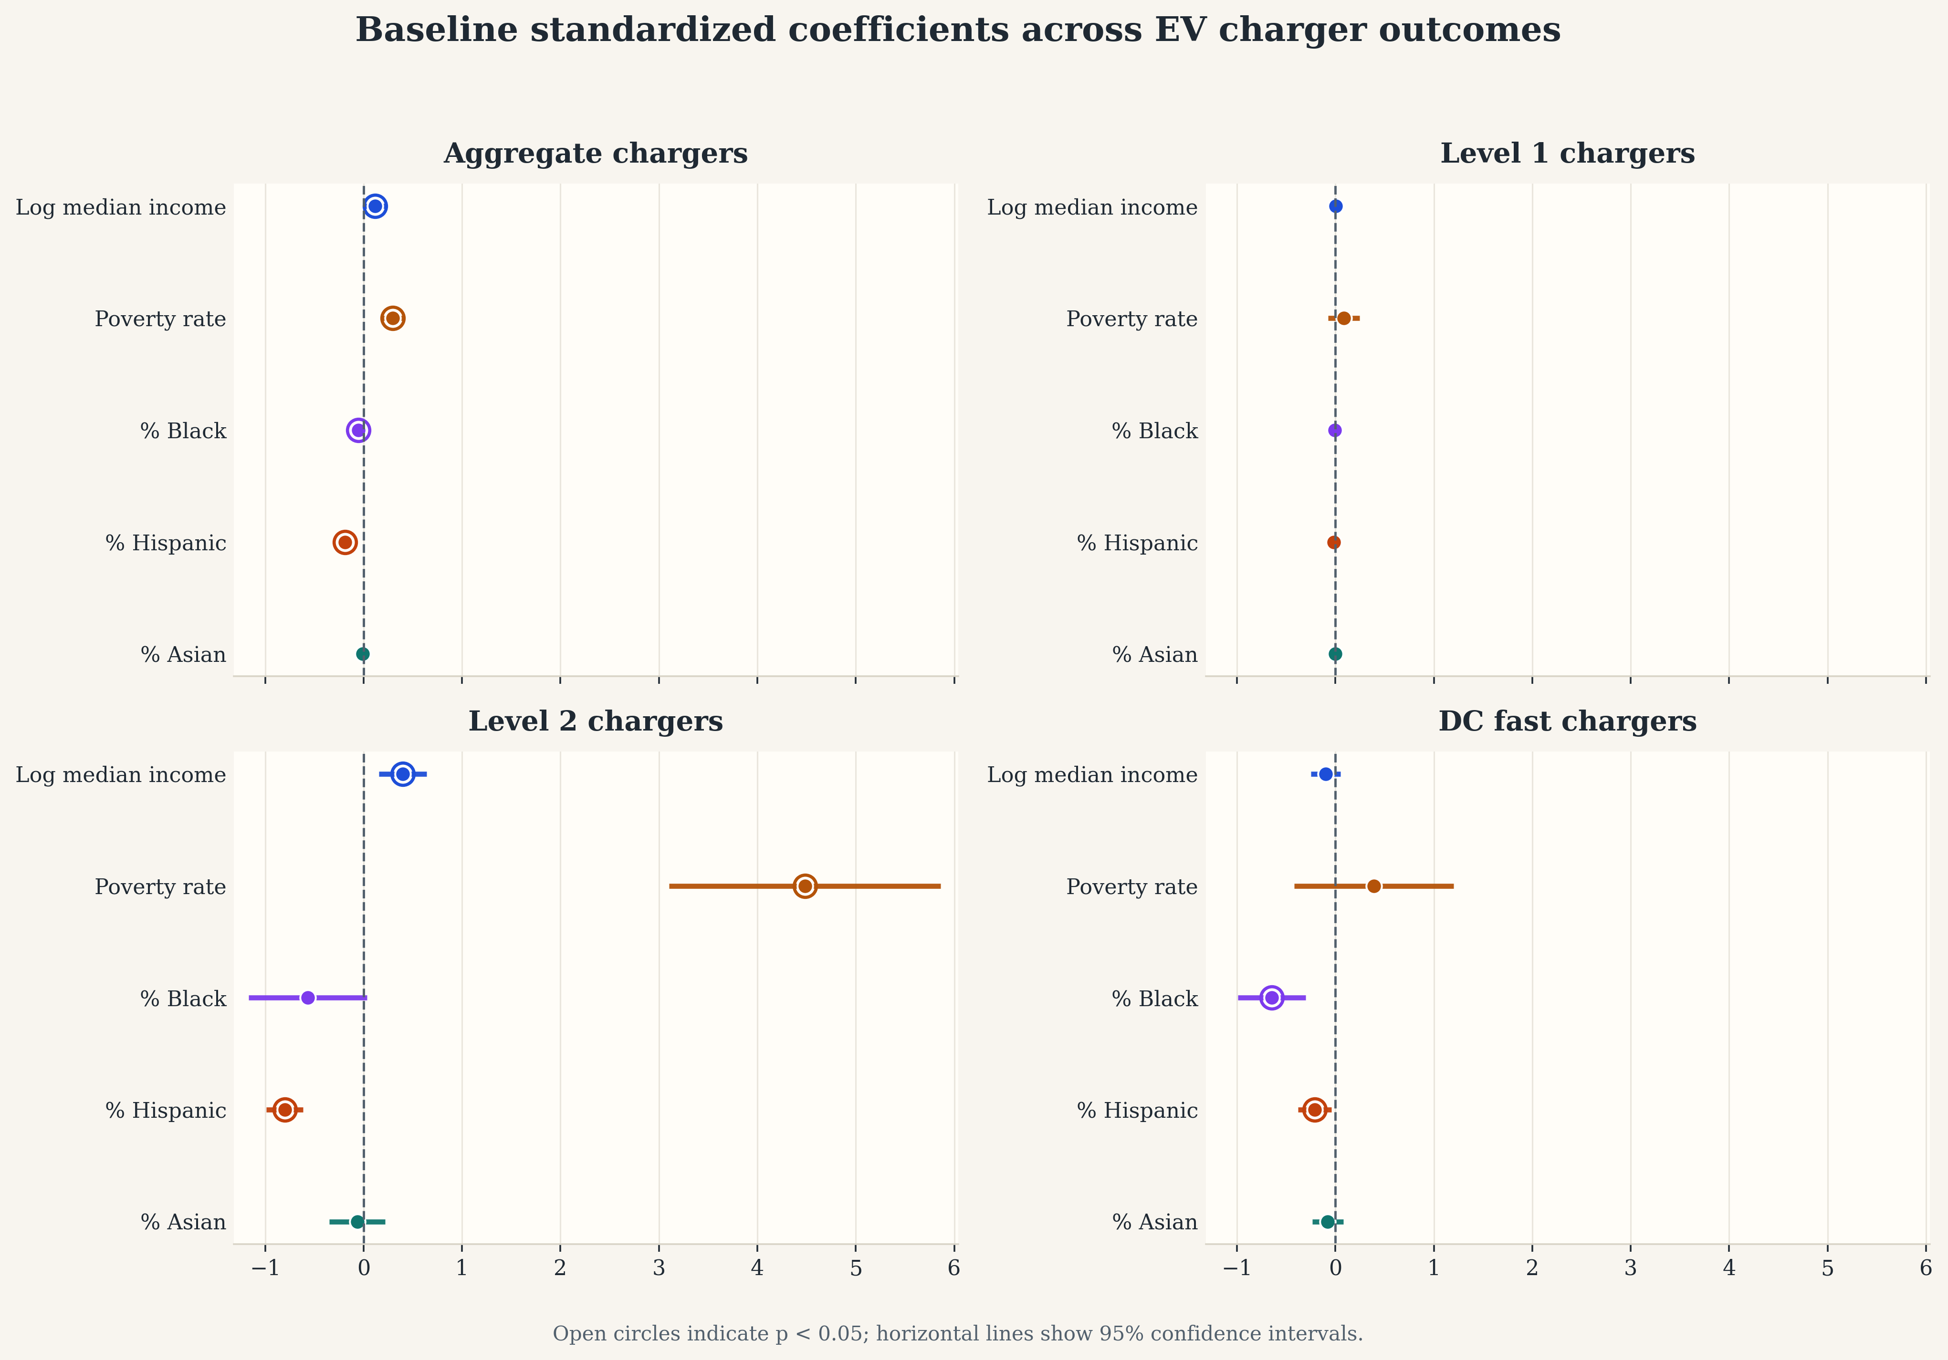
Figure 5. Baseline standardized coefficient comparison across aggregate charging, y_level1_chargers , y_level2_chargers , and y_dc_fast_chargers . This figure makes the subtype result explicit: the positive aggregate association with poverty_rate is not present for Level 1 charging and is driven primarily by Level 2 charging. Source file: outputs/standardized_figures/charger_subtype_comparison.svg .
Table 4. EV charger subtype comparison in baseline models.
Predictor | Aggregate | Level 1 | Level 2 | DC Fast
log_median_household_income | 0.241 (0.151) | 0.016 (0.025) | 0.334** (0.150) | 0.037 (0.081)
pct_black | -1.077** (0.442) | -0.034 (0.028) | -0.796* (0.424) | -0.594*** (0.175)
pct_hispanic | -0.889*** (0.151) | -0.033 (0.024) | -0.913*** (0.145) | -0.146 (0.093)
pct_asian | -0.118 (0.209) | -0.002 (0.033) | -0.110 (0.212) | -0.064 (0.099)
poverty_rate | 3.552*** (0.788) | 0.136 (0.110) | 3.899*** (0.778) | 0.601 (0.440)
N | 1,148 | 1,148 | 1,148 | 1,148
R² | 0.103 | 0.005 | 0.104 | 0.049

5.5 Descriptive nonlinear gradients
The regression tables summarize conditional associations, but the raw outcome gradients are also informative. Figure 6 plots a combined non-white share against the three main DER outcomes using deterministic LOWESS smoothing with seeded 95% bootstrap confidence intervals. The fitted gradients are negative for all three technologies, with the largest descriptive decline for storage. Over the middle 90 percent of the observed predictor range, the fitted endpoint change is about -0.21 for PV, -1.58 for storage, and -0.12 for aggregate chargers. These are descriptive summaries rather than causal effects, but they reinforce the regression finding that more heavily non-white ZIP/ZCTAs tend to be less served across multiple DER outcomes.
Figure 7 provides the corresponding education view using pct_bachelors_plus . The regenerated deterministic LOWESS audit shows a mildly negative unconditional gradient for PV ( -0.09 ) but positive gradients for storage ( 0.61 ) and EV charging ( 1.14 ). The corresponding standardized Model 2 charger regression also estimates a positive education coefficient ( 1.670 , p < 0.001 ). If an earlier figure or notebook export suggested a negative bachelors relationship for EV chargers, that should be read as a stale or specification-specific mismatch rather than the current paper result. In the current generated evidence, bachelor’s attainment is positively associated with aggregate EV charger deployment.
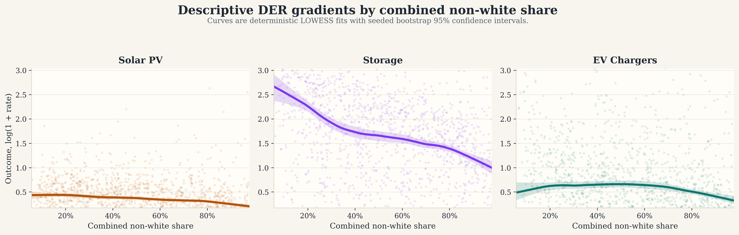
Figure 6. Descriptive LOWESS gradients between combined non-white share and the three headline DER outcomes. Shaded ribbons show 95% bootstrap confidence intervals. These panels are descriptive only; they do not condition on the full control set used in the regressions.
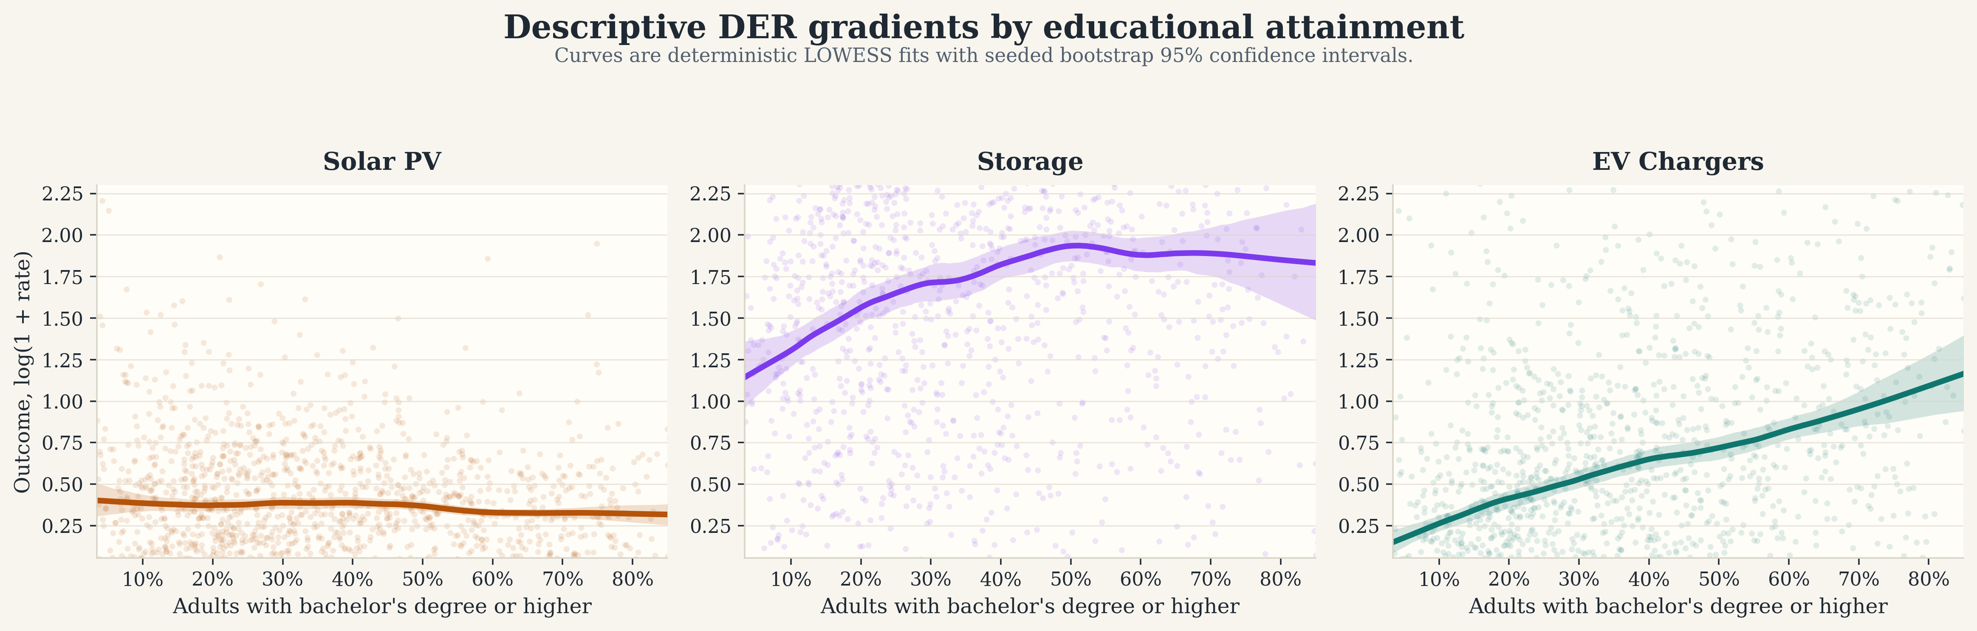
Figure 7. Descriptive LOWESS gradients between pct_bachelors_plus and the three headline DER outcomes. Shaded ribbons show 95% bootstrap confidence intervals. The education panels are included as descriptive context rather than as a claim that education is the paper’s central explanatory variable.

5.6 Exploratory clustering of ZIP/ZCTA types
In addition to the regression ladder, I use a PCA plus K-means clustering exercise to summarize the kinds of ZIP/ZCTA contexts that appear in the statewide sample. This is descriptive rather than causal, but it is useful for showing that the analysis is not comparing one uniform set of neighborhoods. Instead, California ZIP/ZCTAs sort into distinct socioeconomic and DER-deployment profiles.
The cluster map in Figure 8 shows that these profiles are spatially coherent rather than randomly scattered. Table 5 indicates that the clusters differ along multiple dimensions at once: cluster 1 is affluent with a large Asian share and relatively strong charging outcomes; cluster 2 has the highest Hispanic and combined non-white shares together with the highest poverty rate and the weakest charging deployment; and cluster 0 combines comparatively strong PV, storage, and charging outcomes with a larger residual white/other share. These differences are consistent with the broader paper argument that technology access is shaped by bundles of demographic, economic, and infrastructural conditions rather than by one variable in isolation.
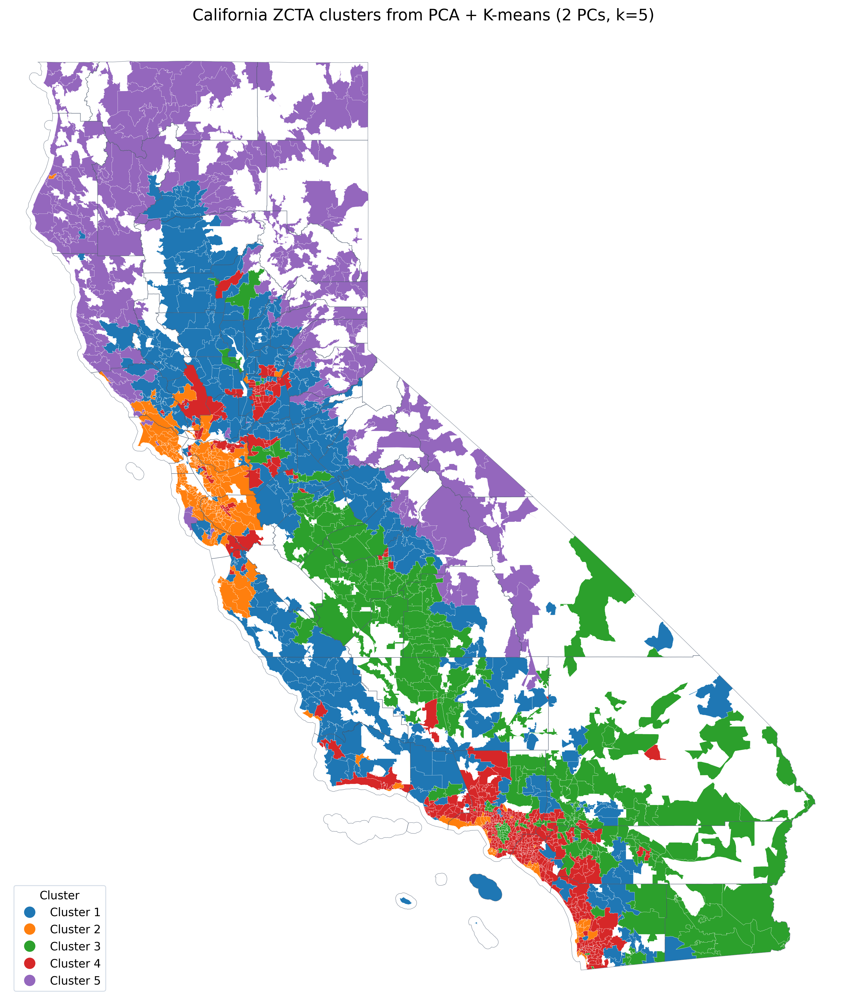
Figure 8. California ZIP/ZCTA clusters from the exploratory PCA plus K-means analysis. The cluster labels are arbitrary identifiers, but the map shows that the resulting neighborhood profiles are geographically structured rather than random.
Table 5. Cluster-profile means from the PCA plus K-means assignment.
Cluster | N ZIPs | Income | Poverty | Black | Hispanic | Asian | Residual white/other share | PV / 1k | Storage / 100k | Chargers / 1k
Blue (1) | 1,218 | $87.5k | 12.9% | 2.5% | 30.1% | 4.1% | 63.3% | 0.89 | 11.00 | 13.66
Orange (2) | 279 | $159.6k | 7.8% | 3.3% | 15.9% | 24.0% | 56.8% | 0.52 | 10.66 | 10.83
Green (3) | 323 | $64.2k | 20.2% | 5.6% | 63.4% | 4.7% | 26.3% | 0.92 | 5.62 | 2.81
Red (4) | 488 | $104.9k | 10.4% | 6.0% | 33.9% | 16.8% | 43.3% | 0.43 | 5.13 | 2.39
Purple (5) | 252 | $74.4k | 13.7% | 0.9% | 14.9% | 1.5% | 82.7% | 0.45 | 10.63 | 5.40

5.7 Wind as a contextual comparison outcome
The wind-capacity outcome is useful as contextual comparison but is less central to the paper’s main equity argument. For y_wind_mw , the most consistent predictor is wind_ws50m_mean_2023 , which is positive and statistically significant across all examined models. By contrast, the social variables are weaker and less stable. This suggests that wind siting is much more tightly tied to physical resource conditions than the other DER outcomes considered here.
Because wind is less directly comparable to behind-the-meter or consumer-facing DER adoption, it is best treated as supplementary context rather than as one of the paper’s headline findings. The paper therefore does not foreground the binary turbine-presence outcome in the reported results.
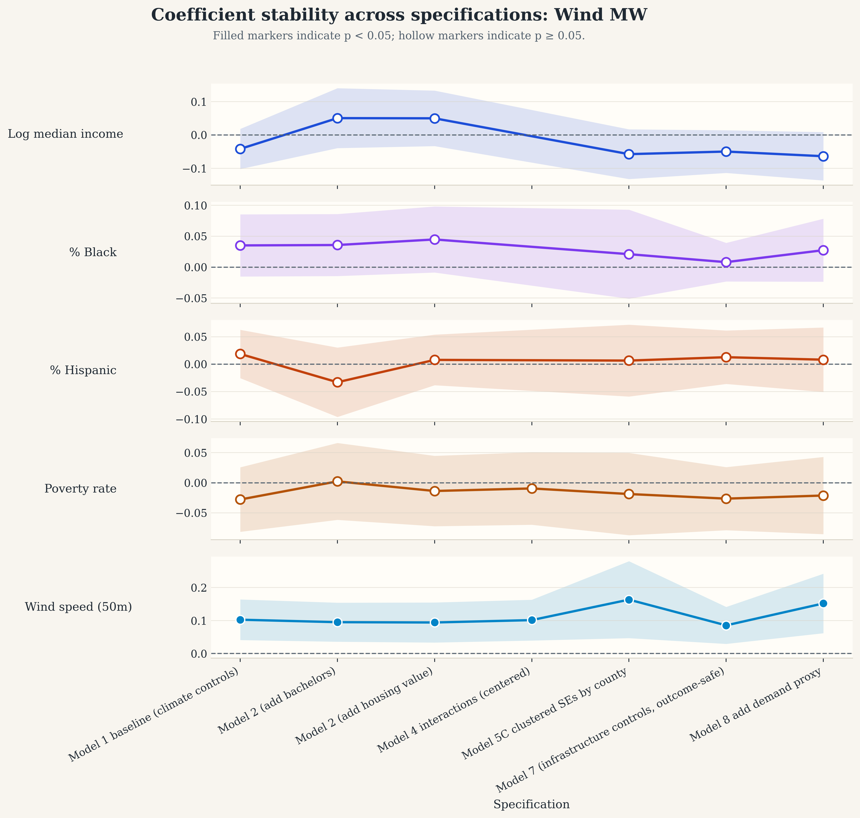
Figure 9. Standardized robustness summary for y_wind_mw , included mainly as contextual evidence rather than as a headline equity result. Source file: outputs/standardized_figures/y_wind_mw_robustness.svg .

5.8 Overall interpretation
Taken together, the results suggest that inequity in California’s DER transition is not a single repeated pattern across technologies. Instead, the form of disparity depends on the technology being considered. Solar PV and especially storage show persistent negative associations with Black, Hispanic, and Asian population shares even after major socioeconomic and contextual controls are included. EV charging shows a more mixed pattern: Black and Hispanic population shares are associated with lower charger deployment, but aggregate charging is also positively associated with poverty, a relationship that appears to be driven mainly by Level 2 charging rather than by Level 1 charging. This indicates that different technologies are shaped by different barriers and siting dynamics, and that a policy solution aimed at “DER equity” in the abstract may miss the fact that solar, storage, and EV charging do not reproduce inequity in exactly the same way.

6. Discussion

6.1 What persists and what changes across DER types
The most important substantive finding is that the clean energy transition does not reproduce inequality in the same way across technologies. Solar PV shows persistent racial and socioeconomic patterning, but storage appears even more unequal and more stable across specifications, including after conditioning on local PV deployment. EV charging, by contrast, does not fit a simple underserved-versus-served story. Instead, the aggregate charging measure mixes together infrastructure types that likely serve different users and are governed by different siting logics. The paper’s contribution is therefore not only to show that disparities exist, but to show that the meaning of those disparities changes by technology.
This matters conceptually. A community that appears relatively “served” on one aggregate infrastructure metric may still be underserved in the specific DER benefits that matter most, such as bill savings from rooftop PV, resilience from storage, or residentially usable charging access. In that sense, the paper supports a more technology-specific approach to energy equity measurement and a race-aware approach to DER planning rather than a purely race-neutral framework.

6.2 Plausible mechanisms
Several mechanisms are consistent with the observed patterns, though the analysis does not identify them causally. For rooftop PV, the persistence of negative coefficients after controlling for income is consistent with barriers beyond household income alone, including roof access, housing tenure, installer market penetration, credit constraints, or permitting and interconnection frictions. For storage, the larger and more stable disparities are consistent with the fact that storage often involves higher capital costs, stronger dependence on bundled solar-plus-storage adoption pathways, and programmatic complexity that may advantage already well-positioned households and communities.
The EV charging results point to a different mechanism story. The positive poverty association in the aggregate charging outcome is not visible for Level 1 charging and appears to be driven primarily by Level 2 charging. That pattern is more consistent with commercial, workplace, corridor, municipal, or multifamily siting than with broad household-serving access. A key implication is that aggregate charger counts are not neutral measures of equitable access. They may capture infrastructure abundance in ways that overstate practical charging access for residents, especially where charger types and host settings differ.
The clustering exercise adds another descriptive layer to this story. More affluent clusters with higher residual white/other shares and lower poverty tend to have stronger charger and storage outcomes, while the high-Hispanic, high-poverty cluster shows the weakest charging outcomes. Those spatial profiles are descriptive, but they are consistent with the broader argument that race, income, and existing energy-system context are jointly structuring where DER benefits accumulate.

6.3 Policy relevance
The policy implication is not simply that disadvantaged places need “more DERs.” Rather, different technologies appear to require different equity strategies. For rooftop solar, the persistence of disparities after observed controls suggests the continued importance of targeted incentives, community-solar expansion, financing support, and outreach policies that reduce adoption frictions in underserved communities. For storage, the stronger disparities suggest that resilience-oriented subsidy programs, backup-power programs, and community-serving storage deployments may need sharper equity targeting if storage benefits are to reach communities that face higher vulnerability to outages, wildfire-related shutoffs, and climate-related disruptions.
For EV charging, the results suggest that policymakers should distinguish much more carefully between charger counts and usable charging access. A place with many chargers is not necessarily a place with equitable residential charging opportunities. Programs focused on multifamily charging, curbside or neighborhood charging, renter-serving infrastructure, and targeted deployment outside purely commercial corridors may therefore matter more than aggregate public charger deployment targets alone. More broadly, the findings suggest that clean energy equity policy should be technology-specific rather than assuming that one design principle can cover PV, storage, and charging simultaneously.

6.4 Broader implications for energy burden and community resilience
These findings also matter beyond adoption statistics themselves. DERs can alter household bills, outage resilience, air-quality exposure, and who benefits from the clean-energy transition. If rooftop PV, storage, and residentially useful charging remain concentrated in already advantaged communities, then lower-income and more heavily non-white communities may face a double burden: higher exposure to outage risk and energy burden alongside lower access to technologies that buffer those risks. That is one reason the race results matter for policy even in a non-causal paper. If race remains statistically significant after the main socioeconomic controls are added, then a purely race-neutral planning frame may miss communities that are persistently underserved in practice.
The energy-burden connection differs by technology. For rooftop PV, lower deployment in communities with larger Black and Asian population shares matters because PV is one of the main household-level pathways through which customers can reduce net electricity costs or hedge against future rate increases. For storage, the Model 9 result is especially relevant: even after conditioning on local PV deployment, storage disparities remain, which means the resilience benefit associated with backup power is not simply following solar access in an equitable way. In high-burden communities, that can compound vulnerability because households may face both higher bill stress and weaker access to outage protection.
EV charging raises a related but distinct burden issue. Transportation electrification can lower fuel and maintenance costs for some households, but only if charging is practically usable, affordable, and located near daily routines. The positive poverty-rate coefficient in aggregate charger models therefore should not be interpreted as evidence that higher-poverty communities are necessarily better positioned to benefit from EV adoption. If chargers are concentrated in commercial, workplace, corridor, or municipal settings, then the count may represent infrastructure presence without equivalent household-serving access, particularly for renters, multifamily residents, and households without reliable home charging.
The present paper does not include a dedicated transit, corridor, tenure, or charger-host dataset, so it cannot fully unpack why charging is more prevalent in some higher-poverty ZIP/ZCTAs. That remains an important extension. But the current evidence is already sufficient to show that aggregate infrastructure counts should not be mistaken for equitable access, and that future DER planning needs to distinguish commercial siting from household-serving benefit. Connecting DER deployment to energy burden therefore requires more than asking where assets are installed; it requires asking whether the communities with the highest bill, resilience, and electrification pressures can actually use the technologies being counted.

7. Limitations
This study is designed to identify area-level conditional associations, not causal effects. The regressions show how DER deployment differs across ZIP/ZCTA areas with different observed characteristics, but they do not establish that demographic composition causes those differences. Unmeasured confounding may remain, especially around housing tenure, roof suitability, installer availability, local permitting conditions, program participation, and technology-specific incentive access.
The use of ZIP/ZCTA geography is a practical strength for harmonizing multiple datasets, but it also introduces limitations. ZIP/ZCTAs can blur substantial within-area heterogeneity, and ecological inference problems remain. The analysis therefore cannot describe the behavior of individual households or residents. In addition, some raw source files required spatial assignment from latitude and longitude, manual ZIP corrections, or source-specific cleaning decisions, all of which may introduce measurement error.
There are also technology-specific measurement limitations. Aggregate charger counts mix charger types and host contexts that may not represent equivalent forms of access. The charger-type decomposition helps, but even that does not fully distinguish residential, workplace, corridor, and municipal use cases. Wind outcomes are also less directly comparable to behind-the-meter technologies, which is why the paper treats wind capacity as supplementary context rather than a headline equity result.
Finally, the paper is a California 2023 cross-sectional snapshot. California is substantively important as a large and policy-active clean energy market, but the results may not generalize mechanically to other states, years, or regulatory contexts. Future work would benefit from longitudinal analysis, stronger measures of tenure and housing structure, more direct data on technology-specific access mechanisms, and additional place-based variables such as transit and corridor intensity to sharpen the interpretation of charger siting patterns.

8. Conclusion
This paper asks whether racial and socioeconomic disparities in distributed energy resource deployment persist across California ZIP/ZCTA areas once observed socioeconomic, geographic, institutional, and infrastructure controls are added. The answer is yes, but the form of disparity depends strongly on the technology being considered. Solar PV and especially battery storage remain unequally distributed across communities even in more demanding specifications, while EV charging shows a more complicated pattern in which aggregate charger counts can obscure meaningful differences across charger types.
The broader lesson is that clean energy inequality is not one phenomenon. Technologies that appear under the same DER umbrella deliver different benefits, face different barriers, and are deployed through different market and institutional pathways. If equity is measured too coarsely, policy can mistake infrastructure counts for access, or progress in one technology for progress in another. A more credible clean energy transition therefore requires not only more deployment, but better measurement of who can actually use, benefit from, and rely on each technology.
Viewed in that light, California serves as both an empirical case and an early warning. As decarbonization expands, the question is not only how quickly DERs diffuse, but whether the benefits of that diffusion are structured in ways that reduce inequality or reproduce it in new forms. This paper’s evidence suggests that answering that question requires a multi-DER equity lens rather than a single-technology one.

Appendix: Additional Robustness Visuals
This appendix keeps the heavier visual material out of the main results flow while still making the broader model inventory easy to inspect. It includes representative model-comparison and spatial outputs for the main reported outcomes plus the supplementary wind-capacity context.

Outcome-specific model comparisons
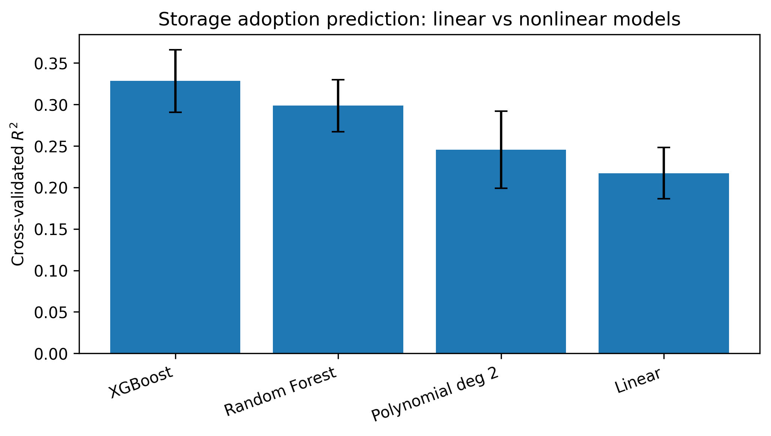
Storage model-comparison figure. The same appendix folder also includes EV charging and wind comparison exports for side-by-side review.

EV charging model comparison
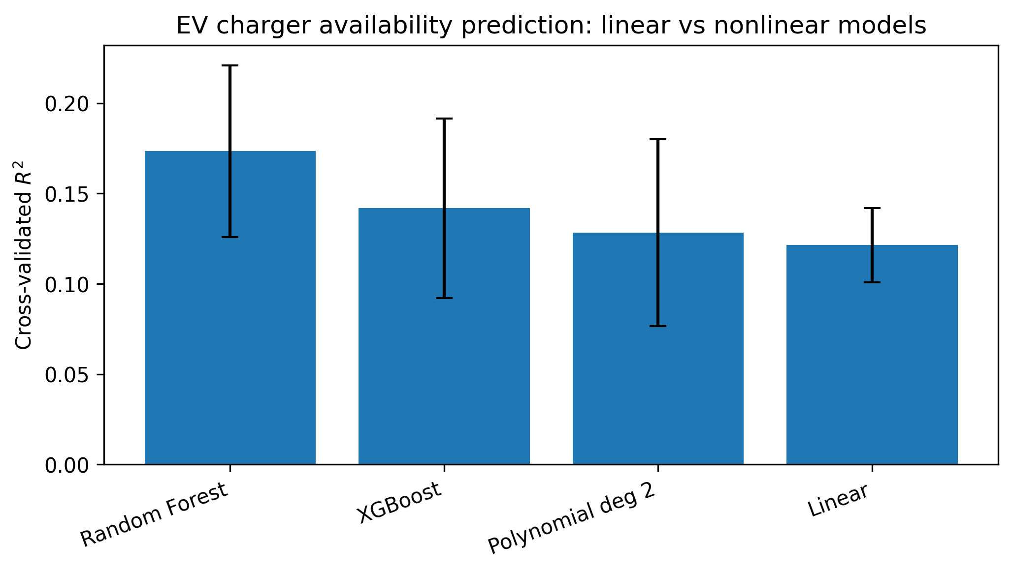
Aggregate charging comparison across the model ladder, included here rather than inline so the main section can focus on the headline robustness and subtype composition figures.

Representative baseline spatial maps
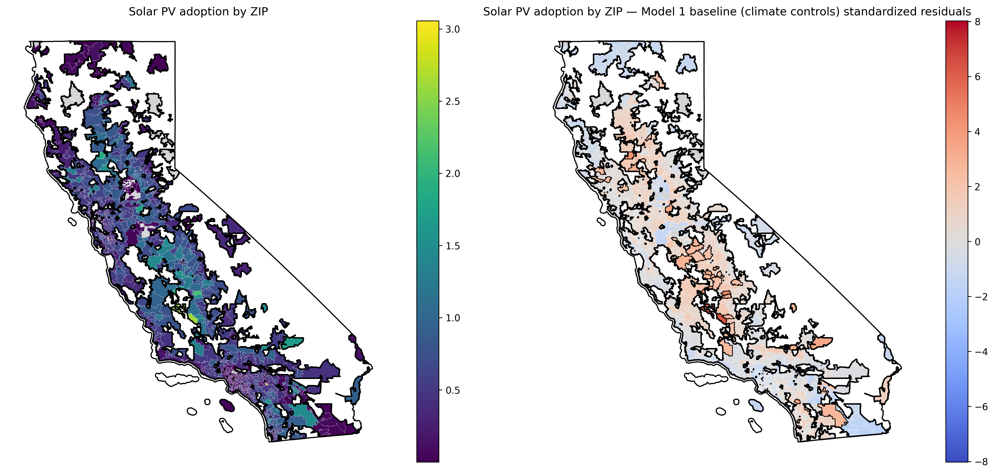
Representative baseline spatial output for rooftop PV. Matching storage and charging spatial maps are linked in the same appendix asset folder.

Supplementary wind comparison
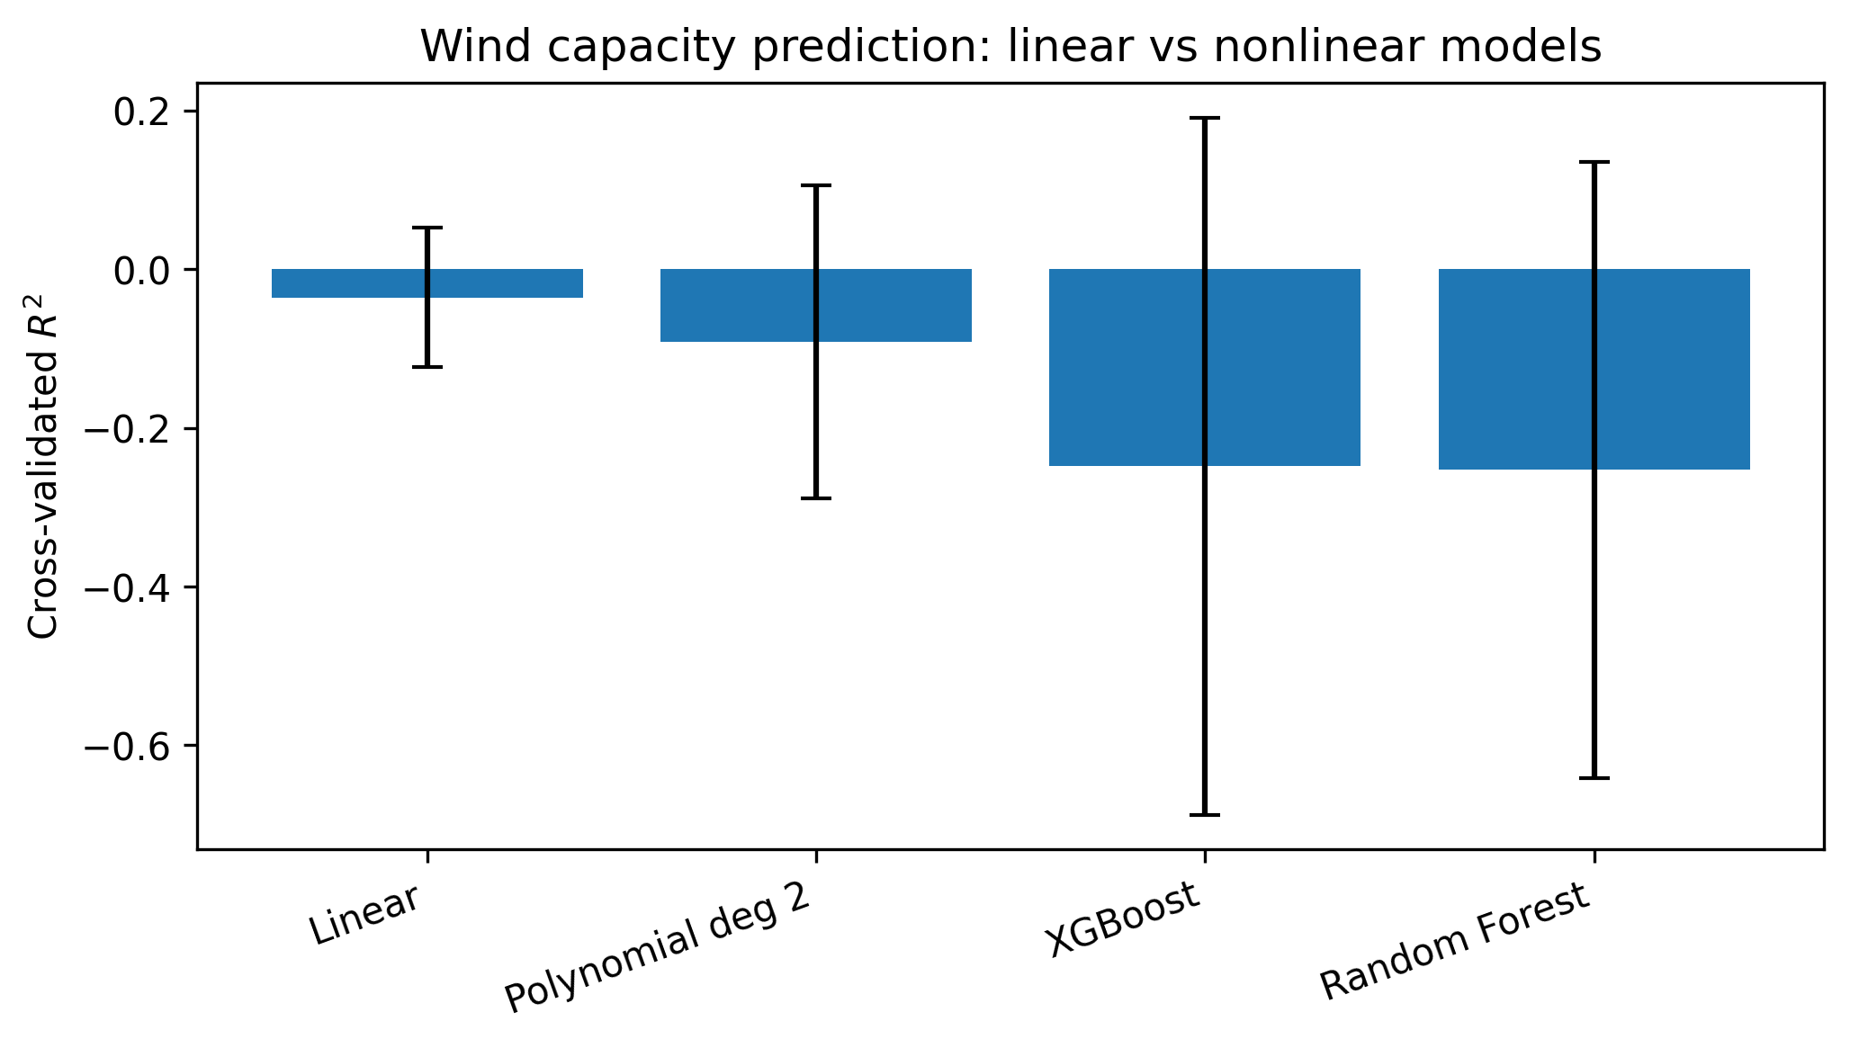
Wind remains supplementary in the paper, but the model-comparison export is preserved here as a contextual benchmark against the consumer-facing DER outcomes.

9. References
- American Council for an Energy-Efficient Economy (ACEEE). 2023. Racial disparities in the energy burden .
- Borenstein, Severin, and James Bushnell. 2016. Work on residential electricity rate design and equity implications for DER uptake.
- Brockway, Anna M., et al. 2021. “Inequitable access to distributed energy resources due to grid infrastructure limits in California.”
- Caballero-Peña, et al. 2022. Work on network impacts of DERs and distribution-system constraints.
- California Public Utilities Commission (CPUC). 2021. Distributed Energy Resources Integration Research Roadmap .
- Clean Energy Group. 2021. Energy Storage as an Equity Asset .
- Federal Energy Regulatory Commission (FERC) Staff. 2018. Distributed Energy Resources: Technological and Policy Considerations .
- Feinberg, et al. 2017. “Data-driven planning amidst socio-technical complexities.”
- Greenlining Institute. 2024. Demystifying Equity in California’s Energy Grid Transition .
- Gridworks. 2022. Advancing Equity in Access to DERs in California .
- Kurdgelashvili, Lado, Roy Kwon, and Peter Larsen. 2019. “An empirical analysis of county-level residential PV adoption in California.”
- Lukanov, Boris R., and Elizabeth M. Krieger. 2019. “Distributed solar and environmental justice: Exploring the demographic and socio-economic trends of residential PV adoption in California.”
- NREL / DOE. n.d. Optimal coordination of flexible DERs .
- Parra, et al. 2017. “Assessing the implications of socioeconomic diversity for low-carbon technology uptake in electrical distribution networks.”
- SEIA / Vote Solar. 2022. Work on California community-solar policy gaps and renter exclusion.
- Stokes, Leah C., and Christopher Warshaw. 2022. Work on motivations and barriers to residential solar adoption.
- Sunter, Deborah A., Sergio Castellanos, and Daniel M. Kammen. 2019. “Disparities in rooftop photovoltaics deployment in the United States by race and ethnicity.”
- U.S. Department of Energy. 2023. Towards Closing the Data Gap .
- Urban Institute. 2023. Identifying Disadvantaged Communities in the United States .

