Inequity in distributed energy adoption is technology-specific, not uniform
Vineet Jagadeesan Nair¹*, [co-authors] · ¹Massachusetts Institute of Technology, Cambridge, MA, USA · *Corresponding author: jvineet9@mit.edu

Abstract
Distributed energy resources are central to decarbonisation, resilience and electrification, but their benefits are not guaranteed to be shared evenly. Evidence of racial disparity in rooftop solar is usually assumed to generalise across technologies. We test that assumption across 1,390 California ZIP Code Tabulation Areas, harmonising rooftop photovoltaics, battery storage and electric-vehicle charging under one set of outcomes and controls. The technologies do not share a disparity pattern. Areas with larger Black and Asian population shares hold less solar and less storage after conditioning on income and poverty, and area-level housing type and tenure absorb 32 to 53 per cent of those gaps. Under a fully stacked specification, storage disparities persist on all three race terms, solar only for Asian share, and charging not at all. Charger counts instead rise with poverty, concentrated in faster public units. Counts measure infrastructure, not usable access, so technology-blind equity targets misread all three.
As electricity systems decarbonise, distributed energy resources (DERs) are becoming central to emissions reduction, local resilience and electrification. Policy debate treats them as a single category, but the benefits they deliver are heterogeneous. Rooftop photovoltaics (PV) reduce bills for the household that hosts them. Battery storage delivers backup power and outage protection, which matter most where wildfire shutoffs and grid stress are common. Charging infrastructure determines who can participate in transportation electrification, and only if it sits where people actually live and park. The clean energy transition is therefore not only a deployment problem but a distributional one: where access depends on financing, housing conditions, siting decisions, permitting, interconnection or neighbourhood infrastructure, the transition can reproduce existing inequities rather than reduce them.
The evidence that it does so is almost entirely about solar. Lukanov and Krieger show that California PV deployment is patterned by neighbourhood socioeconomic conditions [1], and Sunter, Castellanos and Kammen show that racial and ethnic disparities in rooftop PV persist after accounting for income [2]. Kurdgelashvili and colleagues model county-level adoption in the same state [3], while Reames and Darghouth et al. document uneven rooftop access across communities and Sigrist et al. argue that inequitable siting reduces the carbon value of residential solar [4], [5], [6]. A parallel literature explains why race should be modelled explicitly rather than assumed away: race-linked inequities in energy burden persist net of income [7], transition planning cannot be treated as race-neutral when the underlying burdens are not [8], and structural barriers limit participation in California's DER programmes even where they are designed for low-income households [9]. Because rooftop solar measurably reduces energy burden for low- and moderate-income adopters [10], unequal access to DERs also means unequal access to bill relief and resilience.
What this literature does not establish is whether inequity in DER adoption is a solar-specific phenomenon or a general feature of the transition. The distinction matters because the barriers differ. Rooftop PV depends on roof control, housing tenure, financing and installer availability. Storage overlaps with PV but adds stronger dependence on upfront capital, resilience value and programme design; it has been framed as an equity asset that can either broaden resilience or entrench advantage depending on ownership [14], [15]. Charging depends far more on siting, commercial activity and host context. Adoption is also gated by the grid itself: hosting-capacity constraints in California are socially patterned and limit deployment in disadvantaged communities [11], a problem that fairness-aware allocation schemes are only beginning to address [12], and that interconnection roadmaps identify as a national bottleneck [13]. A community adopting solar at the state average may still lack the storage that protects it during an outage, or the charging that lets its residents switch vehicles. Collapsing all three into one undifferentiated measure of “DER access” can hide exactly these offsetting patterns.
Three gaps follow. First, the evidence base for racial disparity net of income is solar-only, so we do not know whether inequity is a property of solar adoption or of the transition. Second, work that looks beyond PV treats each technology in isolation, under different data, geographies and specifications, which prevents direct comparison. Third, no harmonised, race-inclusive, multi-technology dataset exists at fine spatial granularity for a single high-penetration market, because DER data is fragmented across technologies and agencies [16], [17].
This paper addresses all three. We assemble a California ZIP Code Tabulation Area (ZCTA) dataset integrating rooftop PV, battery storage and EV charging with American Community Survey demographics, climate and resource data, utility territory and electricity demand, and estimate one consistent set of specifications across all three, retaining race in every model rather than assuming socioeconomic controls absorb it. California is an informative case because it combines high DER penetration, ambitious climate policy, substantial socioeconomic diversity and pronounced spatial inequality. The study is area-level and cross-sectional; we report conditional associations, not causal effects. The central finding is that the form of inequity changes by technology, and that for charging the standard metric — the count of installed units — does not measure what equity policy assumes it measures.

Results

Disparities differ by technology
Racial and socioeconomic disparities are not uniform across technologies. In the baseline specification (Table 1), rooftop PV and battery storage both carry clear negative associations with ZCTA shares of Black and Asian residents after conditioning on income and poverty. EV charging departs from that pattern: charger deployment is negatively associated with Hispanic share and positively associated with poverty rate. Figure 2 places the three outcomes on a common scale. Coefficients reported in the main text use standardised predictors, so a coefficient is the change in the log(1 + rate) outcome associated with a one-standard-deviation change in the predictor; one standard deviation is 6.6 percentage points for Black share, 23.8 for Hispanic share and 14.1 for Asian share, and a coefficient near −0.10 corresponds to roughly a 10 per cent lower deployment rate (Supplementary Table S3).
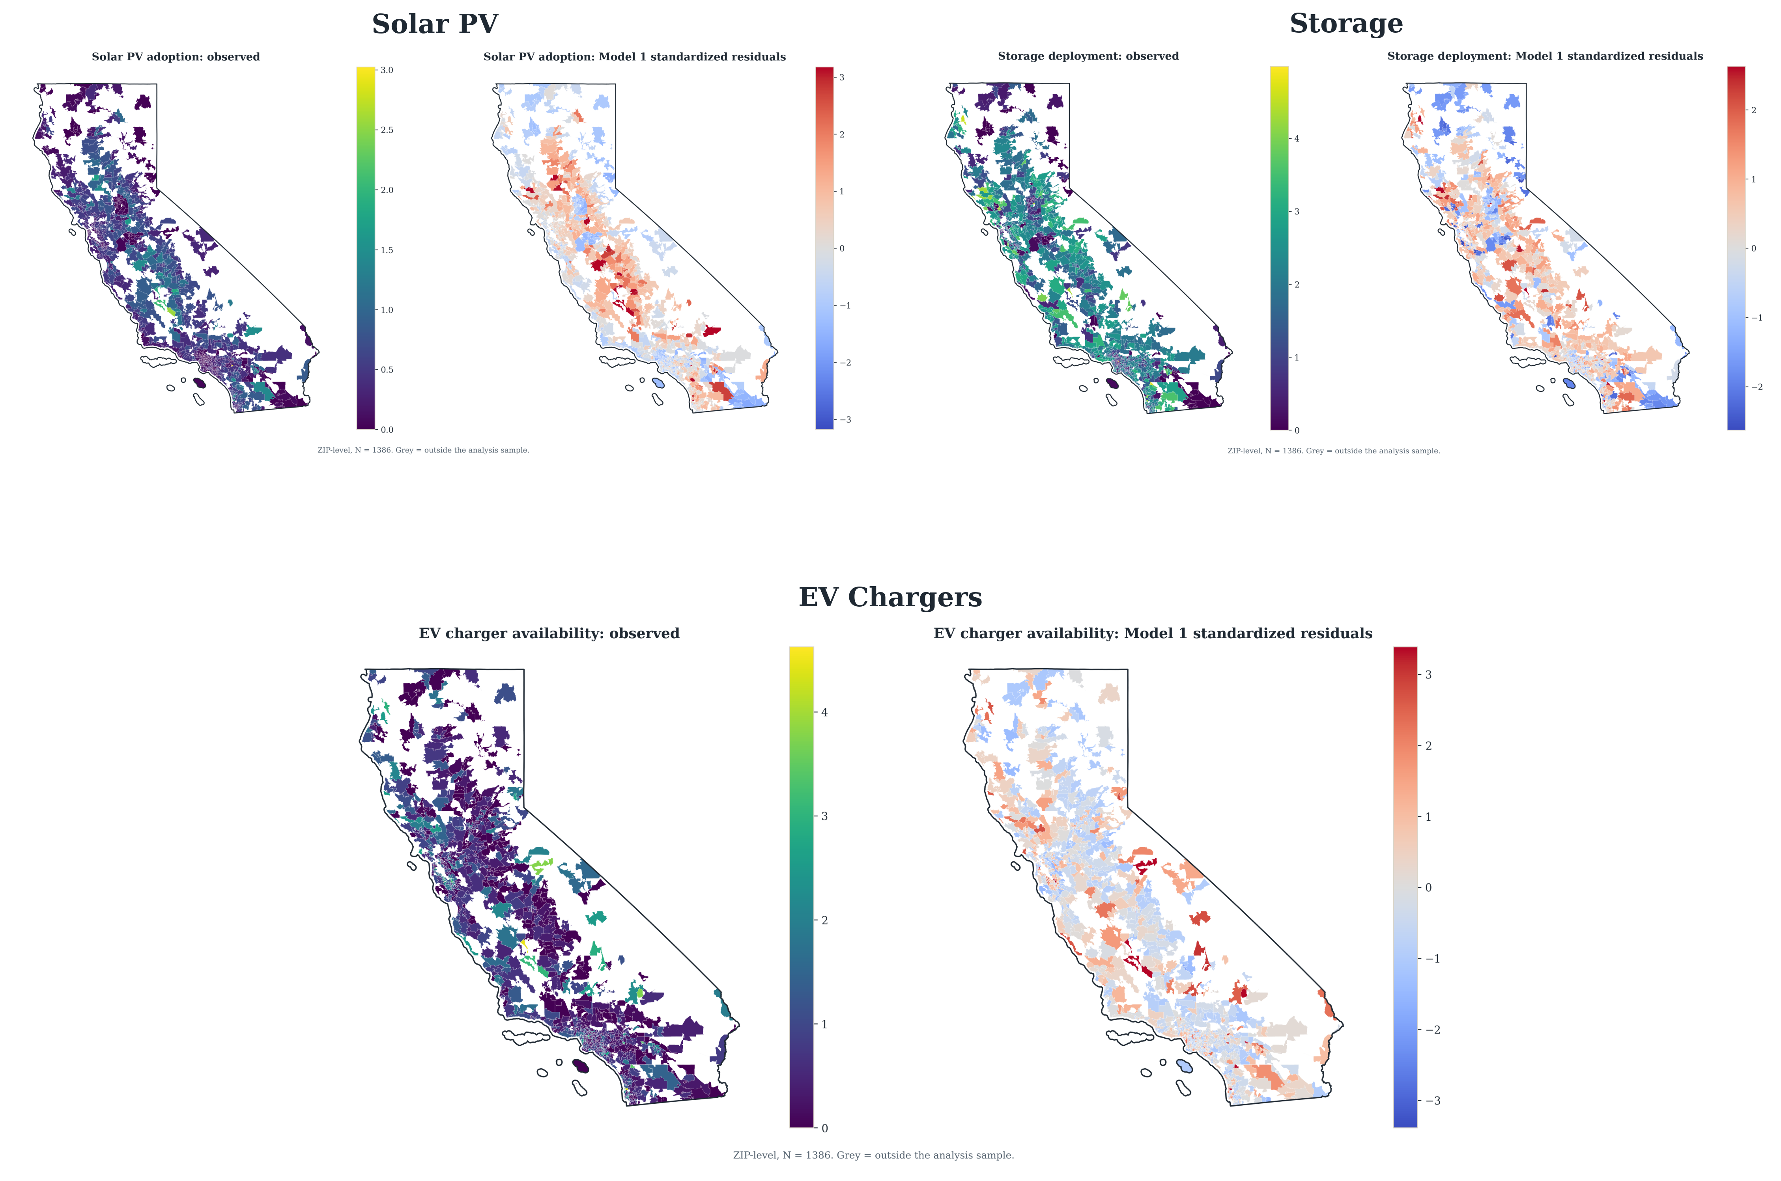
Fig. 1 | Distributed energy deployment across California ZIP Code Tabulation Areas. Rooftop photovoltaics, battery storage and aggregate EV charging, before any regression adjustment. Blank areas indicate excluded or missing observations.
Table 1 | Baseline associations between neighbourhood composition and distributed energy deployment. Standardised predictors; heteroskedasticity-robust (HC1) standard errors in parentheses. *p < 0.05, **p < 0.01, ***p < 0.001.
Predictor | Rooftop PV | Battery storage | EV charging
Log median household income | 0.439*** (0.084) | 0.310*** (0.049) | 0.066 (0.039)
Black share | −0.218*** (0.047) | −0.106*** (0.021) | −0.000 (0.022)
Hispanic share | 0.219*** (0.059) | −0.146*** (0.030) | −0.096*** (0.025)
Asian share | −0.297*** (0.043) | −0.252*** (0.023) | 0.058** (0.021)
Poverty rate | −0.043 (0.081) | −0.017 (0.042) | 0.149*** (0.037)
Resource / climate control | GHI 0.106* (0.044) | CDD 0.033 (0.033); HDD −0.003 (0.035) | CDD −0.120*** (0.022); HDD −0.025 (0.027)
N | 1,390 | 1,390 | 1,390
R² | 0.074 | 0.188 | 0.079
Baseline explanatory power is low by construction — R² runs from 0.07 to 0.24 across the three outcomes. The objective here is coefficient stability under conditioning rather than prediction, and area-level cross-sections of this kind carry substantial local heterogeneity that no set of ZCTA-level covariates absorbs. As controls accumulate, R² rises to 0.49 for PV and 0.42 for storage.
Housing is tested directly rather than left as a proposed mechanism. Adding the exhaustive ACS B25024 structure composition, with single-family units as the reference, and B25003 owner occupancy, with renters as the reference, moves every race coefficient for PV and storage toward zero without eliminating it (Figure 3). Area-level housing composition absorbs between 32 and 53 per cent of these coefficients across the four technology-by-race combinations, most for the PV Black share and least for the storage Asian share; the coefficient pairs are in Supplementary Table S2. What remains is not explained by the housing stock, but these models do not identify household-level tenure or roof access.
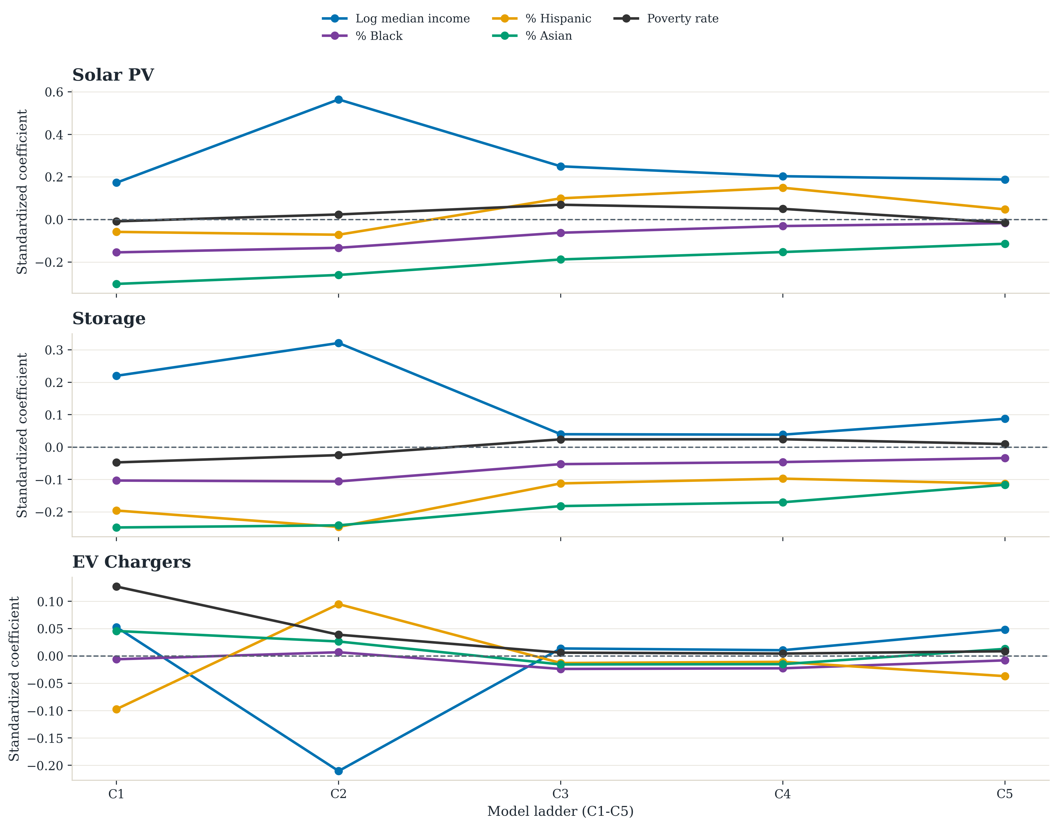
Fig. 2 | Coefficients across the nested cumulative ladder, C1 to C5. Standardised predictors; each panel traces one coefficient as confounder blocks accumulate on a frozen common sample of 1,160 ZCTAs. Filled markers denote p < 0.05.

Rooftop solar and storage
For rooftop PV, ZCTAs with higher median household income show higher adoption intensity, while those with larger Black and Asian population shares show substantially lower intensity. Hispanic share runs the other way for PV alone, positive and significant, and does not follow the Black and Asian pattern in any specification; we therefore treat the PV racial gradient as a Black- and Asian-share result rather than a general non-white one. Solar resource potential behaves as expected: mean global horizontal irradiance is positive and highly significant, so the racial gradient is not an artefact of lower-income areas having worse solar resource. The negative Black- and Asian-share coefficients persist as education, county clustering, infrastructure context and electricity demand enter the specification (Supplementary Fig. S1).
Battery storage shows the strongest and most stable disparity pattern of the three. Income is strongly positive, and Black, Hispanic and Asian shares are all negative, with coefficients larger in magnitude than the corresponding PV estimates and negative across nearly every specification examined (Supplementary Fig. S2). Adding local PV deployment to the most controlled storage specification leaves the race coefficients negative and significant, so the storage gap is not simply the solar gap restated further down the same adoption pathway. That model conditions on a parallel outcome of the same predictors and is therefore not a better-identified estimate of the storage gap; it answers only that narrower question (Supplementary Table S6).
The substantive point is that storage inequity is deeper than solar inequity, and storage is the technology whose benefit — backup power during outages and wildfire shutoffs — is most concentrated in exactly the communities that show the lowest deployment. Reported standard errors are heteroskedasticity-robust; spatially robust alternatives that allow residuals to covary with distance are reported in Supplementary Table S8, and residual spatial dependence is documented in Supplementary Table S7.
The Asian-share coefficients deserve separate comment, because they point in different directions across technologies and because housing composition explains most of that difference. In the baseline the coefficient is negative for PV and storage and positive for aggregate charging. Once housing structure and tenure enter, the charging coefficient falls to approximately zero and is no longer distinguishable from it, while the PV and storage coefficients attenuate but remain negative at p < 0.001. The apparent sign reversal is not a stable feature of the data. High-Asian-share ZCTAs are also the highest-income profiles in the sample, which is hard to square with an income-based reading of their low PV and storage deployment; they concentrate in dense metropolitan submarkets where multifamily housing and lower owner-occupancy limit roof control, and the same density supports commercial charging siting.
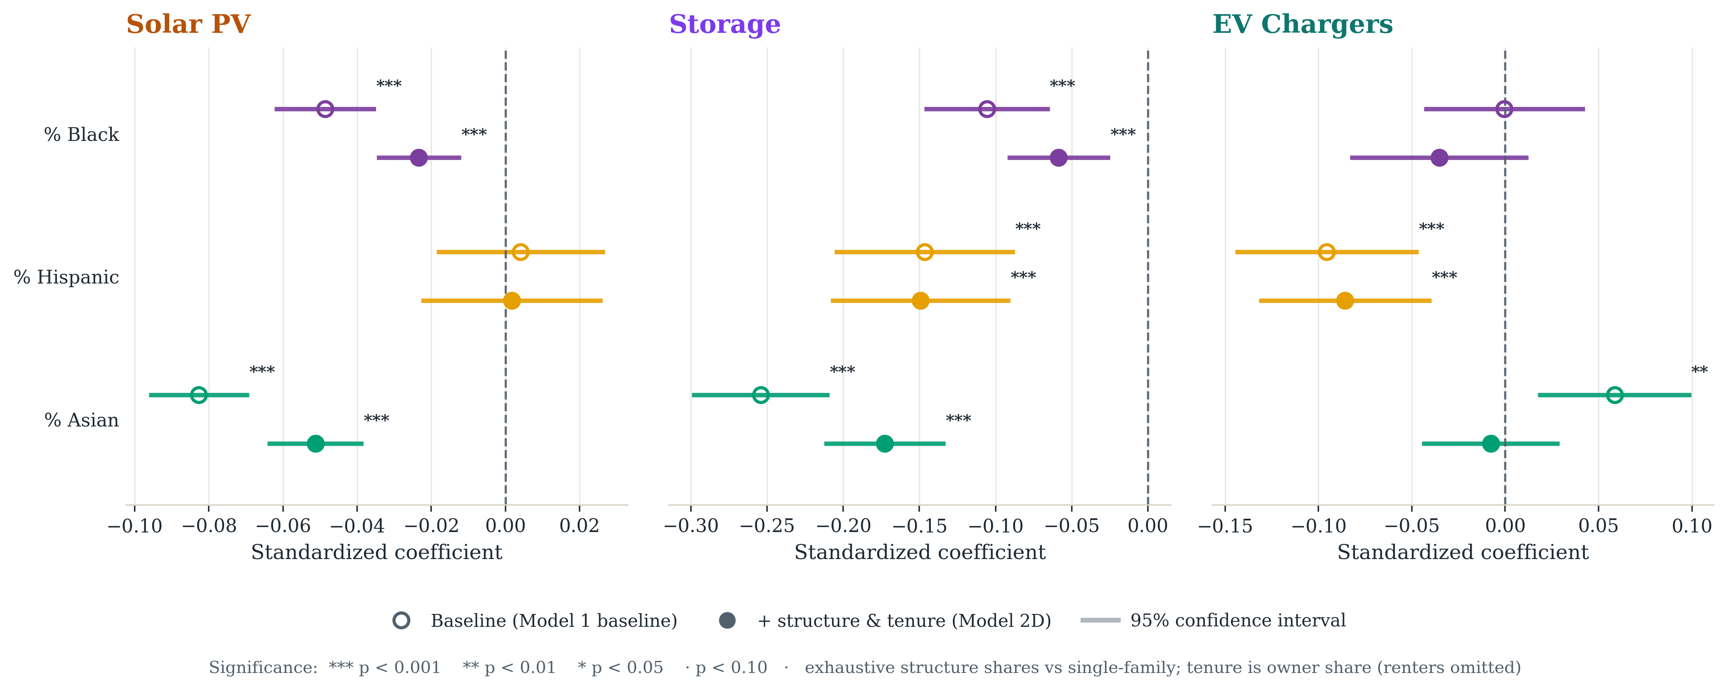
Fig. 3 | Race-coefficient attenuation after adding housing structure and tenure. Hollow points are the baseline specification; filled points add exhaustive ACS B25024 structure shares (single-family reference) and B25003 owner occupancy (renter reference).

Charging measures infrastructure, not access
The charging results are more complex. The aggregate baseline has a positive but not conventionally significant income coefficient, a near-zero Black-share coefficient, a negative Hispanic-share coefficient and a positive Asian-share coefficient, while poverty rate is strongly positive. The positive Asian-share coefficient is not stable: under Conley spatially robust standard errors it remains significant at 50 km and 200 km but not at 100 km, and it reverses sign once housing structure and tenure enter, so we build no interpretation on it.
The charger-type decomposition clarifies what the aggregate is measuring. The positive association with poverty is driven by Level 2 units; for DC fast chargers the coefficient is positive but imprecisely estimated (Figure 4, Supplementary Table S4). Level 1 units cannot be tested at all: 97.8 per cent of ZCTAs report zero, against a statewide total of 256 Level 1 ports compared with 40,078 Level 2 and 13,852 DC fast. We therefore report the Level 1 zero share rather than a coefficient, and the aggregate-versus-Level 2 contrast carries the argument.
Two features of the charger data govern how these counts should be read. The inventory records public and shared-use stations only — every station row is flagged public access — so residential charging is unobserved, and no measure in this study speaks to whether a household can charge where it parks overnight. And because the association concentrates in Level 2 units rather than the slowest ports, the pattern is consistent with siting driven by commercial and industrial activity rather than by household-serving provision. We treat that siting interpretation as a hypothesis: the dataset carries no charger-host or facility-type field, so it is not directly tested here. What the data do establish is narrower and still consequential — a higher charger count in a higher-poverty ZCTA is not evidence of better household charging access, because the counts do not include the charging that households actually use.
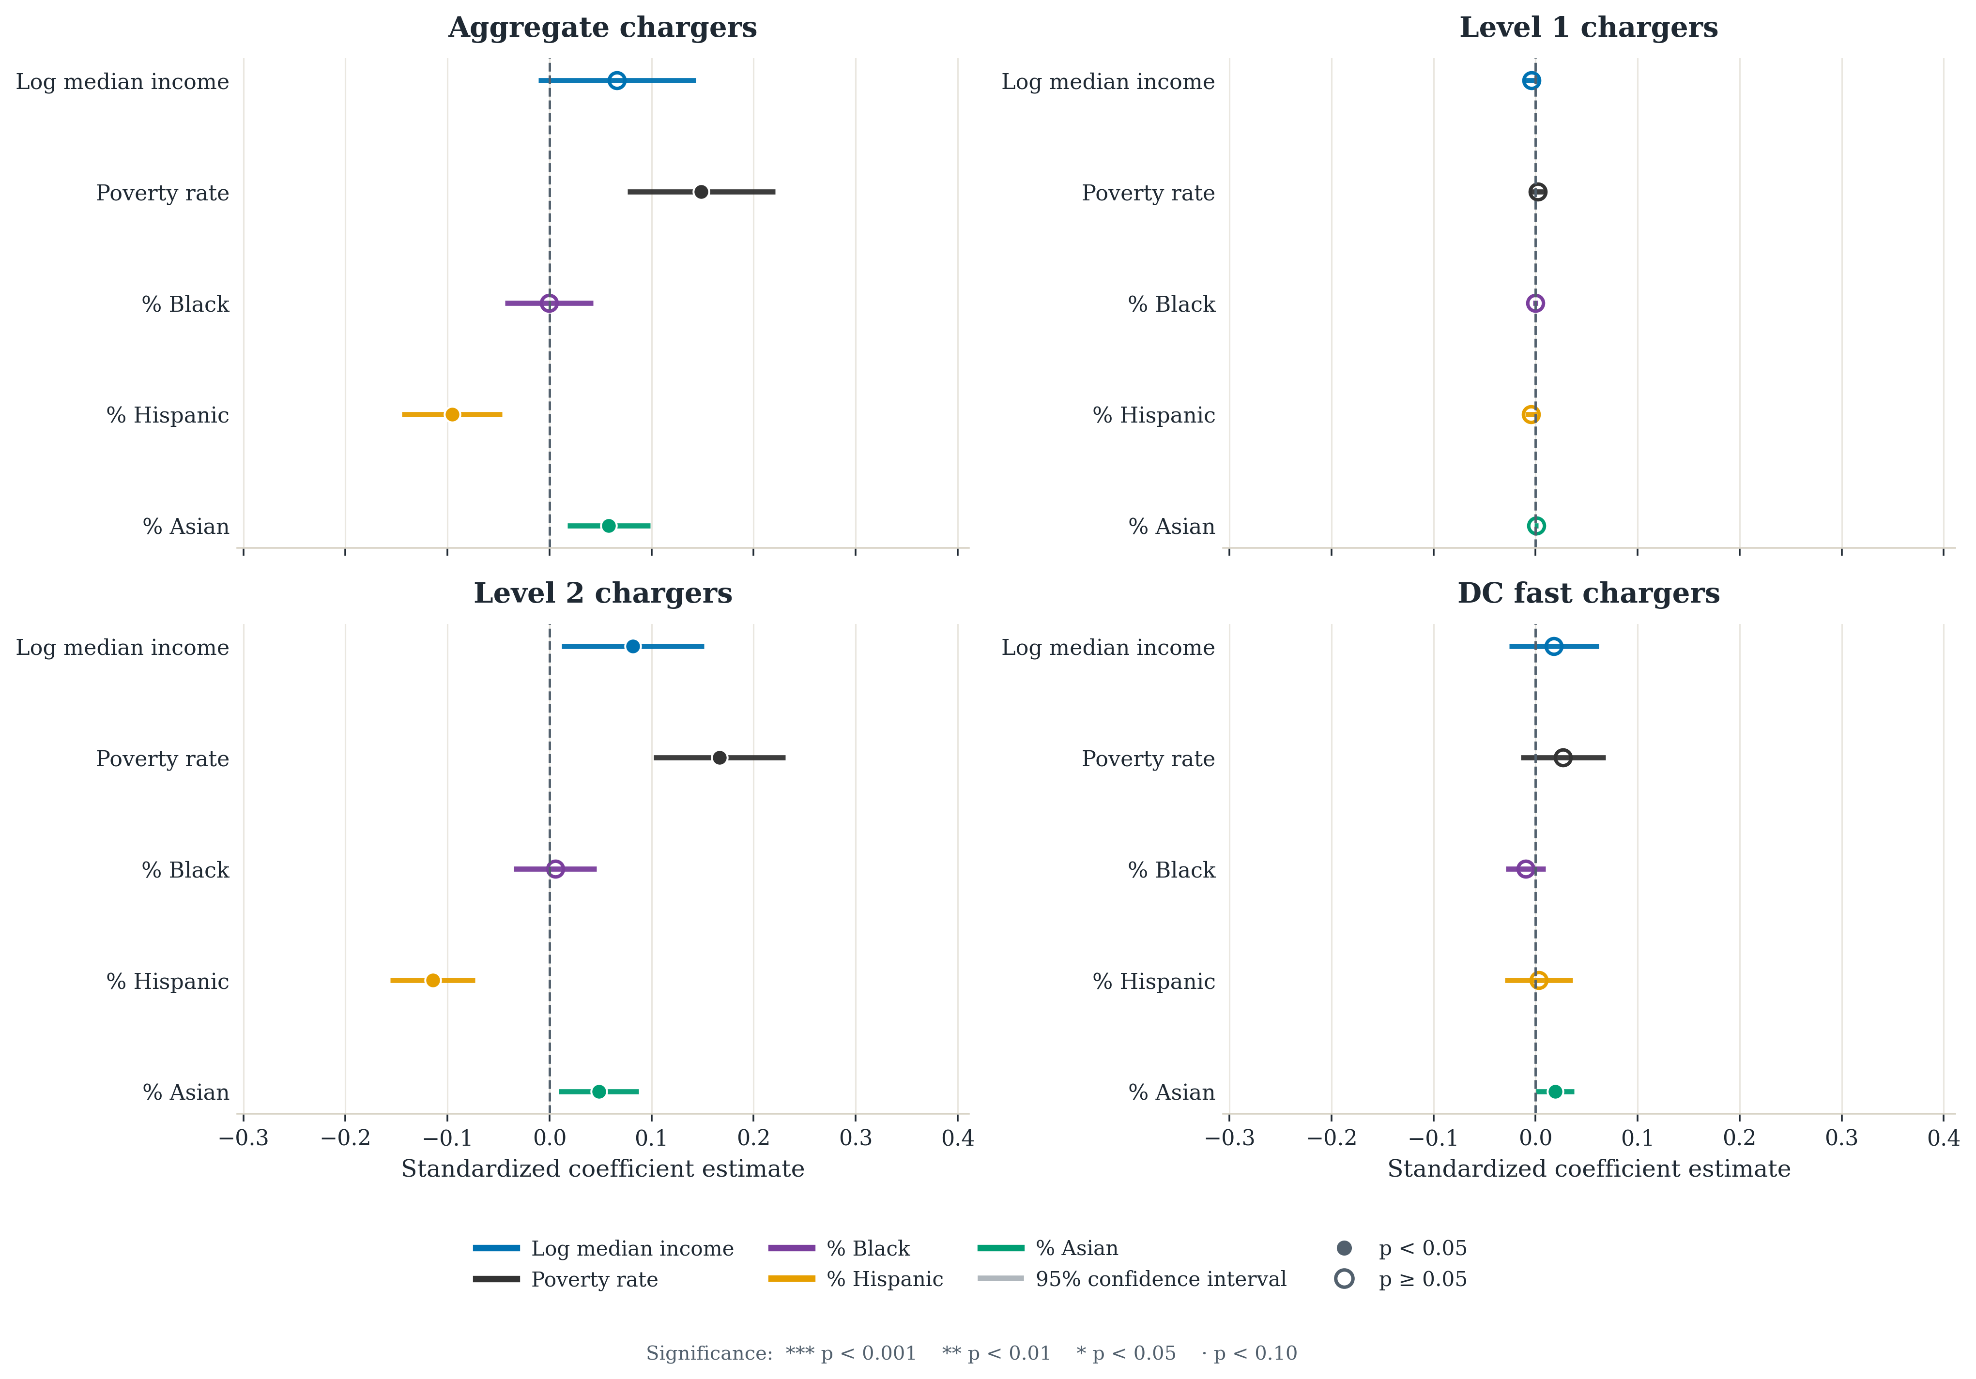
Fig. 4 | Charger-type decomposition. Baseline coefficients for aggregate charging and for Level 1, Level 2 and DC fast units separately. The positive association with poverty is carried by Level 2 units; Level 1 is zero in 97.8 per cent of ZCTAs and is shown for completeness only.

Disparities under a fully stacked specification
The specifications above vary one control block at a time against a fixed core. That design isolates which block moves which coefficient, but it is a model series rather than a nested sequence, and it cannot show whether the controls jointly absorb the race coefficients. We therefore also estimate a genuinely nested cumulative ladder: C1 (income, race, poverty, climate), C2 (adding education and housing value), C3 (adding housing structure and tenure), C4 (adding utility fixed effects) and C5 (adding county fixed effects with county-clustered standard errors). All five rungs are fitted on one frozen common sample of 1,160 ZCTAs across 42 county clusters, identical at every rung, so movement reflects added controls rather than sample drift. A further model adds electricity demand and infrastructure capacity; these sit on the causal path from income and race to adoption, so it is reported only as a conservative lower bound (Supplementary Table S5).
Figure 2 traces the result, and it is weaker than the baseline models imply. Coefficients attenuate by roughly two-thirds to three-quarters between C1 and C5, and what survives differs by technology. For storage, all three race terms remain negative and significant at C5: Black share −0.034 (p = 0.009), Hispanic share −0.113 (p = 0.016) and Asian share −0.116 (p < 0.001). For PV, only Asian share survives, at −0.114 (p = 0.010); the Black-share coefficient falls to −0.017 and is no longer distinguishable from zero (p = 0.472). For aggregate charging, no race term survives. Storage is thus the one technology whose racial disparities hold under the full confounder set.
Two further checks agree with that ranking. Across all 48 valid combinations of the six confounder blocks, the storage Asian-share coefficient is significant and same-signed in 48 of 48 specifications, Hispanic share in 44 and Black share in 36; the corresponding PV counts are 34, 31 and 28; and for aggregate charging the Black-share coefficient is significant in 0 of 48, despite appearing significant in some single specifications (Supplementary Fig. S3). Oster bounds tell the same story: storage Hispanic share (δ = 1.99), PV Asian share (1.57) and storage Asian share (1.29) exceed the conventional threshold of one, meaning selection on unobservables would have to be stronger than selection on the observed confounders to explain them away. We do not report δ for the PV income term or for aggregate charging: adding the full confounder set increases rather than shrinks those coefficients, so the assumption underlying the bound does not hold.
A spatial error model reaches the same conclusion by a different route. Fitting the core specification with an eight-nearest-neighbour spatial error term (λ = 0.85 for PV, 0.65 for storage, 0.45 for charging) leaves all three storage race coefficients negative and significant, leaves PV significant for Asian share only (−0.070, p = 0.012) and not for Black share (p = 0.259), and leaves charging significant for Hispanic share alone (Supplementary Table S9). Two methods that treat spatial structure very differently therefore produce the same ordering. Functional form does not drive the result either: Poisson pseudo-maximum-likelihood models on raw counts with a population offset, which handle the zeros directly rather than through a log(1 + x) transformation, reproduce the sign and significance of every headline coefficient (Supplementary Table S10), as do population-weighted estimates (Supplementary Table S11).
The fully stacked estimates are the conservative reading. The model series shows which controls do the absorbing, and housing composition does most of it.
Table 2 | Robustness of the focal coefficients. β C1 and β C5 are the bottom and top rungs of the nested cumulative ladder (standardised predictors, frozen sample of 1,160 ZCTAs, 42 county clusters). Conley HAC reports significance under spatially robust standard errors at distance cutoffs from 50 to 200 km. Spec curve counts specifications, out of 48 confounder-block combinations, in which the coefficient is significant and same-signed as the median. Oster δ is reported only where adding controls attenuates the coefficient. *p < 0.05, **p < 0.01, ***p < 0.001.
Outcome | Term | β C1 | β C5 | Conley HAC | Spec curve (n/48) | Oster δ
Rooftop PV | Black share | −0.154*** | −0.017 | significant, 5% | 28 | 0.32
 | Hispanic share | −0.058 | 0.047 | not significant | 31 | —
 | Asian share | −0.303*** | −0.114** | significant, 0.1%, every cutoff | 34 | 1.57
 | Log income | 0.173** | 0.188 | significant, 5% | 46 | —
Battery storage | Black share | −0.103*** | −0.034** | significant, 5% | 36 | 0.71
 | Hispanic share | −0.196*** | −0.113* | significant, 1% | 44 | 1.99
 | Asian share | −0.248*** | −0.116*** | significant, 0.1%, every cutoff | 48 | 1.29
 | Log income | 0.220*** | 0.087 | significant, 0.1% | 44 | 0.96
EV charging | Black share | −0.006 | −0.008 | not significant | 0 | —
 | Hispanic share | −0.097*** | −0.037 | significant, 5% | 22 | 1.50
 | Asian share | 0.046* | 0.013 | significant at 50 and 200 km only | 4 | 0.97
 | Poverty rate | — | — | significant, 1% | — | —

Affordability context
The energy-burden outcomes provide affordability context rather than orthogonal controls: burden is strongly negatively correlated with income (−0.75) and positively with poverty (0.55). Income is strongly negative for both burden measures and Hispanic share positive, consistent with affordability stress being itself demographically structured. The per-capita affordability gap is severely skewed — the median ZCTA reports about $75 while the maximum exceeds $236,000, and the top 100 ZCTAs account for 92 per cent of the statewide total — which we attribute to error in the source series rather than to real variation. Main-text estimates therefore exclude the 134 ZCTAs above $1,000 per capita; the full-sample results are in Supplementary Table S12. The exclusion matters: the positive Asian-share association with the affordability gap in the full sample (0.090, p = 0.010) disappears once the outliers are removed (−0.019, p = 0.477), and we do not report it as a finding.

Discussion

What persists and what changes across technologies
The clean energy transition does not reproduce inequality in the same way across technologies. Rooftop PV shows racial and socioeconomic patterning that is substantially, though not entirely, explained by housing composition. Storage is more unequal and more stable, and is the only technology whose disparities survive a fully stacked specification, a specification curve and a spatial error model alike. Aggregate charging does not fit an underserved-versus-served story at all; the measure mixes infrastructure types that serve different users under different siting logics. A community that appears relatively well served on one aggregate metric may still be underserved in the specific benefit that matters — bill savings from PV, resilience from storage, or charging it can actually use.

Plausible mechanisms
For rooftop PV, the persistence of negative coefficients after income controls is consistent with barriers beyond household income: roof access, housing tenure, installer market penetration, credit constraints, and permitting and interconnection frictions. For storage, larger and more stable disparities are consistent with higher upfront capital requirements, dependence on bundled solar-plus-storage pathways and programmatic complexity that advantages already well-positioned households.
One result runs against the expected direction and deserves its own explanation. Adding the full confounder set does not shrink the PV income coefficient; it increases it. Education, housing value, structure, tenure and geography together leave the income gradient in rooftop solar larger than the core specification implies, which is the opposite of what omitted-variable reasoning predicts and why the Oster bound is not interpretable for that term. The most plausible reading is that these controls are absorbing variation that suppresses the income gradient — dense, high-value, high-income submarkets with low owner-occupancy — and that once housing is held fixed, the remaining income effect reflects financing and adoption capacity more directly. If so, the barrier is not price alone but access to capital and to installers, which points at third-party ownership and inclusive financing rather than at incentive levels.
For charging, the positive poverty association appears in Level 2 units and not in the aggregate's slowest ports, which is consistent with siting driven by commercial and industrial activity rather than household-serving provision. Because the inventory covers only public and shared-use stations, the counts cannot speak to residential charging at all. Aggregate charger counts are therefore not neutral measures of equitable access: they can record infrastructure abundance in places where practical charging access for residents, particularly renters and multifamily residents, remains limited.

Implications for how equity is measured
If equity is measured too coarsely, policy can mistake infrastructure counts for access, or progress in one technology for progress in another. The charging result is the sharpest case: a deployment target expressed in chargers per capita can be met entirely through commercial siting while household-serving access does not move. The storage result is the sharpest equity case: the communities most exposed to outages and wildfire shutoffs show the lowest deployment of the technology that buffers them, and that gap does not follow solar access. If PV, storage and residentially usable charging remain concentrated in already advantaged communities, lower-income and more heavily non-white communities face a double burden — higher exposure to outage risk and cost burden alongside lower access to the technologies that reduce both.
That racial disparities persist after income controls, for storage under every specification we examined, is the reason these results bear on race-neutral planning. Eligibility rules keyed only to income or to generic disadvantaged-community designations will miss communities that are underserved on race-correlated dimensions. This is an area-level finding and does not describe individual household behaviour, but eligibility rules are themselves written at area level.

Policy levers differ by technology
The implication is not that disadvantaged places need more DERs in the aggregate, but that the three technologies require different instruments. For rooftop solar, the persistence of disparities after observed controls supports targeted incentives, community-solar expansion, financing support and outreach that reduce adoption frictions; the income result above suggests financing access and installer presence matter more than headline incentive levels. For storage, which warrants the sharpest targeting, resilience rebates, backup-power provisioning and community-storage programmes should weight toward communities exposed to outages and wildfire shutoffs, since the storage gap does not follow PV access. For charging, procurement targets should measure usable residential access through multifamily, curbside and renter-serving deployment rather than aggregate counts, which the subtype results show can overstate access.
Two further levers sit outside consumer programmes. Adoption is partly gated by hosting-capacity and interconnection frictions that are themselves socially patterned [11], [12]; operators can publish hosting-capacity and interconnection-queue outcomes disaggregated by community demographics and pilot fairness-aware allocation so that grid upgrades do not concentrate where adoption is already high. And persistent PV and storage gaps after income controls point at non-price barriers — installer market penetration, financing access, split incentives for renters — that third-party ownership, on-bill and inclusive financing, and community solar-plus-storage can address where subsidies alone do not.
California is both an empirical case and an early warning. As decarbonisation expands, the question is not only how quickly DERs diffuse but whether the benefits of that diffusion reduce inequality or reproduce it in new forms. Answering it requires a multi-technology equity lens rather than a single-technology one, and measurement that distinguishes infrastructure presence from usable benefit. Income-keyed eligibility rules, undifferentiated deployment targets and race-neutral planning defaults each need revisiting if the transition is to narrow existing gaps rather than widen them.

Methods

Empirical Approach
This paper uses a cross-sectional regression framework to examine whether racial/ethnic and socioeconomic differences are associated with distributed energy resource deployment intensity across California ZCTA areas. The main goal is not pure prediction. Instead, it is to test whether disparities in DER adoption persist after accounting for differences in adoption capacity, geography, physical suitability, institutional context, and observed energy-system conditions. To do this, we estimate a consistent sequence of models for each DER outcome. This stepwise model series makes the results easier to interpret because changes in the coefficients of interest can be linked to specific added controls rather than to one opaque saturated specification. The Methods state the baseline equation and define each rung of the cumulative ladder, and Figure 2 shows the resulting coefficient paths. It also supports direct comparison across technologies, which is central to the paper’s multi-DER framing.
We report the ladder as a sequence of separate specifications rather than as one fully stacked model. The control blocks are not independent of the outcome: housing structure, existing infrastructure, and electricity demand are shaped by the same development and siting processes that produce the deployment patterns we measure, so entering them together would condition the race and ethnicity coefficients on partial outcomes and hide which block moves the estimates. Reporting the blocks in sequence makes that movement visible, and the housing-structure result depends on seeing it. No single column is the preferred estimate. Each specification answers a different conditional question, and we report the full sequence so that the sensitivity of each coefficient to the conditioning set is explicit rather than assumed.
The three main outcomes are ZCTA-level deployment intensity for rooftop solar PV, battery storage, and EV charging. Each is population-normalized and transformed using a log(1 + rate) specification to reduce skew and retain observations with zero deployment. The main explanatory variables of interest are racial/ethnic composition measures and socioeconomic indicators. We then add contextual controls that capture climate, renewable resource potential, utility territory, built-environment structure, and broader installed-energy context.
Because the analysis is ecological and cross-sectional, the results are interpreted as area-level disparities rather than as individual household adoption behavior. The coefficients therefore describe how DER deployment differs across ZCTA areas with different demographic and socioeconomic characteristics, conditional on the included controls. They should not be read as causal effects of race or income on any individual household’s technology adoption decision.

Data and Measures

Unit of analysis
The unit of analysis is the ZIP-code level, implemented using Census ZIP Code Tabulation Areas (ZCTAs), which are geographic entities defined by the U.S. Census Bureau to approximate ZIP code service areas. ZCTA geography is the most practical common denominator across the DER, demographic, and contextual assembled source files. The analysis is therefore an area-level California snapshot rather than a household panel, and it is framed as a 2023 cross-section using the most recent aligned observations available through that year. All the important variables used for the targets, predictors, and controls are defined in Table 1.

Descriptive distributions
Before turning to regression coefficients, it is useful to see how uneven the raw distributions already are. Figure 1 shows that the DER adoption is quite uneven and heterogeneous across the state for all three DER types (solar PV, storage, and EV charging). Supplementary Fig. S15 shows that the three DER outcomes are right-skewed, while the socioeconomic context variables span materially different neighborhood conditions. Table 2 then summarizes the analysis sample numerically so that the later model comparisons can be interpreted relative to the observed scale of the data.

Dataset Construction and Sample
Two properties of the source data govern how the outcomes should be read. The EV charging inventory records public and shared-use stations only: every station row in the source file carries a public access flag, and the statewide Level 1 total is 256 ports against 40,078 Level 2 and 13,852 DC fast. Residential charging is therefore unobserved, and no charging measure in this study speaks to whether a household can charge where it parks. The storage series is drawn from the California Energy Commission storage system survey and is overwhelmingly customer-sited: the underlying records are 4,957 residential, 41 commercial and 2 utility, so the behind-the-meter reading of the storage results is supported by the source. A sensitivity excluding non-residential records is reported in Supplementary Table S16.
The analysis uses a California ZCTA-level dataset created by merging multiple DER source files with demographic, climate, utility, and infrastructure controls. The final merged file combines measures of solar PV capacity, battery storage capacity, and EV charging infrastructure with American Community Survey variables and place-based controls. The data-construction pipeline and analysis code are available at https://github.com/vineetjnair9/distributed-energy-resources-equity-CA under the MIT License. The harmonized ZCTA analysis file will be deposited as a separate Zenodo record under CC-BY-4.0.
DER measures are first constructed separately by technology and then aggregated to the ZCTA level. Solar PV capacity is derived from Tracking the Sun installation records [19]. Battery storage is built from a California storage dataset containing location and capacity information [21]. EV charging infrastructure is constructed from charger-level records that include charger type and location [22]; charger rows without a valid source ZIP are excluded from ZCTA charger outcomes rather than reassigned using latitude/longitude, while valid source-ZIP rows are retained even if descriptive fields are blank or say No information. Wind capacity and turbine counts come from the USGS wind turbine database [23], power-plant capacity from the EIA power plants layer [24], interconnection records from California Distributed Generation Statistics [20], ZCTA boundaries from Census TIGER/Line shapefiles [26], and energy burden measures from the California Energy Commission energy equity indicators [28]. Figure 1 visualizes the resulting statewide geography and also makes clear that some ZCTAs are absent because the underlying merged sample is incomplete in those places.
After source-specific cleaning, the DER measures are merged with contextual predictors. Demographic and socioeconomic variables come from the 2023 American Community Survey 5-year estimates[25]. Housing structure uses every category in ACS B25024: single-family, multifamily, mobile-home, and boat/RV/van/other shares sum to one. Tenure uses B25003 owner occupancy, with renter occupancy as its complement. Climate and renewable-resource controls come from NASA POWER[27]; utility territory uses a ZIP-to-utility spatial crosswalk; and annualized utility usage provides the electricity-demand proxy[29].
The unit of analysis is the ZCTA. We use ZCTAs because they provide the most practical common geography across the available DER and demographic sources. The study is designed as a 2023 cross-sectional snapshot, using the most recent data aligned as closely as possible to that year. In the regression stage, ZCTAs with total population below 1,000 are excluded from outcome construction to avoid unstable per-capita rates in very small areas. Table 2 summarizes the resulting analysis sample.

Outcome Variables
To make the outcomes comparable across technologies, each DER measure is converted into a population-normalized deployment intensity metric and then transformed using log(1 + x). This helps reduce skew and allows ZCTAs with zero deployment to remain in the sample. The three main outcomes are defined as follows. Their definitions and units are also collected in Table 1.
For EV charging:
$$chargers_per_1k = (total_chargers × 1000) / population$$$y_chargers = log(1 + chargers_per_1k)$ (1)
For solar PV:
$$pv_kW_per_1k = (PV_system_size_DC × 1000) / population$$$y_pv = log(1 + pv_kW_per_1k)$ (2)
For battery storage:
$$storage_MW_per_100k = (storage_capacity_mw × 100000) / population$$$y_storage = log(1 + storage_MW_per_100k)$ (3)
Storage is scaled per 100,000 residents rather than per 1,000 in Equation (3) because storage deployment is much smaller and more uneven at the ZIP level, so the larger denominator keeps the raw rate in a more interpretable range before transformation. In supplementary analysis, we also examine more disaggregated charging outcomes, including Level 1, Level 2, and DC fast chargers separately, along with a wind-capacity outcome used mainly as contextual comparison. The core paper, however, focuses on the three outcomes above.
Deployment is zero in a non-trivial share of ZCTAs, and the share differs sharply by technology: 5.3 per cent for PV, 6.6 for storage, 19.0 for aggregate charging, 22.3 for Level 2 and 44.2 for DC fast, but 97.8 per cent for Level 1 and 97.5 per cent for wind capacity (Supplementary Table S17). Level 1 charging and wind are therefore too sparse to support a coefficient at this geography and are reported descriptively rather than modelled in the main text.

Key Explanatory Variables
The main explanatory variables fall into two groups: racial/ethnic composition and socioeconomic status. The race/ethnicity variables are ZCTA-level shares of the population identifying as Black, Hispanic/Latino, and Asian. These variables are included to test whether DER deployment differs systematically across communities in ways that are not fully explained by socioeconomic conditions alone. For descriptive LOWESS plots, we also summarize these patterns using a combined non-white share, but the regressions keep the disaggregated race variables to avoid collapsing distinct demographic patterns into one coefficient.
The socioeconomic variables are intended to proxy for adoption capacity and broader social advantage. The core measures are log median household income and poverty rate. Additional socioeconomic variables used in extended specifications include percent bachelor’s degree or higher and log median housing value. Education is therefore treated primarily as a control rather than as the paper’s headline predictor: it captures information, housing-market position, and adoption capacity that overlap with income, but the central research question is whether race remains statistically associated with DER deployment after those proxies are included.
The central empirical question is whether the race/ethnicity coefficients weaken substantially once these socioeconomic proxies are included, or whether meaningful disparities remain after accounting for them. If the race coefficients remain negative and statistically distinguishable from zero in richer models, that is evidence against a purely race-neutral account of observed DER deployment patterns.

Contextual Controls
We include several categories of place-based controls to account for non-demographic factors that may shape DER deployment. First, we include climate and resource controls. Baseline models use heating and cooling degree days to capture broad climatic differences across California. Alternative specifications use more technology-specific contextual variables, including global horizontal irradiance for solar PV and wind speed measures for wind-related outcomes. Temperature controls are also used in some robustness checks.
Second, we include institutional controls through utility territory fixed effects. Utility territories matter because rates, interconnection processes, incentive administration, and historical investment can differ substantially across service areas. Including utility fixed effects helps isolate within-utility differences in deployment.
Third, we include broader geographic controls in selected specifications, including total population, latitude and longitude, and county-based adjustments. These help account for large-scale regional gradients and spatially correlated unobservables. When we refer below to county-clustered standard errors, we mean that inference is adjusted for within-county error correlation rather than assuming each ZCTA contributes an independent disturbance.
Fourth, we include electricity demand and infrastructure-context controls in later models. Annual electricity consumption serves as a proxy for underlying load and commercial activity, especially relevant for EV charging. Existing plant, wind, and storage assets are used as installed-energy-context proxies. They are informative about the local energy landscape, but they are not full direct measures of grid infrastructure, feeder capacity, or hosting capacity.
The resource control differs by outcome by design rather than by oversight. Each technology takes the physical suitability measure that governs it: global horizontal irradiance for photovoltaics, heating and cooling degree days for storage and charging, and hub-height wind speed for wind. Holding one common resource control across all three would mis-specify at least two of them. Because the control differs, cross-technology comparison rests on the standardised scale and on the nested ladder, in which the control is held fixed within each outcome, rather than on an identical right-hand side.

Baseline Regression Specification
The main estimation approach is ordinary least squares regression using the transformed ZCTA-level deployment outcomes. The baseline specification is:
y_z = β₀ + β₁ Income_z + β₂ Black_z + β₃ Hispanic_z + β₄ Asian_z + β₅ Poverty_z + γX_z + ε_z (4)
where y_z is the DER deployment outcome in ZCTA z, Income_z is log median household income, Black_z, Hispanic_z, and Asian_z are race/ethnicity population shares, Poverty_z is the ZCTA poverty rate, X_z is a vector of contextual controls for ZCTA z, and ε_z is the error term. Estimates of Equation (4) for the three headline outcomes are reported in Table 1.
All models are estimated with heteroskedasticity-robust HC1 standard errors by default. In plain language, HC1 means the standard errors are adjusted so inference is less sensitive to unequal residual variance across ZCTAs. In selected specifications, we also cluster standard errors at the county level to allow for within-county correlation in errors. Because deployment in one ZCTA may be related to deployment in its neighbors, we also report Conley heteroskedasticity- and autocorrelation-consistent (HAC) standard errors [18], which allow residuals to be correlated across nearby areas rather than treating each ZCTA as independent. Spatially robust alternatives to both estimators are reported in Supplementary Table S8.
Rather than relying on one preferred specification, we estimate a model series. This matters because the paper is not only asking whether disparities appear in one model, but whether they persist as progressively richer controls are introduced. The modeling objective is therefore coefficient stability and interpretability across related specifications, not selection of a single best predictive model.

Model series and nested cumulative ladder
We estimate two complementary families of specifications. The first is a model series: each specification varies exactly one control block against a fixed core of income, race and ethnicity shares, poverty rate and the outcome-specific resource control. The blocks are education, housing value, housing structure, tenure, alternative climate and resource measures, centred income-by-race interactions, utility fixed effects, geographic controls, infrastructure context and an electricity-demand proxy. These are siblings rather than rungs — some swap a control rather than adding one — so the series answers which single block moves which coefficient, not whether the blocks jointly absorb an effect. Full specifications and coefficient tables are in Supplementary Table S18.
The second is a genuinely nested cumulative ladder in which each rung is a strict superset of the last: C1 adds nothing to the core; C2 adds educational attainment and median housing value; C3 adds ACS B25024 housing structure and B25003 tenure; C4 adds utility fixed effects; and C5 adds county fixed effects with county-clustered standard errors, dropping the ZCTA-level climate control that county fixed effects very nearly absorb. County and utility fixed effects are not stacked with climate in one design matrix. All rungs are fitted on one intersected, listwise-deleted sample — rows non-missing on every variable used anywhere in the ladder, plus the minimum cluster-size filter — so N and cluster count are identical at every rung and coefficient movement reflects controls alone. A separate model adds the electricity-demand proxy and infrastructure capacity; these sit on the causal path from income and race to adoption, so conditioning on them estimates a direct rather than a total effect and it is reported only as a conservative lower bound. Interactions are kept out of the cumulative ladder.
Two further robustness families accompany the ladder. A specification curve fits every subset of the six confounder blocks — 48 of the 64 combinations, excluding those that stack county and utility fixed effects together — and records, for each focal term, in how many specifications it is significant and same-signed as the median. Oster δ bounds compare the core specification with the saturated one, with R²max set to 1.3 times the saturated R², capped at one; δ is reported only where adding controls attenuates the coefficient, since the bound is not interpretable otherwise.

Estimation and Inference
The main quantities of interest are the coefficients on the race/ethnicity variables and how those coefficients change across specifications. We compare both the direction and relative magnitude of these coefficients across solar PV, storage, and EV charging outcomes. The interpretation is comparative rather than at the individual level. A negative coefficient on a racial/ethnic population share does not imply anything about the behavior of an individual resident. Instead, it indicates that ZCTA areas with larger shares of that population tend to have lower DER deployment intensity, conditional on the model's controls. If the coefficient decreases after additional controls are added, that suggests part of the disparity is explained by those factors. This comparison across DERs is central to the paper. If the same communities appear underserved across multiple technologies, that points to broader structural inequities in the clean energy transition. If the patterns differ by technology, that suggests more technology-specific barriers.

Robustness and Diagnostic Checks
In addition to the main regression ladder, we conduct several supporting checks. We examine variance inflation factors (VIFs) to monitor multicollinearity across specifications (Supplementary Table S13), compare alternative climate and resource control blocks to test the stability of the results, estimate county-clustered standard errors to assess whether statistical significance is sensitive to local spatial clustering, and generate descriptive maps, distribution plots, and coefficient comparison figures to visualize both the raw patterns and the modeled results (Figure 1, Supplementary Fig. S15, and Figure 2). Residual spatial dependence and spatially robust inference are examined in Statistical robustness and diagnostics (Supplementary Table S7 and Supplementary Table S8).
VIF screening informs the model inventory, but it is not used as a rigid mechanical inclusion rule. Some richer specifications show elevated VIF values (Supplementary Table S13), especially once multiple SES and contextual controls are introduced. We retain predictors when they correspond to substantively distinct constructs that are central to the modeling objective rather than treating any moderate VIF increase as evidence that the model is unusable. The relevant question for this paper is therefore whether the coefficients of interest remain interpretable and stable, not whether every rich specification minimizes collinearity by design.
In exploratory analysis, we compare linear specifications to more flexible predictive models, including polynomial regression, random forest, and gradient-boosted trees, using cross-validation (Supplementary Fig. S5, Supplementary Fig. S6, and Supplementary Fig. S8). These models are not the basis for the paper’s main claims. Instead, they serve as a diagnostic check on whether simple linear models are missing strong nonlinear structure. The substantive conclusions remain grounded in the interpretable OLS results.
Four additional checks are reported in the Supplementary Information. Poisson pseudo-maximum-likelihood models fitted to raw counts with a population offset address the zero-inflation that a log(1 + rate) transformation handles only implicitly. Population-weighted estimates test whether unweighted ZCTA regressions are driven by small areas. A spatial error model with eight-nearest-neighbour weights addresses spatially structured omitted variables, which Conley standard errors correct for in inference but not in the conditional mean. Finally, because six outcomes are estimated across a series of specifications, individual p-values close to conventional thresholds should not be read in isolation; the specification curve and the Oster bounds are reported precisely so that robustness does not rest on any single test.
The per-capita energy affordability gap is the California Energy Commission affordability-gap series divided by ZCTA population, entered as log(1 + gap per capita). Its distribution is severely skewed — median about $75, maximum above $236,000, with the top 100 ZCTAs accounting for 92 per cent of the statewide total — which we attribute to error in the source series. Main-text affordability estimates exclude the 134 ZCTAs above $1,000 per capita; full-sample estimates are in Supplementary Table S12. Mean energy burden in the matched sample is about 2.2 per cent, below commonly cited household energy-burden estimates because the Commission series covers electricity costs rather than total household energy expenditure, and it should be read as a relative affordability-stress index rather than a total-burden measure.

Methodological Limitations
This study identifies area-level conditional associations, not causal effects (Methods). Area-level housing structure and tenure are observed in Models 2C and 2D, but unmeasured confounding may remain around household tenancy, roof suitability, installer availability, local permitting, program participation, and technology-specific incentive access.
The use of ZCTA geography is a practical strength for harmonizing multiple datasets, but it also introduces limitations. ZCTAs can blur substantial within-area heterogeneity, and ecological inference problems remain. The analysis therefore cannot describe the behavior of individual households or residents. In addition, some raw source files required spatial assignment from latitude and longitude, manual ZIP corrections, or source-specific cleaning decisions, all of which may introduce measurement error. For EV chargers specifically, rows without valid source ZIPs are excluded from ZCTA outcomes rather than rescued from coordinates (see Dataset construction), so the charger outcomes should be interpreted as valid-source-ZIP charger records.
There are also technology-specific measurement limitations. Aggregate charger counts mix charger types and host contexts that may not represent equivalent forms of access. The charger-type decomposition (Supplementary Table S4 and Figure 2) helps, but even that does not fully distinguish residential, workplace, corridor, and municipal use cases. Wind outcomes are also less directly comparable to behind-the-meter technologies, which is why the paper treats wind capacity as supplementary context rather than a headline equity result (Supplementary Information; Supplementary Fig. S4).
Finally, the paper is a California 2023 cross-sectional snapshot. The results may not generalize mechanically to other states, years, or regulatory contexts. Future work would benefit from longitudinal analysis, property- or household-level tenancy and roof-suitability measures, direct data on technology-specific access mechanisms, and place-based measures such as transit and corridor intensity.
Descriptive material supporting the analysis sample is reported in the Supplementary Information: variable definitions (Supplementary Table S1), summary statistics (Supplementary Table S15), the distribution of raw deployment rates (Supplementary Fig. S15), non-parametric gradients against non-white share and educational attainment (Supplementary Figs. S9 and S10), the two affordability outcomes and their model coefficients (Supplementary Figs. S12, S13 and S14), the exploratory principal-component and K-means neighbourhood typology (Supplementary Fig. S11 and Supplementary Table S14), spatial residual maps (Supplementary Fig. S7) and the baseline cross-outcome comparison (Supplementary Fig. S16).

Data availability
The harmonised ZCTA analysis dataset is deposited at Zenodo under CC-BY-4.0 [DOI to be inserted before submission]. All underlying sources are public and are listed in the Supplementary Information.

Code availability
Data-construction and analysis code is available at https://github.com/vineetjnair9/distributed-energy-resources-equity-CA under the MIT License.

Author contributions
[To be completed.]

Competing interests
The authors declare no competing interests.

Acknowledgements
[To be completed.]

References
[1]B. R. Lukanov and E. M. Krieger, “Distributed solar and environmental justice: Exploring the demographic and socio-economic trends of residential PV adoption in California,” Energy Policy, vol. 134, 2019, doi:10.1016/j.enpol.2019.110935.
[2]D. A. Sunter, S. Castellanos, and D. M. Kammen, “Disparities in rooftop photovoltaics deployment in the United States by race and ethnicity,” Nat. Sustain., vol. 2, no. 1, pp. 71–76, Jan. 2019, doi:10.1038/s41893-018-0204-z.
[3]L. Kurdgelashvili, C. H. Shih, F. Yang, and M. Garg, “An empirical analysis of county-level residential PV adoption in California,” Technol. Forecast. Soc. Change, vol. 139, 2019, doi:10.1016/j.techfore.2018.11.021.
[4]T. G. Reames, “Distributional disparities in residential rooftop solar potential and penetration in four cities in the United States,” Energy Res. Soc. Sci., vol. 69, p. 101612, Nov. 2020, doi:10.1016/J.ERSS.2020.101612.
[5]N. R. Darghouth, E. O’Shaughnessy, S. Forrester, and G. Barbose, “Characterizing local rooftop solar adoption inequity in the US,” Environmental Research Letters, vol. 17, no. 3, p. 034028, Feb. 2022, doi:10.1088/1748-9326/AC4FDC.
[6]C. Sigrist, A. Lechowicz, J. Champ, N. Bashir, and M. Hajiesmaili, “Lost in Siting: The Hidden Carbon Cost of Inequitable Residential Solar Installations,” Jan. 2025, [Online]. Available:http://arxiv.org/abs/2501.13868
[7]A. Drehobl, L. Ross, R. Ayala, A. Zaman, and J. Amann, “How high are household energy burdens? An assessment of national and metropolitan energy burden across the United States,” American Council for an Energy-Efficient Economy, Report U2006, Sep. 2020.
[8]The Greenlining Institute, “Demystifying Equity in California’s Energy Grid Transition,” Jul. 25, 2024. [Online]. Available:https://greenlining.org/2024/demystifying-equity-in-californias-energy-grid-transition/
[9]T. Light, E. McIntosh, and O. Stephenson, “Advancing Equity in Access to Distributed Energy Resources in California,” Journal of Science Policy & Governance, 2022, doi:10.38126/jspg200106.
[10]S. P. Forrester, C. C. Montañés, E. O’Shaughnessy, and G. Barbose, “Modeling the potential effects of rooftop solar on household energy burden in the United States,” Nature Communications 2024 15:1, vol. 15, no. 1, pp. 4676-, Jun. 2024, doi:10.1038/s41467-024-48967-x.
[11]A. M. Brockway, J. Conde, and D. Callaway, “Inequitable access to distributed energy resources due to grid infrastructure limits in California,” Nat. Energy, vol. 6, no. 9, 2021, doi:10.1038/s41560-021-00887-6.
[12]B. Aydin, R. Holt, and M. Almassalkhi, “Fairness-aware Dynamic Hosting Capacity and the Impacts of Strategic Solar PV Curtailment,” Apr. 2025, [Online]. Available:http://arxiv.org/abs/2504.18905
[13]U.S. Department of Energy, “Distributed energy resource interconnection roadmap,” i2X initiative, 2023. [Online]. Available: https://www.energy.gov/eere/i2x
[14]B. Tarekegne, R. O’Neil, and J. Twitchell, “Energy Storage as an Equity Asset,” 2021. doi:10.1007/s40518-021-00184-6.
[15]M. Alipour, E. Irannezhad, R. A. Stewart, and O. Sahin, “Exploring residential solar PV and battery energy storage adoption motivations and barriers in a mature PV market,” Renew. Energy, vol. 190, 2022, doi:10.1016/j.renene.2022.03.040.
[16]R. Haider, Y. Xu, and W. Yang, “Towards closing the data gap: A project-driven distributed energy resource dataset for the U.S. Grid,” in e-Energy 2023 Companion - Proceedings of the 14th ACM International Conference on Future Energy Systems, 2023. doi:10.1145/3599733.3600250.
[17]L. Ge, T. Du, C. Li, Y. Li, J. Yan, and M. U. Rafiq, “Virtual Collection for Distributed Photovoltaic Data: Challenges, Methodologies, and Applications,” 2022. doi:10.3390/en15238783.

[18]T. G. Conley, "GMM estimation with cross sectional dependence," Journal of Econometrics, vol. 92, no. 1, pp. 1-45, Sep. 1999, doi: 10.1016/S0304-4076(98)00084-0.
[19]Lawrence Berkeley National Laboratory, "Tracking the Sun: public data file," 2024. [Online]. Available: https://emp.lbl.gov/tracking-the-sun
[20]California Distributed Generation Statistics, "Interconnected project sites report, 31 December 2023," 2023. [Online]. Available: https://www.californiadgstats.ca.gov/downloads/
[21]California Energy Commission, "California energy storage system survey," 2024. [Online]. Available: https://www.energy.ca.gov/data-reports/energy-almanac/california-electricity-data/california-energy-storage-system-survey
[22]California Energy Commission, "Zero emission vehicle and infrastructure statistics," 2024. [Online]. Available: https://www.energy.ca.gov/data-reports/energy-almanac/zero-emission-vehicle-and-infrastructure-statistics-collection/electric
[23]B. D. Hoen, J. E. Diffendorfer, J. T. Rand, L. A. Kramer, C. P. Garrity, and H. E. Hunt, "United States wind turbine database," U.S. Geological Survey data release, 2018, doi: 10.5066/F7TX3DN0.
[24]U.S. Energy Information Administration, "Power plants," 2023. [Online]. Available: https://atlas.eia.gov/datasets/eia::power-plants/explore
[25]U.S. Census Bureau, "American Community Survey 5-year estimates, detailed tables," 2023. [Online]. Available: https://api.census.gov/data/2023/acs/acs5
[26]U.S. Census Bureau, "TIGER/Line shapefiles," 2023. [Online]. Available: https://www.census.gov/geographies/mapping-files/time-series/geo/tiger-line-file.html
[27]NASA Langley Research Center, "Prediction of Worldwide Energy Resources (POWER)," 2023. [Online]. Available: https://power.larc.nasa.gov/
[28]California Energy Commission, "Energy equity indicators: deep dive energy," 2023. [Online]. Available: https://www.energy.ca.gov/data-reports/data-exploration-tools/energy-equity-indicators-dashboard-collection/deep-dive-energy
[29]Pacific Gas and Electric Company, Southern California Edison, and San Diego Gas and Electric, "Electric usage by ZIP code, 2023 quarterly datasets," 2023. [Online]. Available: https://pge-energydatarequest.com/public_datasets

