Supplementary Information
Supplementary figures and tables for “Inequity in distributed energy adoption is technology-specific, not uniform”. Every item here is cited at least once in the main text.

Supplementary Figures
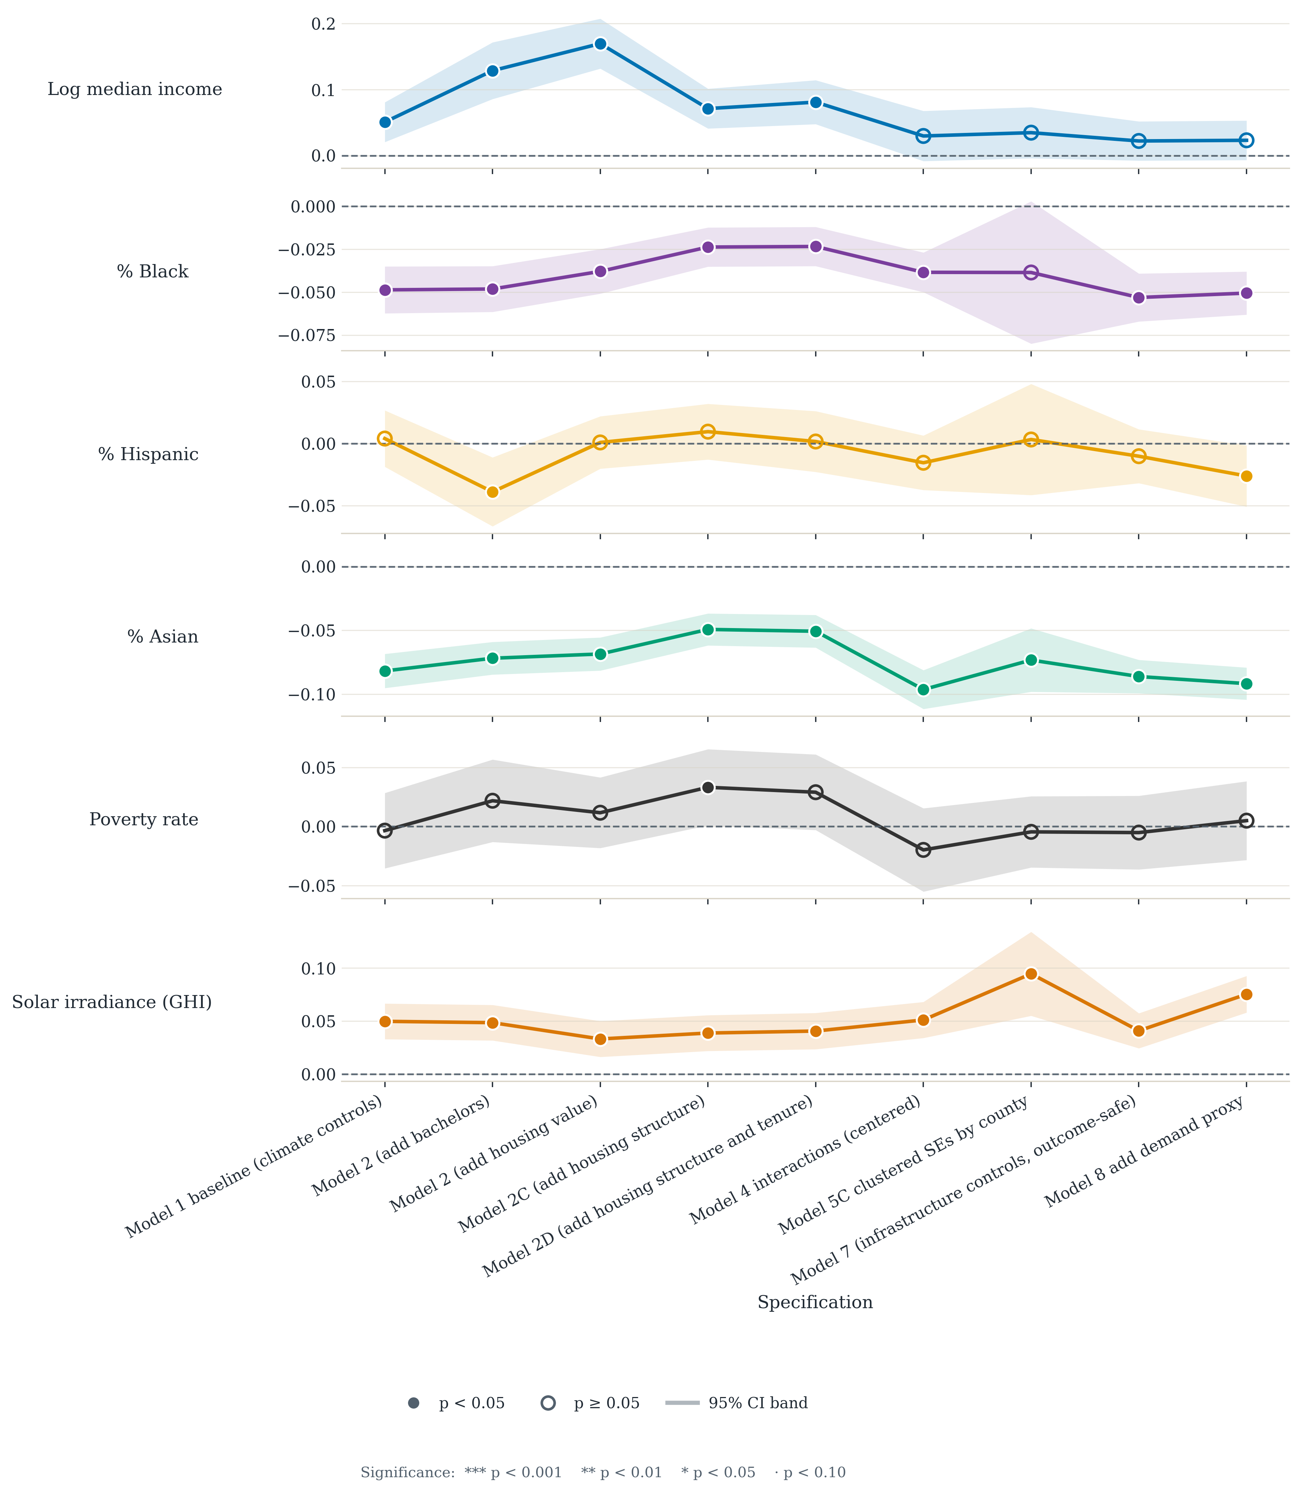
Supplementary Fig. S1 | Rooftop PV: coefficients across the model series. Each panel traces one coefficient across the control-block sensitivity specifications, with 95% confidence bands; filled markers denote p < 0.05.
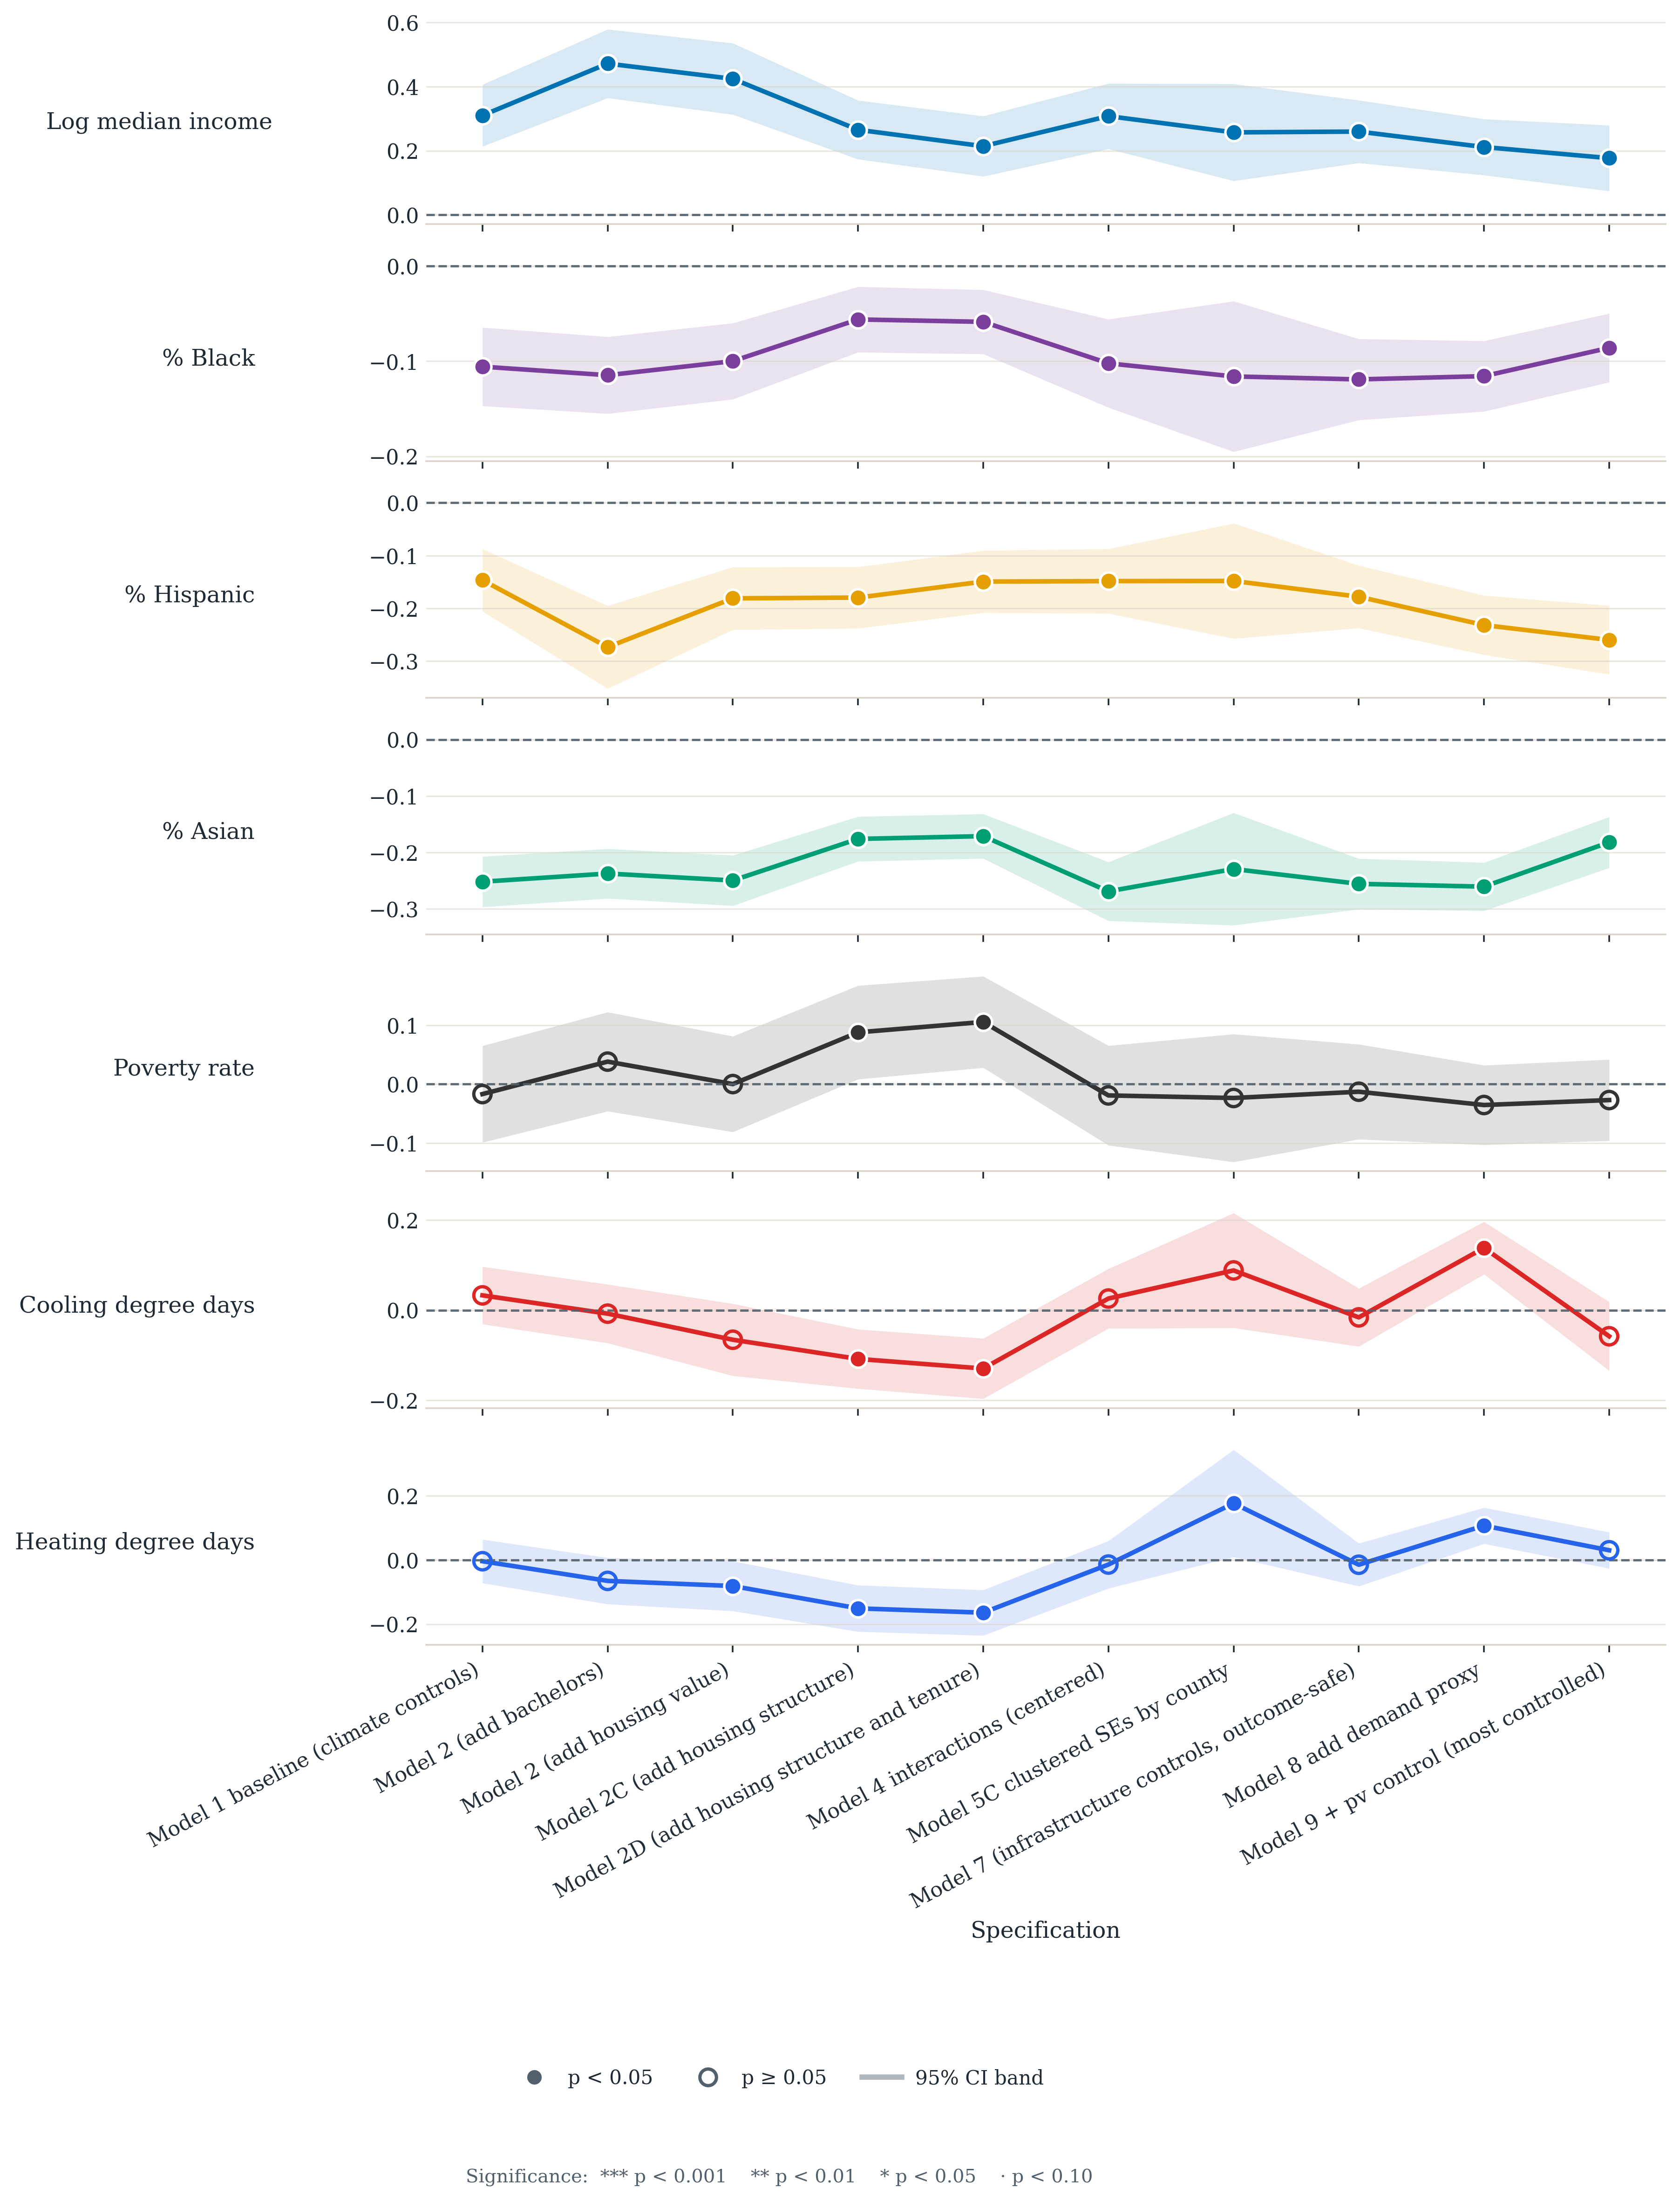
Supplementary Fig. S2 | Battery storage: coefficients across the model series. Coefficients are larger and more persistent than the corresponding PV estimates.
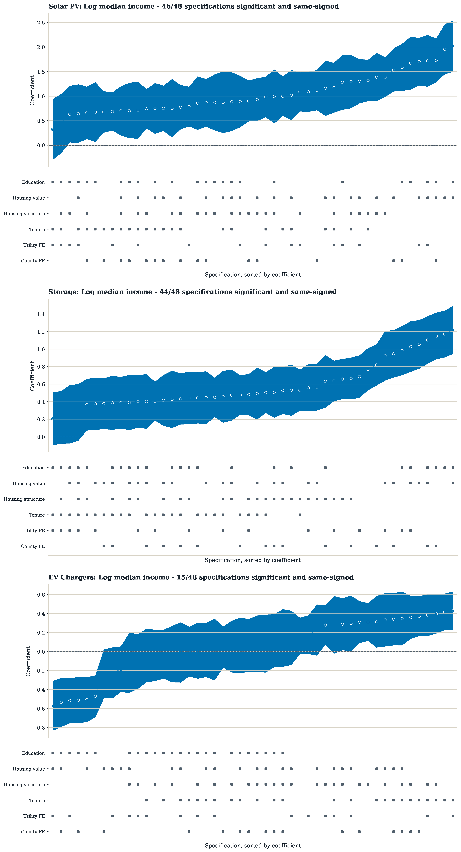
Supplementary Fig. S3 | Specification curve for rooftop PV, battery storage and aggregate EV charging. Each panel sorts the focal coefficient across all 48 valid combinations of the six confounder blocks, with the block-membership matrix below.
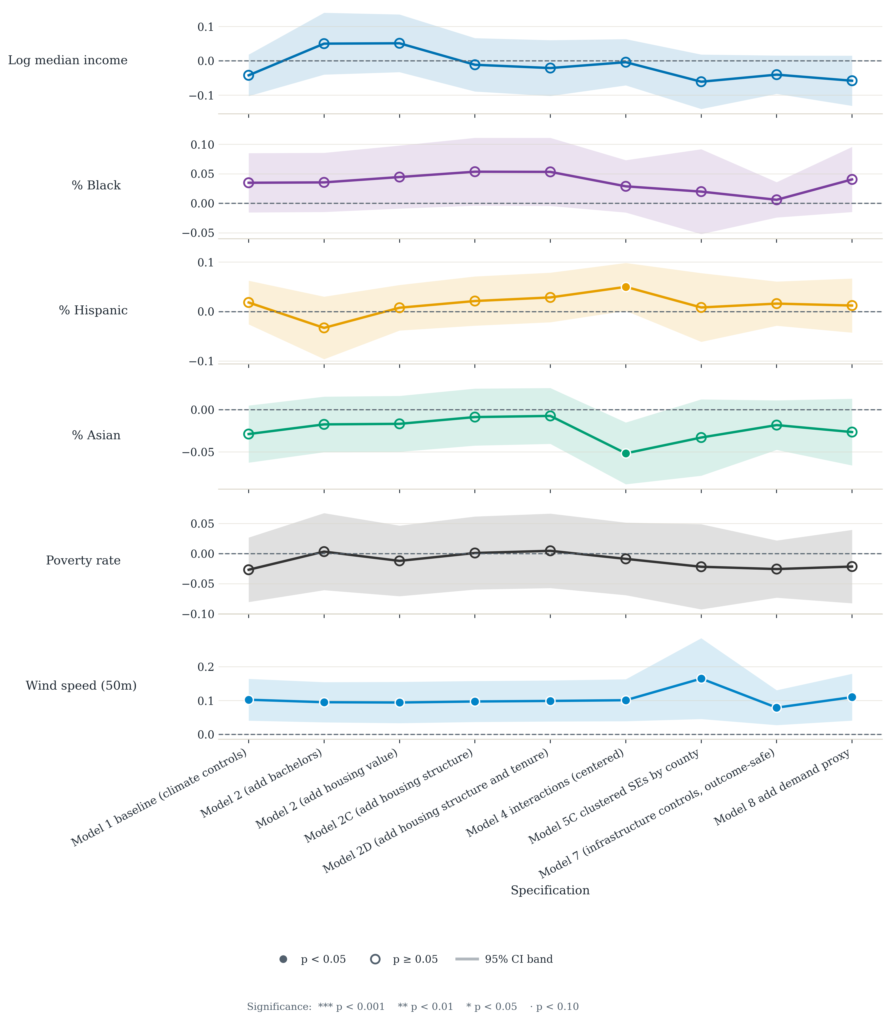
Supplementary Fig. S4 | Wind capacity: coefficients across the model series, included as contextual material. Wind capacity is zero in 97.5 per cent of ZCTAs.
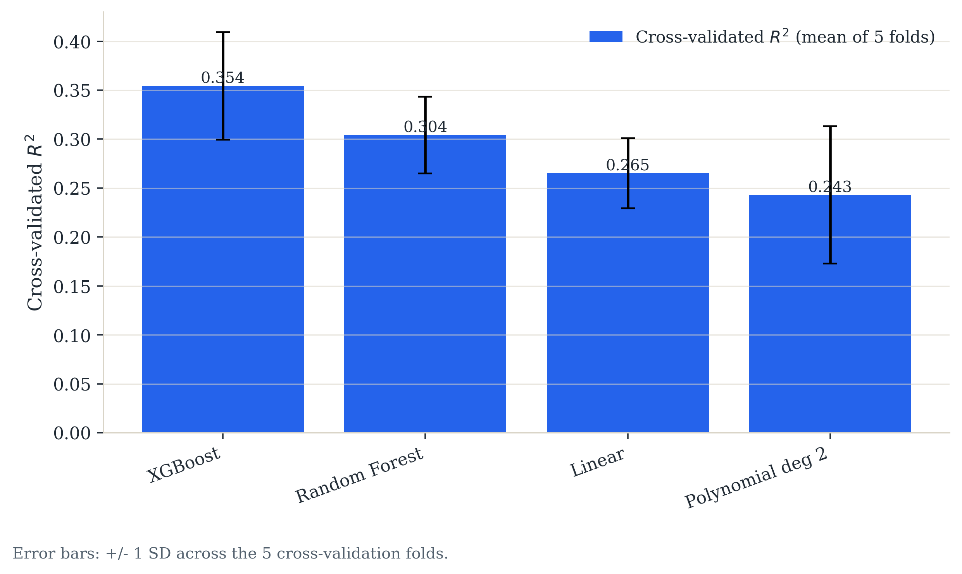
Supplementary Fig. S5 | Battery storage: cross-validated predictive comparison of linear and nonlinear models. Error bars are ±1 s.d. across five cross-validation folds.
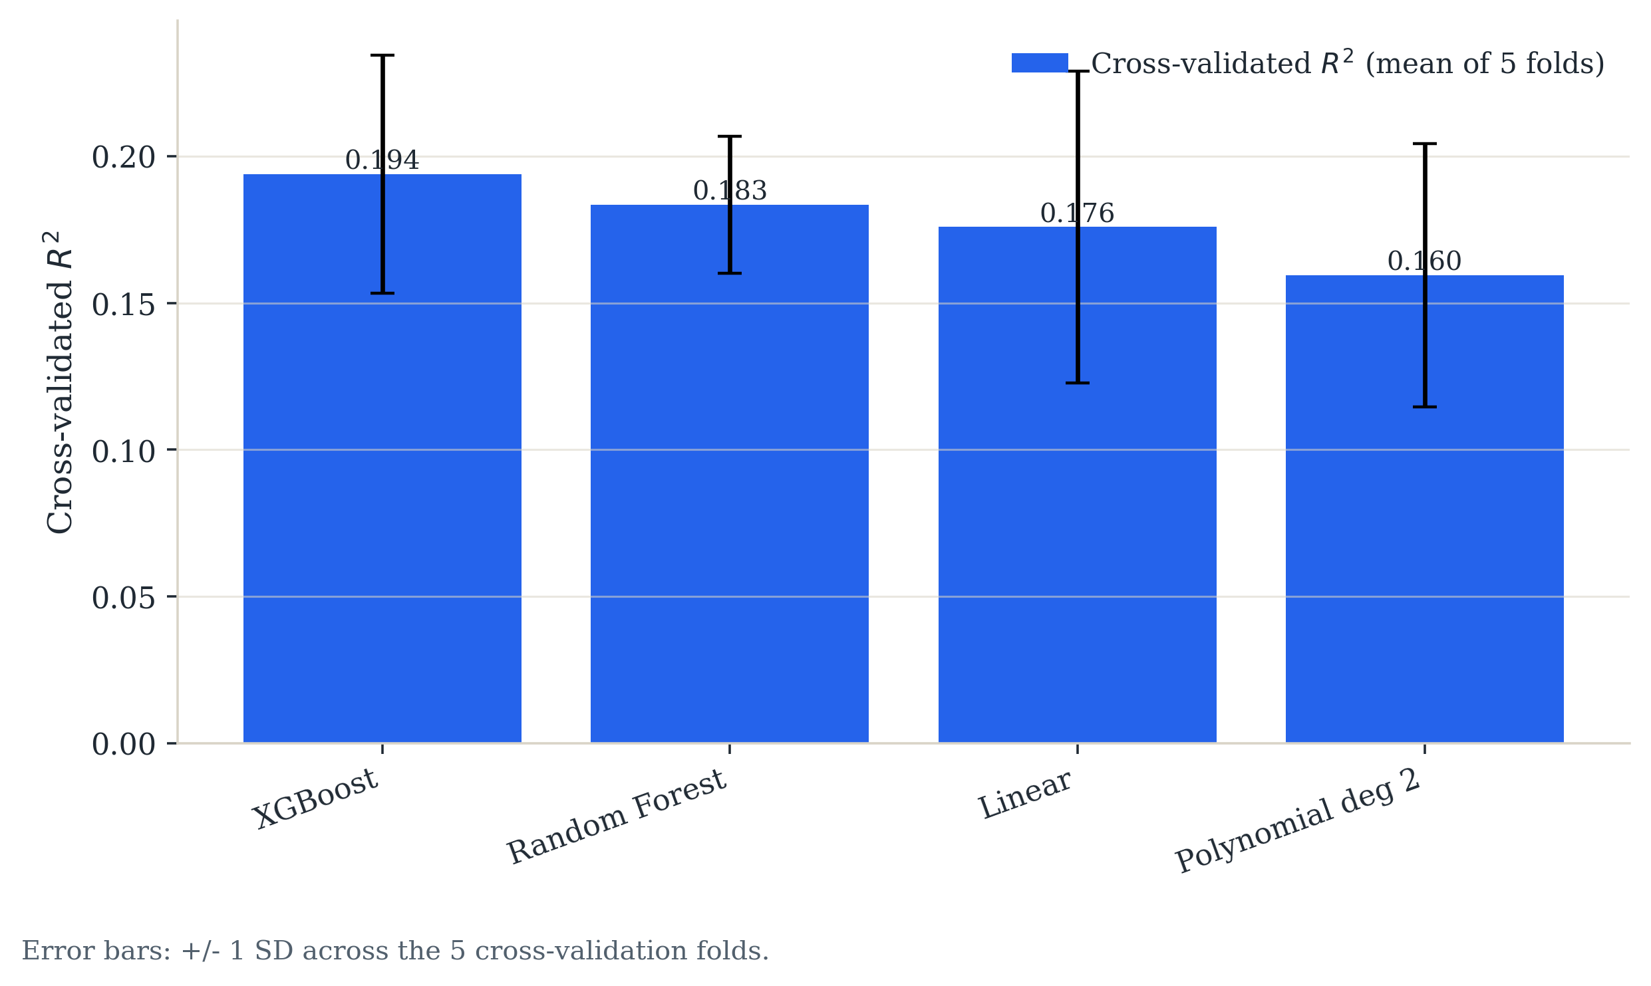
Supplementary Fig. S6 | Aggregate EV charging: cross-validated predictive comparison of linear and nonlinear models.
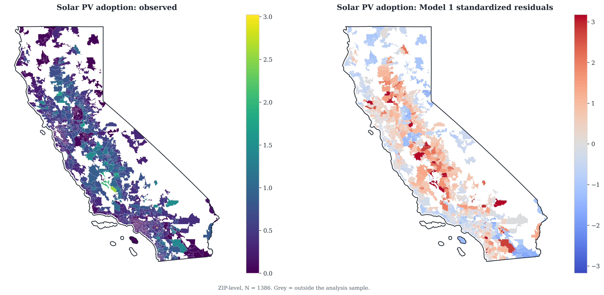
Supplementary Fig. S7 | Rooftop PV: observed adoption and baseline standardised residuals by ZCTA.
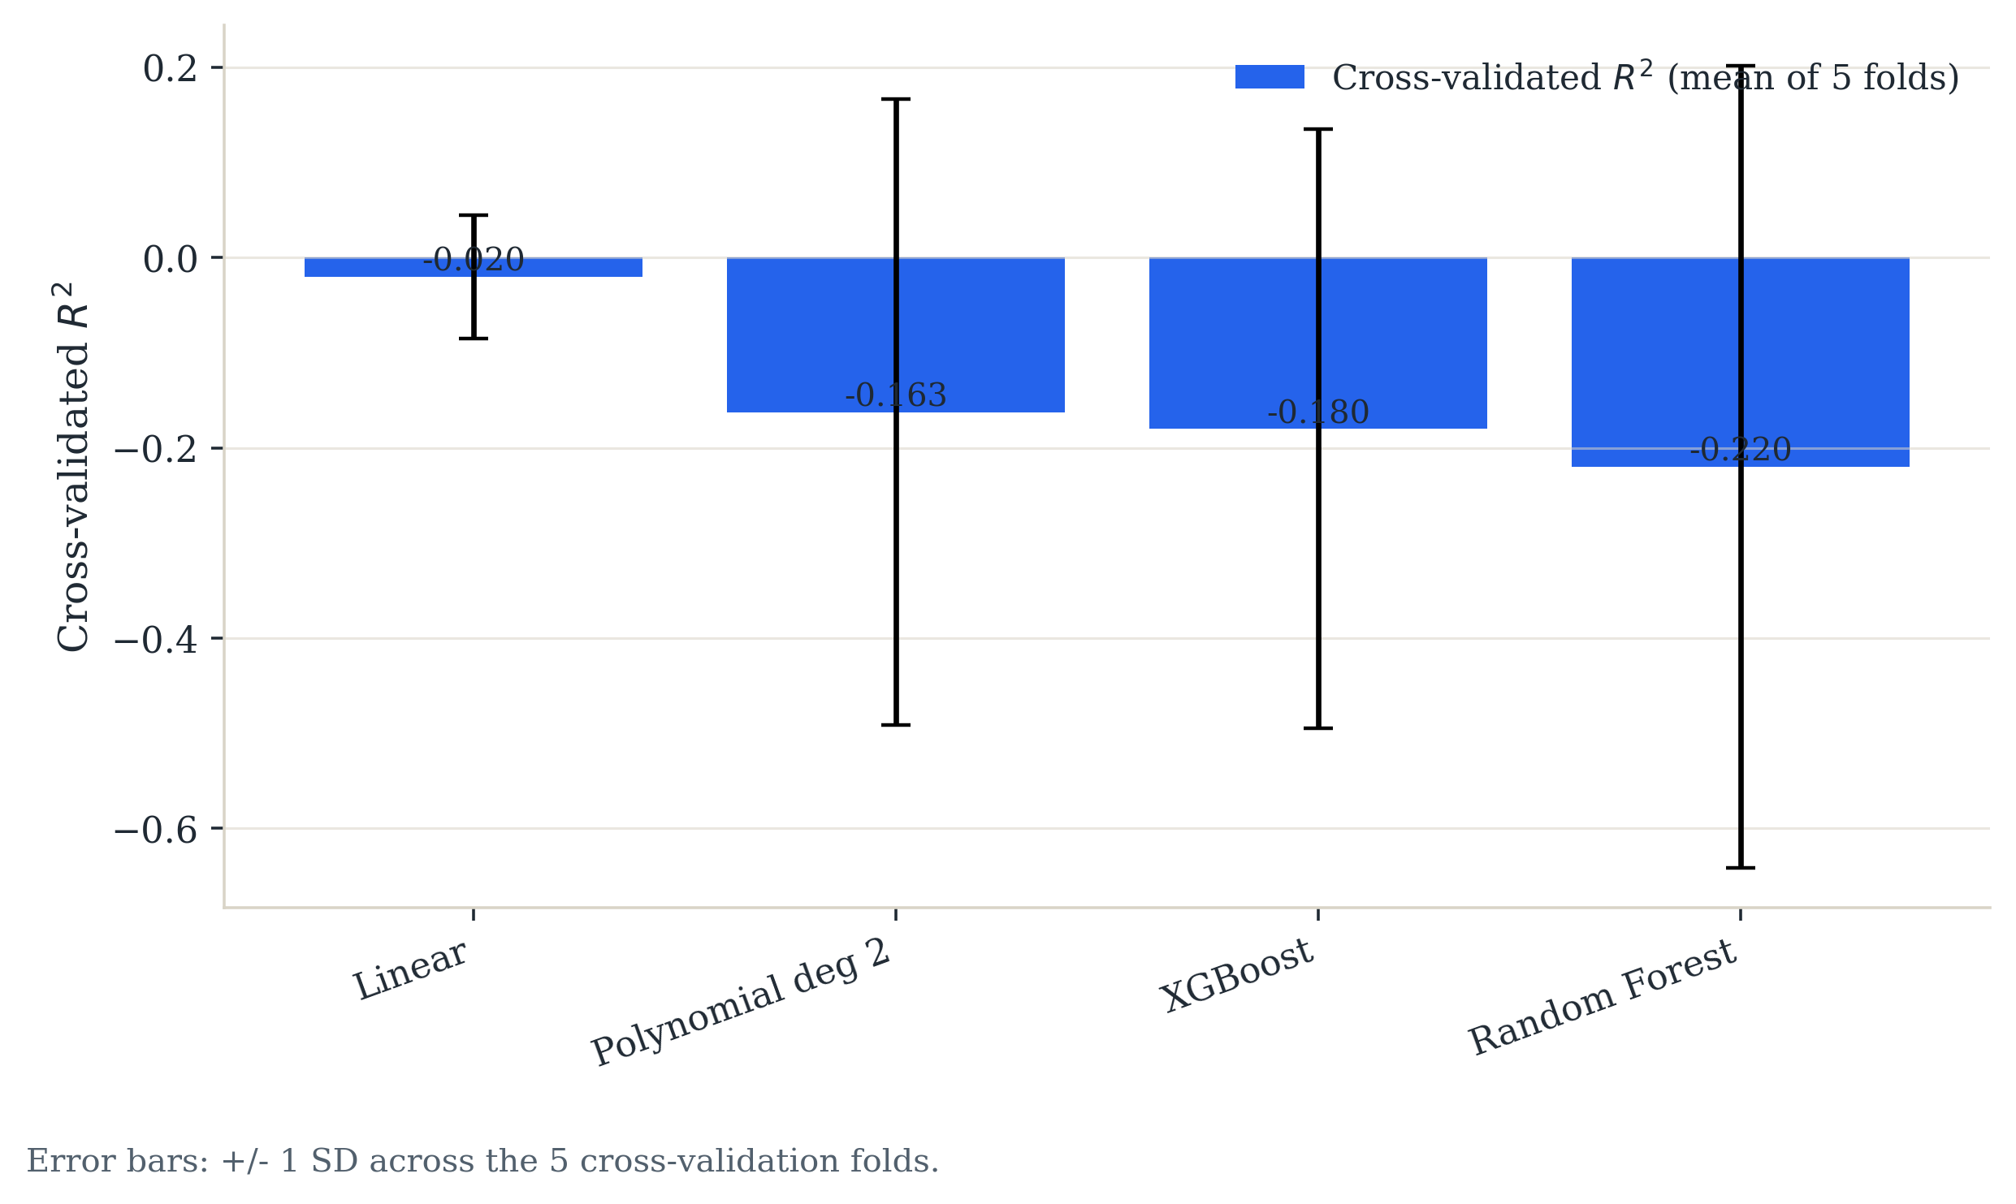
Supplementary Fig. S8 | Wind capacity: cross-validated predictive comparison of linear and nonlinear models.
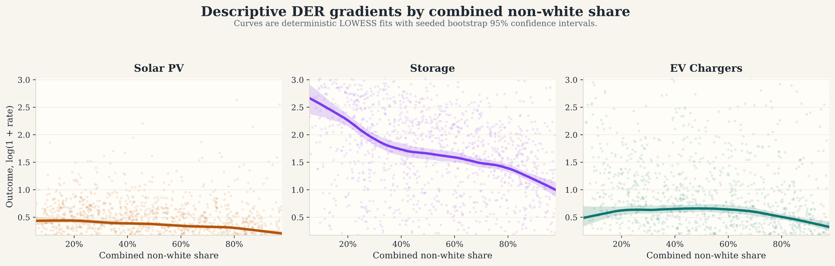
Supplementary Fig. S9 | Descriptive LOWESS gradients between combined non-white share and the three headline outcomes. Shaded ribbons are 95% bootstrap confidence intervals; these panels do not condition on the full control set.
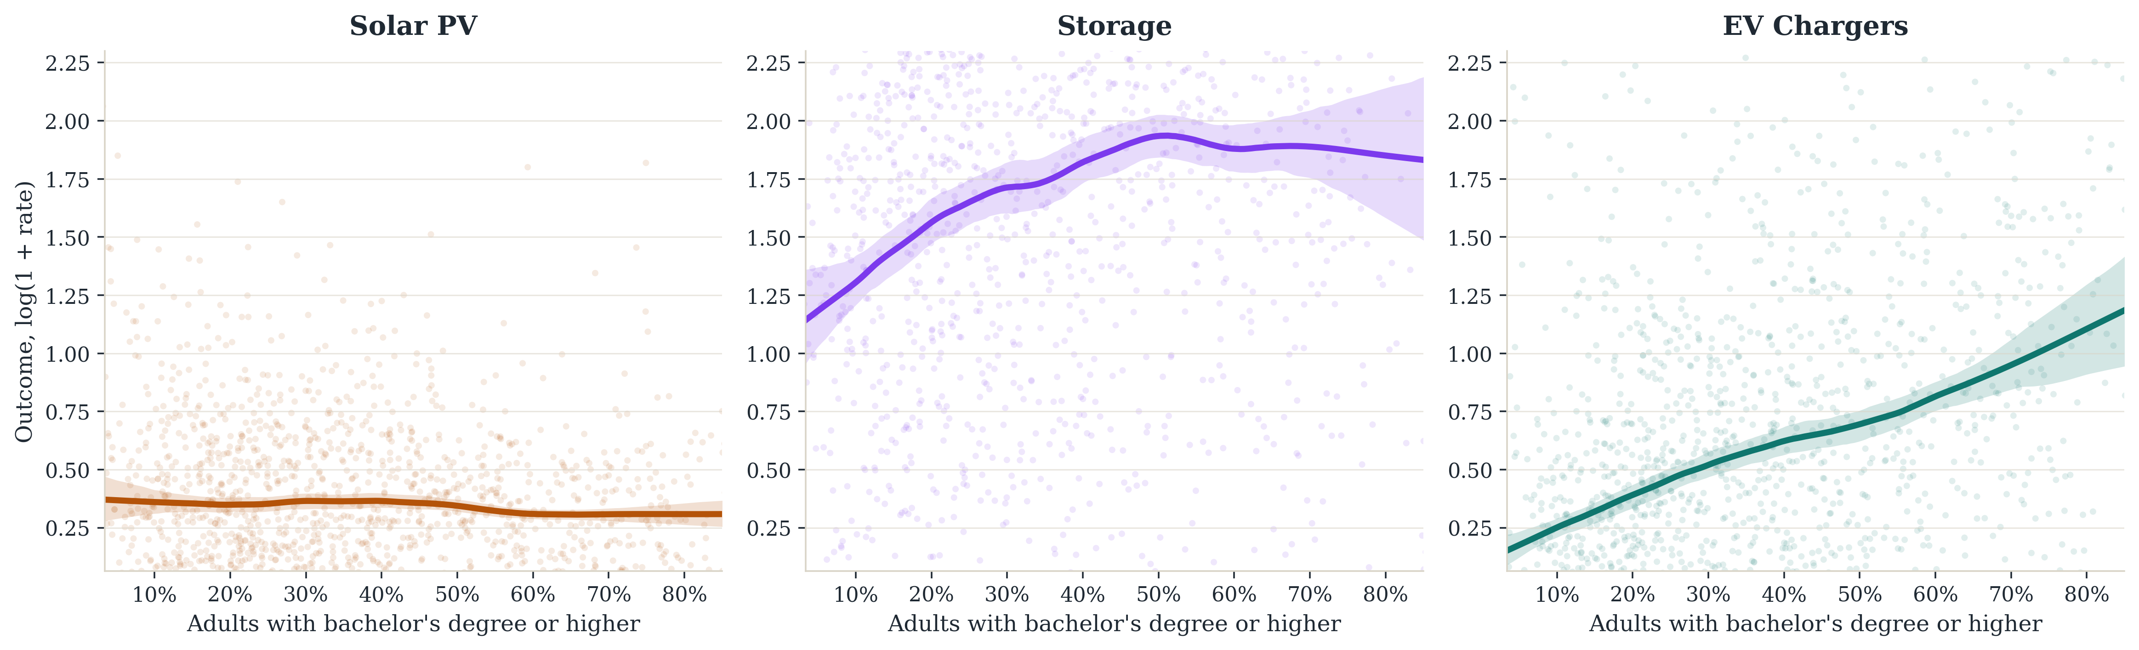
Supplementary Fig. S10 | Descriptive LOWESS gradients between bachelor's-degree attainment and the three headline outcomes.
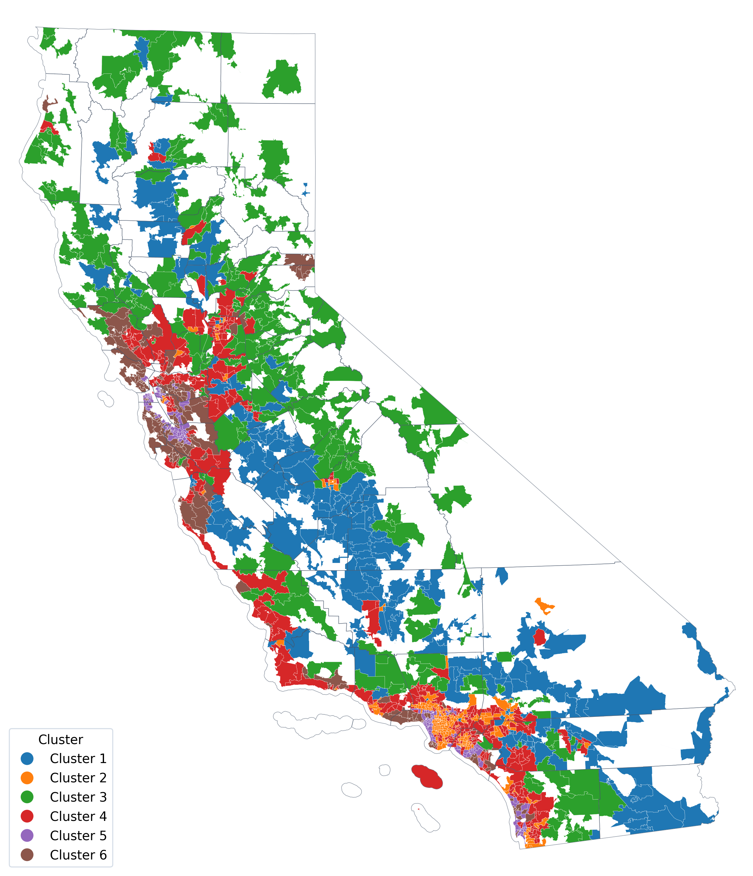
Supplementary Fig. S11 | California ZCTA clusters from exploratory principal-component and K-means analysis. Cluster identifiers are ordered from lowest to highest mean household income.
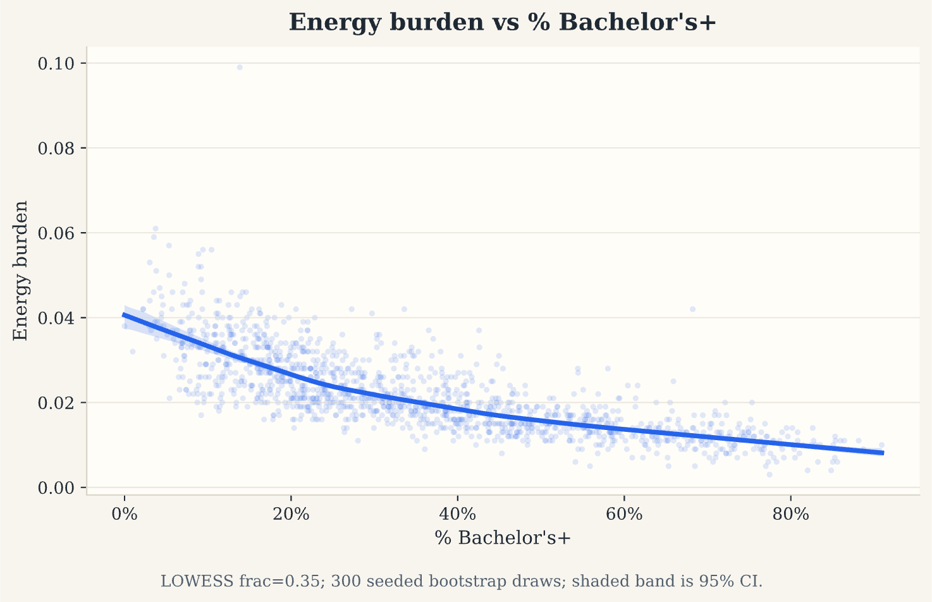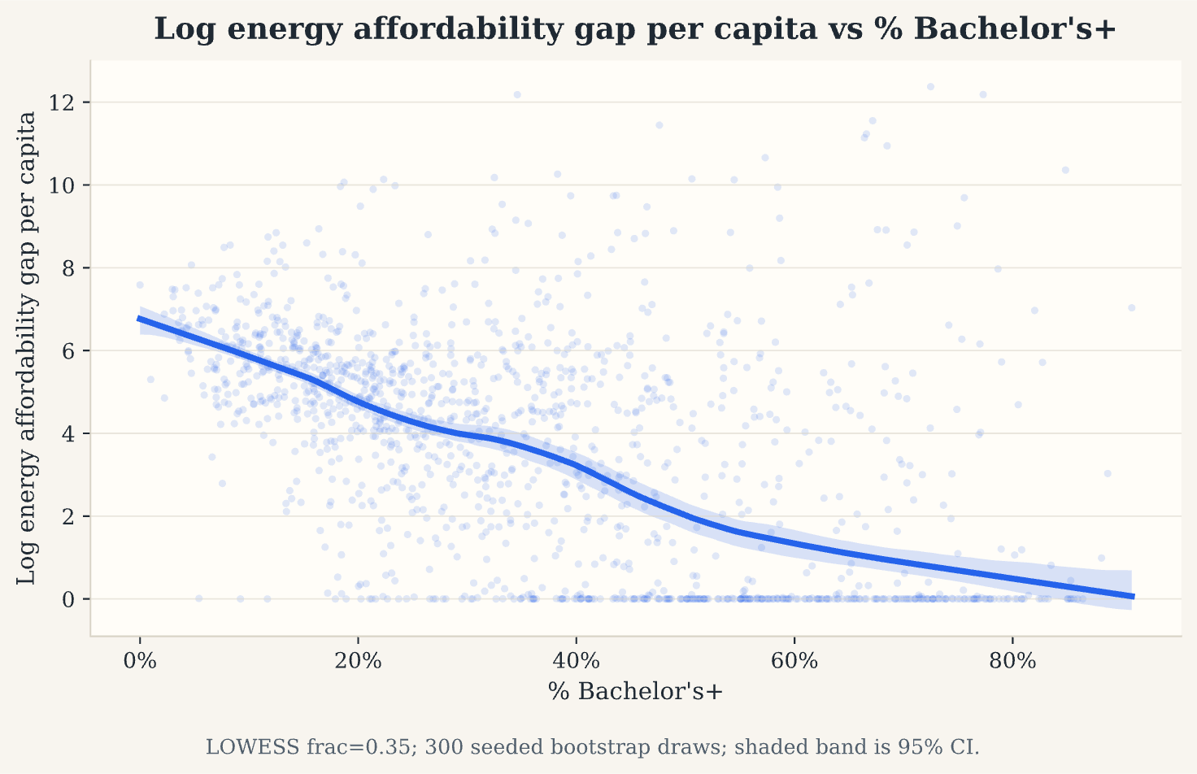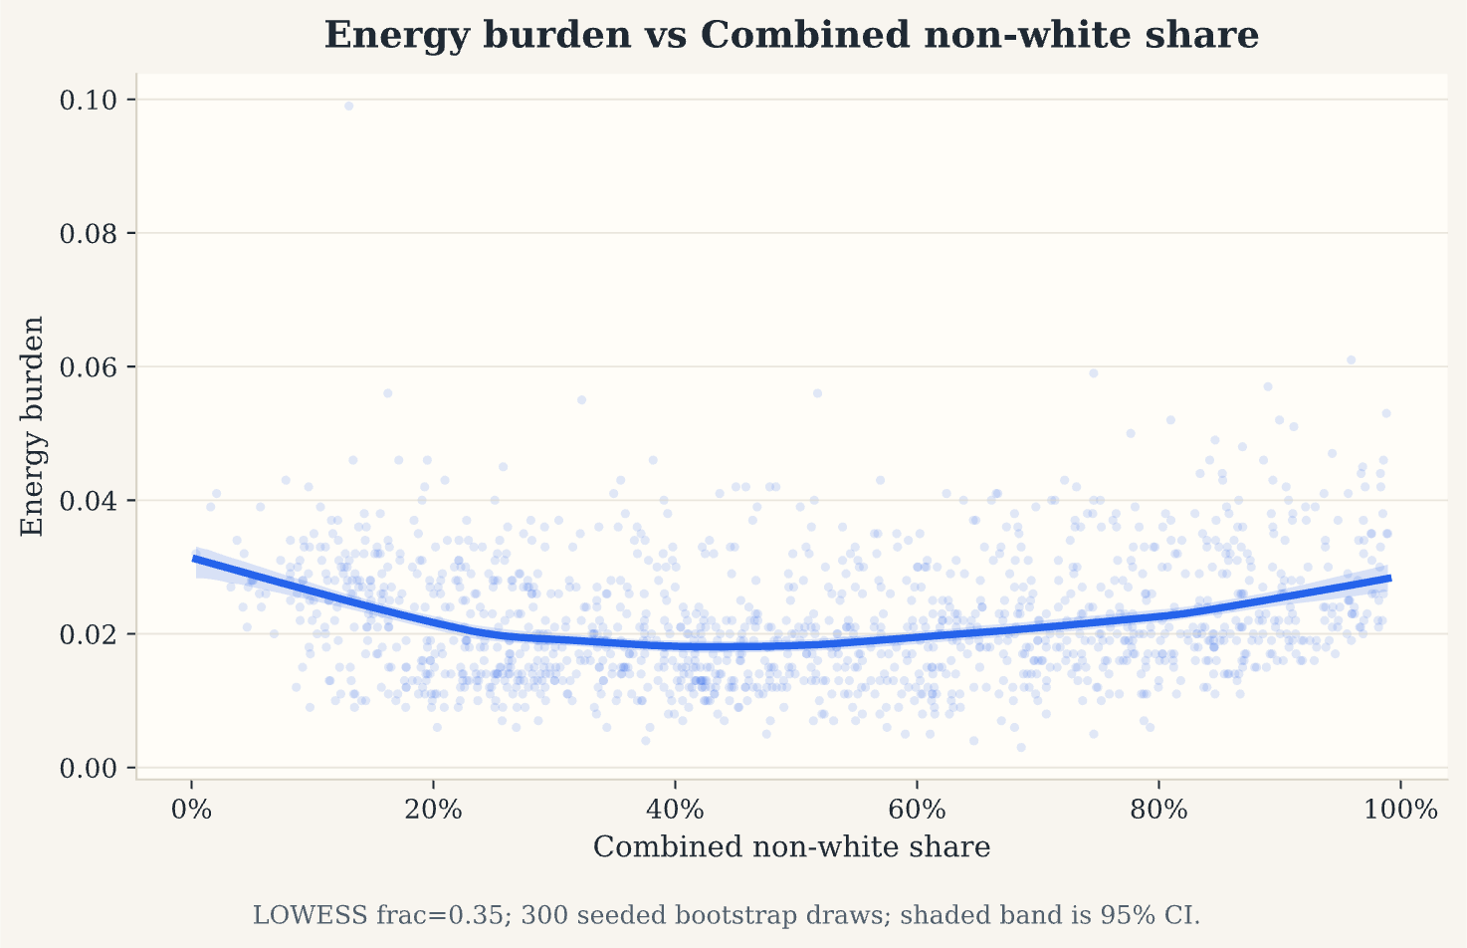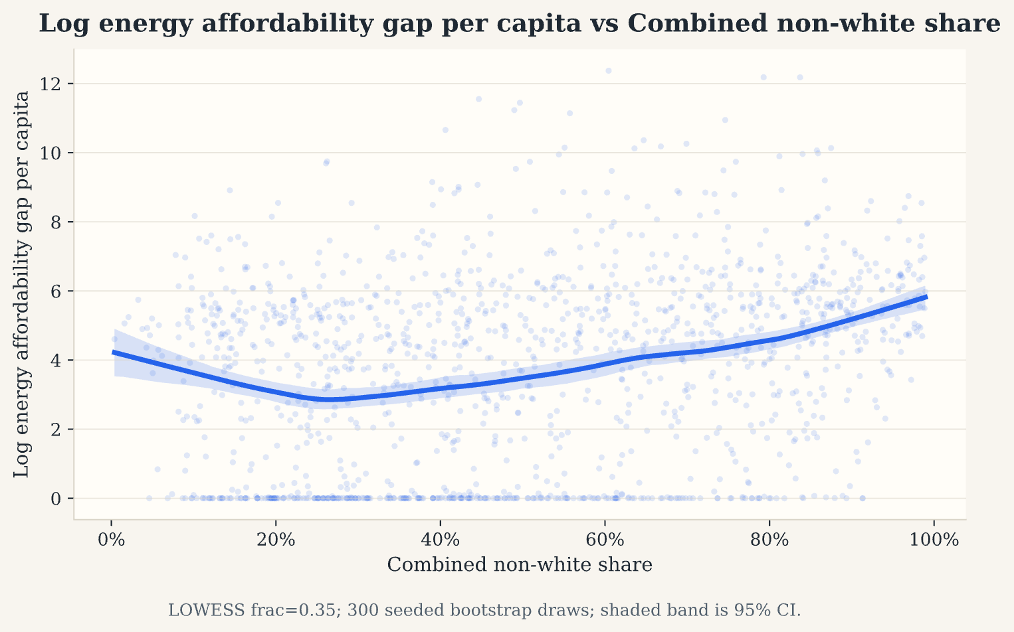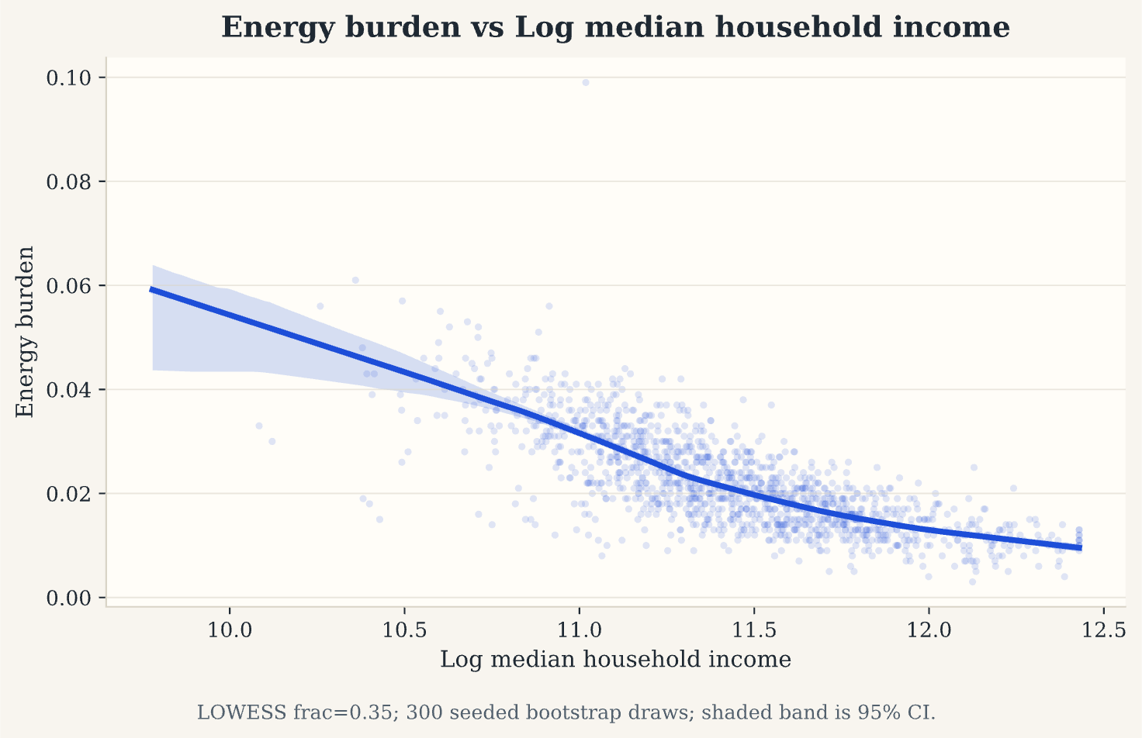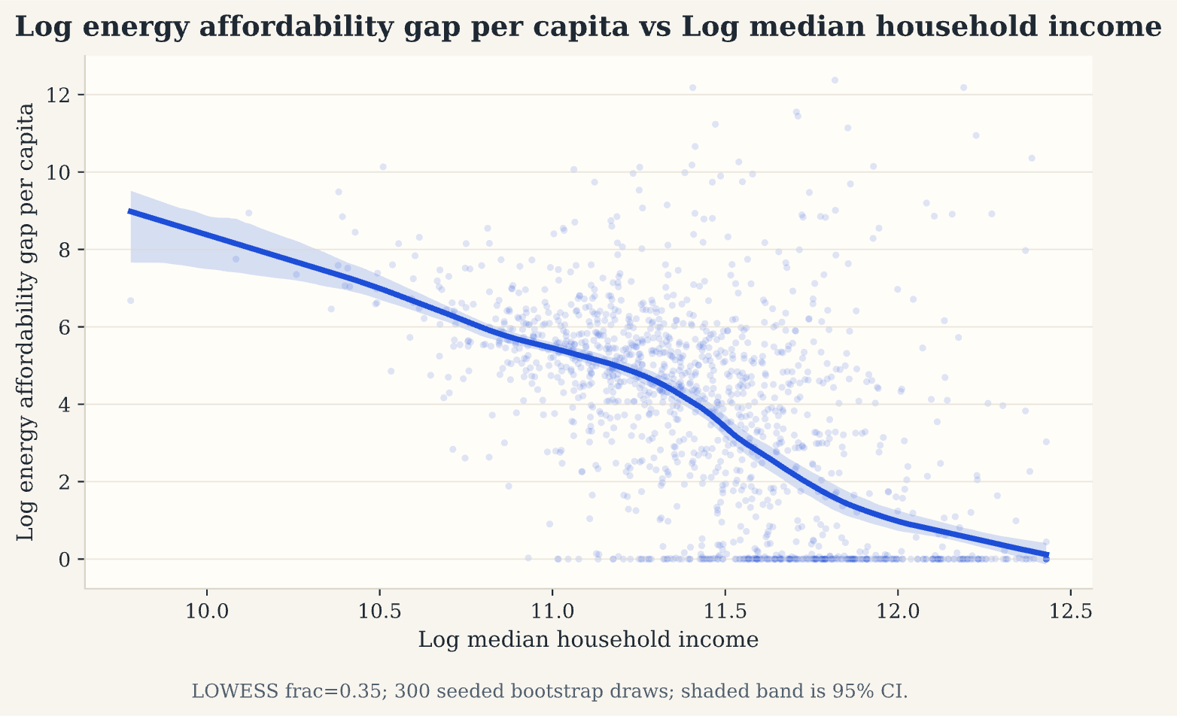
Supplementary Fig. S12 | Descriptive LOWESS gradients between neighbourhood characteristics and the two energy-affordability outcomes.
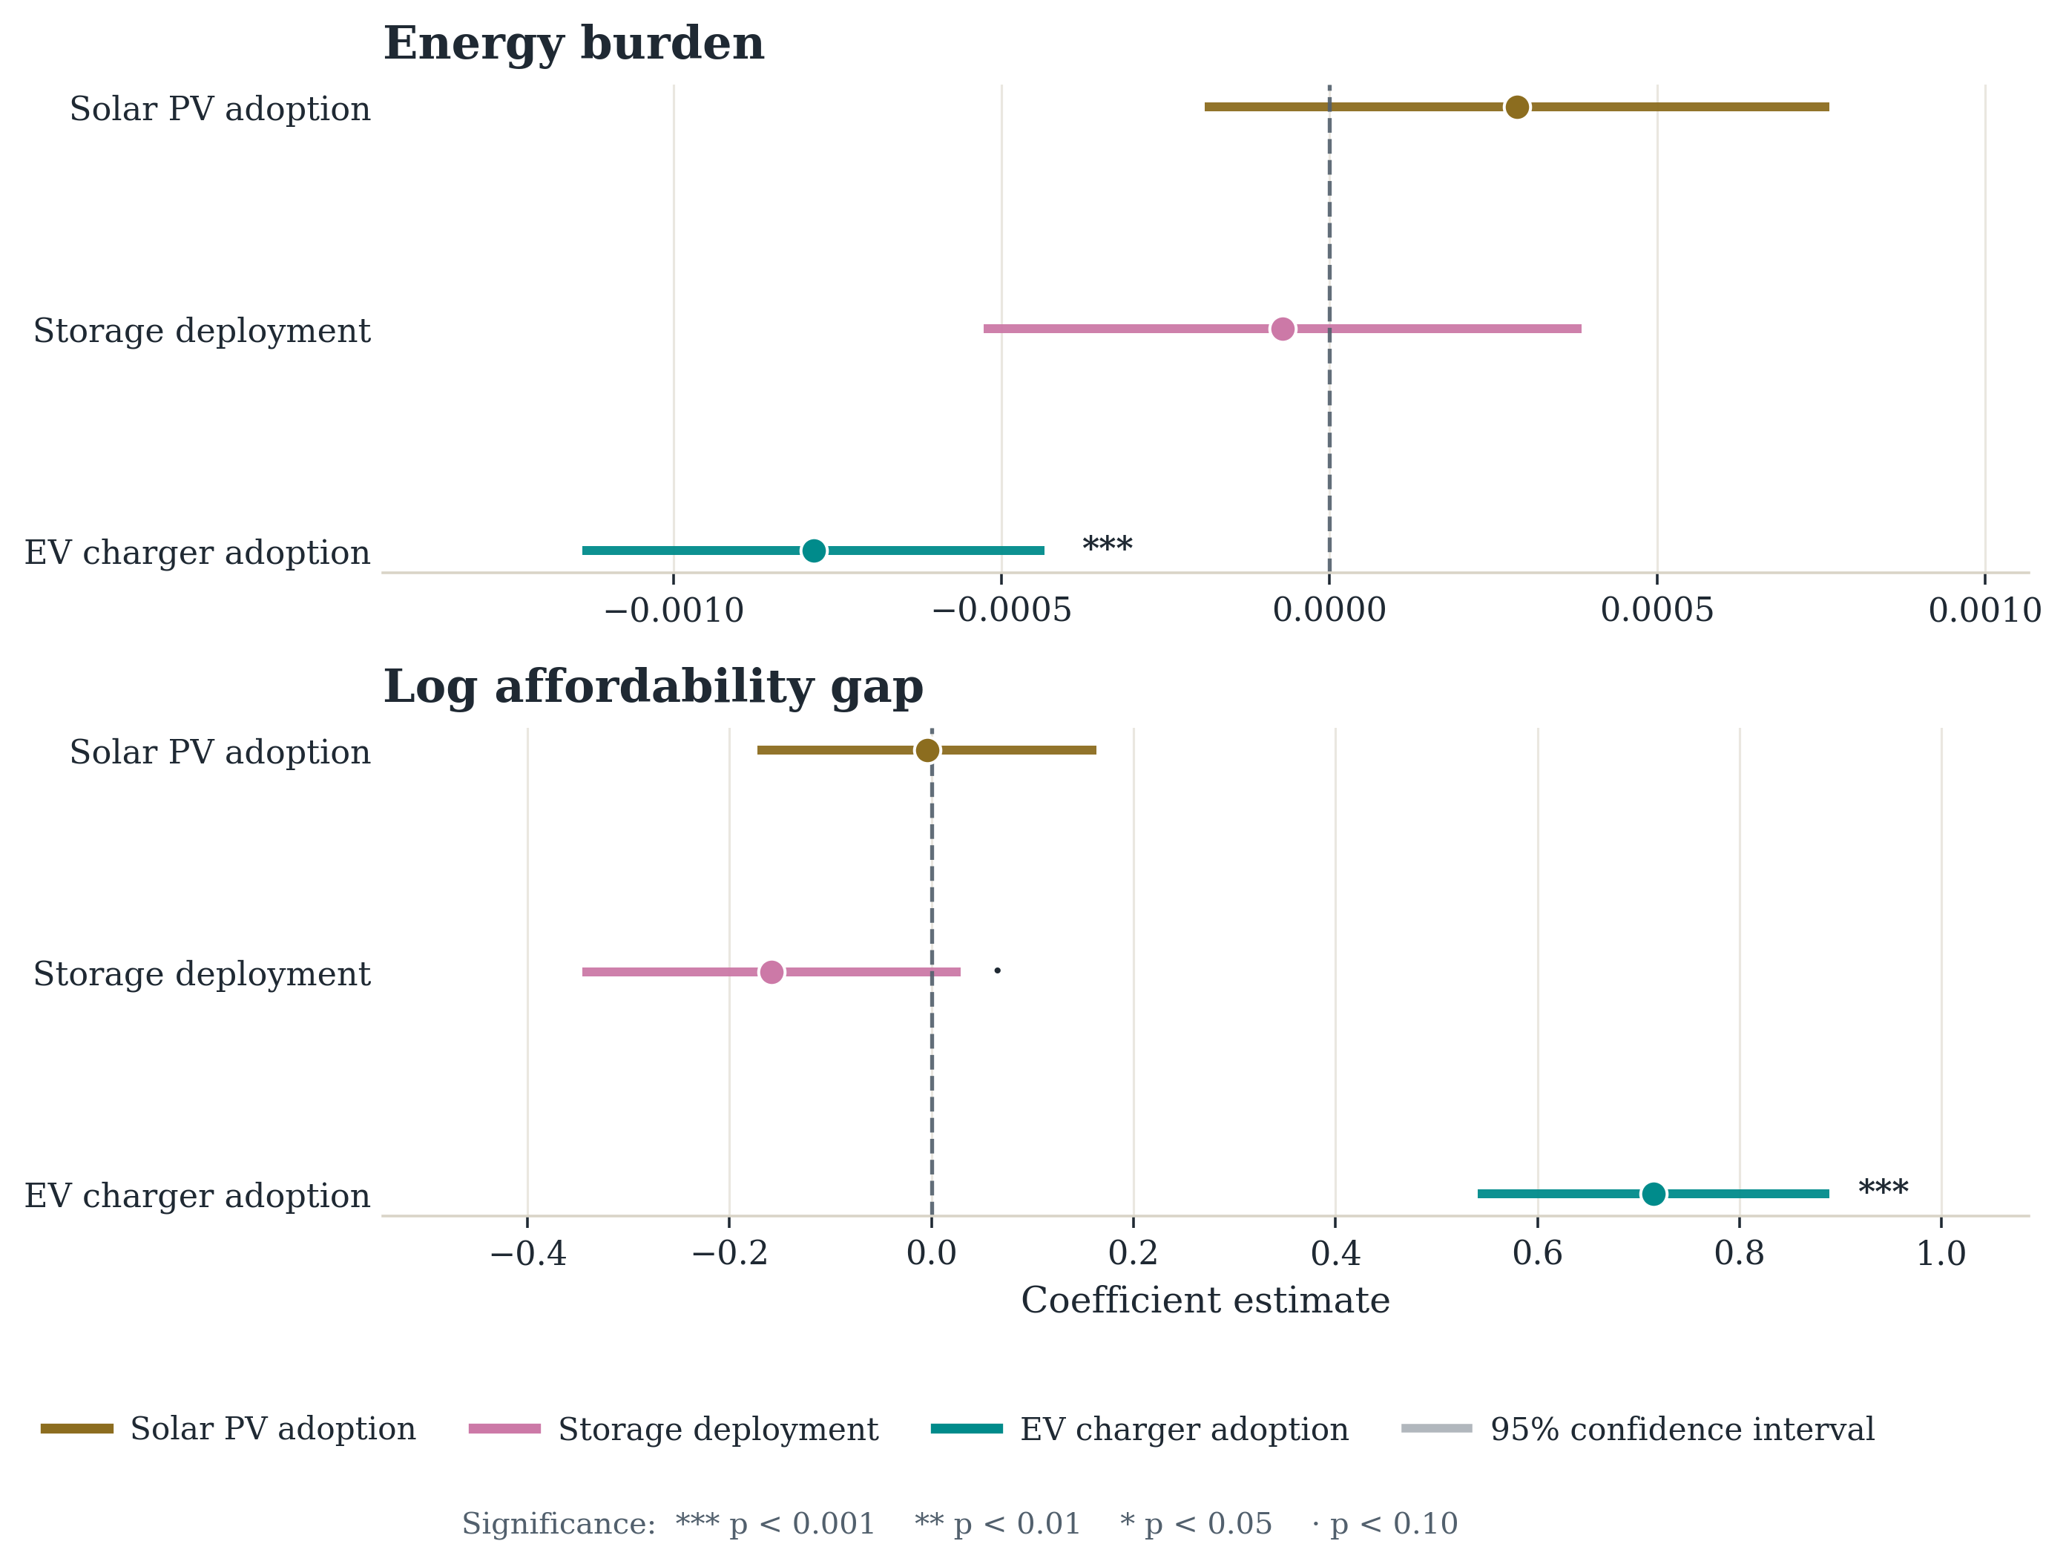
Supplementary Fig. S13 | DER predictors in the energy-burden and affordability-gap models. Points are coefficient estimates; horizontal lines are 95% confidence intervals.
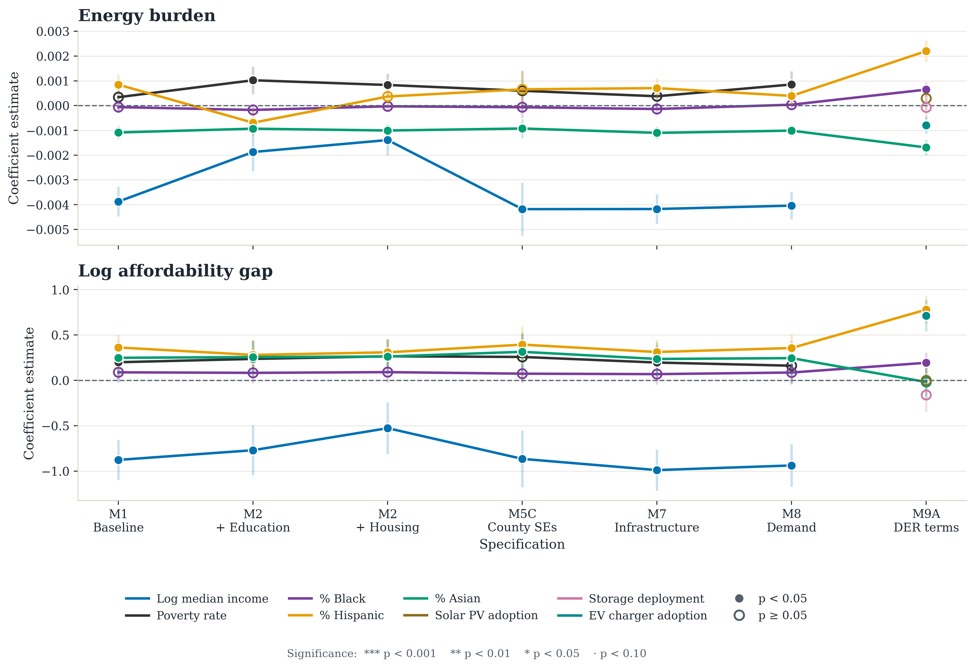
Supplementary Fig. S14 | Coefficient stability for the energy-burden and affordability-gap outcomes across the model series.
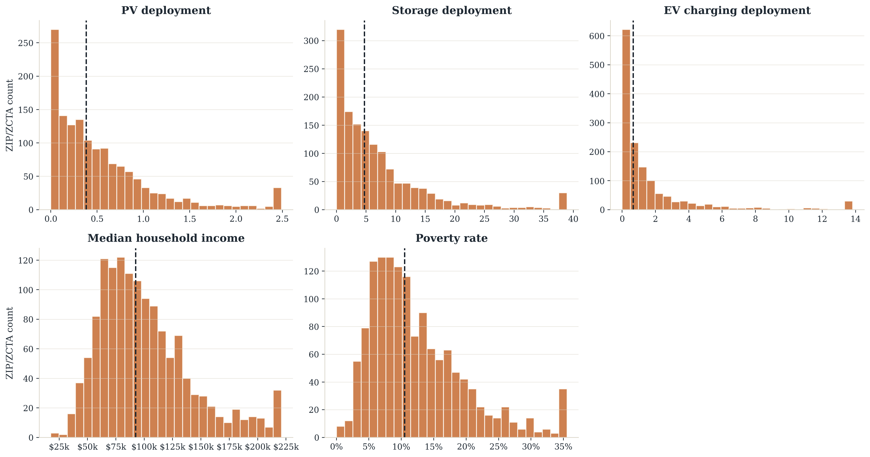
Supplementary Fig. S15 | Descriptive distributions for raw DER deployment rates together with median household income and poverty rate.
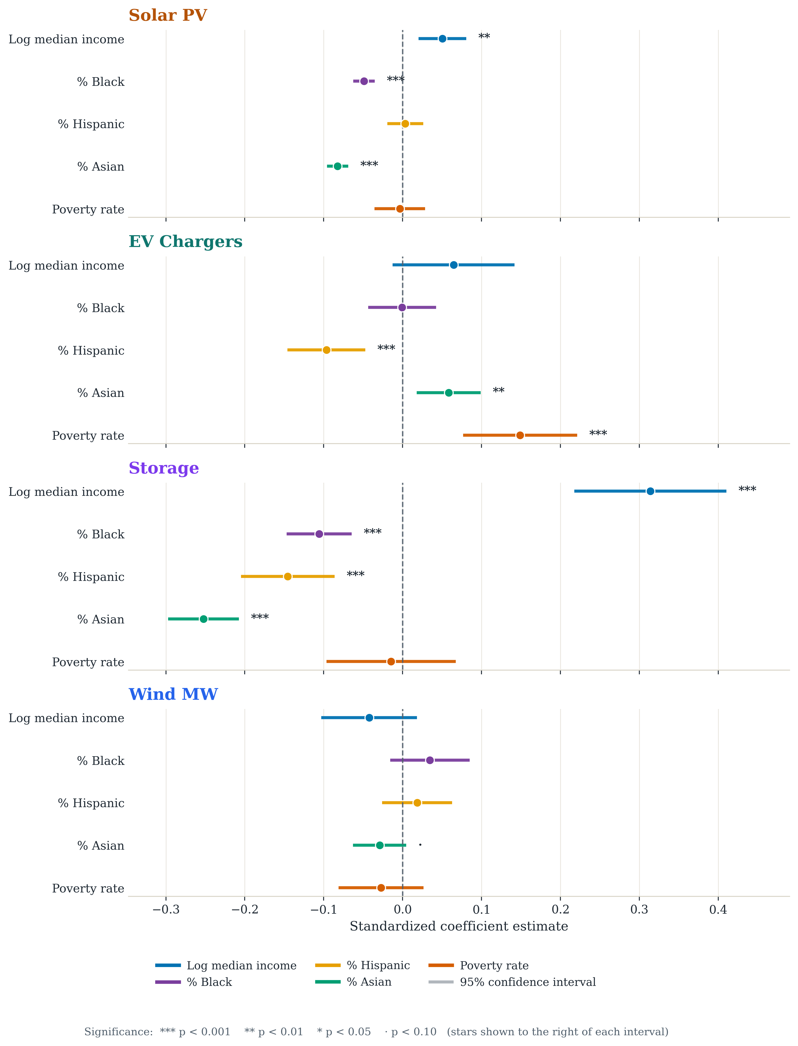
Supplementary Fig. S16 | Cross-outcome dot-whisker comparison of baseline standardised coefficients for rooftop PV, storage and EV charging.

Supplementary Tables
Supplementary Table S1 | Variable definitions for the main outcomes, predictors and controls.
Variable | Meaning | Scale / notes
y_pv | Solar PV deployment intensity | log(1 + PV kW DC per 1,000 residents)
y_storage | Battery storage deployment intensity | log(1 + storage MW per 100,000 residents)
y_chargers | EV charging availability | log(1 + total chargers per 1,000 residents)
pct_black | Share of ZIP/ZCTA population identifying as Black | ACS 2023 5-year estimate
pct_hispanic | Share of ZIP/ZCTA population identifying as Hispanic or Latino | ACS 2023 5-year estimate
pct_asian | Share of ZIP/ZCTA population identifying as Asian | ACS 2023 5-year estimate
log_median_household_income | Logged median household income | Socioeconomic/adoption-capacity proxy
poverty_rate | Share of residents below the poverty line | Socioeconomic control
pct_bachelors_plus | Share of adults with a bachelor’s degree or higher | Education and adoption-capacity control
ghi_mean_kwh_m2_day_2023 | Mean daily global horizontal irradiance | Solar resource / physical suitability control
cdd65_2023 | Cooling degree days relative to 65°F | Climate control
hdd65_2023 | Heating degree days relative to 65°F | Climate control
log_kwh | Logged annual electricity consumption | Demand/load proxy
energy_burden_pct | Household energy burden | ZIP-level energy costs as a share of income; used in the energy-burden outcome model
log_energy_gap_per_capita | Logged per-capita energy affordability gap | Scale-adjusted burden-gap measure used alongside energy_burden_pct
Supplementary Table S2 | Race-coefficient attenuation after adding housing structure and tenure. Standardised coefficients; baseline versus the specification adding exhaustive ACS B25024 structure shares and B25003 owner occupancy.
Outcome | Term | Baseline | + structure & tenure | Attenuation
Rooftop PV | Black share | −0.049 | −0.023 | 53%
Rooftop PV | Asian share | −0.082 | −0.051 | 38%
Battery storage | Black share | −0.106 | −0.059 | 44%
Battery storage | Asian share | −0.252 | −0.171 | 32%
Aggregate charging | Asian share | 0.058 | −0.008 | not distinguishable from zero
Supplementary Table S3 | Predictor means and standard deviations on the analysis sample, for converting standardised coefficients to percentage-point changes.
Predictor | Mean | Standard deviation | One s.d. in percentage points
log_median_household_income | 11.440 | 0.403 | —
pct_black | 0.043 | 0.066 | 6.6
pct_hispanic | 0.345 | 0.238 | 23.8
pct_asian | 0.119 | 0.141 | 14.1
Supplementary Table S4 | EV charger subtype comparison in baseline models.
Predictor | Aggregate | Level 1 | Level 2 | DC Fast
log_median_household_income | 0.164* (0.098) | -0.010 (0.011) | 0.203** (0.088) | 0.045 (0.056)
pct_black | -0.007 (0.343) | -0.004 (0.018) | 0.089 (0.323) | -0.148 (0.155)
pct_hispanic | -0.399*** (0.105) | -0.018 (0.012) | -0.478*** (0.089) | 0.013 (0.070)
pct_asian | 0.410*** (0.146) | 0.006 (0.006) | 0.341** (0.141) | 0.135** (0.068)
poverty_rate | 2.003*** (0.497) | 0.030 (0.056) | 2.242*** (0.444) | 0.364 (0.285)
N | 1,390 | 1,390 | 1,390 | 1,390
R² | 0.079 | 0.006 | 0.117 | 0.012
Supplementary Table S5 | Nested cumulative ladder, C1 to C5. Standardised predictors; frozen common sample of 1,160 ZCTAs and 42 county clusters, identical at every rung. C5 uses county-clustered standard errors. *p < 0.05, **p < 0.01, ***p < 0.001.
Outcome | Term | C1 | C2 | C3 | C4 | C5
Rooftop PV | Log income | 0.136** | 0.441*** | 0.195** | 0.159* | 0.147
Rooftop PV | Black share | -0.127*** | -0.109*** | -0.051* | -0.025 | -0.014
Rooftop PV | Hispanic share | -0.046 | -0.057 | 0.079 | 0.119* | 0.038
Rooftop PV | Asian share | -0.251*** | -0.216*** | -0.155*** | -0.127*** | -0.094**
Battery storage | Log income | 0.251*** | 0.370*** | 0.046 | 0.045 | 0.100
Battery storage | Black share | -0.125*** | -0.128*** | -0.064** | -0.056** | -0.041**
Battery storage | Hispanic share | -0.230*** | -0.289*** | -0.132** | -0.115* | -0.132*
Battery storage | Asian share | -0.303*** | -0.295*** | -0.222*** | -0.208*** | -0.142***
EV charging | Log income | 0.076 | -0.298*** | 0.021 | 0.019 | 0.068
EV charging | Black share | -0.008 | 0.011 | -0.035 | -0.033 | -0.012
EV charging | Hispanic share | -0.136*** | 0.141** | -0.014 | -0.012 | -0.053
EV charging | Asian share | 0.070* | 0.040 | -0.024 | -0.023 | 0.019
Supplementary Table S6 | Battery storage conditional on local PV deployment. This model conditions on a parallel outcome of the same predictors and is not a better-identified estimate of the storage gap.
Predictor | Coefficient | Robust SE | p-value
log_median_household_income | 0.440*** | 0.130 | < 0.001
pct_black | -1.343*** | 0.288 | < 0.001
pct_hispanic | -1.085*** | 0.139 | < 0.001
pct_asian | -1.287*** | 0.163 | < 0.001
pct_bachelors_plus | -0.491** | 0.220 | 0.026
y_pv | 0.952*** | 0.170 | < 0.001
Supplementary Table S7 | Moran's I on OLS residuals, eight-nearest-neighbour weights. Every entry is significant at p < 0.001 by permutation test.
Outcome | M1 baseline | M6A + lat/lon | M6B county FE | M8 + demand proxy
Solar PV | 0.437 | 0.426 | 0.145 | 0.359
Storage | 0.319 | 0.314 | 0.096 | 0.150
EV chargers (aggregate) | 0.140 | 0.132 | 0.078 | 0.127
EV chargers (Level 2) | 0.162 | 0.152 | 0.100 | 0.149
Energy burden | 0.352 | 0.434 | 0.275 | 0.289
Log affordability gap | 0.153 | 0.142 | 0.112 | 0.127
Supplementary Table S8 | Conley spatial HAC standard errors, Bartlett kernel over great-circle distance. Coefficients are identical across columns; only standard errors differ.
Term | Coefficient | HC1 | Conley 50 km | Conley 100 km | Conley 200 km
Solar PV
Log median income | 0.126 | 0.038*** | 0.053* | 0.056* | 0.053*
% Black | -0.760 | 0.109*** | 0.173*** | 0.237** | 0.298*
% Hispanic | 0.017 | 0.048 | 0.105 | 0.122 | 0.144
% Asian | -0.579 | 0.048*** | 0.071*** | 0.085*** | 0.085***
Poverty rate | -0.047 | 0.219 | 0.240 | 0.254 | 0.259
Storage
Log median income | 0.771 | 0.122*** | 0.176*** | 0.179*** | 0.168***
% Black | -1.652 | 0.328*** | 0.464*** | 0.557** | 0.644*
% Hispanic | -0.612 | 0.126*** | 0.205** | 0.213** | 0.182***
% Asian | -1.780 | 0.162*** | 0.292*** | 0.344*** | 0.339***
Poverty rate | -0.228 | 0.562 | 0.681 | 0.710 | 0.682
EV chargers (aggregate)
Log median income | 0.164 | 0.098 | 0.130 | 0.120 | 0.102
% Black | -0.007 | 0.343 | 0.275 | 0.294 | 0.285
% Hispanic | -0.399 | 0.105*** | 0.156* | 0.165* | 0.173*
% Asian | 0.410 | 0.146** | 0.207* | 0.218 | 0.197*
Poverty rate | 2.003 | 0.497*** | 0.641** | 0.674** | 0.692**
Supplementary Table S9 | Spatial error model, maximum likelihood, eight-nearest-neighbour weights. Standardised predictors; λ is the spatial autoregressive error parameter.
Outcome | Term | Coefficient | Std. error | p | λ | N
Rooftop PV | Log income | 0.203 | 0.036 | 0.000 | 0.85 | 1390
Rooftop PV | Black share | -0.028 | 0.025 | 0.259 | 0.85 | 1390
Rooftop PV | Hispanic share | -0.045 | 0.030 | 0.127 | 0.85 | 1390
Rooftop PV | Asian share | -0.070 | 0.028 | 0.012 | 0.85 | 1390
Battery storage | Log income | 0.345 | 0.046 | 0.000 | 0.65 | 1390
Battery storage | Black share | -0.077 | 0.031 | 0.012 | 0.65 | 1390
Battery storage | Hispanic share | -0.222 | 0.036 | 0.000 | 0.65 | 1390
Battery storage | Asian share | -0.207 | 0.034 | 0.000 | 0.65 | 1390
EV charging | Log income | 0.001 | 0.052 | 0.985 | 0.45 | 1390
EV charging | Black share | 0.025 | 0.033 | 0.442 | 0.45 | 1390
EV charging | Hispanic share | -0.119 | 0.039 | 0.002 | 0.45 | 1390
EV charging | Asian share | 0.083 | 0.036 | 0.021 | 0.45 | 1390
Supplementary Table S10 | Poisson pseudo-maximum-likelihood models on raw counts with a population offset. Fitted directly to counts rather than to a log(1 + rate) transformation, so structural zeros are handled without transformation. HC1 standard errors.
Outcome | Term | Coefficient | Std. error | p | N
chargers (aggregate) | Log income | 0.892 | 0.251 | 0.000 | 1390
chargers (aggregate) | Black share | -0.577 | 0.745 | 0.439 | 1390
chargers (aggregate) | Hispanic share | -1.367 | 0.262 | 0.000 | 1390
chargers (aggregate) | Asian share | 0.235 | 0.301 | 0.435 | 1390
Level 2 chargers | Log income | 1.068 | 0.302 | 0.000 | 1390
Level 2 chargers | Black share | -0.137 | 0.846 | 0.871 | 1390
Level 2 chargers | Hispanic share | -1.536 | 0.328 | 0.000 | 1390
Level 2 chargers | Asian share | 0.375 | 0.356 | 0.292 | 1390
DC fast chargers | Log income | 0.294 | 0.247 | 0.234 | 1390
DC fast chargers | Black share | -1.583 | 0.922 | 0.086 | 1390
DC fast chargers | Hispanic share | -0.732 | 0.263 | 0.005 | 1390
DC fast chargers | Asian share | -0.094 | 0.272 | 0.730 | 1390
storage MW | Log income | 0.851 | 0.146 | 0.000 | 1390
storage MW | Black share | -1.529 | 0.473 | 0.001 | 1390
storage MW | Hispanic share | -0.817 | 0.144 | 0.000 | 1390
storage MW | Asian share | -1.756 | 0.187 | 0.000 | 1390
PV capacity | Log income | 0.477 | 0.138 | 0.001 | 1390
PV capacity | Black share | -2.127 | 0.534 | 0.000 | 1390
PV capacity | Hispanic share | -0.509 | 0.138 | 0.000 | 1390
PV capacity | Asian share | -1.986 | 0.192 | 0.000 | 1390
Supplementary Table S11 | Population-weighted versus unweighted baseline estimates. Standardised predictors; weights are ZCTA total population.
Outcome | Term | Unweighted | p | Population-weighted | p | N
Rooftop PV | Log income | 0.233 | 0.000 | 0.346 | 0.000 | 1390
Rooftop PV | Black share | -0.116 | 0.000 | -0.075 | 0.003 | 1390
Rooftop PV | Hispanic share | 0.117 | 0.000 | 0.095 | 0.021 | 1390
Rooftop PV | Asian share | -0.158 | 0.000 | -0.144 | 0.000 | 1390
Battery storage | Log income | 0.326 | 0.000 | 0.266 | 0.000 | 1390
Battery storage | Black share | -0.112 | 0.000 | -0.058 | 0.004 | 1390
Battery storage | Hispanic share | -0.156 | 0.000 | -0.108 | 0.001 | 1390
Battery storage | Asian share | -0.266 | 0.000 | -0.155 | 0.000 | 1390
EV charging | Log income | 0.098 | 0.073 | 0.220 | 0.000 | 1390
EV charging | Black share | 0.001 | 0.974 | -0.057 | 0.008 | 1390
EV charging | Hispanic share | -0.128 | 0.000 | -0.195 | 0.000 | 1390
EV charging | Asian share | 0.083 | 0.004 | 0.013 | 0.617 | 1390
Supplementary Table S12 | Energy-affordability models with and without the 134 ZCTAs whose per-capita affordability gap exceeds $1,000. Standardised predictors.
Outcome | Sample | Term | Coefficient | p | N | R²
energy_burden_pct | full sample | Log income | -0.410 | 0.000 | 1374 | 0.735
energy_burden_pct | full sample | Black share | -0.008 | 0.548 | 1374 | 0.735
energy_burden_pct | full sample | Hispanic share | 0.084 | 0.000 | 1374 | 0.735
energy_burden_pct | full sample | Asian share | -0.118 | 0.000 | 1374 | 0.735
energy_burden_pct | excl. gap outliers | Log income | -0.434 | 0.000 | 1242 | 0.753
energy_burden_pct | excl. gap outliers | Black share | 0.007 | 0.566 | 1242 | 0.753
energy_burden_pct | excl. gap outliers | Hispanic share | 0.087 | 0.000 | 1242 | 0.753
energy_burden_pct | excl. gap outliers | Asian share | -0.116 | 0.000 | 1242 | 0.753
log_energy_gap_per_capita | full sample | Log income | -0.326 | 0.000 | 1374 | 0.317
log_energy_gap_per_capita | full sample | Black share | 0.032 | 0.142 | 1374 | 0.317
log_energy_gap_per_capita | full sample | Hispanic share | 0.130 | 0.000 | 1374 | 0.317
log_energy_gap_per_capita | full sample | Asian share | 0.090 | 0.010 | 1374 | 0.317
log_energy_gap_per_capita | excl. gap outliers | Log income | -0.366 | 0.000 | 1242 | 0.450
log_energy_gap_per_capita | excl. gap outliers | Black share | 0.034 | 0.159 | 1242 | 0.450
log_energy_gap_per_capita | excl. gap outliers | Hispanic share | 0.161 | 0.000 | 1242 | 0.450
log_energy_gap_per_capita | excl. gap outliers | Asian share | -0.019 | 0.477 | 1242 | 0.450
Supplementary Table S13 | Variance inflation factors across four rooftop PV specifications. Values above about 10 indicate a coefficient is not separately identified.
Predictor | M1 baseline | M2 + housing value | M2D + structure/tenure | M7 per-capita infrastructure
Log median income | 3.09 | 4.94 | 3.64 | 3.18
Poverty rate | 2.59 | 2.68 | 2.80 | 2.61
% Hispanic | 1.42 | 1.43 | 1.61 | 1.46
% Asian | 1.26 | 1.29 | 1.37 | 1.34
Solar irradiance (GHI) | 1.15 | 1.18 | 1.18 | 1.15
% Black | 1.04 | 1.05 | 1.13 | 1.06
Log housing value | — | 2.84 | — | —
% owner-occupied | — | — | 5.30 | —
% multifamily units | — | — | 4.62 | —
% mobile-home units | — | — | 1.56 | —
% boat/RV/van/other units | — | — | 1.11 | —
Wind MW per 100k | — | — | — | 27.40
Turbines per 100k | — | — | — | 27.38
Storage MW per 100k | — | — | — | 1.15
Plant MW per 100k | — | — | — | 1.02
Maximum VIF | 3.09 | 4.94 | 5.30 | 27.40
Supplementary Table S14 | Cluster-profile means from the principal-component and K-means assignment.
Cluster | N ZIPs | Income | Poverty | Black | Hispanic | Asian | Residual white/other share | PV / 1k | Storage / 100k | Chargers / 1k
Cluster 1 | 222 | $61.3k | 20.5% | 3.5% | 60.4% | 3.5% | 32.6% | 1.02 | 5.34 | 1.46
Cluster 2 | 222 | $72.5k | 17.2% | 8.4% | 55.2% | 12.5% | 23.9% | 0.22 | 3.15 | 1.84
Cluster 3 | 250 | $86.1k | 11.2% | 1.3% | 21.4% | 2.2% | 75.1% | 0.85 | 13.14 | 1.53
Cluster 4 | 349 | $106.0k | 9.3% | 4.9% | 33.1% | 14.2% | 47.9% | 0.51 | 5.85 | 1.10
Cluster 5 | 174 | $132.6k | 9.6% | 4.8% | 18.0% | 26.2% | 51.0% | 0.25 | 4.14 | 4.61
Cluster 6 | 173 | $166.8k | 6.2% | 1.8% | 14.6% | 16.9% | 66.6% | 0.64 | 15.68 | 2.55
Supplementary Table S15 | Summary statistics for the main outcomes and key predictors.
Variable | N | Mean | Median | P25 | P75
y_pv | 1,390 | 0.392 | 0.326 | 0.131 | 0.568
y_storage | 1,390 | 1.706 | 1.752 | 1.012 | 2.350
y_chargers | 1,390 | 0.694 | 0.515 | 0.142 | 1.027
pct_black | 1,390 | 0.042 | 0.020 | 0.007 | 0.049
pct_hispanic | 1,390 | 0.347 | 0.277 | 0.151 | 0.498
pct_asian | 1,390 | 0.119 | 0.066 | 0.023 | 0.156
log_median_household_income | 1,390 | 11.440 | 11.435 | 11.169 | 11.703
poverty_rate | 1,390 | 0.123 | 0.104 | 0.070 | 0.161
pct_bachelors_plus | 1,390 | 0.359 | 0.324 | 0.191 | 0.505
ghi_mean_kwh_m2_day_2023 | 1,390 | 5.118 | 5.104 | 4.855 | 5.339
log_kwh | 1,196 | 17.270 | 18.016 | 16.672 | 18.883
energy_burden_pct | 1,374 | 0.022 | 0.020 | 0.015 | 0.028
log_energy_gap_per_capita | 1,374 | 3.786 | 4.342 | 1.072 | 5.648
Supplementary Table S16 | Storage sensitivity by customer sector. The California Energy Commission storage records are 193,070 residential, 3,211 commercial and 291 utility. Standardised predictors; models re-fitted on capacity aggregated from all sectors and from residential records only.
Term | All sectors | p | Residential only | p
Log income | 0.523 | <0.001 | 0.421 | <0.001
Black share | −0.116 | 0.002 | −0.107 | <0.001
Hispanic share | −0.024 | 0.646 | −0.247 | <0.001
Asian share | −0.303 | <0.001 | −0.302 | <0.001
Poverty rate | 0.130 | 0.162 | −0.022 | 0.467
N | 1,390 |  | 1,390
R² | 0.087 |  | 0.414
Supplementary Table S17 | Share of ZCTAs reporting zero deployment, by outcome. Level 1 charging and wind capacity are too sparse to support a coefficient at this geography.
Outcome | Source variable | N | % zero | Median | Maximum
Rooftop PV | PV_system_size_DC | 1422 | 5.3 | 6.38 | 142.1
Battery storage | storage_capacity_mw | 1422 | 6.6 | 0.95 | 8.2
EV charging | total_chargers | 1422 | 19.0 | 16.00 | 800.0
y_level1_chargers | level1_chargers | 1422 | 97.8 | 0.00 | 52.0
y_level2_chargers | level2_chargers | 1422 | 22.3 | 9.00 | 768.0
y_dc_fast_chargers | dc_fast_chargers | 1422 | 44.2 | 2.00 | 235.0
y_wind_mw | wind_capacity_mw | 1422 | 97.5 | 0.00 | 1542.5
Supplementary Table S18 | Specifications in the model series. Each varies one control block against the fixed core of income, race and ethnicity shares, poverty rate and the outcome-specific resource control.
Label | Deviation from the core
M1 | Core specification
M2 / M2C / M2D | Adds educational attainment, or housing value, or exhaustive housing structure, or structure and tenure
M3A / M3B / M3C | Resource control swapped: degree days, mean temperature, or global horizontal irradiance
M4 / M4R | Adds centred income-by-race interactions; M4R drops the poverty control
M5 / M5C | Adds utility fixed effects; M5C re-estimates the core with county-clustered standard errors
M6A / M6B | Replaces the resource control with latitude and longitude, or with county fixed effects
M7 / M7pc | Adds installed infrastructure capacity, in levels or per capita
M8 | Adds the logged electricity-demand proxy
M9 | Storage only: adds local PV deployment

