

Containerization and DevOPS
Project Assignment-1

Name : Vineet Kumar
Sap-id : 500124147
Batch : 1( CCVT)

GITHUB REPOSITORY: https://github.com/vineetkumar58/docker-containerization/tree/main/Assignment1
1.Introduction
Containerization is a modern software deployment approach that packages applications and their dependencies into lightweight, portable containers. Docker is one of the most widely used containerization platforms, enabling developers to build, ship, and run applications consistently across different environments.
In this assignment, a containerized web application was developed using FastAPI as the backend and PostgreSQL as the database. The containers were orchestrated using Docker Compose, enabling easy management of multiple services.
The system also implements:
- Multi-stage Docker builds for optimized image size
- Macvlan networking for static container IP addresses
- Persistent storage using Docker volumes
- Service orchestration using Docker Compose

2.System Architecture
The application consists of two main services:
- FastAPI Backend
- PostgreSQL Database
Both services are deployed as separate Docker containers and communicate through a macvlan network with static IP addresses.
Architecture Overview:
FastAPI Backend
Container
IP: 192.168.50.10

Macvlan Network 192.168.50.0/24

PostgreSQL DB
Container
IP: 192.168.50.20

Docker Volume Containerized-webapp_pgdata

3.Technologies Used

Technology | Purpose
Docker | Containerization platform
Docker compose | Service orchestration
FastAPI | Backend web framework
postgreSQL | Database
Macvlan Network | Static IP networking
Docker Volumes | Persistent Storage

4. Backend Application Code
The backend was implemented using FastAPI and connects to PostgreSQL using psycopg2.

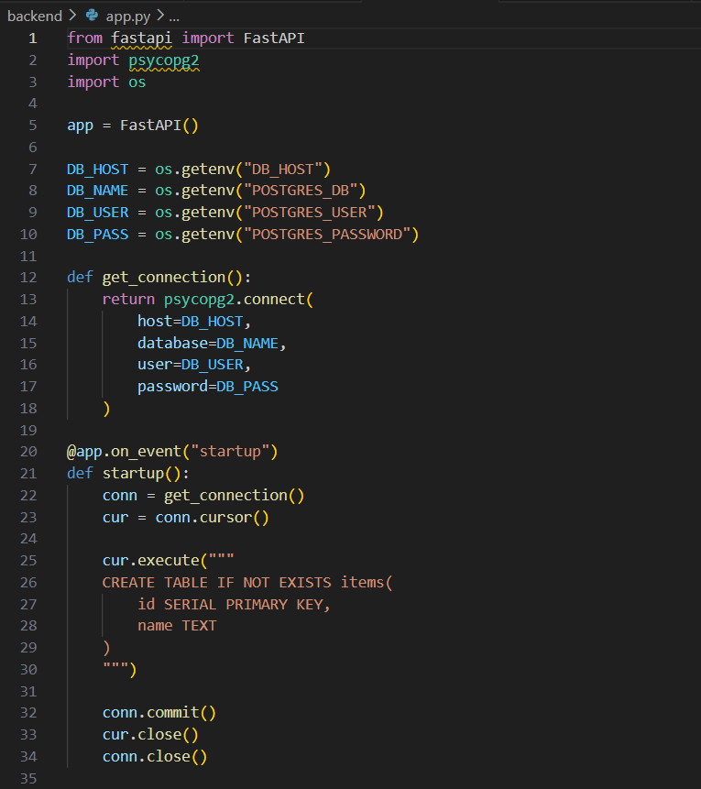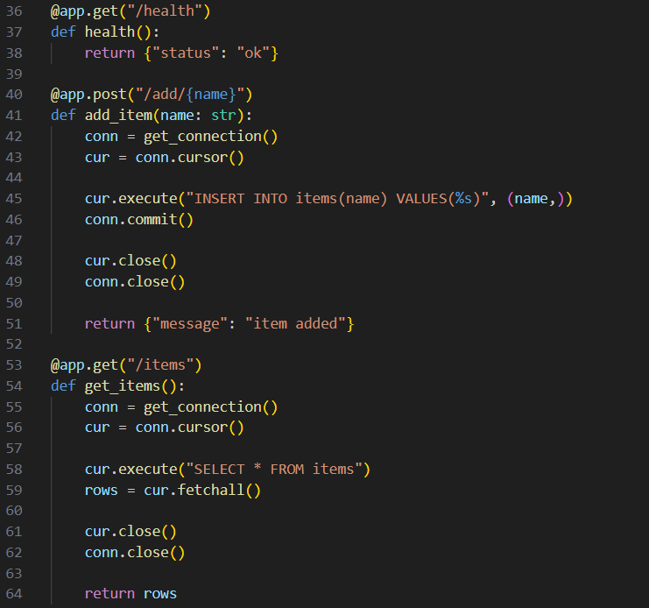

5.Dockerfile for Backend (Multi-Stage Build)
A multi-stage build was used to reduce the final image size.
Advantages of multi-stage builds:
- Reduces final image size
- Removes build dependencies
- Improves container security

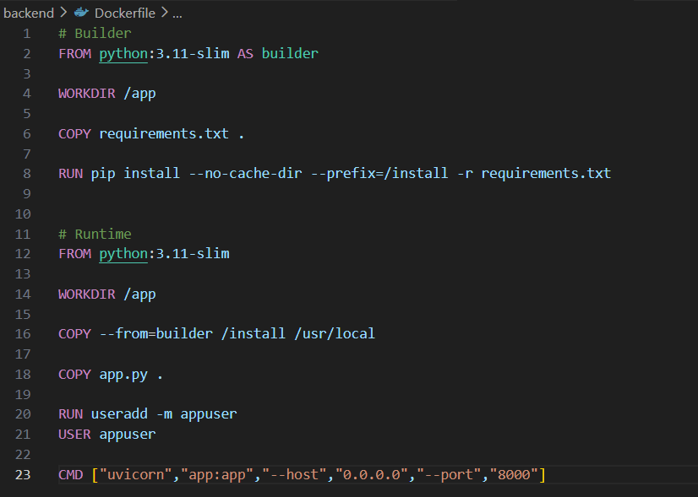

6.Database Initialization
The PostgreSQL container automatically initializes a database using an SQL script.

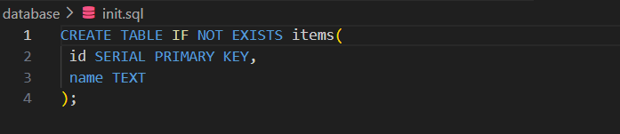

7.Dockerfile for Database
This Dockerfile extends the official PostgreSQL image and automatically runs the initialization script during container startup.

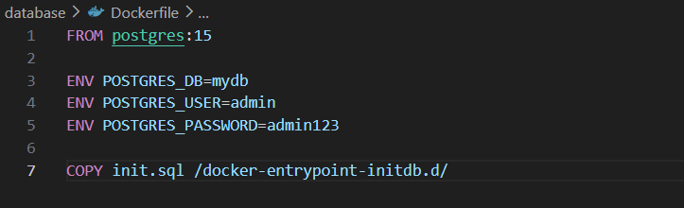

8. image build :
Docker images for both the backend and database services were built using the Docker Compose build command.

The --no-cache option ensures that Docker rebuilds every layer from scratch instead of using cached layers. This guarantees that the latest application code and dependencies are included in the image.
During the build process:
- The backend image was built using a multi-stage Dockerfile.
- Python dependencies were installed.
- The final optimized image was created.
- The database image was built from the official PostgreSQL base image.
- The initialization SQL script was copied into the container.

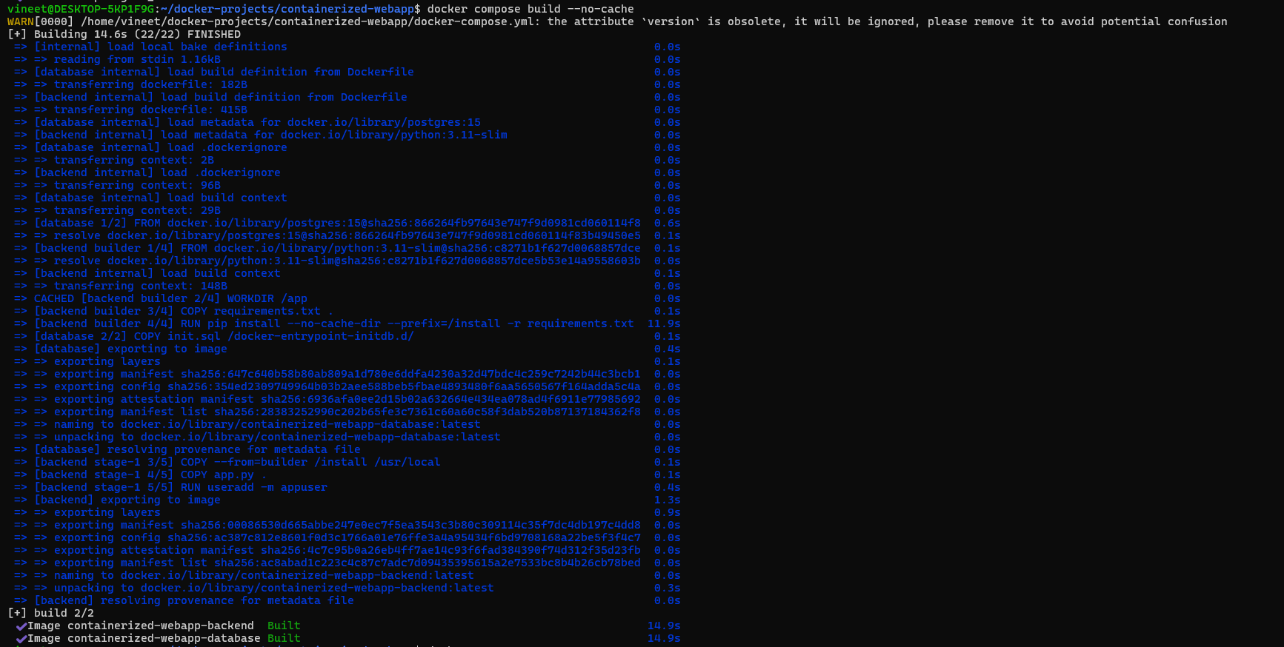

The output confirms that both Docker images were successfully built:
- containerized-webapp-backend
- containerized-webapp-database
Each layer of the Dockerfile was executed sequentially, and the final images were exported to the local Docker image repository.
9.Docker Compose Configuration
Docker Compose was used to manage and orchestrate the multi-container application. The docker-compose.yml file defines the services, networking, and storage configuration required to run the application.
The configuration file specifies:
- Backend service – builds the FastAPI application from the backend directory and assigns it a static IP address 192.168.50.10.
- Database service – builds the PostgreSQL container from the database directory and assigns it the static IP address 192.168.50.20.
- Environment variables used for PostgreSQL database authentication and configuration.
- Docker volume (pgdata) which ensures database data persists even if the container is restarted.
- Macvlan network (mymacvlan) that allows containers to communicate using real IP addresses within the network.

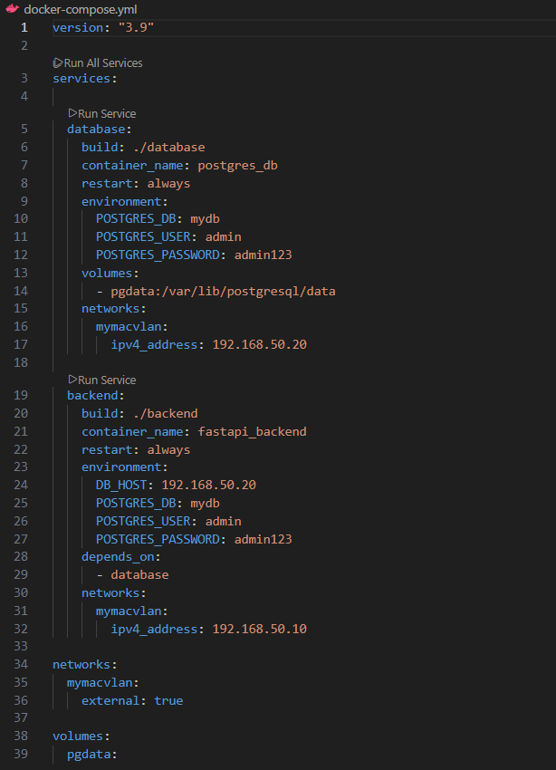

10.Docker Compose Configuration Validation
This command displays the fully resolved Docker Compose configuration after processing the docker-compose.yml file.
It helps to:
- Validate the syntax of the Compose file.
- Show the complete configuration used to start containers.
- Confirm service definitions, networks, volumes, and environment variables.
- Detect configuration errors before running the containers.
This step ensures that the Docker Compose configuration is correct before deployment.

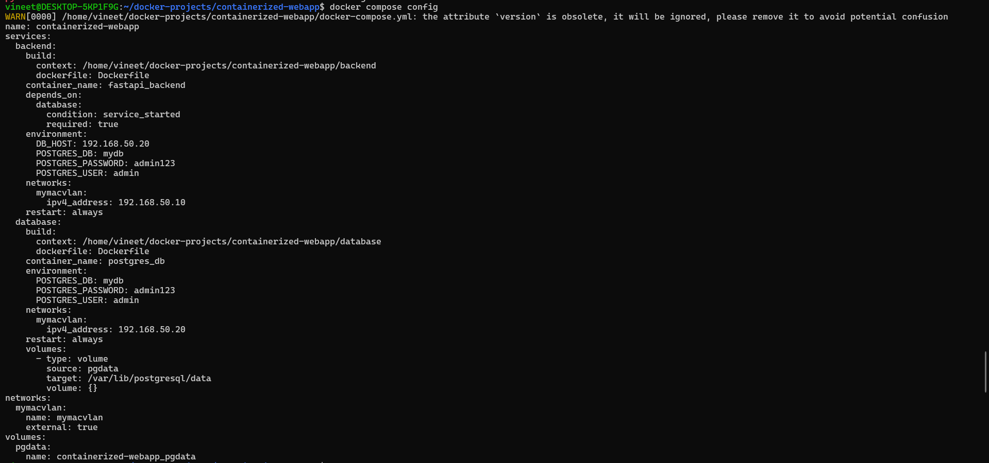

11.Docker Network Configuration
A macvlan network was created to assign static IP addresses to containers.
Command used :
docker network create -d macvlan \
--subnet=192.168.50.0/24 \
--gateway=192.168.50.1 \
-o parent=eth0 \
mymacvlan
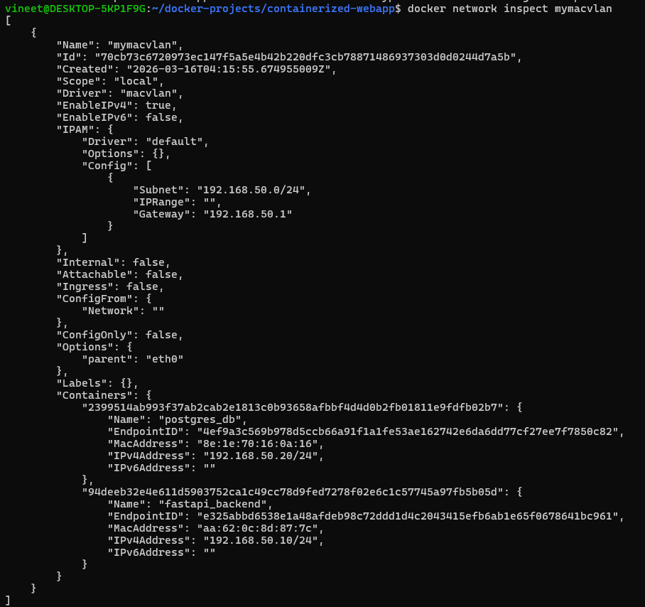
Key details:
Property | Value
Network Driver | Macvlan
Subnet | 192.168.50.0/24
Gateway | 192.168.50.1

12.Running Containers
Containers were launched using: docker compose up
This command performs the following tasks:
- Builds the required Docker images if they are not already available.
- Creates and starts the backend and database containers.
- Connects both containers to the macvlan network.
- Attaches the persistent volume for the PostgreSQL database.
Once executed, Docker Compose launches both services and the FastAPI backend becomes available on port 8000.

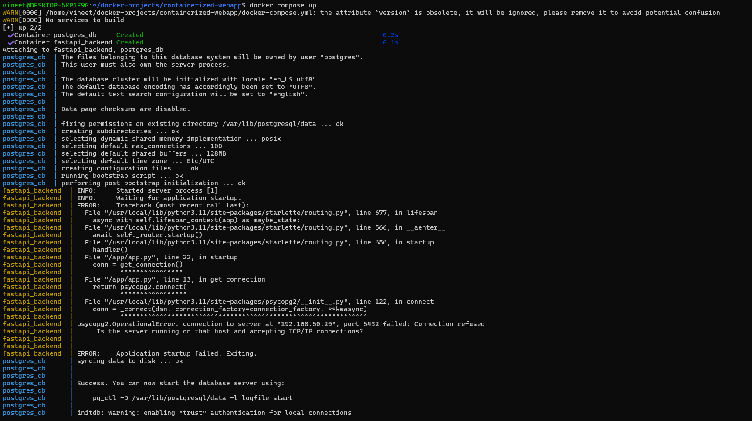

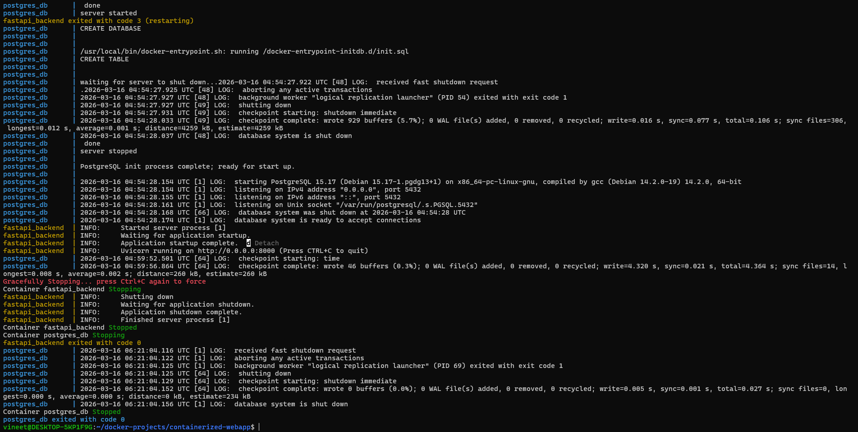
13.Running Containers Verification
Output confirmed both containers running:
Containers | Status
Fastapi_backend | Up
Postgres_db | Up

14.Static IP Address Verification
The static IP addresses assigned through the macvlan network were verified using Docker inspect commands.
- The backend container was assigned the IP address 192.168.50.10.
- The database container was assigned the IP address 192.168.50.20.
- These IP addresses were defined in the docker-compose.yml file.
- Static IP addressing ensures reliable communication between containers.

15. Persistent Storage Using Docker Volumes
Docker volumes were used to ensure that database data remains available even if the container stops or restarts.
- A Docker volume named containerized-webapp_pgdata was created.
- This volume is mounted to the path /var/lib/postgresql/data inside the PostgreSQL container.
- It stores database files outside the container filesystem.
- This ensures data persistence and reliability.
- The volume configuration is defined inside the docker-compose.yml file.
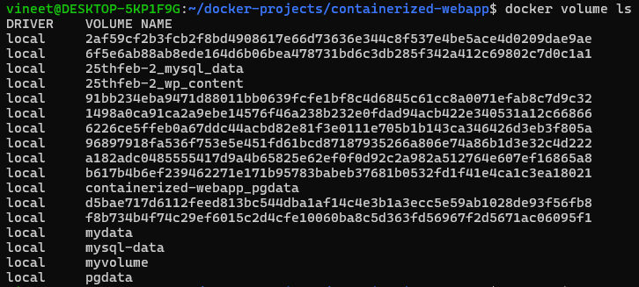
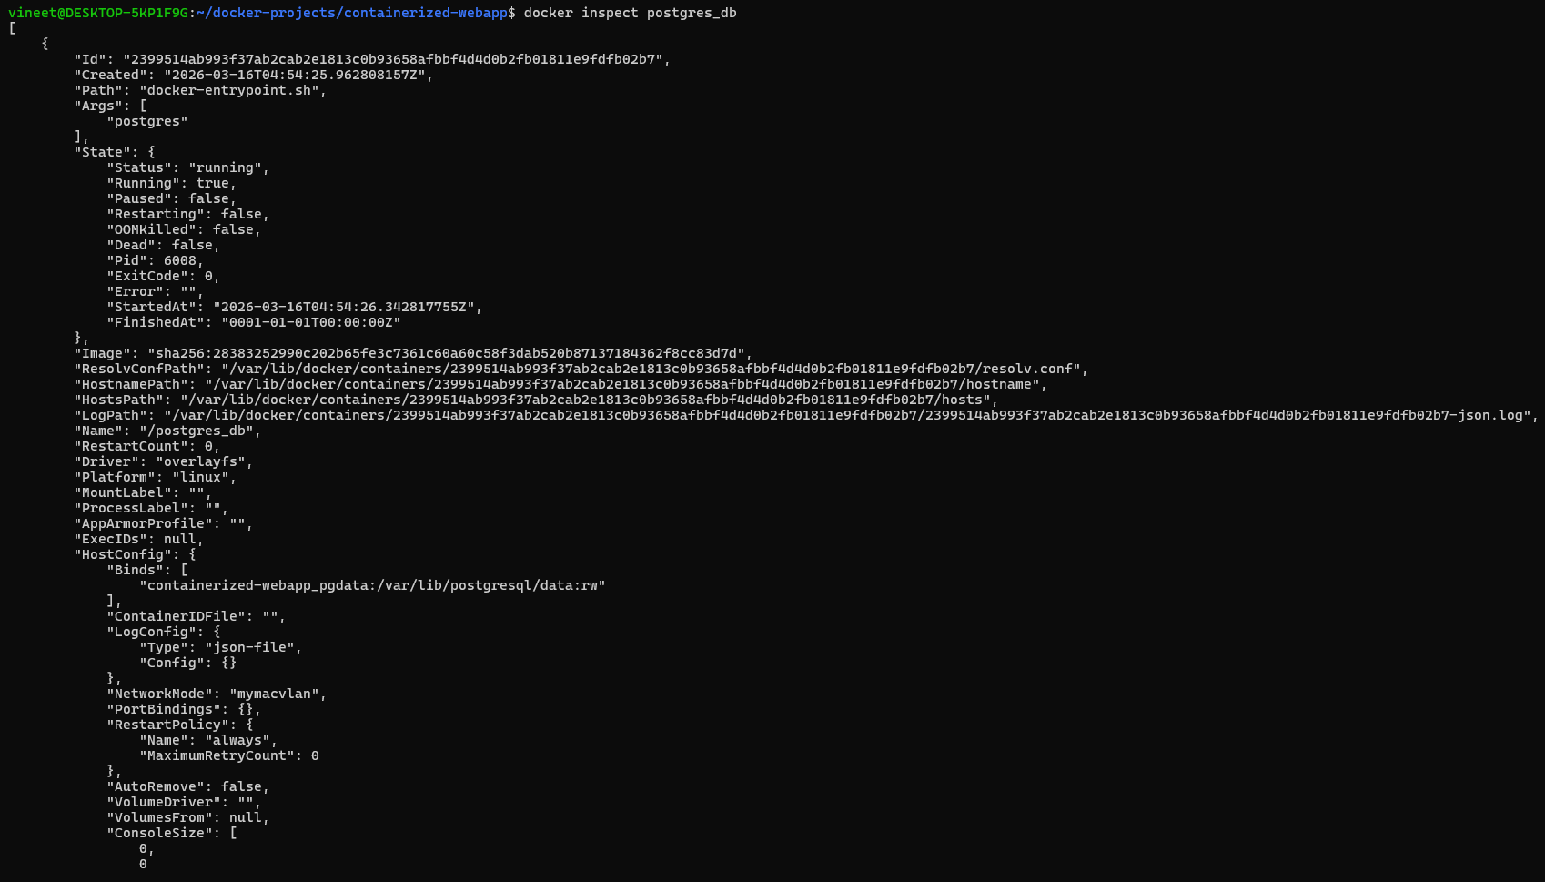
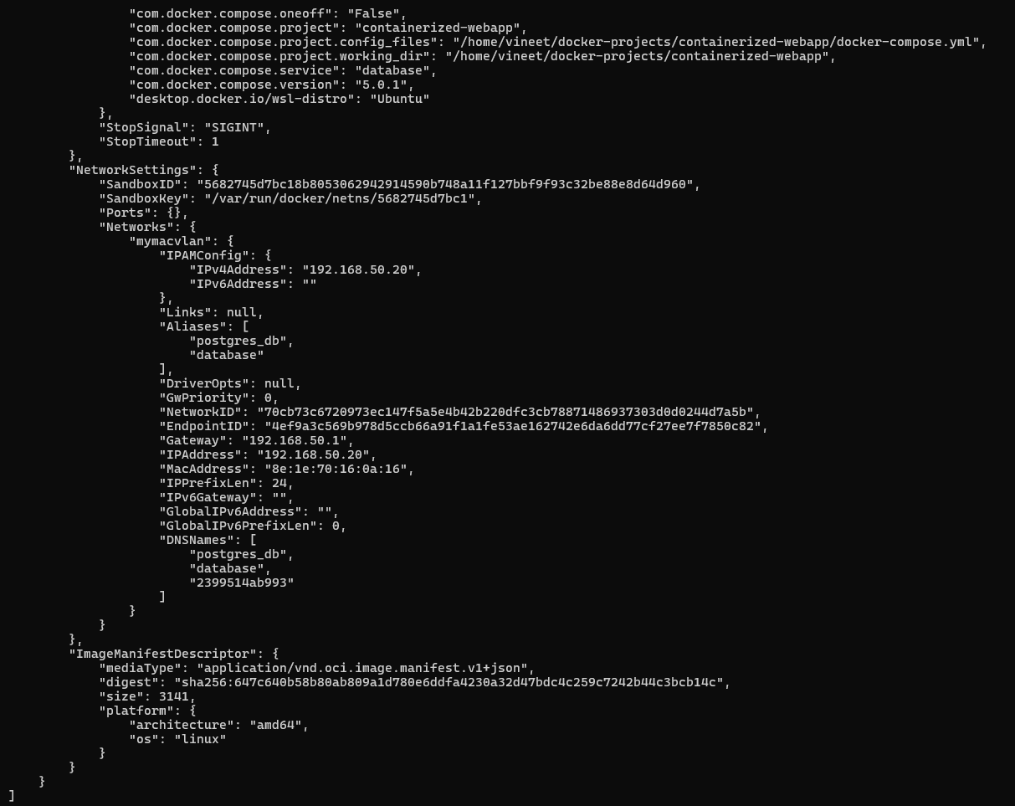
16.Docker Image Size Comparison
Docker images were analyzed to understand the size of the built application images.
- The backend image size is 218 MB.
- The database image size is 627 MB.
- The backend image is smaller because it uses a lightweight Python base image (python:3.11-slim).
- The PostgreSQL image is larger because it includes the full database engine and configuration tools.
- Multi-stage builds help reduce unnecessary files in the final image.

17. Macvlan vs Ipvlan Networking
Docker provides different network drivers for container communication. Two commonly used drivers are Macvlan and Ipvlan.
Macvlan network assigns containers real IP addresses on the local network.

Feature | Macvlan | Ipvlan
IP assignment | Each container gets its own MAC address | Containers share host MAC address
Network visibility | Containers appears as separate devices | Containers share host identity
Performance | High | High
Use case | Direct network access | Large scale container deployements

In this project, Macvlan networking was used to assign containers real IP addresses on the local network.

18. Macvlan Host Isolation Behavior
During testing, the backend container was accessed using its assigned static IP address: http://192.168.50.10:8000
However, when accessed from the host machine, the browser displayed the following error:
ERR_CONNECTION_TIMED_OUT

This behavior occurs because the containers are connected using macvlan networking.
Important characteristics of macvlan networking include:
- Containers receive real IP addresses on the local network.
- Containers can communicate with each other normally.
- Other devices on the network can access the containers.
- However, the host machine cannot directly communicate with macvlan containers due to network isolation.
Therefore, the timeout error observed in the browser is expected behavior and does not indicate a problem with the application.
This confirms that the macvlan network was configured correctly.

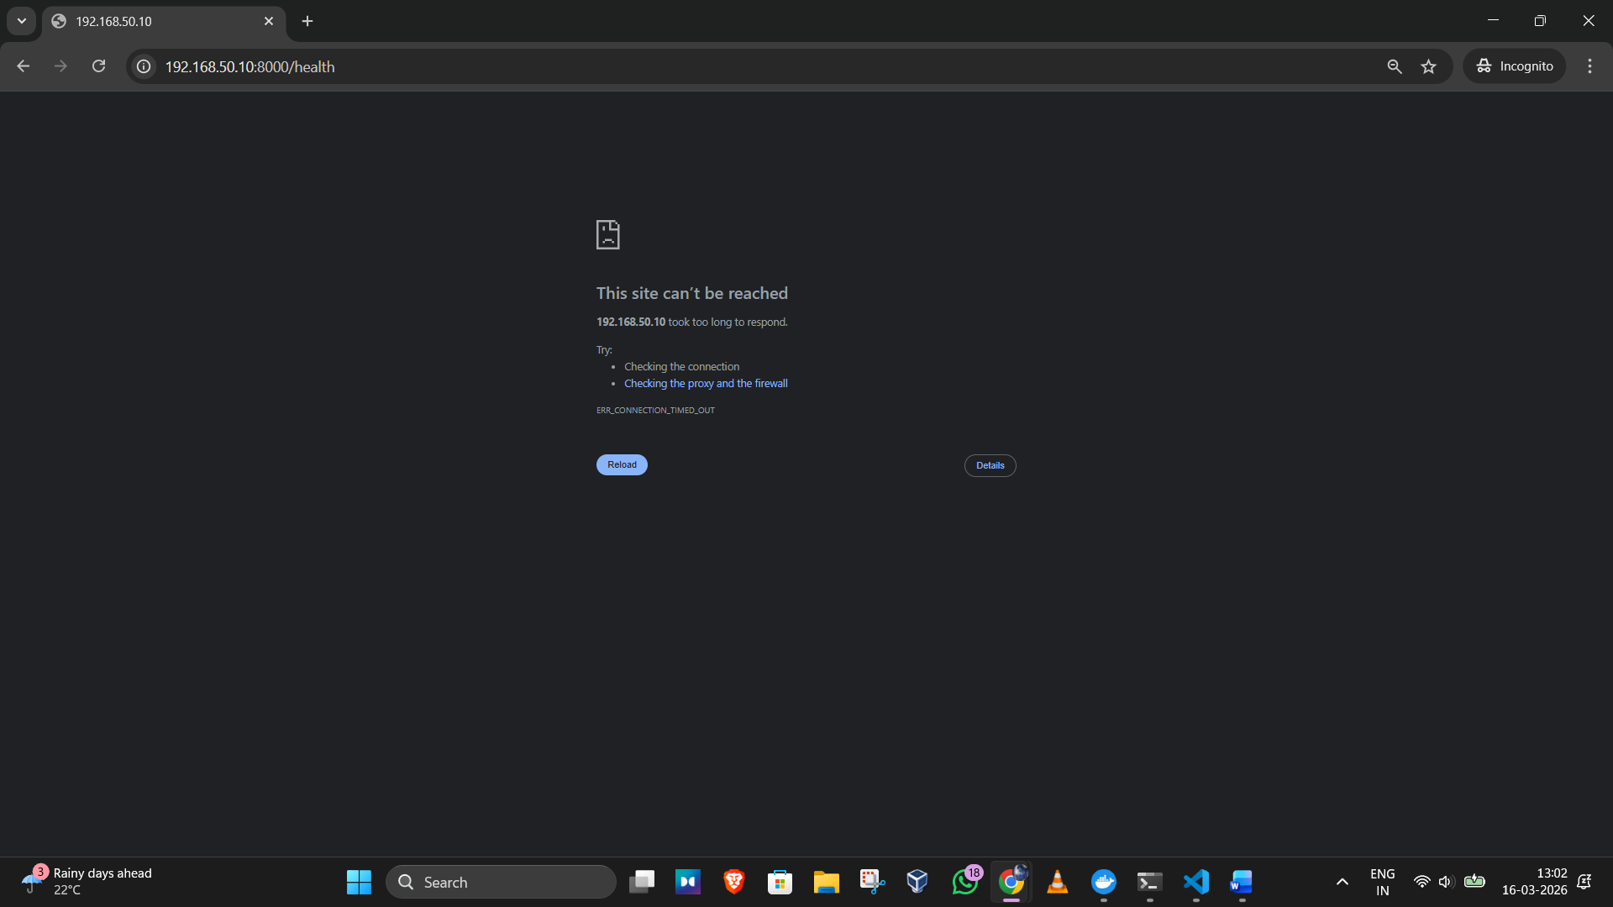

19. FastAPI API Verification
The FastAPI backend service was verified by accessing the API documentation endpoint inside the container network.
The FastAPI framework automatically provides an interactive API documentation interface using Swagger UI, which is available at the /docs endpoint.
The following command was used to test the API endpoint from within the running container:
docker exec -it fastapi_backend python -c "import urllib.request; print(urllib.request.urlopen('http://192.168.50.10:8000/docs').read()[:200])"

The output returned HTML content of the Swagger UI page, confirming that the FastAPI server was running successfully and serving API documentation.

20. Conclusion
This project demonstrated the deployment of a containerized web application using Docker.
Key outcomes of the project include:
- Successful deployment of a FastAPI backend and PostgreSQL database using Docker containers.
- Implementation of Docker Compose for multi-container orchestration.
- Use of macvlan networking to assign static IP addresses to containers.
- Implementation of Docker volumes for persistent database storage.
- Optimization of images using multi-stage Docker builds.
This approach improves application portability, scalability, and ease of deployment, making it suitable for modern cloud-native environments.

