**Zebra Medical Vision Teaching Plan**

Spring 2025

Vineet Kumar, Yale School of Management

kumar.vineet@gmail.com

I use this case in my class on “AI Strategy and Marketing” at Yale to illustrate the following ideas:

1) how value is created by AI/ML in a complex, high-stakes medical setting for stakeholders in the ecosystem

2) what ML problems we should be solving – supervised, unsupervised and reinforcement learning

3) how the technology interfaces with human decision making

4) the impact of “accuracy” and “errors” on how we should think about decision making using the *confusion matrix* as a tool

Introduction:

Zebra has a technology that can potentially detect and classify cancer based on imaging input (which typically includes X-ray, CT, MRI etc.). We are going to do a deep dive to understand what the technology is trying to do, how it creates value and for whom, how Zebra should and would interface with humans especially for decision making, and in the process understand the risks with AI. Finally, we will take a look at where is future of the technology is heading.

Q1. [12 minutes]

What value does (Z)ebra create for each of the participants in the healthcare (HC) ecosystem?

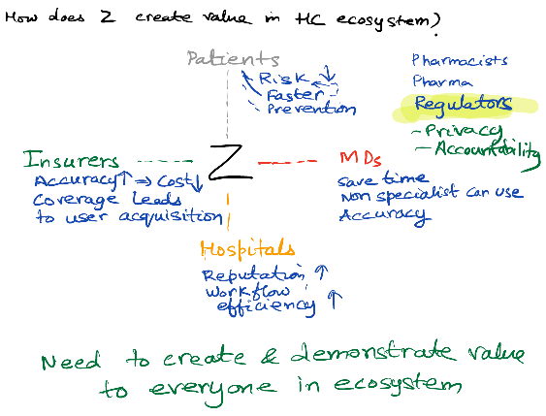

First step is to identify the relevant participants in the healthcare ecosystem who could be impacted. Second, we need to determine whether and how value creation happens for that participant. Third, much more difficult, is how to demonstrate the value to each participant. Can also explore how decision making happens, including the decision making process / decision making unit.

Q2. [15-18 minutes]

What is the value of (Z)ebra to a (R)adiologist, who is responsible for interpreting imaging scans?

How does it vary with accuracy?

This question is important because, over time, as the system accumulates more data, we expect the machine learning algorithm to become more accurate.

Typically, I just write down the curves they suggest. Some students say value to (R) is monotonically increasing with accuracy, some suggest it plateaus after some accuracy level, and some say value can even decrease at very high levels of accuracy.

If no one suggests value can decrease with accuracy, it might be useful to collectively think through whether that might happen and why.

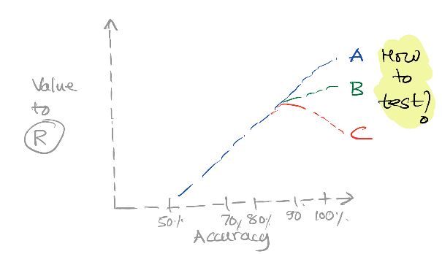Students who see trajectory **A** as the most likely have the view that AI is there to help the (R)adiologist. In contrast, students who take the view that trajectory **C** is most likely take the view that AI is a substitute for human expertise. This is not just in radiology, but across many areas of intellectual labor, including copyediting, software development etc.

We do not need to resolve this debate here, the next area of discussion will better inform us about this issue.

(How to test?) I then ask whether and how they might be able to test which trajectory might be more applicable to their potential users / customers. This is a pretty challenging task, but you can reach out to a panel of radiologists (how to find them?), and then see response to different levels of claims. Of course, radiologists might be rightfully skeptical of such claims of 100% accuracy.

The point is that there is much uncertainty in how increases in accuracy will impact how the technology is received, and how much resistance there will be. So, it is not going to be easy to develop a clear marketing strategy for the product, but even more important to be more thoughtful in doing so.

Q3. [12 minutes]

So what does a (R)adiologist do?

1. Interpret Imaging – get obvious point out of the way, then ask what else?

2. Provide diagnostic reports to other medical professionals

3. Coordinate and discuss care with healthcare team – primary doctor, oncologist, other specialists, nurses etc.

4. Communicate with family of patient

5. Determine how the disease prognosis looks based on experience

Note that there are also interventional radiologists in addition to diagnostic radiologists.

I ask: Which of these tasks are more or less likely to be taken over by AI? Can lay them out on a spectrum or in categories from least likely to most likely.

Q4. [15 minutes]

Let’s look at *supervised learning* to start. How would you specify the ML or prediction problem?

All prediction problems are of the form:

Y = f (X)

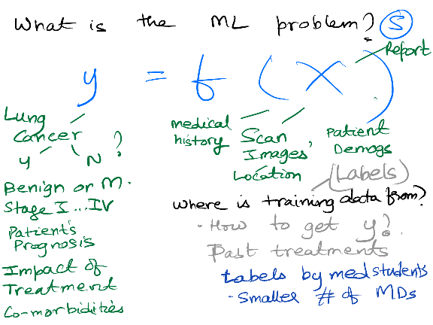

1. What are possible Ys you might want to predict?
2. What X variables do you think would be useful?
3. Where do you get the training data?
4. Where you get ground truth labels? Getting high quality ground truth labels (true Y variables) can be a huge problem.

WSJ: Want to Know Your Future Breast-Cancer Risk? Just Ask AI

## Health-tech companies are designing models that identify patients at risk of developing cancer, and who might need more screening or preventive care

https://www.wsj.com/health/ai-breast-cancer-screening-tool-8d3ac976

Q5. [12-15 minutes] This is a life and death situation. Suppose you have an accuracy of 99.x%, is that good enough to deploy? Let’s try to understand the impact of getting things wrong using the confusion matrix.

Introduce the confusion matrix.

*Oracle AI & Data Science Blog: A simple guide to building a confusion matrix*

https://blogs.oracle.com/ai-and-datascience/post/a-simple-guide-to-building-a-confusion-matrix

Want students to understand and appreciate the following:

1. Cost and impact of False Negative (FN) is very different from False Positive (FP)
2. Accuracy of 99.x% does not distinguish between the two false outcomes, even though it is critically important.
3. Confusion matrix maps out the distinctions fully, so we can evaluate the impact
4. Below a certain accuracy, this technology can actually make the (R)adiologist’s job harder.
5. There are multiple stakeholders (Patient, MD, Hospital, Insurer), each is going to be differentially impacted by this confusion matrix.

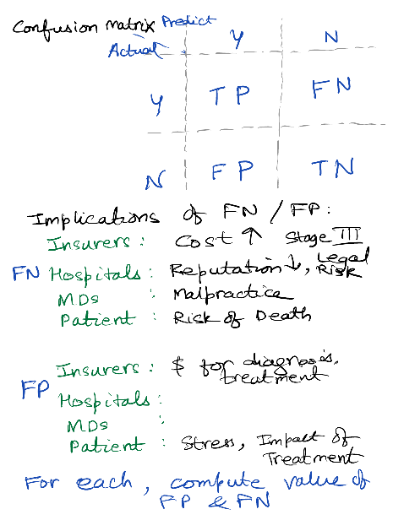

Q6. Let’s take a look at where this technology is going in the future.

[**Deep Dive into AI in Cancer detection**](https://www.dropbox.com/scl/fi/2z4b7cub5ojbtydt6d7y0/AICancer.mp4?rlkey=kcjii9lq5d8bfom8riv6izelp&e=1&dl=0)

<https://www.dropbox.com/scl/fi/2z4b7cub5ojbtydt6d7y0/AICancer.mp4?rlkey=kcjii9lq5d8bfom8riv6izelp&e=1&dl=0>

What do we learn from this? What do you think the implications are for the different participants / stakeholders that we looked at earlier? Who should be concerned by this development and why?

_____________________________________________________________________

**Takeaways:**

1. AI / ML can create a lot of value but it is important to understand for whom it creates value and how much
2. Don’t confuse good prediction with value creation. What might matter is the differential improvement in especially challenging cases
   * 80% accuracy in condition A can be more useful than 100% for condition B
3. Creating value for the Radiologist does not imply that you will be able to sell easily
4. Value creation also requires assigning value to elements of confusion matrix for each condition.
5. Positioning as a substitute (disruptor) versus complement is a hard managerial choice with long-term implications
   * Much easier doing this as a complementor to (R)

_____________________________________________________________________