**VISVESVARAYA TECHNOLOGICAL UNIVERSITY BELAGAVI-590018**



**A PROJECT REPORT**

**ON**

**INVENTORY MANAGEMENT OF MUSIC SCHOOL**

**BY**

Vineet Nayak S

4SF18CS180

Sushma

4SF18CS162

In the partial fulfillment of the requirement for V Sem. B. E. (CSE)

**DBMS LABORATORY WITH MINI PROJECT**

Under the guidance of

**Mrs. Babitha**

Assistant Professor, Dept. of CSE





**Department of Computer Science & Engineering**

**SAHYADRI**

**COLLEGE OF ENGINEERING & MANAGEMENT**

**Adyar, Mangaluru-575007**

**2020-2021**

**SAHYADRI**

**COLLEGE OF ENGINEERING & MANAGEMENT**

**(Affiliated to Visvesvaraya Technological University, BELAGAVI)**

**Adyar, Mangaluru – 07**

**DEPARTMENT OF COMPUTER SCIENCE & ENGINEERING**

*CERTIFICATE*



This is to certify that the project entitled **“INVENTORY MANAGEMENT SYSTEM OF MUSIC SCHOOL”** is submitted in partial fulfillment for therequirement of V Sem. B.E. (Computer Science & Engineering), “DBMS LABORATORY WITH MINI PROJECT” during the year 2020 – 21 is a result of bonafide work carried out by

**VINEET NAYAK S**

**4SF18CS180**

**SUSHMA**

**4SF18CS162**

|  |  |
| --- | --- |
| **……………………………..** | **…………………………** |
| Mrs. Babitha | Dr. Pushpalatha K |
| Asst. Prof, Dept. of CS&E | HOD, Dept. of CS&E |
| SCEM, Mangaluru | SCEM, Mangaluru |

**Signature of the Examiners**

1. **…………………………..**
2. **………………………….**

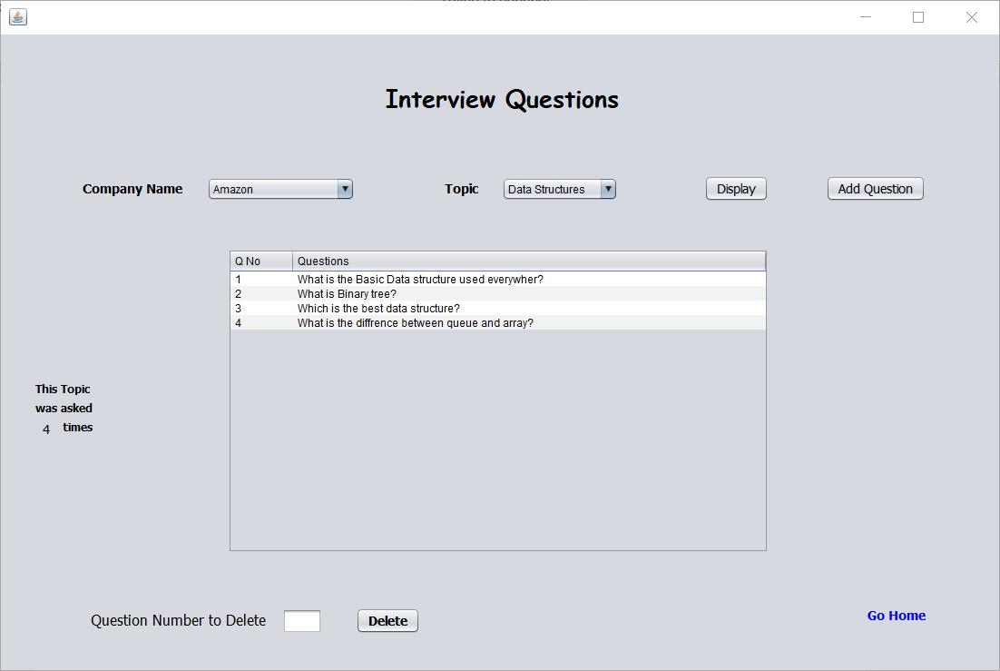

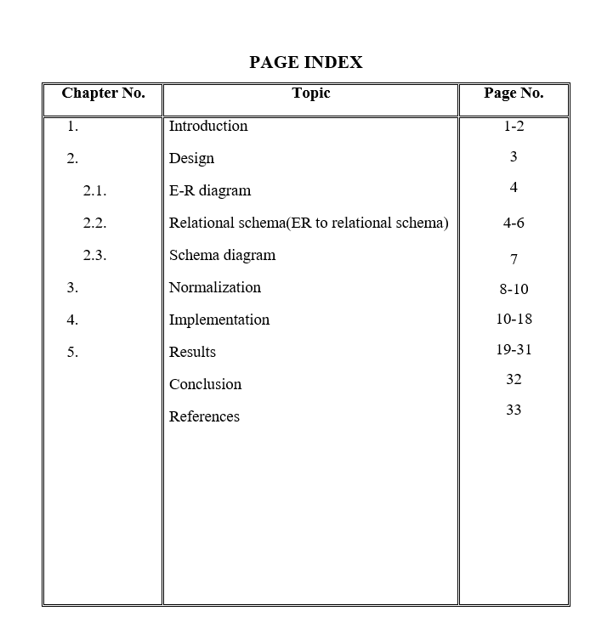

**ABSTRACT**

A Database Management System (DBMS) is a software used to store and manipulate data in a database. DBMS Software provides an interface between the end-user and the database by simultaneously managing the data, the database schema, and the database engine which in turn facilitates data organization and manipulation. The main aim of DBMS is to provide convenience in storing and retrieving database information efficiently. A Database Management System (DBMS) is a software used to store and manipulate data in a database. A database management system functions through the use of system commands, first receiving instructions from a database administrator in DBMS, then instructing the system accordingly, either to retrieve data, modify data, or load existing data from the system.

Inventory management system of Music School is a software application created using the framework of Python i.e., Flask. It has been developed to help the administrator of Music School to store the information of student and about their fee payment history, examination status, and progress and retrieve when necessary. Basic information is stored in database systems in cities, but the music schools present in rural areas, the student’s basic details like name, address, fees payment details etc are written and kept in books.

The main objective of Inventory management system of Music School is to store information related to Hindustani Classical Music portions, student details, fees payment details, agency details, examination details and event details of students.

**ACKNOWLEDGEMENT**

The satisfaction that accompanies the successful completion of any work would be incomplete without thinking of the people who made it perfect with their constant guidance and encouragement.

We take this opportunity to express our sincere thanks and indebtedness to our Project guide and mentor, **Mrs. Babitha, Assistant Professor, Department of CSE**, for her support and guidance. Her vision and suggestions throughout the project period has been fundamental in the completion of project.

We extend our warm gratitude to **Dr. Pushpalatha K, Head of the Department, Department of CSE**, for her constant support and advice that helped us to complete this project successfully.

We are extremely grateful to our beloved **Principal, Dr. Rajesha S,** for encouraging us to come up with new ideas and to express them in a systematic manner.

We also like to thank all Teaching &Non-teaching staff of Sahyadri College of Engineering and Management, Mangaluru for their kind co-operation during the course of my work.

Finally, we are thankful to our friends who helped us in our work and made the project a successful one.

Vineet Nayak S (4SF18CS180)

Sushma (4SF18CS162)