Software Requirements Specification

for

Safe Space: A Mental Health Wellness Chatbot

Version

Prepared by Team G-21

Syracuse University CSE687

**Table of Contents**

1 Introduction 4

1.1 Purpose 4

1.2 Scope 4

1.3 Definitions 4

1.4 References 4

1.5 Overview 5

2 Overall Description 5

2.1 Product Perspective 5

2.2 Product Functions 5

2.3 Product Behaviors 5

2.4 Product Requirements 6

**Table of Figures**

Figure 1 System Block Diagram 5

Figure 2 Use Case Diagram 5

Figure 1 Enter Available Ingredients Activity Diagram 5

**Table of Tables**

Table 1 Acronyms and Definitions 4

|  |  |  |  |
| --- | --- | --- | --- |
| **Name** | **Date** | **Reason For Changes** | **Version** |
| Team Wac | 3/26/2023 | Initial Revision | -- |
| Team Wac | 3/27/2023 | Added acronym list  Added Chatbot Feature Activity Diagram and Requirements  Update System Block Diagram | 01 |

# Introduction

## Purpose

This Software Requirements Specification (SRS) is designed to specify the software needs for the Safe Space mental health wellness chatbot project. Its purpose is to guide the development team in incorporating the necessary features and to assist the testing team in creating suitable Verification and Validation (V&V) strategies and processes. These efforts are aimed at ensuring the project meets the specified requirements and demonstrates to stakeholders that the system has been developed according to this specification.

## Scope

This document specifies the requirements for the following capabilities.

1. User Interaction and Assessment Features.
2. Healthcare Professional Locator Features.
3. Privacy and Security Features.
4. User Experience and Improvement Features.
5. Accessibility and Usability Features.

## Definitions

Table 1 Acronyms and Definitions

BDD: Block Definition Diagram.

SRS: Software Requirements Specification.

UML: Unified Modeling Language.

V&V: Verification and Validation.

## References

1. IEEE Std 830-1998 - IEEE Recommended Practice for Software Requirements Specifications - Revision of IEEE Std 830-1993

## Overview

This document follows the recommended format specified in IEEE Std 830-1998 IEEE Recommended Practice for Software Specifications. For Section 3, the specific template A.5 for organizing information by feature is followed.

# Overall Description

## Product Perspective

Safe Space is envisioned as a comprehensive support system within the digital mental health landscape, embedded within a broader ecosystem of mental health resources and services. This document outlines the capabilities designed to empower users through self-assessment and direct assistance, supporting both individuals in need and healthcare professionals by facilitating connections between them. Whether standalone or integrated within a larger health portal, Safe Space functions within a defined system architecture, conceptualized through a Unified Modeling Language (UML) Block Definition Diagram (BDD) to delineate its operational context and interactions.

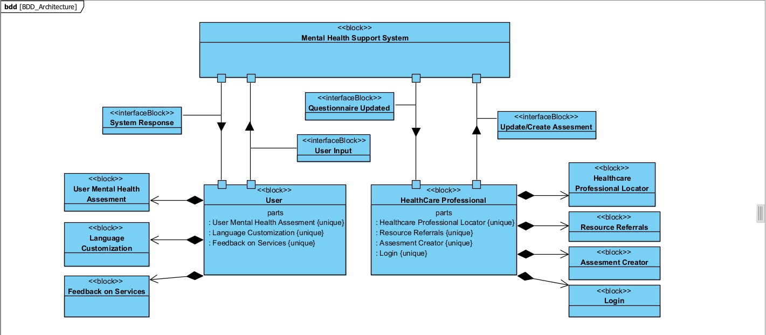

Figure 1 System Block Diagram

## Product Functions

This section details the user interactions facilitated by Safe Space, utilizing a use case diagram to map out the intended functionalities. These include conversational assessments, feedback provision, mental health resource suggestions, and professional locator services, among others.

Figure 2 Use Case Diagram

## 2.2.1 Use Case Requirements

This section will comprehensively list the specific requirements necessary for Safe Space to function effectively. It will include technical specifications, user interface design principles, privacy and security measures, and compliance with relevant healthcare regulations. The requirements are developed to ensure Safe Space meets its objectives of providing accessible, immediate, and confidential mental health support, facilitating connections with healthcare professionals, and promoting mental wellness. Use Case Requirements define the interactions between end users (actors) and the system to achieve specific goals within the scope of your mental health assessment and resource allocation system. These requirements detail the expected behavior of the system from the initiation of a use case by the user to the system’s response and the end of the interaction. Each use case encapsulates a sequence of actions performed by the system in response to user inputs or in pursuit of a user-oriented goal.

| **Use Case ID** | **Requirement ID** | **Description** | **Source** | **Risk** | **Status** |
| --- | --- | --- | --- | --- | --- |
| UC02 | UC02.REQ001 | Develop a conversational interface that customizes the assessment based on previous answers and calculates mental health scores. | Business Process Analysis | Low | Proposed |
| UC02 | UC02.REQ003 | The system shall handle and analyze assessment data instantaneously, populating questions on the fly without significant delays. | Business Process Analysis | High | Proposed |
| UC02 | UC02.REQ002 | Ensure privacy and confidentiality for user responses, safeguarding sensitive information from unauthorized access or disclosure. | Industry Standards | Medium | Proposed |
| UC02 | UC02.REQ007 | The system interface should be intuitive, easy to navigate, and user-friendly, enhancing overall usability and user satisfaction. | Business Process Requirements | Low | Proposed |
| UC05 | UC05.REQ002 | Collect user information solely for retrieving nearby healthcare professional details based on their location, maintaining accurate and up-to-date records of professionals. | Regulatory Requirements, User Stories | Medium | Proposed |
| UC05 | UC05.REQ001 | Maintain a comprehensive database of healthcare professionals with a robust search and filtering algorithm, integrating third-party data APIs for data enrichment. | Market Research, User Stories | Medium | Proposed |
| UC09 | UC09.REQ001 | Implement a system where all psychoeducational resources undergo a rigorous approval process by healthcare professionals. | Regulatory Compliance Guidelines | Medium | Proposed |
| UC09 | UC09.REQ002 | Ensure that each resource provided is authenticated and verified by healthcare professionals to guarantee its accuracy and reliability. | Project Stakeholder Interviews, Regulatory Compliance Guidelines | Medium | Proposed |
| UC09 | UC09.REQ003 | Ensure that psychoeducational resources are accessible to users with diverse needs. | User Stories | Medium | Proposed |
| UC10 | UC10.REQ001 | The system must integrate with email services to send referrals directly to users' email addresses. | Use Case Analysis | Low | Proposed |
| UC10 | UC10.REQ002 | Obtain explicit consent from users before sending referrals to their email, ensuring compliance with privacy regulations. | User Privacy Policy Requirements | Medium | Proposed |
| UC06 | UC06.REQ001 | Offer multiple language options in the chatbot and enable dynamic language switching for users. | Stakeholder Feedback | Low | Proposed |
| UC06 | UC06.REQ002 | Provide smooth transitions between languages based on user preferences to enhance usability and satisfaction. | User Stories | Low | Proposed |
| UC07 | UC07.REQ001 | Develop an interface for collecting service feedback and implement a data storage system to store this feedback. | Market Survey | Low | Proposed |
| UC07 | UC07.REQ002 | Maintain users' anonymity when providing feedback to ensure their identity remains confidential. | Regulatory Requirements | High | Proposed |
| UC04 | UC04.REQ002 | The system shall handle data securely and create an interface that is user-friendly for non-technical professionals. | Business Process Analysis | Low | Proposed |
| UC04 | UC04.REQ001 | Develop a secure login system for professionals and an intuitive editing interface, allowing for real-time updates to the chatbot's database. | Regulatory Requirements, Market Research | Medium | Proposed |
| UC08 | UC08.REQ002 | Ensure all user credentials are stored in encrypted format with access restricted to authorized personnel, and all access must be logged. | Compliance Requirements | High | Proposed |
| UC08 | UC08.REQ001 | Offer secure authentication methods during login and signup, ensuring data encryption both in transit and at rest. | Industry Best Practices | High | Proposed |

Fig 2.2.1 Language Customization Use Case

Fig 2.2.2 User Mental health Use Case

Fig 2.2.3 Feedback on Services Use Case

Fig 2.2.4 Assessment Creator Use Case

Fig 2.2.5 Healthcare Information Service Use Case

Fig 2.2.6 Psychoeducation Use Case

Fig 2.2.7 Resource Referrals Use Case

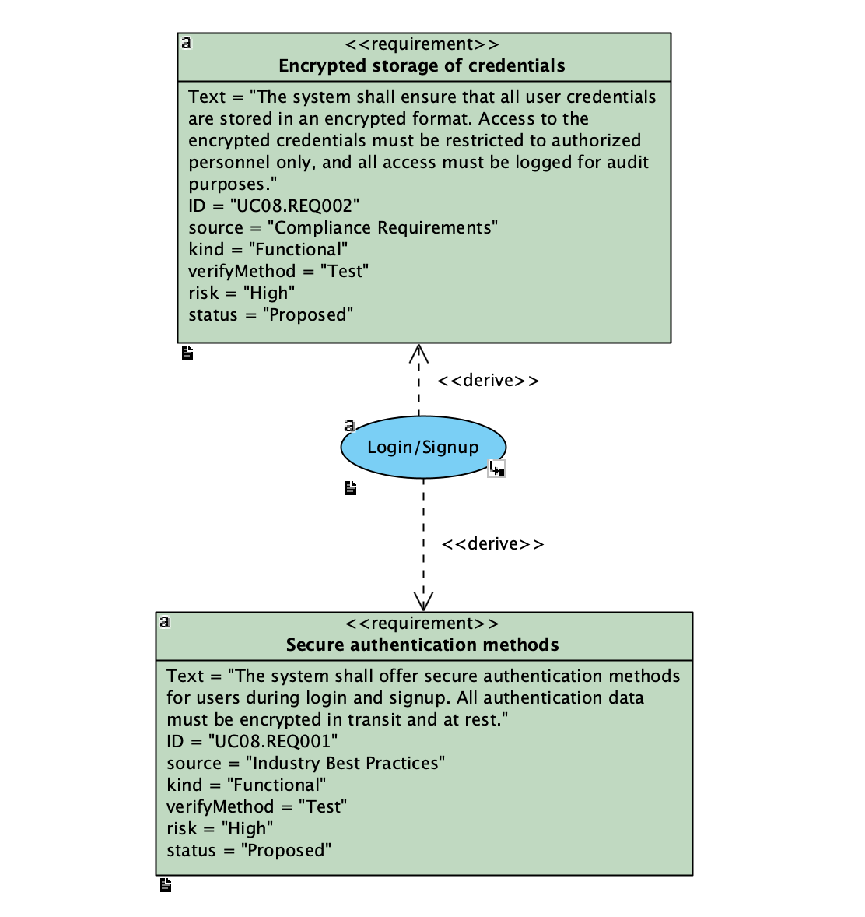

Fig 2.2.8 Login/Signup Use Case

## Product Behaviors

Safe Space's dynamic interaction process is captured through an activity diagram, showcasing the sequence of actions from initial engagement to the delivery of personalized mental health support.

Figure 3 Enter Available Ingredients Activity Diagram