INDEX
Sr no | List | Page
1 | Project Profile | 2-5
 | 1.1 Existing System | 2
 | 1.2 proposed System | 4
 | 1.3 development tools and technology | 5
2 | User Wise Role | 6-7
 | 2.1 student role | 6
 | 2.2 admin role | 7
3 | Entity relationship | 8
4 | UML Diagrams | 9-17
 | 4.1 use case diagram | 9-10
 | 4.2 activity diagram | 11-12
 | 4.3 sequence diagram | 13-16
 | 4.4 class diagram | 17
5 | Data dictionary | 18-23
 | Bibliography | 24

Knowledge sharing platform
Group Details

- Parmar Vinit
- Yadav Ketan
- Chaudhary Jayesh

- Asst.Prof. Khodidas Vaghela
- Group no: 7

1. Project Profile

1.1 . Existing System
- In most colleges, students form study groups informally using WhatsApp or other social media.

- There is no centralized platform to:
  - Join topic-based groups
  - Share study materials
  - Collaborate with peers
- Notes are shared in unorganized ways (messages, random folders).

1.2. Proposed System

- A website where students can:
  - Create or join study groups
  - Chat or collaborate
  - Upload and download study materials (notes, PDFs)
  - Access premium features
- Admins can:
  - Moderate content, add premium content

1.3. Development Tools and Technology

Front-end
  - HTML
  - CSS
  - JavaScript

Back-end
  - Python
  - Django

Users Wise Role

Student
  - Log-in
  - Registration
  - Join or create study groups
  - Upload & download notes

Users Wise Role

Admin:
  - Approve user-generated content
  - Manage users
  - Manage groups
  - Mange Reports
  - Manage sharing and downloading materials

ER Diagram

An ER Diagram (Entity-Relationship Diagram) is a visual representation of the data and relationships between entities in a database. It is used in database design to show how data is structured and how different entities (such as users, products, or transactions) are related to each other.

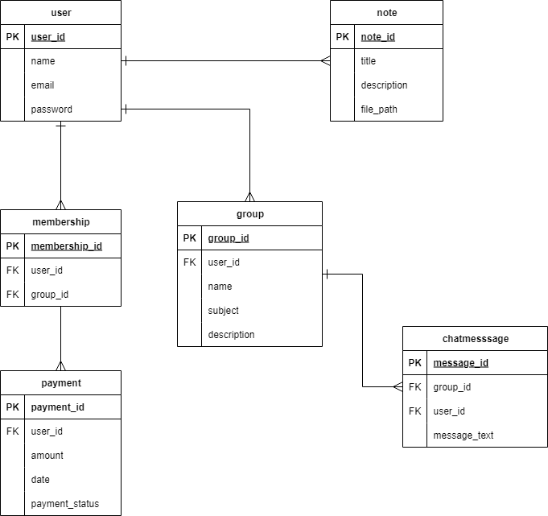

UML Diagram
A Use Case Diagram is a type of UML (Unified Modelling Language) diagram that visually represents the interaction between users (actors) and the system to achieve specific goals. It shows what the system does from the user's point of view, rather than how it is done.
user:
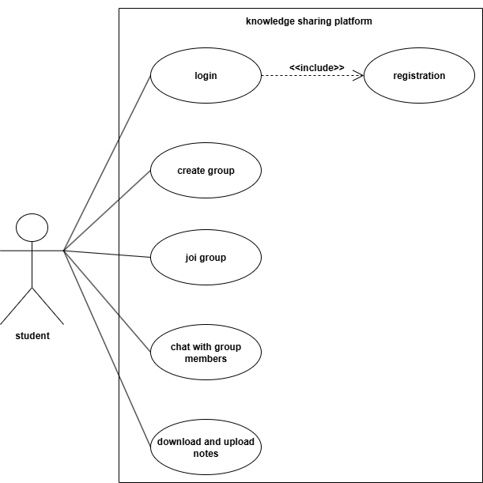

Admin:

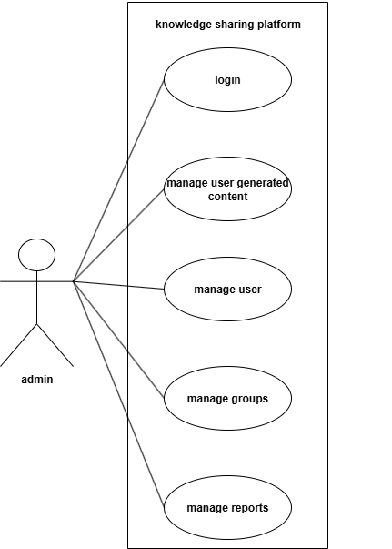

Activity diagram
An Activity Diagram is a type of UML (Unified Modelling Language) diagram that represents the flow of activities or actions in a system. It shows how a process starts, the sequence of steps involved, decisions made, and how it ends.

user: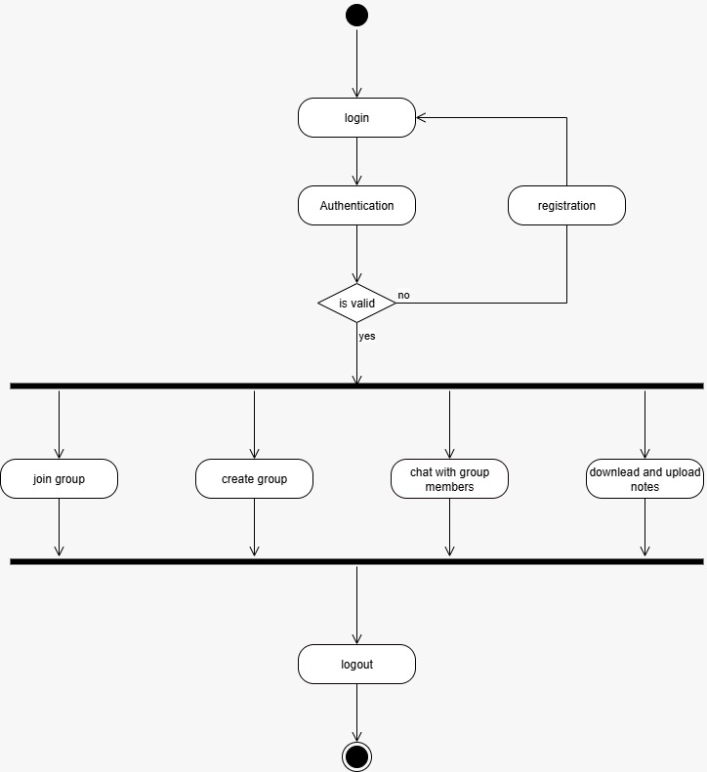

Admin:

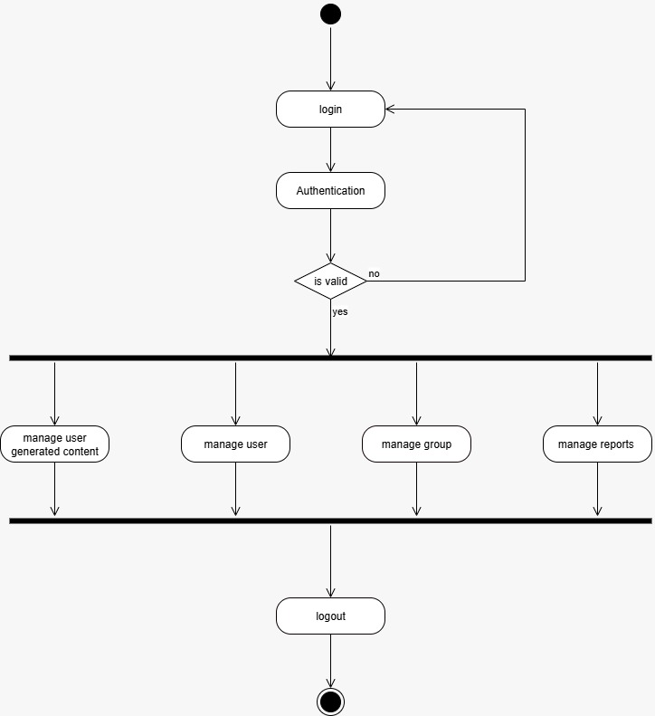

Sequence Diagram
A Sequence Diagram is a type of UML (Unified Modelling Language) diagram that shows the interaction between objects or components in a system in a time sequence. It illustrates how messages are passed between different parts of the system to complete a specific process or function.

user:
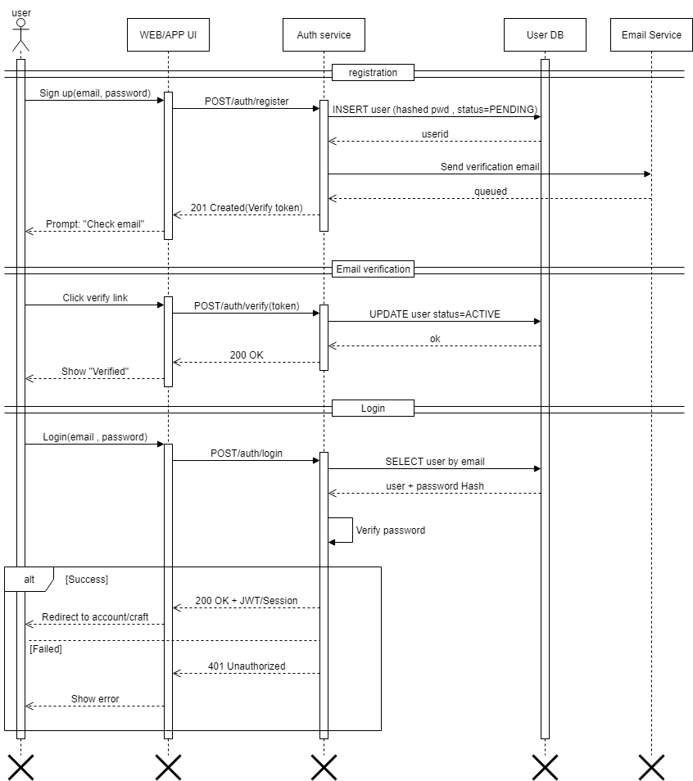

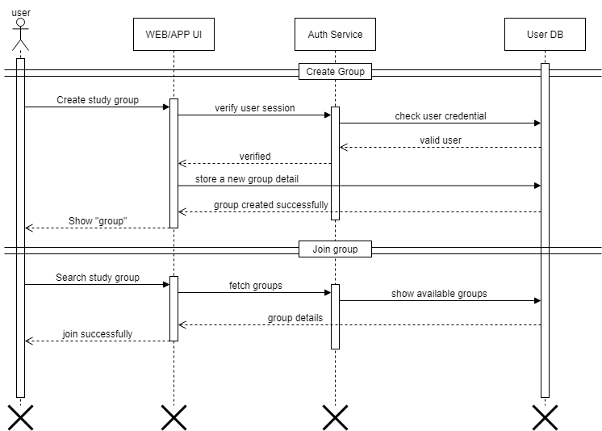

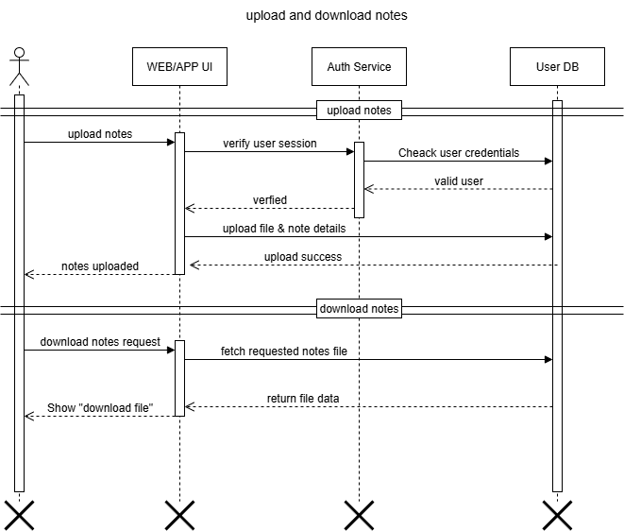
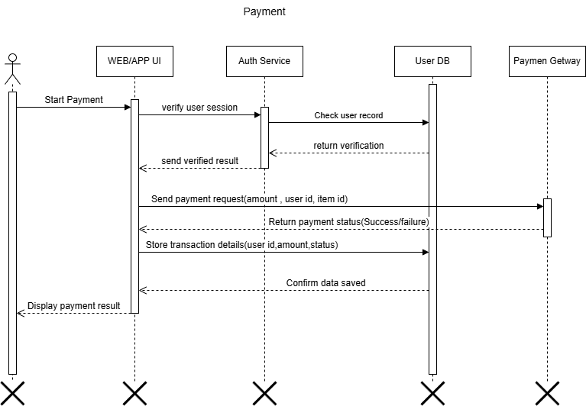

Class diagram

A Class Diagram is a type of UML (Unified Modelling Language) diagram that shows the static structure of a system by representing its classes, attributes, methods, and relationships. It is mainly used in object-oriented design to describe how different classes interact with each other.

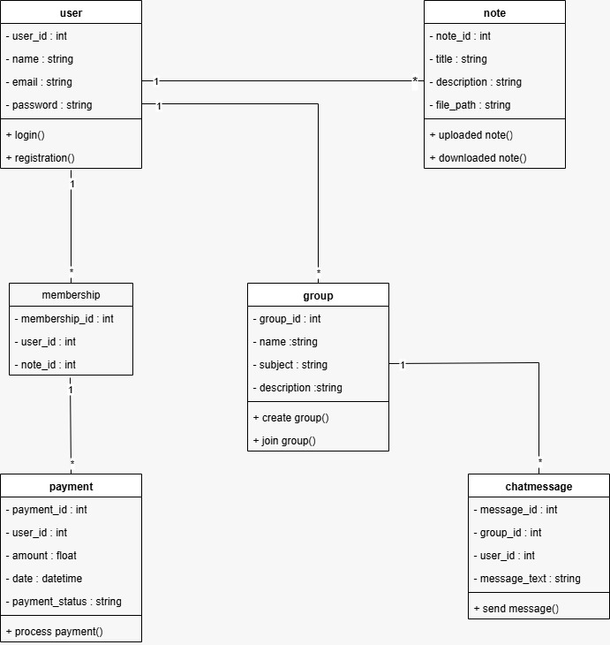

Data dictionary

A Data Dictionary is a detailed description of all the data elements used in a database or information system. It defines each data item’s name, type, size, format, and purpose, along with its relationships with other data elements.

User:

Table name | User
Primary key | User_id

Field name | Data type | size | description | constraints
User_id | INT | 11 | Unique ID for each user | Primary key, Auto Increment
name | VARCHAR | 30 | User’s full name | Not Null
Email | VARCHAR | 20 | User’s email address | Unique , Not Null
password | VARCHAR | 10 | Encrypted password | Not Null

2. Group table

Table name | Group
Primary key | Group_id
Foreign key | User_id

Field name | Data type | size | Description | Constraints
Group_id | INT | 11 | Unique ID for each group | Primary key , Auto Increment
User_id | INT | 11 | Id of user | Foreign key
name | VARCHAR | 30 | Study Group name | Not Null
subject | VARCHAR | 20 | Subject / topic for group | Not Null
description | TEXT | - | Details about the group | Nullable

3. Membership table

Table name | Membership
Membership_id | Primary key
Group_id | Foreign key
User_id | Foreign key

Field name | Data type | Size | Description | Constraint
Membership_id | INT | 11 | Unique membership ID | Primary key , Auto increment
Group_id | INT | 11 | ID of User who joined | Foreign key
User_id | INT | 11 | ID of group joined | Foreign key

4. ChatMessage table

Table name | ChatMessage
Message_id | Primary key
User_id | Foreign key
Group_id | Foreign key

Field name | Data type | Size | Description | Constraint
Message_id | INT | 11 | Unique ID for each message | Primary key , Auto increment
User_id | INT | 11 | User who sent the message | Foreign key
Group_id | INT | 11 | Group in which message sent | Foreign key
Message_text | TEXT | - | Chat message text | Not Null

5. Note Table

Table name | note
Note_id | Primary key

Field name | Data type | Size | Description | Constraints
Note_id | INT | 11 | Unique ID for each note | Primary key , Auto Increment
title | VARCHAR | 30 | Title of the note | Not Null
description | TEXT | - | Note description | Nullable
File_path | VARCHAR | 20 | File storage path | Not Null

6. Payment table

Table name | Payment
Payment_id | Primary key
User_id | Foreign key

Field name | Data type | Size | Description | Constraints
Payment_id | INT | 11 | Unique payment ID | Primary key , Auto Increment
User_id | INT | 11 | User making the payment | Foreign key
amount | DECIMAL | 10.5 | Payment amount | Not Null
date | DATETIME | - | DATE of payment | Default CURRENT_TIMESTAMP
Payment_status | VARCHAR | 50 | status | Default =“pending”

6. Bibliography :
www.google.com
www.youtube.com

