**Assignment No. 2**

**Student Name:** Sahil Kamdar **MIS:** 112003120

**Aim:** Demonstrate Git Commands and show integration of Remote git account in lab.

**Theory:**

Create a git remote repository on any of the git hosting websites, using one of the software you have written so far. Practice the git-commands and give demo for:

Reporting of bugs,

assigning issues,

fixing bugs/conflicts,

git branch,

merge,

git push & pull requests

**git config**

Syntax: git config --global user.email "your_email@example.com"

Description: This command defines author name and email for all commits

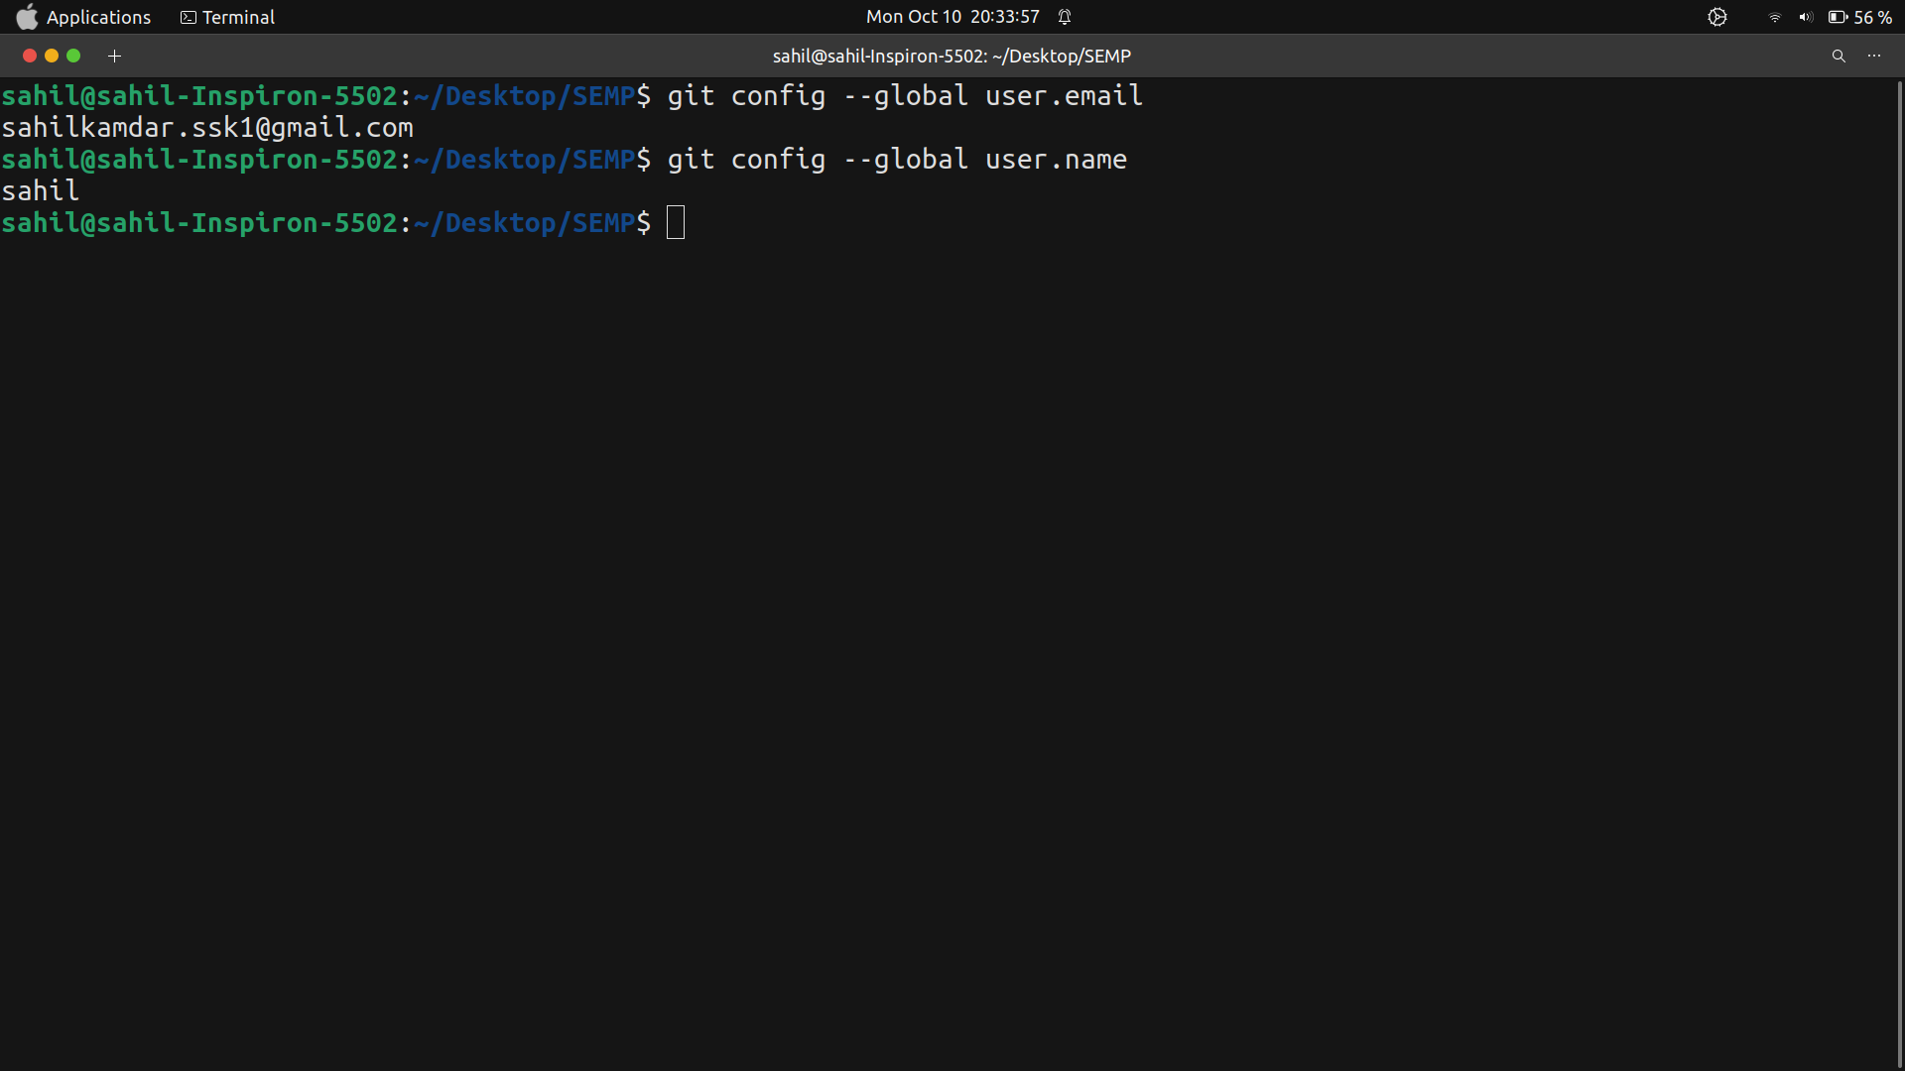

**git init**

Syntax:

Description: Initialize an existing directory as a Git repository.

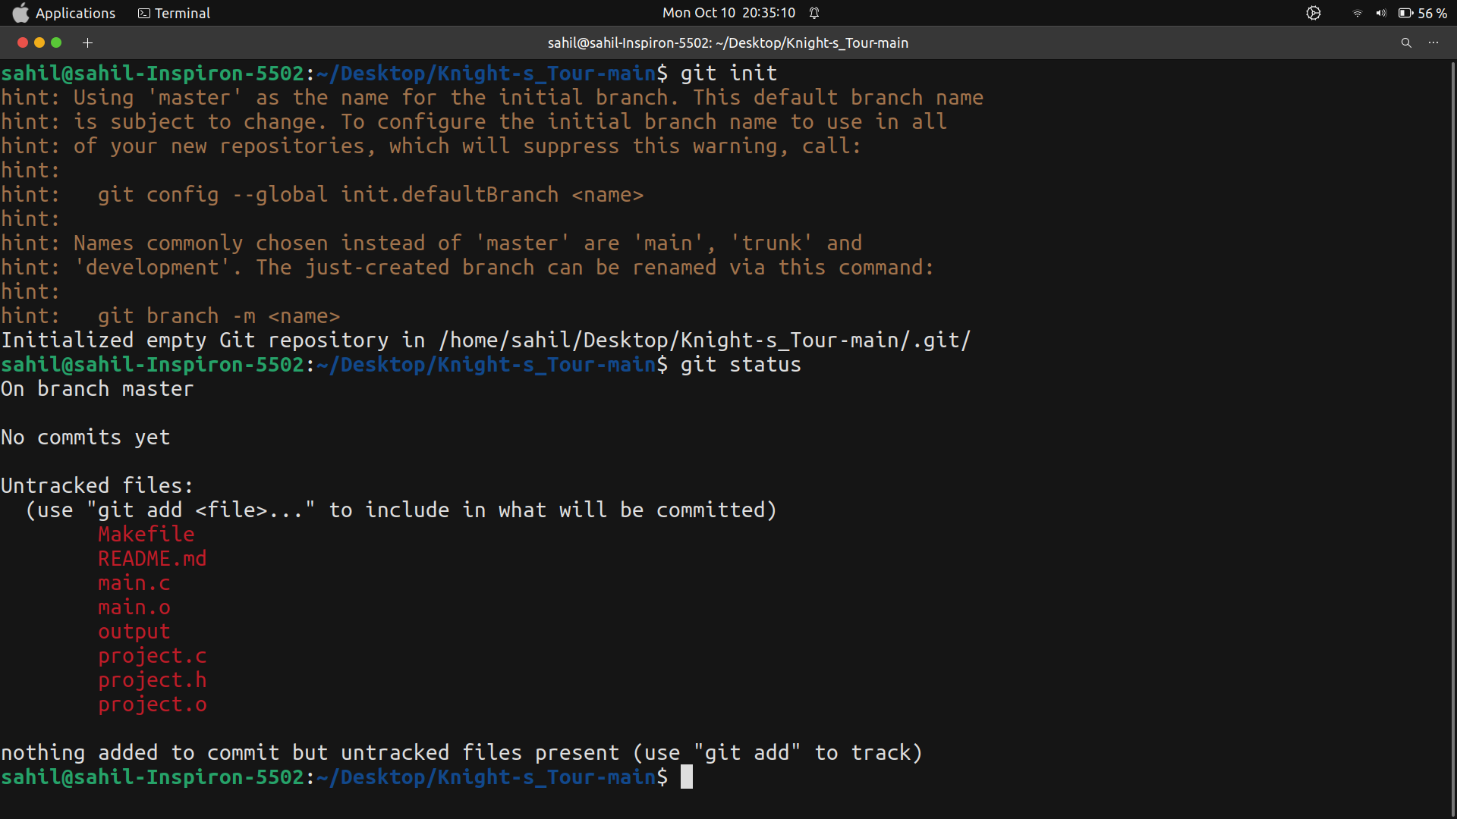

**git add:**

Syntax: git add [file]

This command stage all changes in particular file or whole 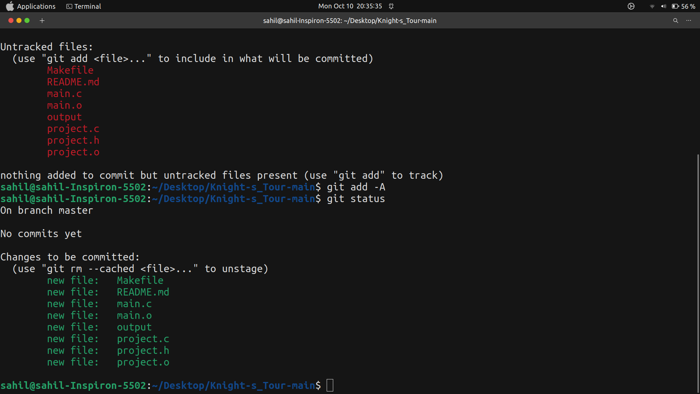directory for the next commit.

**git commit:**

Syntax: git commit -m “commit message”

This command commit the staged changes using message as commit message

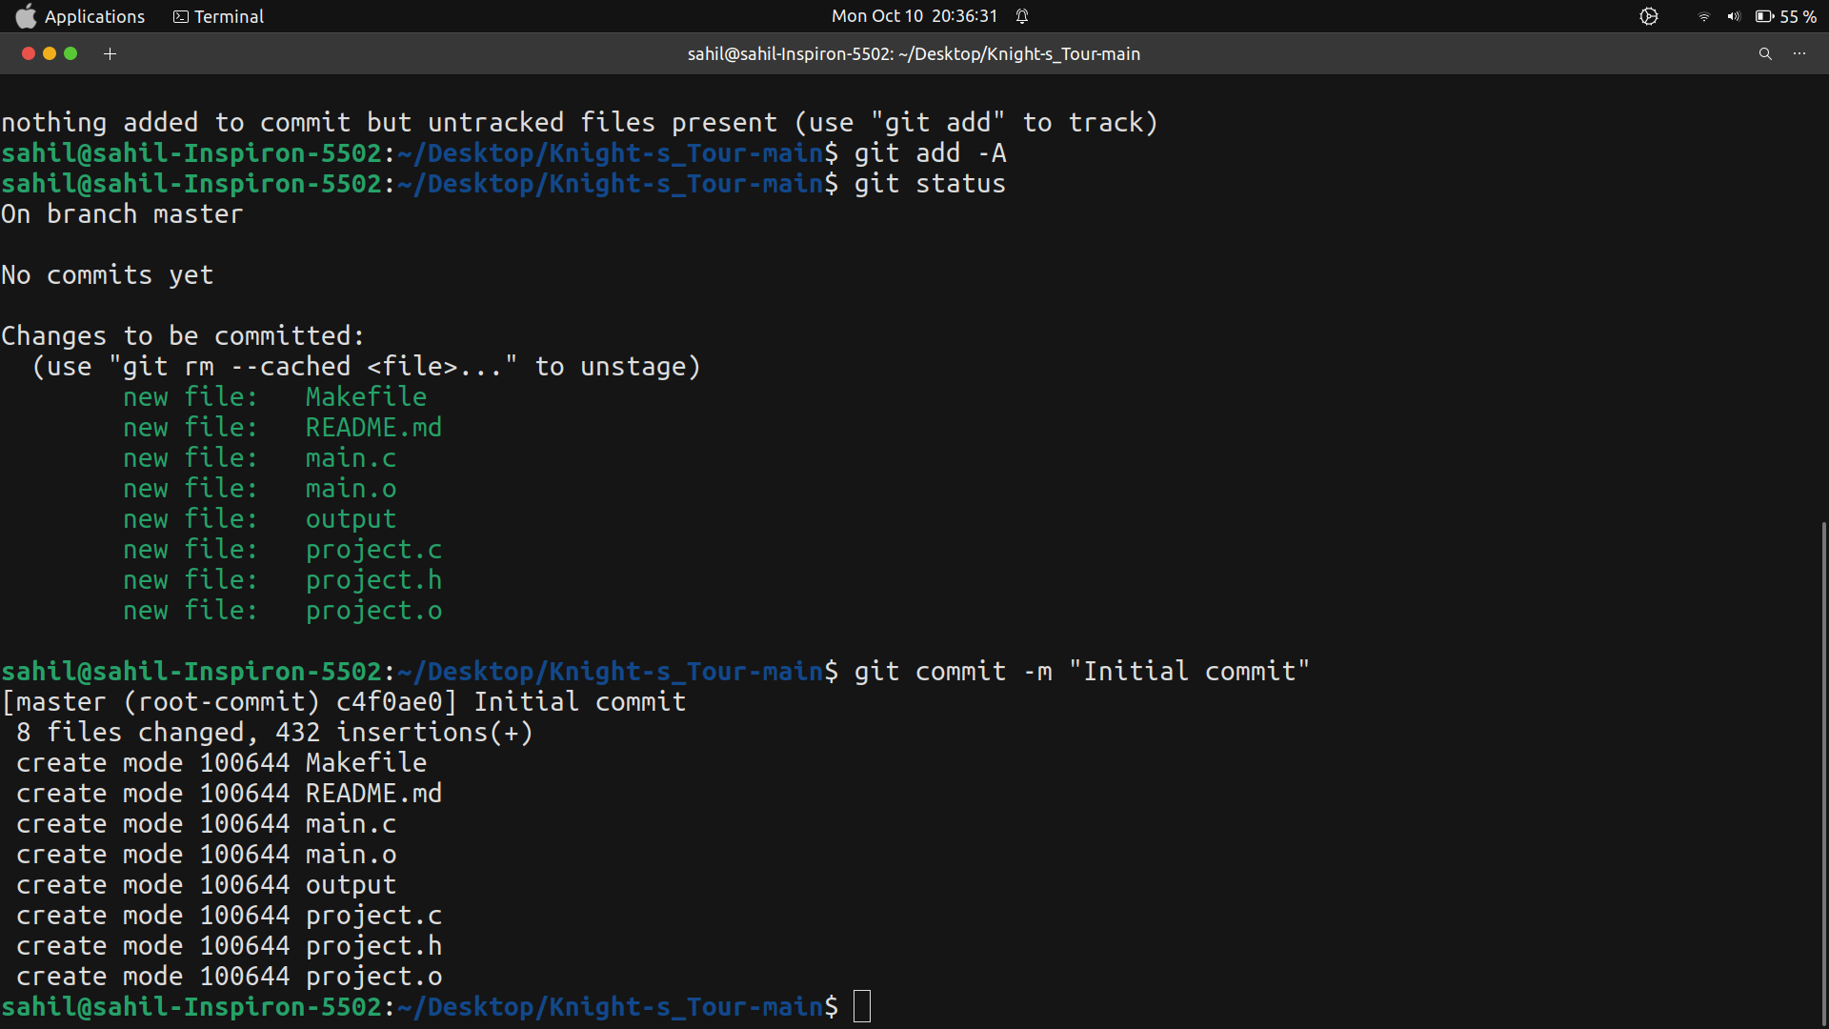

**Adding all file to git repository**

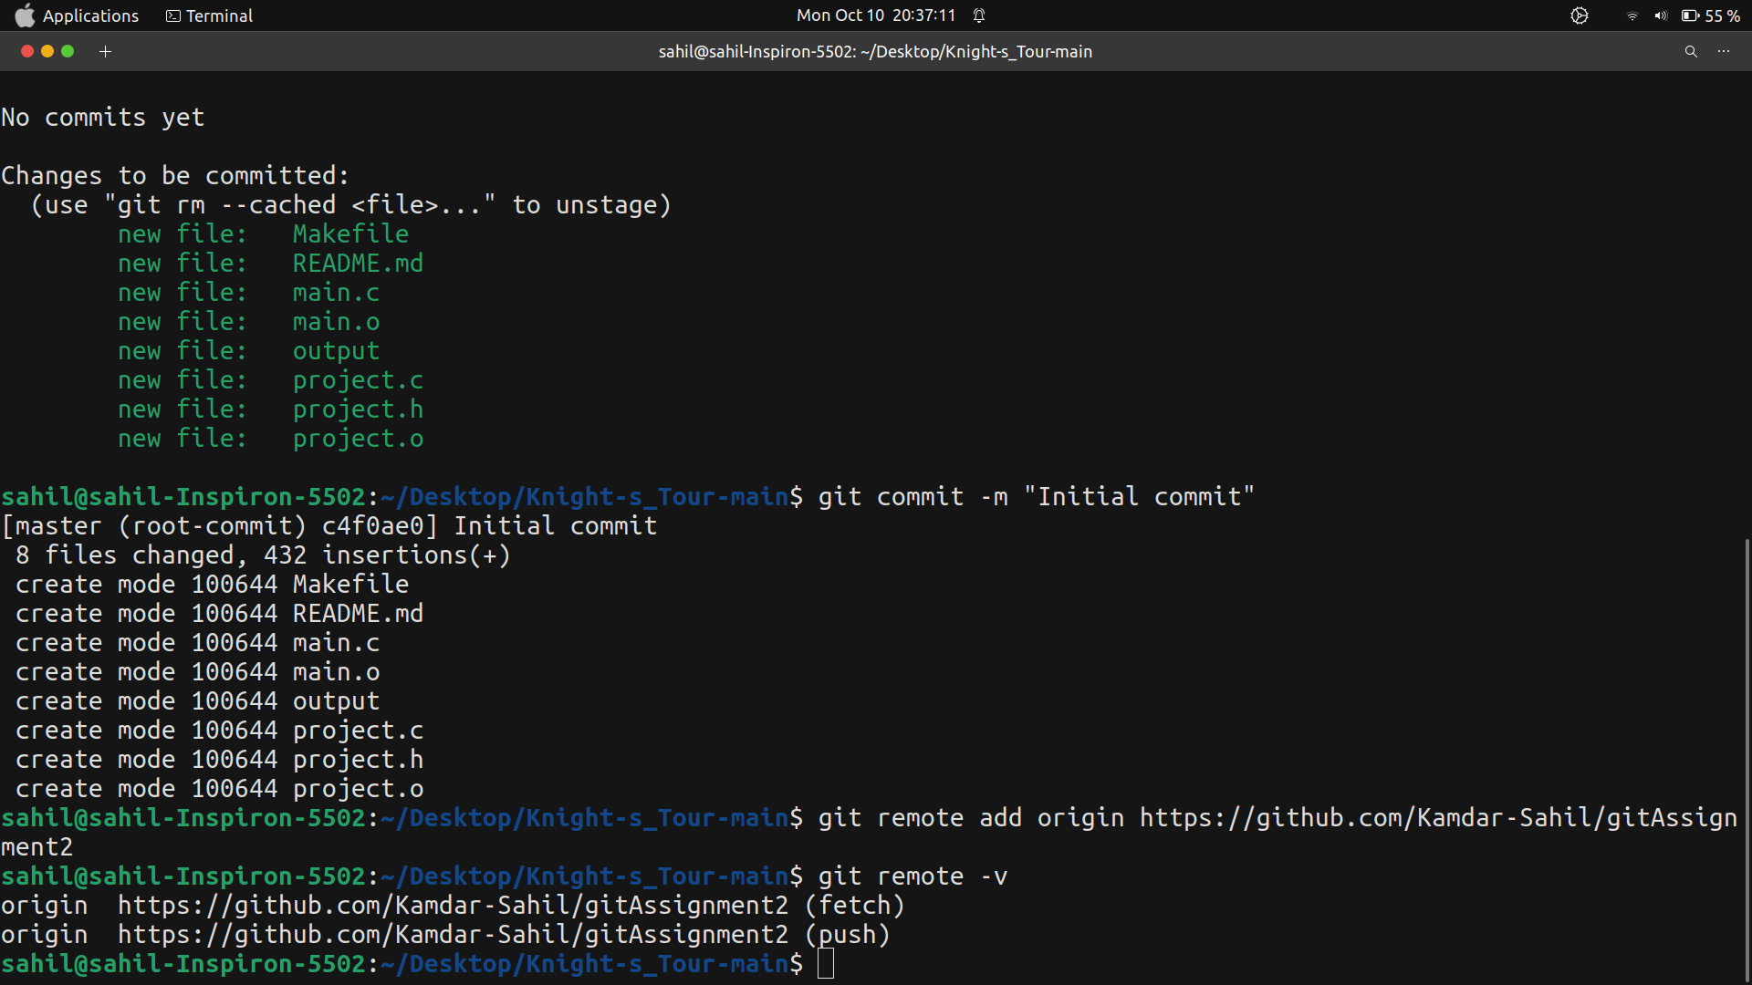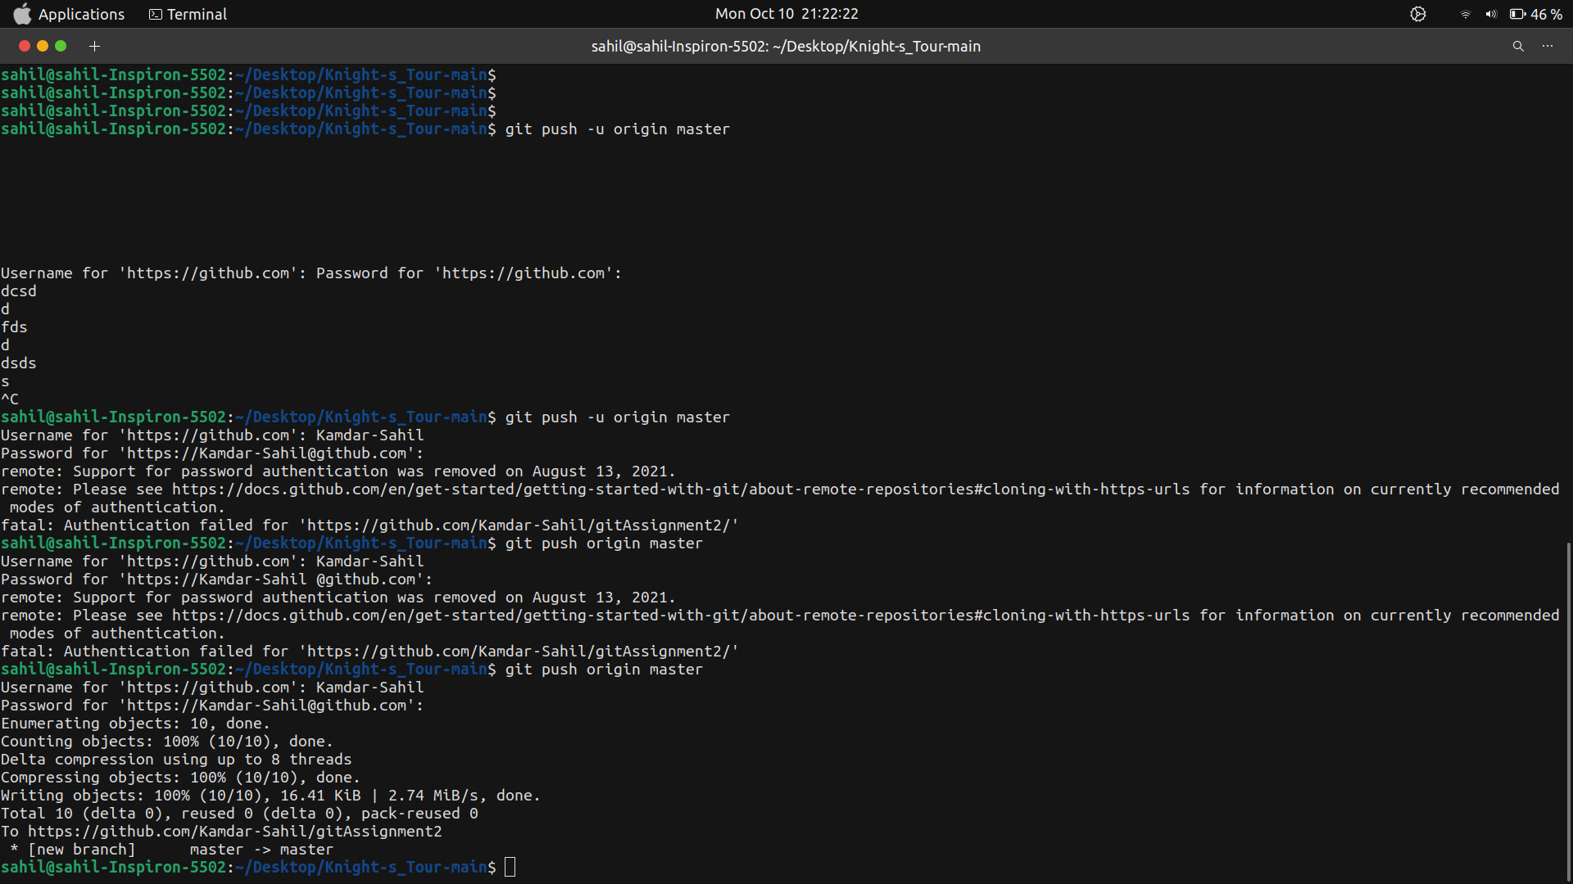

**Add changes to local file and Commit the changes made**

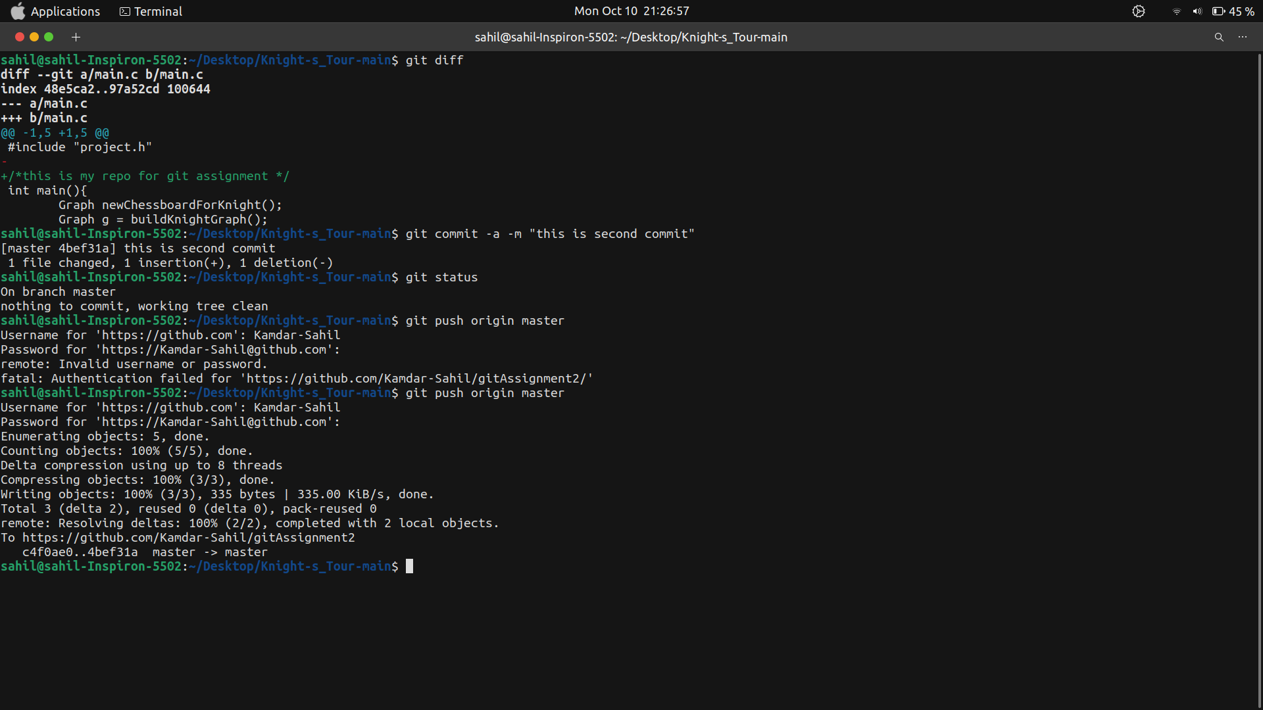

**git pull:**

Syntax: git pull

This command is used to fetch as well as merge it into the local copy of repo.

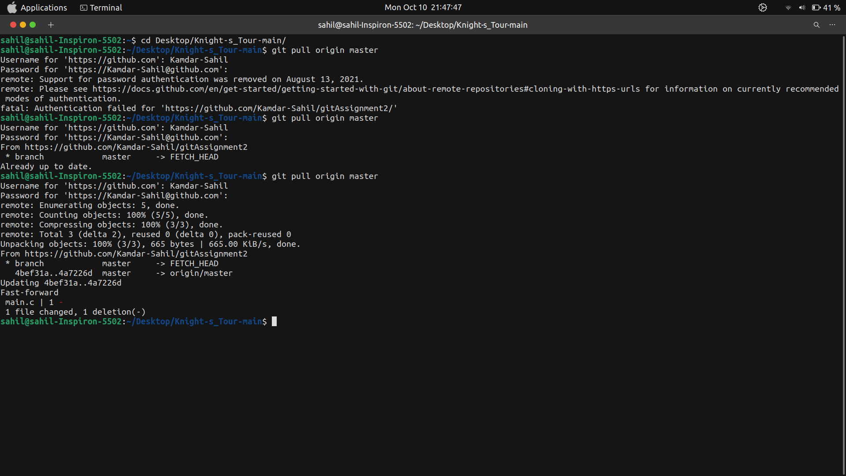

**git merge/branch/checkout:**

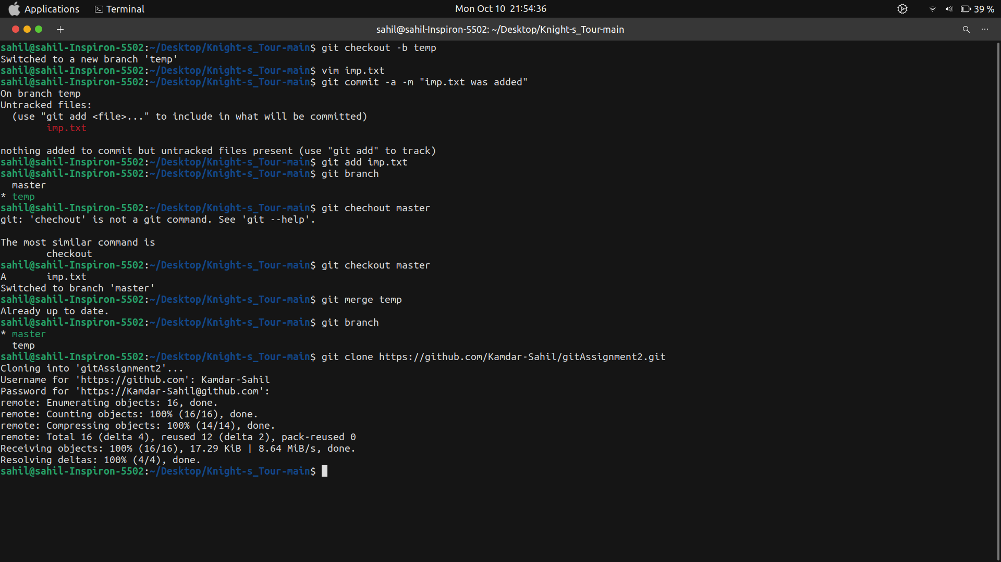

**Git clone**



**Git issues**

