PREMNATHRAIL PORTAL
Store & Inventory
User Manual for the Store Team

Version 1.0 | 2 November 2026
Written from the current portal. Where a screen is different from older guided tours, this manual follows the screen.

Contents
1. How the Store works (start here)
2. Item Master: creating and managing items
3. Store settings: types, units, categories, stores
4. Inward: receiving goods (GRN, Before PO, returns)
5. Stock views: Stock, Batches, Bins, Serial Nos., Movements
6. Outward: issues, transfers, reservations, job work
7. Stock control: adjustments, physical count, reorder, opening stock
8. How Store works with Procurement, Projects, Finance and Service
9. A storekeeper's day with the demo items
10. Messages you may see and what to do
11. Good habits and checklists
Appendix A. Things to confirm with the owner
Appendix B. Glossary
Note: This manual is for storekeepers, store managers and the people who work with them. It explains every screen in the Store module, every field on the Item Master form, and what each action does to stock. Words in bold are exact button or field names on screen.

1. How the Store works (start here)

1.1 What the Store module does
The Store module is the book of record for material. It answers four questions at any moment: what do we have, where is it, what state is it in, and why did it move.
Material comes in through a purchase (a Goods Receipt, called GRN), comes back from a job (a Material Return) or arrives before its purchase order (Before PO). It leaves through an issue, a transfer to another store, or a job-work challan. Stock is never typed in or out by hand. Every movement has its own document, and every document leaves a trace in the Movements page.
Direction | What happens | Document | Where in the portal
Coming in | Goods from a vendor against a PO | GRN (GRN-2026-0001) | Inward > GRN & Inspection
Coming in | Goods arrived but the PO is not made yet | Before PO receipt (BPO-...) | Inward > Before PO
Coming in | Unused or faulty material coming back from a job | Material Return (MR-...) | Inward > Returns
Going out | Material handed to production, project, maintenance and so on | Material Issue (MI-...) | Outward > Issues
Going out | Material sent to a vendor for processing | Job Work challan | Outward > Job Work
Moving | From one store to another | Stock Transfer (ST-...) | Outward > Transfers
Held | Earmark stock for a project | Reservation (RES-...) | Outward > Reservations
Correcting | Book stock is different from the shelf | Stock Adjustment (SA-...), Physical Count (PC-...) | Inventory > Adjustments / Physical Count

1.2 The kinds of stock
Every item in every store is split into buckets. Learn these words first. They appear on the Stock page, in Movements and in many messages.
Bucket | Meaning | Can it be issued?
Free (shown as On Hand) | Good stock that is ready to use | Yes, after taking away what is Reserved
Reserved | Part of Free stock earmarked for a project or order. It is not an extra quantity | No, only for the project it is held for
Available | Free minus Reserved. This is what you can really give out | Yes
Quality | Received, waiting for inspection | No
Blocked | Rejected or damaged (also called quarantine) | No
With Vendor | Sent out on a job-work challan. Still our stock and still valued | No

Rule: Only Available stock can be issued, transferred or reserved. If the Stock page shows 100 On Hand and 40 Reserved, you can give out 60.

1.3 Screens at a glance
Open Store & Inventory in the left menu. The top bar has three groups, and a gear icon for settings next to the bell.
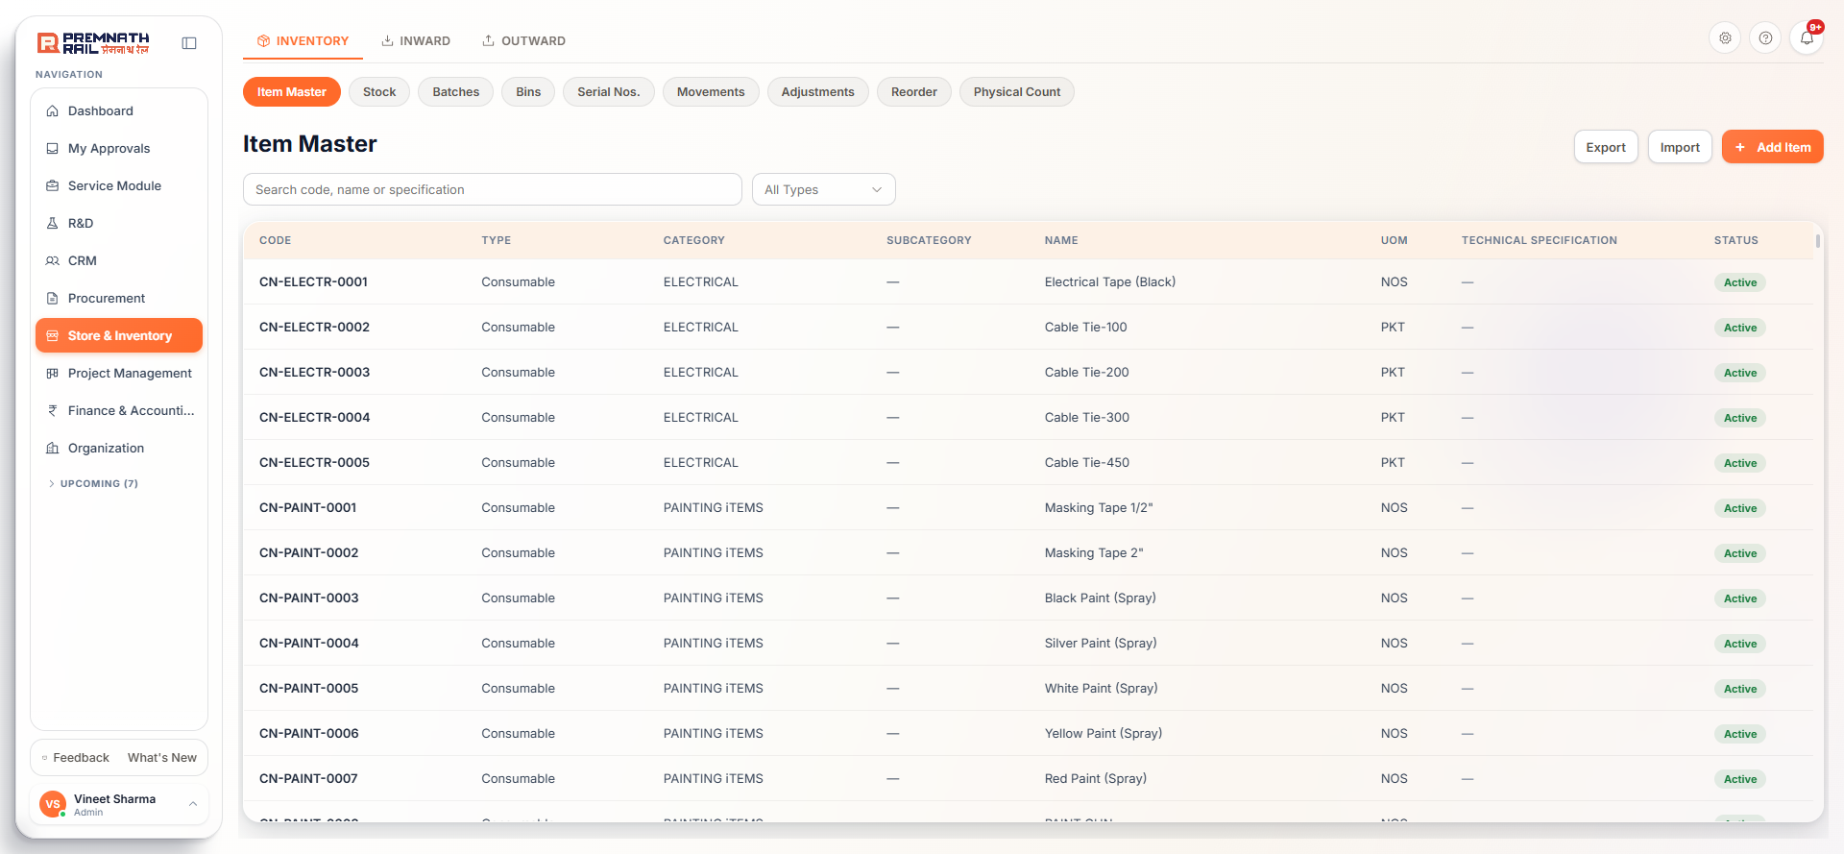
Figure 1. Store top bar: Inventory, Inward, Outward, with the second row of pills.
Group | Pills (second row) | Used for
Inventory | Item Master, Stock, Batches, Bins, Serial Nos., Movements, Adjustments, Reorder, Physical Count | The item list and the stock picture
Inward | GRN & Inspection, Before PO, Returns | Material coming in
Outward | Issues, Job Work, Transfers, Reservations | Material going out or held
Gear icon | Item Types, Units of Measure, Categories, Stores, Issue Types | Master data

You only see the pills you are allowed to use. If a screen is missing, ask your admin to change your role under Organization > Role & Permissions.

1.4 Rules of the Store that never change
- No manual stock entry. Stock cannot be added or removed by typing a number. Goods from a vendor use a GRN. Material for a job uses an Issue. Unused material coming back uses a Return. Store to store uses a Transfer. Damaged, lost or found stock uses an Adjustment or a Physical Count. Opening stock at go-live is loaded with the Opening Stock Import.
- Count the goods, do not copy the bill. On a GRN you type what you physically counted. The system shows the difference against the vendor bill.
- A saved GRN cannot be edited. A wrong GRN is reversed by the Purchase team and entered again.
- An issue is final. Material Issues post at once and have no approval, edit, delete or cancel. If you gave out too much, take it back with a Return.
- Four-eyes rule. The person who raises an adjustment, a transfer or a return can never approve it.
- No stock moves in a closed accounting month, and no stock moves for an item that is being physically counted.
- Item codes are never reused, even if the item is deleted.

1.5 Who can do what
Permissions are set per role under Organization > Role & Permissions. These are the ones storekeepers meet most often.
To do this | You need
Add, edit, delete, import or export items | Store > Item Master: Create / Edit / Delete / Import / Export
Record a GRN | Store or Purchase module, GRN: Create. Store keepers receive only into stores of their own plant
Inspect a GRN (accept or reject) | GRN > Inspection: Approve
Return goods to the vendor | GRN > Return to Vendor: Create
Reverse a GRN | GRN > Reverse: Approve, and the Purchase module
Raise a Material Return | Returns: Create
Issue material | Issues: Create. Scrap needs a Store Manager
Raise a transfer, dispatch it, receive it | Transfers: Create, Dispatch, Receive (separate rights)
Reserve stock | Reservations: Create; Cancel / Fulfill need Edit
Raise or approve an adjustment | Adjustments: Create / Approve. The approver must be a Store Manager
Start a physical count | Adjustments > Physical Count: Create
See money values (rates, stock value) | Items > Stock value & rates: View. Without it, values show blank
Load opening stock | Adjustments: Create

Note: Store users see only the stores of their own plant. If your plant is not set, the Stock page says so. Ask your admin to set it in Organization > Users.

1.6 Document numbers
Document | Number looks like | Document | Number looks like
Goods Receipt (GRN) | GRN-2026-0001 | Material Issue | MI-2026-0001
Gate entry | GE-2026-0001 | Stock Transfer | ST-2026-0001
Before PO receipt | BPO-2026-0001 | Reservation | RES-2026-0001
Return to Vendor | RTV-2026-0001 | Job work receipt | JWR-2026-0001
Batch | BT-2026-0001 | Stock Adjustment | SA-2026-0001
Inspection lot (Quality) | IL-2026-0001 | Physical Count | PC-2026-0001
Material Return | MR-2026-0001 | Bin move | BM-2026-0001

The year changes every January and the last four digits count up within the year. Item codes are different: they are one plain running number for all items (01, 02, ... 100, 101).

2. Item Master: creating and managing items
The Item Master is the list of everything the company buys, stores, issues or sells: raw material, bought-out parts, consumables, tools and services. Every stock document uses an item from this list. If the item is not here, it cannot be received or issued. Good item records save time in Purchase, Quality and Finance.

2.1 The item list
Open Inventory > Item Master. The list shows Code, Type, Category, Subcategory, Name, UOM, Technical Specification and Status.
Figure 2. Item Master list with search, filters, Export, Import and + Add Item.
- Search box ("Search code, name or specification"). Type any words in any order. It looks in name, code, old code, part code, specification and category. Names that match come first.
- Type, Category and Subcategory filters. Category appears after you pick a type. Subcategory appears after you pick a category. Clear filters resets them.
- Click a row to open the item.
- Export downloads an Excel file of exactly what the list shows (same search and filters).
- Import adds many items from a file. See 2.6.
- + Add Item opens the form in 2.3.
Tip: Search before you add. Typing two or three words of the item (for example "hex bolt M12") shows whether it already exists. Duplicate items split stock and confuse Purchase.

Note: The list is sorted by code as text, so code 100 appears between 10 and 11. This is a known display issue (see Appendix A).

2.2 Before you add an item: three checks
1. Search the list for the item, its part number and its old code.
2. Is the type, category and unit there? Types, categories and units are picked from lists. If one is missing, add it first in the gear settings (chapter 3). The item form cannot add them.
3. Know the facts that matter: the unit you stock in, the HSN and GST rate from the vendor's tax invoice, whether the item needs inspection, a test certificate, batch numbers, serial numbers or an expiry date.

2.3 The Add Item form, field by field
Click + Add Item. The form has two columns. The right column shows the automatic Item Code and the Photo. The left column has six sections. Only Item Name and UOM are required. A red star marks required fields and "(optional)" marks the others.
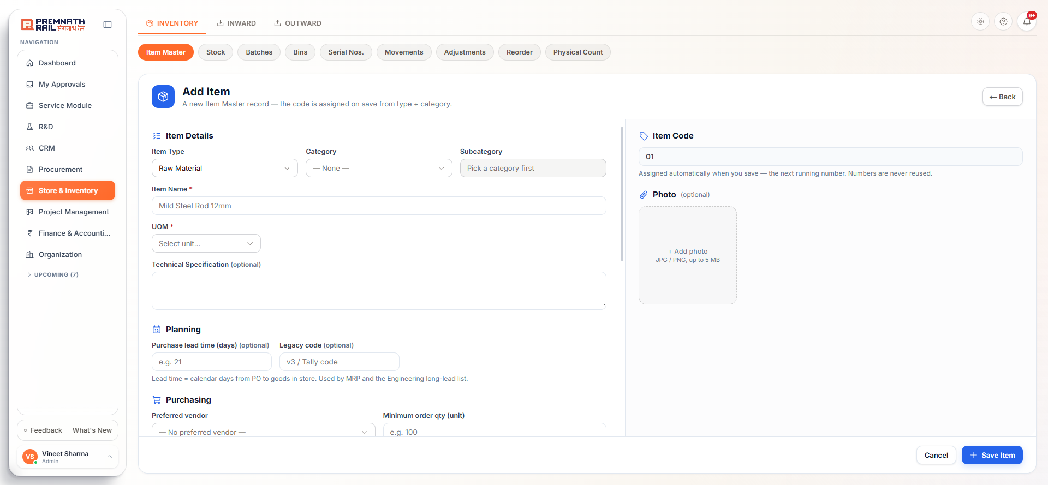
Figure 3. The Add Item form, top: Item Details and Planning, with the automatic Item Code and Photo on the right.
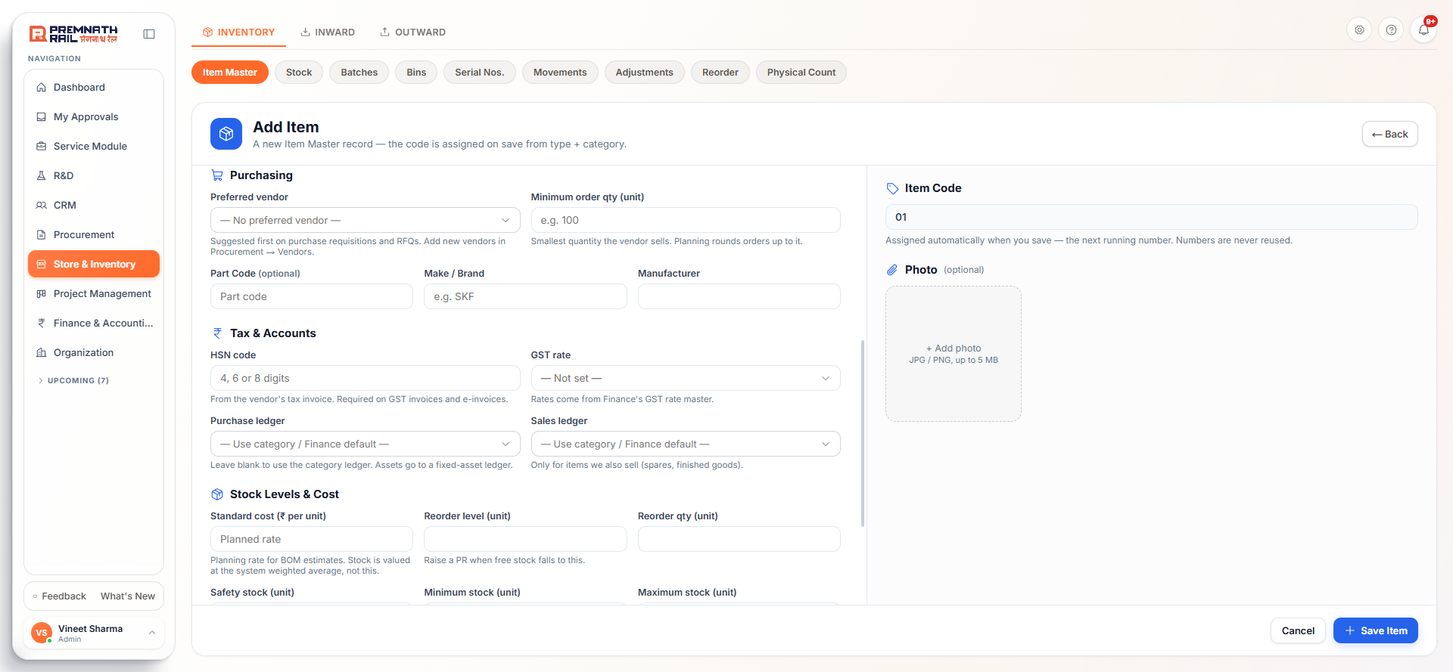
Figure 4. The Add Item form, middle: Purchasing and Tax & Accounts.
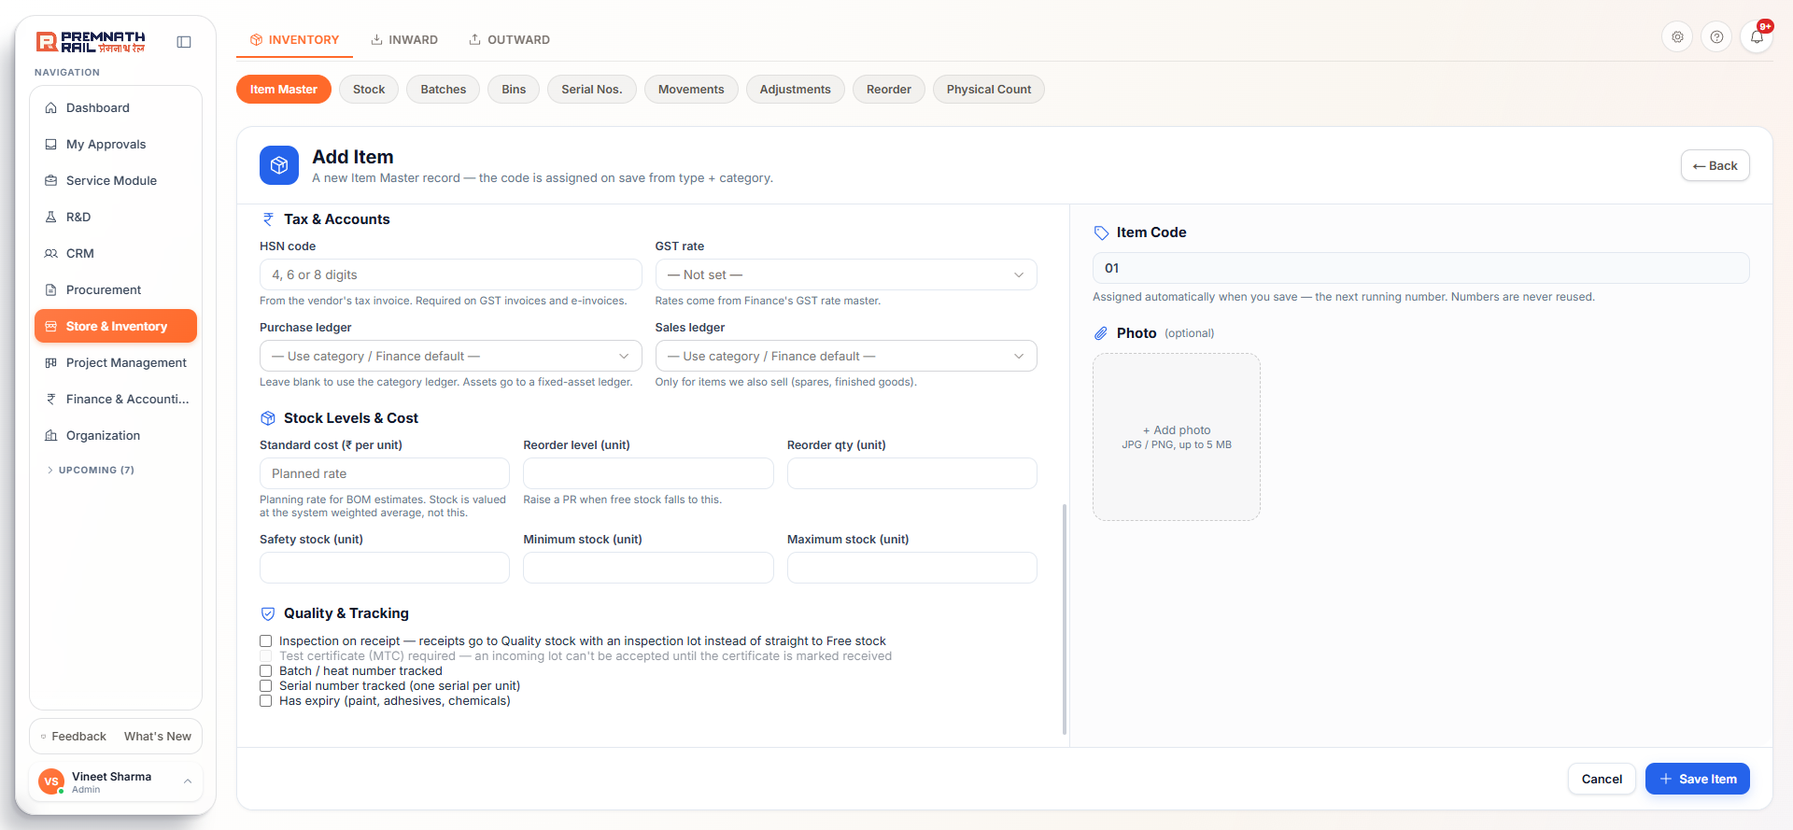
Figure 5. The Add Item form, bottom: Stock Levels & Cost and Quality & Tracking.

Item Code (right column, read only)
The grey box shows the next running number for the whole company, for example 01 on an empty master or 398 later. The number is assigned when you save. Numbers are never reused, even if an item is deleted. You cannot type a code. Old items may still carry old-style codes such as CN-ELECTR-0001.
Note: The page subtitle still says the code comes from type and category. That text is old. The code is only a running number.

Section 1: Item Details
Field | Required? | What to enter | Example
Item Type | No (starts as Material) | Pick the nature of the item: Material, Service, Asset, Consumable or Tool & Equipment. Changing the type clears Category and Subcategory | Material
Category | Optional | Pick from the categories of that type. Used for filters, reports and the default Finance ledger | Raw Material
Subcategory | Optional | Pick after the category. Only that category's subcategories appear | (blank)
Item Name * | Required | The full name including size and grade. Up to 200 characters | MS Plate 20mm IS 2062 E250
UOM * | Required | The unit you stock, issue and buy in. Shown like KG, Kilogram. Saved in capitals. Cannot be changed once the item has any stock movement | KG
Technical Specification | Optional | Grade, standard, dimensions, make. Import checks duplicates on name plus this field | IS 2062 E250 BR, 20 mm thick, 2500 x 1250

The five item types mean:
Type | Use it for
Material | Raw, production, electrical, hydraulic, mechanical, hardware, paint and packaging material
Consumable | Office, cleaning, PPE, workshop and production consumables
Tool & Equipment | Hand and power tools, measuring and testing instruments, engineering tools
Asset | Machinery, equipment, vehicles, IT assets, furniture. Received on a GRN but not carried as stock quantity or value. Finance capitalises it
Service | Job work, maintenance, professional services. A service has no stock, so the Stock Levels and Quality sections disappear, and it is never received on a GRN

Section 2: Planning
Field | Required? | What to enter and why
Purchase lead time (days) | Optional | Calendar days from PO to goods in store, a whole number from 0 to 730. Used by Production planning and the Engineering long-lead list. If blank, the planner assumes a default
Legacy code | Optional | The code from the old sheet or Tally, up to 50 characters. Must be unique. It is searchable, so people who know the old code can still find the item

Section 3: Purchasing
Field | Required? | What to enter and why
Preferred vendor | Optional | Pick from the shared vendor master (active vendors only). Purchase sees this vendor first on a PR or RFQ. Add new vendors in Procurement > Vendors
Minimum order qty | Optional | The smallest quantity the vendor sells, in the item's unit. Planning rounds an order up to this
Part Code | Optional | The vendor's or drawing part number. Searching by the maker's number is often faster than by name
Make / Brand | Optional (hidden for Service) | For example SKF
Manufacturer | Optional (hidden for Service) | The maker if different from the brand

Section 4: Tax & Accounts
Field | Required? | What to enter and why
HSN code (SAC code for a Service) | Optional | Digits only. Goods: 4, 6 or 8 digits. Services: exactly 6 digits starting with 99. Copy it from the vendor's tax invoice. Needed on GST invoices and e-invoices
GST rate | Optional | Pick from the rates Finance has set up. It fills the tax on PO and invoice lines so buyers do not type it
Purchase ledger | Optional | Leave blank in most cases. The category's ledger, then Finance's default, is used. Pick one only to override this single item. Capital items go to a fixed-asset ledger
Sales ledger | Optional | Only for items the company also sells (spares, finished goods)

Section 5: Stock Levels & Cost (not shown for Services)
Field | What it means
Standard cost (rupees per unit) | A planned rate for BOM and job estimates. Stock itself is valued at the system's weighted average, not at this number
Reorder level | When available stock plus what is already on order falls to this level, the item appears on the Reorder page
Reorder qty | The quantity normally ordered each time
Safety stock | A buffer you try never to touch
Minimum stock | The lowest acceptable level. Used as the trigger when no reorder level is set
Maximum stock | The upper limit. Suggested order quantities top up to it

Rule: The form checks the numbers together: Safety stock must not be above the Reorder level, the Reorder level must not be above Maximum stock, and Minimum stock must not be above Maximum stock. Otherwise you get a clear message and the item is not saved.

Section 6: Quality & Tracking (not shown for Services)
Tick box | What it does when ticked
Inspection on receipt | Each incoming lot gets a Quality inspection lot. Quality decides, and only then is the quantity released to Free stock
Test certificate (MTC) required | Needs Inspection on receipt. Quality cannot accept the lot until the mill test certificate is marked received. Use for steel, castings and critical parts
Batch / heat number tracked | The GRN asks for the vendor's batch or heat numbers with quantities. Issues pick from batches, oldest first. You can trace where a heat went
Serial number tracked (one serial per unit) | One serial number per unit is entered on receipt and picked on every issue, return and transfer. For engines, pumps, gearboxes, PLCs
Has expiry | A box for Shelf life (days) appears. Expiry dates are kept per batch, and issues take the earliest expiry first

Careful: For paint, adhesives and chemicals tick both Batch tracked and Has expiry. Expiry dates live on batches. The form does not force this, so you must remember.

Photo (right column, optional)
Click the box and pick a JPG or PNG up to 5 MB so staff can recognise the item on the rack. On the Add Item form the photo is held until you click Save Item. After saving you can use Change or Remove on the item page.

Saving
Click Save Item. You go to the new item's page. If something is missing, a box titled Cannot Save Item lists what to fix. The form also keeps an automatic draft. If you leave and come back, a blue strip offers your unsaved data with a Discard button.

2.4 Six demo items you can create today
Use these to practise. They cover the main kinds of item. Pick the real vendor and the real GST rates for your company. HSN and GST values here are examples only: confirm with Finance before saving real items.
Field | 1. Raw material | 2. Bought-out part | 3. Consumable
Type / Category | Material / Raw Material | Material / Hydraulic & Pneumatic | Consumable / PPE
Item Name | MS Plate 20mm IS 2062 E250 | Hydraulic Pump 63 cc/rev Gear Type | Safety Gloves Cotton Palm Coated
UOM | KG | NOS | PAIR
Specification | IS 2062 E250 BR, 20 mm, 2500 x 1250 sheet, mill TC with each heat | Fixed displacement, 63 cc, SAE B 2 bolt flange | Size 9, PU palm coat, EN 388
Part code | (blank) | PMP-63-SAEB | (blank)
Min order qty | 500 | 1 | 50
HSN / GST | 7208 / 18% | 8413 / 18% | 6116 / 12%
Standard cost | 62 | 18500 | 45
Reorder / qty / safety | 2000 / 5000 / 1000 | 2 / 2 / 1 | 100 / 200 / 50
Min / Max stock | 1000 / 10000 | 1 / 6 | 50 / 400
Inspection on receipt | Tick | Tick | No
MTC required | Tick | No | No
Batch tracked | Tick | No | No
Serial tracked | No | Tick | No
Has expiry | No | No | No

Field | 4. Paint (expiry) | 5. Tool | 6. Service
Type / Category | Material / Paint & Chemicals | Tool & Equipment / Measuring Instruments | Service / Job Work
Item Name | Epoxy Primer Red Oxide 20 L | Digital Vernier Caliper 0-150 mm | Machining Job Work (Turning)
UOM | LTR | NOS | JOB
Specification | 2 pack epoxy, 20 L can, mix 4:1, pot life 4 h | 0-150 mm, 0.01 mm resolution, with case | Turning on customer-supplied rod, tolerance as per drawing
Make | Asian Paints | Mitutoyo | (hidden)
Min order qty | 20 | 1 | (blank)
HSN or SAC / GST | 3208 / 18% | 9017 / 18% | SAC 998898 (confirm) / 18%
Standard cost | 3800 | 2800 | (hidden)
Reorder / qty / safety | 40 / 80 / 20 | (blank) | (hidden)
Min / Max stock | 20 / 160 | (blank) | (hidden)
Inspection on receipt | No | Tick (calibration check) | (hidden)
Batch tracked | Tick | No | (hidden)
Has expiry | Tick, 365 days | No | (hidden)

Tip: Item 4 shows the rule from section 6: paint needs both Batch tracked and Has expiry. Item 6 shows how a Service hides the stock sections and labels the tax code as SAC.

2.5 The item page, editing and removing
Click a row in the list to open the item. The page shows everything in one card, in this order: summary and photo, Item Details, Planning & Cost, Purchasing, Tax & Accounts, Stock Levels, Quality & Tracking, then Plant data and Vendors for this item (these two need their own permissions).
- The item page does not show stock by store or history. For that use Inventory > Stock, Movements, Batches and Serial Nos.
- Plant data (MRP views) sets planning per plant: MRP type (Reorder point, MRP or No planning), Make or buy, reorder and safety levels, purchase days, default store and a Purchasing blocked switch that stops buying the item for that plant.
- Vendors for this item lists the preferred vendor first, then vendors we bought it from with the last PO rate, then vendors whose catalog lists it.
- Standard cost and Weighted average are visible only with the Stock value & rates permission.

Edit
Click Edit. The same form opens as Edit <item name>. The Item Code is fixed. A new Status field appears: Active, Inactive or Discontinued. Click Save Changes. Posted documents keep their old values. If the item already has any stock movement, you cannot change its UOM: create a new item for the new unit.

Status: Active, Inactive, Discontinued
Inactive and Discontinued items disappear from Purchasing pickers (PR, PO, BOM pickers). Store's own forms (Issue, Transfer, Return, Adjustment) still offer them so you can clear remaining stock. The two statuses behave the same.

Delete
Delete asks "Delete this item?" and removes the item permanently. It is refused if the item has stock movements, issue, return, transfer or adjustment lines, reservations, or links in a BOM, work order, drawing or spares list. The message tells you what to do. Set the status to Inactive instead.

2.6 Import and export
1. Click Import on the Item Master. Click Download template and fill it in Excel. Keep the header row.
2. Save as .csv (UTF-8) or .xlsx. Up to 5000 rows at a time.
3. Click the upload box, pick the file and click Import.
4. Read the result: New items saved, Already exist, not saved and Problems, not saved. Row numbers are Excel row numbers. Fix the problem rows in the file and import again (only the fixed rows are needed).
Template columns: item_type, category, subcategory, item_name, uom, technical_specification, lead_time_days, legacy_code, part_code, hsn_sac_code, gst_rate, preferred_vendor, standard_cost, min_order_qty, reorder_level. Only item_name and uom are required.
- An item code in the file is ignored. Codes are generated.
- Item type blank means Material. Category must already exist for that type.
- A new subcategory name is created automatically. A typo creates a wrong subcategory, so check your spelling.
- A row with the same name and specification as an existing item is not saved. The same name with a different specification is a different item.
- Make, manufacturer, ledgers, safety, minimum and maximum stock, and the tracking tick boxes are not imported. Set them on each item afterwards.
- Good rows are saved even if other rows fail.

3. Store settings: types, units, categories, stores
Click the gear icon next to the bell. The pills are Item Types, Units of Measure, Categories, Stores and Issue Types. Each shows only if your role allows. Rows have Edit and Delete links on the right, and delete always asks first.

3.1 Item Types
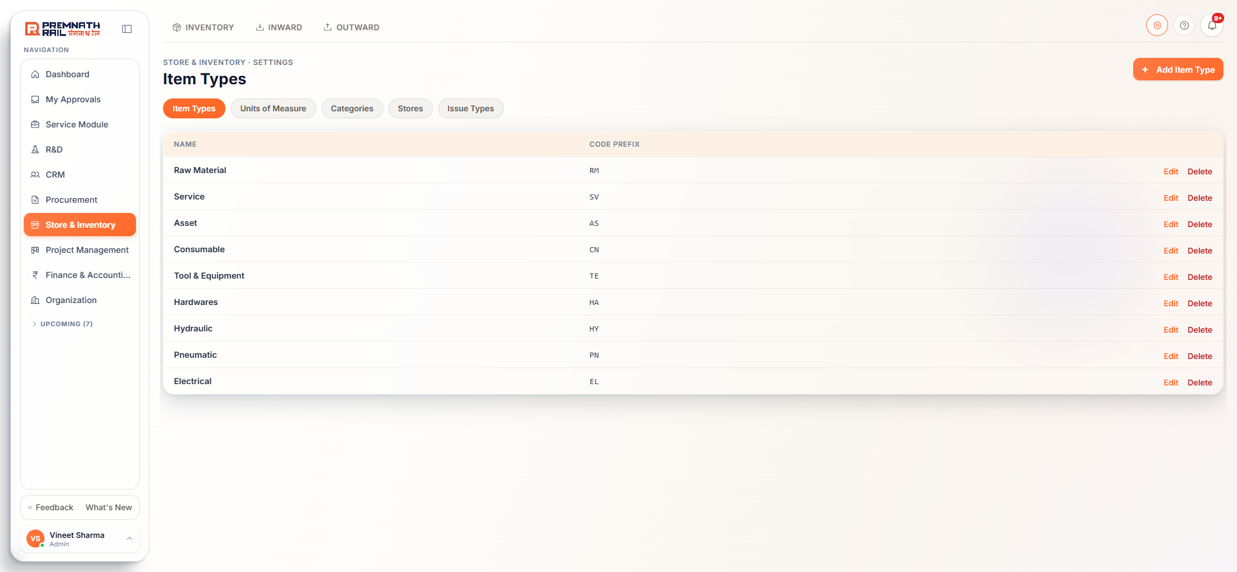
Figure 6. Item Types.
The standard five are Material, Service, Asset, Consumable and Tool & Equipment. + Add Item Type asks for a Name and an optional two-letter code prefix. The prefix is only a tag and is not used in item codes. Material is the default type and cannot be deleted. A type used by items or categories cannot be deleted.

3.2 Units of Measure
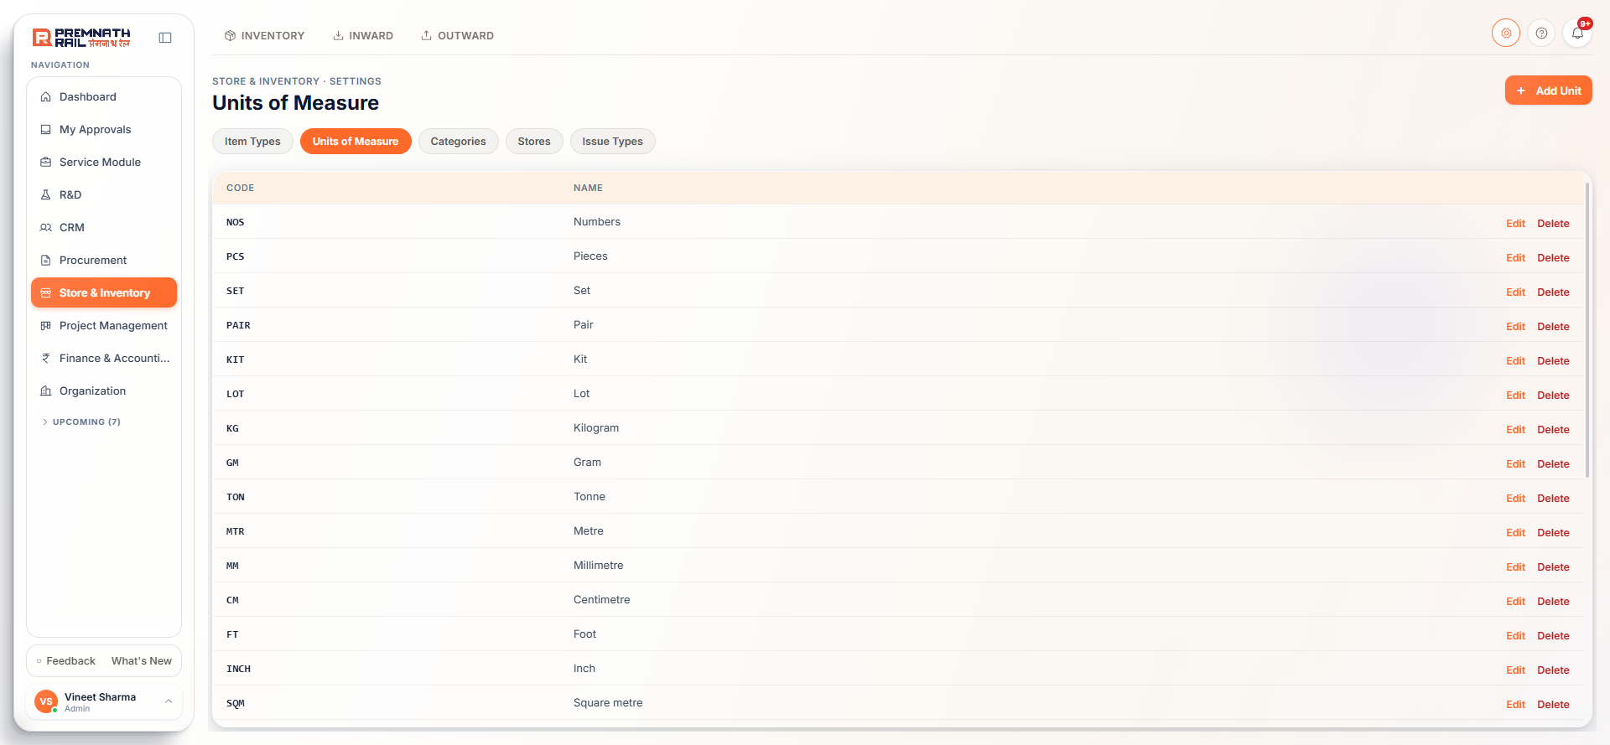
Figure 7. Units of Measure.
+ Add Unit asks for a Unit code (such as KG, up to 20 characters, saved in capitals) and a Unit name. Units are shared with Purchase Requisition lines. Once a unit is used on an item or a PR, PO or GRN line, its code cannot change (only its name) and it cannot be deleted. The item form picks units from this list, so add a missing unit here first.

3.3 Categories
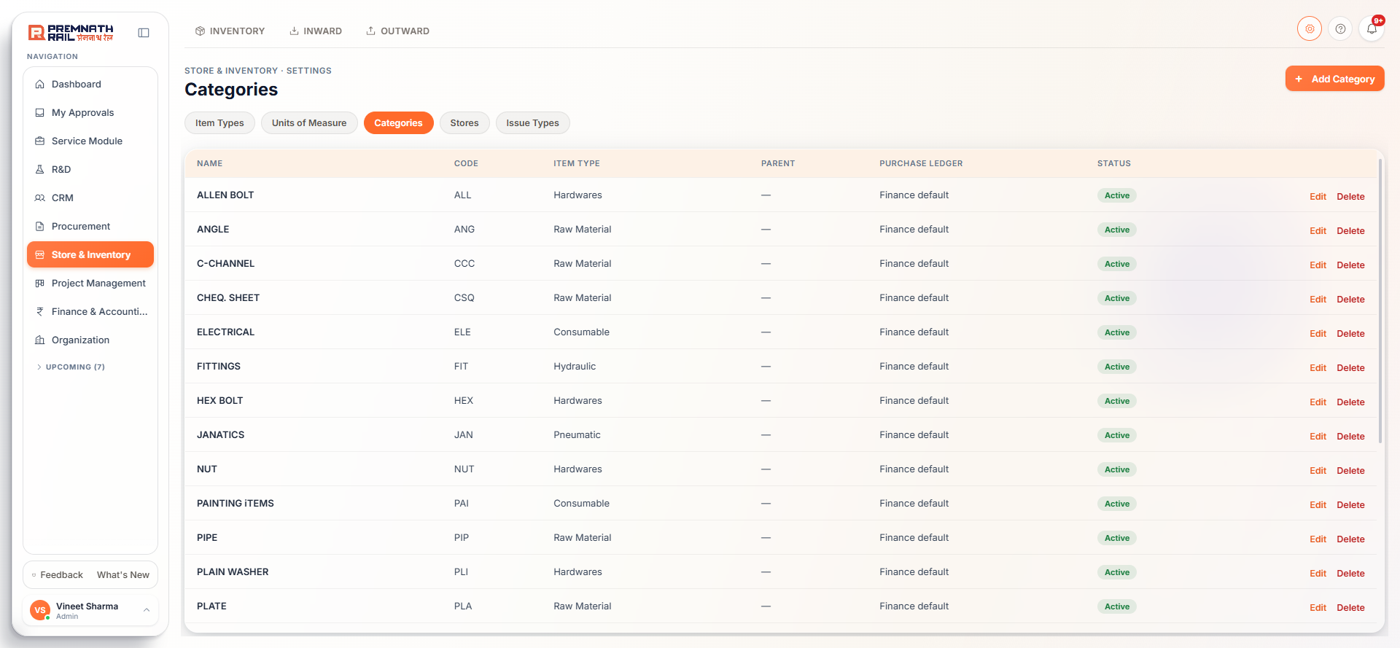
Figure 8. Categories and subcategories.
Categories have two levels. + Add Category asks for a Name, an optional 3-letter Code, a Parent (leave empty for a top-level category) and, for top-level ones, the Item Type and optional Purchase and Sales ledgers. Items in the category book to those ledgers unless the item sets its own. Agree ledgers with Finance. Renaming a category renames it on every item. A category with subcategories or items cannot be deleted.
Standard categories already exist for each type, for example Raw Material, Electrical, Hydraulic & Pneumatic and Paint & Chemicals under Material; Job Work and Maintenance Service under Service; Machinery and Vehicle under Asset; PPE and Office Consumables under Consumable; Hand Tools and Measuring Instruments under Tool & Equipment.

3.4 Stores
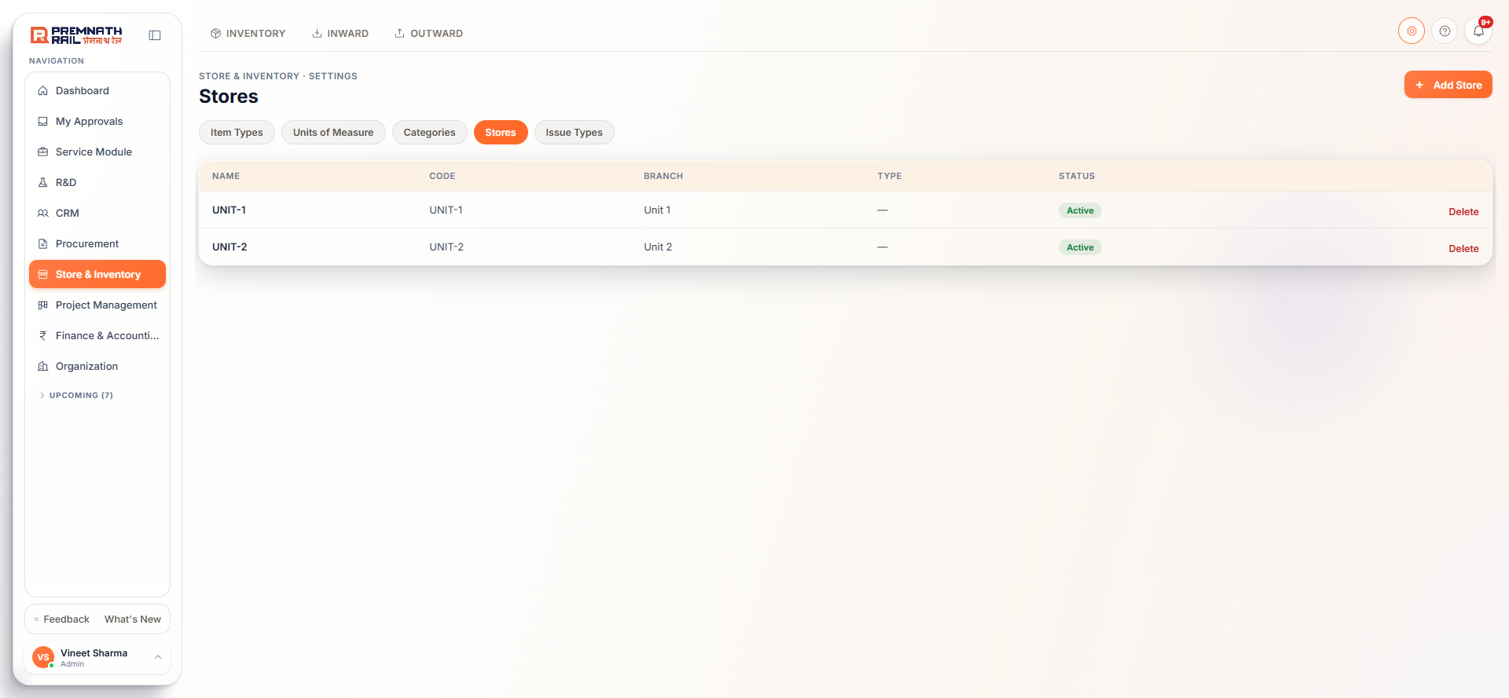
Figure 9. Stores.
A store is a physical place where stock is kept. Every stock document is posted against a store, and each store belongs to a plant (branch). The plant decides who can see the store's stock. + Add Store asks for Name, Code (unique, such as WH-01), Branch, Store Type and Address. You can create stores in your own plant only. A store with any history cannot be deleted.
Note: There is no Edit button on this page today, so a store cannot be set to Inactive from the screen. See Appendix A.

3.5 Issue Types
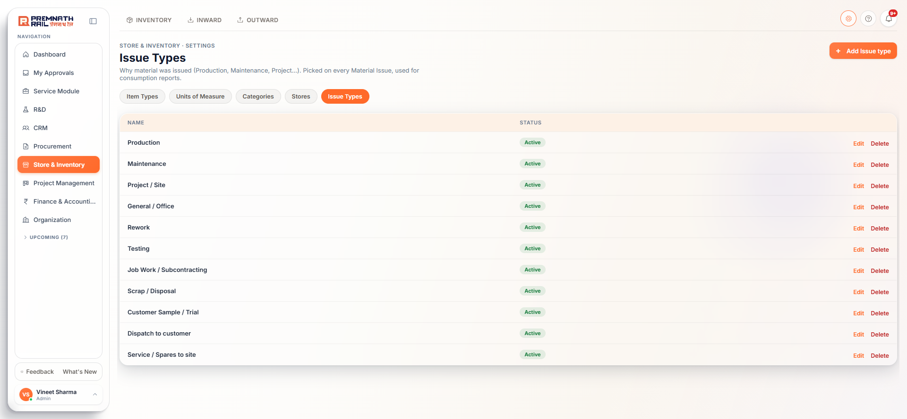
Figure 10. Issue Types (fixed list).
The eleven issue types are fixed in the system: Production, Maintenance, Project / Site, General / Office, Rework, Testing, Job Work / Subcontracting, Scrap / Disposal, Customer Sample / Trial, Dispatch to customer and Service / Spares to site. Only an admin can rename them. The page may still show Add and Delete buttons. They will be refused.

4. Inward: receiving goods

4.1 Which screen do I use?
Situation | Use | Effect on stock
Goods arrive and a PO exists | GRN & Inspection | Goes into Quality stock at once. Inspection releases it to Free or Blocked
Goods arrive but the PO is not made yet | Before PO | Nothing. The goods are held and Procurement makes the PO. Then you do a normal GRN
Unused or faulty material comes back from a job | Returns | Posts when approved (or at once for good material against an issue)
Good goods must go back to the vendor | Return to Vendor (button on the GRN) | Leaves stock, PO opens again
The GRN itself was entered by mistake | Reverse GRN (Purchase team) | Stock taken back out

4.2 GRN & Inspection: the list
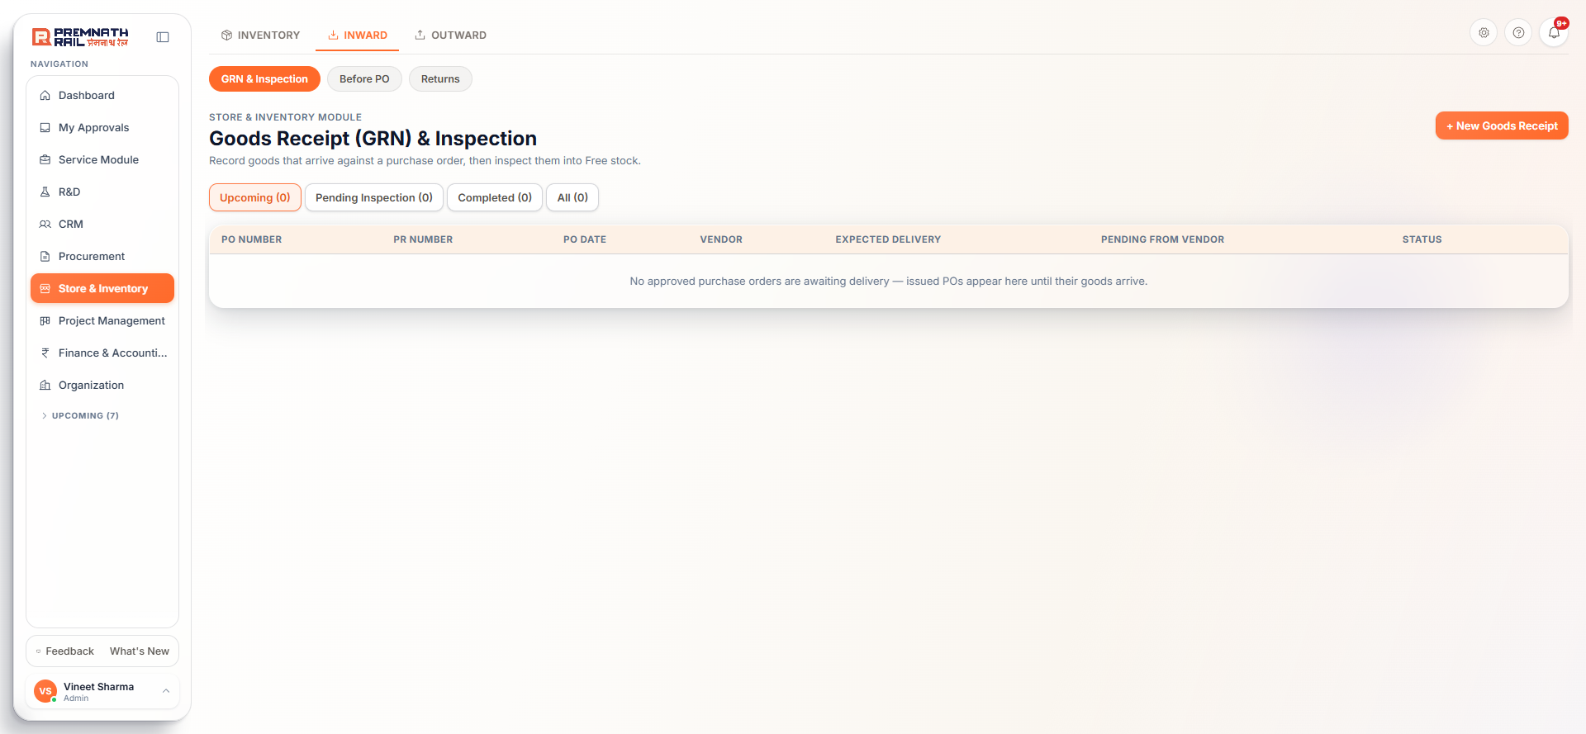
Figure 11. GRN & Inspection with its four buckets.
The buckets at the top:
- Upcoming: approved POs with quantity still to come. The columns include Expected Delivery and Pending from Vendor. Click Receive on a row to open the GRN form with that PO already picked. (Shown to Store and Purchase users.)
- Pending Inspection: GRNs saved but not yet decided.
- Completed: GRNs where every line is decided.
- All: everything, including reversed GRNs.

4.3 Record a goods receipt (GRN), step by step
Only POs that are issued, have finished their own approval and have at least one stock line can be received. Service lines are never received on a GRN.
1. Open Inward > GRN & Inspection. Click Receive next to the PO in Upcoming, or click + New Goods Receipt and search for the PO.
2. Pick the Store Location the goods are physically going into and check the Received Date (today or earlier, not before the PO date).
3. Fill the Gate Entry & Vendor Documents that apply: Gate Entry No. (leave blank and the system makes GE-2026-nnnn), Vendor Invoice No. with its date, Delivery Challan No. with its date, E-way Bill No. (exactly 12 digits), Vehicle No., Transporter and LR No.
4. In Line Items, type Received Now for each item: what you physically counted. If the vendor bill says something else, type the bill quantity in Invoice Qty. The Variance column shows Matches, Short or Excess.
5. Pick a Bin per line if the store uses bins.
6. For a batch-tracked item, enter each heat or batch number with its quantity and Mill TC number. For a serial-tracked item, type one serial number per unit.
7. Add Remarks (condition on arrival, packing). Click Save Goods Receipt.
Field | Required? | Rule
Purchase Order | Required | Changing the PO clears quantities
Store Location | Required | Inactive stores are refused
Received Date | Required | Not in the future, not before the PO date, not in a closed accounting month
Vendor Invoice No. | Optional | Each vendor invoice number can be received only once (not counting reversed GRNs). If you give a number, the Invoice Date is required and cannot be after the received date
Delivery Challan No. / Date | Optional | Date required if the number is given
E-way Bill No. | Optional | Exactly 12 digits
Received Now | Required on at least one line | Cannot be more than what is pending on the PO. There is no over-receipt tolerance
Invoice Qty | Optional | What the bill says. Only for comparison, never blocks
Bin | Optional | Active bin of the chosen store

Short and partial receipts
You may receive less than the PO. The row says Short by n, stays pending from vendor, the PO stays open for the balance, and Purchase is notified of what the vendor still owes. You may not receive more than is pending.

Batch / heat numbers
A batch-tracked item shows a box "Batch-tracked - heat / batch numbers from the mill TC". Use one row per heat: Heat / batch no., Qty, Mill TC no., an expiry date if the item has expiry, and a file box for the scanned test certificate. + Another heat adds a row. The heat quantities must add up exactly to Received Now. Each heat becomes a batch number such as BT-2026-0001. The TC scan uploads after the GRN is saved. If it fails the GRN is still saved and you attach the scan from Inventory > Batches.

Serial numbers
A serial-tracked item shows a box "Serial numbers - one per unit". Type or paste one serial per line, as printed on the name plate. The count must equal Received Now. A serial already in the books is refused.
Tip: Count, then type. If you copy the bill quantity into Received Now, the system cannot warn you about a shortage.

4.4 What saving a GRN does to stock
Stock enters the Quality bucket the moment you save, at the PO rate (plus planned delivery cost). It is not usable yet.
Item setting | What happens at save | What releases it to Free stock
Inspection on receipt is ticked | A Quality inspection lot (IL-2026-nnnn) is created, one per heat. Line shows "In Quality inspection". Quality inspectors are notified | Quality's usage decision on the lot (Accept, Accept with deviation, Reject, Partial). If MTC is required, the certificate must be marked received first
Normal item | Goods sit in Quality stock. The Store role is notified that the GRN is waiting for inspection | Someone with Inspection approve rights clicks Complete Inspection on the GRN
Asset line | Received and inspected but never carried as stock quantity or value | Finance capitalises it when the vendor invoice is booked

In Inventory > Movements a GRN shows first as GRN into Quality, then as Quality -> Free (accepted) and/or Quality -> Blocked (rejected).

4.5 Inspect a GRN
Open the GRN from Pending Inspection. For each line still pending, set Accepted, Rejected, Quality Status (Passed, Failed or Partially Accepted) and a Rejection Reason if anything is rejected. Accepted plus Rejected must equal the received quantity. Click Complete Inspection.
- Accepted quantity moves from Quality to Free stock. Rejected quantity moves to Blocked stock until it goes back to the vendor.
- Passed with rejected quantity above zero, or Failed with accepted quantity above zero, is refused: choose Partially Accepted.
- A line marked "In Quality inspection" is decided by Quality, not on the GRN.
- The GRN becomes Completed when no line is waiting. The PO and requisition status update and the requester is notified.
- Without Inspection approve rights the page tells you who must complete it.

4.6 Return to Vendor
Use this when goods really arrived and must go back (rejected, damaged, wrong item, excess). Open the completed GRN and click Return to Vendor.
1. Enter Return accepted and/or Return rejected quantities per line. You cannot return more than accepted (or rejected) minus what was already returned.
2. Pick the Reason (Rejected in inspection, Damaged in transit or on receipt, Wrong item supplied, Excess quantity supplied, Other). If Other, write the reason in Remarks.
3. Set the Return Date (not in the future, not before the received date) and optionally the vehicle number.
4. Click Save Return. You get an RTV number.
Accepted goods leave Free stock and rejected goods leave Blocked stock, at the PO rate. The PO opens again for a replacement. If Finance has already posted the vendor's invoice for those goods, a pending debit note is raised for Finance to review. Goods rejected by a Quality lot go back through Quality's NCR instead.

4.7 Reverse a GRN
Use only when the GRN was entered by mistake (wrong PO, wrong quantity, wrong store). The button needs the Reverse right and the Purchase module. Give a reason. The stock is taken back out and the PO opens again. It is refused if goods went through a Quality lot, if anything was returned, if the vendor's invoice already covers the goods, or if the stock was already issued. In those cases use Return to Vendor.

4.8 Before PO: goods that arrive before the PO
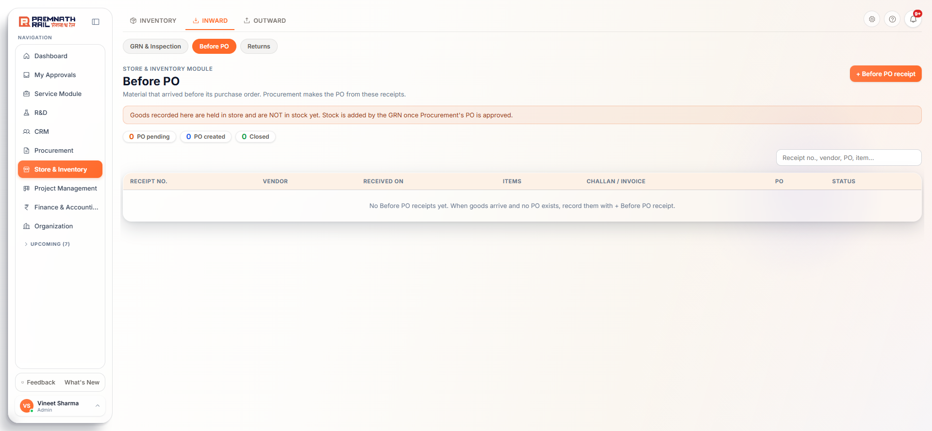
Figure 12. Before PO.
Use this when material is physically at the gate but Procurement has not made the PO yet. Nothing goes into stock. The receipt is a held record. A banner on the page says so.
1. Click + Before PO receipt.
2. Pick the Vendor (active vendors only), Received on (today or earlier) and your Store (locked if you have one).
3. Add the Delivery challan no., Vendor invoice no. and attach the challan or invoice if you have them.
4. Under Items received pick Type, Category and Item from the Item Master, then the Quantity. Add each item once.
5. Click Save receipt. You get a BPO number and Procurement is notified to make the PO.
Status | Meaning
PO pending | Waiting for Procurement to make the PO. You can cancel it with a reason
PO created | The buyer uploaded the PO. Now record a normal GRN against that PO
Closed | The PO was received in full by GRN
Cancelled | Cancelled by you while still PO pending, with a reason

4.9 Returns: material coming back to the store
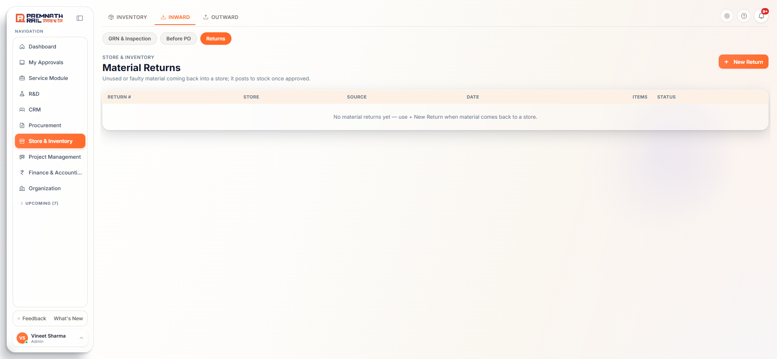
Figure 13. Material Returns.
This is not the vendor return. It is unused or faulty material coming back from a job into a store. Click + New Return.
1. Pick the Store and the Source: "Against a Material Issue" (pick the issue; no approval) or "Other (no issue reference)" (describe it; the store's manager approves).
2. Add each Item, Quantity and Condition: Good (to usable stock, no approval), Damaged (to quarantine, approved by the head of the department the material was issued to) or Rejected quality (to quarantine, approved by designated users).
3. A Damaged line needs the Department.
4. Click Submit for Approval or Record Return. The button name tells you if approval is needed.
You cannot return more than was issued less what was already returned. Statuses are Pending Approval, Approved, Rejected and Withdrawn. Good lines go to Free stock, Damaged and Rejected lines go to Blocked stock. Clear Blocked stock later from the Stock page (7.5). Nobody can approve their own return.
Note: The Material Return form has no bin or serial box today. A serial-numbered item cannot be returned from this form (see Appendix A).

5. Stock views

5.1 Stock
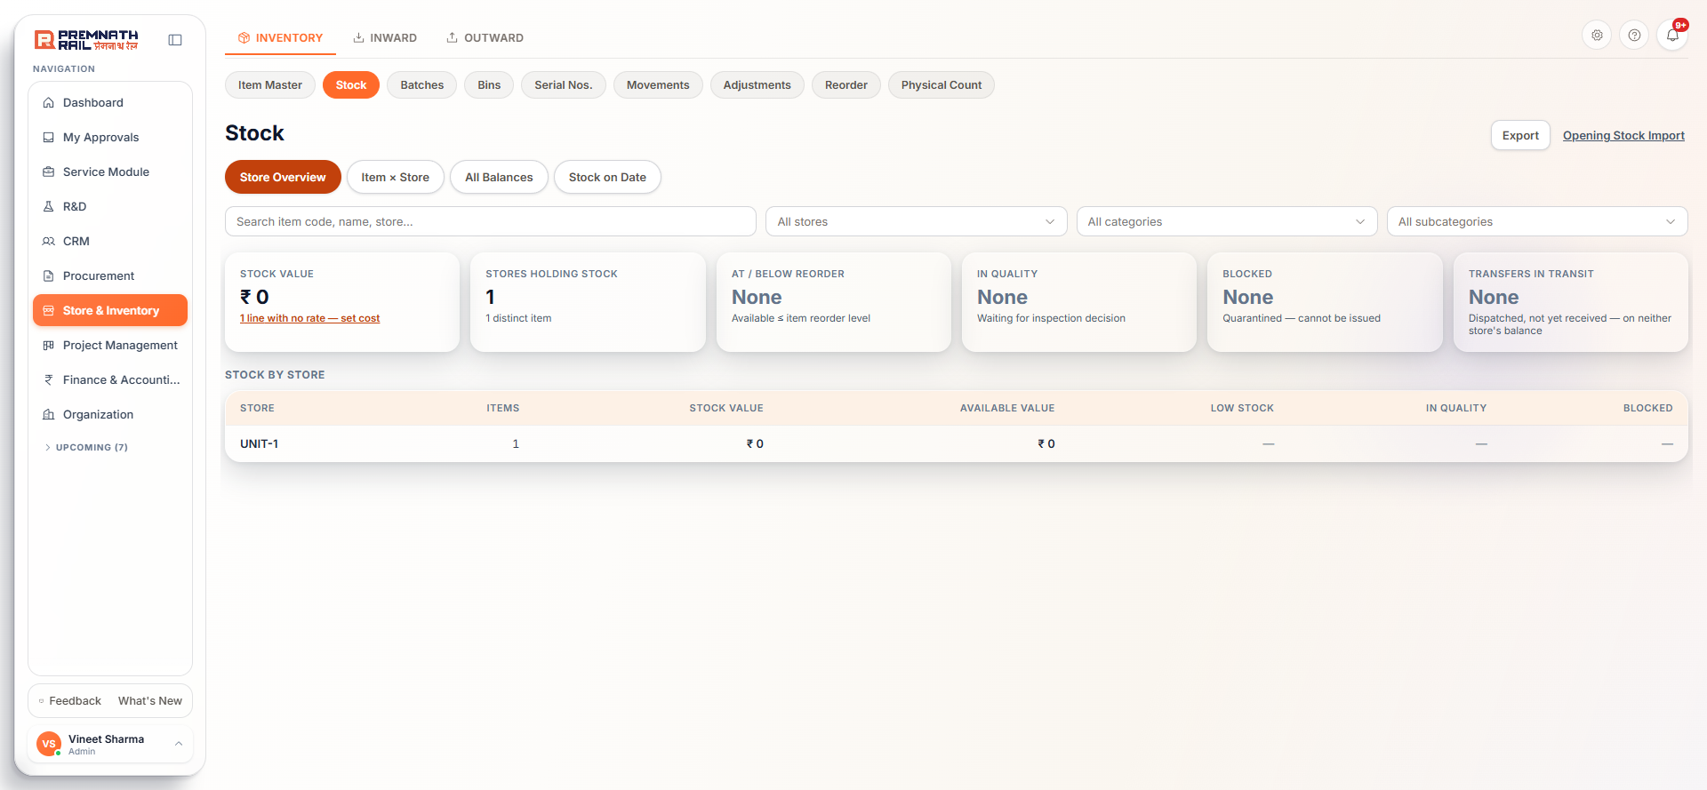
Figure 14. The Stock page.
Use the view chips at the top: Store Overview, Item x Store, All Balances and Stock on Date. The search box, store, category and subcategory filters work on all views. Export downloads Excel.
View | What it shows
Store Overview | Tiles: Stock Value, Stores Holding Stock, At / Below Reorder, In Quality, Blocked, Transfers In Transit. Below, a table per store. Click a row to jump to its balances
Item x Store | A grid of Available quantity per item per store with a total
All Balances | One row per item per store: On Hand (Free), Reserved, Available, Quality, Blocked, With Vendor. A Clear link next to Blocked stock lets you dispose of it (7.5)
Stock on Date | Stock as it was on a past date, rebuilt from the ledger: Opening, Receipts, Issues, Closing and the rate and value

Money values (Stock Value, rate, closing value) show only with the Stock value & rates permission. Stock value uses one company-wide weighted average per item. Receipts are valued at the PO rate plus planned delivery cost. Moving stock between Free, Quality and Blocked does not change value.
Note: Goods in transit between stores are on neither store's balance. They appear on the Transfers page under the In transit chip.

5.2 Batches
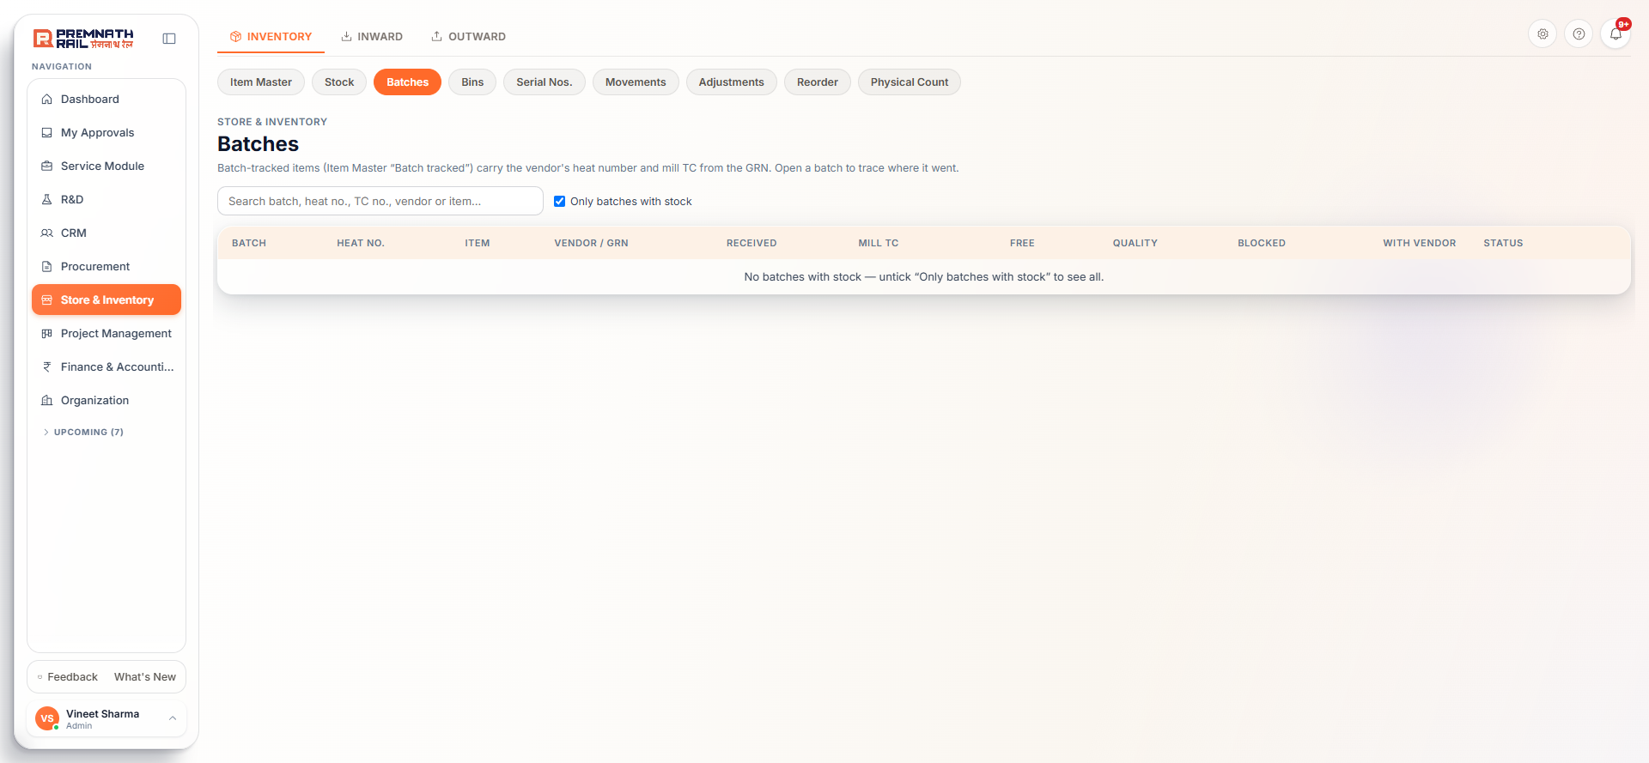
Figure 15. Batches.
Every batch of a batch-tracked item has a line: Batch (BT-...), Heat no., Item, Vendor / GRN, Received, Mill TC, Free, Quality, Blocked, With vendor and Status. The box Only batches with stock is ticked by default. Click Trace for the full story: the receipt, the mill test certificate, where each quantity went (issues, job work, Quality lots and NCRs) and all movements.
- Attach mill TC or Replace mill TC (PDF, JPG or PNG up to 15 MB).
- Block batch needs a reason, which is shown to anyone who tries to issue it. Release batch undoes it.
- Issues pick batches oldest first, or earliest expiry first for expiry items. Blocked or expired batches are not issued.

5.3 Bins
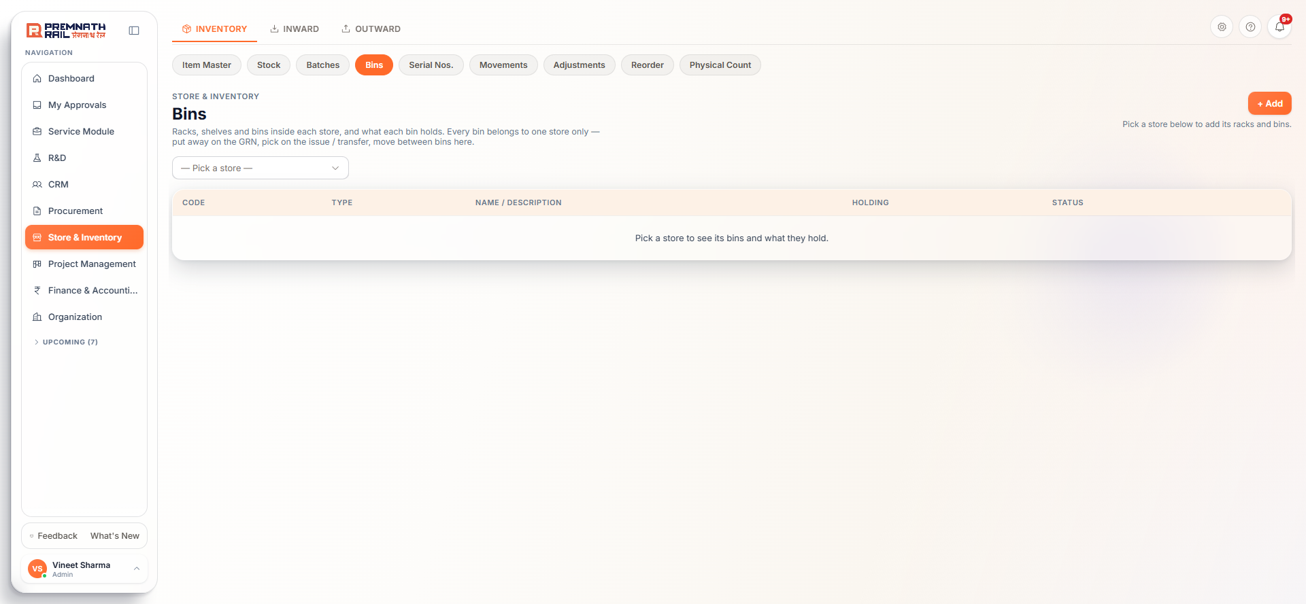
Figure 16. Bins.
Racks, shelves and bins inside a store, and what each holds. Pick a store first. You then see Rack > Shelf > Bin. A bin belongs to one store only.
- + Add creates a Rack, Shelf or Bin. Codes are unique within the store, for example R1, R1-S2, R1-S2-B3.
- Put away places stock that is in the store but in no bin (the Unassigned row) into a bin. Move shifts stock between bins. Both create a move note (BM-...) and do not change value.
- A bin can be deactivated only when empty. It can be deleted only when nothing ever moved through it.
- Once an item is kept in bins, an issue or transfer must name the bin it comes from.

5.4 Serial Nos.
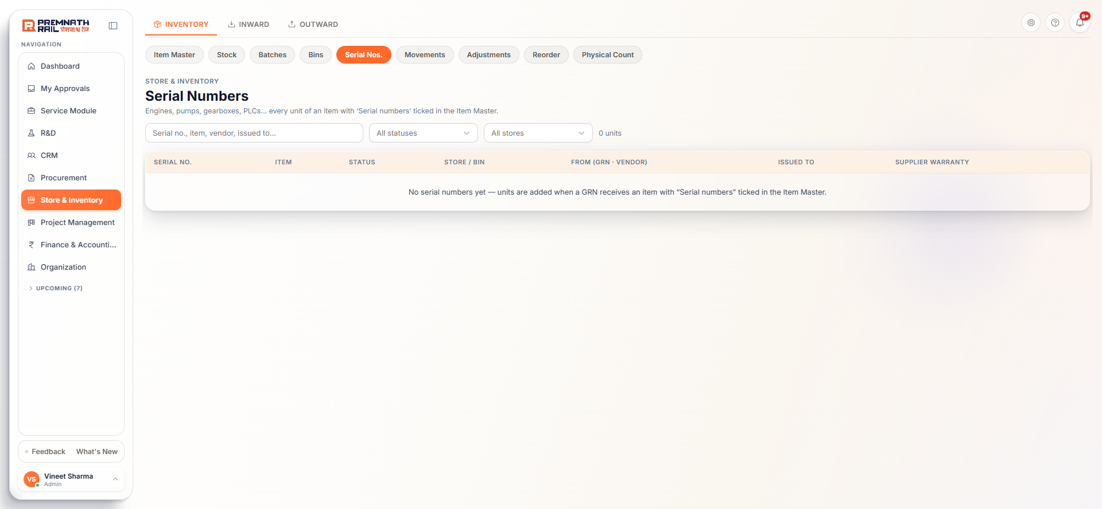
Figure 17. Serial Nos.
Every unit of a serial-tracked item has a line: Serial no., Item, Status, Store / bin, From (GRN and vendor), Issued to and Supplier warranty. Statuses are In Quality stock, In stock, Blocked, In transit, Issued, Returned to vendor and Cancelled (GRN reversed). Click a row for the Serial History. Statuses change only through documents. The one manual action is Release to stock or Block for a unit still in Quality stock (needs Inspection approve rights and a reason).

5.5 Movements
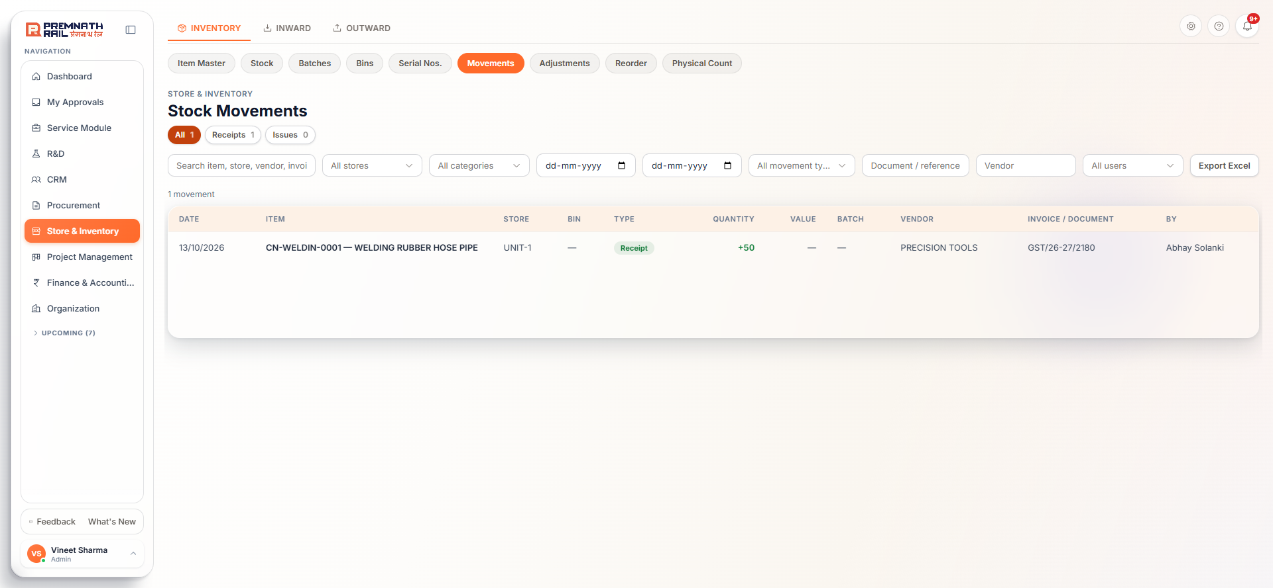
Figure 18. Movements, the stock ledger.
A read-only ledger of every stock movement, newest first, 200 rows a page. Use the date range, store, movement type, document number, vendor and user filters, then Export Excel (up to 50,000 rows). Quantities show in green for in and red for out. The Value column needs the Stock value permission.
Movement type | What it means
Receipt / Issue | Goods in / goods out
Return (in) / Return (out) | Material back from a job / goods back to the vendor
Transfer In / Out | Between stores
Adjustment (+) / (-) | Corrections after approval
GRN into Quality | Received, waiting for inspection
Quality -> Free / Quality -> Blocked | Inspection accepted / rejected
Quarantine (in/out), Blocked -> Free | Handling of blocked stock
Job work out / back / consumed | Material at and back from a job-work vendor
Stock in | Opening stock loaded at go-live

6. Outward: issues, transfers, reservations, job work

6.1 Material Issue
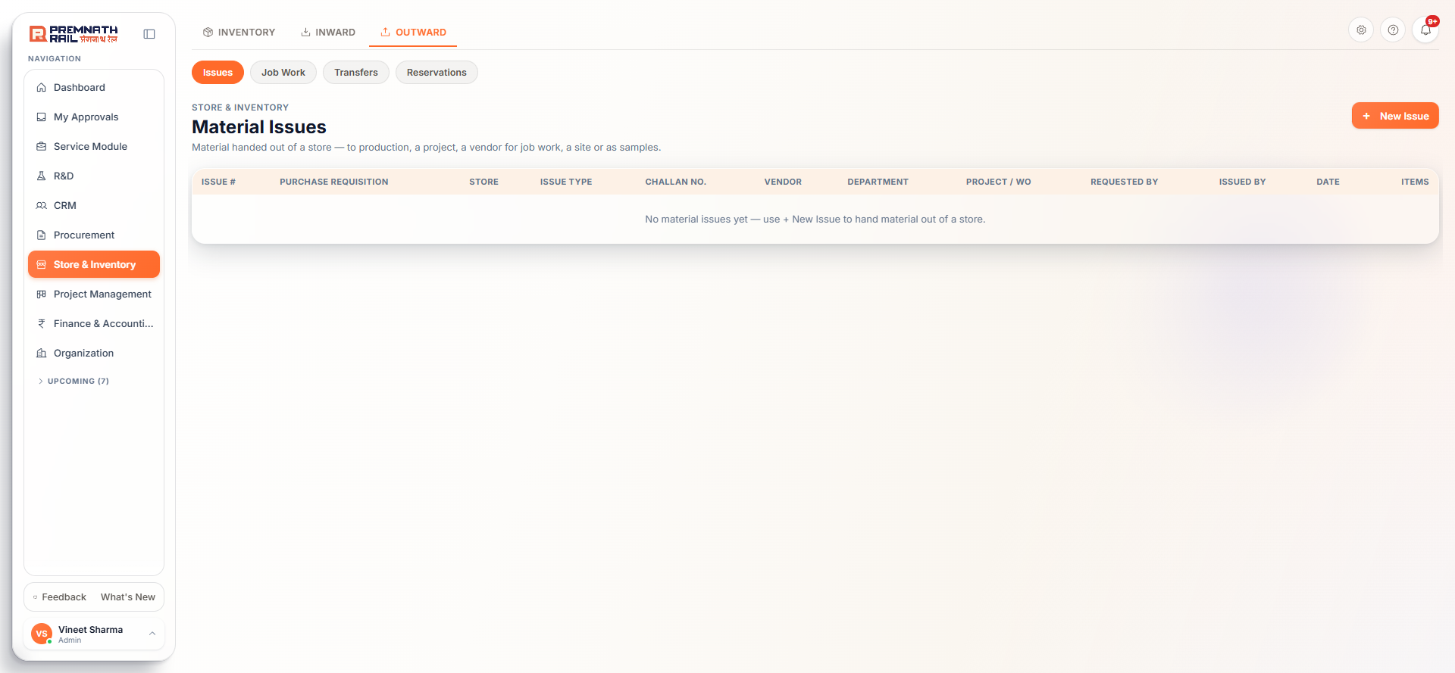
Figure 19. Issues list.
An issue hands material out of a store. It posts at once: the stock leaves the store the moment you click the button. There is no status, approval, edit, delete or cancel on an issue. To take material back, use a Return. The issue date is always today.

Create an issue, step by step
1. Open Outward > Issues and click + New Issue.
2. Pick the Store. The live stock of that store loads (refreshes every 30 seconds, or click Refresh stock).
3. Pick the Issue Type. The fields for that type appear (see the table below). Changing the type clears what you typed.
4. Add Remarks if you like. They are required for Scrap.
5. Under Items click Add Item, search by code or name, and type the Quantity. The Available in store column tells you at once if you are short. Import from Excel fills lines from a file (item_code, quantity, batch_number, remarks) without posting.
6. Pick the Batch / bin / serial where the column asks for it (see 6.1.2).
7. Click Issue Material (N lines). You land on the new issue.
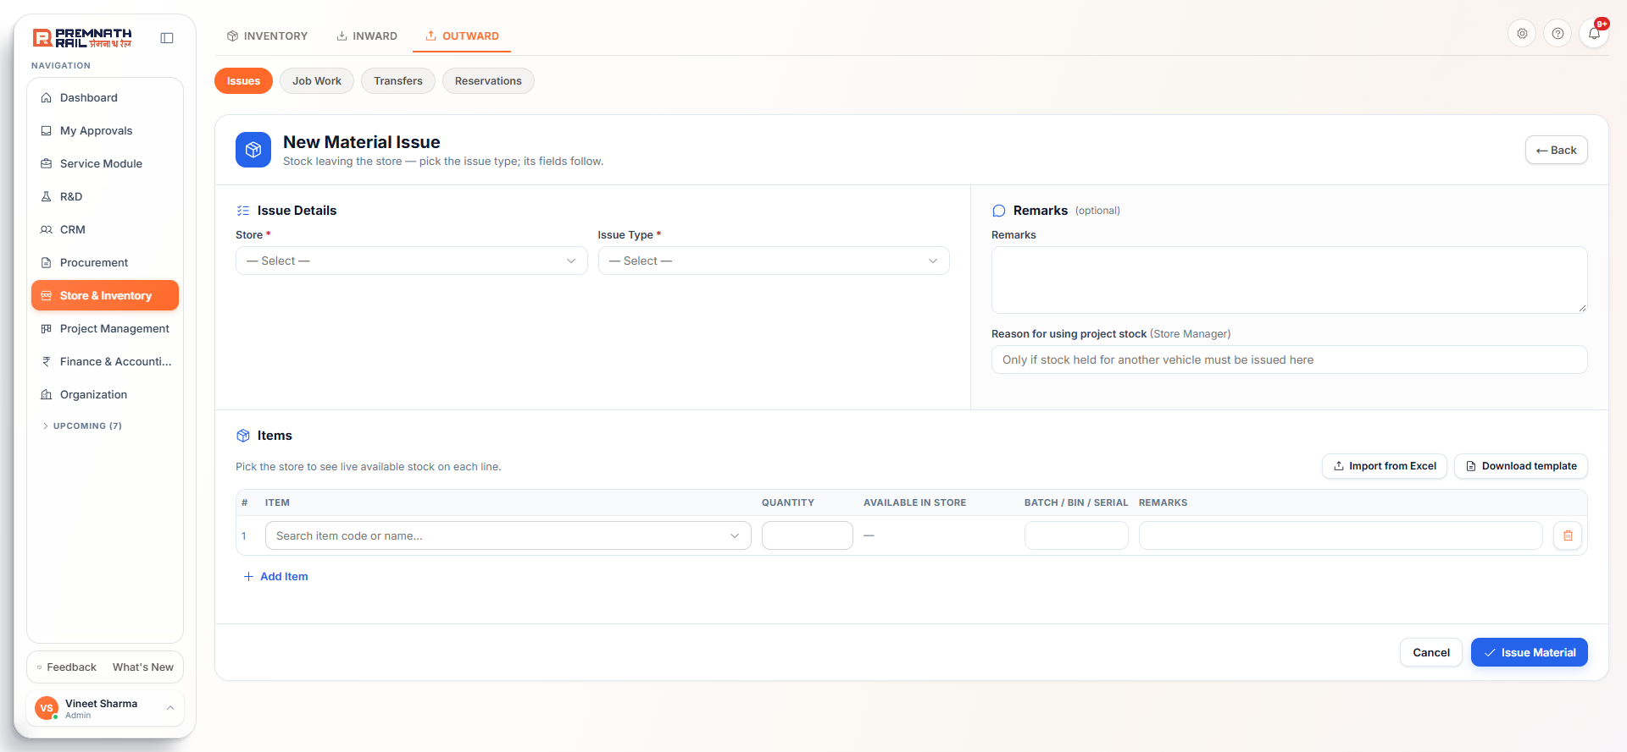
Figure 20. New Material Issue form.

6.1.1 The issue types and what each one asks for
R = required, O = optional, E = either of two, C = conditional. Material that leaves the factory always needs a Delivery challan no. that you type.
Issue type | Fields asked | Notes
Production | Work order no. (O), Project unit (O) | Work order can be a Production work order or RRV build number
Maintenance | Maintenance work order (E), Machine / asset (E) | At least one of the two
Project / Site | Project / machine (R), Site address (O), Returnable (O), Expected return date (C), Delivery challan no. (R), Vehicle (O) | Leaves the factory. Return date required if Returnable is Yes
General / Office | Department (R) | Cost goes to that department
Rework | NCR (E), Work order no. (E) | One of the two
Testing | Inspection lot (E), NCR (E), Destructive test (R), Expected return date (C) | Return date required if the test is not destructive
Scrap / Disposal | Scrap buyer (O), Delivery challan no. (C), Vehicle (O) | Remarks required. Only a Store Manager, the store's manager or an admin can post
Customer Sample / Trial | Customer (R), Purpose (R: Sample or Trial), Returnable (R), Return date (C), Delivery challan no. (R) | Leaves the factory
Dispatch to customer | Project / machine (R), Delivery challan no. (R), Transporter, Vehicle, LR no. (O) | Finished goods. Quality and Finance clearance can block it
Service / Spares to site | Service request (R), Site address (O), Delivery challan no. (R), Vehicle (O) | Quantities and cost are booked on the service request line
Job Work / Subcontracting | Vendor, Process, Expected return date, Delivery challan no. | Not on this form. Use Job Work > + New Challan (6.4)

6.1.2 Batch, bin and serial on an issue line
- Batch: for a batch-tracked item the picker offers "Auto - first in, first out" and lists each batch with its free quantity and expiry. For other items you may type a batch.
- Bin: shown if the store has bins. Once an item is kept in bins you must name the bin, or the unassigned stock must cover the quantity.
- Serial: for a serial-tracked item pick exactly one serial per unit. Quantity must be a whole number.

6.1.3 If stock is short
A line that cannot be issued in full turns red with a note such as "Short by 300", and a banner offers Issue only what's available (cuts the quantities) or Remove short lines. Stock waiting in Quality or Blocked cannot be issued. Stock cannot be issued for an item being physically counted, or in a closed accounting month.

6.1.4 Stock reserved for a project
For the types Production, Rework, Project / Site and Dispatch, a Project unit picker appears. The issue uses stock reserved for that project first. If free stock is short and the rest is held for another project, a normal user is blocked with the reservation numbers. A Store Manager may take project-held stock by writing a reason in Reason for using project stock. The reason is recorded on the issue and on the reservation.
Rule: An issue cannot be edited or cancelled. To undo it use Inward > Returns > Against a Material Issue. A Scrap issue is a write-off. Only a stock adjustment can reverse it.

Note: There is no cost-centre or internal-order box on the issue form. The issue is charged to whatever the type asks for (project, work order, department, machine and so on). Finance recognises the cost at month-end closing stock.

6.2 Stock Transfer between stores
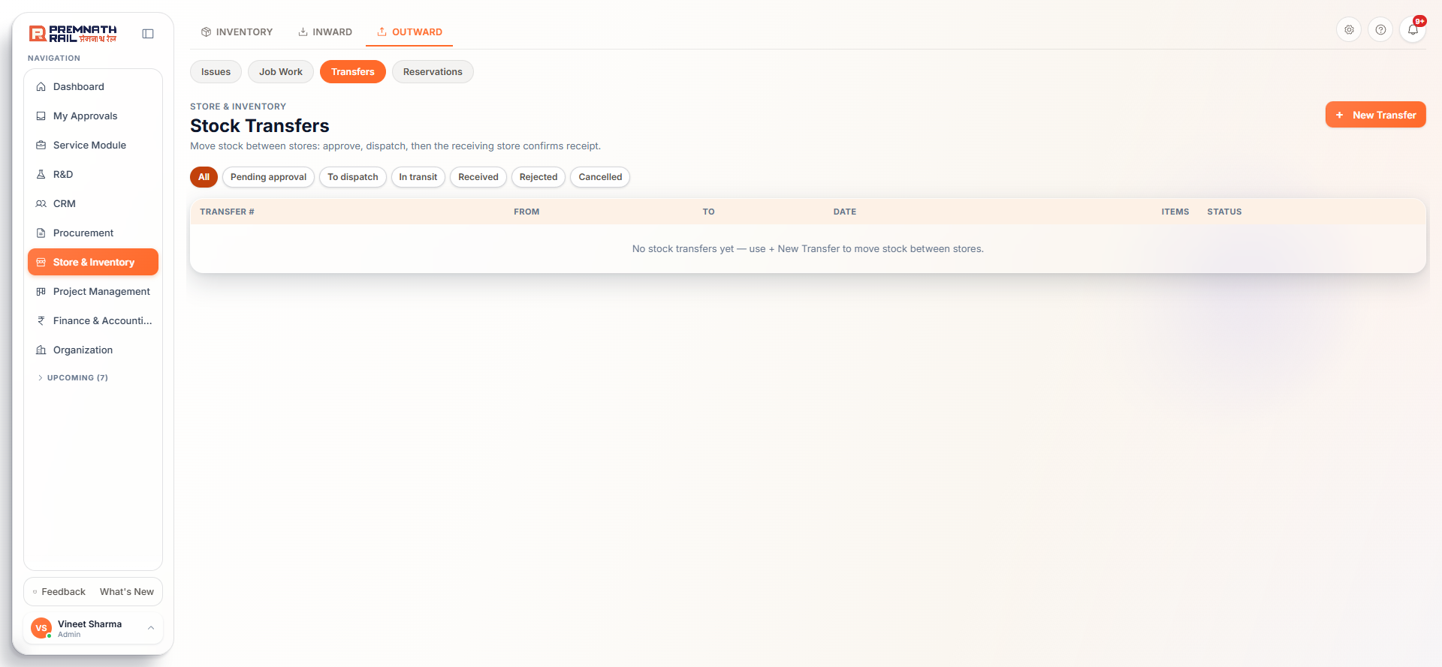
Figure 21. Transfers with status chips.
A transfer moves stock from one store to another, including stores in other plants. It has an approval in front and two physical steps. It is not posted at once.
Status | What it means | Who acts next
Pending approval | Raised, nothing has moved | The sending store's manager approves
Approved (To dispatch) | Approved | Sending store clicks Dispatch
In transit | Stock left the sending store and is on neither store's balance | Receiving store clicks Confirm Receipt
Received | Stock added to the receiving store at the same value | Done
Rejected / Cancelled | Approver rejected it, or the person who raised it cancelled it before dispatch | Raise a new transfer if needed

1. Raise: Outward > Transfers > + New Transfer. Pick From Store and To Store (they must differ), an optional Reason, then the items, quantities and an optional Batch. Click Submit for Approval. The system checks that the quantity is Available.
2. Approve: the sending store's manager approves. You cannot approve your own transfer.
3. Dispatch: the sending store opens the transfer and clicks Dispatch. Enter Vehicle Number, Transporter, Driver name and phone, and the E-way Bill number (12 digits, needed when the two plants are in different states). For transfers between plants with different GST numbers, the system issues a tax invoice at the stock's average cost. Otherwise it makes a delivery challan.
4. Print the Stock Transfer Note (a Word document, with PDF also available) from the transfer page.
5. Receive: at the other store click Confirm Receipt. The full dispatched quantity is added to that store. There is no partial receipt. If something arrived short or damaged, receive it and then raise an Adjustment at the receiving store for the difference.
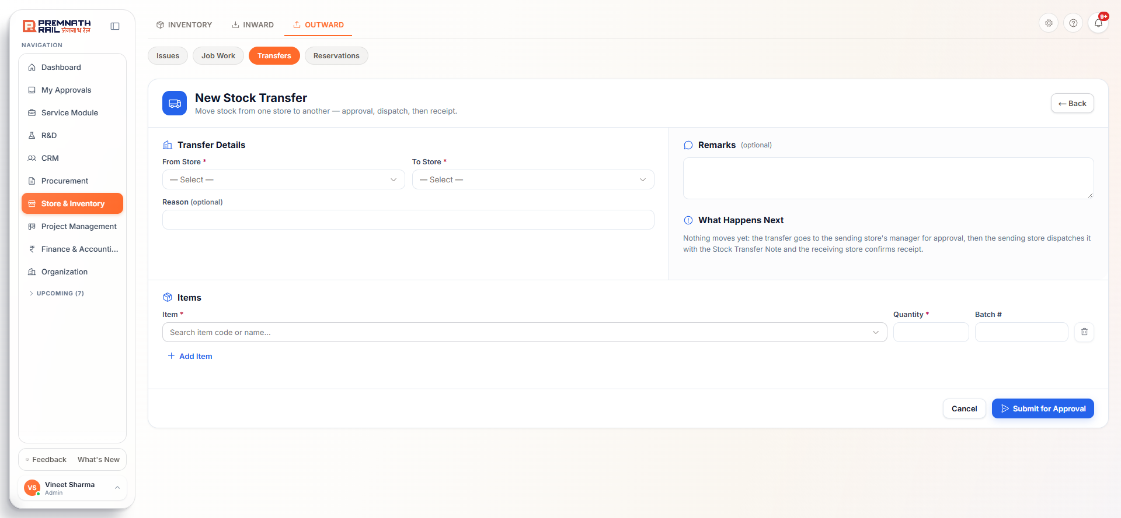
Figure 22. New Stock Transfer form.
Careful: The transfer form has no bin or serial pickers today. A serial-numbered item, or an item kept in bins, may be refused with a message. Ask your admin if you hit this (Appendix A).

6.3 Reservations
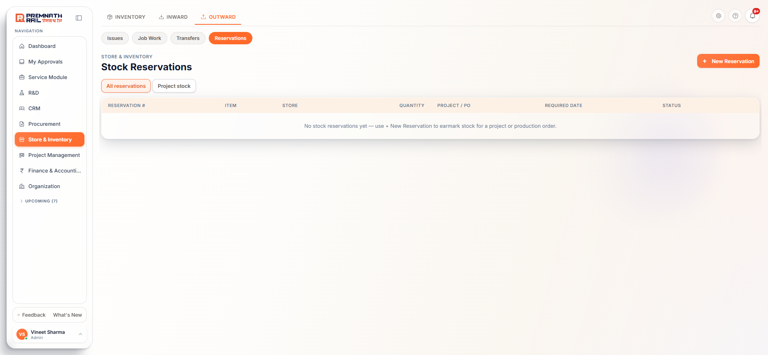
Figure 23. Reservations.
A reservation earmarks Free stock for a project or order so nobody else can issue or transfer it. It does not move stock. On the Stock page Reserved goes up and Available goes down, while On Hand stays the same.
1. Open Outward > Reservations and click + New Reservation.
2. Pick the Item, Store and Quantity.
3. Under Reserved For you may pick a Project - Unit, a project note, a production order, a required date and remarks.
4. Click Reserve Stock. You get RES-2026-nnnn with status Active.
- Cancel releases the reserved quantity back to Available.
- Fulfill marks it done once you have issued the material separately. It does not issue anything and does not reduce stock.
- Stock bought for a project is held for that project automatically when the GRN reaches Free stock. These holds show under Project stock.

6.4 Job Work
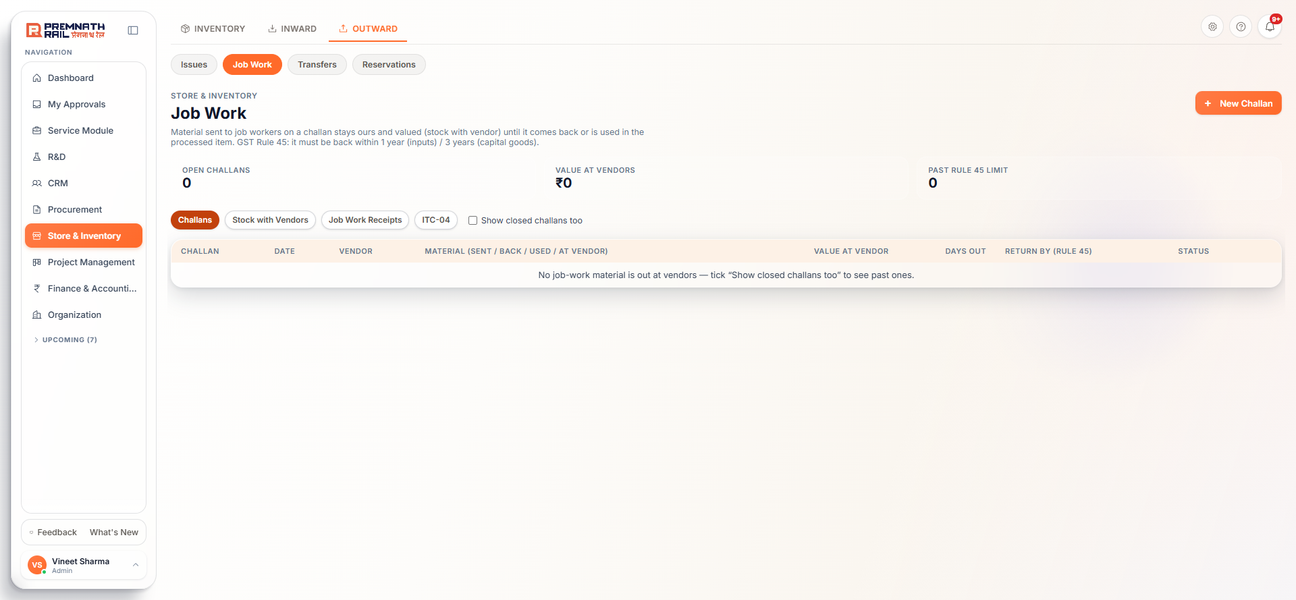
Figure 24. Job Work.
Job work means sending material to a vendor for processing (machining, plating, heat treatment, fabrication, outside testing). The material stays ours and valued, in the With Vendor bucket, until it comes back. Under GST Rule 45 inputs must return within one year and capital goods within three. The page shows cards for Open challans, Value at vendors and Past Rule 45 limit, and tabs for Challans, Stock with Vendors, Job Work Receipts and ITC-04.
1. Send: click + New Challan. Pick Store, Vendor, Process, Expected return date and the Delivery challan no. Add the items to send. Optionally fill Items to receive back when the vendor will return something different (for example plate sent, flange back). Click Create Challan. Stock moves from Free to With Vendor. A challan Word document is made.
2. Vendor returns processed goods: click Receive processed items on the challan row. Enter the processed items and quantities, the job charge (from an issued PO if there is one), how much challan material was used and how much became process scrap. Click Post receipt. You get JWR-2026-nnnn. Processed items go to Free stock, or to Quality stock if the item needs a job-work inspection.
3. Vendor returns the same material unprocessed: click Return as-is, enter quantities and condition, and give the reason. This creates a Material Return.
A challan shows At vendor, Past expected return, Rule 45 limit passed or Closed. Reminders go to the Store team before the limit. The ITC-04 tab gives the GST return report with an Excel download.

7. Stock control: adjustments, physical count, reorder

7.1 Stock Adjustments
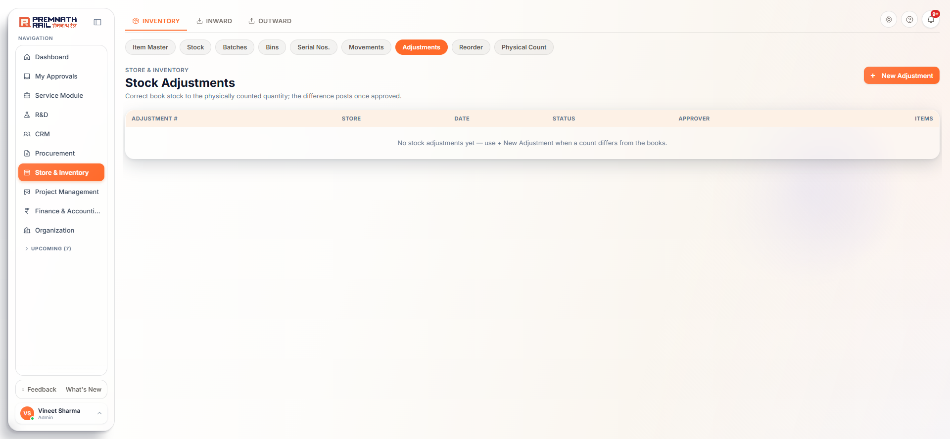
Figure 25. Adjustments.
An adjustment corrects book stock to the real quantity when you find a difference. A Store Manager must approve it before stock changes.
1. Open Inventory > Adjustments and click + New Adjustment.
2. Pick the Store and the Approver (a Store Manager, not yourself).
3. Add each Item. The Existing Qty is read from the live Free balance. Type the Actual Qty you counted. The difference shows in green or red.
4. Add a Reason and click Send for Approval. Nothing posts yet.
5. The approver opens it and approves or rejects (a reason is required to reject). On approval each difference posts as Adjustment (+) or (-) to Free stock at the average rate.
Rule: You cannot approve your own adjustment. The approver must hold Approve rights and be a Store Manager (or the store's manager). The difference is counted from the moment you raised it, so later receipts or issues are not wiped.

7.2 Physical Count
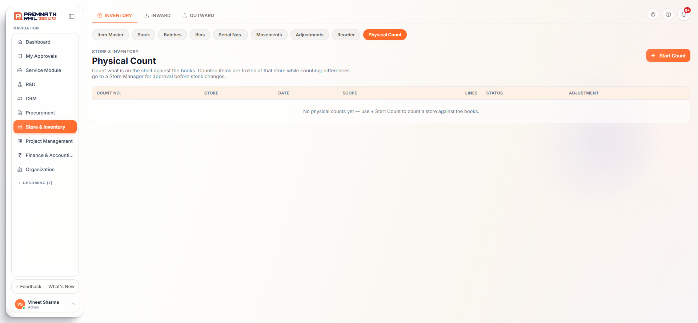
Figure 26. Physical Count.
A physical count compares the shelf with the books for a whole store or category. Counted items are frozen at that store while you count: no receipts, issues, transfers or adjustments for them until the count is submitted or cancelled.
1. Click + Start Count. Pick the Store, optionally a Category, and leave Blind count ticked if counters should not see book stock.
2. Open the count (PC-2026-nnnn) and type the Counted quantity for every line. Use Save counts as you go. Typing a different number later is a recount and keeps the first count.
3. If you find an item that is not on the list, use Add to count.
4. Every line must be counted. Enter 0 for anything not found.
5. Click Submit count. Pick the Store Manager who will approve the differences.
6. The differences become one stock adjustment that goes through the normal approval. When approved, the count is Posted and the freeze lifts.
Cancel count (with a reason) lifts the freeze without posting anything. A rejected adjustment puts the count back to Counting for a recount.

7.3 Reorder
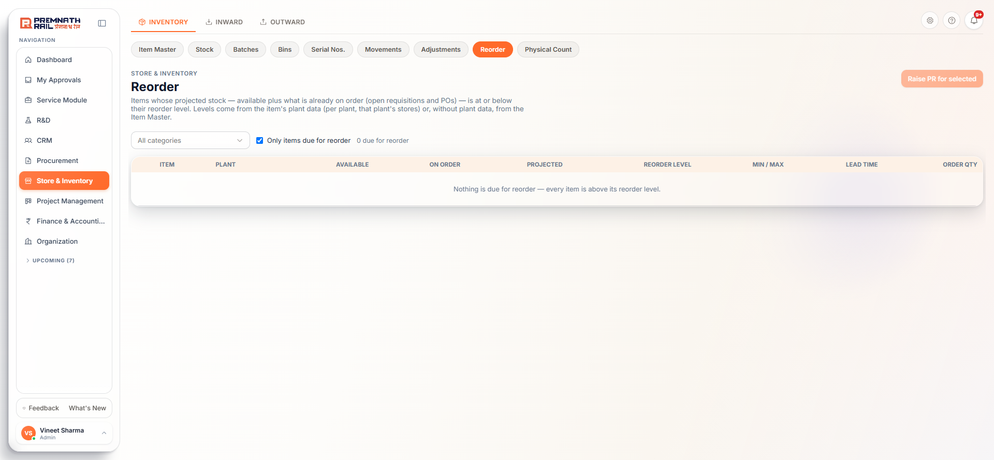
Figure 27. Reorder.
This page lists items whose projected stock is at or below the reorder level (or below minimum stock when no reorder level is set). Projected stock is Available plus what is already on open requisitions and POs. Items with neither a reorder level nor a minimum never appear.
- Use the category filter, and the box Only items due for reorder.
- The columns show Available, On order, Projected, Reorder level, Min / Max, Lead time and a suggested Order qty you can change.
- Tick the rows and click Raise PR for n selected. The PR form opens pre-filled. Nothing is raised until the PR is submitted. (Needs the Procurement module.)
- The Store team is also notified when stock falls to the reorder level after a movement.
The suggested quantity tops up to maximum stock when that is set. Otherwise it uses the reorder quantity in lots, then rounds up to the item's minimum order quantity.

7.4 Opening stock import
At go-live, or when a new store opens, the stock already on the shelves is loaded with Inventory > Stock > Opening Stock Import. Click Download template. Columns: item_code, warehouse (store code or name), quantity, rate, batch_number (optional), reference_number (required, for example OPENING-STOCK-2026), transaction_date and remarks (required). Upload and click Import.
Rule: The import is all or nothing. If any row has a problem, nothing is posted and the box "Nothing Posted" lists each row and how to fix it. Fix the file and upload again. A good rate matters because it sets the starting stock value.

7.5 Clearing blocked stock
On Stock > All Balances a Clear link next to a Blocked quantity opens Clear Quarantine. Choose what happened: Scrap, write it off, Returned to vendor, or Release to usable stock (passed re-inspection). Enter the quantity and a remark such as the scrap note number. Blocked stock held by an open Quality NCR can only be handled through that NCR. Scrap and return here are direct write-offs, so use them with care.

8. How Store works with other modules

8.1 Procurement: PR, RFQ, PO and GRN
1. Someone raises a Purchase Requisition (PR). Every PR line is linked to an Item Master item by its code, never by name.
2. When the PR is approved, the system checks store stock automatically. Not in store: it goes to Procurement for an RFQ. Fully in store: it waits for the Store Manager named on the PR to issue it. Partly in store: it splits.
3. The Store Manager named on the PR sees Issue from Stock (or Issue x and Buy y) and must write a comment. This creates a Material Issue with no type and the PR number linked. Only that manager (or an admin) can do it.
4. Procurement runs the RFQ and the PO for the rest.
5. The goods arrive and you record the GRN (chapter 4). Stock is valued at the PO rate. If a GRN line is for a project, the stock is held for that project automatically.

8.2 Projects
- Issue material to a project with the types Production, Rework, Project / Site or Dispatch and the Project unit picker, or reserve it first (6.3).
- In Project Management, the project's Store Issues tab lists these issues. The project's unit view shows a Store chip: items held, items issued, or short.

8.3 Finance
- Valuation: issues go out at the company's weighted average cost. Transfers and job work are value-neutral.
- No journal per movement. Finance uses the periodic method: at month end it takes a closing-stock valuation of Free plus Quality plus Blocked plus With Vendor stock. Issued material then shows as consumption automatically.
- 3-way match: Finance matches the vendor invoice with the PO and the accepted quantity on GRNs, less returns. A GRN must be inspected before its goods can be billed.
- Period close: stock cannot be posted in a closed month.
- Debit note: a Return to Vendor after the invoice is posted raises a pending debit note for Finance.

8.4 Service
- On a Service Request, the engineer's Material Request checks store stock. The part in stock becomes a line to issue from store. The shortfall raises a purchase requisition automatically.
- The Store issues the spare either from the service request's Materials tab or in Store with the issue type Service / Spares to site. The quantity and cost are booked on the request. The engineer asks and the Store issues.
Note: Material is bought in Procurement and gets into stock only through a GRN. If something cannot be found in the PO or GRN pickers, check that the PO is approved and that its line is linked to an Item Master item.

9. A storekeeper's day with the demo items
This walk-through uses the six demo items from section 2.4. Create them first, then follow the day. You need a vendor (for example Shree Steel Traders), a store (Main Store) with bins R1, R1-S1 and R1-S1-B1, an approved PO for 500 kg plate, 200 hex bolts and 2 pumps, and a Store Manager user.
# | When | What you do | What you should see
1 | Morning | Inward > GRN & Inspection > Upcoming. Find the PO due today | PO with Pending from Vendor lines
2 | Truck arrives with no PO for a sample lot | Inward > Before PO > + Before PO receipt. Vendor, today, challan no., one item and quantity | BPO number, status PO pending, nothing in Stock
3 | Real delivery | Upcoming > Receive. Store Location Main Store, today. Vendor invoice no. with date, challan, e-way bill, vehicle | Variance column ready
4 | Counting | Invoice Qty = bill (500, 200, 2). Received Now = counted (480, 200, 2). Pick a bin for the bolts | Short 20 on the plate, PO stays open
5 | Heats and serials | Plate: heat H-77821 300 kg and H-77822 180 kg, with TC numbers and scans. Pumps: serials HP-1001 and HP-1002. Save Goods Receipt | GRN number, status Pending Inspection
6 | Check | Stock > All Balances and Movements | Quality column holds 480, 200, 2. Movements shows GRN into Quality
7 | Inspect | Open the GRN. Bolts: Partially Accepted, 190 accepted, 10 rejected (thread damaged). Pumps: Passed. Complete Inspection | Bolts 190 Free, 10 Blocked. Plate stays In Quality inspection until Quality decides
8 | Put away | Inventory > Bins > Main Store > Unassigned > Put away, pumps to R1-S1-B1 | Bin move BM-...
9 | Send damaged bolts back | On the GRN > Return to Vendor, return rejected 10, reason Damaged in transit, vehicle number | RTV number, Blocked stock falls by 10
10 | Issue to a project | Outward > Reservations: reserve 40 bolts for the project. Then Issues > + New Issue, type Production, Project unit, items and quantities. Try quantity 500 to see the shortage banner, then set a valid quantity and Issue Material | MI number. Stock shows lower On Hand and a lower Reserved
11 | Return unused | Inward > Returns > + New Return, Against a Material Issue, 5 bolts, Good | Posts at once, Free stock up by 5
12 | Found a difference | Inventory > Physical Count > + Start Count for Main Store. Count, Save, enter 0 where nothing found, pick the Store Manager, Submit count. The manager approves the adjustment | Count Posted, adjustment SA-... posted
13 | End of day | Inventory > Reorder: tick bolts, Raise PR. Stock > Stock on Date for today. Movements filtered by your user | Your day's postings listed

Optional: a transfer between stores
Outward > Transfers > + New Transfer from Main Store to another store, 100 bolts, Submit for Approval. The approver approves. At Main Store click Dispatch with a vehicle number. At the other store click Confirm Receipt. Open the Stock Transfer Note.

10. Messages you may see and what to do
Message (shortened) | What it means | What to do
Not enough stock of '...' in store: n on hand, r reserved, q requested | Available is less than the quantity | Lower the quantity, use Issue only what's available, or free reserved stock
Also n is in Quality stock waiting for inspection | Part of the stock is not released | Wait for the inspection or ask Quality to release it
... is being physically counted ... its stock movements are on hold | The item is frozen by a physical count | Submit or cancel the count (Inventory > Physical Count)
Period ... is closed in Finance > Period Close | The accounting month is closed | Post with today's date, or ask Finance to reopen the month
Received quantity exceeds what's still outstanding on the PO | Over-receipt | Receive only the pending quantity. Ask Purchase to amend the PO if more is truly needed
PO line isn't linked to an Item Master item | The PO line has no item | Ask Purchase to use Link to Item Master on that PO line
Vendor invoice no. ... is already received | The same bill was received twice | Check the number. Reverse the earlier GRN only if it was wrong
... is batch-tracked - add the vendor's heat / batch number(s) | The item needs batches | Enter the heats with quantities that add up to Received Now
... is serial-numbered - enter N serial number(s), one per unit | Wrong count of serials | Enter exactly one serial per unit
'Test certificate required' only works with 'Inspection on receipt' | Item setup | Tick both on the item, or untick the certificate
Expiry-controlled items need a shelf life | Item setup | Enter the shelf life in days or untick expiry
Safety stock is above the reorder level / Minimum stock is more than maximum | Stock level numbers contradict | Keep Safety <= Reorder level <= Maximum, and Minimum <= Maximum
... already has stock movements in KG, so its unit can't be changed | UOM is locked | Create a new item for the new unit
... can't be deleted: it has n stock movement(s) | The item has history | Set the item to Inactive
You can't approve your own stock adjustment | Four-eyes rule | Pick a different approver
... isn't a Store Manager, so they can't approve | Wrong approver | Pick a Store Manager, or ask an admin to tick Store Manager on the user
Only a Store Manager can post Scrap / Disposal | Scrap is a write-off | Ask a Store Manager
... is kept in bins ... pick the bin | The item is put away in bins | Choose the bin on the issue line
Source and destination store must be different | Transfer form | Pick two different stores
Store has no GST state / E-way bill needed | Transfer dispatch between plants | Set the plant's GSTIN in Organization > Plants, and enter the 12-digit e-way bill

11. Good habits and checklists

Every day
- Check GRN & Inspection > Upcoming and Pending Inspection. Clear inspections the same day.
- Check Before PO for receipts still waiting for a PO.
- Check Transfers: dispatch what is approved and receive what is in transit.
- Check Reorder and raise PRs for items due.
- Check your bell for approvals waiting and Quality results.

Every week
- Look at Blocked stock and clear it: return to vendor, scrap with a Store Manager, or release after re-inspection.
- Look at Job Work for challans past the expected return date.
- Do a cycle count of fast-moving or high-value items with Physical Count.
- Put away anything in the Unassigned row of the bin page.

Every month end
- Finish all pending GRN inspections, adjustments and counts so the closing stock is right.
- Check Stock on Date for the last day of the month and compare with the physical situation.
- Tell Finance before the period is closed. After closing, no stock can be posted for that month.

When adding or changing items
- Search first. One item, one record.
- Fill HSN and GST from the vendor's tax invoice.
- Tick Inspection, MTC, Batch, Serial and Expiry according to how the item is really handled.
- Never use Inactive to hide a mistake: if an item was added twice, ask the owner how to merge the stock.

Appendix A. Things to confirm with the owner
While writing this manual from the current screens we found places where the screen, the guided tours and the system rules do not match, and a few gaps. None of these stop daily work, but the Store team should know about them. Section numbers refer to this manual.
# | What we found | Where
1 | The Add Item page subtitle and the guided tour still say the item code is made from type and category, or typed by the user. The code is a plain running number | 2.3
2 | The item list sorts codes as text, so 100 shows between 10 and 11. Most Store lists (GRN, Returns, Adjustments, Batches, Serials, Movements, Issues, Transfers, Reservations) load newest first, not ascending by number | 2.1
3 | The Stores page has no Edit button, but the delete message tells users to set the store Inactive by editing it | 3.4
4 | The Issue Types page shows Add and Delete, which the server always refuses. The refusal text points to the retired Issue Rules page. The role editor still lists the retired tabs Issue Rules and Stock Entry Types | 3.5
5 | Inactive categories still appear on the Add Item form | 2.3
6 | "Has expiry" can be ticked without "Batch tracked", but expiry dates exist only on batches | 2.3
7 | The Import help text lists 6 columns, but the template and the server use 15 | 2.6
8 | The Units edit note says renaming a code moves every item. The server refuses a code change once the unit is used | 3.2
9 | Transfers: the form has no bin or serial pickers, Confirm Receipt has no bin picker, and Dispatch has no per-line rate. Serial-numbered or binned items can fail from the screen | 6.2
10 | Material Return form has no bin or serial input. Return to Vendor has no serial picker. The GRN form has no supplier-warranty or manufacturing-date field | 4.6, 4.9
11 | Start Count offers only store and category. Counts by item list or by bin exist only in the API | 7.2
12 | Clear Quarantine (scrap or return to vendor) writes stock off without an approval | 7.5
13 | Spares-only dispatch cannot be created because Dispatch always asks for a project or machine | 6.1
14 | Stock value depends on the Weighted-average valuation setting, which has no screen switch. Confirm it is on in production before relying on rupee figures | 5.1
15 | Goods in transit between stores appear on no Stock page, only on the Transfers page | 5.1
16 | The Reverse GRN button shows to anyone with the right, but the server also needs the Purchase module | 4.7
17 | Tours that are out of date: Add Item, Item Types, Categories, Stores, Issue Types, Issue form, Transfer form and detail, GRN form and detail, GRN list, Stock, Movements, Reorder, Material Return form, Adjustment detail | Guided tours

Appendix B. Glossary
Word | Meaning
Available | Free stock minus Reserved stock
Batch / heat | A lot from one production run of a vendor. Carries the heat number and mill test certificate
Blocked | Rejected or damaged stock that cannot be issued (quarantine)
Bin | The smallest storage place: rack, shelf, bin
Free stock | Good stock that is ready to use. Shown as On Hand
GRN | Goods Receipt Note: the record of goods received against a PO
HSN / SAC | GST classification code: HSN for goods, SAC for services
Inspection lot | A Quality record created for an item that needs inspection on receipt
Item Master | The list of every item the company buys or stores
MTC | Mill test certificate
NCR | Non-conformance report raised by Quality for rejected material
PO / PR / RFQ | Purchase Order / Purchase Requisition / Request for Quotation
Quality stock | Received stock waiting for inspection
Reserved | Free stock earmarked for a project or order
Reorder level | The level at which new stock should be ordered
RTV | Return to Vendor
Rule 45 / ITC-04 | GST rule and report for material sent for job work
UOM | Unit of measure
With Vendor | Stock sent to a job-work vendor, still ours

