**Candidate No. 1: 14661**

**Candidate No. 2: 29423**

**Candidate No. 3: 17958**

**Candidate No. 4: 35219**

**Candidate 5. Ophelie Renard**

**Word Count: 1997**

**Mg 100 Group Project**

Indra Krishnamurthy Nooyi, a native of Madras (India) is an Indian-American business executive and the current Chairperson and Chief Executive Officer of PepsiCo, the second largest food and beverage business in the world by net revenue. PepsiCo has 22 brands[1] that generate more than $1 billion each in annual retail sales. Forbes ranked her as the third most powerful women in 2008. Her unique leadership abilities also helped in boosting PepsiCo’s earnings as “the revenue jumped 1.2% to $13 billion” (Forbes 2013). Her clear-sightedness and determination led the firm to grow and expand.

However, all this success did not come her way without struggles. Firstly, a year after she became the CEO the business world faced one of the biggest financial crisis. This financial crisis was followed by a ban on Soda and sugary drinks over 16 ounces by Michael Bloomberg in September 2012. This change in the statutory requirement encouraged Indira Nooyi to introduce a new vision to PepsiCo which she termed as “Performance with Purpose”. This new strategy introduced by Indra Nooyi included the shift for PepsiCo into a healthier food and beverages sector. This strategy has led to an increase in the well being of organisation as well as the employees, however, most of the investors still don’t believe in her.

In our essay, we aim to critically evaluate her qualities using various theories such as the glass ceiling theory, the transformational leadership theory, the power and influence theory and the communication theories that have helped Indra Nooyi overcome these major obstacles and take the company in a profit-making direction since 2006.

The world’s most influential woman (Times 2013) had to face a lot of struggle to reach this position. One of the major reasons for her struggle was being a woman. “Being a woman, being foreign born, you’ve got to be smarter than anyone else.” (Forbes, 2014). This reflects the ‘Glass Ceiling’ issue faced by Nooyi and other females from moving to higher positions in the organisational heirarchy (Cotter et al., 2001). As defined by Cotter et al., a glass ceiling inequality represents a gender or racial difference that is not explained by other job-relevant characteristics of the employee”. According to Eagly and Schmidt (2001), this discrimination takes place in two forms; firstly, men are generally considered to be better leaders and secondly, agentic behaviour (confident, assertive etc.) which is ascribed more to men, is believed to be more desirable for good leadership. Yet, if a woman portrays such behavior, she is considered less likable her colleagues (Eagly and Schimdt, 2001). Hence, there is a trade off involved and women have to balance between the two. But, Indra Nooyi has been able to break this invisible ceiling and not only become the CEO of the world’s second largest food and beverage company, but also successfully transform its product portfolio.

To overcome this invisible glass ceiling and ensure that followers agreed to her desire in changing PepsiCo’s product portfolio, Nooyi used framing in the form of value amplification. She did this by identifying her values and conveying them as the company’s mission to encourage followers to work towards it (Conger, 1991). The main objective she introduced as CEO was “Performance with a Purpose” where PepsiCo sees revenue growth whilst also addressing the interests of all other stakeholders, especially in the form of a balanced product portfolio (BlogHer, 2011). This framing, according to Conger as well as Yukl (2002) is intrinsically appealing to the employees as it addresses broader societal contributions like increasing nutrition knowledge globally (Nooyi, 2011). This can thus be seen as successful communication by Nooyi, which aided PepsiCo’s success in expanding the portfolio.

Following this framing, Nooyi could have achieved the goal of successful portfolio expansion by being a charismatic leader. H. Bommer et al. (2004) found that a charismatic leader should have expertise, power base, likableness, and environmental sensitivity and that charismatic leadership often leads to success in firms. One form of charismatic leadership that Nooyi has is a considerate personality, which leads to her likeability. This personality is shown through her quotes like “Companies today are bigger than the economies. If companies don’t do (responsible) things, who is going to?” (Organizational Behavior: managing people and organizations, 2010). This highlights that Indra is attentive towards the demands of all her stakeholders, especially the employees, who she considers as the most important asset of the organisation (Forbes, 2014). This considerate nature is evident by the fact that she blogs her 300,000 employees every fortnight (BlogHer, 2011). This shows how Nooyi’s personality could have encouraged followers to work with her towards the successful portfolio transformation.

Nooyi has also shown to gain likeability through her use of non-verbal communication, which contributes towards 55% of effective leader communication (Conger, 2011) and Nooyi’s body language also, could have been a factor in communicating the mission successfully. Her body language is evident in her interview where, Nooyi consistently makes eye contact to engage with people/employees who are listening to her in order to make them also feel responsible in achieving the goal. Most importantly though, she smiles continuously which can translate to positivity in what she is talking about and encourage followers to achieve the goal. These factors could have increased the fondness that employees had for her (Mehrabian, 1971, cited in lecture slides) which is the principle of persuasion (Cialdini, 2001, cited in lecture slides) and therefore may have been a factor that led to the success of the newly balanced product portfolio.

One of the most important factors of Nooyi’s leadership, which has led to PepsiCo’s success, is her use of a combination of sources of power to influence her followers. The first form is Expert Power, which is, “power based on a person’s experience and knowledge” (Forbes, 2014). Indra Nooyi can be seen to have this experience from studying in prestigious universities like Yale and working in several different roles in companies like BCG and Motorola as well as her several years of experience in PepsiCo before becoming the CEO (BlogHer, 2011)**.**

The second form was referent power, which is based on liking, admiration, and identification by the followers towards the leader. Several of her followers have shown to be fond of their CEO as well as she is highly engaged with most of them (BlogHer’11)**.** Nooyi’s experience and her followers’ admiration towards her together could have led to her followers wanting to follow her mission. Overall, it can thus be seen that Nooyi relied heavily on expert power and referent power in order for her followers to agree to and work with her towards the change in PepsiCo.

However, during her tenure, Indra has often failed to hit her stated profit targets, which investors consider an unforgiveable sin. This indicates that although she may be a charismatic leader, but it might not have contributed towards PepsiCo’s success, especially when it came to Nooyi having to deal with factors like the unstable economy and government actions during that period. (CNN Money, 2012)

Nooyi acquired this power though, through her power of talk (Tannen, 1995), which is the use of a combination of communication tactics to enforce the power on followers (Tannen, 2000). This shows that her communication is an integral part of PepsiCo’s success. Nooyi’s rhetoric and delivery used in several interviews can be shown as an indicator of how she actually communicates the mission to employees. For example, she especially uses analogies to communicate messages like when she described her company as a racecar that is not performing badly but is in the pit stop, rejuvenating to come back stronger (Nooyi, 2012). She uses this to engage her followers so they listen to her thoroughly and, therefore more willingly work towards the change (Willner, 1984, cited in Bligh and Hess, 2007). Thus, one can see that Nooyi’s use of verbal communication could have been a factor in the success of PepsiCo’s portfolio expansion.

However, Nooyi was also described as “testy” (Bay, 2011) which can be seen as an example of where her communication skills were not effective in getting shareholders to like her and this negative perception could have affected PepsiCo’s share value and thus affected the “performance” part of Nooyi’s main mission. Nooyi (2011) mentions how this could be because of her cynical responses at times and instead that she could learn to be more diplomatic and say “thank you for your question, I will have to think about that one and get back to you”. Another factor that could have hindered PepsiCo’s success was her speed of communication. Nooyi (2011) said that she had to learn to slow down her speech in order to deliver messages more effectively. This is a factor in rhetoric and delivery that has a high impact on the ability for a leader to inspire change (Tannen, 2000). Thus, these weaknesses in her communication skills could have affected PepsiCo’s success in expanding the portfolio.

The biggest factor to PepsiCo’s success though, was Nooyi’s ability to be a transformational leader. This was her ability to get followers to want to make a change (week 6 lecture slides, 2014). This was especially done through Nooyi’s confidence. In an interview regarding how Nooyi encouraged her employees to make the change in the portfolio happen, she replied “I was out there, like a missionary with all the employees, explaining why we're doing what we are doing.” (CNN Money, 2014) Moreover, involving the employees and explaining what the company was doing shows traits of a transformational leader in her. As found by William H. Bommer et al. (2004), “the people in organisations use the behaviour of others to inform and regulate their own behaviour”. Therefore, Indra’s confidence could be one of the reasons that helped such a drastic change in PepsiCo to occur. Although, as said in the interview, there were a number of investors who didn’t believe in Indra and sold their stock, -they were proved wrong due to PepsiCo’s success a few years later under Indra’s guidance.

Hence, Indra Nooyi had to face a lot of obstacles throughout her career, one of which is portrayed by the following quote. “Conforming to their gender role can produce a failure to meet the requirements of their leader role, and conforming to their leader role can produce a failure to meet the requirements of their gender role.” (Eagly and Schimdt, 2001) Despite this, Nooyi has successfully managed to balance her communal and agentic behavior leading to an effective implementation of policies such as “performance with purpose” and preventing the gender discrimination women generally face. This has not only increased the company’s profits but also helped her to break the glass ceiling. Moreover, her power and influential ability was also crucial in gaining the trust of her employees and convincing them to follow her. Combined with her use of communication skills such as her engaging eye contacts, her use of analogies and repetitions as well as her delivery she inspired her followers, communicated the mission effectively and facilitated the changes. Furthermore, Indra Nooyi’s actions over the years as CEO have demonstrated her belief in transformational leadership, one who trusts her employees to work up to their potential. In an interview, she said “my dad told me to always believe that people have positive intentions”, this statement shows that she is a positive leader and her leadership style has helped the company to reach new heights, even in bad times.

However, today several of its most valuable brands, such as Pepsi and Doritos, have lost strength or market share, or both making shareholders expect lower profits in the future[2] and her cynical responses are being negatively perceived. We still believe, after evaluating Indra’s leadership skills in different situations PepsiCo has been through (2008 financial crisis, law regarding sugary drinks), the unique leadership abilities possessed by Indra Nooyi will help her overcome the criticisms she is currently facing by investors and take PepsiCo to new levels.

**REFERENCES:**

* Bligh, M.C. & Hess, G.D. (2007), [The power of leading subtly: Alan Greenspan, rhetorical leadership, and monetary policy](http://readinglists.lse.ac.uk/items/718B69E8-8E3F-5D0E-D88F-EFD9BFBFDA92.html?referrer=%2Flists%2FF505B398-2E06-7250-0A21-B3A0846CC57F.html%23item-718B69E8-8E3F-5D0E-D88F-EFD9BFBFDA92)
* Bommer, W. H., Rubin, R. S. and Baldwin, T. T. 2004. Setting the stage for effective leadership: Antecedents of transformational leadership behavior. *The Leadership Quarterly*, 15 (2), pp. 195--210.
* Bono, J. E. and Judge, T. A. 2003. Self-concordance at work: Toward understanding the motivational effects of transformational leaders. *Academy of Management Journal*, 46 (5), pp. 554--571.
* Conger, J. A., (1991), [Inspiring Others: The Language of Leadership](http://readinglists.lse.ac.uk/items/7CF7C0BB-86DC-4567-23F7-0111218977C9.html?referrer=%2Flists%2FF505B398-2E06-7250-0A21-B3A0846CC57F.html%23item-7CF7C0BB-86DC-4567-23F7-0111218977C9)
* Cotter A.D. et. al. 2001. The glass ceiling effect. *Social Forces*, 80(2), pp. 655-682
* Eagly A.H. and Johannesen-Schimdt M.C. 2001.The Leadership Styles of Women and Men. *Journal of Social Issues*, 57(4), pp. 781-797
* Eagly, A. H., Makhijani, M. G., & Klonsky, B. G. 1992. Gender and the evaluation of leaders: A meta-analysis*. Psychological Bulletin*, *111*, pp. 3–22.
* The Economic Times. 2014. *Indra Nooyi, Chanda Kochhar in Fortune’s list of 50 powerful businesswomen* [Online]. India. Available at <http://articles.economictimes.indiatimes.com/2014-02-07/news/47126562_1_pepsico-ceo-indra-nooyi-fortune-list-petrobras-ceo-maria>. [Accessed: 9th March 2014]
* Edwin A. Locke, 2003. The Blackwell Handbook of Principles of Organizational Behaviour, pp. 25-28
* Forbes. 2014. *Why Pepsi’s CEO writes to her employees’ parents* [ONLINE]. USA. Available at: <http://www.forbes.com/sites/kevinkruse/2014/02/06/indra-nooyi-wholehearted-leader/>. [Accessed: 10th March 2014]
* Griffin R.W. and Moorehead G, 2010. *Organizational Behavior: managing people and organizations.* 9th ed. Australia: Cengage Learning
* Hovland, C, & Weiss, W. 1951. The influence of source credibility on communication effectiveness. *Public Opinion Quarterly*, 1951, 15, 635-650
* Moore, H. 1921 the comparative influence of majority and expert opinion. *American Journal of Psychology*, pp, 16-20
* NDTV. 2013. *Never be happy with what you know: Indra Nooyi* [ONLINE]. India. Available at: <http://www.ndtv.com/video/player/news/never-be-happy-with-what-you-know-indra-nooyi/301374>. [Accessed: 10th March 2014]
* Nooyi, I. K. (2011), BlogHer conference (<http://www.youtube.com/watch?v=7NH3EdYvT4M> )
* Nooyi, I.K. (2012), Pepsico Business Update<http://www.youtube.com/watch?v=tk0xoWxpCKY>
* Tannen, Deborah, 1995. "The Power of Talk: Who Gets Heard and Why." *Harvard Business Review*, 73(5), pp. 139-148
* YouTube. 2014. *Five C's of Leadership with Indra Nooyi*. [online] Available at: http://www.youtube.com/watch?v=u0DMaydBOxk [Accessed: 21 Mar 2014].
* YouTube. 2014. *PepsiCo CEO Indra K. Nooyi Talks Personal and Professional Inspiration During BlogHer '11 Keynote*. [online] Available at: http://www.youtube.com/watch?v=7NH3EdYvT4M [Accessed: 21 Mar 2014].
* Yukl, Gary. Upper Saddle River N.J 2006 ’Power and Influence’ Leadership in organizations pp.1-2,

**APPENDIX:**

**Image 1:**

* **Source:** <http://management.fortune.cnn.com/2012/05/29/pepsi-indra-nooyi-2/>)

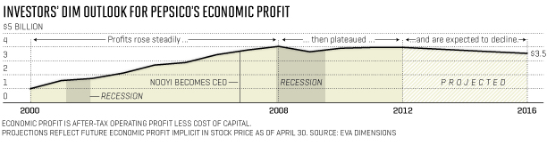

**Image 2**

* **Source:** [**http:/**/www.pepsico.com/Brands/BrandExplorer#good-for-you](http://www.pepsico.com/Brands/BrandExplorer#good-for-you)

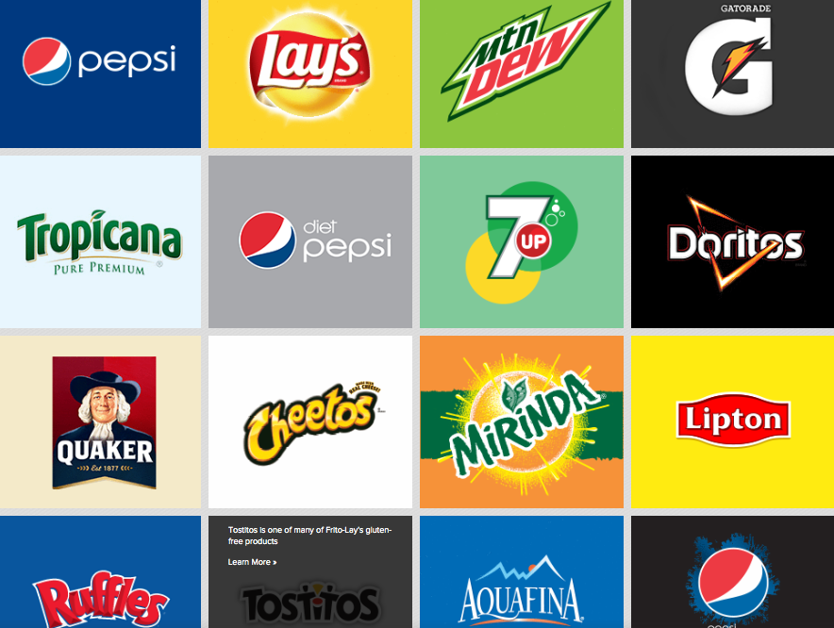

1. Refer to appendix, image 2
2. Refer to appendix, image 1