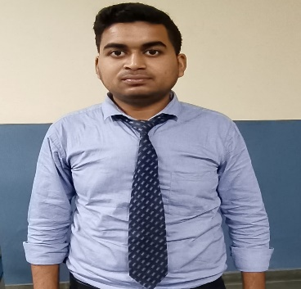

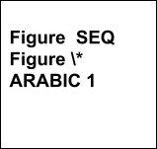Vivek Rana

## Contact: 7300790014

Email id: [vivekrana730079@gmail.com](mailto:vivekrana730079@gmail.com)

## Linkedin: https://[www.linkedin.com/in/vivek-rana](http://www.linkedin.com/in/vivek-rana)



To succeed in an environment of growth and excellence and earn a job which provides me job satisfaction and self-development and help me achieve personal as well as organizational goals. I am eager to leverage my skills in web development and software programming to contribute effectively to dynamic projects, with a passion for technology and a determination to learn, I am seeking opportunities to kickstart my career in the field of MERN stack development.



**CAREER OBJECTIVE**

# Bachelor of Technology in Computer Science Engineering



**EDUCATIONAL QUALIFICATION**

IMS Engineering College, Ghaziabad CGPA :7.21

# 12th(Intermediate)

Agrasen Inter College, Harduaganj(Aligarh) Percentage: 70.2%

# 10th(High School)

Agrasen Inter College,Harduaganj(Aligarh) Percentage: 75.66%

**INTERNSHIP TechnoFunnel – (July 2023- August2023)**

It was a one month internship program where I was trained in MERN and henceforth

Collaborated with a team of developers to create and maintain web applications using the MERN stack.

Assisted in the development of interactive and user-friendly interfaces, ensuring seamless user experiences.

**LANGUAGES KNOWN :** HTML, CSS,JAVASCRIPT,C++,C

**TECHNICAL SKILLS**

**FRAMEWORKS KNOWN :** REACT **DEVELOPER TOOL :** VS Code **DATABASE KNOWLEDGE :** mongoDB



Certified in Cybersecurity from CISCO- **2022**

Certified in Getting start in python-2021



**WORKSHOP**

**CERTIFICATIONS**



Attended the workshop of python. Attended the workshop of C.



Awarded as the top scorer in Business Communication.

**INTERESTS**

**ACHIEVEMENTS**

Solving real-life problems related to programming and developing logics related to programming.

Playing Cricket, Badminton.



Worked in various projects as Team Member in IMSEC Worked in NGO as a Volunteer in IMSEC



**EXTRA CURRICULAR ACTIVITIES**

**PROJECTS**

* **Car Racing Game-**

## To create a car racing game using the popular library pygame, which is used to create fun games in Python. We learned how to manipulate the movement of a race car in your program by applying various “speeds” and how to make the car collide with the wall and other cars. You can also add different types of cars

change the background to your liking etc.

**Signature**

## Vivek Rana